**Engineering Machinery**

Engineering machinery has a wide diversity of types and functions, including excavator,crane, road roller, piling machine and etc. As the globalization grows rapidly,especially in developing market, there is a great demand of engineering machinery for public facilities, construction, agriculture, and etc.

Machinery manufacture requires massive drilling, cutting with high precise in varies of materials and thickness. By using laser technology, both quality and efficiency can be achieved because of its high energy, great accuracy and flexibility.

Hymson Laser offers flexible laser cutting solution to customer through different materials. Continuously researching and developing in laser technology and application, we understand the machine better. Therefore, the machine we designed is stable, efficient and intelligent. An exceptional service team cares each Hymson machine and serves 24/7 with quick-response.



**Shipbuilding**

Ship,especially freighter, is one of the most important parts in globalization that bridging different economy, culture and activity. The amount of ships is increasing significantly through stronger connection among countries, therefore, there is huge demand of new ships.

Laser is an advanced and flexible technology, can easily handle different metal processes. Owing to its high energy, high precise and contact less processing features, laser has been broadly used for massive metal cutting and welding.Compared with traditional method (flame cutting and plasma cutting), laser can achieve better quality with much less time.

Hymson Laser offers flexible laser cutting solution to customer through different materials. Continuously researching and developing in laser technology and application, we understand the machine better. Therefore, the machine we designed is stable, efficient and intelligent. An exceptional service team cares each Hymson machine and serves 24/7 with quick-response.



**Fitness Equipment**

People are willing to spend more on time and items with healthy attributes, and this kind of idea has brought health and fitness awareness around the world. It is said that the global fitness club industry can generates more than 80 billion U.S. dollars in revenue every year.

There is a huge market growth for fitness industry, as well as fitness equipment. However,it needs a great number of machines to deal with different parts of these fitness equipment as they are varied with different function. Unfortunately,not too many factories can afford the machine fees or labor resources.

The situation changes when laser technology was introduced into the industry. Laser can easily process a diversity of material, shape and thickness without bur or galling. A better quality and efficiency product can be achieved without secondary operation.

Hymson Laser offers flexible laser cutting solution to customer through different materials. Continuously researching and developing in laser technology and application, we understand the machine better. Therefore, the machine we designed is stable, efficient and intelligent. An exceptional service team cares each Hymson machine and serves 24/7 with quick-response.

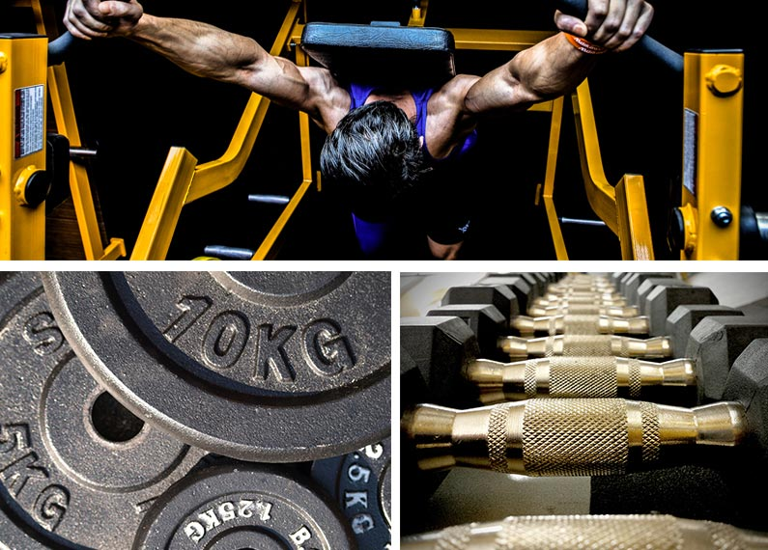

**Electronic Cabinet**

More and more metal material was used for electronic cabinet in varied industries,and it requests higher standard for the manufacturer.

By using laser technology, the edge of the cabinet can be handled without burr,galling or sharp edge. Compared with traditional mechanical methods, laser has a great advantage, that is the flexibility. It requires good precise, high quality customization ability with limited time. Therefore, laser technology becomes the prefect choice for manufacturer.

Owing to time saving, flexibility, high quality and simple control, laser technology changed the electronic cabinet into a high efficiency, professional industry.

Hymson Laser offers flexible laser cutting solution to customer through different materials. Continuously researching and developing in laser technology and application, we understand the machine better. Therefore, the machine we designed is stable, efficient and intelligent. An exceptional service team cares each Hymson machine and serves 24/7 with quick-response.



**Petroleum**

As globalization has been developing continuously nowadays,the demand for energy in various countries and regions is increasing, meanwhile leads to the acceleration of growth in petroleum pipelines industry. Due to the diversities of terrain and climate in different regions, the quality standard for pipelines are extremely high,and it has to undergo rigorous quality inspections. Furthermore, pipeline also challenges the manufacturing and processing technology in terms of precision and efficiency. Be that as it may, with all the advantages and features, the state-of-the-art laser manufacturing technology becomes an ideal solution to pipeline industry.

In the petrochemical industry, laser cutting technology is widely used in precision cutting of various types of pipes. Among them, in the process of petroleum drilling, it is required to pass the looses and layer. Therefore, sand control of the pipeline is one of the key steps in drilling. An effective solution is to block a large number of small gaps around the pipelines.Traditional processing methods are low precision, rough, deformation, and low efficiency, resulting in poor sand control. By using laser's high-density energy processing features, the screen pipe can be precisely machined to obtain smooth, uniform, burr-free holes that allow pipes to perform better. Laser processing is a flexible process which can quickly fabricate multiple types of pipes with high quality.

Hymson provides customers with a variety of high-quality sheet metal laser processing equipment that can meet the fabrication requirement of different materials and thicknesses. The ongoing research and development of the Hymson laser’s technology empower its machine tool getting more stable,productive and smarter.An exceptional service team cares each Hymson machine and provide fast and quick-response after-sales service.

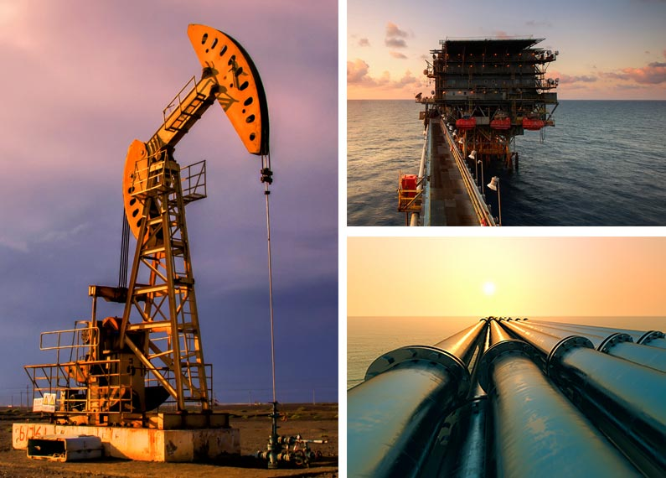

**Automobile**

Automobile are an important tool in modern society with respect to present standard of living. Consumers' pursuit of personalization,function, and taste also leads to persistent innovation in automotive manufacturing technology and continues to introduce new generations of products.This is a big challenge for car makers.It needs to consider how to reduce manufacturing costs while also improving manufacturing technology.

Thanks to the advantages of non-contact, flexible and high-precision machining, laser application technology has basically covered all areas of the automobile manufacturing industry, especially laser cutting technology, and has been fully applied to auto parts, body, door frames, trunks, roof cover etc.

As one of the industries with the highest level of intelligence, automobile manufacturing has integrated a variety of production processes. Lasers, as one of the most important technologies, have achieved up to 70% of intelligent parts production.The emergence of laser cutting technology has greatly reduced the production cost and improved the production efficiency.

Hymson provides customers with a variety of high-quality sheet metal laser processing equipment that can meet the fabrication requirement of different materials and thicknesses. The ongoing research and development of the Hymson laser’s technology empower its machine tool getting more stable,productive and smarter.An exceptional service team cares each Hymson machine and provide fast and quick-response after-sales service.

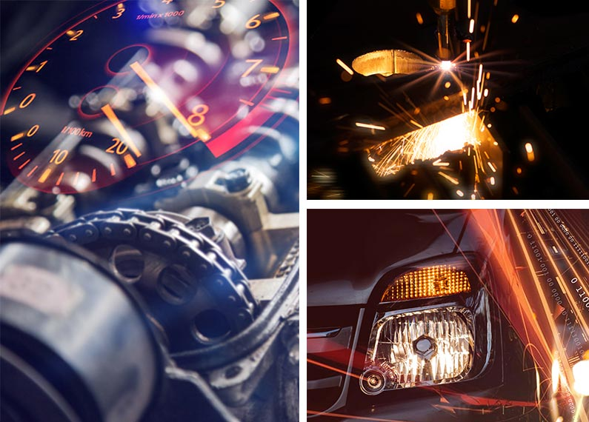

**Sheet metal**

The sheet metal industry has developed rapidly in recent years and is widely used in every industry. The total market volume is increasing, which has brought economic benefits to enterprises and regions, promoted the development of upstream and downstream industries, and further consolidating China to become a global sheet metal manufacturing center.

As an important supporting technology for sheet metal, laser advanced manufacturing technology has the characteristics of high efficiency, high precision and flexible processing. Compared with the traditional processing methods, laser technology has significantly improved the processing speed, accuracy and efficiency. By using the non-contact processing methods, laser processing does not require grinding tools, and no deformation caused by machining; especially for some common metal materials, such as carbon steel plate, laser cutting has obvious processing advantages.

Hymson provides customers with a variety of high-quality sheet metal laser processing equipment that can meet the fabrication requirement of different materials and thicknesses. The ongoing research and development of the Hymson laser’s technology empower its machine tool getting more stable,productive and smarter.An exceptional service team cares each Hymson machine and provide fast and quick-response after-sales service.

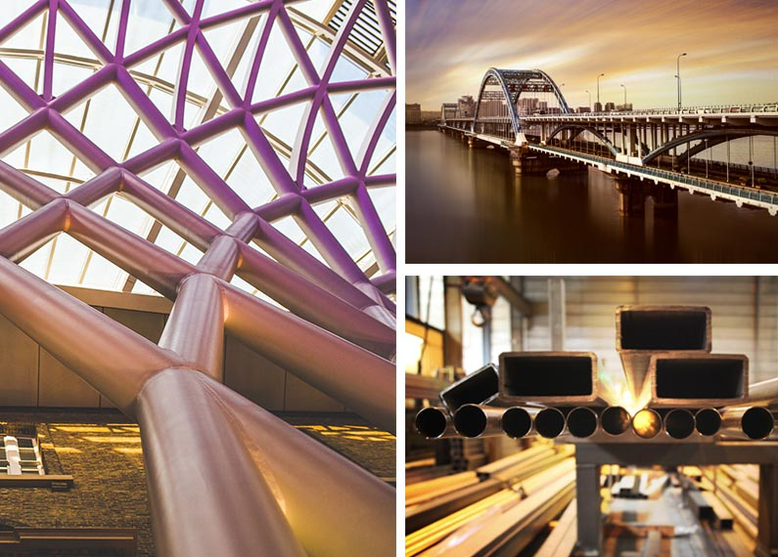

**Elevator**

With the dramatic changes in the residential sector, China has become the world's largest and fastest growing elevator market. Throughout the history of the development of China's elevator industry, from the reform and opening up to today, the elevator industry already walked through a long development process.

As proliferation of real estate infrastructure, the demand for elevators and accessories is also rising. Elevator manufacturing and accessories industry usher in a new stage of development. It is estimated that the market scale has reached 100 billion level. The contradiction between the ever-increasing product quality demand and the obsolete production process has made the use of laser cutting technology increasingly common in elevator manufacturing.

The processing range of laser cutting is relatively wide, but because the material used for elevator sheet metal parts are limited, there is not much attention to the processing of copper, aluminum or plastic materials. For elevator sheet metal parts, the key to laser cutting machine requirements is speed.In recent years, the newly emerging fiber laser cutting machine in the laser processing market has been widely used in elevator manufacturing.This is mainly due to the fact that its processing range is in good agreement with the processing requirements of elevator sheet metal parts, including the need for thin plates (below 3 mm),low requirements on the accuracy of cutting edges, and high cutting speeds.

Hymson provides customers with a variety of high-quality sheet metal laser processing equipment that can meet the fabrication requirement of different materials and thicknesses. The ongoing research and development of the Hymson laser’s technology empower its machine tool getting more stable,productive and smarter.An exceptional service team cares each Hymson machine and provide fast and quick-response after-sales service.

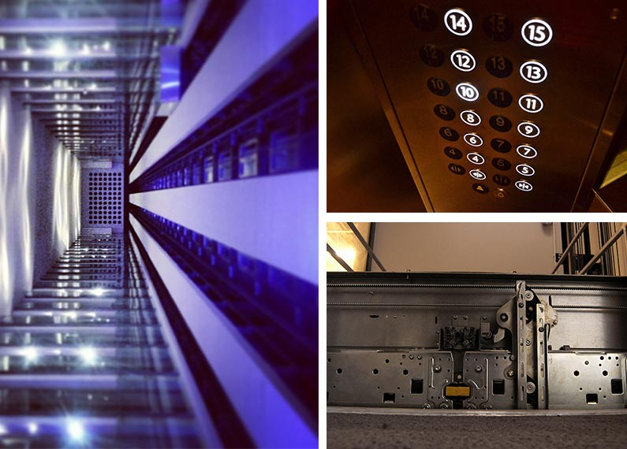

**Aviation**

The aviation industry is a leading technology in manufacturing equipped with intelligent control, automation product line, smart software, and laser technology. For example, the engine of a modern plane is an aggregation of comprehensive motion design and materials, which requires high precise fabrication during the processing.

There are more than 70% of the metal processing in aviation manufacture use laser technology. Because of the high energy, great accuracy and flexibility, laser can easily handle the metal cutting, drilling and welding with quality and efficiency. Especially for those special steel with strength and melting point,they are difficult to be treat by traditional method, thus, laser become the most wise and economic process method, that helps the plane travel long distance under the condition of heat and strong pressure.

Hymson Laser offers flexible laser cutting solution to customer through different materials. Continuously researching and developing in laser technology and application, we understand the machine better. Therefore, the machine we designed is stable, efficient and intelligent. An exceptional service team cares each Hymson machine and serves 24/7 with quick-response.

