- Using the idea of positional numbering system, determine the decimal value of the following numbers
  - 122（base 4）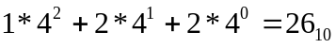
  - 457（base 8）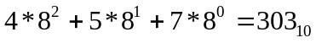
  - 12AF（base 16）
  - 4455 （base 6）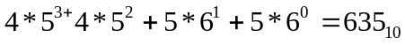
- Determine the decimal value of the following binary numbers.
  - 11000=24
  - 1001001111=591
  - 11111=32
  - 1001=9
- Convert the following decimal numbers into binary
  - 101=1100101
  - 23=10111
  - 55=110111
  - 255=11111111
- Show the step-by-step addition of the following binary numbers, including showing the carry bit to each successive column.
  - 1000+1100
    - 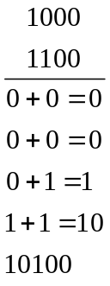
  - 11110001+01011010=101001011
  - 1110+1110=11100
  - 11101+11101=111010
  - The answer is add one more zero at the end of the value itself
- Use the ASCII table to show the internal binary representation for the following character strings.
  - ABC= 65 66 67
  - $25.00 = 36 50 53 46 48 48
  - Paul = 80 97 117 108
  - CS 101 = 67 83 32 49 48 49
  - (5+2)=7 = 40 53 43 50 41 61 55
- How many binary digits would it take to represent the following phrase in ASCII code?
ASCII code uses 8 bits
- How many bits does it take to store a 2-minute song using an audio encoding method that samples at 40,000 samples per second and each sample is represented using 16 bits, and does not use any compression method?
  - 120*40000*16 = 76800000
- How many bits does it take to store an uncompressed 1280 x 768 RGB color image? The color depth of RGB is 8 bits for Red, Green, and Blue, respectively.
  - 1280*768*8=7864320

