幻灯片1
Names, Bindings, Type Checking and Scope
Chapter 5
CS 304 – Programming Languages – Ch. 5
幻灯片2
Introduction
- von Neumann’s Architecture
- Memory cells
- Processor
- Data path
- In programs, memory cells are represented as variables
- Variables
- name
- address
- type ( ➔ size)
- value
- lifetime
- scope

CS 304 – Programming Languages – Ch. 5
幻灯片3
Names
- or Identifiers
- Not the same as variables !

- Design issues for names:
- Maximum length?
- Are connector characters allowed?
- Are names case sensitive?
- Are special words reserved words or keywords?

- Length
- - FORTRAN I: maximum 6
- - COBOL: maximum 30
- - FORTRAN 90 and ANSI C: maximum 31
- - Ada: no limit, and all are significant
- - C++: no limit, but implementors often impose one
- Why?

CS 304 – Programming Languages – Ch. 5
幻灯片4
Names
- Connectors
- “-”, “_”,…
- Pascal, Modula-2, and FORTRAN 77 don't allow
- Others do
- Case sensitivity
- C, C++, Java, and Modula-2 names are case sensitive
- The names in other languages are not

- Disadvantage: readability (names that look alike are different)
- worse in Modula-2 because predefined names are mixed case (e.g. WriteCard)
- Not so bad if you have “statement completion” feature in your compiler

CS 304 – Programming Languages – Ch. 5
幻灯片5
Special Words
- Name actions of a PL to be performed

- Keywords
- is a word that is special only in certain contexts
- In FORTRAN:
- REAL is a keyword and it could also be a variable name
- Disadvantage: poor readability
- Reserved Words
- is a special word that cannot be used as a user-defined name
- Predefined names
- INTEGER and FLOAT in Ada
- Library function names (e.g., std::cin)

CS 304 – Programming Languages – Ch. 5
幻灯片6
Variables
- A name for a memory location that has a type and size (and value?)
- An abstraction of memory cells in the computer

- Variables are more than names
- Attributes that characterize a variable:
- name, address, value, type, lifetime, and scope

CS 304 – Programming Languages – Ch. 5
幻灯片7
Variables
- Name
- not all variables have them
- Address
- the memory address with which it is associated
- A variable may have different addresses at different times during execution
- A variable may have different addresses at different places in a program
- If two variable names can be used to access the same memory location, they are called aliases

- Aliases are harmful to readability

CS 304 – Programming Languages – Ch. 5
幻灯片8
Variables
- How aliases can be created:
- Pointers, reference variables, Pascal variant records, C and C++ unions, and FORTRAN EQUIVALENCE (and through parameters - discussed in Chapter 8)
- Some of the original justifications for aliases are no longer valid; e.g. memory reuse in FORTRAN
- replace them with dynamic allocation
- Type
- determines the range of values of variables and the set of operations that are defined for values of that type
- in the case of floating point, type also determines the precision

- Ex: int (16 bit) : -32, 768 to 32, 676

CS 304 – Programming Languages – Ch. 5
幻灯片9
Variables
- Value
- the contents of the location with which the variable is associated
- Abstract memory cell :
- the physical cell or collection of cells associated with a variable

- The l-value of a variable
- is its address
- need this for a PL concept to appear on the LHS in an assignment statement

- The r-value of a variable
- is its value (value of the RHS in an assignment statement)

CS 304 – Programming Languages – Ch. 5
幻灯片10
Binding
- Def: A binding is an association, such as between an attribute and an entity, or between an operation and a symbol

- Def: Binding time is the time at which a binding takes place.

- “*” usually bound to the multiplication operator at language design time
- Variables can be bound to certain types at compile time

CS 304 – Programming Languages – Ch. 5
幻灯片11
Possible binding times
- 1. Language design time
- e.g., bind operator symbols to operations

- 2. Language implementation time
- e.g., bind floating pt. type to a representation

- 3. Compile time
- e.g., bind a variable to a type in C or Java

- 4. Link Time
- e.g., “cin” is bound to an appropriate static library (namespaces in C++)

- 5. Load time
- e.g., bind a FORTRAN 77 variable to a memory cell (or a C static variable)

- 6. Runtime
- e.g., bind a nonstatic local variable to a memory cell

CS 304 – Programming Languages – Ch. 5
幻灯片12
Binding of Attributes to Variables
- Def: A binding is static if it occurs before run time and remains unchanged throughout program execution.

- Def: A binding is dynamic if it occurs during execution or can change during execution of the program.

- Note: these do not describe physical bindings of vars into storage cells
- Paging causes these to be bound and unbound quite often!

CS 304 – Programming Languages – Ch. 5
幻灯片13
Type Bindings
- In typed languages, a variable must be bound to a data type
- How to specify types and when to bind?
- Variable declarations
- Explicit Declaration
- Statement that lists variable names and specifies their types
- Most common form of declarations

- Implicit Declaration
- Means of associating variables with types through default conventions (instead of declarations)
- Basic, PL/I, FORTRAN (I,J,K are implicitly integer variables)
- Prevent compiler from preventing type errors
- May in turn reduce reliability
- Perl tries to avoid these problems with special name requirements

CS 304 – Programming Languages – Ch. 5
幻灯片14
Type Bindings
- In C and C++:
- Declarations
- Specify types, but do not cause storage allocation

- Definitions
- Specify attributes and cause storage allocation

- For a specific name in a C program:
- May have any number of compatible declarations
- May have only a single definition
- Reason: provide type of variable to other entities (functions)
- Just like function prototypes

CS 304 – Programming Languages – Ch. 5
幻灯片15
Type Bindings
- Dynamic Type Binding
- Types are not specified by declarations
- Variable is bound to a type during execution of assignment statement
- Type of variable becomes the type of the expression on the RHS
- Ex: Javascript, APL. SNOBOL
- Dynamic binding provides a great deal of flexibility
- Make lists and use them on any types (e.g., LISP)
- Similar to Templates in C++ (but no type declarations)
- Disadvantages:
- Compiler cannot check for type errors at compile time
- Dynamic type binding is costly (execution time)
- Coercion may / may not be a desirable effect
- Often implemented using pure interpretation

CS 304 – Programming Languages – Ch. 5
幻灯片16
Type Bindings
- Type Inference
- Inferring the type of an expression
- Example : ML (Machine Learning) – Milner et. al., 1990

- fun circumf(r) = 3.14 * r * r;

- fun times10(x) = 10 * x;

- fun square(x) = x * x

- fun square(x:int) = x * x
- fun square(x) = (x:int) * x
- fun square(x) : int = x * x
- fun square(x) = x * (x:int)

CS 304 – Programming Languages – Ch. 5
幻灯片17
Storage Bindings and Lifetime
- Memory Allocation
- Reserving a memory cell to which a variable is bound from a pool of available memory

- Memory Deallocation
- Returning the memory cell unbound from a variable into the pool of available memory

- Lifetime of a Variable
- Time during which the variable is bound to a specific memory location
- Static, Stack-Dynamic, Explicit / Implicit Heap-Dynamic variables according to their lifetimes

CS 304 – Programming Languages – Ch. 5
幻灯片18
Storage Bindings and Lifetime
- Static Variables
- Bound to memory cells before execution begins and remain bound to the same memory cell throughout execution
- Global and history-sensitive variables
- e.g. all FORTRAN 77 variables, C static variables

- Advantage:
- Efficiency (direct addressing, history-sensitive subprogram support, no run-time allocation and deallocation overhead)
- Disadvantage:
- Lack of flexibility (no recursion)
- Cannot share storage among the variables

CS 304 – Programming Languages – Ch. 5
幻灯片19
Storage Bindings and Lifetime
- 2. Stack-dynamic variables
- Storage bindings are created for variables when their declaration statements are elaborated, but whose types are statically bound
- In Java, if scalar variable is used, all attributes except address are statically bound
- e.g. local variables in Pascal, Java, C++ and C subprograms
- run-time stack, run-time elaboration
- Advantage:
- allows recursion; conserves storage
- Disadvantages:
- Overhead of allocation and deallocation
- Subprograms cannot be history sensitive
- Inefficient references (indirect addressing)

CS 304 – Programming Languages – Ch. 5
幻灯片20
Storage Bindings and Lifetime
- 3. Explicit heap-dynamic variables
- Allocated and deallocated by explicit directives, specified by the programmer, which take effect during execution
- Allocated / deallocated from the heap
- Referenced only through pointers or references
- Bound to types at compile time, bound to storage at run-time
- e.g. dynamic objects in C++ (via new and delete)
- all objects in Java (except primitive scalar types)
- Often used in dynamic structures (e.g., linked-lists)

- Advantage:
- provides for dynamic storage management
- Disadvantage:
- inefficient and unreliable (C’s malloc)

CS 304 – Programming Languages – Ch. 5
幻灯片21
Storage Bindings and Lifetime
- 4. Implicit heap-dynamic variables
- Bound to heap storage only when they are assigned values
- Allocation and deallocation caused by assignment statements
- e.g. all variables in APL
- strings and arrays in Perl and Javascript
- Dynamic type-binding

- Advantage:
- flexibility
- Disadvantages:
- Inefficient, because all attributes are dynamic
- Loss of error detection

CS 304 – Programming Languages – Ch. 5
幻灯片22
Type Checking
- Generalize the concept of operands and operators to include subprograms and assignments

- Def: Type checking is the activity of ensuring that the operands of an operator are of compatible types

- Def: A compatible type is one that is either legal for the operator, or is allowed under language rules to be implicitly converted, by compiler-generated code, to a legal type.
- This automatic conversion is called a coercion.
- Def: A type error is the application of an operator to an operand of an inappropriate type

CS 304 – Programming Languages – Ch. 5
幻灯片23
Type Checking
- If all type bindings are static, nearly all type checking can be static
- If type bindings are dynamic, type checking must be dynamic
- Which one is better?
- Some static typed languages still must use dynamic typing
- Variant Records (Ada, Pascal), Union (C++), EQUIVALENCE (FORTRAN)
- Def: A programming language is strongly typed if type errors are always detected

- Advantage:
- allows the detection of the misuses of variables that result in type errors

CS 304 – Programming Languages – Ch. 5
幻灯片24
Type Checking
1. FORTRAN 77 is not: parameters, EQUIVALENCE

2. Pascal is not: variant records

3. Modula-2 is not: variant records, WORD type

4. C and C++ are not: parameter type checking can be avoided; unions are not type checked

5. Ada is, almost (UNCHECKED_CONVERSION is loophole) (Java is similar)
Coercion rules strongly affect strong typing—they can weaken it considerably (C++ versus Ada)

6. ML is strongly typed !!!
CS 304 – Programming Languages – Ch. 5
幻灯片25
Type Compatibility
- Def: Type compatibility by name means the two variables have compatible types if they are in either the same declaration or in declarations that use the same type name

- Easy to implement but highly restrictive:
- Subranges of integer types are not compatible with integer types
- Formal parameters must be the same type as their corresponding actual parameters (Pascal)

- Def: Type compatibility by structure means that two variables have compatible types if their types have identical structures
- More flexible, but harder to implement

CS 304 – Programming Languages – Ch. 5
幻灯片26
Type Compatibility
- Consider the problem of two structured types:
- - Suppose they are circularly defined
- - Are two record types compatible if they are structurally the same but use different field names?
- - Are two array types compatible if they are the same except that the subscripts are different? (e.g. [1..10] and [-5..4])
- - Are two enumeration types compatible if their components are spelled differently?

- - With structural type compatibility, you cannot differentiate between types of the same structure (e.g. different units of speed, both float)

CS 304 – Programming Languages – Ch. 5
幻灯片27
Type Compatibility
- Language examples:
- Pascal: usually structure, but in some cases name is used (formal parameters)
- type
- type1 = array [1..10] of integer;
- type2 = array [1..10] of integer;
- type3 = type2;
- declaration equivalence
- C: structure, except for records and unions
- except when they are defined in two separate files (structural type equivalence)
- C++ : name
- typedefs

- Ada: restricted form of name – derived types and subtypes
- Derived types allow types with the same structure to be different
- Anonymous types are all unique, even in:
- A, B : array (1..10) of INTEGER:
- FORTRAN AND COBOL – structure (no type names!)
- OOP – inheritance?

CS 304 – Programming Languages – Ch. 5
幻灯片28
Scope
- Def: The scope of a variable is the range of statements over which it is visible

- Def: The nonlocal variables of a program unit are those that are visible but not declared there

- The scope rules of a language determine how references to names are associated with variables

CS 304 – Programming Languages – Ch. 5
幻灯片29
Scope
- Static scope
- Based on program text

- To connect a name reference to a variable, you (or the compiler) must find the declaration

- Search process: search declarations, first locally, then in increasingly larger enclosing scopes, until one is found for the given name

- Enclosing static scopes (to a specific scope) are called its static ancestors; the nearest static ancestor is called a static parent

CS 304 – Programming Languages – Ch. 5
幻灯片30
Scope
- Variables can be hidden from a unit by having a "closer" variable with the same name
- C++ and Ada allow access to these "hidden" variables
- Blocks
- a method of creating static scopes inside program units--from ALGOL 60
- A.K.A. “compound statements” in C and C++

- Examples:
- C and C++:
- for (...) {
- int index;
- ...
- }

- Ada: declare LCL : FLOAT;
- begin
- ...
- end

CS 304 – Programming Languages – Ch. 5
幻灯片31
Scope

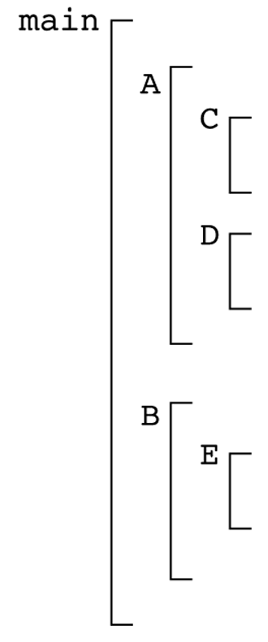
- Evaluation of Static Scoping
- Consider the example:
- Assume
- MAIN calls A and B
- A calls C and D
- B calls A and E

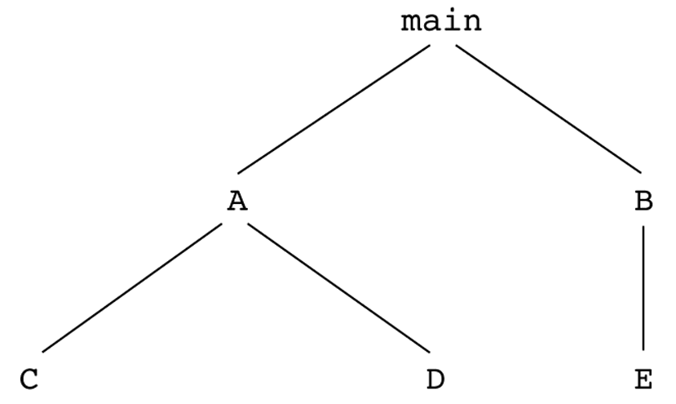
CS 304 – Programming Languages – Ch. 5
幻灯片32

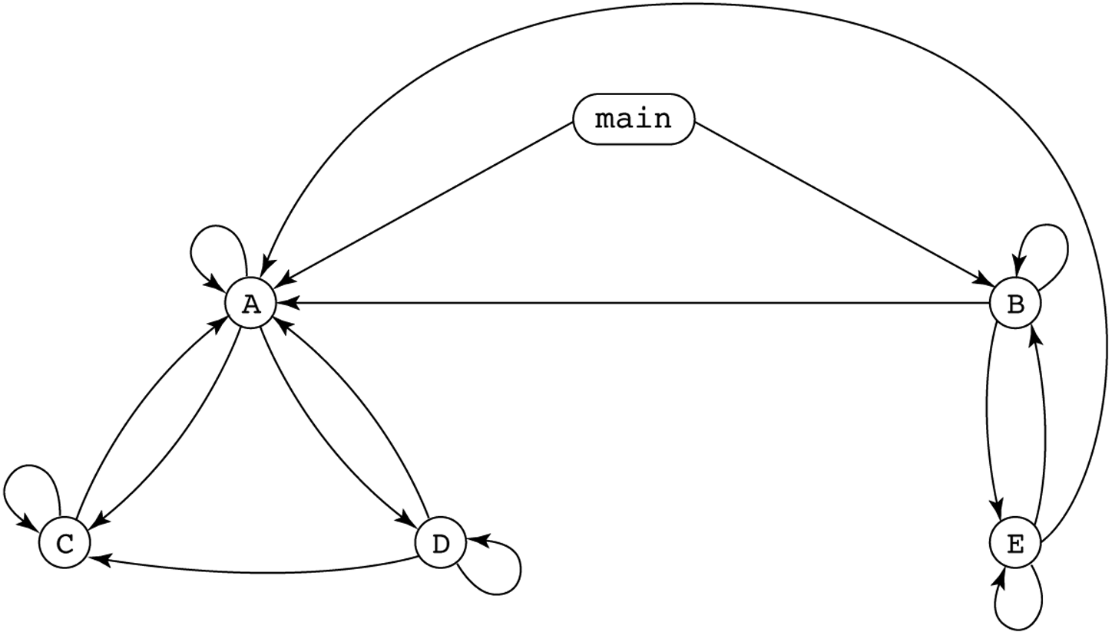

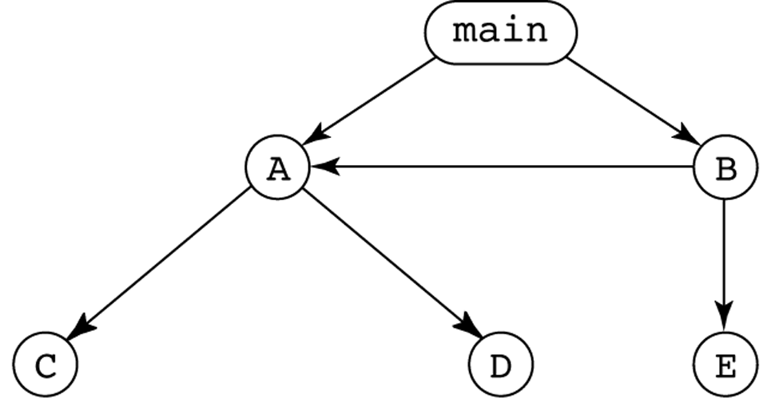
CS 304 – Programming Languages – Ch. 5
幻灯片33
Scope
- Suppose the spec is changed so that D must now access some data in B
- Solutions:
- 1. Put D in B (but then C can no longer call it and D cannot access A's variables)

- 2. Move the data from B that D needs to MAIN (but then all procedures can access them)

- Same problem for procedure access!

- Overall: static scoping often encourages many globals

CS 304 – Programming Languages – Ch. 5
幻灯片34
Scope
- Too much data access
- Globals visible everywhere, no way to protect them

- Globals are harmful to readability
- Declarations are too far from their uses

- Programmers tend to use far more globals than necessary

- To remedy problems of static scoping:
- Encapsulation constructs
- e.g., Classes

CS 304 – Programming Languages – Ch. 5
幻灯片35
Scope
- Dynamic scope
- Based on calling sequences of program units, not their textual layout (temporal versus spatial)

- References to variables are connected to declarations by searching back through the chain of subprogram calls that forced execution to this point

- Search process:
- Look in the caller for variable declarations
- Up to the main calling function

CS 304 – Programming Languages – Ch. 5
幻灯片36
Scope
- Example:

- MAIN
- - declaration of x
- SUB1
- - declaration of x -
- ...
- call SUB2
- ...

- SUB2
- ...
- - reference to x -
- ...

- ...
- call SUB1
- ...

- MAIN calls SUB1

- SUB1 calls SUB2

- SUB2 uses x

- Static scoping - reference to x is to MAIN's x

- Dynamic scoping - reference to x is to SUB1's x

CS 304 – Programming Languages – Ch. 5
幻灯片37
Dynamic Scoping
- Evaluation of Dynamic Scoping:
- Advantage:
- convenience
- No need to pass variables !!!
- Disadvantage:
- poor readability (caller’s local vars visible in the called fnct)
- no way to determine scope statically
- longer access time to nonlocal vars

- Scope and lifetime are sometimes closely related, but are different concepts!!
- Consider a static variable in a C or C++ function

CS 304 – Programming Languages – Ch. 5
幻灯片38
Referencing Environments
- Def: The referencing environment of a statement is the collection of all names that are visible in the statement

- In a static scoped language, that is the local variables plus all of the visible variables in all of the enclosing scopes
- See book example (p. 235)

- A subprogram is active if its execution has begun but has not yet terminated

- In a dynamic-scoped language, the referencing environment is the local variables plus all visible variables in all active subprograms
- See book example (p. 236)

CS 304 – Programming Languages – Ch. 5
幻灯片39
Named Constants
- Def: A named constant is a variable that is bound to a value only when it is bound to storage

- Advantages: readability and modifiability

- The binding of values to named constants can be either static (called manifest constants) or dynamic

- Languages:
- Pascal: literals only
- Modula-2 and FORTRAN 90: constant-valued expressions
- Ada, C++, and Java: expressions of any kind

CS 304 – Programming Languages – Ch. 5
幻灯片40
Variable Initialization
- Def: The binding of a variable to a value at the time it is bound to storage is called initialization

- Initialization is often done on the declaration statement

- e.g., Ada
- SUM : FLOAT := 0.0;

CS 304 – Programming Languages – Ch. 5

幻灯片1
Data Types
Chapter 6
CS 304 – Fall 2003 – Ch. 6
幻灯片2
Introduction
- Data types allow for versatility in programming
- FORTRAN (<90)
- Primitive types, arrays (linked lists and binary trees)
- COBOL
- Structs and decimal values (precise)
- PL/I
- Integer and Floating-Point types with higher accuracy
- ALGOL 68
- Highly orthogonal – User-Defined Types (typedefs : modifiable)
- Ada 83
- user-defined types, types are abstractions of problem-space variables
- Abstract Data Types : ADTs

CS 304 – Fall 2003 – Ch. 6
幻灯片3
Introduction
- Arrays and Records
- most common structured (non-scalar) data types
- specified by operators that form expressions
- Example: C type operators
- brackets, parentheses, asterisks
- arrays, functions, pointers
- Descriptor
- collection of attributes of a variable
- Static attributes – descriptors required at compile time
- Symbol tables
- Dynamic attributes – descriptors used for type checking and allocation/deallocation operations

CS 304 – Fall 2003 – Ch. 6
幻灯片4
Primitive Data Types
- Design Issues for all data types:

- 1. What is the syntax of references to variables?
- 2. What operations are defined and how are they specified?

- Primitive Data Types
- Types not defined in terms of other data types
- Used to define other (complex) data types
- May be supported in the hardware

CS 304 – Fall 2003 – Ch. 6
幻灯片5
Numeric Types
- Integers
- Almost always an exact reflection of the hardware, so the mapping is trivial

- There may be many different integer types in a language
- Signed/Unsigned, short, int, long

- Usually stored in the two’s complement representation
- Negative ints are complemented, then 1 is added to them
- Allows for easy arithmetic

CS 304 – Fall 2003 – Ch. 6
幻灯片6
Numeric Types
- Floating Point
- Model real numbers, but only as approximations
- Languages for scientific use support at least two floating-point types; sometimes more
- Usually exactly like the hardware, but not always; some languages allow accuracy specs in code
- e.g. (Ada)
- type SPEED is digits 7 range 0.0..1000.0;
- type VOLTAGE is delta 0.1 range -12.0..24.0;

- Problem: Loss of accuracy, finite amount of space
- Cannot represent PI

CS 304 – Fall 2003 – Ch. 6
幻灯片7
Numeric Types

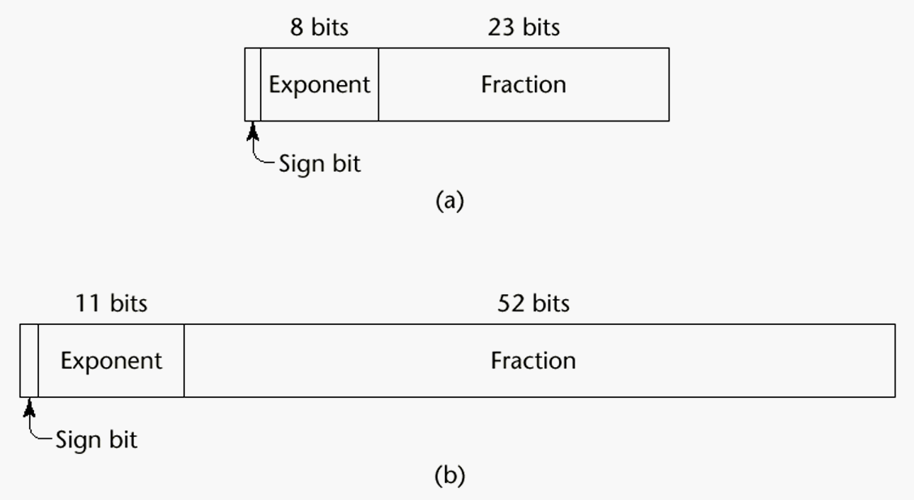
CS 304 – Fall 2003 – Ch. 6
幻灯片8
Numeric Types
- Decimal 4b
- For business applications (money)
- Store a fixed number of decimal digits (coded)
- Advantage: accuracy
- Disadvantages: limited range, wastes memory

- Boolean
- Most languages have them
- C uses integer values for booleans
- Could be implemented as bits, but often as bytes
- Advantage: readability
- Disadvantage: representation

CS 304 – Fall 2003 – Ch. 6
幻灯片9
Numeric Types
- Character
- Usually stored as small positive ints
- Mapping of numbers to printable characters
- ASCII and EBCDIC
- Unicode characters : 16 bits
- Include characters for most od the world’s languages
- Java uses Unicode exclusively

CS 304 – Fall 2003 – Ch. 6
幻灯片10
Character String Types
- Character String Types
- Values are sequences of characters

- Design issues:
- 1. Is it a primitive type or just a special kind of array?
- 2. Is the length of objects static or dynamic?

- Operations:
- - Assignment
- - Comparison (=, >, etc.)
- - Catenation
- - Substring reference
- - Pattern matching

CS 304 – Fall 2003 – Ch. 6
幻灯片11
Character String Types
- Examples:
- Pascal
- Not primitive; assignment and comparison only (of packed arrays)
- Ada, FORTRAN 77, FORTRAN 90 and BASIC
- Somewhat primitive
- Assignment, comparison, catenation, substring reference
- FORTRAN has an intrinsic for pattern matching
- e.g. (Ada)
- N := N1 & N2 (catenation)
- N(2..4) (substring reference)

CS 304 – Fall 2003 – Ch. 6
幻灯片12
Character String Types
- C and C++
- Not primitive
- Use char arrays and a library of functions that provide operations
- SNOBOL4 (a string manipulation language)
- Primitive
- Many operations, including elaborate pattern matching
- Perl
- Patterns are defined in terms of (loose) regular expressions
- A very powerful facility!
- e.g.,
- /[A-Za-z][A-Za-z\d]+/
- Java - String class (not arrays of char)
- StringBuffer also, for non-constant Strings

CS 304 – Fall 2003 – Ch. 6
幻灯片13
Character String Types
- String Length Options:

- 1. Static - FORTRAN 77, Ada, COBOL
- e.g. (FORTRAN 90)
- CHARACTER (LEN = 15) NAME;
- 2. Limited Dynamic Length - C and C++
- actual length is indicated by a null character

- 3. Dynamic - SNOBOL4, Perl, Javascript

- Evaluation (of character string types):
- Aid to writability
- As a primitive type with static length, they are inexpensive to provide--why not have them?
- Dynamic length is nice, but is it worth the expense?

CS 304 – Fall 2003 – Ch. 6
幻灯片14
Character String Types Implementation
- Implementation:
- Static length
- compile-time descriptor
- simplest implementation
- Limited dynamic length
- may need a run-time descriptor for length (but not in C and C++ : null-terminating character)

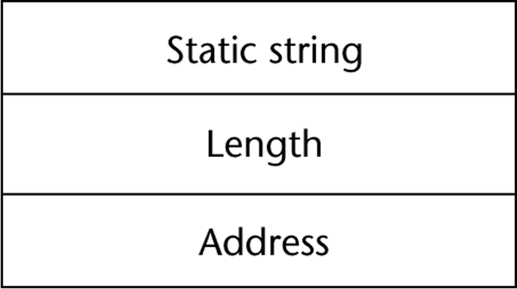

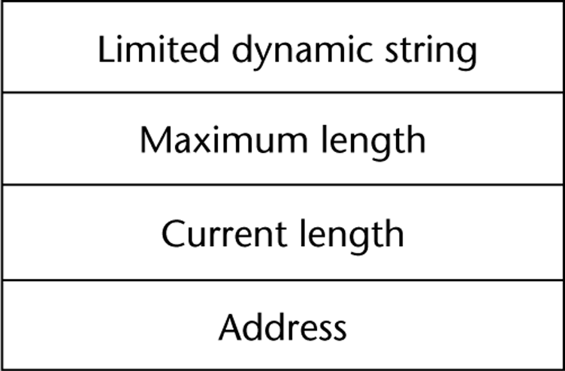
CS 304 – Fall 2003 – Ch. 6
幻灯片15
Character String Types Implementation
- Dynamic length
- need run-time descriptor; allocation/deallocation is the biggest implementation problem
- Run-time descriptor need not include maximum length
- Dynamic allocation approaches:
- Linked-list approach
- grows and shrinks freely, but links may occupy large amount of storage
- string operations may be slow due to the pointer chasing
- Adjacent storage cells approach
- simpler, but may need to move the complete string into other storage when it grows
- faster and simpler string operations

CS 304 – Fall 2003 – Ch. 6
幻灯片16
User-Defined Ordinal Types
- An ordinal type is one in which the range of possible values can be easily associated with the set of positive integers
- Enumeration and Subrange types

- 1. Enumeration Types
- Types where the user enumerates all of the possible values, which are symbolic constants
- enum RelationType = {LESS, EQUAL, GREATER}
- Primary Design Issue:
- Should a literal constant be allowed to be in more than one type definition?
- If so, how to check for the type of the occurrence of the literal?

CS 304 – Fall 2003 – Ch. 6
幻灯片17
User-Defined Ordinal Types
- Pascal
- cannot reuse constants
- can be used for array subscripts, for variables, case selectors
- NO input or output
- can be compared

- type Days = (Sun, Mon, Tue, Wed, Thu, Fri, Sat);
- var weekDay : Days;
- …
- weekDay := Tue;
- if weekDay > Sun …

CS 304 – Fall 2003 – Ch. 6
幻灯片18
User-Defined Ordinal Types
- Ada
- constants can be reused (overloaded literals)
- disambiguate with context or type_name (one of them)
- can be used as in Pascal
- CAN be input and output

- C and C++
- like Pascal, except they can be input and output as integers
- Enumeration types are converted into integers

- Java does not include an enumeration type
- But classes can implement Enumeration interface

CS 304 – Fall 2003 – Ch. 6
幻灯片19
User-Defined Ordinal Types
- Evaluation (of enumeration types):

- a. Aid to readability
- e.g. no need to code a color as a number
- b. Aid to reliability
- e.g. compiler can check operations and ranges of values

CS 304 – Fall 2003 – Ch. 6
幻灯片20
User-Defined Ordinal Types
- 2. Subrange Type
- an ordered contiguous subsequence of an ordinal type
- Primary Design Issue: How can they be used?

- Examples:

- Pascal
- Subrange types behave as their parent types
- can be used as for variables and array indices
- e.g. type pos = 0 .. MAXINT;

CS 304 – Fall 2003 – Ch. 6
幻灯片21
User-Defined Ordinal Types
- Ada
- Subtypes are not new types, just constrained existing types (so they are compatible); can be used as in Pascal, plus case constants
- e.g.
- subtype POS_TYPE is INTEGER range 0..1000;

- Evaluation of enumeration types:
- Aid to readability
- Reliability
- restricted ranges add error detection

CS 304 – Fall 2003 – Ch. 6
幻灯片22
User-Defined Ordinal Types
- Implementation of user-defined ordinal types
- Enumeration types are implemented as integers
- Subrange types are the parent types with code inserted (by the compiler) to restrict assignments to subrange variables

CS 304 – Fall 2003 – Ch. 6
幻灯片23
Arrays
- An array is an aggregate of homogeneous data elements in which an individual element is identified by its position in the aggregate, relative to the first element.

- Design Issues:

- 1. What types are legal for subscripts?
- 2. Are subscripting expressions in element references range checked?
- 3. When are subscript ranges bound?
- 4. When does allocation take place?
- 5. What is the maximum number of subscripts?
- 6. Can array objects be initialized?
- 7. Are any kind of slices allowed?

CS 304 – Fall 2003 – Ch. 6
幻灯片24
Arrays
- Indexing
- A mapping from indices to elements

- map(array_name, index_value_list) → an element

- Syntax
- FORTRAN, PL/I, Ada use parentheses
- Most others use brackets

CS 304 – Fall 2003 – Ch. 6
幻灯片25
Arrays
- Element types

- Subscript Types:
- FORTRAN, C
- int only
- Pascal
- any ordinal type (int, boolean, char, enum)
- Ada
- int or enum (includes boolean and char)
- Java
- integer types only

CS 304 – Fall 2003 – Ch. 6
幻灯片26
Arrays
- Four Categories of Arrays
- based on subscript binding and binding to storage
- 1. Static
- range of subscripts and storage bindings are static
- e.g. FORTRAN 77, some arrays in Ada
- Advantage: execution efficiency (no allocation or deallocation)

- 2. Fixed stack dynamic
- range of subscripts is statically bound, but storage is bound at elaboration time
- e.g. Pascal locals and C locals that are not static
- Advantage: space efficiency

CS 304 – Fall 2003 – Ch. 6
幻灯片27
Arrays
- 3. Stack dynamic
- range and storage are dynamic, but fixed from then on for the variable’s lifetime
- e.g. Ada declare blocks
- declare
- STUFF : array (1..N) of FLOAT;
- begin
- ...
- end;
- Advantage:
- flexibility - size need not be known until the array is about to be used

CS 304 – Fall 2003 – Ch. 6
幻灯片28
Arrays
- 4. Heap dynamic
- subscript range and storage bindings are dynamic and not fixed
- e.g. (FORTRAN 90)
- INTEGER, ALLOCATABLE, ARRAY (:,:) :: MAT
- (Declares MAT to be a dynamic 2-dim array)

- ALLOCATE (MAT (10, NUMBER_OF_COLS))
- (Allocates MAT to have 10 rows and
- NUMBER_OF_COLS columns)

- DEALLOCATE MAT
- (Deallocates MAT’s storage)

- In APL & Perl, arrays grow and shrink as needed
- In Java, all arrays are objects (heap-dynamic)

CS 304 – Fall 2003 – Ch. 6
幻灯片29
Arrays
- Number of subscripts
- FORTRAN I allowed up to three
- FORTRAN 77 allows up to seven
- C, C++, and Java allow just one, but elements can be arrays
- Others - no limit

- Array Initialization
- Usually just a list of values that are put in the array in the order in which the array elements are stored in memory

- int testScores = {79, 83, 99};

CS 304 – Fall 2003 – Ch. 6
幻灯片30
Arrays
- 1. FORTRAN - uses the DATA statement, or put the values in / ... / on the declaration

- 2. C and C++ - put the values in braces; can let the compiler count them
- e.g. int stuff [] = {2, 4, 6, 8};

- 3. Ada - positions for the values can be specified
- e.g.
- SCORE : array (1..14, 1..2) :=
- (1 => (24, 10), 2 => (10, 7),
- 3 =>(12, 30), others => (0, 0));

- 4. Pascal and Modula-2 do not allow array initialization

CS 304 – Fall 2003 – Ch. 6
幻灯片31
Array Operations
- 1. APL - many, see book (p. 216-217)
- 2. Ada
- assignment; RHS can be an aggregate constant or an array name
- catenation; for all single-dimensioned arrays
- relational operators (= and /= only)

- 3. FORTRAN 90
- intrinsics (subprograms) for a wide variety of array operations (e.g., matrix multiplication, vector dot product)

CS 304 – Fall 2003 – Ch. 6
幻灯片32
One-Dimensional Array at the Logical Level
- A one-dimensional array is a structured composite data type made up of a finite, fixed size (known at compile time) collection of homogeneous (all of the same data type) elements having relative positions and to which there is direct access (any element can be accessed immediately).

- Array operations (creation, storing a value, retrieving a value) are performed using a declaration and indexes.

CS 304 – Fall 2003 – Ch. 6
幻灯片33
Implementation Example
This ACCESSING FUNCTION gives position of values[Index]
Address(Index) = BaseAddress + Index * SizeOfElement
float values[5]; // assume element size is 4 bytes

Base Address

7000 7004 7008 7012 7016

values[0] values[1] values[2] values[3] values[4]

Indexes
CS 304 – Fall 2003 – Ch. 6
幻灯片34
One-Dimensional Arrays in C++
- The index must be of an integral type (char, short, int, long, or enum).

- The index range is always 0 through the array size minus 1.

- Arrays cannot be assigned one to another, and cannot be the return type of a function.

CS 304 – Fall 2003 – Ch. 6
幻灯片35
Passing Arrays as Parameters

- In C++, arrays are always passed by reference, and & is not used with the formal parameter type.
- Whenever an array is passed as a parameter, its base address is sent to the called function.

- Because arrays are always passed as reference parameters, you can protect the actual parameter from unintentional changes by using const in formal parameter list and function prototype.

- float SumValues ( const float values[ ],
- int numOfValues );

CS 304 – Fall 2003 – Ch. 6
幻灯片36
Two-Dimensional Array at the Logical Level
- A two-dimensional array is a structured composite data type made up of a finite, fixed size collection of homogeneous elements having relative positions and to which there is direct access.

- Array operations (creation, storing a value, retrieving a value) are performed using a declaration and a pair of indexes (called row and column) representing the component’s position in each dimension.

CS 304 – Fall 2003 – Ch. 6
幻灯片37

EXAMPLE -- To keep monthly high temperatures for 50 states in a two-dimensional array.

const int NUM_STATES = 50 ;
const int NUM_MONTHS = 12 ;
int stateHighs [ NUM_STATES ] [ NUM_MONTHS ] ;

[ 0 ]
[ 1 ]
[ 2 ]
.
. stateHighs [2] [7]
.
[ 48 ]
[ 49 ]

[0] [1] [2] [3] [4] [5] [6] [7] [8] [9] [10] [11]

66 64 72 78 85 90 99 115 98 90 88 80
row 2,
col 7
might be
Arizona’s
high for
August

CS 304 – Fall 2003 – Ch. 6
幻灯片38
const int NUM_STATES = 50 ;
const int NUM_MONTHS = 12 ;
int stateHighs [ NUM_STATES ] [ NUM_MONTHS ] ;

STORAGE
rows columns
- In memory, C++ stores arrays in row order. The first row is followed by the second row, etc.

Base Address
8000
8024
8048

. . .

12 highs for state 0 12 highs for state 1 etc.
Alabama Alaska
first row second row
CS 304 – Fall 2003 – Ch. 6
幻灯片39
Implementation Level View

stateHighs[ 0 ] [ 0 ]
stateHighs[ 0 ] [ 1 ]
stateHighs[ 0 ] [ 2 ]
stateHighs[ 0 ] [ 3 ]
stateHighs[ 0 ] [ 4 ]
stateHighs[ 0 ] [ 5 ]
stateHighs[ 0 ] [ 6 ]
stateHighs[ 0 ] [ 7 ]
stateHighs[ 0 ] [ 8 ]
stateHighs[ 0 ] [ 9 ]
stateHighs[ 0 ] [10 ]
stateHighs[ 0 ] [11 ]
stateHighs[ 1 ] [ 0 ]
stateHighs[ 1 ] [ 1 ]
stateHighs[ 1 ] [ 2 ]
stateHighs[ 1 ] [ 3 ]
.
.
.
Base Address 8000
To locate an element such as
stateHighs [ 2 ] [ 7]
the compiler needs to know
that there are 12 columns
in this two-dimensional array.

At what address will
stateHighs [ 2 ] [ 7 ] be found?

Assume 2 bytes for type int.

CS 304 – Fall 2003 – Ch. 6
幻灯片40
Two-Dimensional Array Parameters
- Just as with a one-dimensional array, when a two- (or higher) dimensional array is passed as a parameter, the base address of the actual array is sent to the function.
- The size of all dimensions except the first must be included in the function heading and prototype.
- The sizes of those dimensions for the formal parameter must be exactly the same as in the actual array.

CS 304 – Fall 2003 – Ch. 6
幻灯片41
Use the two-dimensional stateHighs array to fill a
one-dimensional stateAverages array
const int NUM_STATES = 50 ;
const int NUM_MONTHS = 12 ;
int stateHighs [ NUM_STATES ] [ NUM_MONTHS ] ;
int stateAverages [ NUM_STATES ] ;

[ 0 ]
? [ 1 ]
? [ 2 ]
.
.
.
[ 48 ]
[ 49 ]

[0] [1] [2] [3] [4] [5] [6] [7] [8] [9] [10] [11]

Alaska

Arizona
43 42 50 55 60 78 79 80 77 72 63 40
66 64 72 78 85 90 99 115 98 90 88 80
CS 304 – Fall 2003 – Ch. 6
幻灯片42
Declaring Multidimensional Arrays
EXAMPLE USING TYPEDEF

const int NUM_DEPTS = 5; // mens, womens, childrens, electronics, linens
const int NUM_MONTHS = 12 ;
const int NUM_STORES = 3 ; // White Marsh, Owings Mills, Towson

typedef long MonthlySalesType [NUM_DEPTS] [NUM_MONTHS] [NUM_STORES];

MonthlySalesType monthlySales;
CS 304 – Fall 2003 – Ch. 6
幻灯片43
const int NUM_DEPTS = 5; // mens, womens, childrens, electronics, linens
const int NUM_MONTHS = 12 ;
const int NUM_STORES = 3 ; // White Marsh, Owings Mills, Towson

typedef long MonthlySalesType [NUM_DEPTS] [NUM_MONTHS] [NUM_STORES] ;
MonthlySalesType monthlySales;

monthlySales[3][7][0]
sales for electronics in August at White Marsh

3 STORES
sheets

5 DEPTS
rows
43
12 MONTHS columns
CS 304 – Fall 2003 – Ch. 6
幻灯片44
Slices
- A slice is some substructure of an array
- A referencing mechanism

- Slice Examples:
- 1. FORTRAN 90
- INTEGER CUBE(1:3, 1:3, 1:4)
- INTEGER MAT (1 : 4, 1 : 4)
- MAT(1 : 4, 1) - the first column
- MAT(2, 1 : 4) - the second row

- 2. Ada - single-dimensioned arrays only
- LIST(4..10)

CS 304 – Fall 2003 – Ch. 6
幻灯片45

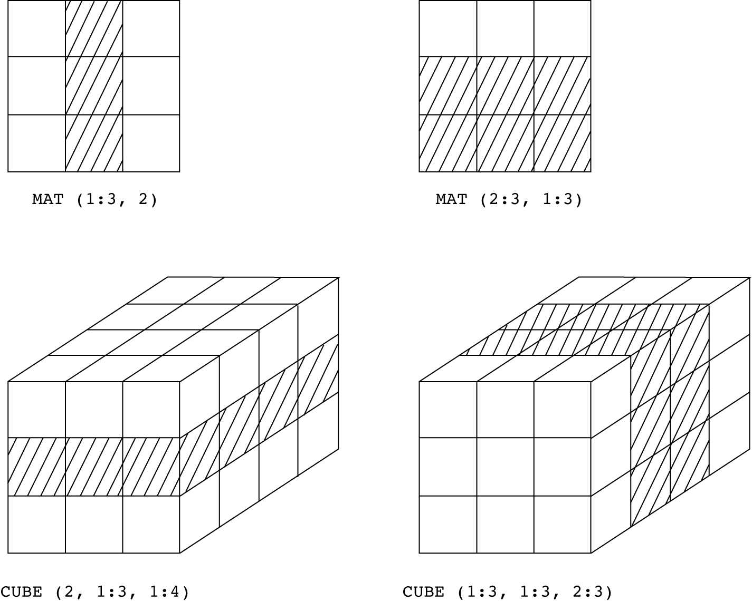
CS 304 – Fall 2003 – Ch. 6
幻灯片46
Implementation of Array Types
- More compile-time effort than we need for simple types
- At run-time, array access code is executed to gain access to array elements
- Compute Access Function to access an array element
- Access function maps subscript expressions to an address in the array
- If lower bound is 1:
- address(list[k]) = address(list[1]) + (k-1)*element_size
- If lower bound is M:
- address(list[k]) = address(list[M]) + (k-M)*element_size
- Arrays need a compile-time (static) descriptor
- for access function construction
- Run-time descriptor is needed only for range checks

CS 304 – Fall 2003 – Ch. 6
幻灯片47

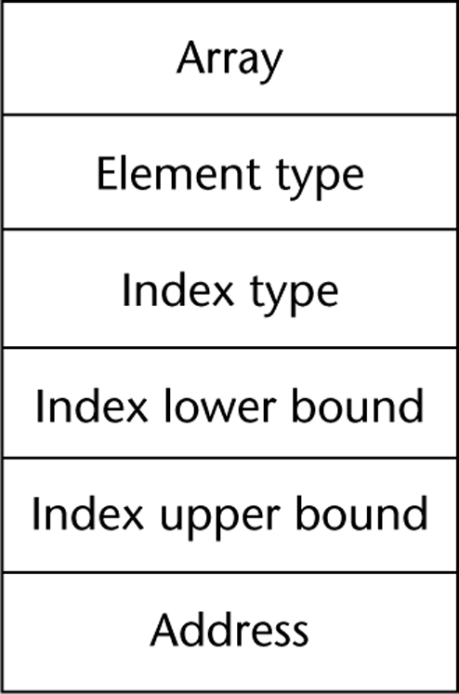
CS 304 – Fall 2003 – Ch. 6
幻灯片48
Multidimensional Arrays
Row major order (by rows)
Column major order (by columns)
See previous C++ examples…

Access function needs to know how array elements are stored
If row major order, lower bound of 1:
address(list[i,j]) = address(list[1,1]) +
(((i – 1) * rowSize) + (j – 1)) * elementSize

- Access to array elements with several subscripts is costly!

CS 304 – Fall 2003 – Ch. 6
幻灯片49

Need to know how arrays are stored
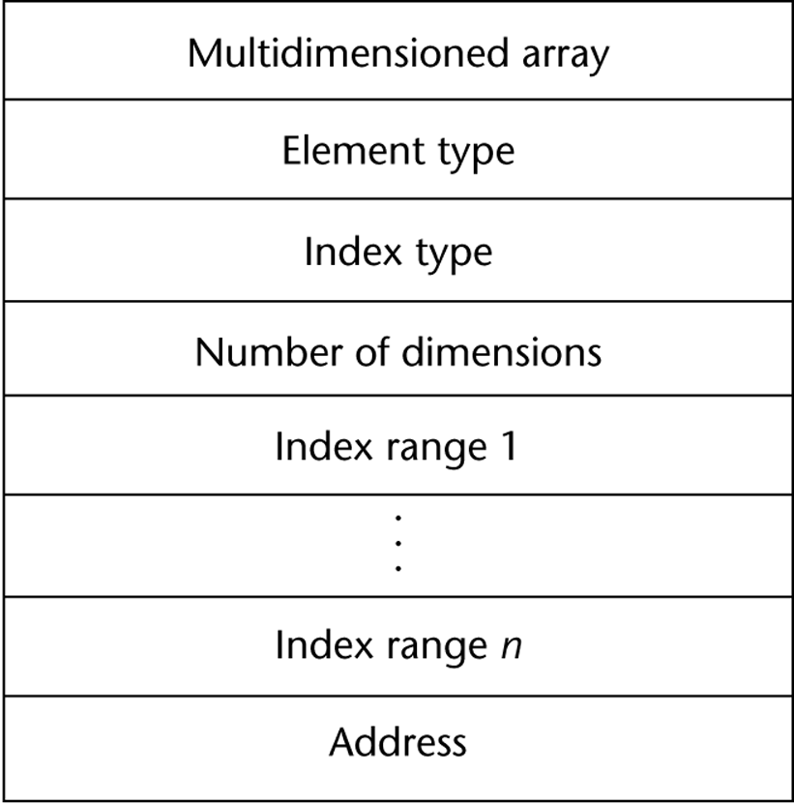
CS 304 – Fall 2003 – Ch. 6
幻灯片50
Associative Arrays
Unordered collection of data elements that are indexed by an equal number of values called keys
Each element is essentially a pair (key, value) : A.K.A. HASHING
Design Issues:
1. What is the form of references to elements?
2. Is the size static or dynamic?
Structure and Operations in Perl
Names begin with %
Literals are delimited by parentheses, e.g.,
%hi_temps = ("Monday" => 77, "Tuesday" => 79,…);
Subscripting is done using braces and keys, e.g.,
$hi_temps{"Wednesday"} = 83;
Elements can be removed with delete, e.g.,
delete $hi_temps{"Tuesday"};
- Implementation : Hashing Functions

CS 304 – Fall 2003 – Ch. 6
幻灯片51
Record Types
A record is a possibly heterogeneous aggregate of data elements in which the individual elements are identified by names
Similar to arrays, but for non-homogeneous types
Elements are not directly accessed by indices
Fields are named with identifiers
Provide access to individual elements of the record

Design Issues:
1. What is the form of references?
2. What unit operations are defined?

CS 304 – Fall 2003 – Ch. 6
幻灯片52
Record Types
Record Definition Syntax
COBOL uses level numbers to show nested records; others use recursive definitions
C and C++ use structures (structs) for records
Record Field References
1. COBOL
field_name OF record_name_1 OF ... OF record_name_n
2. Others (dot notation)
record_name_1.record_name_2. ... .record_name_n.field_name

Elliptical and Fully Qualified References:
Fully qualified references must include all record names
Elliptical references allow leaving out record names as long as the reference is unambiguous

- Pascal and Modula-2 provide a with clause to abbreviate references

CS 304 – Fall 2003 – Ch. 6
幻灯片53
Record Types
Record Operations
1. Assignment
Pascal, Ada, and C allow it if the types are identical
In Ada, the RHS can be an aggregate constant
2. Initialization
Allowed in Ada, using an aggregate constant
3. Comparison
In Ada, = and /=; one operand can be an aggregate constant
4. MOVE CORRESPONDING
- In COBOL - it moves all fields in the source record to fields with the same names in the destination record

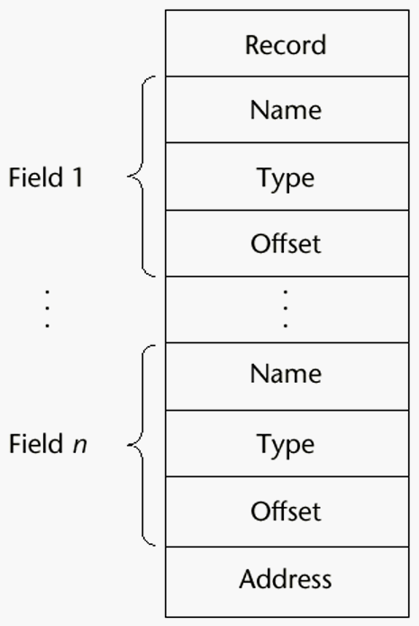CS 304 – Fall 2003 – Ch. 6
CS 304 – Fall 2003 – Ch. 6
幻灯片55
Union Types
A union is a type whose variables are allowed to store different type values at different times during execution
Design Issues for unions:
1. What kind of type checking, if any, must be done?
2. Should unions be integrated with records?

Free Unions
No language support for type checking
Complete freedom from type checking while programming
Discriminated Unions
- unions that include a type indicator

CS 304 – Fall 2003 – Ch. 6
幻灯片56
Union Types
Pascal - both discriminated and nondiscriminated unions
e.g.
type intreal = record tagg : Boolean of true : (blint : integer); false : (blreal : real); end;
Problem with Pascal’s design: type checking is ineffective
Reasons:
a. User can create inconsistent unions (because the tag can be individually assigned)

var blurb : intreal;
x : real;
blurb.tagg := true; {it is an integer }
blurb.blint := 47; {ok }
blurb.tagg := false; {it is a real }
- x := blurb.blreal; {assigns an integer to a real }

CS 304 – Fall 2003 – Ch. 6
幻灯片57
Union Types
b. The tag is optional!
Now, only the declaration and the second and last assignments are required to cause trouble

Algol 68 - discriminated unions

Use a hidden tag to maintain the current type
Tag is implicitly set by assignment
This runtime type selection is a safe method of accessing union objects

CS 304 – Fall 2003 – Ch. 6
幻灯片58
Union Types
Ada - discriminated unions
Reasons they are safer than Pascal & Modula-2:
a. Tag must be present
b. It is impossible for the user to create an inconsistent union (because tag cannot be assigned by itself--All assignments to the union must include the tag value)
C and C++ - free unions (no tags)
Not part of their records
No type checking of references

Java has neither records nor unions

Evaluation - potentially unsafe in most languages
- not in Ada, however
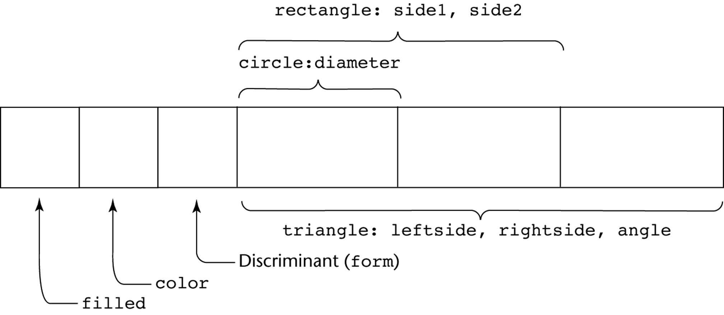
CS 304 – Fall 2003 – Ch. 6
CS 304 – Fall 2003 – Ch. 6
幻灯片60
Set Types
A set is a type whose variables can store unordered collections of distinct values from some ordinal type
Design Issue:
What is the maximum number of elements in any set base type?
Examples:
1. Pascal
No maximum size in the language definition
(not portable, poor writability if max is too small)
- Operations: union (+), intersection (*), difference (-), =, <>, superset (>=), subset (<=), in

CS 304 – Fall 2003 – Ch. 6
幻灯片61
Set Types
2. Modula-2 and Modula-3
Additional operations: INCL, EXCL, / (symmetric set difference (elements in one but not both operands))
3. Ada
does not include sets, but defines in as set membership operator for all enumeration types
4. Java
includes a class for set operations

Evaluation
If a language does not have sets, they must be simulated, either with enumerated types or with arrays
Arrays are more flexible than sets, but have much slower operations
Implementation
- Usually stored as bit strings and use logical operations for the set operations

CS 304 – Fall 2003 – Ch. 6
幻灯片62
Pointer Types
A pointer type is a type in which the range of values consists of memory addresses and a special value, nil (or null)
Uses:
1. Addressing flexibility
2. Dynamic storage management

Design Issues:
1. What is the scope and lifetime of pointer variables?
2. What is the lifetime of heap-dynamic variables?
3. Are pointers restricted to pointing at a particular type?
4. Are pointers used for dynamic storage management, indirect addressing, or both?
5. Should a language support pointer types, reference types, or both?

CS 304 – Fall 2003 – Ch. 6
幻灯片63
Pointer Types
Fundamental Pointer Operations:
1. Assignment of an address to a pointer
So that a variable may be manipulated via the pointer
2. Dereferencing (explicit versus implicit dereferencing)
For accessing the values of data to which the pointer is pointing
Example:
Consider a pointer variable ptr that is bound to memory address 7080, where a value of 206 is stored
e.g.,
int x = 206;
int j;
int *ptr = &x;
int *ptr1;
Now, what happens if : ptr1 = ptr;
- j = *ptr;

CS 304 – Fall 2003 – Ch. 6
幻灯片64

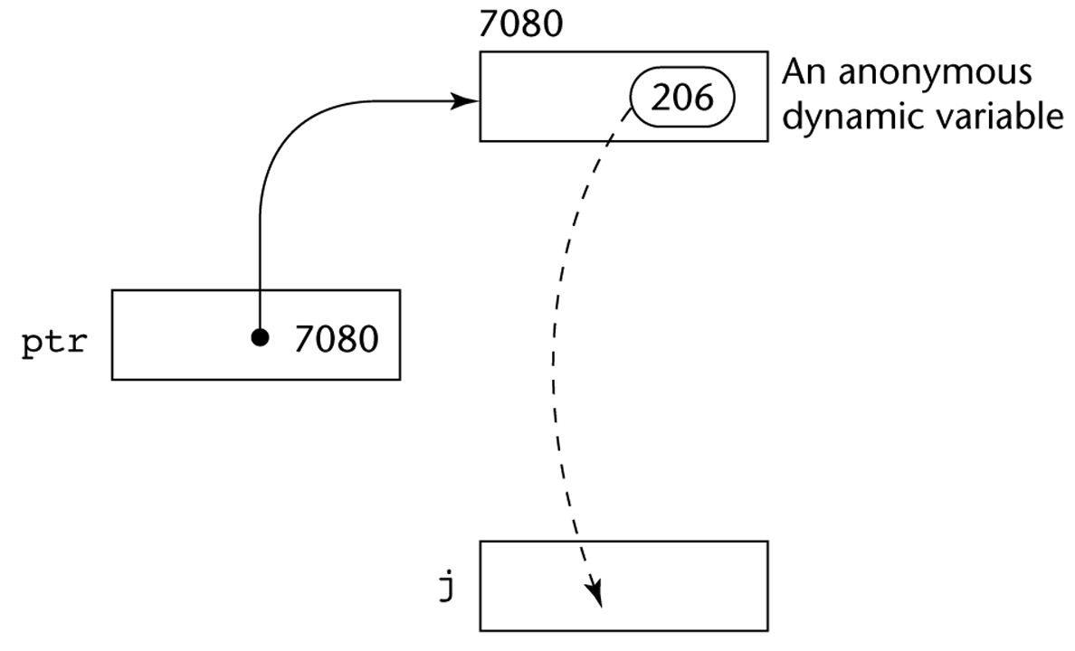

CS 304 – Fall 2003 – Ch. 6
幻灯片65
Pointer Types
Problems with pointers:
1. Dangling pointers
A pointer points to a heap-dynamic variable that has been deallocated
Dangerous

Creating a dangling pointer :
a. Allocate a heap-dynamic variable and set a pointer to point at it
b. Set a second pointer to the value of the first pointer
- c. Deallocate the heap-dynamic variable, using the first pointer

CS 304 – Fall 2003 – Ch. 6
幻灯片66
Pointer Types
2. Lost Heap-Dynamic Variables
A heap-dynamic variable that is no longer referenced by any program pointer
Wasteful

Creating a lost heap-dynamic variable:
a. Pointer p1 is set to point to a newly created heap-dynamic variable
b. p1 is later set to point to another newly created heap-dynamic variable

The process of losing heap-dynamic variables is called memory leakage

CS 304 – Fall 2003 – Ch. 6
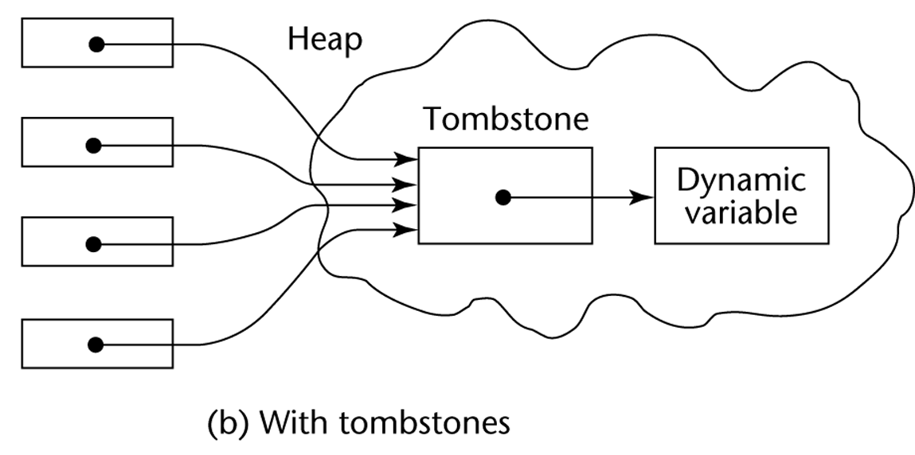幻灯片67
Solutions to Dangling Pointer Problem

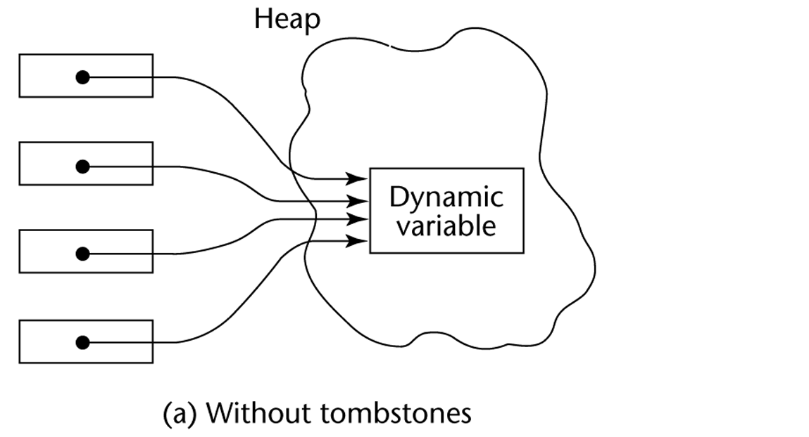Tombstones:

Lock-and-key:

Maintain pointers as (key, address) pairs

Heap-Dynamic variables also have associated integer keys
Match must exist before access is allowed

CS 304 – Fall 2003 – Ch. 6
幻灯片68
Pointer Types
1. Pascal
Used for dynamic storage management only
Explicit dereferencing
Dangling pointers are possible (dispose)
Dangling objects are also possible

2. Ada
A little better than Pascal and Modula-2
Some dangling pointers are disallowed because dynamic objects can be automatically deallocated at the end of pointer's scope
All pointers are initialized to null
- Similar dangling object problem (but rarely happens)

CS 304 – Fall 2003 – Ch. 6
幻灯片69
Pointer Types
3. C and C++
Used for dynamic storage management and addressing
Explicit dereferencing and address-of (&) operator
Can do address arithmetic in restricted forms
Domain type need not be fixed (void * )

e.g.

float stuff[100];
float *p;
p = stuff;

*(p+5) is equivalent to stuff[5] and p[5]
*(p+i) is equivalent to stuff[i] and p[i]

void * - can point to any type and can be type checked (cannot be dereferenced)

CS 304 – Fall 2003 – Ch. 6
幻灯片70
Pointer Types
4. FORTRAN 90 Pointers
Can point to heap and non-heap variables
Implicit dereferencing
Special assignment operator for non-dereferenced references

e.g.
REAL, POINTER :: ptr (POINTER is an attribute)
ptr => target (where target is either a pointer or a non-pointer with the TARGET attribute))

The TARGET attribute is assigned in the declaration, as in:

INTEGER, TARGET :: NODE
There is a special assignment when dereferencing is not wanted
e.g.,
pointer => target

CS 304 – Fall 2003 – Ch. 6
幻灯片71
Reference Types
5. C++ Reference Types
Constant pointers that are implicitly dereferenced
Used for parameters
Advantages of both pass-by-reference and pass-by-value

6. Java - Only references
No pointer arithmetic
Can only point at objects (which are all on the heap)
No explicit deallocator (garbage collection is used)
Means there can be no dangling references!
Dereferencing is always implicit

CS 304 – Fall 2003 – Ch. 6
幻灯片72
Pointer Types
Evaluation of pointers:

1. Dangling pointers and dangling objects are problems, as is heap management
2. Pointers are like goto's
they widen the range of cells that can be accessed by a variable

TRUE or FALSE:
3. Pointers are necessary
so we can't design a language without them ???

CS 304 – Fall 2003 – Ch. 6
幻灯片73
Smart Pointers
Smart pointers are objects that look and feel like pointers, but are smarter ☺
Example of a smart pointer is auto_ptr, which is included in the standard C++ library, in the header <memory>

template <class T> class auto_ptr
{
T* ptr;
public:
explicit auto_ptr(T* p = 0) : ptr(p) {}
~auto_ptr() {delete ptr;}
T& operator*() {return *ptr;}
T* operator->() {return ptr;}
// ...
- };

CS 304 – Fall 2003 – Ch. 6
幻灯片74
Smart Pointers
“Smartness” in the destructor: the destructor takes care of deleting the pointer
For the user of auto_ptr, this means that instead of writing:
void foo()
{
MyClass* p(new MyClass);
p->DoSomething();
delete p;
}
You can write:
void foo()
{
auto_ptr<MyClass> p(new MyClass);
p->DoSomething();
}
And trust p to cleanup after itself.
- What does this buy you?

CS 304 – Fall 2003 – Ch. 6
幻灯片75
Smart Pointers
Less bugs
Automatic cleanup
Smart pointers that clean after themselves can save a few lines of code
The importance : reducing the probability for bugs
you don't need to remember to free the pointer, and so there is no chance you will forget about it.
Automatic initialization
You don't need to initialize the auto_ptr to NULL, since the default constructor does that for you. This is one less thing for the programmer to forget.

Dangling pointers
A common pitfall of regular pointers is the dangling pointer: a pointer that points to an object that is already deleted. The following code illustrates this situation:

MyClass* p(new MyClass);
MyClass* q = p;
delete p;
p->DoSomething(); // Watch out! p is now dangling!
p = NULL; // p is no longer dangling
- q->DoSomething(); // Ouch! q is still dangling!

CS 304 – Fall 2003 – Ch. 6
幻灯片76
Smart Pointers
For auto_ptr, this is solved by setting its pointer to NULL when it is copied:
template <class T>
auto_ptr<T>& auto_ptr<T>::operator=(auto_ptr<T>& rhs)
{
if (this != &rhs) {
delete ptr;
ptr = rhs.ptr;
rhs.ptr = NULL;
}
return *this;
}

CS 304 – Fall 2003 – Ch. 6
幻灯片77
Smart Pointers
Other smart pointers may do other things when they are copied
Possible strategies for handling the statement q = p, where p and q are smart pointers:
Create a new copy
of the object pointed by p, and have q point to this copy
Ownership transfer:
Let both p and q point to the same object, but transfer the responsibility for cleaning up ("ownership") from p to q
Reference counting:
Maintain a count of the smart pointers that point to the same object, and delete the object when this count becomes zero. So the statement q = p causes the count of the object pointed by p to increase by one
Reference linking:
The same as reference counting, only instead of a count, maintain a circular doubly linked list of all smart pointers that point to the same object
Copy on write:
- Use reference counting or linking as long as the pointed object is not modified. When it is about to be modified, copy it and modify the copy

CS 304 – Fall 2003 – Ch. 6
幻灯片78
Smart Pointers
Exception Safety
Let's take another look at this simple example:
void foo() {
MyClass* p(new MyClass);
p->DoSomething();
delete p;
}
What happens if DoSomething() throws an exception?
All the lines after it will not get executed and p will never get deleted!
If we're lucky, this leads only to memory leaks. However, MyClass may free some other resources in its destructor (file handles, threads, transactions) and so not calling it my cause severe resource locks.
If we use a smart pointer:
p will be cleaned up whenever it gets out of scope, whether it was during the normal path of execution or during the stack unwinding caused by throwing an exception.

CS 304 – Fall 2003 – Ch. 6
幻灯片79
Smart Pointers
But isn't it possible to write exception safe code with regular pointers?
Sure, but it is so painful… Here is what you would do in this simple case:

void foo()
{
MyClass* p;
try {
p = new MyClass;
p->DoSomething();
delete p;
}
catch (...) {
delete p;
throw;
}
}
- Now imagine what would happen if we had some if's and for's in there...

CS 304 – Fall 2003 – Ch. 6
幻灯片80
Smart Pointers
Garbage collection
Since C++ does not provide automatic garbage collection like some other languages, smart pointers can be used for that purpose.
Simplest garbage collection scheme is reference counting or reference linking, but it’s quite possible to implement more sophisticated garbage collection schemes with smart pointers
Efficiency
Smart pointers can be used to make more efficient use of available memory and to shorten allocation and deallocation time.
A common strategy for using memory more efficiently is copy on write (COW):
This means that the same object is shared by many COW pointers as long as it is only read and not modified.
When some part of the program tries to modify the object ("write"), the COW pointer creates a new copy of the object and modifies this copy instead of the original object.
The standard string class is commonly implemented using COW semantics (see the <string> file)

string s("Hello");
string t = s; // t and s point to the same buffer of // characters
t += " there!"; // a new buffer is allocated for t before
// appending " there!", so s is unchanged.

CS 304 – Fall 2003 – Ch. 6
幻灯片81
Heap Management
A complex Run-Time process
Single-sized vs. Variable-sized heap cells
Single-sized cells:
LISP : every cell contains a pointer
Deallocation : when should it be performed:
Deallocation methods:
Reference Counters – Eager Approach
Additional cell for the count of references to the object
Problems:
Significant space for reference counters
Expensive to maintain reference counters
Circular connections : how to handle the counter variables?
Mark-Sweep – Lazy Approach
Every heap cell has an additional status bit
Trace all pointers that are not garbage
Those that are not traced are garbage
- When to start collecting garbage?

CS 304 – Fall 2003 – Ch. 6
幻灯片82
Heap Management

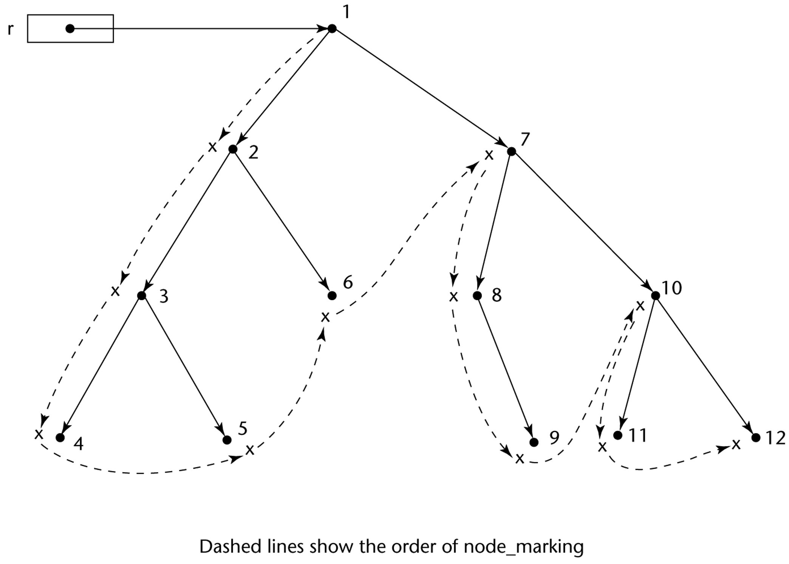
幻灯片59
Variable-sized cells have additional problems:
The initial setting of the indicators of all cells in the heap to indicate that they are garbage is difficult
Require cells to have the cell size as the first field
The marking process is non-trivial
Maintaining the list of available space is additional overhead
List becomes a long list of various-size segments
Requests cause the list to be searched for sufficiently large blocks

CS 304 – Fall 2003 – Ch. 6

幻灯片54
Record Types
Comparing records and arrays
1. Access to array elements is much slower than access to record fields, because subscripts are dynamic (field names are static)
2. Dynamic subscripts could be used with record field access, but it would disallow type checking and it would be much slower

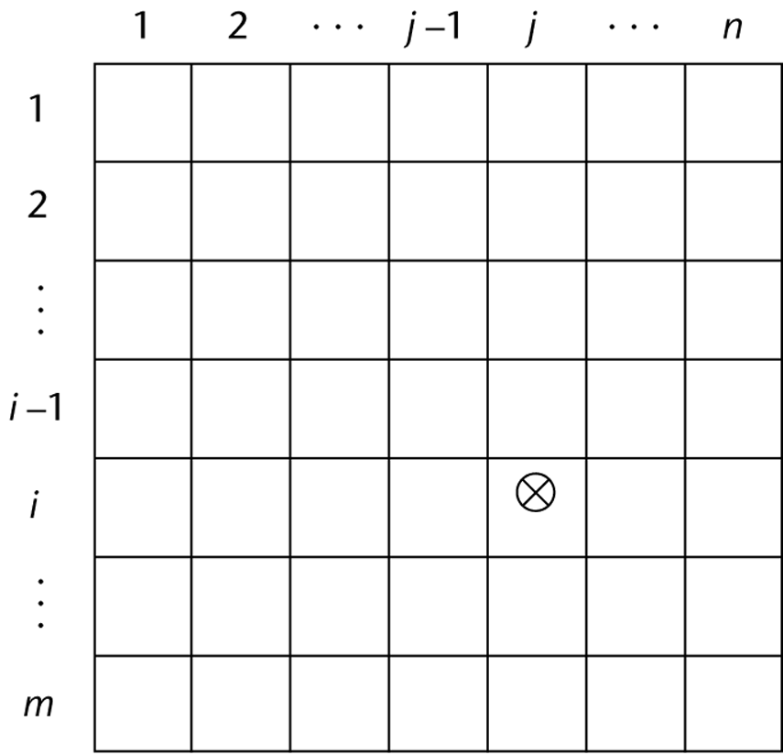

幻灯片1
Expressions and Assignment Statements
Chapter 7
CS 304 – Ch. 7
幻灯片2
Introduction
- Crucial for understanding programming languages
- Expressions in C:
- Sequences of operand and operators that reduce to a single value
- Postfix, prefix, unary, binary, assignment, comma, ternary
- Understanding expression evaluation:
- orders of operator/operand evaluations
- Associativity and precedence rules

- Imperative Languages ⬄ Assignment Statements

CS 304 – Ch. 7
幻灯片3
Arithmetic Expressions
- Their evaluation was one of the motivations for the development of the first programming languages
- Arithmetic expressions consist of operators, operands, parentheses, and function calls
- Design issues for arithmetic expressions:
- 1. What are the operator precedence rules?
- 2. What are the operator associativity rules?
- 3. What is the order of operand evaluation?
- 4. Are there restrictions on operand evaluation side effects?
- 5. Does the language allow user-defined operator overloading?
- 6. What mode mixing is allowed in expressions?

CS 304 – Ch. 7
幻灯片4
Operator Evaluation Order
- Def: The operator precedence rules for expression evaluation define the order in which “adjacent” operators of different precedence levels are evaluated (“adjacent” means they are separated by at most one operand)
- Typical precedence levels
- 1. parentheses
- 2. unary operators
- 3. ** (if the language supports it)
- 4. *, /
- 5. +, -

CS 304 – Ch. 7
幻灯片5
Operator Evaluation Order
- Def: The operator associativity rules for expression evaluation define the order in which adjacent operators with the same precedence level are evaluated
- Typical associativity rules:
- Left to right, except **, which is right to left
- Sometimes unary operators associate right to left (e.g., FORTRAN)
- APL is different; all operators have equal precedence and all operators associate right to left
- Precedence and associativity rules can be overridden with parentheses
- Addition in CS may not be associative !!!

CS 304 – Ch. 7
幻灯片6
Operator Evaluation Order
- The process:
- 1. Variables: just fetch the value
- 2. Constants: sometimes a fetch from memory; sometimes the constant is in the machine language instruction
- 3. Parenthesized expressions: evaluate all operands and operators first
- 4. Function references: The case of most interest!
- Order of evaluation is crucial

- Functional side effects
- when a function changes one of its parameters or a nonlocal variable

CS 304 – Ch. 7
幻灯片7
Operator Evaluation Order
- The problem with functional side effects:
- When a function referenced in an expression alters another operand of the expression
- e.g., for a parameter change:
- a = 10;
- b = a + fun(&a);
- /* Assume that fun changes its parameter */

- Two Possible Solutions to the Problem:

CS 304 – Ch. 7
幻灯片8
Operator Evaluation Order
- 1. Write the language definition to disallow functional side effects
- No two-way parameters in functions
- No nonlocal references in functions
- Advantage: it works!
- Disadvantage: Programmers want the flexibility of two-way (reference) parameters and nonlocal references

- 2. Write the language definition to demand that operand evaluation order be fixed
- Disadvantage: limits some compiler optimizations

CS 304 – Ch. 7
幻灯片9
Operator Evaluation Order
- Conditional Expressions

- C, C++, and Java (?:)
- Ternary Expressions
- three operands, two operators
- e.g.
- average = (count == 0)? 0 : sum / count;

CS 304 – Ch. 7
幻灯片10
Operator Overloading
- Some is common (e.g., + for int and float)
- Some is potential trouble (e.g., * in C and C++)
- Loss of compiler error detection (omission of an operand should be a detectable error)
- Can be avoided by introduction of new symbols (e.g., Pascal’s div)
- C++ and Ada allow user-defined overloaded operators

- Potential problems:
- Users can define nonsense operations
- Readability may suffer

CS 304 – Ch. 7
幻灯片11
Type Conversions
- Implicit Type Conversions
- Def: A narrowing conversion is one that converts an object to a type that cannot include all of the values of the original type

- Def: A widening conversion is one in which an object is converted to a type that can include at least approximations to all of the values of the original type

- Def: A mixed-mode expression is one that has operands of different types

- Def: An implicit type conversion is also known as coercion

CS 304 – Ch. 7
幻灯片12
Type Conversions
- The disadvantage of coercions:
- They decrease in the type error detection ability of the compiler
- In most languages, all numeric types are coerced in expressions, using widening conversions
- In Modula-2 and Ada, there are virtually no coercions in expressions

- Explicit Type Conversions (A.K.A. Casts)
- e.g.
- Ada:
- FLOAT(INDEX) -- INDEX is INTEGER type

- C:
- (int)speed /* speed is float type */

CS 304 – Ch. 7
幻灯片13
Type Conversions
- Errors in Expressions
- Caused by:
- Inherent limitations of arithmetic
- e.g. division by zero

- Limitations of computer arithmetic
- e.g. overflow

- Such errors are often ignored by the run-time system

CS 304 – Ch. 7
幻灯片14
Relational and Boolean Expressions
- Relational Expressions

- Use relational operators and operands of various types
- Evaluate to some boolean representation
- Operator symbols used vary somewhat among languages (!=, /=, .NE., <>, #)

- Boolean Expressions
- Operands are boolean and the result is boolean
- Operators:

- FORTRAN 77 FORTRAN 90 C Ada

- .AND. and && and
- .OR. or || or
- .NOT. not ! not

- C has no boolean type
- uses int type with 0 for false and nonzero for true

- One odd characteristic of C’s expressions:
- a < b < c is a legal expression
- but the result is not what you might expect

CS 304 – Ch. 7
幻灯片15
Short-Circuit Evaluation
- Pascal: does not use short-circuit evaluation
- Problem: table look-up
- index := 1;
- while (index <= length) and LIST[index] <> value) do
- index := index + 1
- C, C++, and Java: use short-circuit evaluation for the usual Boolean operators (&& and ||), but also provide bitwise Boolean operators that are not short circuit (& and |)

- Ada: programmer can specify either (short-circuit is specified with and then and or else)

- FORTRAN 77: short circuit, but any side-affected place must be set to undefined

- Short-circuit evaluation exposes the potential problem of side effects in expressions
- e.g. (a > b) || (b++ / 3)

CS 304 – Ch. 7
幻灯片16
Assignment Statements
- The operator symbol:
- 1. =
- FORTRAN, BASIC, PL/I, C, C++, Java
- 2. :=
- ALGOLs, Pascal, Modula-2, Ada

- “=“ can be bad if it is overloaded for the relational operator for equality
- e.g. (PL/I) A = B = C;
- Note difference from C

CS 304 – Ch. 7
幻灯片17
Assignment Statements
- More complicated assignments:

- 1. Multiple targets (PL/I)
- A, B = 10

- 2. Conditional targets (C, C++, and Java)
- (first = true) ? total : subtotal = 0

- 3. Compound assignment operators (C, C++, and Java)
- sum += next;

- 4. Unary assignment operators (C, C++, and Java)
- a++;

- C, C++, and Java treat “=“ as an arithmetic binary operator
- e.g.
- a = b * (c = d * 2 + 1) + 1
- This is inherited from ALGOL 68

CS 304 – Ch. 7
幻灯片18
Assignment Statements
- Assignment as an Expression
- In C, C++, and Java, the assignment statement produces a result
- So, they can be used as operands in expressions
- e.g. while ((ch = getchar() != EOF) { ... }

- Disadvantage
- Another kind of expression side effect

CS 304 – Ch. 7
幻灯片19
Assignment Statements
- Mixed-Mode Assignment

- In FORTRAN, C, and C++, any numeric value can be assigned to any numeric scalar variable; whatever conversion is necessary is done

- In Pascal, integers can be assigned to reals, but reals cannot be assigned to integers (the programmer must specify whether the conversion from real to integer is truncated or rounded)

- In Java, only widening assignment coercions are done

- In Ada, there is no assignment coercion

CS 304 – Ch. 7

幻灯片1
Functional Programming
Chapter 15
CS 304 – Ch. 15
幻灯片2
Introduction
- Functional Programming Languages

- The design of the imperative languages is based directly on the von Neumann architecture
- Efficiency is the primary concern, rather than the suitability of the language for software development

- The design of the functional languages is based on mathematical functions
- A solid theoretical basis that is also closer to the user, but relatively unconcerned with the architecture of the machines on which programs will run

CS 304 – Ch. 15
幻灯片3
Introduction
- Functional programming began in the late 1950s with LISP programming language
- The second oldest programming language (after FORTRAN)
- John McCarthy (MIT) - 1958
- There are many LISP dialects
- LISP 1.5 (1960)
- Scheme (1975)
- Common LISP (1985)
- LISP ⬄ LISt Processing
- LISP ⬄ Lots of Irritating Stupid Parenthesis ☺
- Other important functional programming languages :
- ML, Miranda, Haskell.
- The mathematical basis of many functional programming languages is -calculus
- Allows expressions that have functions as values

CS 304 – Ch. 15
幻灯片4
Mathematical Functions
- Def: A mathematical function is a mapping of members of one set, called the domain set, to another set, called the range set

- A lambda expression specifies the parameter(s) and the mapping of a function in the following form
- l(x) x * x * x
- for the function cube (x) = x * x * x

- Lambda functions are nameless functions

CS 304 – Ch. 15
幻灯片5
Simple Functions
- Lambda expressions describe nameless functions
- Alonzo Church, 1941
- Lambda expressions are applied to parameter(s) by placing the parameter(s) after the expression
- e.g. ((x) x * x * x)(3)
- which evaluates to 27

- Parameters of a function represent any member of the domain set
- However, during function application, each parameter is bound to exactly one specific member of the domain set

CS 304 – Ch. 15
幻灯片6
Functional Forms
- Def: A higher-order function, or functional form, is one that either takes functions as parameters or yields a function as its result, or both

- 1. Function Composition
- A functional form that takes two functions as parameters and yields a function whose result is a function whose value is the first actual parameter function applied to the result of the application of the second
- Form: h = f ° g
- which means h (x) =  f ( g ( x))

CS 304 – Ch. 15
幻灯片7
Functional Forms
- 2. Construction
- A functional form that takes a list of functions as parameters and yields a list of the results of applying each of its parameter functions to a given parameter
- Form: [f, g]
- For f (x) = x * x * x and g (x) = x + 3,
- [f, g] (4) yields (64, 7)

- For f (x) = x * x, g (x) = 2 * x + 3, h (x) = 5 – x
- [f, g, h] (5) = (25, 13, 0)

CS 304 – Ch. 15
幻灯片8
Functional Forms
- 3. Apply-to-all
- A functional form that takes a single function as a parameter and yields a list of values obtained by applying the given function to each element of a list of parameters
- Form: 
- For h (x) =  x * x * x
-  ( h, (3, 2, 4)) yields (27, 8, 64)

- Scheme example of apply to all:
- (apply (lambda (x) (+ x 3)) ‘(3 5 2 6))
- result: (6, 8, 5, 9)

CS 304 – Ch. 15
幻灯片9
Fundamentals of Functional Languages
- The objective of the design of a Functional Programming Language (FPL) is to mimic mathematical functions to the greatest extent possible
- The basic process of computation is fundamentally different in a FPL than in an imperative language
- In an imperative language, operations are done and the results are stored in variables for later use
- Management of variables is a constant concern and source of complexity for imperative programming
- In an FPL, variables are not necessary, as is the case in mathematics

CS 304 – Ch. 15
幻灯片10
Fundamentals of Functional Languages
- In an FPL, the evaluation of a function always produces the same result given the same parameters
- This is called referential transparency
- Makes semantics of pure functional languages simpler that that of imperative languages
- No side effects !!!

- A functional programming language provides:
- A set of primitive functions
- A set of functional forms for complex function construction
- A function application operation
- Data structure(s) for data representation

CS 304 – Ch. 15
幻灯片11
LISP
- LISP - the first functional programming language
- Originally, LISP was a typeless language
- Data object types: originally only atoms and lists

- List form: parenthesized collections of sublists and/or atoms
- e.g., (A B (C D) E (F (G H)))
- 4层- 第一A B E 第二 C D 第三F 第四 G H

- LISP lists are stored internally as single-linked lists
- Lambda notation is used to specify functions and function definitions
- function applications, and data all have the same form

CS 304 – Ch. 15
幻灯片12
Figure 15.1
Internal representation of two LISP lists

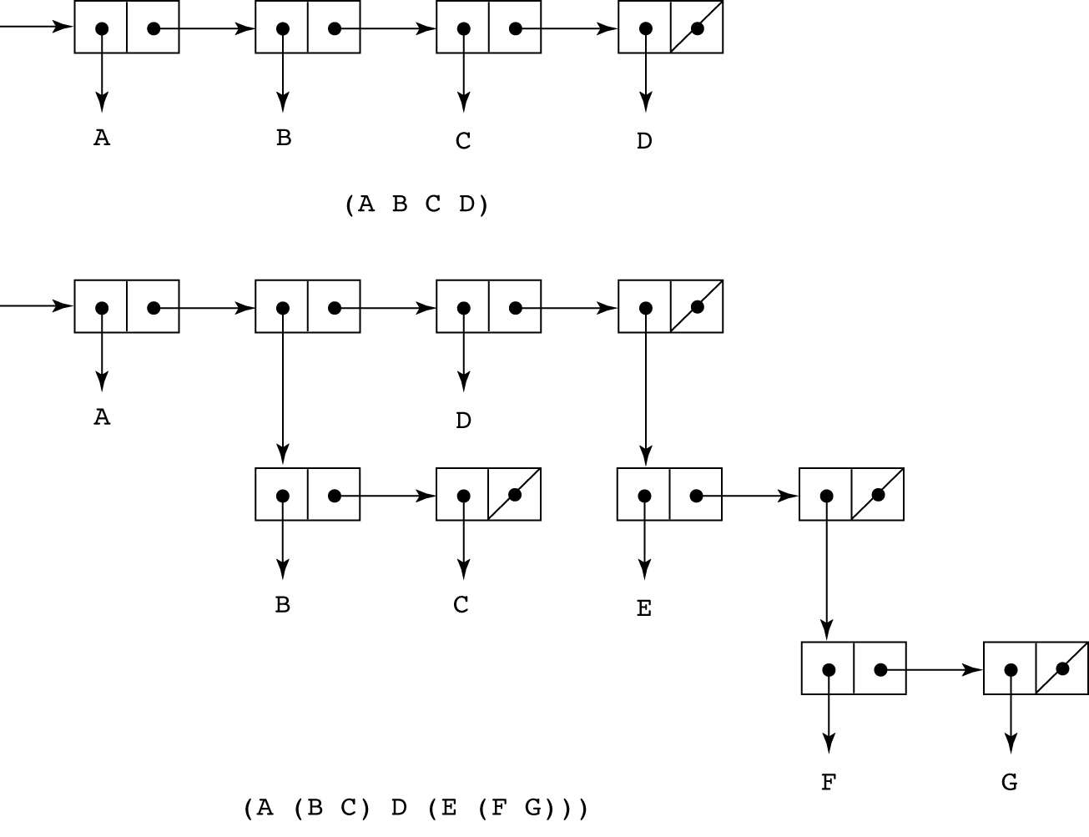

CS 304 – Ch. 15
幻灯片13
LISP
- Lambda notation is used to specify functions and function definitions
- Function applications and data all have the same form
- e.g.,
- If the list (A B C) is interpreted as data it is a simple list of three atoms, A, B, and C
- If it is interpreted as a function application, it means that the function named A is applied to the two parameters, B and C
- The first LISP interpreter appeared only as a demonstration of the universality of the computational capabilities of the notation
- The original lisp used dynamic scoping
- Functions were evaluated in the caller’s environment

CS 304 – Ch. 15
幻灯片14
LISP
- John McCarthy
- Wrote a paper about symbolic derivation to promote functional programming
- But thought list processing can replace Turing machines
- More natural way of computation
- EVAL :
- universal LISP function that evaluates other functions
- Cambridge Polish notation (prefix):
- Expressing data and functions in the same way
- (function_name arg_1 … arg_n)
- (+ 5 7 9)
- Lambda notation for function specification
- (function_name (LABMDA (arg_1 … arg_n) expression)
- Lisp data and code are called S-expressions

CS 304 – Ch. 15
幻灯片15
Scheme
- A mid-1970s dialect of LISP, designed to be cleaner, more modern, and simpler version than the contemporary dialects of LISP
- Sussman and Steele, 1975
- Uses only static scoping
- Functions are first-class entities
- They can be the values of expressions and elements of lists
- They can be assigned to variables and passed as parameters

- Identifiers in Scheme:
- consist of letters, digits, and special characters except parentheses; cannot begin with a digit

CS 304 – Ch. 15
幻灯片16
Scheme
- Scheme interpreter
- Read – Evaluate – Write loop
- Primitive Functions
- 1. Arithmetic: +, -, *, /, ABS, SQRT
- e.g., (+ 5 2) yields 7
- Can have more than two parameters
- (+ 1 2 3 4 5) yields 15
- (- 15 2 3 1) yields 9
- (- 24 (* 3 2)) yields 18
- 2. EVAL
- Basis of all evaluation in LISP
- Evaluate portion of the Read-Evaluate-Write loop
- EVAL evaluates all parameters of the given function first

CS 304 – Ch. 15
幻灯片17
Scheme
- But sometimes data is not to be evaluated immediately
- A function receiving an atom and a list, deciding whether the atom is in the list
- The list and the atom should not be evaluated, but rather examined
- To avoid parameter evaluation, use function QUOTE
- 3. QUOTE
- takes one parameter; returns the parameter without evaluation
- QUOTE is required because the Scheme interpreter, named EVAL, always evaluates parameters to function applications before applying the function
- QUOTE is used to avoid parameter evaluation when it is not appropriate

- (QUOTE (A B C)) yields (A B C) : not evaluated as a function call!

- QUOTE can be abbreviated with the apostrophe prefix operator
- e.g., '(A B) is equivalent to (QUOTE (A B))

CS 304 – Ch. 15
幻灯片18
Scheme
- Primitive functions for list operations:
- 4. CAR (Contents of the Address Register)
- takes a list parameter; returns the first element of that list
- e.g., (CAR '(A B C)) yields A
- (CAR '((A B) C D)) yields (A B)
- 5. CDR (Contents of the Decrement Register)
- takes a list parameter; returns the list after removing its first element
- e.g., (CDR '(A B C)) yields (B C)
- (CDR '((A B) C D)) yields (C D)
- 6. CONS
- takes two parameters, the first of which can be either an atom or a list and the second of which is a list
- returns a new list that includes the first parameter as its first element and the second parameter as the remainder of its result
- e.g., (CONS 'A '(B C)) returns (A B C)

- (CONS (CAR lis) (CDR lis)) = lis : identity function

CS 304 – Ch. 15
幻灯片19
Figure 15.2
The result of
several CONS
operations

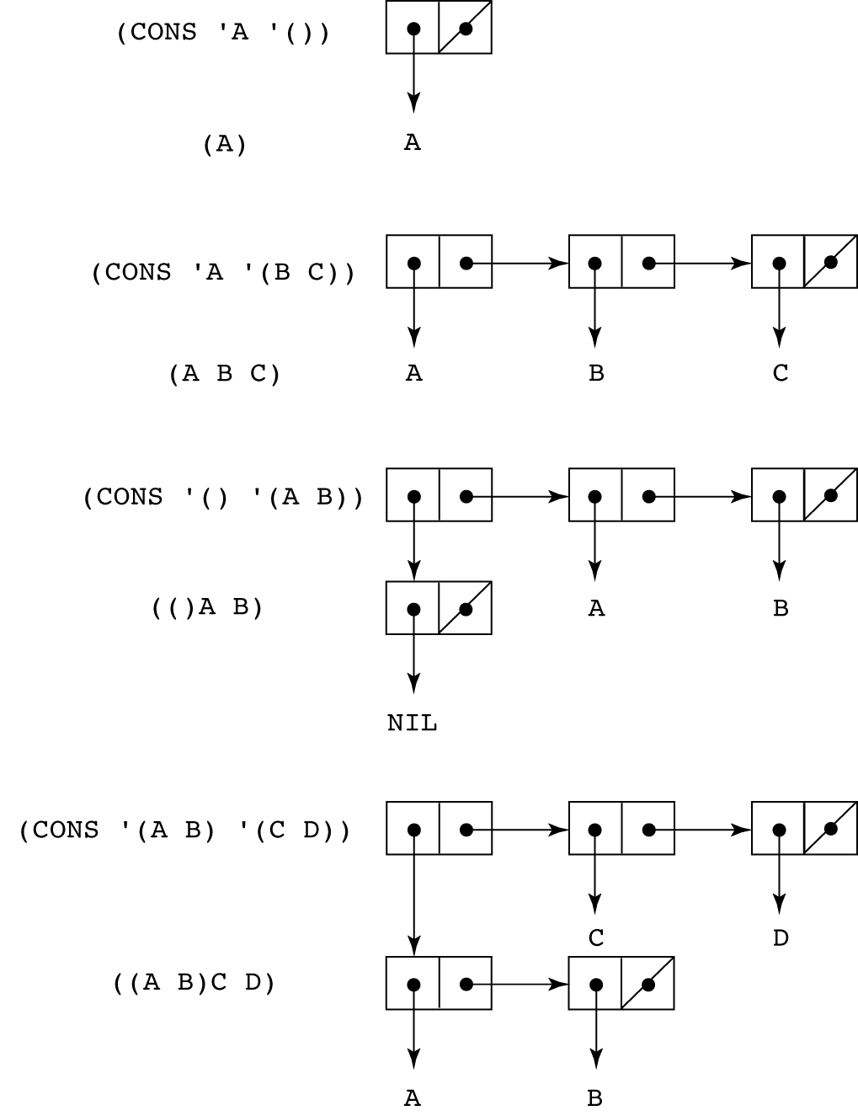
CS 304 – Ch. 15
幻灯片20
Scheme
- 7. LIST
- takes any number of parameters; returns a list with the parameters as elements
- e.g., (list ‘A ‘B ‘C ‘D) yields (A B C D)
- (list ‘A ‘(B F) ‘(C D)) yields (A (B F) (C D))

- Predicate Functions: (#T and () are true and false)
- 1. EQ?
- takes two symbolic parameters; it returns #T if both parameters are atoms and the two are the same
- e.g., (EQ? 'A 'A) yields #T
- (EQ? 'A '(A B)) yields ()
- Note that if EQ? is called with list parameters, the result is not reliable
- Depends on the internal list representation
- Also, EQ? does not work for numeric atoms

CS 304 – Ch. 15
幻灯片21
Scheme
- 2. LIST?
- takes one parameter; it returns #T if the parameter is an list; otherwise ()
- (LIST? ‘(A B)) ➔ #T
- (LIST? ‘A) ➔ ()
- 3. NULL?
- takes one parameter; it returns #T if the parameter is the empty list; otherwise ()
- Note that NULL? returns #T if the parameter is ()
- (NULL? ‘A) ➔ ()
- (NULL? ‘(())) ➔ ()
- 4. Numeric Predicate Functions
- =, <>, >, <, >=, <=, EVEN?, ODD?, ZERO?
- (EVEN? 3) ➔ () (ODD? 3) ➔ #T

CS 304 – Ch. 15
幻灯片22
Scheme
- 5. Output Utility Functions:
- (DISPLAY expression)
- (NEWLINE)
- e.g.,
- (DISPLAY “Please enter a number:”)
- (NEWLINE)
- Lambda Expressions
- Form is based on  notation
- e.g.,
- (LAMBDA (L) (CAR (CAR L)))
- L is called a bound variable
- Lambda expressions can be applied
- e.g.,
- ((LAMBDA (L) (CAR (CAR L))) '((A B) C D))

CS 304 – Ch. 15
幻灯片23
Scheme
- Functions for Constructing Functions

- DEFINE - Two forms:
- 1. To bind a symbol to an expression
- e.g.,
- (DEFINE pi 3.141593)
- (DEFINE two_pi (* 2 pi))
- 2. To bind names to lambda expressions
- e.g.,
- (DEFINE (cube x) (* x x x))
- Example use:
- (cube 4)

CS 304 – Ch. 15
幻灯片24
Scheme
- More examples:
- Function definition
- Bind name to a function

- (DEFINE (function_name parameters)
- body
- )

- (DEFINE square (LAMBDA (number) (* number number)))
- or
- (DEFINE (square number) (* number number))
- LAMBDA is implicit and therefore can be omitted

- Call:
- (square 10) ➔ 100

CS 304 – Ch. 15
幻灯片25
Scheme
- Evaluation process (for normal functions):
- 1. Parameters are evaluated, in no particular order
- 2. The values of the parameters are substituted into the function body
- 3. The function body is evaluated
- 4. The value of the last expression in the body is the value of the function

- Special forms use a different evaluation process
- E.g., IF, COND, etc…

CS 304 – Ch. 15
幻灯片26
Control Flow
- Modeled after the mathematical functions
- 1. Selection - the special form IF
- (IF predicate then_exp else_exp)
- e.g.,
- (IF (<> count 0)
- (/ sum count)
- 0
- )
- Example:
- (DEFINE (fact number)
- (IF (= number 0)
- 1
- ( (* number
- (fact (- number 1))))
- )

CS 304 – Ch. 15
幻灯片27
Control Flow
- 2. Multiple Selection - the special form COND
- General form:
- (COND
- (predicate_1 expr {expr})
- (predicate_2 expr {expr})
- ...
- (predicate_n expr {expr})
- (ELSE expr {expr})
- )
- Returns the value of the last expr in the first pair whose predicate evaluates to true
- (DEFINE (compare x y)
- (COND
- ((> x y) (DISPLAY “X > Y.”))
- ((< x y) (DISPLAY “X < Y.”))
- (#T (DISPLAY “X and Y are equal))
- )
- )

CS 304 – Ch. 15
幻灯片28
Example Scheme Functions
- 1. member
- takes an atom and a list; returns #T if the atom is in the list; () otherwise

- (member ‘B ‘(A B C)) ➔ #T
- (member ‘D ‘(A B C)) ➔ ()

- (DEFINE (member atm lis)
- (COND
- ((NULL? lis) '())
- ((EQ? atm (CAR lis)) #T)
- ((ELSE (member atm (CDR lis)))
- ))

CS 304 – Ch. 15
幻灯片29
Example Scheme Functions
- 2. equalsimp
- takes two simple lists as parameters; returns #T if the two simple lists are equal; () otherwise

- (DEFINE (equalsimp lis1 lis2)
- (COND
- ((NULL? lis1) (NULL? lis2))
- ((NULL? lis2) '())
- ((EQ? (CAR lis1) (CAR lis2))
- (equalsimp (CDR lis1) (CDR lis2)))
- (ELSE '())
- ))

CS 304 – Ch. 15
幻灯片30
Example Scheme Functions
- 3. equal
- takes two lists as parameters; returns #T if the two general lists are equal; () otherwise

- (DEFINE (equal lis1 lis2)
- (COND
- ((NOT (LIST? lis1)) (EQ? lis1 lis2))
- ((NOT (LIST? lis2)) '())
- ((NULL? lis1) (NULL? lis2))
- ((NULL? lis2) '())
- ((equal (CAR lis1) (CAR lis2))
- (equal (CDR lis1) (CDR lis2)))
- (ELSE '())
- ))

CS 304 – Ch. 15
幻灯片31
Example Scheme Functions
- 4. append
- takes two lists as parameters; returns the first parameter list with the elements of the second parameter list appended at the end
- (append ‘(B D E) ‘(A B C)) ➔ (B D E A B C)
- (append ‘((B) D E) ‘(A (B C))) ➔ ((B) D E A (B C))

- (DEFINE (append lis1 lis2)
- (COND
- ((NULL? lis1) lis2)
- (ELSE (CONS (CAR lis1)
- (append (CDR lis1) lis2)))
- ))

CS 304 – Ch. 15
幻灯片32
Functional Forms in Scheme
- 1. Composition
- The previous examples have used it
- e.g., (CAR (CDR ‘(A B C)))

- 2. Apply to All
- one form in Scheme is mapcar
- Applies the given function to all elements of the given list; result is a list of the results

- (DEFINE mapcar fun lis)
- (COND
- ((NULL? lis) '())
- (ELSE (CONS (fun (CAR lis))
- (mapcar fun (CDR lis))))
- ))

CS 304 – Ch. 15
幻灯片33
Functions that Build Code
- It is possible in Scheme to define a function that builds Scheme code and requests its interpretation
- This is possible because the interpreter is a user-available function, EVAL
- e.g., suppose we have a list of numbers that must be added together
- ((DEFINE (adder lis)
- (COND
- ((NULL? lis) 0)
- (ELSE (+ (CAR lis) (adder (CDR lis))))
- ))
- ALTERNATIVELY, WE CAN USE EVAL …

- ((DEFINE (adder lis)
- (COND
- ((NULL? lis) 0)
- (ELSE (EVAL (CONS '+ lis)))
- ))
- The parameter is a list of numbers to be added; adder inserts a + operator and interprets the resulting list

CS 304 – Ch. 15
幻灯片34
Trees in Scheme
- List representation of trees
- Format : (ROOT child_1 child_2 .... child_n)
- Where children may be other trees (lists)

- (define tree '(A (B (C D E)) F))

- A
- / \
- B F
- |
- C
- / \
- D E

CS 304 – Ch. 15
幻灯片35
- After the definition
(define dozen 12)
what will be the value of the Scheme expression (number? dozen)?

- Give a Scheme definition that will determine the sum of 31, 29, 31, 30, 31, and 10 and bind the identifier day-of-year to this sum.

- Define a recursive Scheme procedure first-symbol that finds and returns the first element of a given list that is a symbol (but returns #f if none of the elements of the list is a symbol).

(define first-symbol
(lambda (li)
(cond ((null? li) #f)
((symbol? (car li)) (car li))
(else (first-symbol (cdr li))))))

10. Define a recursive Scheme procedure add-1-to-each that, given any list of numbers, returns a list of equal length in which each element is 1 greater than the corresponding element of the given list. For example, the value of (add-1-to-each '(3 8 6)) should be (4 9 7).

(define add-1-to-each
(lambda (li)
(if (null? li)
'()
(cons (+ (car li) 1) (add-1-to-each (cdr li))))))

CS 304 – Ch. 15
幻灯片36

- Define a recursive Scheme procedure tally that counts and returns the number of occurrences of a given value in a given list. For example, the value of
(tally 'a '(b a 7 c a a 3 a)) should be 4.

(define tally
(lambda (val li)
(cond ((null? li) 0)
((equal? (car li) val) (+ 1 (tally val (cdr li))))
(else (tally val (cdr li))))))

- Define a Scheme procedure all-different? that determines whether all of the top-level elements of a given list are distinct (that is, not equal?).
This solution uses the member? procedure (can you define it?)

(define all-different?
(lambda (li)
(if (null? li)
#t
(and (not (member? (car li) (cdr li)))
(all-different? (cdr li))))))

CS 304 – Ch. 15
幻灯片37
- Define a Scheme procedure attach-at-end that takes any value as its first argument and a list as its second argument and returns a list containing all of the same elements as the given list except that the given value has been added as the last element.
(define attach-at-end
(lambda (val li)
(if (null? li)
(list val)
(cons (car li) (attach-at-end val (cdr li))))))

- Define a Scheme procedure mean that takes a non-empty list of numbers and returns the arithmetic mean of its elements.

(define mean
(lambda (li)
(/ (sum li) (length li))))

(define sum
(lambda (li)
(if (null? li)
0
(+ (car li) (sum (cdr li))))))

CS 304 – Ch. 15
幻灯片38
Imperative Features of Scheme
- No needed in functional programming
- Included only to “spoil” imperative programmers ☺

- 1. SET!
- binds or rebinds a value to a name
- 2. SET-CAR!
- replaces the car of a list
- 3. SET-CDR!
- replaces the cdr part of a list
- Functional programs that use imperative features are harder to debug
- Side Effects and Aliasing may cause trouble!

CS 304 – Ch. 15
幻灯片39
Common LISP
- A combination of many of the features of the popular dialects of LISP around in the early 1980s

- A large and complex language
- Can be said that it is the opposite of Scheme

- LISP includes:
- - records
- - arrays
- - complex numbers
- - character strings
- - powerful i/o capabilities
- - packages with access control
- - imperative features like those of Scheme
- - iterative control statements

CS 304 – Ch. 15
幻灯片40
Common LISP
- Example (iterative set membership, member)

- (DEFUN iterative_member (atm lst)
- (PROG ()
- loop_1
- (COND
- ((NULL lst) (RETURN NIL))
- ((EQUAL atm (CAR lst)) (RETURN T))
- )
- (SETQ lst (CDR lst))
- (GO loop_1)
- ))

CS 304 – Ch. 15
幻灯片41
ML (Machine Learning)
- A static-scoped functional language with syntax that is closer to Pascal than to LISP

- Uses type declarations, but also does type inferencing to determine the types of undeclared variables (See Chapter 4)

- It is strongly typed (whereas Scheme is essentially typeless) and has no type coercions

- Includes exception handling and a module facility for implementing abstract data types

- Includes lists and list operations

CS 304 – Ch. 15
幻灯片42
ML (Machine Learning)
- The val statement binds a name to a value (similar to DEFINE in Scheme)

- Function declaration form:
- fun function_name (formal_parameters) =
- function_body_expression;
- e.g., fun cube (x : int) = x * x * x;

- Functions that use arithmetic or relational operators cannot be polymorphic--those with only list operations can be polymorphic
- Powerful pattern-matching facilities

CS 304 – Ch. 15
幻灯片43
Haskell
- Similar to ML (syntax, static scoped, strongly typed, type inferencing)

- Different from ML (and most other functional languages) in that it is PURELY functional
- e.g., no variables, no assignment statements, and no side effects of any kind!!!

- Most Important Features
- Uses lazy evaluation (evaluate no subexpression until the value is needed)
- Has “list comprehensions,” which allow it to deal with infinite lists

- Examples:

- 1. Fibonacci numbers (illustrates function definitions with different parameter forms)

- fib 0 = 1
- fib 1 = 1
- fib (n + 2) = fib (n + 1) + fib n

CS 304 – Ch. 15
幻灯片44
Haskell
- Examples:
- product [] = 1
- product (a:x) = a * product x
- fact n = product [1..n]
- 4. List comprehensions: set notation
- e.g., [n * n | n  [1..20]]
- defines a list of the squares of the first 20 positive integers

- factors n = [i | i [1..n div 2],
- n mod i == 0]
- This function computes all of the factors of its given parameter

- Quicksort:
- sort [] = []
- sort (a:x) = sort [b | b  x; b <= a]
- ++ [a] ++
- sort [b | b  x; b > a]

CS 304 – Ch. 15
幻灯片45
Haskell
- 5. Lazy evaluation
- Infinite lists
- e.g.,
- positives = [0..]
- squares = [n * n | n  [0..]]
- (only compute those that are necessary)
- e.g., member squares 16
- would return True
- The member function could be written as:
- member [] b = False
- member (a:x) b = (a == b) || member x b
- However, this would only work if the parameter to squares was a perfect square; if not, it will keep generating them forever. The following version will always work:
- member2 (m:x) n
- | m < n = member2 x n
- | m == n = True
- | otherwise = False

CS 304 – Ch. 15
幻灯片46
Haskell
- 2. Factorial (illustrates guards)
- fact n
- | n == 0 = 1
- | n > 0 = n * fact (n - 1)
- The special word otherwise can appear as a guard

- 3. List operations
- List notation: Put elements in brackets
- e.g., directions = [north, south, east, west]
- Length: #
- e.g., #directions is 4
- Arithmetic series with the .. operator
- e.g., [2, 4..10] is [2, 4, 6, 8, 10]
- Catenation is with +
- e.g., [1, 3] ++ [5, 7] results in [1, 3, 5, 7]
- CAR and CDR via the colon operator (as in Prolog)
- e.g., 1:[3, 5, 7] results in [1, 3, 5, 7]

CS 304 – Ch. 15
幻灯片47
Applications of Functional Languages
- APL is used for throw-away programs

- LISP is used for artificial intelligence
- - Knowledge representation
- - Machine learning
- - Natural language processing
- - Modeling of speech and vision

- Scheme is used to teach introductory programming at a significant number of universities

CS 304 – Ch. 15
幻灯片48
Comparing Functional and Imperative Languages
- Imperative Languages:
- Efficient execution
- Complex semantics
- Complex syntax
- Concurrency is programmer designed

- Functional Languages:
- Simple semantics
- Simple syntax
- Inefficient execution
- Programs can automatically be made concurrent

CS 304 – Ch. 15

