幻灯片1
Functional Programming
Chapter 15
CS 304 – Ch. 15
幻灯片2
Introduction
- Functional Programming Languages

- The design of the imperative languages is based directly on the von Neumann architecture
- Efficiency is the primary concern, rather than the suitability of the language for software development

- The design of the functional languages is based on mathematical functions
- A solid theoretical basis that is also closer to the user, but relatively unconcerned with the architecture of the machines on which programs will run

CS 304 – Ch. 15
幻灯片3
Introduction
- Functional programming began in the late 1950s with LISP programming language
- The second oldest programming language (after FORTRAN)
- John McCarthy (MIT) - 1958
- There are many LISP dialects
- LISP 1.5 (1960)
- Scheme (1975)
- Common LISP (1985)
- LISP ⬄ LISt Processing
- LISP ⬄ Lots of Irritating Stupid Parenthesis ☺
- Other important functional programming languages :
- ML, Miranda, Haskell.
- The mathematical basis of many functional programming languages is -calculus
- Allows expressions that have functions as values

CS 304 – Ch. 15
幻灯片4
Mathematical Functions
- Def: A mathematical function is a mapping of members of one set, called the domain set, to another set, called the range set

- A lambda expression specifies the parameter(s) and the mapping of a function in the following form
- l(x) x * x * x
- for the function cube (x) = x * x * x

- Lambda functions are nameless functions

CS 304 – Ch. 15
幻灯片5
Simple Functions
- Lambda expressions describe nameless functions
- Alonzo Church, 1941
- Lambda expressions are applied to parameter(s) by placing the parameter(s) after the expression
- e.g. ((x) x * x * x)(3)
- which evaluates to 27

- Parameters of a function represent any member of the domain set
- However, during function application, each parameter is bound to exactly one specific member of the domain set

CS 304 – Ch. 15
幻灯片6
Functional Forms
- Def: A higher-order function, or functional form, is one that either takes functions as parameters or yields a function as its result, or both

- 1. Function Composition
- A functional form that takes two functions as parameters and yields a function whose result is a function whose value is the first actual parameter function applied to the result of the application of the second
- Form: h = f ° g
- which means h (x) =  f ( g ( x))

CS 304 – Ch. 15
幻灯片7
Functional Forms
- 2. Construction
- A functional form that takes a list of functions as parameters and yields a list of the results of applying each of its parameter functions to a given parameter
- Form: [f, g]
- For f (x) = x * x * x and g (x) = x + 3,
- [f, g] (4) yields (64, 7)

- For f (x) = x * x, g (x) = 2 * x + 3, h (x) = 5 – x
- [f, g, h] (5) = (25, 13, 0)

CS 304 – Ch. 15
幻灯片8
Functional Forms
- 3. Apply-to-all
- A functional form that takes a single function as a parameter and yields a list of values obtained by applying the given function to each element of a list of parameters
- Form: 
- For h (x) =  x * x * x
-  ( h, (3, 2, 4)) yields (27, 8, 64)

- Scheme example of apply to all:
- (apply (lambda (x) (+ x 3)) ‘(3 5 2 6))
- result: (6, 8, 5, 9)

CS 304 – Ch. 15
幻灯片9
Fundamentals of Functional Languages
- The objective of the design of a Functional Programming Language (FPL) is to mimic mathematical functions to the greatest extent possible
- The basic process of computation is fundamentally different in a FPL than in an imperative language
- In an imperative language, operations are done and the results are stored in variables for later use
- Management of variables is a constant concern and source of complexity for imperative programming
- In an FPL, variables are not necessary, as is the case in mathematics

CS 304 – Ch. 15
幻灯片10
Fundamentals of Functional Languages
- In an FPL, the evaluation of a function always produces the same result given the same parameters
- This is called referential transparency
- Makes semantics of pure functional languages simpler that that of imperative languages
- No side effects !!!

- A functional programming language provides:
- A set of primitive functions
- A set of functional forms for complex function construction
- A function application operation
- Data structure(s) for data representation

CS 304 – Ch. 15
幻灯片11
LISP
- LISP - the first functional programming language
- Originally, LISP was a typeless language
- Data object types: originally only atoms and lists

- List form: parenthesized collections of sublists and/or atoms
- e.g., (A B (C D) E (F (G H)))
- 4层- 第一A B E 第二 C D 第三F 第四 G H

- LISP lists are stored internally as single-linked lists
- Lambda notation is used to specify functions and function definitions
- function applications, and data all have the same form

CS 304 – Ch. 15
幻灯片12
Figure 15.1
Internal representation of two LISP lists

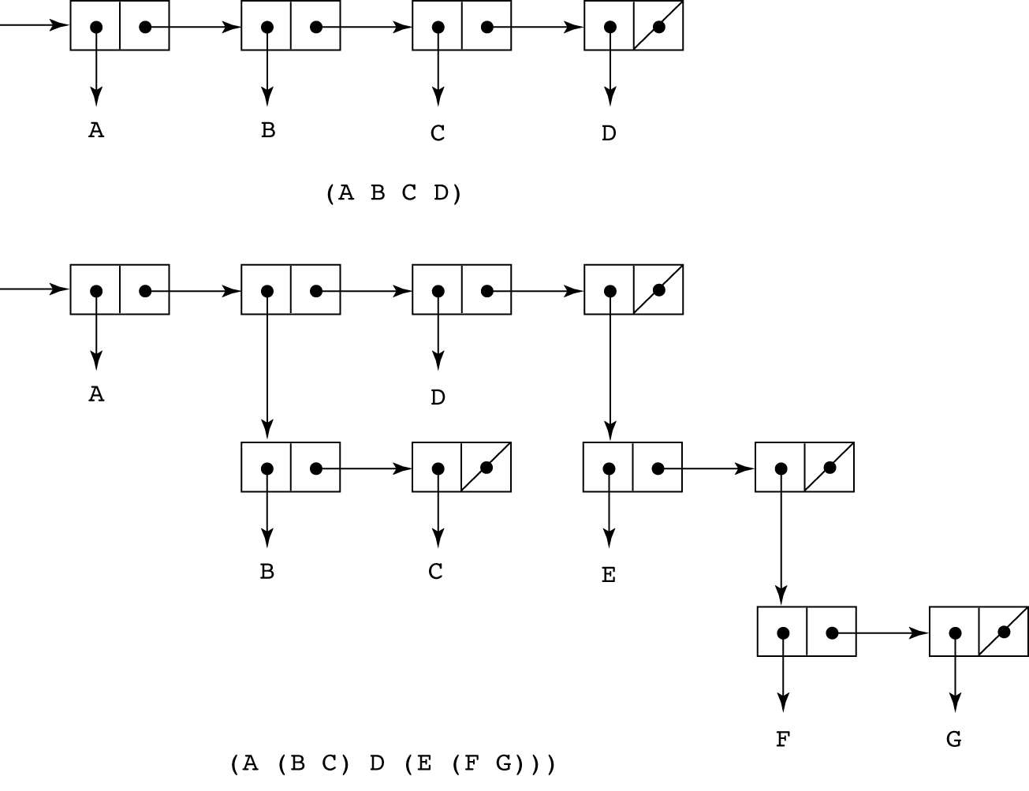

CS 304 – Ch. 15
幻灯片13
LISP
- Lambda notation is used to specify functions and function definitions
- Function applications and data all have the same form
- e.g.,
- If the list (A B C) is interpreted as data it is a simple list of three atoms, A, B, and C
- If it is interpreted as a function application, it means that the function named A is applied to the two parameters, B and C
- The first LISP interpreter appeared only as a demonstration of the universality of the computational capabilities of the notation
- The original lisp used dynamic scoping
- Functions were evaluated in the caller’s environment

CS 304 – Ch. 15
幻灯片14
LISP
- John McCarthy
- Wrote a paper about symbolic derivation to promote functional programming
- But thought list processing can replace Turing machines
- More natural way of computation
- EVAL :
- universal LISP function that evaluates other functions
- Cambridge Polish notation (prefix):
- Expressing data and functions in the same way
- (function_name arg_1 … arg_n)
- (+ 5 7 9)
- Lambda notation for function specification
- (function_name (LABMDA (arg_1 … arg_n) expression)
- Lisp data and code are called S-expressions

CS 304 – Ch. 15
幻灯片15
Scheme
- A mid-1970s dialect of LISP, designed to be cleaner, more modern, and simpler version than the contemporary dialects of LISP
- Sussman and Steele, 1975
- Uses only static scoping
- Functions are first-class entities
- They can be the values of expressions and elements of lists
- They can be assigned to variables and passed as parameters

- Identifiers in Scheme:
- consist of letters, digits, and special characters except parentheses; cannot begin with a digit

CS 304 – Ch. 15
幻灯片16
Scheme
- Scheme interpreter
- Read – Evaluate – Write loop
- Primitive Functions
- 1. Arithmetic: +, -, *, /, ABS, SQRT
- e.g., (+ 5 2) yields 7
- Can have more than two parameters
- (+ 1 2 3 4 5) yields 15
- (- 15 2 3 1) yields 9
- (- 24 (* 3 2)) yields 18
- 2. EVAL
- Basis of all evaluation in LISP
- Evaluate portion of the Read-Evaluate-Write loop
- EVAL evaluates all parameters of the given function first

CS 304 – Ch. 15
幻灯片17
Scheme
- But sometimes data is not to be evaluated immediately
- A function receiving an atom and a list, deciding whether the atom is in the list
- The list and the atom should not be evaluated, but rather examined
- To avoid parameter evaluation, use function QUOTE
- 3. QUOTE
- takes one parameter; returns the parameter without evaluation
- QUOTE is required because the Scheme interpreter, named EVAL, always evaluates parameters to function applications before applying the function
- QUOTE is used to avoid parameter evaluation when it is not appropriate

- (QUOTE (A B C)) yields (A B C) : not evaluated as a function call!

- QUOTE can be abbreviated with the apostrophe prefix operator
- e.g., '(A B) is equivalent to (QUOTE (A B))

CS 304 – Ch. 15
幻灯片18
Scheme
- Primitive functions for list operations:
- 4. CAR (Contents of the Address Register)
- takes a list parameter; returns the first element of that list
- e.g., (CAR '(A B C)) yields A
- (CAR '((A B) C D)) yields (A B)
- 5. CDR (Contents of the Decrement Register)
- takes a list parameter; returns the list after removing its first element
- e.g., (CDR '(A B C)) yields (B C)
- (CDR '((A B) C D)) yields (C D)
- 6. CONS
- takes two parameters, the first of which can be either an atom or a list and the second of which is a list
- returns a new list that includes the first parameter as its first element and the second parameter as the remainder of its result
- e.g., (CONS 'A '(B C)) returns (A B C)

- (CONS (CAR lis) (CDR lis)) = lis : identity function

CS 304 – Ch. 15
幻灯片19
Figure 15.2
The result of
several CONS
operations

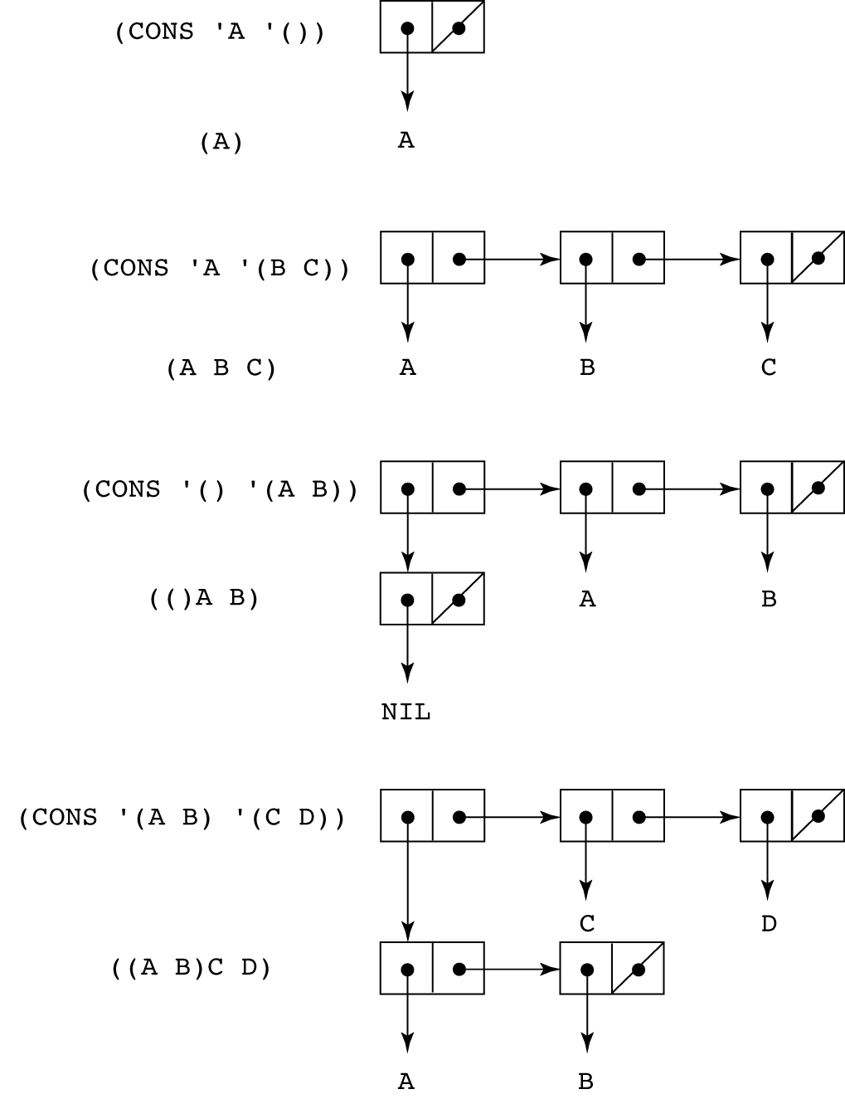
CS 304 – Ch. 15
幻灯片20
Scheme
- 7. LIST
- takes any number of parameters; returns a list with the parameters as elements
- e.g., (list ‘A ‘B ‘C ‘D) yields (A B C D)
- (list ‘A ‘(B F) ‘(C D)) yields (A (B F) (C D))

- Predicate Functions: (#T and () are true and false)
- 1. EQ?
- takes two symbolic parameters; it returns #T if both parameters are atoms and the two are the same
- e.g., (EQ? 'A 'A) yields #T
- (EQ? 'A '(A B)) yields ()
- Note that if EQ? is called with list parameters, the result is not reliable
- Depends on the internal list representation
- Also, EQ? does not work for numeric atoms

CS 304 – Ch. 15
幻灯片21
Scheme
- 2. LIST?
- takes one parameter; it returns #T if the parameter is an list; otherwise ()
- (LIST? ‘(A B)) ➔ #T
- (LIST? ‘A) ➔ ()
- 3. NULL?
- takes one parameter; it returns #T if the parameter is the empty list; otherwise ()
- Note that NULL? returns #T if the parameter is ()
- (NULL? ‘A) ➔ ()
- (NULL? ‘(())) ➔ ()
- 4. Numeric Predicate Functions
- =, <>, >, <, >=, <=, EVEN?, ODD?, ZERO?
- (EVEN? 3) ➔ () (ODD? 3) ➔ #T

CS 304 – Ch. 15
幻灯片22
Scheme
- 5. Output Utility Functions:
- (DISPLAY expression)
- (NEWLINE)
- e.g.,
- (DISPLAY “Please enter a number:”)
- (NEWLINE)
- Lambda Expressions
- Form is based on  notation
- e.g.,
- (LAMBDA (L) (CAR (CAR L)))
- L is called a bound variable
- Lambda expressions can be applied
- e.g.,
- ((LAMBDA (L) (CAR (CAR L))) '((A B) C D))

CS 304 – Ch. 15
幻灯片23
Scheme
- Functions for Constructing Functions

- DEFINE - Two forms:
- 1. To bind a symbol to an expression
- e.g.,
- (DEFINE pi 3.141593)
- (DEFINE two_pi (* 2 pi))
- 2. To bind names to lambda expressions
- e.g.,
- (DEFINE (cube x) (* x x x))
- Example use:
- (cube 4)

CS 304 – Ch. 15
幻灯片24
Scheme
- More examples:
- Function definition
- Bind name to a function

- (DEFINE (function_name parameters)
- body
- )

- (DEFINE square (LAMBDA (number) (* number number)))
- or
- (DEFINE (square number) (* number number))
- LAMBDA is implicit and therefore can be omitted

- Call:
- (square 10) ➔ 100

CS 304 – Ch. 15
幻灯片25
Scheme
- Evaluation process (for normal functions):
- 1. Parameters are evaluated, in no particular order
- 2. The values of the parameters are substituted into the function body
- 3. The function body is evaluated
- 4. The value of the last expression in the body is the value of the function

- Special forms use a different evaluation process
- E.g., IF, COND, etc…

CS 304 – Ch. 15
幻灯片26
Control Flow
- Modeled after the mathematical functions
- 1. Selection - the special form IF
- (IF predicate then_exp else_exp)
- e.g.,
- (IF (<> count 0)
- (/ sum count)
- 0
- )
- Example:
- (DEFINE (fact number)
- (IF (= number 0)
- 1
- ( (* number
- (fact (- number 1))))
- )

CS 304 – Ch. 15
幻灯片27
Control Flow
- 2. Multiple Selection - the special form COND
- General form:
- (COND
- (predicate_1 expr {expr})
- (predicate_2 expr {expr})
- ...
- (predicate_n expr {expr})
- (ELSE expr {expr})
- )
- Returns the value of the last expr in the first pair whose predicate evaluates to true
- (DEFINE (compare x y)
- (COND
- ((> x y) (DISPLAY “X > Y.”))
- ((< x y) (DISPLAY “X < Y.”))
- (#T (DISPLAY “X and Y are equal))
- )
- )

CS 304 – Ch. 15
幻灯片28
Example Scheme Functions
- 1. member
- takes an atom and a list; returns #T if the atom is in the list; () otherwise

- (member ‘B ‘(A B C)) ➔ #T
- (member ‘D ‘(A B C)) ➔ ()

- (DEFINE (member atm lis)
- (COND
- ((NULL? lis) '())
- ((EQ? atm (CAR lis)) #T)
- ((ELSE (member atm (CDR lis)))
- ))

CS 304 – Ch. 15
幻灯片29
Example Scheme Functions
- 2. equalsimp
- takes two simple lists as parameters; returns #T if the two simple lists are equal; () otherwise

- (DEFINE (equalsimp lis1 lis2)
- (COND
- ((NULL? lis1) (NULL? lis2))
- ((NULL? lis2) '())
- ((EQ? (CAR lis1) (CAR lis2))
- (equalsimp (CDR lis1) (CDR lis2)))
- (ELSE '())
- ))

CS 304 – Ch. 15
幻灯片30
Example Scheme Functions
- 3. equal
- takes two lists as parameters; returns #T if the two general lists are equal; () otherwise

- (DEFINE (equal lis1 lis2)
- (COND
- ((NOT (LIST? lis1)) (EQ? lis1 lis2))
- ((NOT (LIST? lis2)) '())
- ((NULL? lis1) (NULL? lis2))
- ((NULL? lis2) '())
- ((equal (CAR lis1) (CAR lis2))
- (equal (CDR lis1) (CDR lis2)))
- (ELSE '())
- ))

CS 304 – Ch. 15
幻灯片31
Example Scheme Functions
- 4. append
- takes two lists as parameters; returns the first parameter list with the elements of the second parameter list appended at the end
- (append ‘(B D E) ‘(A B C)) ➔ (B D E A B C)
- (append ‘((B) D E) ‘(A (B C))) ➔ ((B) D E A (B C))

- (DEFINE (append lis1 lis2)
- (COND
- ((NULL? lis1) lis2)
- (ELSE (CONS (CAR lis1)
- (append (CDR lis1) lis2)))
- ))

CS 304 – Ch. 15
幻灯片32
Functional Forms in Scheme
- 1. Composition
- The previous examples have used it
- e.g., (CAR (CDR ‘(A B C)))

- 2. Apply to All
- one form in Scheme is mapcar
- Applies the given function to all elements of the given list; result is a list of the results

- (DEFINE mapcar fun lis)
- (COND
- ((NULL? lis) '())
- (ELSE (CONS (fun (CAR lis))
- (mapcar fun (CDR lis))))
- ))

CS 304 – Ch. 15
幻灯片33
Functions that Build Code
- It is possible in Scheme to define a function that builds Scheme code and requests its interpretation
- This is possible because the interpreter is a user-available function, EVAL
- e.g., suppose we have a list of numbers that must be added together
- ((DEFINE (adder lis)
- (COND
- ((NULL? lis) 0)
- (ELSE (+ (CAR lis) (adder (CDR lis))))
- ))
- ALTERNATIVELY, WE CAN USE EVAL …

- ((DEFINE (adder lis)
- (COND
- ((NULL? lis) 0)
- (ELSE (EVAL (CONS '+ lis)))
- ))
- The parameter is a list of numbers to be added; adder inserts a + operator and interprets the resulting list

CS 304 – Ch. 15
幻灯片34
Trees in Scheme
- List representation of trees
- Format : (ROOT child_1 child_2 .... child_n)
- Where children may be other trees (lists)

- (define tree '(A (B (C D E)) F))

- A
- / \
- B F
- |
- C
- / \
- D E

CS 304 – Ch. 15
幻灯片35
- After the definition
(define dozen 12)
what will be the value of the Scheme expression (number? dozen)?

- Give a Scheme definition that will determine the sum of 31, 29, 31, 30, 31, and 10 and bind the identifier day-of-year to this sum.

- Define a recursive Scheme procedure first-symbol that finds and returns the first element of a given list that is a symbol (but returns #f if none of the elements of the list is a symbol).

(define first-symbol
(lambda (li)
(cond ((null? li) #f)
((symbol? (car li)) (car li))
(else (first-symbol (cdr li))))))

10. Define a recursive Scheme procedure add-1-to-each that, given any list of numbers, returns a list of equal length in which each element is 1 greater than the corresponding element of the given list. For example, the value of (add-1-to-each '(3 8 6)) should be (4 9 7).

(define add-1-to-each
(lambda (li)
(if (null? li)
'()
(cons (+ (car li) 1) (add-1-to-each (cdr li))))))

CS 304 – Ch. 15
幻灯片36

- Define a recursive Scheme procedure tally that counts and returns the number of occurrences of a given value in a given list. For example, the value of
(tally 'a '(b a 7 c a a 3 a)) should be 4.

(define tally
(lambda (val li)
(cond ((null? li) 0)
((equal? (car li) val) (+ 1 (tally val (cdr li))))
(else (tally val (cdr li))))))

- Define a Scheme procedure all-different? that determines whether all of the top-level elements of a given list are distinct (that is, not equal?).
This solution uses the member? procedure (can you define it?)

(define all-different?
(lambda (li)
(if (null? li)
#t
(and (not (member? (car li) (cdr li)))
(all-different? (cdr li))))))

CS 304 – Ch. 15
幻灯片37
- Define a Scheme procedure attach-at-end that takes any value as its first argument and a list as its second argument and returns a list containing all of the same elements as the given list except that the given value has been added as the last element.
(define attach-at-end
(lambda (val li)
(if (null? li)
(list val)
(cons (car li) (attach-at-end val (cdr li))))))

- Define a Scheme procedure mean that takes a non-empty list of numbers and returns the arithmetic mean of its elements.

(define mean
(lambda (li)
(/ (sum li) (length li))))

(define sum
(lambda (li)
(if (null? li)
0
(+ (car li) (sum (cdr li))))))

CS 304 – Ch. 15
幻灯片38
Imperative Features of Scheme
- No needed in functional programming
- Included only to “spoil” imperative programmers ☺

- 1. SET!
- binds or rebinds a value to a name
- 2. SET-CAR!
- replaces the car of a list
- 3. SET-CDR!
- replaces the cdr part of a list
- Functional programs that use imperative features are harder to debug
- Side Effects and Aliasing may cause trouble!

CS 304 – Ch. 15
幻灯片39
Common LISP
- A combination of many of the features of the popular dialects of LISP around in the early 1980s

- A large and complex language
- Can be said that it is the opposite of Scheme

- LISP includes:
- - records
- - arrays
- - complex numbers
- - character strings
- - powerful i/o capabilities
- - packages with access control
- - imperative features like those of Scheme
- - iterative control statements

CS 304 – Ch. 15
幻灯片40
Common LISP
- Example (iterative set membership, member)

- (DEFUN iterative_member (atm lst)
- (PROG ()
- loop_1
- (COND
- ((NULL lst) (RETURN NIL))
- ((EQUAL atm (CAR lst)) (RETURN T))
- )
- (SETQ lst (CDR lst))
- (GO loop_1)
- ))

CS 304 – Ch. 15
幻灯片41
ML (Machine Learning)
- A static-scoped functional language with syntax that is closer to Pascal than to LISP

- Uses type declarations, but also does type inferencing to determine the types of undeclared variables (See Chapter 4)

- It is strongly typed (whereas Scheme is essentially typeless) and has no type coercions

- Includes exception handling and a module facility for implementing abstract data types

- Includes lists and list operations

CS 304 – Ch. 15
幻灯片42
ML (Machine Learning)
- The val statement binds a name to a value (similar to DEFINE in Scheme)

- Function declaration form:
- fun function_name (formal_parameters) =
- function_body_expression;
- e.g., fun cube (x : int) = x * x * x;

- Functions that use arithmetic or relational operators cannot be polymorphic--those with only list operations can be polymorphic
- Powerful pattern-matching facilities

CS 304 – Ch. 15
幻灯片43
Haskell
- Similar to ML (syntax, static scoped, strongly typed, type inferencing)

- Different from ML (and most other functional languages) in that it is PURELY functional
- e.g., no variables, no assignment statements, and no side effects of any kind!!!

- Most Important Features
- Uses lazy evaluation (evaluate no subexpression until the value is needed)
- Has “list comprehensions,” which allow it to deal with infinite lists

- Examples:

- 1. Fibonacci numbers (illustrates function definitions with different parameter forms)

- fib 0 = 1
- fib 1 = 1
- fib (n + 2) = fib (n + 1) + fib n

CS 304 – Ch. 15
幻灯片44
Haskell
- Examples:
- product [] = 1
- product (a:x) = a * product x
- fact n = product [1..n]
- 4. List comprehensions: set notation
- e.g., [n * n | n  [1..20]]
- defines a list of the squares of the first 20 positive integers

- factors n = [i | i [1..n div 2],
- n mod i == 0]
- This function computes all of the factors of its given parameter

- Quicksort:
- sort [] = []
- sort (a:x) = sort [b | b  x; b <= a]
- ++ [a] ++
- sort [b | b  x; b > a]

CS 304 – Ch. 15
幻灯片45
Haskell
- 5. Lazy evaluation
- Infinite lists
- e.g.,
- positives = [0..]
- squares = [n * n | n  [0..]]
- (only compute those that are necessary)
- e.g., member squares 16
- would return True
- The member function could be written as:
- member [] b = False
- member (a:x) b = (a == b) || member x b
- However, this would only work if the parameter to squares was a perfect square; if not, it will keep generating them forever. The following version will always work:
- member2 (m:x) n
- | m < n = member2 x n
- | m == n = True
- | otherwise = False

CS 304 – Ch. 15
幻灯片46
Haskell
- 2. Factorial (illustrates guards)
- fact n
- | n == 0 = 1
- | n > 0 = n * fact (n - 1)
- The special word otherwise can appear as a guard

- 3. List operations
- List notation: Put elements in brackets
- e.g., directions = [north, south, east, west]
- Length: #
- e.g., #directions is 4
- Arithmetic series with the .. operator
- e.g., [2, 4..10] is [2, 4, 6, 8, 10]
- Catenation is with +
- e.g., [1, 3] ++ [5, 7] results in [1, 3, 5, 7]
- CAR and CDR via the colon operator (as in Prolog)
- e.g., 1:[3, 5, 7] results in [1, 3, 5, 7]

CS 304 – Ch. 15
幻灯片47
Applications of Functional Languages
- APL is used for throw-away programs

- LISP is used for artificial intelligence
- - Knowledge representation
- - Machine learning
- - Natural language processing
- - Modeling of speech and vision

- Scheme is used to teach introductory programming at a significant number of universities

CS 304 – Ch. 15
幻灯片48
Comparing Functional and Imperative Languages
- Imperative Languages:
- Efficient execution
- Complex semantics
- Complex syntax
- Concurrency is programmer designed

- Functional Languages:
- Simple semantics
- Simple syntax
- Inefficient execution
- Programs can automatically be made concurrent

CS 304 – Ch. 15

