幻灯片1
Names, Bindings, Type Checking and Scope
Chapter 5
CS 304 – Programming Languages – Ch. 5
幻灯片2
Introduction
- von Neumann’s Architecture
- Memory cells
- Processor
- Data path
- In programs, memory cells are represented as variables
- Variables
- name
- address
- type ( ➔ size)
- value
- lifetime
- scope

CS 304 – Programming Languages – Ch. 5
幻灯片3
Names
- or Identifiers
- Not the same as variables !

- Design issues for names:
- Maximum length?
- Are connector characters allowed?
- Are names case sensitive?
- Are special words reserved words or keywords?

- Length
- - FORTRAN I: maximum 6
- - COBOL: maximum 30
- - FORTRAN 90 and ANSI C: maximum 31
- - Ada: no limit, and all are significant
- - C++: no limit, but implementors often impose one
- Why?

CS 304 – Programming Languages – Ch. 5
幻灯片4
Names
- Connectors
- “-”, “_”,…
- Pascal, Modula-2, and FORTRAN 77 don't allow
- Others do
- Case sensitivity
- C, C++, Java, and Modula-2 names are case sensitive
- The names in other languages are not

- Disadvantage: readability (names that look alike are different)
- worse in Modula-2 because predefined names are mixed case (e.g. WriteCard)
- Not so bad if you have “statement completion” feature in your compiler

CS 304 – Programming Languages – Ch. 5
幻灯片5
Special Words
- Name actions of a PL to be performed

- Keywords
- is a word that is special only in certain contexts
- In FORTRAN:
- REAL is a keyword and it could also be a variable name
- Disadvantage: poor readability
- Reserved Words
- is a special word that cannot be used as a user-defined name
- Predefined names
- INTEGER and FLOAT in Ada
- Library function names (e.g., std::cin)

CS 304 – Programming Languages – Ch. 5
幻灯片6
Variables
- A name for a memory location that has a type and size (and value?)
- An abstraction of memory cells in the computer

- Variables are more than names
- Attributes that characterize a variable:
- name, address, value, type, lifetime, and scope

CS 304 – Programming Languages – Ch. 5
幻灯片7
Variables
- Name
- not all variables have them
- Address
- the memory address with which it is associated
- A variable may have different addresses at different times during execution
- A variable may have different addresses at different places in a program
- If two variable names can be used to access the same memory location, they are called aliases

- Aliases are harmful to readability

CS 304 – Programming Languages – Ch. 5
幻灯片8
Variables
- How aliases can be created:
- Pointers, reference variables, Pascal variant records, C and C++ unions, and FORTRAN EQUIVALENCE (and through parameters - discussed in Chapter 8)
- Some of the original justifications for aliases are no longer valid; e.g. memory reuse in FORTRAN
- replace them with dynamic allocation
- Type
- determines the range of values of variables and the set of operations that are defined for values of that type
- in the case of floating point, type also determines the precision

- Ex: int (16 bit) : -32, 768 to 32, 676

CS 304 – Programming Languages – Ch. 5
幻灯片9
Variables
- Value
- the contents of the location with which the variable is associated
- Abstract memory cell :
- the physical cell or collection of cells associated with a variable

- The l-value of a variable
- is its address
- need this for a PL concept to appear on the LHS in an assignment statement

- The r-value of a variable
- is its value (value of the RHS in an assignment statement)

CS 304 – Programming Languages – Ch. 5
幻灯片10
Binding
- Def: A binding is an association, such as between an attribute and an entity, or between an operation and a symbol

- Def: Binding time is the time at which a binding takes place.

- “*” usually bound to the multiplication operator at language design time
- Variables can be bound to certain types at compile time

CS 304 – Programming Languages – Ch. 5
幻灯片11
Possible binding times
- 1. Language design time
- e.g., bind operator symbols to operations

- 2. Language implementation time
- e.g., bind floating pt. type to a representation

- 3. Compile time
- e.g., bind a variable to a type in C or Java

- 4. Link Time
- e.g., “cin” is bound to an appropriate static library (namespaces in C++)

- 5. Load time
- e.g., bind a FORTRAN 77 variable to a memory cell (or a C static variable)

- 6. Runtime
- e.g., bind a nonstatic local variable to a memory cell

CS 304 – Programming Languages – Ch. 5
幻灯片12
Binding of Attributes to Variables
- Def: A binding is static if it occurs before run time and remains unchanged throughout program execution.

- Def: A binding is dynamic if it occurs during execution or can change during execution of the program.

- Note: these do not describe physical bindings of vars into storage cells
- Paging causes these to be bound and unbound quite often!

CS 304 – Programming Languages – Ch. 5
幻灯片13
Type Bindings
- In typed languages, a variable must be bound to a data type
- How to specify types and when to bind?
- Variable declarations
- Explicit Declaration
- Statement that lists variable names and specifies their types
- Most common form of declarations

- Implicit Declaration
- Means of associating variables with types through default conventions (instead of declarations)
- Basic, PL/I, FORTRAN (I,J,K are implicitly integer variables)
- Prevent compiler from preventing type errors
- May in turn reduce reliability
- Perl tries to avoid these problems with special name requirements

CS 304 – Programming Languages – Ch. 5
幻灯片14
Type Bindings
- In C and C++:
- Declarations
- Specify types, but do not cause storage allocation

- Definitions
- Specify attributes and cause storage allocation

- For a specific name in a C program:
- May have any number of compatible declarations
- May have only a single definition
- Reason: provide type of variable to other entities (functions)
- Just like function prototypes

CS 304 – Programming Languages – Ch. 5
幻灯片15
Type Bindings
- Dynamic Type Binding
- Types are not specified by declarations
- Variable is bound to a type during execution of assignment statement
- Type of variable becomes the type of the expression on the RHS
- Ex: Javascript, APL. SNOBOL
- Dynamic binding provides a great deal of flexibility
- Make lists and use them on any types (e.g., LISP)
- Similar to Templates in C++ (but no type declarations)
- Disadvantages:
- Compiler cannot check for type errors at compile time
- Dynamic type binding is costly (execution time)
- Coercion may / may not be a desirable effect
- Often implemented using pure interpretation

CS 304 – Programming Languages – Ch. 5
幻灯片16
Type Bindings
- Type Inference
- Inferring the type of an expression
- Example : ML (Machine Learning) – Milner et. al., 1990

- fun circumf(r) = 3.14 * r * r;

- fun times10(x) = 10 * x;

- fun square(x) = x * x

- fun square(x:int) = x * x
- fun square(x) = (x:int) * x
- fun square(x) : int = x * x
- fun square(x) = x * (x:int)

CS 304 – Programming Languages – Ch. 5
幻灯片17
Storage Bindings and Lifetime
- Memory Allocation
- Reserving a memory cell to which a variable is bound from a pool of available memory

- Memory Deallocation
- Returning the memory cell unbound from a variable into the pool of available memory

- Lifetime of a Variable
- Time during which the variable is bound to a specific memory location
- Static, Stack-Dynamic, Explicit / Implicit Heap-Dynamic variables according to their lifetimes

CS 304 – Programming Languages – Ch. 5
幻灯片18
Storage Bindings and Lifetime
- Static Variables
- Bound to memory cells before execution begins and remain bound to the same memory cell throughout execution
- Global and history-sensitive variables
- e.g. all FORTRAN 77 variables, C static variables

- Advantage:
- Efficiency (direct addressing, history-sensitive subprogram support, no run-time allocation and deallocation overhead)
- Disadvantage:
- Lack of flexibility (no recursion)
- Cannot share storage among the variables

CS 304 – Programming Languages – Ch. 5
幻灯片19
Storage Bindings and Lifetime
- 2. Stack-dynamic variables
- Storage bindings are created for variables when their declaration statements are elaborated, but whose types are statically bound
- In Java, if scalar variable is used, all attributes except address are statically bound
- e.g. local variables in Pascal, Java, C++ and C subprograms
- run-time stack, run-time elaboration
- Advantage:
- allows recursion; conserves storage
- Disadvantages:
- Overhead of allocation and deallocation
- Subprograms cannot be history sensitive
- Inefficient references (indirect addressing)

CS 304 – Programming Languages – Ch. 5
幻灯片20
Storage Bindings and Lifetime
- 3. Explicit heap-dynamic variables
- Allocated and deallocated by explicit directives, specified by the programmer, which take effect during execution
- Allocated / deallocated from the heap
- Referenced only through pointers or references
- Bound to types at compile time, bound to storage at run-time
- e.g. dynamic objects in C++ (via new and delete)
- all objects in Java (except primitive scalar types)
- Often used in dynamic structures (e.g., linked-lists)

- Advantage:
- provides for dynamic storage management
- Disadvantage:
- inefficient and unreliable (C’s malloc)

CS 304 – Programming Languages – Ch. 5
幻灯片21
Storage Bindings and Lifetime
- 4. Implicit heap-dynamic variables
- Bound to heap storage only when they are assigned values
- Allocation and deallocation caused by assignment statements
- e.g. all variables in APL
- strings and arrays in Perl and Javascript
- Dynamic type-binding

- Advantage:
- flexibility
- Disadvantages:
- Inefficient, because all attributes are dynamic
- Loss of error detection

CS 304 – Programming Languages – Ch. 5
幻灯片22
Type Checking
- Generalize the concept of operands and operators to include subprograms and assignments

- Def: Type checking is the activity of ensuring that the operands of an operator are of compatible types

- Def: A compatible type is one that is either legal for the operator, or is allowed under language rules to be implicitly converted, by compiler-generated code, to a legal type.
- This automatic conversion is called a coercion.
- Def: A type error is the application of an operator to an operand of an inappropriate type

CS 304 – Programming Languages – Ch. 5
幻灯片23
Type Checking
- If all type bindings are static, nearly all type checking can be static
- If type bindings are dynamic, type checking must be dynamic
- Which one is better?
- Some static typed languages still must use dynamic typing
- Variant Records (Ada, Pascal), Union (C++), EQUIVALENCE (FORTRAN)
- Def: A programming language is strongly typed if type errors are always detected

- Advantage:
- allows the detection of the misuses of variables that result in type errors

CS 304 – Programming Languages – Ch. 5
幻灯片24
Type Checking
1. FORTRAN 77 is not: parameters, EQUIVALENCE

2. Pascal is not: variant records

3. Modula-2 is not: variant records, WORD type

4. C and C++ are not: parameter type checking can be avoided; unions are not type checked

5. Ada is, almost (UNCHECKED_CONVERSION is loophole) (Java is similar)
Coercion rules strongly affect strong typing—they can weaken it considerably (C++ versus Ada)

6. ML is strongly typed !!!
CS 304 – Programming Languages – Ch. 5
幻灯片25
Type Compatibility
- Def: Type compatibility by name means the two variables have compatible types if they are in either the same declaration or in declarations that use the same type name

- Easy to implement but highly restrictive:
- Subranges of integer types are not compatible with integer types
- Formal parameters must be the same type as their corresponding actual parameters (Pascal)

- Def: Type compatibility by structure means that two variables have compatible types if their types have identical structures
- More flexible, but harder to implement

CS 304 – Programming Languages – Ch. 5
幻灯片26
Type Compatibility
- Consider the problem of two structured types:
- - Suppose they are circularly defined
- - Are two record types compatible if they are structurally the same but use different field names?
- - Are two array types compatible if they are the same except that the subscripts are different? (e.g. [1..10] and [-5..4])
- - Are two enumeration types compatible if their components are spelled differently?

- - With structural type compatibility, you cannot differentiate between types of the same structure (e.g. different units of speed, both float)

CS 304 – Programming Languages – Ch. 5
幻灯片27
Type Compatibility
- Language examples:
- Pascal: usually structure, but in some cases name is used (formal parameters)
- type
- type1 = array [1..10] of integer;
- type2 = array [1..10] of integer;
- type3 = type2;
- declaration equivalence
- C: structure, except for records and unions
- except when they are defined in two separate files (structural type equivalence)
- C++ : name
- typedefs

- Ada: restricted form of name – derived types and subtypes
- Derived types allow types with the same structure to be different
- Anonymous types are all unique, even in:
- A, B : array (1..10) of INTEGER:
- FORTRAN AND COBOL – structure (no type names!)
- OOP – inheritance?

CS 304 – Programming Languages – Ch. 5
幻灯片28
Scope
- Def: The scope of a variable is the range of statements over which it is visible

- Def: The nonlocal variables of a program unit are those that are visible but not declared there

- The scope rules of a language determine how references to names are associated with variables

CS 304 – Programming Languages – Ch. 5
幻灯片29
Scope
- Static scope
- Based on program text

- To connect a name reference to a variable, you (or the compiler) must find the declaration

- Search process: search declarations, first locally, then in increasingly larger enclosing scopes, until one is found for the given name

- Enclosing static scopes (to a specific scope) are called its static ancestors; the nearest static ancestor is called a static parent

CS 304 – Programming Languages – Ch. 5
幻灯片30
Scope
- Variables can be hidden from a unit by having a "closer" variable with the same name
- C++ and Ada allow access to these "hidden" variables
- Blocks
- a method of creating static scopes inside program units--from ALGOL 60
- A.K.A. “compound statements” in C and C++

- Examples:
- C and C++:
- for (...) {
- int index;
- ...
- }

- Ada: declare LCL : FLOAT;
- begin
- ...
- end

CS 304 – Programming Languages – Ch. 5
幻灯片31
Scope

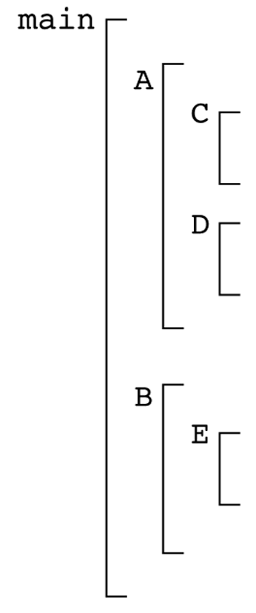
- Evaluation of Static Scoping
- Consider the example:
- Assume
- MAIN calls A and B
- A calls C and D
- B calls A and E

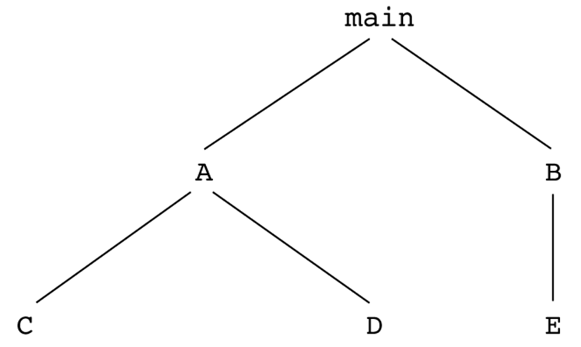
CS 304 – Programming Languages – Ch. 5
幻灯片32

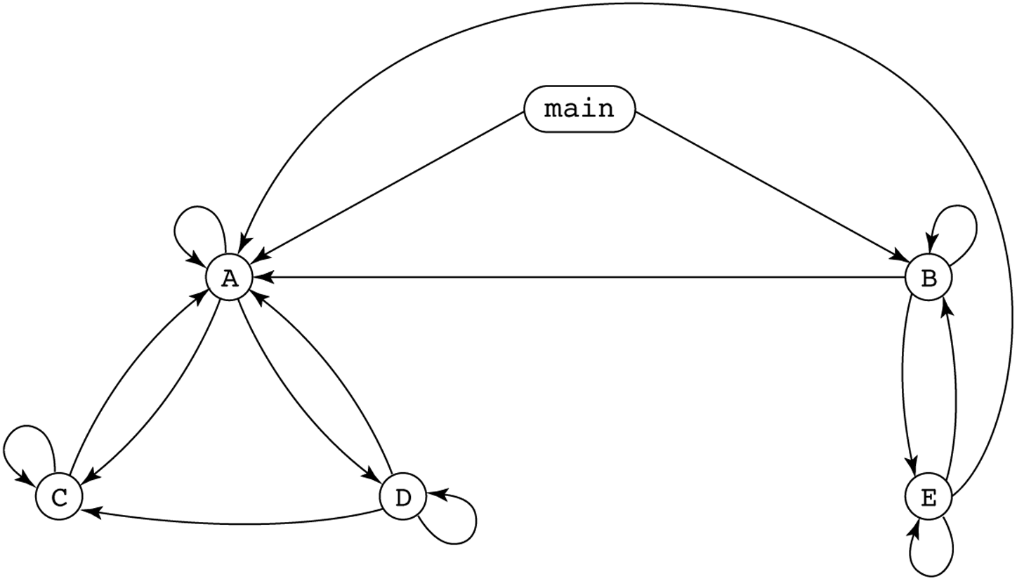

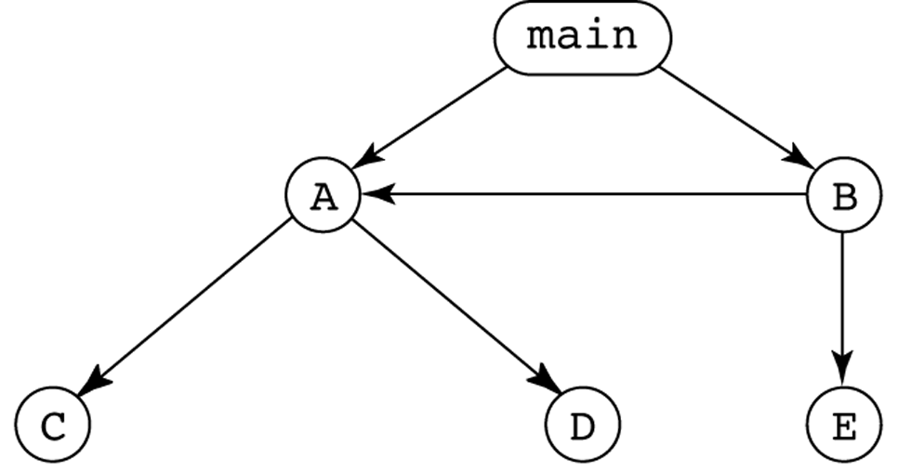
CS 304 – Programming Languages – Ch. 5
幻灯片33
Scope
- Suppose the spec is changed so that D must now access some data in B
- Solutions:
- 1. Put D in B (but then C can no longer call it and D cannot access A's variables)

- 2. Move the data from B that D needs to MAIN (but then all procedures can access them)

- Same problem for procedure access!

- Overall: static scoping often encourages many globals

CS 304 – Programming Languages – Ch. 5
幻灯片34
Scope
- Too much data access
- Globals visible everywhere, no way to protect them

- Globals are harmful to readability
- Declarations are too far from their uses

- Programmers tend to use far more globals than necessary

- To remedy problems of static scoping:
- Encapsulation constructs
- e.g., Classes

CS 304 – Programming Languages – Ch. 5
幻灯片35
Scope
- Dynamic scope
- Based on calling sequences of program units, not their textual layout (temporal versus spatial)

- References to variables are connected to declarations by searching back through the chain of subprogram calls that forced execution to this point

- Search process:
- Look in the caller for variable declarations
- Up to the main calling function

CS 304 – Programming Languages – Ch. 5
幻灯片36
Scope
- Example:

- MAIN
- - declaration of x
- SUB1
- - declaration of x -
- ...
- call SUB2
- ...

- SUB2
- ...
- - reference to x -
- ...

- ...
- call SUB1
- ...

- MAIN calls SUB1

- SUB1 calls SUB2

- SUB2 uses x

- Static scoping - reference to x is to MAIN's x

- Dynamic scoping - reference to x is to SUB1's x

CS 304 – Programming Languages – Ch. 5
幻灯片37
Dynamic Scoping
- Evaluation of Dynamic Scoping:
- Advantage:
- convenience
- No need to pass variables !!!
- Disadvantage:
- poor readability (caller’s local vars visible in the called fnct)
- no way to determine scope statically
- longer access time to nonlocal vars

- Scope and lifetime are sometimes closely related, but are different concepts!!
- Consider a static variable in a C or C++ function

CS 304 – Programming Languages – Ch. 5
幻灯片38
Referencing Environments
- Def: The referencing environment of a statement is the collection of all names that are visible in the statement

- In a static scoped language, that is the local variables plus all of the visible variables in all of the enclosing scopes
- See book example (p. 235)

- A subprogram is active if its execution has begun but has not yet terminated

- In a dynamic-scoped language, the referencing environment is the local variables plus all visible variables in all active subprograms
- See book example (p. 236)

CS 304 – Programming Languages – Ch. 5
幻灯片39
Named Constants
- Def: A named constant is a variable that is bound to a value only when it is bound to storage

- Advantages: readability and modifiability

- The binding of values to named constants can be either static (called manifest constants) or dynamic

- Languages:
- Pascal: literals only
- Modula-2 and FORTRAN 90: constant-valued expressions
- Ada, C++, and Java: expressions of any kind

CS 304 – Programming Languages – Ch. 5
幻灯片40
Variable Initialization
- Def: The binding of a variable to a value at the time it is bound to storage is called initialization

- Initialization is often done on the declaration statement

- e.g., Ada
- SUM : FLOAT := 0.0;

CS 304 – Programming Languages – Ch. 5

