幻灯片1
Data Types
Chapter 6
CS 304 – Fall 2003 – Ch. 6
幻灯片2
Introduction
- Data types allow for versatility in programming
- FORTRAN (<90)
- Primitive types, arrays (linked lists and binary trees)
- COBOL
- Structs and decimal values (precise)
- PL/I
- Integer and Floating-Point types with higher accuracy
- ALGOL 68
- Highly orthogonal – User-Defined Types (typedefs : modifiable)
- Ada 83
- user-defined types, types are abstractions of problem-space variables
- Abstract Data Types : ADTs

CS 304 – Fall 2003 – Ch. 6
幻灯片3
Introduction
- Arrays and Records
- most common structured (non-scalar) data types
- specified by operators that form expressions
- Example: C type operators
- brackets, parentheses, asterisks
- arrays, functions, pointers
- Descriptor
- collection of attributes of a variable
- Static attributes – descriptors required at compile time
- Symbol tables
- Dynamic attributes – descriptors used for type checking and allocation/deallocation operations

CS 304 – Fall 2003 – Ch. 6
幻灯片4
Primitive Data Types
- Design Issues for all data types:

- 1. What is the syntax of references to variables?
- 2. What operations are defined and how are they specified?

- Primitive Data Types
- Types not defined in terms of other data types
- Used to define other (complex) data types
- May be supported in the hardware

CS 304 – Fall 2003 – Ch. 6
幻灯片5
Numeric Types
- Integers
- Almost always an exact reflection of the hardware, so the mapping is trivial

- There may be many different integer types in a language
- Signed/Unsigned, short, int, long

- Usually stored in the two’s complement representation
- Negative ints are complemented, then 1 is added to them
- Allows for easy arithmetic

CS 304 – Fall 2003 – Ch. 6
幻灯片6
Numeric Types
- Floating Point
- Model real numbers, but only as approximations
- Languages for scientific use support at least two floating-point types; sometimes more
- Usually exactly like the hardware, but not always; some languages allow accuracy specs in code
- e.g. (Ada)
- type SPEED is digits 7 range 0.0..1000.0;
- type VOLTAGE is delta 0.1 range -12.0..24.0;

- Problem: Loss of accuracy, finite amount of space
- Cannot represent PI

CS 304 – Fall 2003 – Ch. 6
幻灯片7
Numeric Types

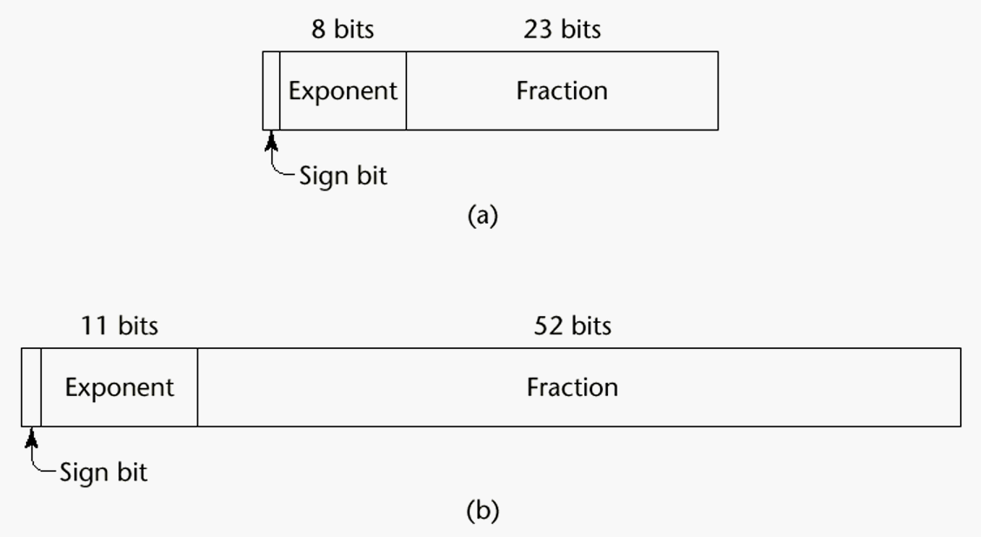
CS 304 – Fall 2003 – Ch. 6
幻灯片8
Numeric Types
- Decimal 4b
- For business applications (money)
- Store a fixed number of decimal digits (coded)
- Advantage: accuracy
- Disadvantages: limited range, wastes memory

- Boolean
- Most languages have them
- C uses integer values for booleans
- Could be implemented as bits, but often as bytes
- Advantage: readability
- Disadvantage: representation

CS 304 – Fall 2003 – Ch. 6
幻灯片9
Numeric Types
- Character
- Usually stored as small positive ints
- Mapping of numbers to printable characters
- ASCII and EBCDIC
- Unicode characters : 16 bits
- Include characters for most od the world’s languages
- Java uses Unicode exclusively

CS 304 – Fall 2003 – Ch. 6
幻灯片10
Character String Types
- Character String Types
- Values are sequences of characters

- Design issues:
- 1. Is it a primitive type or just a special kind of array?
- 2. Is the length of objects static or dynamic?

- Operations:
- - Assignment
- - Comparison (=, >, etc.)
- - Catenation
- - Substring reference
- - Pattern matching

CS 304 – Fall 2003 – Ch. 6
幻灯片11
Character String Types
- Examples:
- Pascal
- Not primitive; assignment and comparison only (of packed arrays)
- Ada, FORTRAN 77, FORTRAN 90 and BASIC
- Somewhat primitive
- Assignment, comparison, catenation, substring reference
- FORTRAN has an intrinsic for pattern matching
- e.g. (Ada)
- N := N1 & N2 (catenation)
- N(2..4) (substring reference)

CS 304 – Fall 2003 – Ch. 6
幻灯片12
Character String Types
- C and C++
- Not primitive
- Use char arrays and a library of functions that provide operations
- SNOBOL4 (a string manipulation language)
- Primitive
- Many operations, including elaborate pattern matching
- Perl
- Patterns are defined in terms of (loose) regular expressions
- A very powerful facility!
- e.g.,
- /[A-Za-z][A-Za-z\d]+/
- Java - String class (not arrays of char)
- StringBuffer also, for non-constant Strings

CS 304 – Fall 2003 – Ch. 6
幻灯片13
Character String Types
- String Length Options:

- 1. Static - FORTRAN 77, Ada, COBOL
- e.g. (FORTRAN 90)
- CHARACTER (LEN = 15) NAME;
- 2. Limited Dynamic Length - C and C++
- actual length is indicated by a null character

- 3. Dynamic - SNOBOL4, Perl, Javascript

- Evaluation (of character string types):
- Aid to writability
- As a primitive type with static length, they are inexpensive to provide--why not have them?
- Dynamic length is nice, but is it worth the expense?

CS 304 – Fall 2003 – Ch. 6
幻灯片14
Character String Types Implementation
- Implementation:
- Static length
- compile-time descriptor
- simplest implementation
- Limited dynamic length
- may need a run-time descriptor for length (but not in C and C++ : null-terminating character)

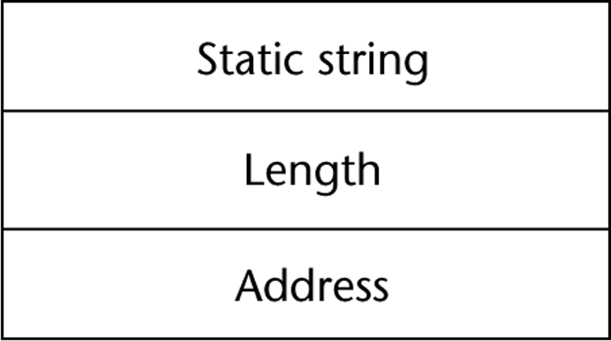

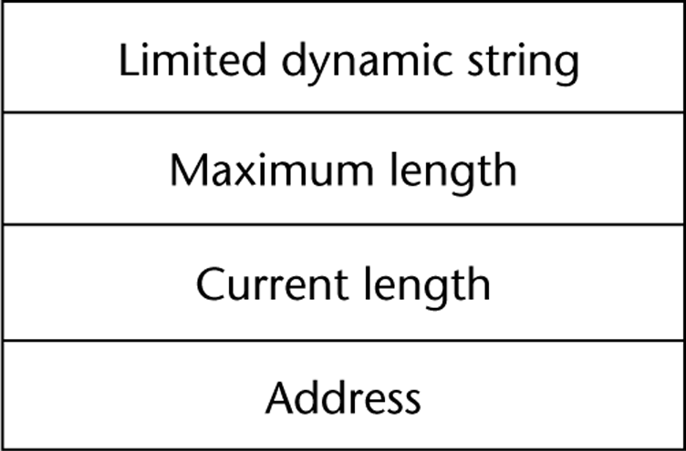
CS 304 – Fall 2003 – Ch. 6
幻灯片15
Character String Types Implementation
- Dynamic length
- need run-time descriptor; allocation/deallocation is the biggest implementation problem
- Run-time descriptor need not include maximum length
- Dynamic allocation approaches:
- Linked-list approach
- grows and shrinks freely, but links may occupy large amount of storage
- string operations may be slow due to the pointer chasing
- Adjacent storage cells approach
- simpler, but may need to move the complete string into other storage when it grows
- faster and simpler string operations

CS 304 – Fall 2003 – Ch. 6
幻灯片16
User-Defined Ordinal Types
- An ordinal type is one in which the range of possible values can be easily associated with the set of positive integers
- Enumeration and Subrange types

- 1. Enumeration Types
- Types where the user enumerates all of the possible values, which are symbolic constants
- enum RelationType = {LESS, EQUAL, GREATER}
- Primary Design Issue:
- Should a literal constant be allowed to be in more than one type definition?
- If so, how to check for the type of the occurrence of the literal?

CS 304 – Fall 2003 – Ch. 6
幻灯片17
User-Defined Ordinal Types
- Pascal
- cannot reuse constants
- can be used for array subscripts, for variables, case selectors
- NO input or output
- can be compared

- type Days = (Sun, Mon, Tue, Wed, Thu, Fri, Sat);
- var weekDay : Days;
- …
- weekDay := Tue;
- if weekDay > Sun …

CS 304 – Fall 2003 – Ch. 6
幻灯片18
User-Defined Ordinal Types
- Ada
- constants can be reused (overloaded literals)
- disambiguate with context or type_name (one of them)
- can be used as in Pascal
- CAN be input and output

- C and C++
- like Pascal, except they can be input and output as integers
- Enumeration types are converted into integers

- Java does not include an enumeration type
- But classes can implement Enumeration interface

CS 304 – Fall 2003 – Ch. 6
幻灯片19
User-Defined Ordinal Types
- Evaluation (of enumeration types):

- a. Aid to readability
- e.g. no need to code a color as a number
- b. Aid to reliability
- e.g. compiler can check operations and ranges of values

CS 304 – Fall 2003 – Ch. 6
幻灯片20
User-Defined Ordinal Types
- 2. Subrange Type
- an ordered contiguous subsequence of an ordinal type
- Primary Design Issue: How can they be used?

- Examples:

- Pascal
- Subrange types behave as their parent types
- can be used as for variables and array indices
- e.g. type pos = 0 .. MAXINT;

CS 304 – Fall 2003 – Ch. 6
幻灯片21
User-Defined Ordinal Types
- Ada
- Subtypes are not new types, just constrained existing types (so they are compatible); can be used as in Pascal, plus case constants
- e.g.
- subtype POS_TYPE is INTEGER range 0..1000;

- Evaluation of enumeration types:
- Aid to readability
- Reliability
- restricted ranges add error detection

CS 304 – Fall 2003 – Ch. 6
幻灯片22
User-Defined Ordinal Types
- Implementation of user-defined ordinal types
- Enumeration types are implemented as integers
- Subrange types are the parent types with code inserted (by the compiler) to restrict assignments to subrange variables

CS 304 – Fall 2003 – Ch. 6
幻灯片23
Arrays
- An array is an aggregate of homogeneous data elements in which an individual element is identified by its position in the aggregate, relative to the first element.

- Design Issues:

- 1. What types are legal for subscripts?
- 2. Are subscripting expressions in element references range checked?
- 3. When are subscript ranges bound?
- 4. When does allocation take place?
- 5. What is the maximum number of subscripts?
- 6. Can array objects be initialized?
- 7. Are any kind of slices allowed?

CS 304 – Fall 2003 – Ch. 6
幻灯片24
Arrays
- Indexing
- A mapping from indices to elements

- map(array_name, index_value_list) → an element

- Syntax
- FORTRAN, PL/I, Ada use parentheses
- Most others use brackets

CS 304 – Fall 2003 – Ch. 6
幻灯片25
Arrays
- Element types

- Subscript Types:
- FORTRAN, C
- int only
- Pascal
- any ordinal type (int, boolean, char, enum)
- Ada
- int or enum (includes boolean and char)
- Java
- integer types only

CS 304 – Fall 2003 – Ch. 6
幻灯片26
Arrays
- Four Categories of Arrays
- based on subscript binding and binding to storage
- 1. Static
- range of subscripts and storage bindings are static
- e.g. FORTRAN 77, some arrays in Ada
- Advantage: execution efficiency (no allocation or deallocation)

- 2. Fixed stack dynamic
- range of subscripts is statically bound, but storage is bound at elaboration time
- e.g. Pascal locals and C locals that are not static
- Advantage: space efficiency

CS 304 – Fall 2003 – Ch. 6
幻灯片27
Arrays
- 3. Stack dynamic
- range and storage are dynamic, but fixed from then on for the variable’s lifetime
- e.g. Ada declare blocks
- declare
- STUFF : array (1..N) of FLOAT;
- begin
- ...
- end;
- Advantage:
- flexibility - size need not be known until the array is about to be used

CS 304 – Fall 2003 – Ch. 6
幻灯片28
Arrays
- 4. Heap dynamic
- subscript range and storage bindings are dynamic and not fixed
- e.g. (FORTRAN 90)
- INTEGER, ALLOCATABLE, ARRAY (:,:) :: MAT
- (Declares MAT to be a dynamic 2-dim array)

- ALLOCATE (MAT (10, NUMBER_OF_COLS))
- (Allocates MAT to have 10 rows and
- NUMBER_OF_COLS columns)

- DEALLOCATE MAT
- (Deallocates MAT’s storage)

- In APL & Perl, arrays grow and shrink as needed
- In Java, all arrays are objects (heap-dynamic)

CS 304 – Fall 2003 – Ch. 6
幻灯片29
Arrays
- Number of subscripts
- FORTRAN I allowed up to three
- FORTRAN 77 allows up to seven
- C, C++, and Java allow just one, but elements can be arrays
- Others - no limit

- Array Initialization
- Usually just a list of values that are put in the array in the order in which the array elements are stored in memory

- int testScores = {79, 83, 99};

CS 304 – Fall 2003 – Ch. 6
幻灯片30
Arrays
- 1. FORTRAN - uses the DATA statement, or put the values in / ... / on the declaration

- 2. C and C++ - put the values in braces; can let the compiler count them
- e.g. int stuff [] = {2, 4, 6, 8};

- 3. Ada - positions for the values can be specified
- e.g.
- SCORE : array (1..14, 1..2) :=
- (1 => (24, 10), 2 => (10, 7),
- 3 =>(12, 30), others => (0, 0));

- 4. Pascal and Modula-2 do not allow array initialization

CS 304 – Fall 2003 – Ch. 6
幻灯片31
Array Operations
- 1. APL - many, see book (p. 216-217)
- 2. Ada
- assignment; RHS can be an aggregate constant or an array name
- catenation; for all single-dimensioned arrays
- relational operators (= and /= only)

- 3. FORTRAN 90
- intrinsics (subprograms) for a wide variety of array operations (e.g., matrix multiplication, vector dot product)

CS 304 – Fall 2003 – Ch. 6
幻灯片32
One-Dimensional Array at the Logical Level
- A one-dimensional array is a structured composite data type made up of a finite, fixed size (known at compile time) collection of homogeneous (all of the same data type) elements having relative positions and to which there is direct access (any element can be accessed immediately).

- Array operations (creation, storing a value, retrieving a value) are performed using a declaration and indexes.

CS 304 – Fall 2003 – Ch. 6
幻灯片33
Implementation Example
This ACCESSING FUNCTION gives position of values[Index]
Address(Index) = BaseAddress + Index * SizeOfElement
float values[5]; // assume element size is 4 bytes

Base Address

7000 7004 7008 7012 7016

values[0] values[1] values[2] values[3] values[4]

Indexes
CS 304 – Fall 2003 – Ch. 6
幻灯片34
One-Dimensional Arrays in C++
- The index must be of an integral type (char, short, int, long, or enum).

- The index range is always 0 through the array size minus 1.

- Arrays cannot be assigned one to another, and cannot be the return type of a function.

CS 304 – Fall 2003 – Ch. 6
幻灯片35
Passing Arrays as Parameters

- In C++, arrays are always passed by reference, and & is not used with the formal parameter type.
- Whenever an array is passed as a parameter, its base address is sent to the called function.

- Because arrays are always passed as reference parameters, you can protect the actual parameter from unintentional changes by using const in formal parameter list and function prototype.

- float SumValues ( const float values[ ],
- int numOfValues );

CS 304 – Fall 2003 – Ch. 6
幻灯片36
Two-Dimensional Array at the Logical Level
- A two-dimensional array is a structured composite data type made up of a finite, fixed size collection of homogeneous elements having relative positions and to which there is direct access.

- Array operations (creation, storing a value, retrieving a value) are performed using a declaration and a pair of indexes (called row and column) representing the component’s position in each dimension.

CS 304 – Fall 2003 – Ch. 6
幻灯片37

EXAMPLE -- To keep monthly high temperatures for 50 states in a two-dimensional array.

const int NUM_STATES = 50 ;
const int NUM_MONTHS = 12 ;
int stateHighs [ NUM_STATES ] [ NUM_MONTHS ] ;

[ 0 ]
[ 1 ]
[ 2 ]
.
. stateHighs [2] [7]
.
[ 48 ]
[ 49 ]

[0] [1] [2] [3] [4] [5] [6] [7] [8] [9] [10] [11]

66 64 72 78 85 90 99 115 98 90 88 80
row 2,
col 7
might be
Arizona’s
high for
August

CS 304 – Fall 2003 – Ch. 6
幻灯片38
const int NUM_STATES = 50 ;
const int NUM_MONTHS = 12 ;
int stateHighs [ NUM_STATES ] [ NUM_MONTHS ] ;

STORAGE
rows columns
- In memory, C++ stores arrays in row order. The first row is followed by the second row, etc.

Base Address
8000
8024
8048

. . .

12 highs for state 0 12 highs for state 1 etc.
Alabama Alaska
first row second row
CS 304 – Fall 2003 – Ch. 6
幻灯片39
Implementation Level View

stateHighs[ 0 ] [ 0 ]
stateHighs[ 0 ] [ 1 ]
stateHighs[ 0 ] [ 2 ]
stateHighs[ 0 ] [ 3 ]
stateHighs[ 0 ] [ 4 ]
stateHighs[ 0 ] [ 5 ]
stateHighs[ 0 ] [ 6 ]
stateHighs[ 0 ] [ 7 ]
stateHighs[ 0 ] [ 8 ]
stateHighs[ 0 ] [ 9 ]
stateHighs[ 0 ] [10 ]
stateHighs[ 0 ] [11 ]
stateHighs[ 1 ] [ 0 ]
stateHighs[ 1 ] [ 1 ]
stateHighs[ 1 ] [ 2 ]
stateHighs[ 1 ] [ 3 ]
.
.
.
Base Address 8000
To locate an element such as
stateHighs [ 2 ] [ 7]
the compiler needs to know
that there are 12 columns
in this two-dimensional array.

At what address will
stateHighs [ 2 ] [ 7 ] be found?

Assume 2 bytes for type int.

CS 304 – Fall 2003 – Ch. 6
幻灯片40
Two-Dimensional Array Parameters
- Just as with a one-dimensional array, when a two- (or higher) dimensional array is passed as a parameter, the base address of the actual array is sent to the function.
- The size of all dimensions except the first must be included in the function heading and prototype.
- The sizes of those dimensions for the formal parameter must be exactly the same as in the actual array.

CS 304 – Fall 2003 – Ch. 6
幻灯片41
Use the two-dimensional stateHighs array to fill a
one-dimensional stateAverages array
const int NUM_STATES = 50 ;
const int NUM_MONTHS = 12 ;
int stateHighs [ NUM_STATES ] [ NUM_MONTHS ] ;
int stateAverages [ NUM_STATES ] ;

[ 0 ]
? [ 1 ]
? [ 2 ]
.
.
.
[ 48 ]
[ 49 ]

[0] [1] [2] [3] [4] [5] [6] [7] [8] [9] [10] [11]

Alaska

Arizona
43 42 50 55 60 78 79 80 77 72 63 40
66 64 72 78 85 90 99 115 98 90 88 80
CS 304 – Fall 2003 – Ch. 6
幻灯片42
Declaring Multidimensional Arrays
EXAMPLE USING TYPEDEF

const int NUM_DEPTS = 5; // mens, womens, childrens, electronics, linens
const int NUM_MONTHS = 12 ;
const int NUM_STORES = 3 ; // White Marsh, Owings Mills, Towson

typedef long MonthlySalesType [NUM_DEPTS] [NUM_MONTHS] [NUM_STORES];

MonthlySalesType monthlySales;
CS 304 – Fall 2003 – Ch. 6
幻灯片43
const int NUM_DEPTS = 5; // mens, womens, childrens, electronics, linens
const int NUM_MONTHS = 12 ;
const int NUM_STORES = 3 ; // White Marsh, Owings Mills, Towson

typedef long MonthlySalesType [NUM_DEPTS] [NUM_MONTHS] [NUM_STORES] ;
MonthlySalesType monthlySales;

monthlySales[3][7][0]
sales for electronics in August at White Marsh

3 STORES
sheets

5 DEPTS
rows
43
12 MONTHS columns
CS 304 – Fall 2003 – Ch. 6
幻灯片44
Slices
- A slice is some substructure of an array
- A referencing mechanism

- Slice Examples:
- 1. FORTRAN 90
- INTEGER CUBE(1:3, 1:3, 1:4)
- INTEGER MAT (1 : 4, 1 : 4)
- MAT(1 : 4, 1) - the first column
- MAT(2, 1 : 4) - the second row

- 2. Ada - single-dimensioned arrays only
- LIST(4..10)

CS 304 – Fall 2003 – Ch. 6
幻灯片45

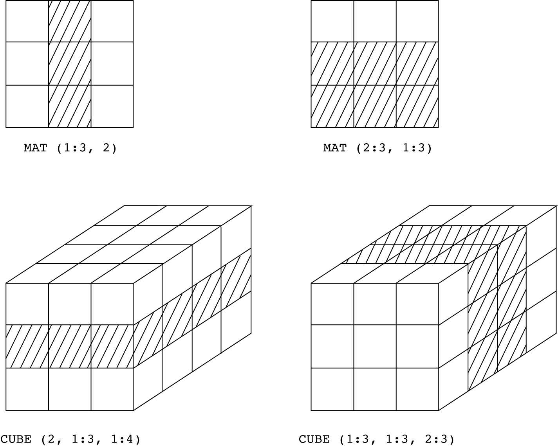
CS 304 – Fall 2003 – Ch. 6
幻灯片46
Implementation of Array Types
- More compile-time effort than we need for simple types
- At run-time, array access code is executed to gain access to array elements
- Compute Access Function to access an array element
- Access function maps subscript expressions to an address in the array
- If lower bound is 1:
- address(list[k]) = address(list[1]) + (k-1)*element_size
- If lower bound is M:
- address(list[k]) = address(list[M]) + (k-M)*element_size
- Arrays need a compile-time (static) descriptor
- for access function construction
- Run-time descriptor is needed only for range checks

CS 304 – Fall 2003 – Ch. 6
幻灯片47

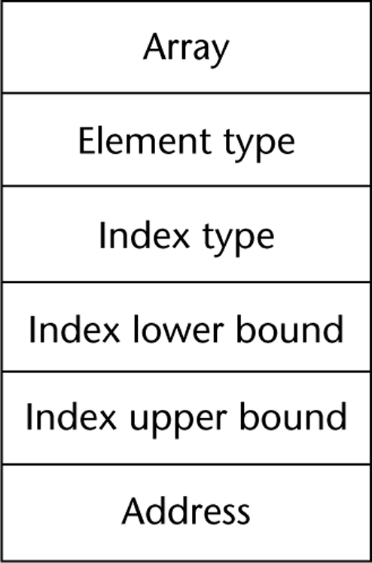
CS 304 – Fall 2003 – Ch. 6
幻灯片48
Multidimensional Arrays
Row major order (by rows)
Column major order (by columns)
See previous C++ examples…

Access function needs to know how array elements are stored
If row major order, lower bound of 1:
address(list[i,j]) = address(list[1,1]) +
(((i – 1) * rowSize) + (j – 1)) * elementSize

- Access to array elements with several subscripts is costly!

CS 304 – Fall 2003 – Ch. 6
幻灯片49

Need to know how arrays are stored
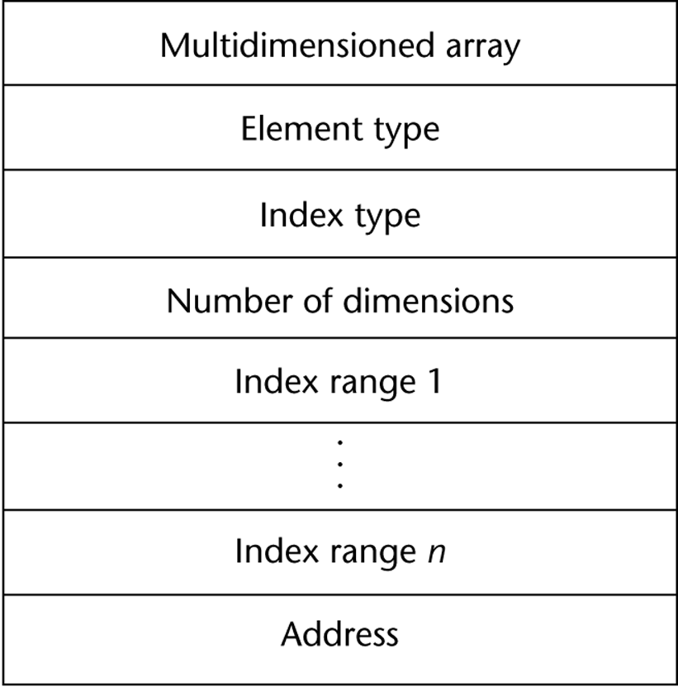
CS 304 – Fall 2003 – Ch. 6
幻灯片50
Associative Arrays
Unordered collection of data elements that are indexed by an equal number of values called keys
Each element is essentially a pair (key, value) : A.K.A. HASHING
Design Issues:
1. What is the form of references to elements?
2. Is the size static or dynamic?
Structure and Operations in Perl
Names begin with %
Literals are delimited by parentheses, e.g.,
%hi_temps = ("Monday" => 77, "Tuesday" => 79,…);
Subscripting is done using braces and keys, e.g.,
$hi_temps{"Wednesday"} = 83;
Elements can be removed with delete, e.g.,
delete $hi_temps{"Tuesday"};
- Implementation : Hashing Functions

CS 304 – Fall 2003 – Ch. 6
幻灯片51
Record Types
A record is a possibly heterogeneous aggregate of data elements in which the individual elements are identified by names
Similar to arrays, but for non-homogeneous types
Elements are not directly accessed by indices
Fields are named with identifiers
Provide access to individual elements of the record

Design Issues:
1. What is the form of references?
2. What unit operations are defined?

CS 304 – Fall 2003 – Ch. 6
幻灯片52
Record Types
Record Definition Syntax
COBOL uses level numbers to show nested records; others use recursive definitions
C and C++ use structures (structs) for records
Record Field References
1. COBOL
field_name OF record_name_1 OF ... OF record_name_n
2. Others (dot notation)
record_name_1.record_name_2. ... .record_name_n.field_name

Elliptical and Fully Qualified References:
Fully qualified references must include all record names
Elliptical references allow leaving out record names as long as the reference is unambiguous

- Pascal and Modula-2 provide a with clause to abbreviate references

CS 304 – Fall 2003 – Ch. 6
幻灯片53
Record Types
Record Operations
1. Assignment
Pascal, Ada, and C allow it if the types are identical
In Ada, the RHS can be an aggregate constant
2. Initialization
Allowed in Ada, using an aggregate constant
3. Comparison
In Ada, = and /=; one operand can be an aggregate constant
4. MOVE CORRESPONDING
- In COBOL - it moves all fields in the source record to fields with the same names in the destination record

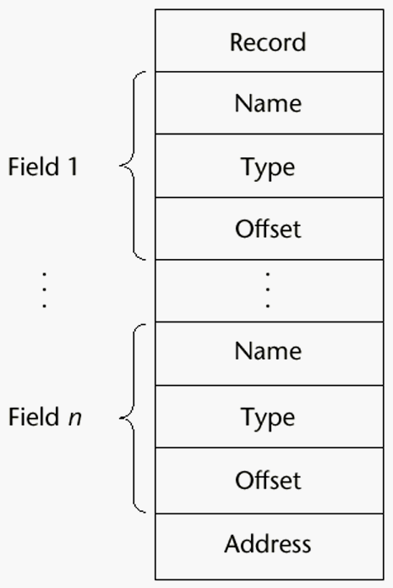CS 304 – Fall 2003 – Ch. 6
CS 304 – Fall 2003 – Ch. 6
幻灯片55
Union Types
A union is a type whose variables are allowed to store different type values at different times during execution
Design Issues for unions:
1. What kind of type checking, if any, must be done?
2. Should unions be integrated with records?

Free Unions
No language support for type checking
Complete freedom from type checking while programming
Discriminated Unions
- unions that include a type indicator

CS 304 – Fall 2003 – Ch. 6
幻灯片56
Union Types
Pascal - both discriminated and nondiscriminated unions
e.g.
type intreal = record tagg : Boolean of true : (blint : integer); false : (blreal : real); end;
Problem with Pascal’s design: type checking is ineffective
Reasons:
a. User can create inconsistent unions (because the tag can be individually assigned)

var blurb : intreal;
x : real;
blurb.tagg := true; {it is an integer }
blurb.blint := 47; {ok }
blurb.tagg := false; {it is a real }
- x := blurb.blreal; {assigns an integer to a real }

CS 304 – Fall 2003 – Ch. 6
幻灯片57
Union Types
b. The tag is optional!
Now, only the declaration and the second and last assignments are required to cause trouble

Algol 68 - discriminated unions

Use a hidden tag to maintain the current type
Tag is implicitly set by assignment
This runtime type selection is a safe method of accessing union objects

CS 304 – Fall 2003 – Ch. 6
幻灯片58
Union Types
Ada - discriminated unions
Reasons they are safer than Pascal & Modula-2:
a. Tag must be present
b. It is impossible for the user to create an inconsistent union (because tag cannot be assigned by itself--All assignments to the union must include the tag value)
C and C++ - free unions (no tags)
Not part of their records
No type checking of references

Java has neither records nor unions

Evaluation - potentially unsafe in most languages
- not in Ada, however
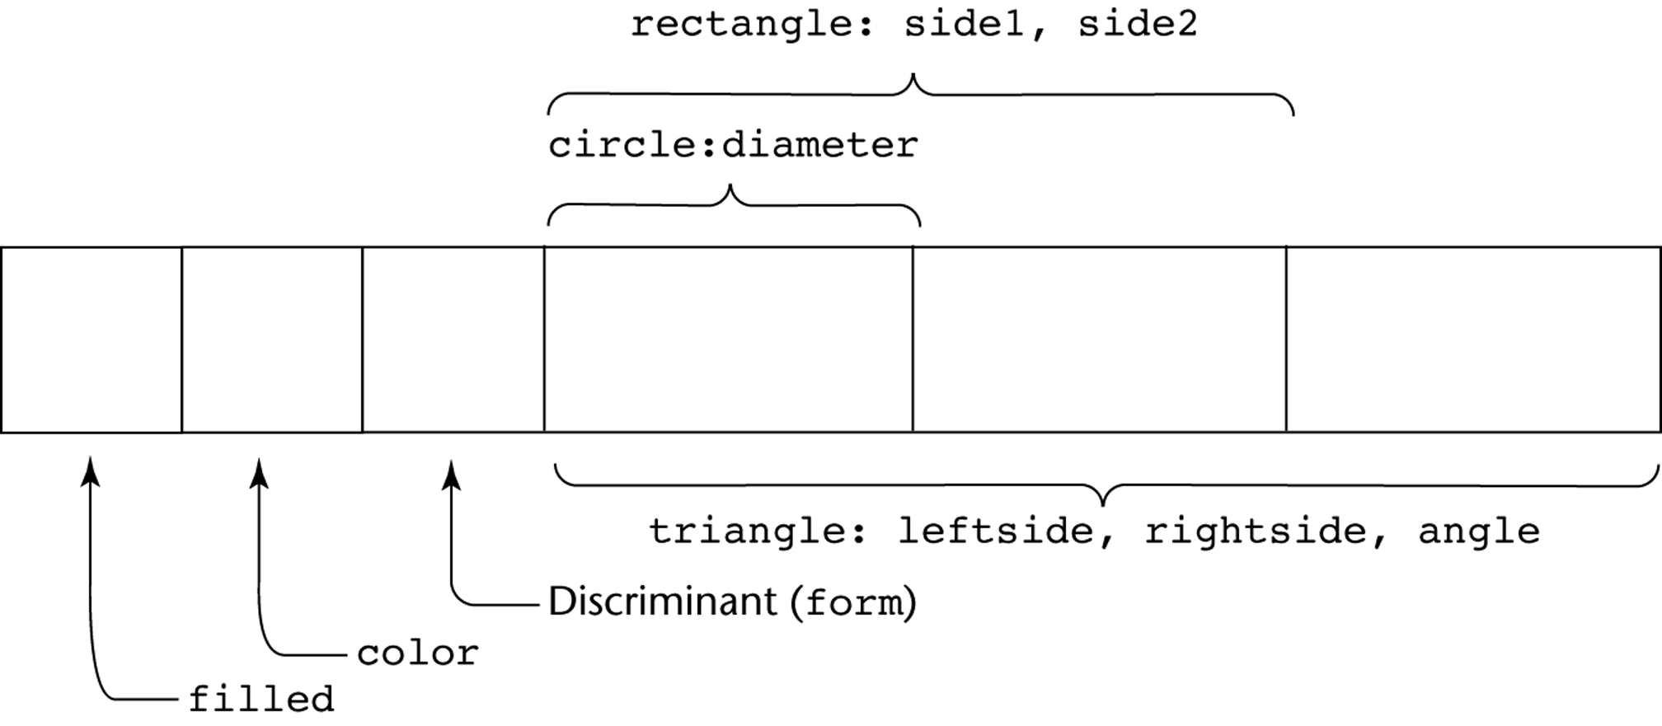
CS 304 – Fall 2003 – Ch. 6
CS 304 – Fall 2003 – Ch. 6
幻灯片60
Set Types
A set is a type whose variables can store unordered collections of distinct values from some ordinal type
Design Issue:
What is the maximum number of elements in any set base type?
Examples:
1. Pascal
No maximum size in the language definition
(not portable, poor writability if max is too small)
- Operations: union (+), intersection (*), difference (-), =, <>, superset (>=), subset (<=), in

CS 304 – Fall 2003 – Ch. 6
幻灯片61
Set Types
2. Modula-2 and Modula-3
Additional operations: INCL, EXCL, / (symmetric set difference (elements in one but not both operands))
3. Ada
does not include sets, but defines in as set membership operator for all enumeration types
4. Java
includes a class for set operations

Evaluation
If a language does not have sets, they must be simulated, either with enumerated types or with arrays
Arrays are more flexible than sets, but have much slower operations
Implementation
- Usually stored as bit strings and use logical operations for the set operations

CS 304 – Fall 2003 – Ch. 6
幻灯片62
Pointer Types
A pointer type is a type in which the range of values consists of memory addresses and a special value, nil (or null)
Uses:
1. Addressing flexibility
2. Dynamic storage management

Design Issues:
1. What is the scope and lifetime of pointer variables?
2. What is the lifetime of heap-dynamic variables?
3. Are pointers restricted to pointing at a particular type?
4. Are pointers used for dynamic storage management, indirect addressing, or both?
5. Should a language support pointer types, reference types, or both?

CS 304 – Fall 2003 – Ch. 6
幻灯片63
Pointer Types
Fundamental Pointer Operations:
1. Assignment of an address to a pointer
So that a variable may be manipulated via the pointer
2. Dereferencing (explicit versus implicit dereferencing)
For accessing the values of data to which the pointer is pointing
Example:
Consider a pointer variable ptr that is bound to memory address 7080, where a value of 206 is stored
e.g.,
int x = 206;
int j;
int *ptr = &x;
int *ptr1;
Now, what happens if : ptr1 = ptr;
- j = *ptr;

CS 304 – Fall 2003 – Ch. 6
幻灯片64

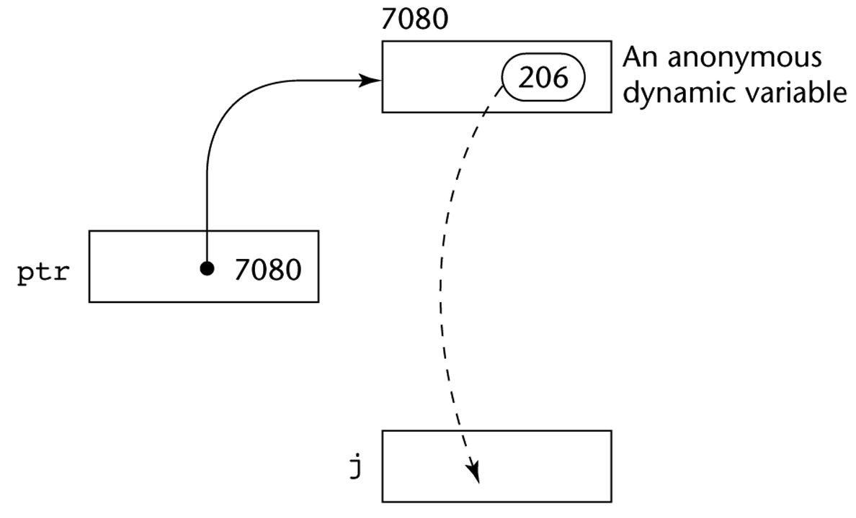

CS 304 – Fall 2003 – Ch. 6
幻灯片65
Pointer Types
Problems with pointers:
1. Dangling pointers
A pointer points to a heap-dynamic variable that has been deallocated
Dangerous

Creating a dangling pointer :
a. Allocate a heap-dynamic variable and set a pointer to point at it
b. Set a second pointer to the value of the first pointer
- c. Deallocate the heap-dynamic variable, using the first pointer

CS 304 – Fall 2003 – Ch. 6
幻灯片66
Pointer Types
2. Lost Heap-Dynamic Variables
A heap-dynamic variable that is no longer referenced by any program pointer
Wasteful

Creating a lost heap-dynamic variable:
a. Pointer p1 is set to point to a newly created heap-dynamic variable
b. p1 is later set to point to another newly created heap-dynamic variable

The process of losing heap-dynamic variables is called memory leakage

CS 304 – Fall 2003 – Ch. 6
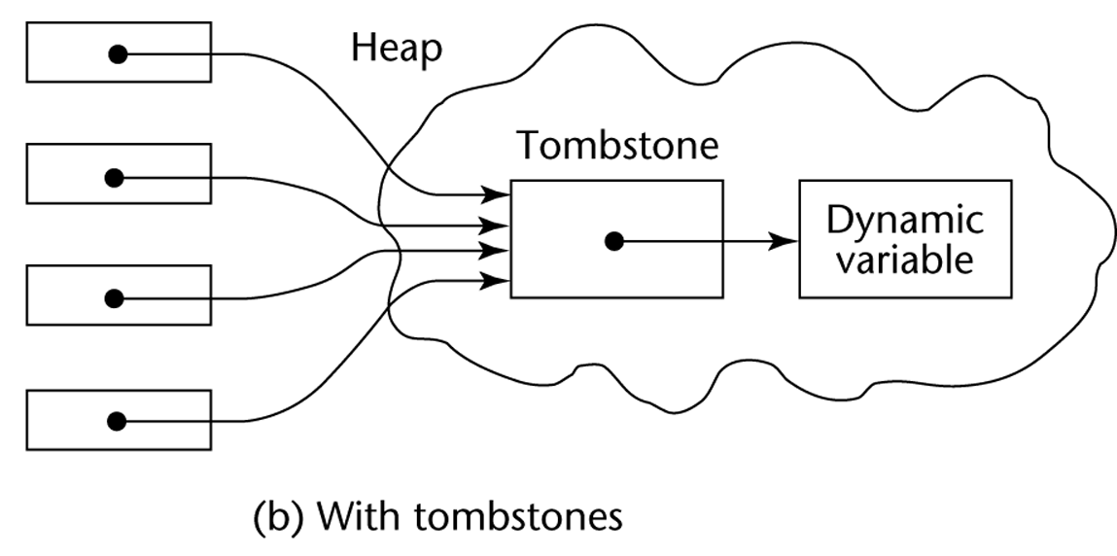幻灯片67
Solutions to Dangling Pointer Problem

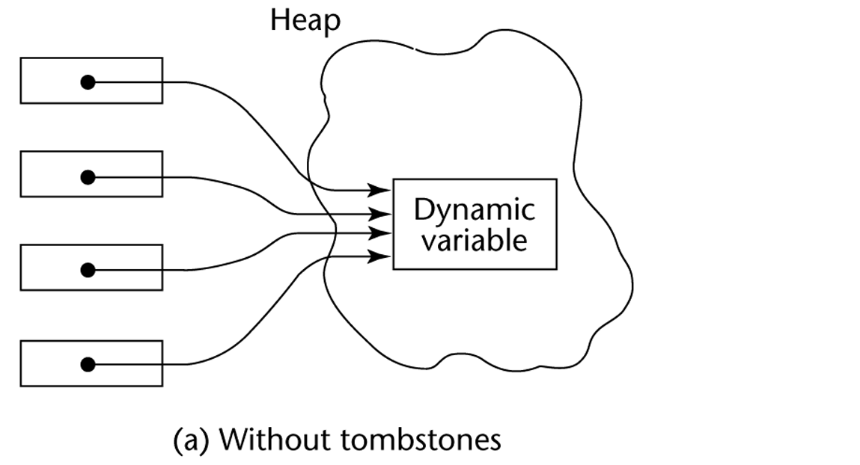Tombstones:

Lock-and-key:

Maintain pointers as (key, address) pairs

Heap-Dynamic variables also have associated integer keys
Match must exist before access is allowed

CS 304 – Fall 2003 – Ch. 6
幻灯片68
Pointer Types
1. Pascal
Used for dynamic storage management only
Explicit dereferencing
Dangling pointers are possible (dispose)
Dangling objects are also possible

2. Ada
A little better than Pascal and Modula-2
Some dangling pointers are disallowed because dynamic objects can be automatically deallocated at the end of pointer's scope
All pointers are initialized to null
- Similar dangling object problem (but rarely happens)

CS 304 – Fall 2003 – Ch. 6
幻灯片69
Pointer Types
3. C and C++
Used for dynamic storage management and addressing
Explicit dereferencing and address-of (&) operator
Can do address arithmetic in restricted forms
Domain type need not be fixed (void * )

e.g.

float stuff[100];
float *p;
p = stuff;

*(p+5) is equivalent to stuff[5] and p[5]
*(p+i) is equivalent to stuff[i] and p[i]

void * - can point to any type and can be type checked (cannot be dereferenced)

CS 304 – Fall 2003 – Ch. 6
幻灯片70
Pointer Types
4. FORTRAN 90 Pointers
Can point to heap and non-heap variables
Implicit dereferencing
Special assignment operator for non-dereferenced references

e.g.
REAL, POINTER :: ptr (POINTER is an attribute)
ptr => target (where target is either a pointer or a non-pointer with the TARGET attribute))

The TARGET attribute is assigned in the declaration, as in:

INTEGER, TARGET :: NODE
There is a special assignment when dereferencing is not wanted
e.g.,
pointer => target

CS 304 – Fall 2003 – Ch. 6
幻灯片71
Reference Types
5. C++ Reference Types
Constant pointers that are implicitly dereferenced
Used for parameters
Advantages of both pass-by-reference and pass-by-value

6. Java - Only references
No pointer arithmetic
Can only point at objects (which are all on the heap)
No explicit deallocator (garbage collection is used)
Means there can be no dangling references!
Dereferencing is always implicit

CS 304 – Fall 2003 – Ch. 6
幻灯片72
Pointer Types
Evaluation of pointers:

1. Dangling pointers and dangling objects are problems, as is heap management
2. Pointers are like goto's
they widen the range of cells that can be accessed by a variable

TRUE or FALSE:
3. Pointers are necessary
so we can't design a language without them ???

CS 304 – Fall 2003 – Ch. 6
幻灯片73
Smart Pointers
Smart pointers are objects that look and feel like pointers, but are smarter ☺
Example of a smart pointer is auto_ptr, which is included in the standard C++ library, in the header <memory>

template <class T> class auto_ptr
{
T* ptr;
public:
explicit auto_ptr(T* p = 0) : ptr(p) {}
~auto_ptr() {delete ptr;}
T& operator*() {return *ptr;}
T* operator->() {return ptr;}
// ...
- };

CS 304 – Fall 2003 – Ch. 6
幻灯片74
Smart Pointers
“Smartness” in the destructor: the destructor takes care of deleting the pointer
For the user of auto_ptr, this means that instead of writing:
void foo()
{
MyClass* p(new MyClass);
p->DoSomething();
delete p;
}
You can write:
void foo()
{
auto_ptr<MyClass> p(new MyClass);
p->DoSomething();
}
And trust p to cleanup after itself.
- What does this buy you?

CS 304 – Fall 2003 – Ch. 6
幻灯片75
Smart Pointers
Less bugs
Automatic cleanup
Smart pointers that clean after themselves can save a few lines of code
The importance : reducing the probability for bugs
you don't need to remember to free the pointer, and so there is no chance you will forget about it.
Automatic initialization
You don't need to initialize the auto_ptr to NULL, since the default constructor does that for you. This is one less thing for the programmer to forget.

Dangling pointers
A common pitfall of regular pointers is the dangling pointer: a pointer that points to an object that is already deleted. The following code illustrates this situation:

MyClass* p(new MyClass);
MyClass* q = p;
delete p;
p->DoSomething(); // Watch out! p is now dangling!
p = NULL; // p is no longer dangling
- q->DoSomething(); // Ouch! q is still dangling!

CS 304 – Fall 2003 – Ch. 6
幻灯片76
Smart Pointers
For auto_ptr, this is solved by setting its pointer to NULL when it is copied:
template <class T>
auto_ptr<T>& auto_ptr<T>::operator=(auto_ptr<T>& rhs)
{
if (this != &rhs) {
delete ptr;
ptr = rhs.ptr;
rhs.ptr = NULL;
}
return *this;
}

CS 304 – Fall 2003 – Ch. 6
幻灯片77
Smart Pointers
Other smart pointers may do other things when they are copied
Possible strategies for handling the statement q = p, where p and q are smart pointers:
Create a new copy
of the object pointed by p, and have q point to this copy
Ownership transfer:
Let both p and q point to the same object, but transfer the responsibility for cleaning up ("ownership") from p to q
Reference counting:
Maintain a count of the smart pointers that point to the same object, and delete the object when this count becomes zero. So the statement q = p causes the count of the object pointed by p to increase by one
Reference linking:
The same as reference counting, only instead of a count, maintain a circular doubly linked list of all smart pointers that point to the same object
Copy on write:
- Use reference counting or linking as long as the pointed object is not modified. When it is about to be modified, copy it and modify the copy

CS 304 – Fall 2003 – Ch. 6
幻灯片78
Smart Pointers
Exception Safety
Let's take another look at this simple example:
void foo() {
MyClass* p(new MyClass);
p->DoSomething();
delete p;
}
What happens if DoSomething() throws an exception?
All the lines after it will not get executed and p will never get deleted!
If we're lucky, this leads only to memory leaks. However, MyClass may free some other resources in its destructor (file handles, threads, transactions) and so not calling it my cause severe resource locks.
If we use a smart pointer:
p will be cleaned up whenever it gets out of scope, whether it was during the normal path of execution or during the stack unwinding caused by throwing an exception.

CS 304 – Fall 2003 – Ch. 6
幻灯片79
Smart Pointers
But isn't it possible to write exception safe code with regular pointers?
Sure, but it is so painful… Here is what you would do in this simple case:

void foo()
{
MyClass* p;
try {
p = new MyClass;
p->DoSomething();
delete p;
}
catch (...) {
delete p;
throw;
}
}
- Now imagine what would happen if we had some if's and for's in there...

CS 304 – Fall 2003 – Ch. 6
幻灯片80
Smart Pointers
Garbage collection
Since C++ does not provide automatic garbage collection like some other languages, smart pointers can be used for that purpose.
Simplest garbage collection scheme is reference counting or reference linking, but it’s quite possible to implement more sophisticated garbage collection schemes with smart pointers
Efficiency
Smart pointers can be used to make more efficient use of available memory and to shorten allocation and deallocation time.
A common strategy for using memory more efficiently is copy on write (COW):
This means that the same object is shared by many COW pointers as long as it is only read and not modified.
When some part of the program tries to modify the object ("write"), the COW pointer creates a new copy of the object and modifies this copy instead of the original object.
The standard string class is commonly implemented using COW semantics (see the <string> file)

string s("Hello");
string t = s; // t and s point to the same buffer of // characters
t += " there!"; // a new buffer is allocated for t before
// appending " there!", so s is unchanged.

CS 304 – Fall 2003 – Ch. 6
幻灯片81
Heap Management
A complex Run-Time process
Single-sized vs. Variable-sized heap cells
Single-sized cells:
LISP : every cell contains a pointer
Deallocation : when should it be performed:
Deallocation methods:
Reference Counters – Eager Approach
Additional cell for the count of references to the object
Problems:
Significant space for reference counters
Expensive to maintain reference counters
Circular connections : how to handle the counter variables?
Mark-Sweep – Lazy Approach
Every heap cell has an additional status bit
Trace all pointers that are not garbage
Those that are not traced are garbage
- When to start collecting garbage?

CS 304 – Fall 2003 – Ch. 6
幻灯片82
Heap Management

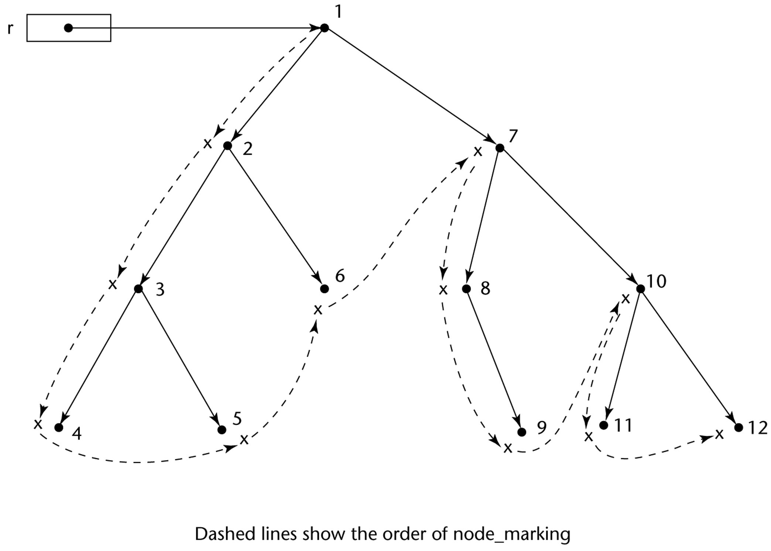
幻灯片59
Variable-sized cells have additional problems:
The initial setting of the indicators of all cells in the heap to indicate that they are garbage is difficult
Require cells to have the cell size as the first field
The marking process is non-trivial
Maintaining the list of available space is additional overhead
List becomes a long list of various-size segments
Requests cause the list to be searched for sufficiently large blocks

CS 304 – Fall 2003 – Ch. 6

幻灯片54
Record Types
Comparing records and arrays
1. Access to array elements is much slower than access to record fields, because subscripts are dynamic (field names are static)
2. Dynamic subscripts could be used with record field access, but it would disallow type checking and it would be much slower

