- (7 points) What arguments can you make against the idea of a single language for all programming domains?
Ans.
Since every language was designed for a particular goal. The language would necessarily be huge and complex ; the language would probably not be very good for any programming domain; Compilers would be expensive and costly to maintain
因為很多時候，我們所需要描述的東西不同，所需要的資料特性也不盡相同，可能有些需要處理大量的浮點數，有些卻是要處理大量的字元，所以若使用統一的語言的話，可能對某些需求來講會不足，導致程式效能不彰。

- (6 points)What is the function of a grammar?
Ans.
Grammars are precise descriptions of formal languages — that is, of a set of strings, commonly used to describe the syntax of programming languages.

(3) (7 points) Java uses a right brace to mark to end of all compound statements. What are the arguments for and against this design?
Ans.
Using the right brace’}’to close all compounds statements is simplicity

The location of its matching left brace’{’is not always obvious(hard to debug)
一個Program的 readability與所使用的語言的special words的形式息息相關，C語言以及它的後裔，包括JAVA，使用右大括號來表示複合敘述句的結尾，這使得使用者可以很容易得知敘述句的結尾在哪；不過因為都是使用右大括號作結束，這使的有可能會同時出現一堆右大括號，讓使用者不知所措。
(4) (10 points) Using the grammar in the following paragraph, show a parse tree and a leftmost derivation for the following statement
A = A * (B + (C*A))
< assign > ->< id > = < expr >
< id > -> A | B | C
< expr > —> < id > + < expr >
| < id > * < expr >
| ( <expr> )
| <id>
Ans.
< assign > => < id > = < expr >
A = < expr >
A = < id > * < expr >
A = A* < expr >
A = A* (< expr >)
A = A* (< id > + < expr >)
A = A* (B + < expr >)
A = A* (B + ( <expr> ))
A = A* (B + (< id > * < expr >))
A = A* (B + (C * <id>))
A = A* (B + (C * A))
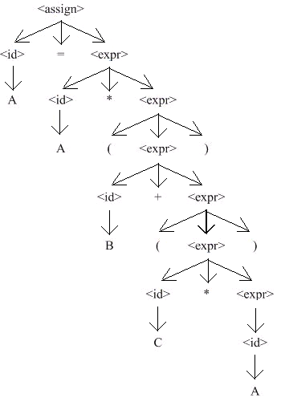

(5) (10 points) Prove the following grammar is ambiguous:
<S> -> <A>
<A> -> <A> + <A>|< id>
<id> -> a|b|c
Ans.
EX. a+b+c
leftmost derivation:
<S> -> <A>
-> <A> + <A>
-> <id> + <A>
-> a+ <A>
-> a+ <A> + <A>
-> a+ <id> + <A>
-> a+ b + <A>
-> a+ b + <id>
-> a+ b + c
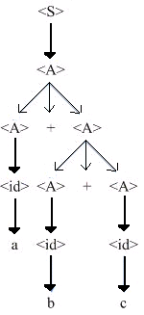
rightmost derivation:
<S> -> <A>
-> <A> + <A>
-> <A> + <id>
-> <A> + c
-> <A> + <A> + c
-> <A> + <id> + c
-> <A> + b + c
-> <id> + b + c
-> a + b + c
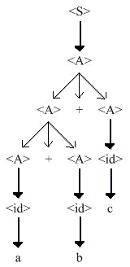
相同的a + b + c卻有不同的tree，表示這個grammar是ambiguous。

(6) (7 points) Many languages distinguish between uppercase and lowercase letters in user-defined names.What are the pros and cons of this design decision?
Ans.
Pors: more variables
It is easy to understand what the variable means. FuelConsumption<-> fuelconsumption(耗油量)
Cons: it makes programs less readable, because words that look very similar are actually completely different , such as SUM and Sum .
使用者在創造變數名稱時，大、小寫確實幫了許多忙(更易於為變數命名)但是這項優點也變成了缺點，因為有時只是一個字母大小寫的不同會導致兩個變數是完全不同的兩個個體，在區別上會很難分辨。

(7) (6 points)What are the major language evaluation criteria?
Ans.
- Readability: the ease with which programs can be read and understood
- Writability: the ease with which a language can be used to create programs
- Reliability: conformance to specifications (i.e., performs to its specifications)
- Cost: the ultimate total cost
- Portability: The ease with which programs can be moved from one implementation to another
- Generality: The applicability to a wide range of applications
- Well-definedness: The completeness and precision of the language’s official definition

(8) (7 points) How do type declaration statements for simple variables affect the readability of a language, considering that some languages do not require them?
Ans.
Type declaration statement have very little effect on the readability of programs.
If no type declaration, it may be an aid to readability.
In a program, the declaration of a variable must be found before the reader can determine the type of that variable when it is used in the program.

(9) (10 points)Write EBNF and syntax graph descriptions for the following:
(i). A Java class definition header statement
(ii). A C switch statement
Ans.
(i) <class_head> -> [<modifier>] class <id> [extends class_name]
[implements <interface_name> {, <interface_name>}]
<modifier> -> public | abstract | final

eg.public class MyClass extends MySuperClass implements YourInterface{//field, constructor, and method declarations}

(ii) <switch_stmt> -> switch ( <expr> ) {case <literal> : <stmt_list>
{case <literal> : <stmt_list> } [default : <stmt_list>] }

switch(expression){
case const_expr:statements;
case const_expr:statements;
default:statements;
}

(10) (7 points) Rewrite the BNF of Example 3.4 to give + precedence over * and force + to be right associative.
Ans.
<assign> -> <id> = <expr>
<id> ->A | B | C
<expr> -> <expr> * <term>
| <term>
<term> -> <factor> + <term>
| <factor>
<factor> -> ( <expr> )
| <id>

(11) (7 points) Modify the grammar of Example 3.4 to add a unary minus operator that has higher precedence than either + or *.
Ans.
Replace the rule
<factor> -><id>
with
<factor> -><id>
| - <id>

(12) (7 points) Write an attribute grammar whose BNF basis is that of Example 3.6 in Section 3.4.5, but whose language rules are as follows: Data types cannot be mixed in expressions, but assignment statements need not have the same types on both sides of the assignment operator.
Ans.
1. Syntax rule: < assign> -> <var> = <expr>
2. Syntax rule: <expr> -> < var>[2] + <var>[3]
predicate: <var>[2].actual_type = = <var>[3].actual_type
3. Syntax rule: <expr> -> <var>
4. Syntax rule: < var > -> A | B | C
Semantic rule; <var>.actual_type <- look-up(<var >.string)

P.S”->”:production “<-”:assign “==”:等於
“look-up”:this function looks up a given variable name in the symbol table and returns the variable’s type.

