Junjun Huang
CS433-assignment 1

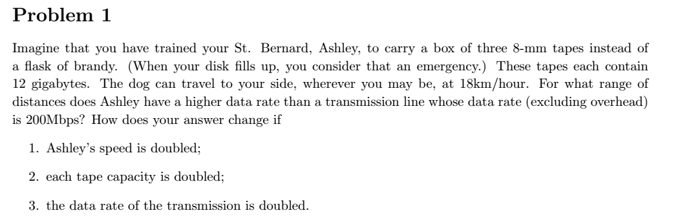
Set the distances x
12*3*8*1000 / ((x/18)*3600) = 200 x = 7.2 Less then 7..2 km Dog>200Mbps

(i) 12*3*8*1000 / ((x/18*2)*3600) = 200 x = 14.4 Less then 14.4km
(ii) 12*3*8*1000*2 / ((x/18)*3600) = 200 x = 14.4 Less then 14.4km
(iii)12*3*8*1000*2 / ((x/18)*3600) = 200*2 x=3.6 Less then 3.6km

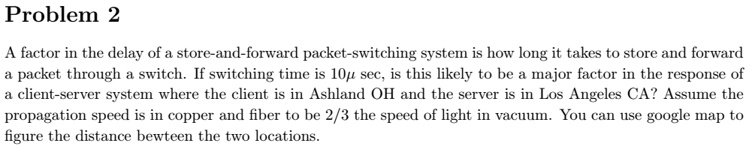
propaganda speed 300000km/s = 300 meters/μsec | 10μsec => 3km | 3km * 2/3 = 2km
AU to LA about 3732.07km
If through 37 switch . Total add about 74km3

74/3732 about 2%. Answer is NO

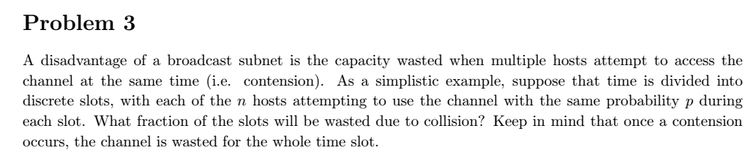
Event 1: (1 -p)^n
Event 2: np(1 - p)^n-1
Event 3: The probability of a collision just 1- (1 -p)^n - np(1 - p)^n-1

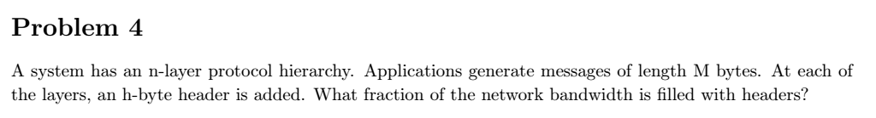

hn/(M + hn) * 100%

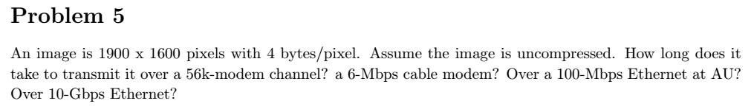

1900*1600*4*8 = 97280000 bits
56000bits / sec about 1737sec
6*10^6/sec about 16sec
100*10^6/sec about 0.9728sec
10*10^9/sec about 0.009728sec

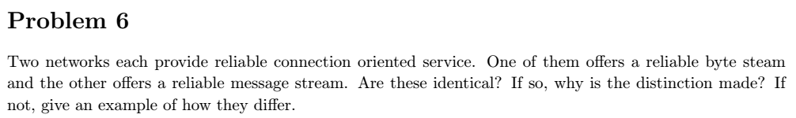
NO
In byte stream, the network don’t keeps track of message boundaries. In message stream, it did.

Send twice 10 bytes. The receiver get 20 bytes.
For byte stream no count message boundaries so will get full 20 bytes and the original two different message is lost.
For message stream, get two message 20 bytes each.

