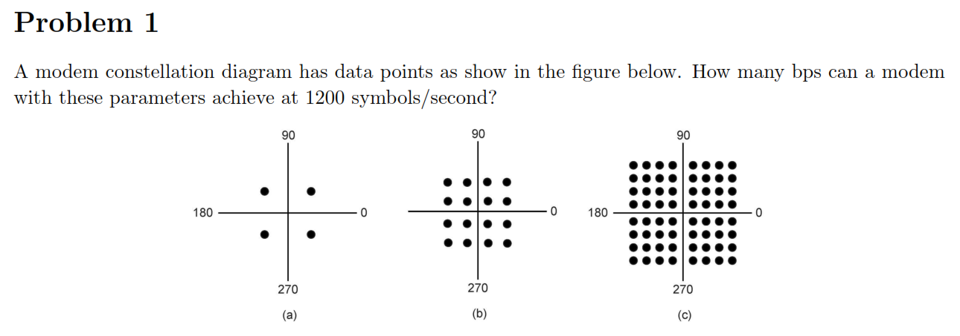
(a) QPSK 2 bit/symbols * 1200 symbols/second = 2400bps
(b) QAM-16 4 bit/symbols * 1200 symbols/second =4800bps
(c) QAM-64 6 bit/symbols * 1200 symbols/second =7200bps

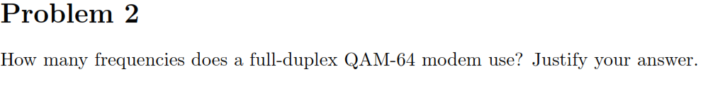

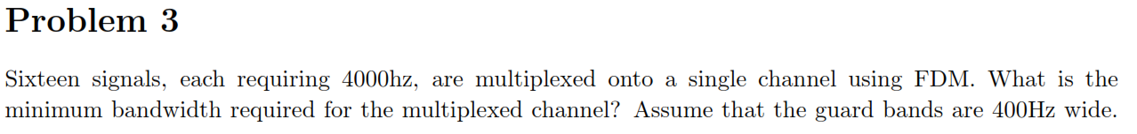
16*4000Hz+15*400Hz = 64000+6000=70,000Hz

