ICT171 Introduction to Server Environments and Architectures

Cloud Server Project & Video Explainer
Student ID: 35811943
Student Name: Victoria Celina S. Azarcon
Website:https://storeapparel.online/
IP Address: 54.144.126.134
Video Explainer:
Github: https://github.com/358811943victoria/ICT171-Cloud-Server-Project

Table of Contents

Introduction 3
Server Setup and Configuration 3
Linking Domain Name 7
Securing the server 7
Scripting and Code 9
Testing and Verification 9
Conclusion 10
References 10

Introduction
This section explains how the Online Clothing and Fashion Accessories Store is deployed on Amazon EC2 using the Infrastructure as a Service (IaaS) model. The process covers every major step: launching an EC2 instance, setting up a secure server environment, installing the necessary software stack (Apache, PHP, and MySQL), deploying the e-commerce application, and enabling HTTPS security with Let’s Encrypt.
All commands and configurations are documented to make the setup fully reproducible from scratch. The goal is to present a clear, hands-on deployment guide — from initial cloud setup to a fully operational online store accessible over the web. By following the steps in sequence, anyone with basic cloud computing knowledge can replicate the environment, validate the deployment, and understand how IaaS enables a scalable and secure e-commerce platform.

Server Setup and Configuration
Login to AWS and search for EC2 service in the console.
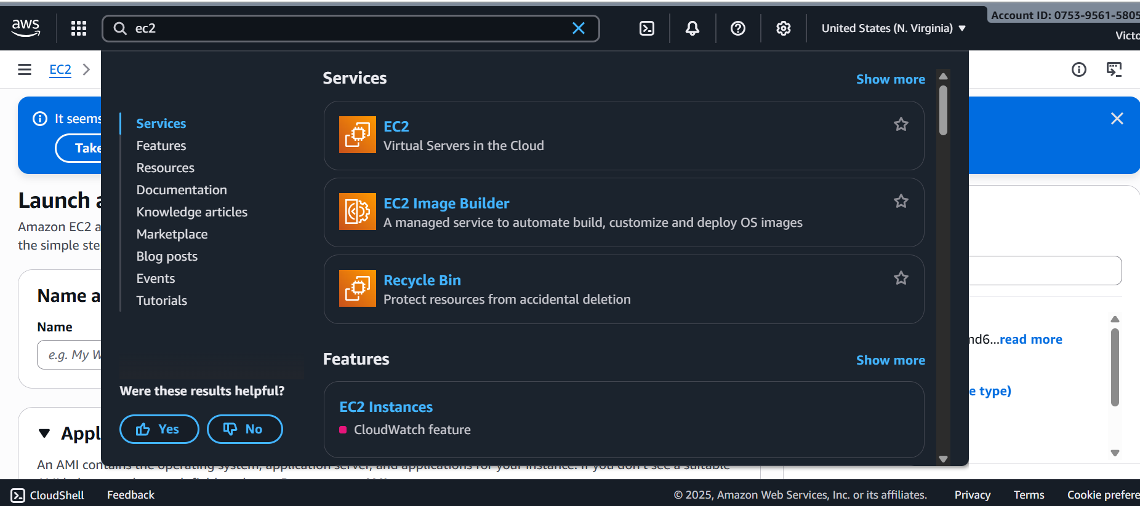

Click 'Launch Instance' to start creating a new virtual server
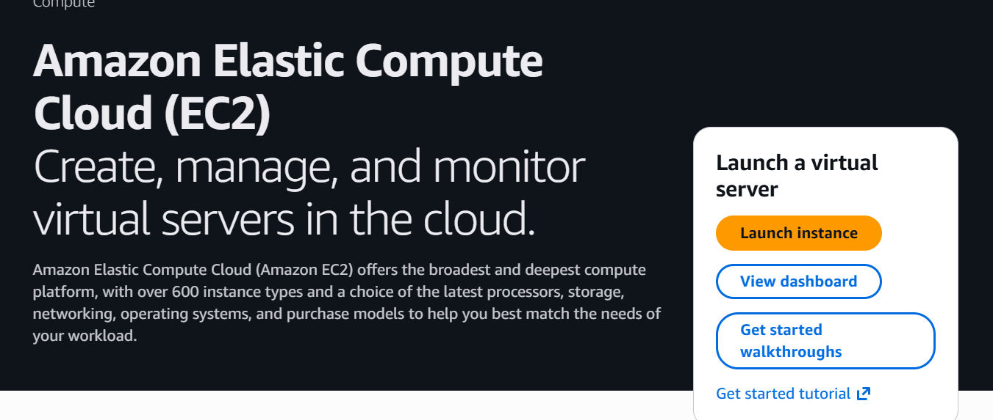
Select an instance: t3. Micro
Configure Instance Details: Default settings
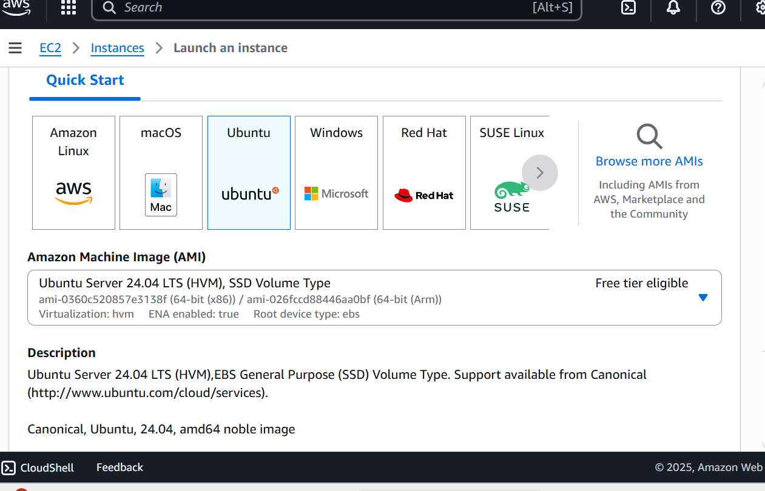

Update and Install Apache, PHP, MySQL
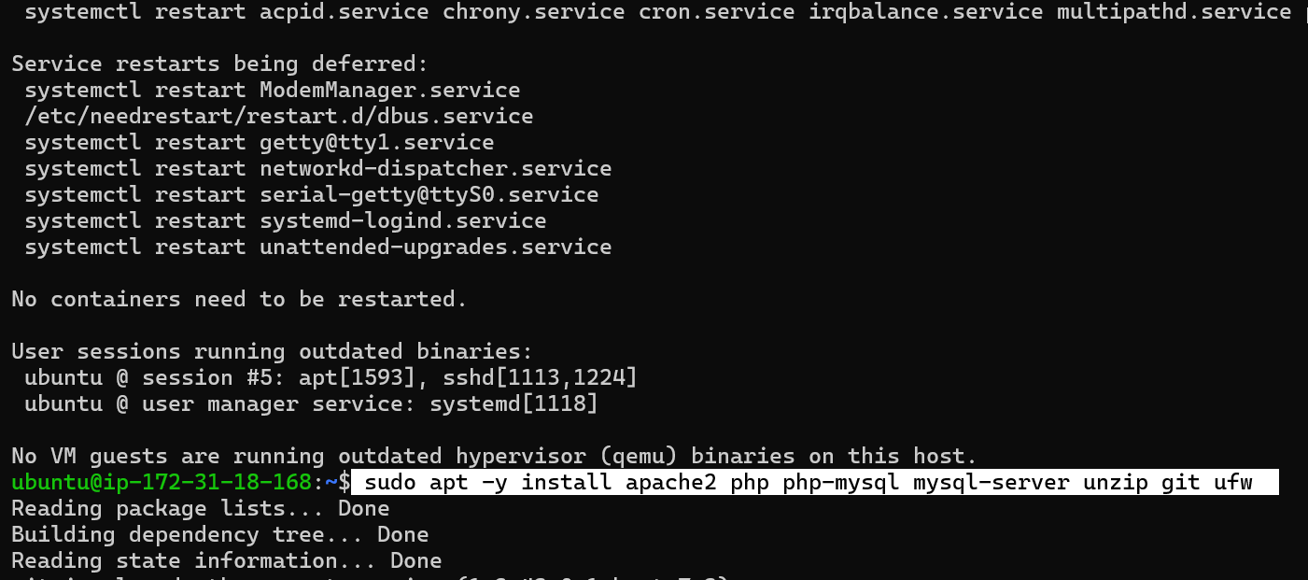
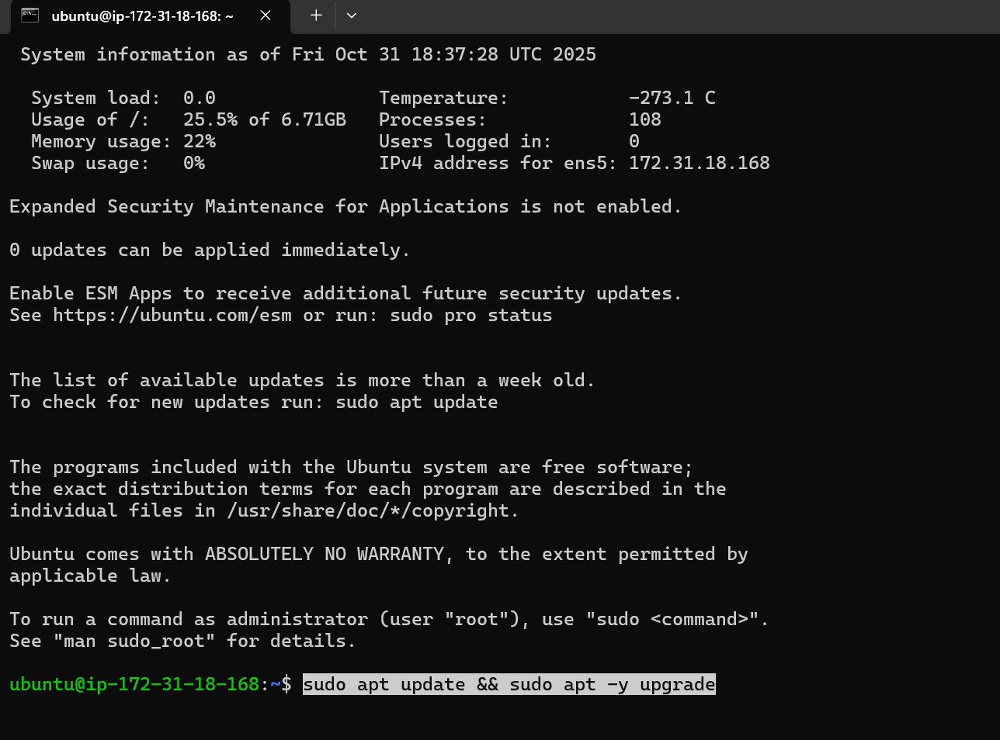

Enable Apache and Firewall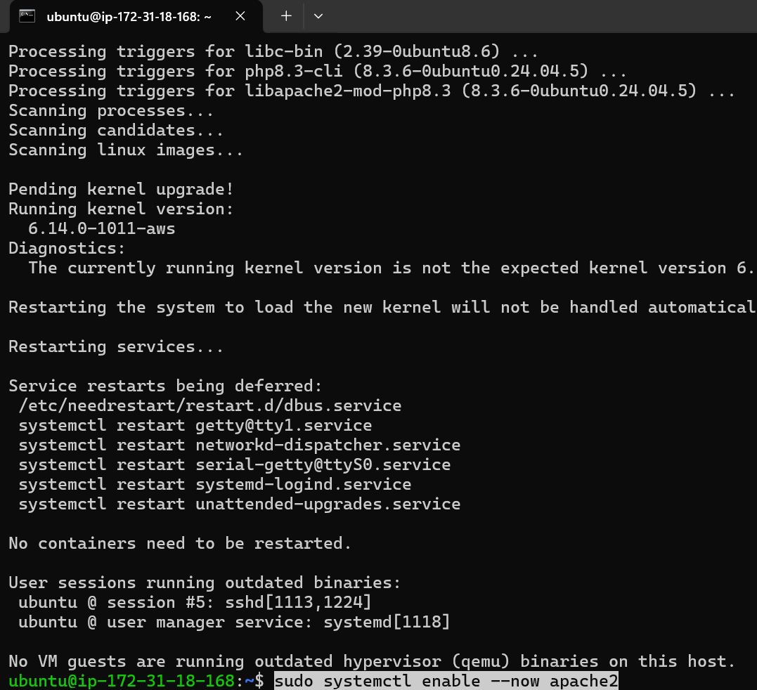

Create a Database and User
\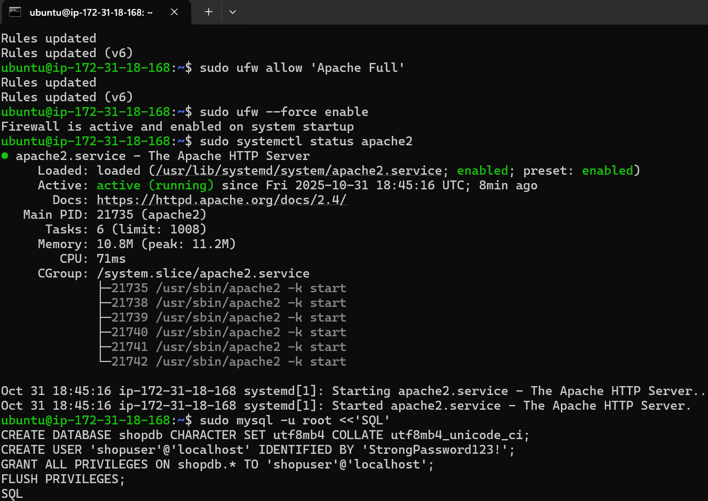
Add Tables and Sample Data
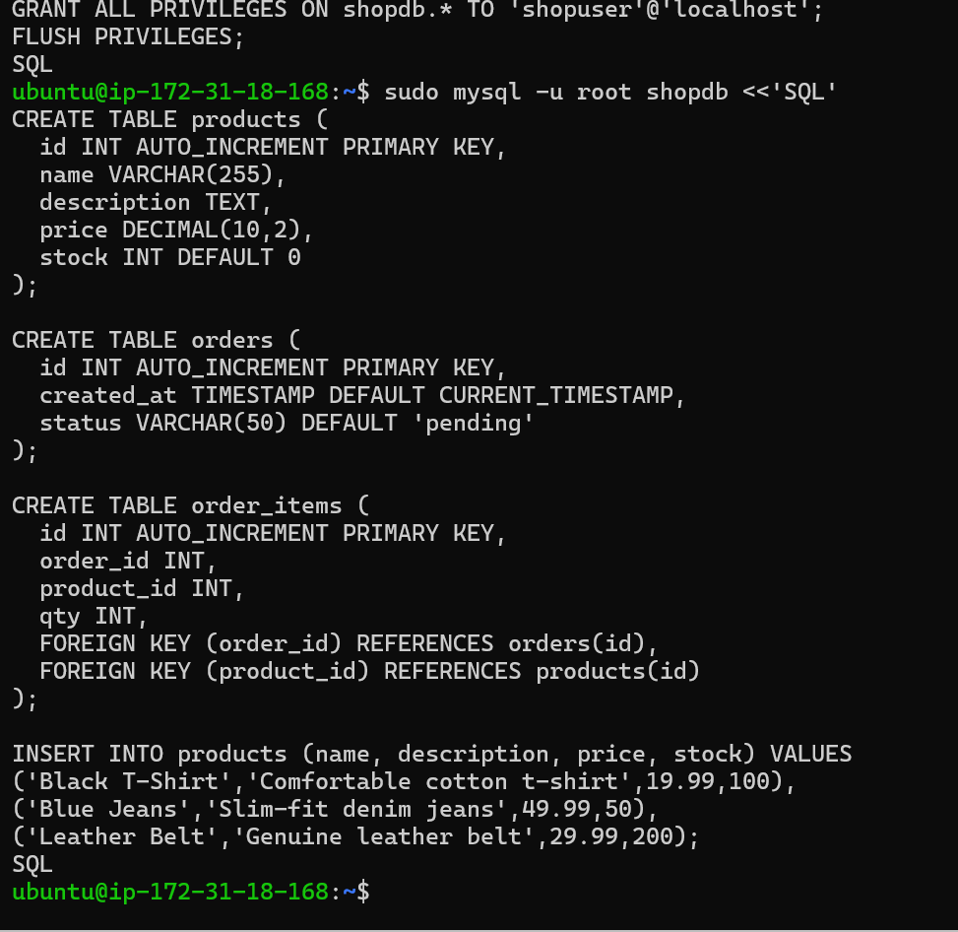

Linking Domain Name
- Purchase a Domain Name
Register a domain name through a domain registrar
- After purchase configure a domain registrars DNS setting
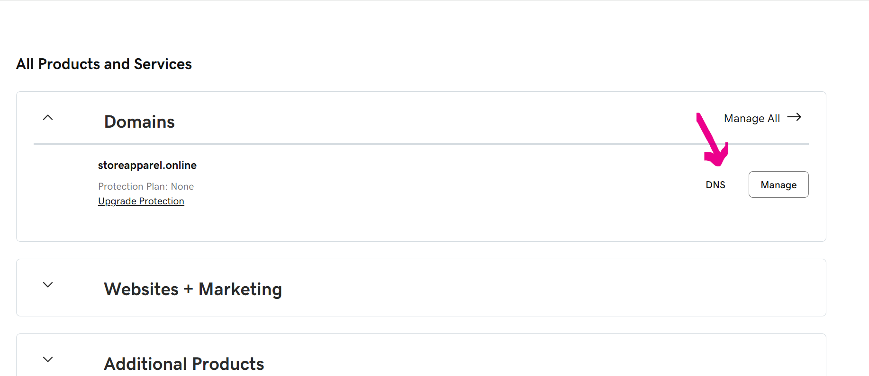
- Edit your a setting to point to you ip address 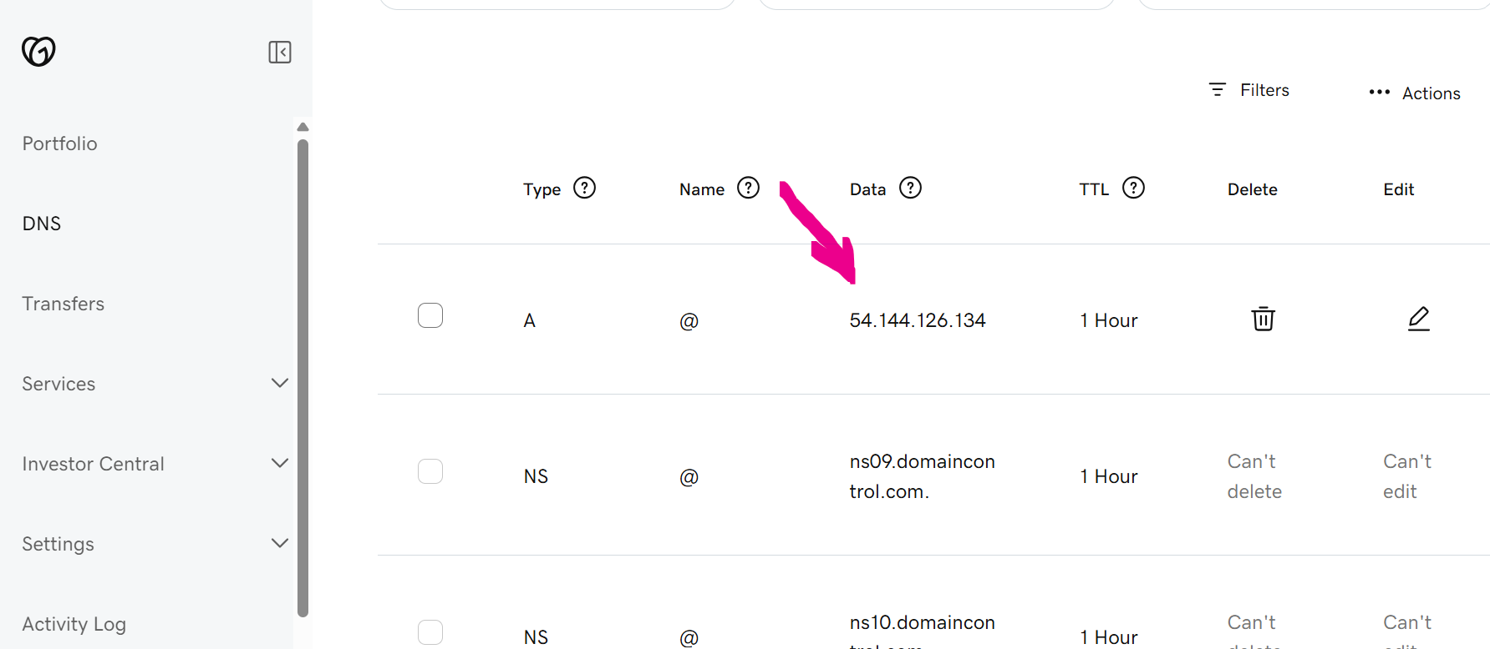

Securing the server
Installing the SSL/TLS Certificate
- Install Certbot
sudo apt install certbot python3-certbot-apache
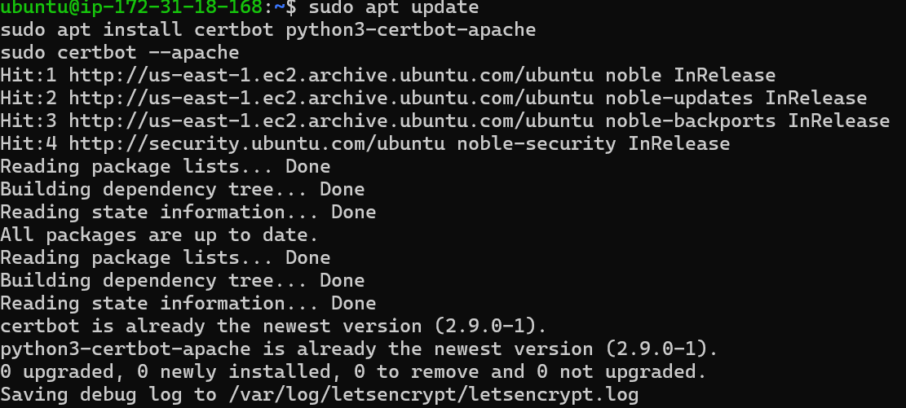

- Obtain SSL Certificate
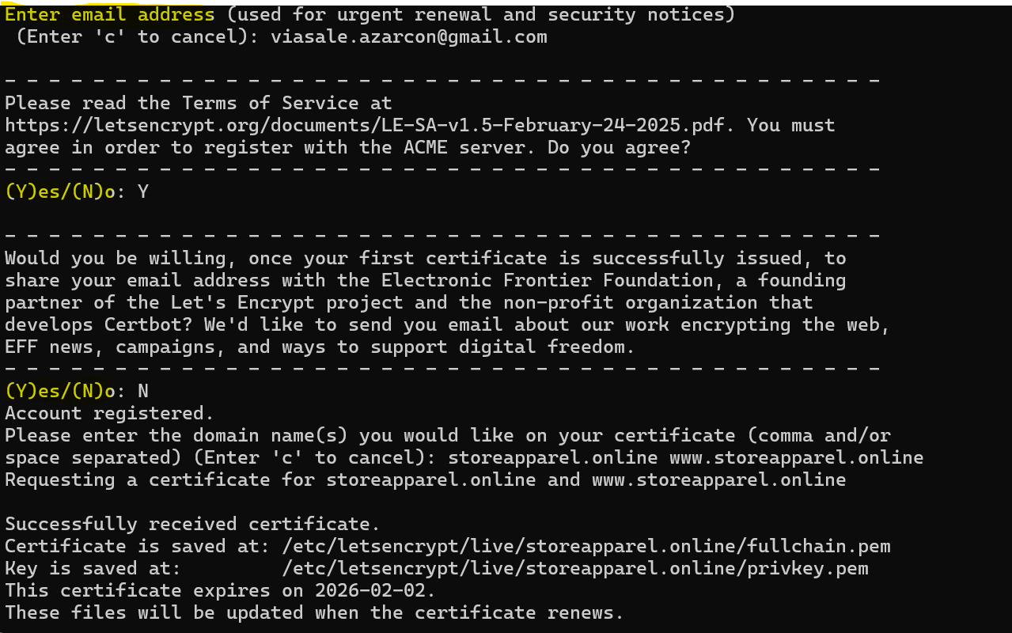

Scripting and Code
This website is based on HTML and CSS codes
The following codes are uploaded here
HTML and CSS code

Testing and Verification
After deploying the cloud server environment, a series of validation tests were conducted to confirm the correct operation of the website and associated server components.
- Web Server Accessibility
The server’s public IP address was accessed through a web browser.
The successful display of the website’s homepage confirmed that the Apache web server was functioning properly.
- Domain Name Verification
The registered domain name was entered into a browser.
The domain correctly redirected to the EC2 instance, verifying that the DNS A-record was configured successfully.
- Database Connectivity
Dynamic web pages retrieving data from the database were tested.
All pages loaded without connection errors, confirming that MySQL was operational and authentication credentials were correctly set.
- SSL / HTTPS Security Validation
The website was accessed using the HTTPS protocol.
The appearance of the padlock icon in the browser address bar indicated that the Let’s Encrypt SSL certificate was successfully installed and active.
- Firewall and Port Accessibility
Browser tests were conducted on ports 80 (HTTP) and 443 (HTTPS).
Both ports responded as expected, confirming that the security group and firewall configurations were correctly applied.

Conclusion
The deployment of an online clothing and fashion accessories store using Amazon EC2 effectively demonstrates the application of the Infrastructure as a Service (IaaS) model for creating scalable and secure web solutions. The project involved launching an EC2 instance, installing a complete web stack (Apache, PHP, MySQL), and linking a custom domain name via DNS configuration. Security was enhanced through the implementation of an SSL certificate from Let’s Encrypt, enabling encrypted HTTPS communication.
This project strengthened core cloud computing competencies, including server setup, database integration, and basic web deployment. The outcomes illustrate that cloud platforms such as AWS offer flexibility, cost-efficiency, and reliability—making them well-suited for hosting modern e-commerce applications.

References
Amazon Web Services. (2025). Amazon EC2 user guide for Linux instances. https://docs.aws.amazon.com/ec2/
Canonical. (2025). Ubuntu server documentation. https://ubuntu.com/server/docs
Electronic Frontier Foundation. (2025). Certbot documentation. https://certbot.eff.org/
PHP Documentation Group. (2025). PHP manual. https://www.php.net/manual/en/
MySQL AB. (2025). MySQL reference documentation. https://dev.mysql.com/doc/

