Experiment No.7
Problem Statement : understanding Javascript
Procedure : Using Event handling and Javascript function
Code :-
HTML and Javascript Code
<html>
<head>
<script>
function effect()
{
var x=document.getElementById("para1");
x.style.backgroundColor="pink";
}
function effectback()
{
var x=document.getElementById("para1");
x.style.backgroundColor="white";
}
</script>
</head>

<body>
<p id="para1" onmouseover="effect()" onmouseout="effectback()" >
Elon Reeve Musk FRS is an engineer, industrial designer,
technology entrepreneur and philanthropist. He is a citizen
of South Africa, Canada, and the United States. Wikipedia
Spouse: Talulah Riley (m. 2013–2016), Talulah Riley (m. 2010–2012), Justine Musk (m. 2000–2008) Trending
Born: 28 June 1971 (age 48 years), Pretoria, South Africa
Partner: Grimes (2018–)
Net worth: 4,210 crores USD (2020)
Children: X Æ A-Xii, Nevada Alexander Musk, Kai Musk, Damian Musk, Griffin Musk, Xavier Musk, Saxon Musk
Education: University of Pennsylvania (1991–1997), MORE
</p>
</body>
</html>
Result :-
- When mouseover is on action background become pink
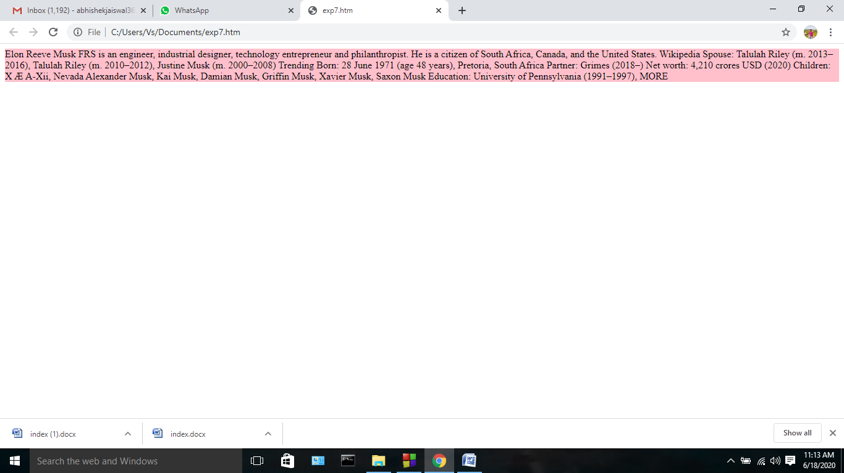

- When mouseout is on action background become white
