Experiment No.8
Problem Statement : Creating a web page with back end in PHP and front end in Javascript and hosting it on XAMPP server
Procedure : Using basic HTML ,CSS , Javascript & PHP
Code :-
HTML Code
<html>
<head>
<meta name="viewport" content="width=800, initial-scale=1" />
<meta http-equiv="Content-Type" content="text/html; charset=utf-8" />
<style type="text/css">
@import url(https://fonts.googleapis.com/css?family=Nobile:400italic,700italic);
@import url(https://fonts.googleapis.com/css?family=Dancing+Script);
* {
box-sizing: border-box;
-moz-box-sizing: border-box;
-webkit-box-sizing: border-box;
}
body {
background: #E5E5E5;

background-image: url("bday.jpg");
padding: 50px;
background-size:cover;
background-position:center;
}

#card-front {
color: #FFDFDF;
}

#card, #card-front, #card-inside {
height: 480px;
}

.wrap {
padding: 1.5em 2.5em;
height: 100%;
}
#card-front, #card-inside {
width: 60%;
-webkit-box-shadow: 2px 2px 30px rgba(0, 0, 0, .25), 0 0 1px rgba(0, 0, 0, .5);
-moz-box-shadow: 2px 2px 30px rgba(0, 0, 0, .25), 0 0 1px rgba(0, 0, 0, .5);
box-shadow: 2px 2px 30px rgba(0, 0, 0, .25), 0 0 1px rgba(0, 0, 0, .5);
position: absolute;
left: 50%;
}

#card-inside .wrap {
background: #FFEFEF;
-webkit-box-shadow: inset 2px 0 1px rgba(0, 0, 0, .05);
-moz-box-shadow: inset 2px 0 1px rgba(0, 0, 0, .05);
box-shadow: inset 2px 0 1px rgba(0, 0, 0, .05);
}
#card {
max-width: 860px;
margin: 0 auto;
transform-style: preserve-3d;
-moz-transform-style: preserve-3d;
-webkit-transform-style: preserve-3d;
perspective: 5000px;
-moz-perspective: 5000px;
-webkit-perspective: 5000px;
position: relative;
}

#card h1 {
text-align: center;
font-family: 'Nobile', sans-serif;
font-style: italic;
font-size: 70px;
text-shadow:
4px 4px 0px rgba(0, 0, 0, .15),
1px 1px 0 rgba(255, 200, 200, 255),
2px 2px 0 rgba(255, 150, 150, 255),
3px 3px 0 rgba(255, 125, 125, 255);
color: #FFF;
}
#card-inside {
font-size: 1.1em;
line-height: 1.4;
font-family: 'Nobile';
color: #331711;
font-style: italic;
}

p {
margin-top: 1em;
}

p:first-child {
margin-top: 0;
}

p.signed {
margin-top: 1.5em;
text-align: center;
font-family: 'Dancing Script', sans-serif;
font-size: 1.5em;
}

#card-front {
background-color: #FF5555;
background-image: linear-gradient(top, #FF5555 0%, #FF7777 100%);
background-image: -moz-linear-gradient(top, #FF5555 0%, #FF7777 100%);
background-image: -webkit-linear-gradient(top, #FF5555 0%, #FF7777 100%);
transform-origin: left;
-moz-transform-origin: left;
-webkit-transform-origin: left;
transition: transform 1s linear;
-moz-transition: -moz-transform 1s linear;
-webkit-transition: -webkit-transform 1s linear;
position: relative;
}

#card-front .wrap {
transition: background 1s linear;
-moz-transition: background 1s linear;
-webkit-transition: background 1s linear;
}

#card-front button {
position: absolute;
bottom: 1em;
right: -12px;
background: #F44;
color: #FFF;
font-family: 'Nobile', sans-serif;
font-style: italic;
font-weight: bold;
font-size: 1.5em;
padding: .5em;
border: none;
cursor: pointer;
box-shadow: 2px 2px 3px rgba(0, 0, 0, .25), 0 0 1px rgba(0, 0, 0, .4);
-moz-box-shadow: 2px 2px 3px rgba(0, 0, 0, .25), 0 0 1px rgba(0, 0, 0, .4);
-webkit-box-shadow: 2px 2px 3px rgba(0, 0, 0, .25), 0 0 1px rgba(0, 0, 0, .4);
}

#card-front button:hover,
#card-front button:focus {
background: #F22;
}

#close {
display: none;
}

#card.open-fully #close,
#card-open-half #close {
display: inline;
}

#card.open-fully #open {
display: none;
}

#card.open-half #card-front,
#card.close-half #card-front {
transform: rotateY(-90deg);
-moz-transform: rotateY(-90deg);
-webkit-transform: rotateY(-90deg);
}
#card.open-half #card-front .wrap {
background-color: rgba(0, 0, 0, .5);
}

#card.open-fully #card-front,
#card.close-half #card-front {
background: #FFEFEF;
}

#card.open-fully #card-front {
transform: rotateY(-180deg);
-moz-transform: rotateY(-180deg);
-webkit-transform: rotateY(-180deg);
}

#card.open-fully #card-front .wrap {
background-color: rgba(0, 0, 0, 0);
}

#card.open-fully #card-front .wrap *,
#card.close-half #card-front .wrap * {
display: none;
}

footer {
max-width: 500px;
margin: 40px auto;
font-family: 'Nobile', sans-serif;
font-size: 14px;
line-height: 1.6;
color: #888;
text-align: center;
}
</style>
</head>
<body>
<div id="card">
<div id="card-inside">
<div class="wrap">
<p>Dear Pallu</p>
<p>“ Happy birthday to a special person who is bringing so much joy to my heart. I am thankful for every moment we spend together, and I wish our happiness never ends. Happy birthday!</p>
<p>I will be there with you forever .
</p>
<center><h4>from</h4></center>
<p class="signed">Abhishek Jaiswal</p>

</div>
</div>
<div id="card-front">
<div class="wrap">
<h1> Happy Birthday !</h1>
</div>
<button id="open">&gt;</button>
<button id="close">&lt;</button>
</div>
</div>
<script>
(function() {
function $(id) {
return document.getElementById(id);
}

var card = $('card'),
openB = $('open'),
closeB = $('close'),
timer = null;
console.log('wat', card);
openB.addEventListener('click', function () {
card.setAttribute('class', 'open-half');
if (timer) clearTimeout(timer);
timer = setTimeout(function () {
card.setAttribute('class', 'open-fully');
timer = null;
}, 1000);
});

closeB.addEventListener('click', function () {
card.setAttribute('class', 'close-half');
if (timer) clearTimerout(timer);
timer = setTimeout(function () {
card.setAttribute('class', '');
timer = null;
}, 1000);
});

}());

</script>

<div style="visibility: hidden;">
<embed src="bday.mp3" autostart="true" loop="true">
</div>
<div style="visibility: hidden;">
<embed src="bday.mp3" autostart="true" loop="true">
</div>

</body>
</html>

PHP Code
<html>
<head>
<meta name="viewport" content="width=300, initial-scale=1" />
<meta http-equiv="Content-Type" content="text/html; charset=utf-8" />
</head>
<style type="text/css">

body
{
overflow-x: hidden;
overflow-y: scroll;
}

/* basic styles for black background and crosshair cursor */
body {
background: #000;
margin: 0;
}

canvas {
cursor: crosshair;
display: block;
}
</style>
<body>
<div style="visibility: hidden;">
<embed src="fireworks.mp3" autostart="true" loop="true">
</div>
<!-- setup our canvas element -->
<canvas id="canvas">Canvas is not supported in your browser.</canvas>
<script>
setTimeout("location.href = 'Birthday.html';",20000);
</script>
<script type="text/javascript">
// when animating on canvas, it is best to use requestAnimationFrame instead of setTimeout or setInterval
// not supported in all browsers though and sometimes needs a prefix, so we need a shim
window.requestAnimFrame = ( function() {
return window.requestAnimationFrame ||
window.webkitRequestAnimationFrame ||
window.mozRequestAnimationFrame ||
function( callback ) {
window.setTimeout( callback, 1000 / 60 );
};
})();

// now we will setup our basic variables for the demo
var canvas = document.getElementById( 'canvas' ),
ctx = canvas.getContext( '2d' ),
// full screen dimensions
cw = window.innerWidth,
ch = window.innerHeight,
// firework collection
fireworks = [],
// particle collection
particles = [],
// starting hue
hue = 120,
// when launching fireworks with a click, too many get launched at once without a limiter, one launch per 5 loop ticks
limiterTotal = 5,
limiterTick = 0,
// this will time the auto launches of fireworks, one launch per 80 loop ticks
timerTotal = 80,
timerTick = 0,
mousedown = false,
// mouse x coordinate,
mx,
// mouse y coordinate
my;

// set canvas dimensions
canvas.width = cw;
canvas.height = ch;

// now we are going to setup our function placeholders for the entire demo

// get a random number within a range
function random( min, max ) {
return Math.random() * ( max - min ) + min;
}

// calculate the distance between two points
function calculateDistance( p1x, p1y, p2x, p2y ) {
var xDistance = p1x - p2x,
yDistance = p1y - p2y;
return Math.sqrt( Math.pow( xDistance, 2 ) + Math.pow( yDistance, 2 ) );
}

// create firework
function Firework( sx, sy, tx, ty ) {
// actual coordinates
this.x = sx;
this.y = sy;
// starting coordinates
this.sx = sx;
this.sy = sy;
// target coordinates
this.tx = tx;
this.ty = ty;
// distance from starting point to target
this.distanceToTarget = calculateDistance( sx, sy, tx, ty );
this.distanceTraveled = 0;
// track the past coordinates of each firework to create a trail effect, increase the coordinate count to create more prominent trails
this.coordinates = [];
this.coordinateCount = 3;
// populate initial coordinate collection with the current coordinates
while( this.coordinateCount-- ) {
this.coordinates.push( [ this.x, this.y ] );
}
this.angle = Math.atan2( ty - sy, tx - sx );
this.speed = 2;
this.acceleration = 1.05;
this.brightness = random( 50, 70 );
// circle target indicator radius
this.targetRadius = 1;
}

// update firework
Firework.prototype.update = function( index ) {
// remove last item in coordinates array
this.coordinates.pop();
// add current coordinates to the start of the array
this.coordinates.unshift( [ this.x, this.y ] );

// cycle the circle target indicator radius
if( this.targetRadius < 8 ) {
this.targetRadius += 0.3;
} else {
this.targetRadius = 1;
}

// speed up the firework
this.speed *= this.acceleration;

// get the current velocities based on angle and speed
var vx = Math.cos( this.angle ) * this.speed,
vy = Math.sin( this.angle ) * this.speed;
// how far will the firework have traveled with velocities applied?
this.distanceTraveled = calculateDistance( this.sx, this.sy, this.x + vx, this.y + vy );

// if the distance traveled, including velocities, is greater than the initial distance to the target, then the target has been reached
if( this.distanceTraveled >= this.distanceToTarget ) {
createParticles( this.tx, this.ty );
// remove the firework, use the index passed into the update function to determine which to remove
fireworks.splice( index, 1 );
} else {
// target not reached, keep traveling
this.x += vx;
this.y += vy;
}
}

// draw firework
Firework.prototype.draw = function() {
ctx.beginPath();
// move to the last tracked coordinate in the set, then draw a line to the current x and y
ctx.moveTo( this.coordinates[ this.coordinates.length - 1][ 0 ], this.coordinates[ this.coordinates.length - 1][ 1 ] );
ctx.lineTo( this.x, this.y );
ctx.strokeStyle = 'hsl(' + hue + ', 100%, ' + this.brightness + '%)';
ctx.stroke();

ctx.beginPath();
// draw the target for this firework with a pulsing circle
ctx.arc( this.tx, this.ty, this.targetRadius, 0, Math.PI * 2 );
ctx.stroke();
}

// create particle
function Particle( x, y ) {
this.x = x;
this.y = y;
// track the past coordinates of each particle to create a trail effect, increase the coordinate count to create more prominent trails
this.coordinates = [];
this.coordinateCount = 5;
while( this.coordinateCount-- ) {
this.coordinates.push( [ this.x, this.y ] );
}
// set a random angle in all possible directions, in radians
this.angle = random( 0, Math.PI * 2 );
this.speed = random( 1, 10 );
// friction will slow the particle down
this.friction = 0.95;
// gravity will be applied and pull the particle down
this.gravity = 1;
// set the hue to a random number +-50 of the overall hue variable
this.hue = random( hue - 50, hue + 50 );
this.brightness = random( 50, 80 );
this.alpha = 1;
// set how fast the particle fades out
this.decay = random( 0.015, 0.03 );
}

// update particle
Particle.prototype.update = function( index ) {
// remove last item in coordinates array
this.coordinates.pop();
// add current coordinates to the start of the array
this.coordinates.unshift( [ this.x, this.y ] );
// slow down the particle
this.speed *= this.friction;
// apply velocity
this.x += Math.cos( this.angle ) * this.speed;
this.y += Math.sin( this.angle ) * this.speed + this.gravity;
// fade out the particle
this.alpha -= this.decay;

// remove the particle once the alpha is low enough, based on the passed in index
if( this.alpha <= this.decay ) {
particles.splice( index, 1 );
}
}

// draw particle
Particle.prototype.draw = function() {
ctx. beginPath();
// move to the last tracked coordinates in the set, then draw a line to the current x and y
ctx.moveTo( this.coordinates[ this.coordinates.length - 1 ][ 0 ], this.coordinates[ this.coordinates.length - 1 ][ 1 ] );
ctx.lineTo( this.x, this.y );
ctx.strokeStyle = 'hsla(' + this.hue + ', 100%, ' + this.brightness + '%, ' + this.alpha + ')';
ctx.stroke();
}

// create particle group/explosion
function createParticles( x, y ) {
// increase the particle count for a bigger explosion, beware of the canvas performance hit with the increased particles though
var particleCount = 30;
while( particleCount-- ) {
particles.push( new Particle( x, y ) );
}
}

// main demo loop
function loop() {
// this function will run endlessly with requestAnimationFrame
requestAnimFrame( loop );

// increase the hue to get different colored fireworks over time
//hue += 0.5;

// create random color
hue= random(0, 360 );

// normally, clearRect() would be used to clear the canvas
// we want to create a trailing effect though
// setting the composite operation to destination-out will allow us to clear the canvas at a specific opacity, rather than wiping it entirely
ctx.globalCompositeOperation = 'destination-out';
// decrease the alpha property to create more prominent trails
ctx.fillStyle = 'rgba(0, 0, 0, 0.5)';
ctx.fillRect( 0, 0, cw, ch );
// change the composite operation back to our main mode
// lighter creates bright highlight points as the fireworks and particles overlap each other
ctx.globalCompositeOperation = 'lighter';

// loop over each firework, draw it, update it
var i = fireworks.length;
while( i-- ) {
fireworks[ i ].draw();
fireworks[ i ].update( i );
}

// loop over each particle, draw it, update it
var i = particles.length;
while( i-- ) {
particles[ i ].draw();
particles[ i ].update( i );
}

// launch fireworks automatically to random coordinates, when the mouse isn't down
if( timerTick >= timerTotal ) {
if( !mousedown ) {
// start the firework at the bottom middle of the screen, then set the random target coordinates, the random y coordinates will be set within the range of the top half of the screen
fireworks.push( new Firework( cw / 2, ch, random( 0, cw ), random( 0, ch / 2 ) ) );
timerTick = 0;
}
} else {
timerTick++;
}

// limit the rate at which fireworks get launched when mouse is down
if( limiterTick >= limiterTotal ) {
if( mousedown ) {
// start the firework at the bottom middle of the screen, then set the current mouse coordinates as the target
fireworks.push( new Firework( cw / 2, ch, mx, my ) );
limiterTick = 0;
}
} else {
limiterTick++;
}
}

// mouse event bindings
// update the mouse coordinates on mousemove
canvas.addEventListener( 'mousemove', function( e ) {
mx = e.pageX - canvas.offsetLeft;
my = e.pageY - canvas.offsetTop;
});

// toggle mousedown state and prevent canvas from being selected
canvas.addEventListener( 'mousedown', function( e ) {
e.preventDefault();
mousedown = true;
});

canvas.addEventListener( 'mouseup', function( e ) {
e.preventDefault();
mousedown = false;
});

// once the window loads, we are ready for some fireworks!
window.onload = loop;

</script>
</body>
<html>
Result :-
- View when book is closed

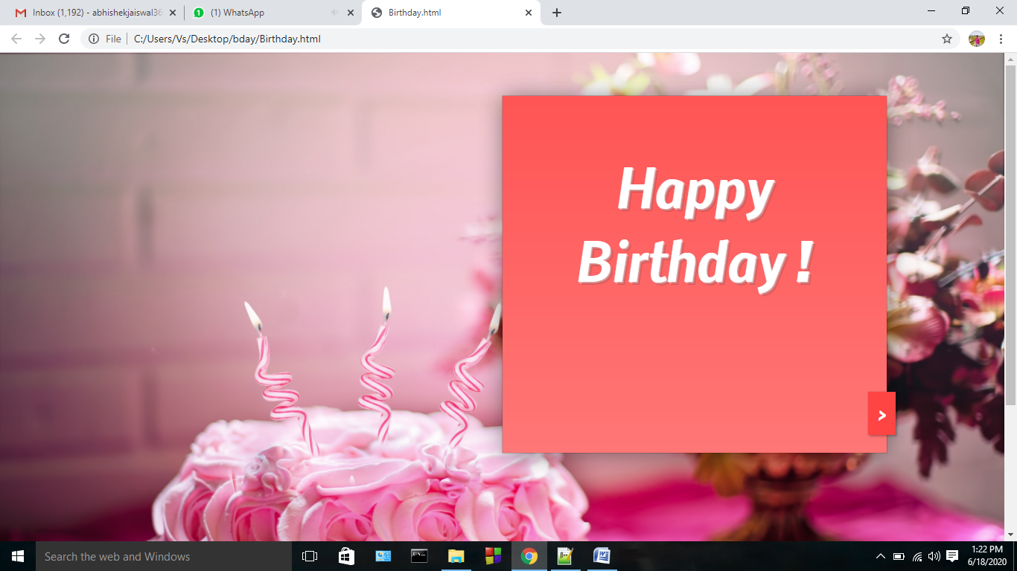

- View of opening of book

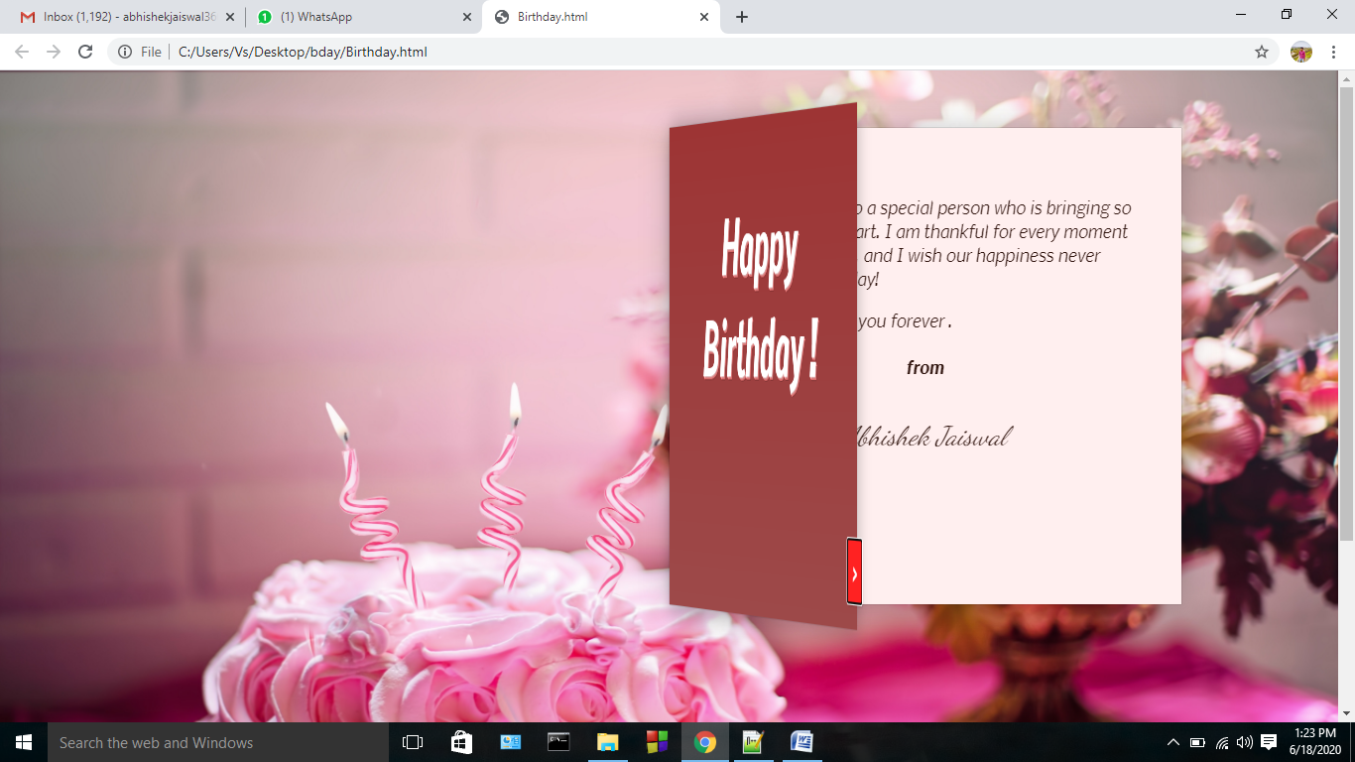

- View of opened book completely

