Coding Standards

Jquery Standards

- All methods that are a result of selecting an element are camel-case:
addClass, removeClass, ajaxComplete, ajaxSend, after, add, append, appendTo
- Most methods/properties that are members of jQuery are also camel-case, with few exceptions.
ajax, ajaxSetup, boxModel, browser, contains, cssHooks, data.
- Variable and function names written as camelCase
- Global variables written in UPPERCASE (We don't use, but it's quite common)
- Constants (like PI) written in UPPERCASE
- Add spaces around group operators (= + - * /)
- Code per Line: Lines should be no longer than 80 characters, and must not exceed 100 (counting tabs as 4 spaces). There are 2 exceptions, both allowing the line to exceed 100 characters.
- If the line contains a regex literal. This prevents having to use the regex constructor which requires otherwise unnecessary string escaping.
- if/else/for/while/try always have braces and always go on multiple lines.
- Unary special-character operators (e.g., !, ++) must not have space next to their operand.
- The ? and : in a ternary conditional must have space on both sides.
- Equality: Strict equality checks (===) must be used in favor of abstract equality checks (==).
- Comments: Comments are always preceded by a blank line. Comments start with a capital first letter, but don't require a period at the end, unless you're writing full sentences. There must be a single space between the comment token and the comment text. Single line comments go over the line they refer to and Multi-line comments are only used for file and function headers.
- Quotes: JQuery uses double quotes.
- DOM Manipulation: (1)Always detach any existing element before manipulation and attach it back after manipulating it(2) Use string concatenation or array.join() over .append(). (3) Don’t Act on Absent Elements.
- AJAX: (1) Avoid using .getJson() or .get(), simply use the $.ajax() as that's what gets called internally.(2) DO NOT use http requests on https sites. Prefer schemaless URLs (leave the protocol http/https out of your URL).(3) DO NOT put request parameters in the URL, send them using data object setting.(4) Try to specify the dataType setting so it's easier to know what kind of data you are working with.(5) Use Delegated event handlers for attaching events to content loaded using Ajax. Delegated events have the advantage that they can process events from descendant elements that are added to the document at a later time (example Ajax).
- MISC: (1) Do not mix CSS with JQuery. (2)DO NOT use Deprecated Methods. (3) It is always important to keep an eye on deprecated methods for each new version and try avoid using them. (4) Combine jQuery with native JavaScript when needed.
SQL

- Use Title Case for Table and SPs
-- This seems loud and obnoxious:
create table EMPLOYEE_MAILING_LIST

-- I still dislike the underscores here (and we're not writing JavaScript, are we?)
create table employee_mailing_list

-- This reads like normal, friendly, solid code:
create table EmployeeMailingList
- Always Add our SP in CCM schema in case of EDW Database
- Prefix the Database Name to Indicate the Environment

use Acme;
go

-- Purge the mailing list table to test something weird and wonderful.
delete from EmployeeMailingList;

-- Oops... Did I just blow out a million records in a production database?
- Use the Same Pattern for Identity-Enabled Primary Keys
-- identity-enabled primary key:
select ID from Hero

-- In case of Foreign key:
select HeroID from Hero
- Use Self-Describing Foreign-Key Column Names
A column that is intended to be a foreign key reference on another table follows this naming convention: AttributeEntityID

C#

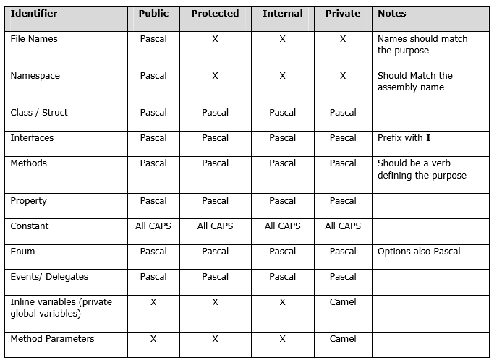
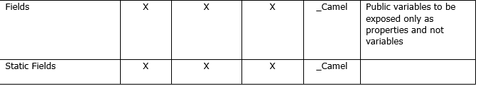

Use Pascal casing for Class names

public class HelloWorld { ... }

2. Use Pascal casing for Method names

void SayHello(string name) { ... }

3. Use Camel casing for variables and method parameters

int totalCount = 0; void SayHello(string name) { string fullMessage = "Hello " + name; ... }

4. Use the prefix “I” with Camel Casing for interfaces ( Example: IEntity )

5. Do not use Hungarian notation to name variables.

In earlier days most of the programmers liked it - having the data type as a prefix for the variable name and using m_ as prefix for member variables. Eg:

string m_sName; int nAge;

However, in .NET coding standards, this is not recommended. Usage of data type and m_ to represent member variables should not be used. All variables should use camel casing.

6. Use Meaningful, descriptive words to name variables. Do not use abbreviations.
Good:

string address √ √√ √ int salary √ √√ √

Not Good:

string nam string addr int sal

7. Never Use single Character Variables

Do not use single character variable names like i, n, s etc. Use names like index, temp

One exception in this case would be variables used for iterations in loops:

for ( int i = 0; i < count; i++ ) { ... }

If the variable is used only as a counter for iteration and is not used anywhere else in the loop, many people still like to use a single char variable (i) instead of inventing a different suitable name.

8. Do not use underscores (_) for local variable names.

9. Member Variables

All member variables must be prefixed with underscore (_) so that they can be identified from other local variables.

10. Never use variable names that resemble keywords.

11. Prefix boolean variables, properties and methods with “is” or similar prefixes.

Ex: private bool _isFinished

12. Namespace names should follow the standard pattern

<company name>.<product name>.<top level module>.<bottom level module>

