Screenshot added: Selenium/Screenshots/locked_out_user.png

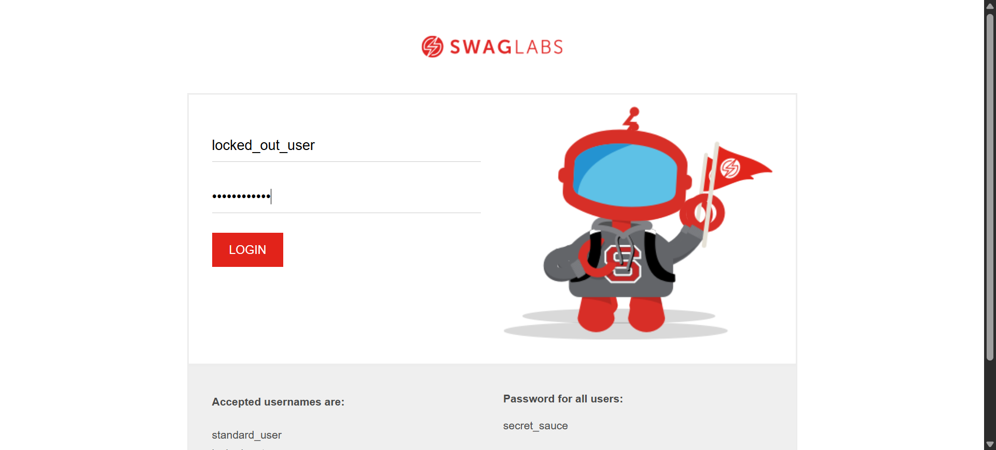

Screenshot added: Selenium/Screenshots/locked_out_user.png

