Screenshot added: Selenium/Screenshots/problem_user.png

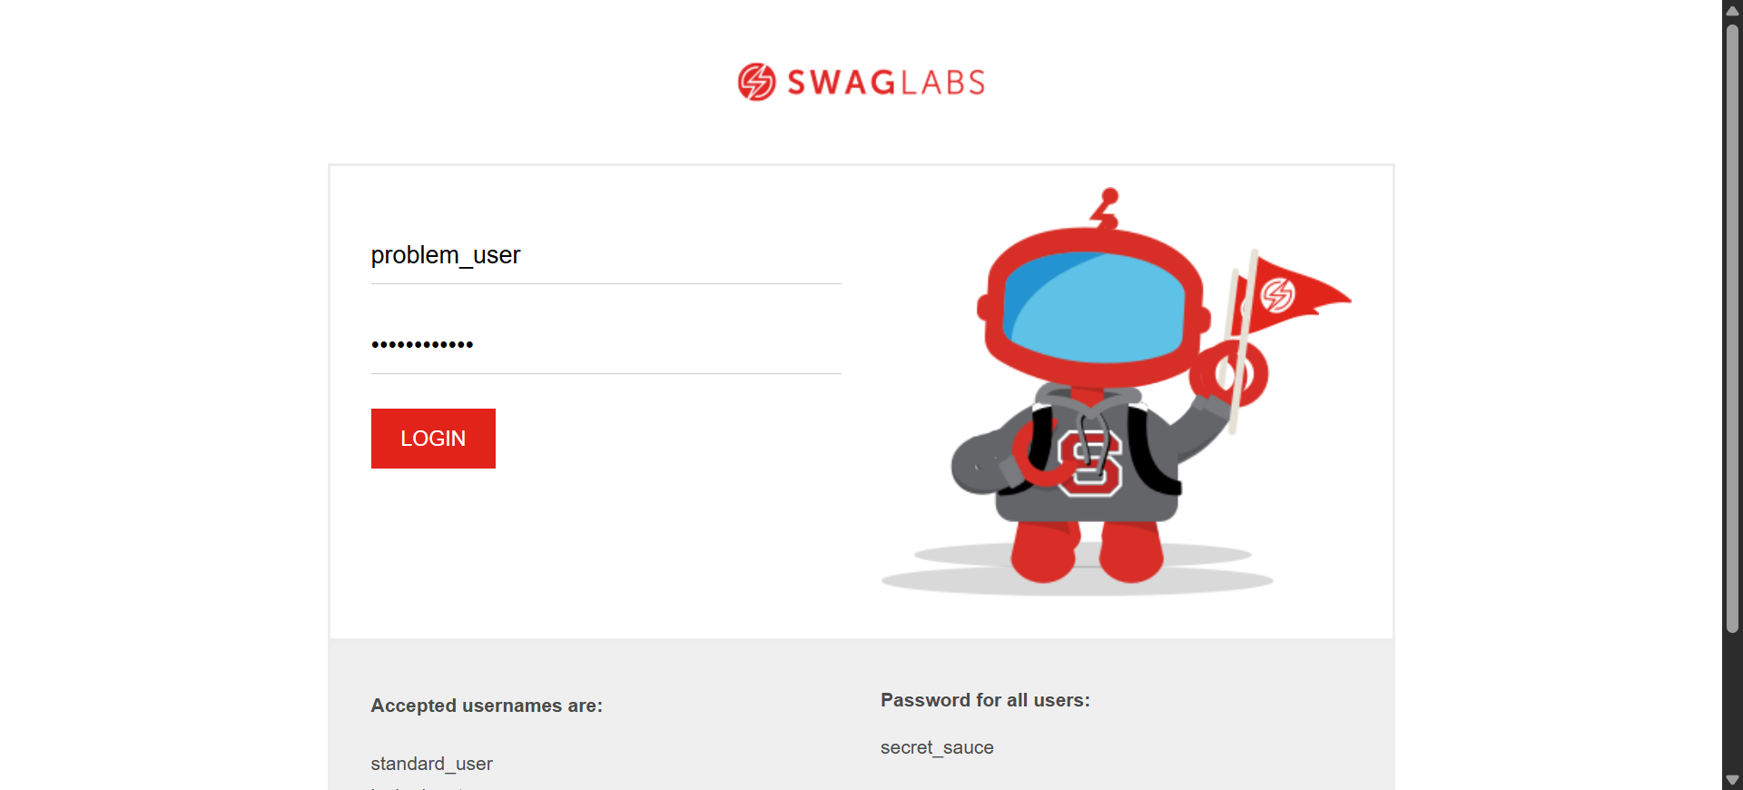

Screenshot added: Selenium/Screenshots/problem_user.png



Screenshot added: Selenium/Screenshots/problem_user.png

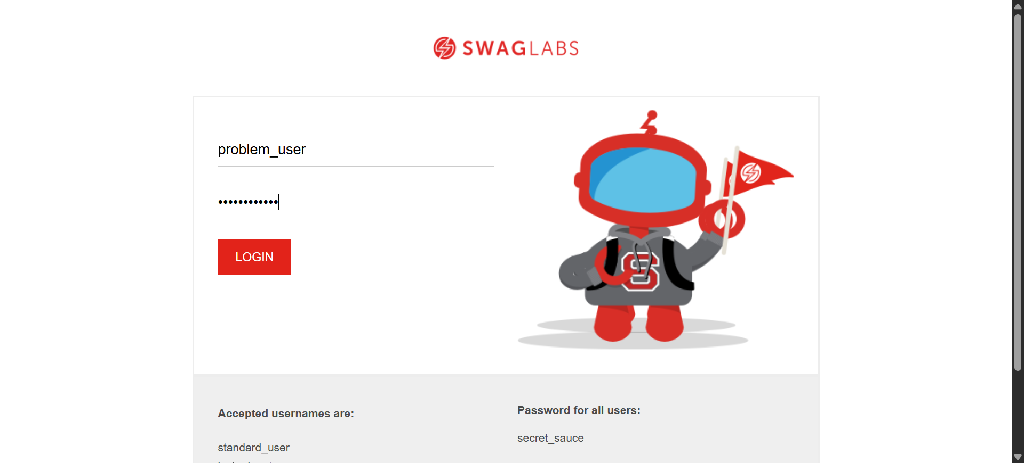

Screenshot added: Selenium/Screenshots/problem_user.png



Screenshot added: Selenium/Screenshots/problem_user.png



Screenshot added: Selenium/Screenshots/problem_user.png



Screenshot added: Selenium/Screenshots/problem_user.png

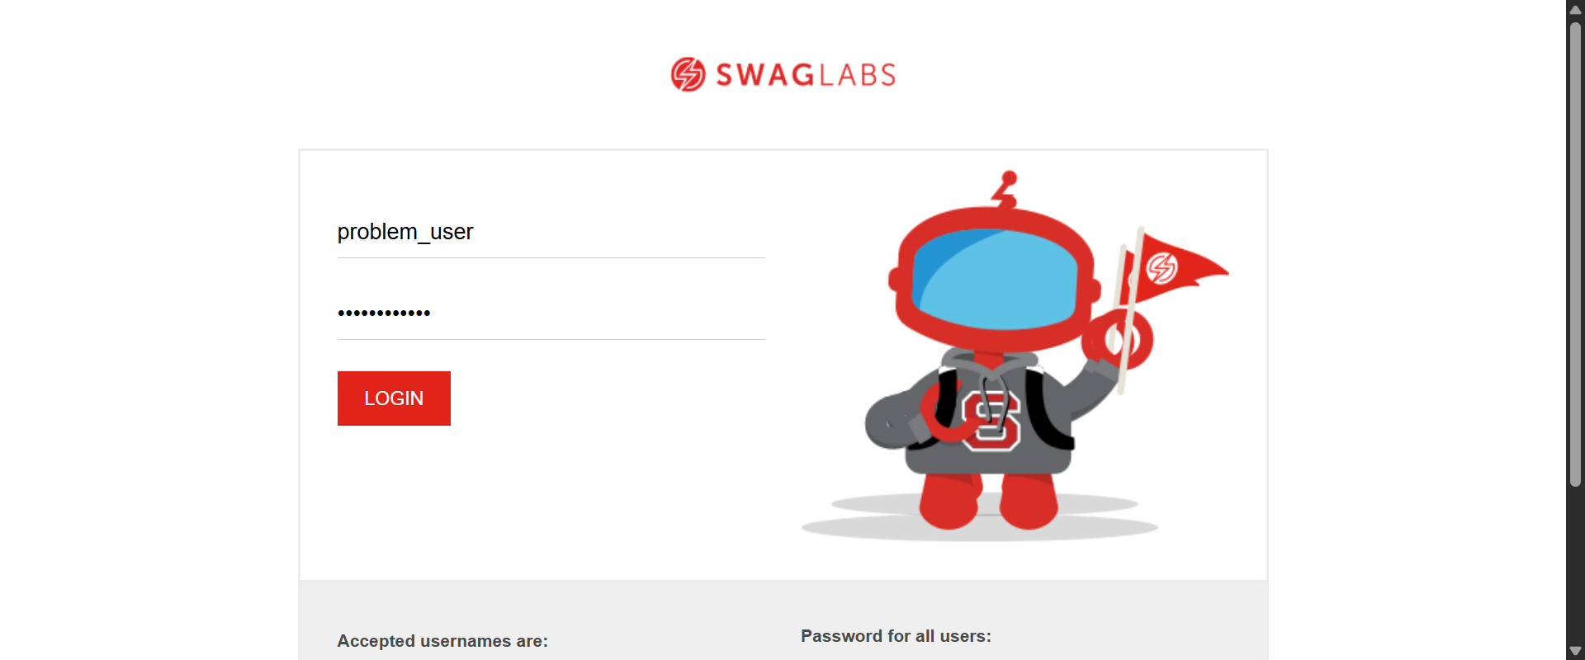

Screenshot added: Selenium/Screenshots/problem_user.png

