Screenshot added: Selenium/Screenshots/standard_user.png

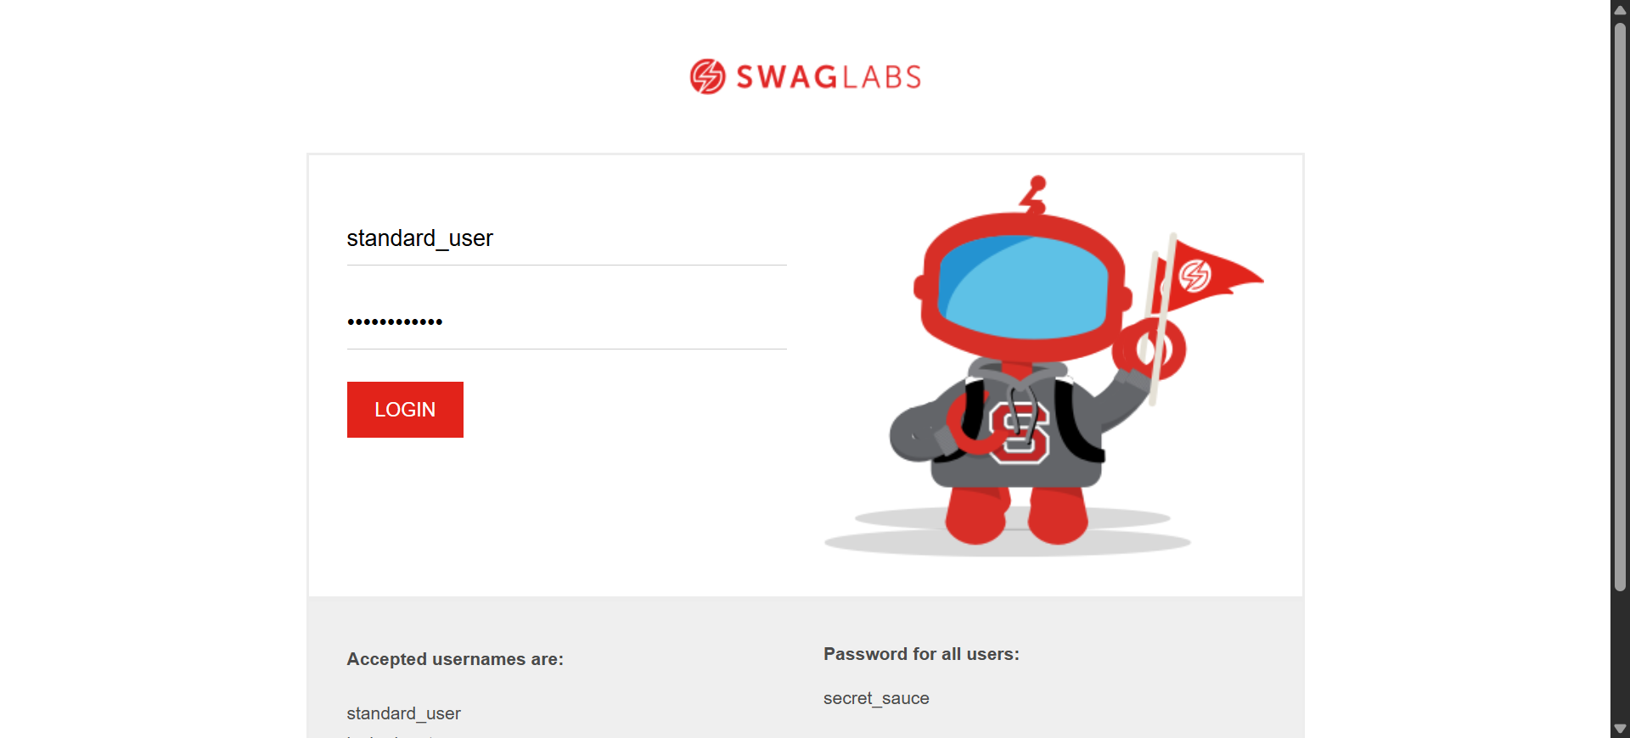

Screenshot added: Selenium/Screenshots/standard_user.png



Screenshot added: Selenium/Screenshots/standard_user.png

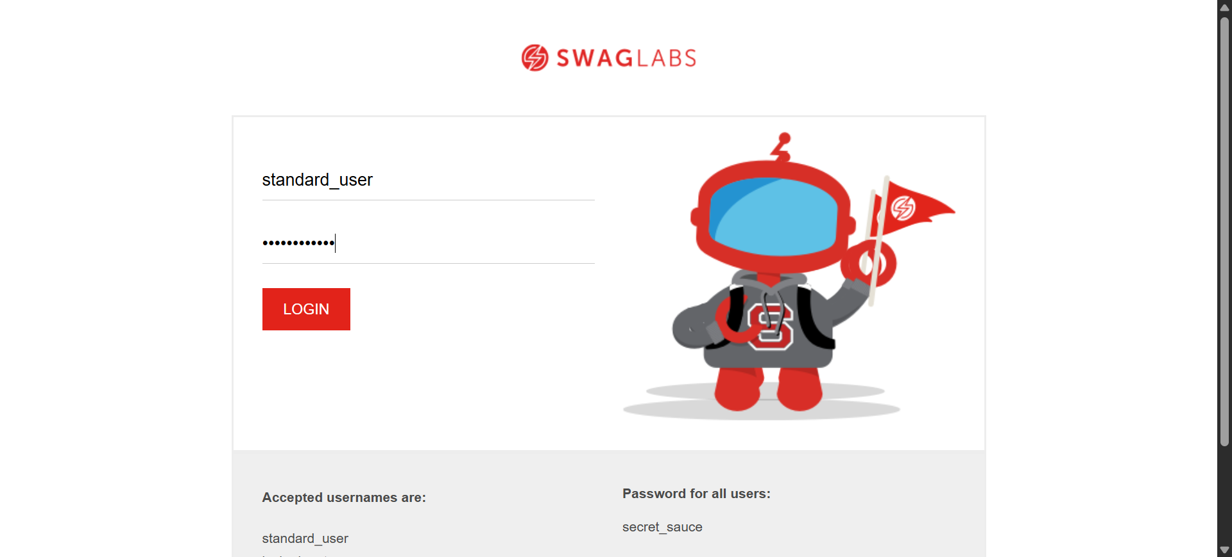

Screenshot added: Selenium/Screenshots/standard_user.png

