Jenkins:

Source Code ---🡪 compile --🡪 syntax check ---🡪 artifact (binary format)

Continuous Integration -🡪 whatever changes are done -- > commit to SCM 🡪 Tester + deployment 🡪 overall progress

Different machine (Environment) -- > Uniform Environment 🡪 bring everything together (Jenkins)

1. Create a key pair

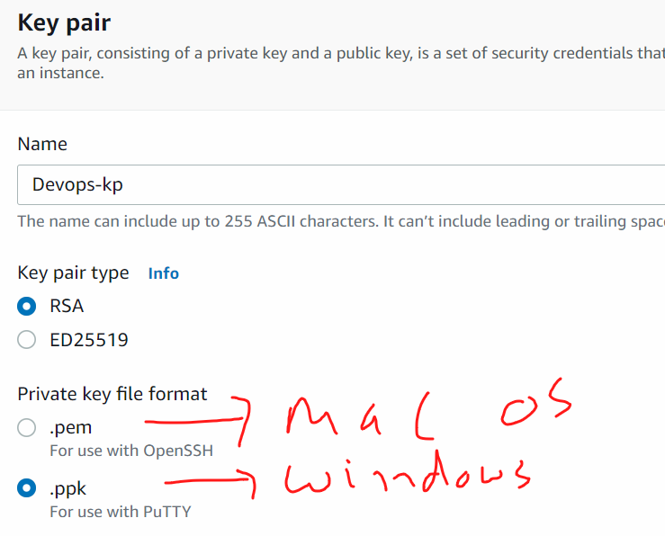

1. Create a Security Group

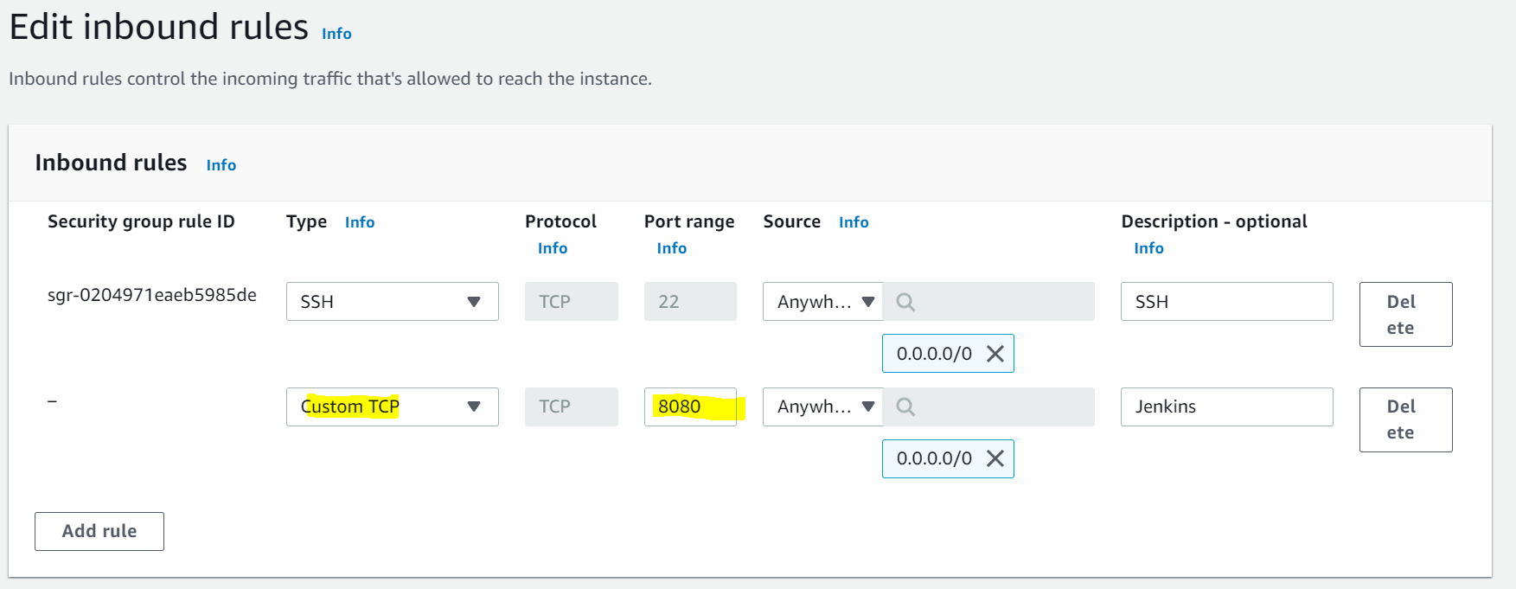

1. Create an Ec2 (Amazon Linux + t2 micro + 8 GB storage + default values)

<https://www.jenkins.io/doc/book/installing/linux/#prerequisites>

### **Red Hat / CentOS -- > Weekly release**

* sudo yum update -y
* sudo su –
* hostname Jenkins-server
* sudo su –
* yum install java-1.8* -y
* java -version
* sudo wget -O /etc/yum.repos.d/jenkins.repo \

https://pkg.jenkins.io/redhat/jenkins.repo

* sudo rpm --import https://pkg.jenkins.io/redhat/jenkins.io.key
* sudo yum install jenkins
* service Jenkins start
* service Jenkins status
* systemctl enable Jenkins

start Jenkins on web: <public-ip>:8080

cat /var/lib/jenkins/secrets/initialAdminPassword

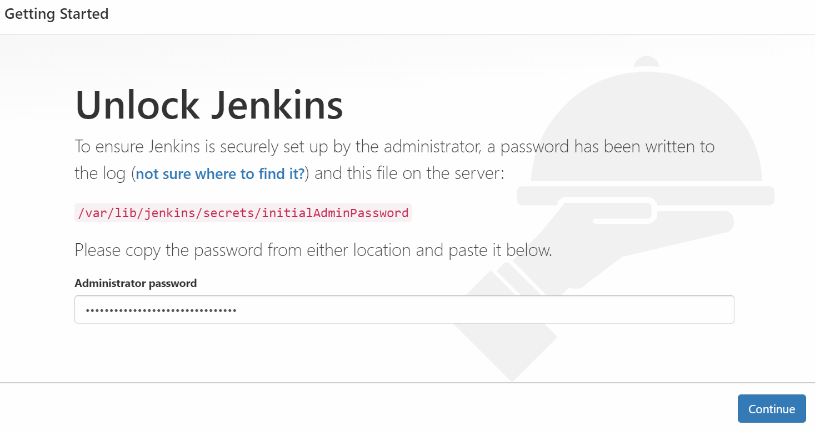

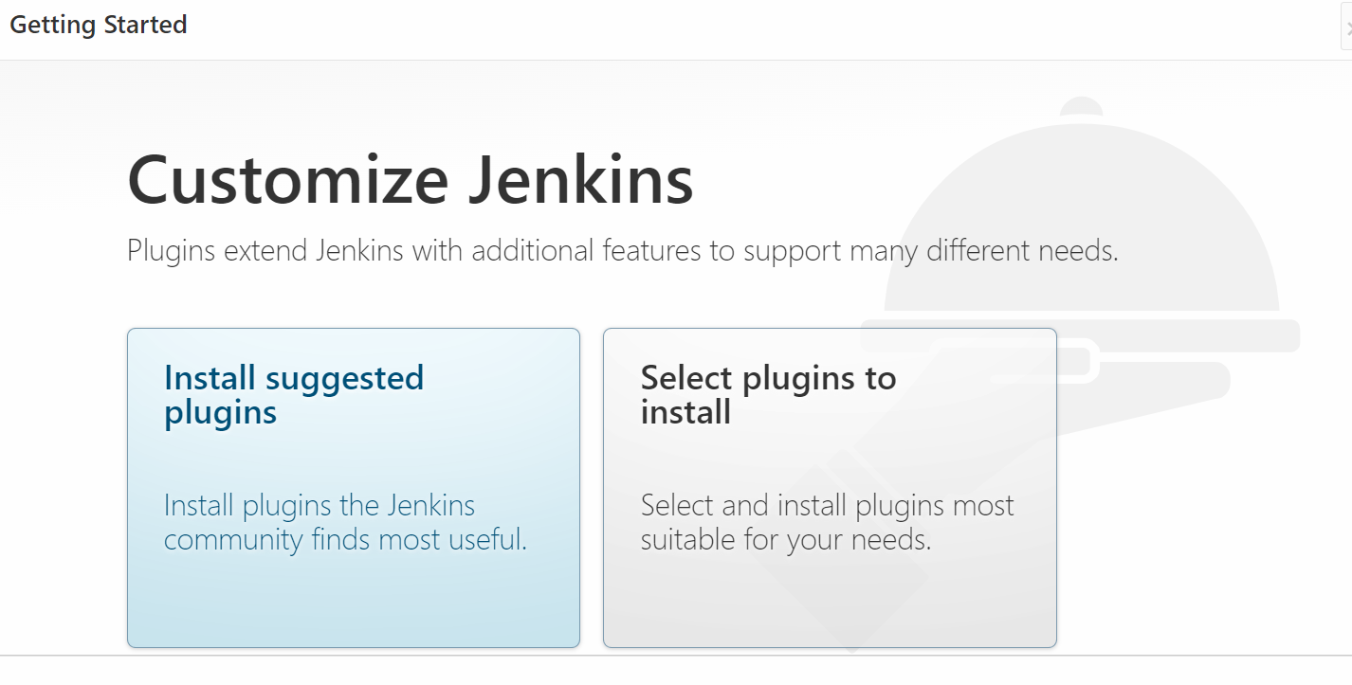

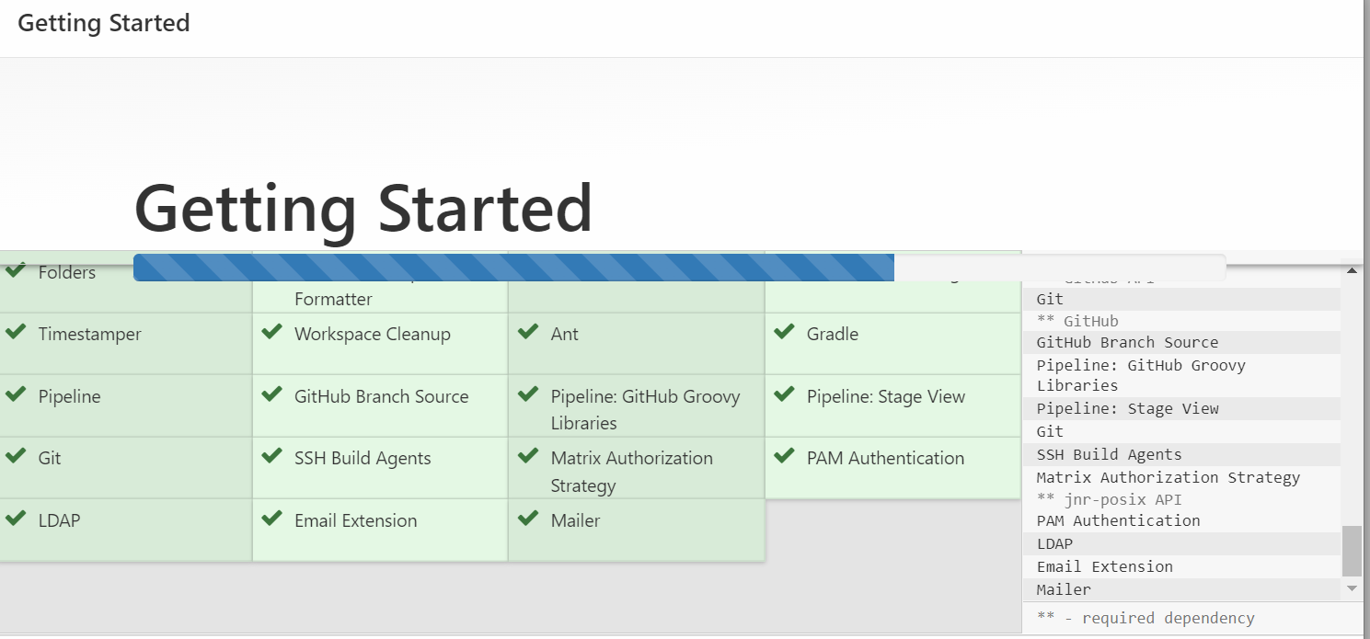

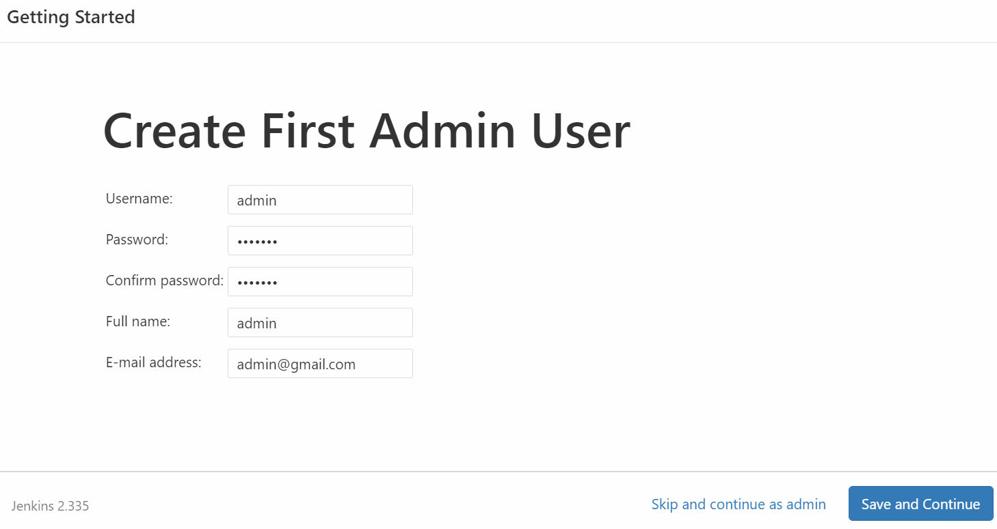

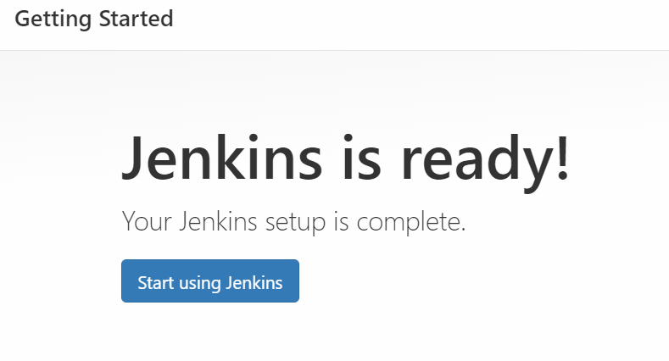

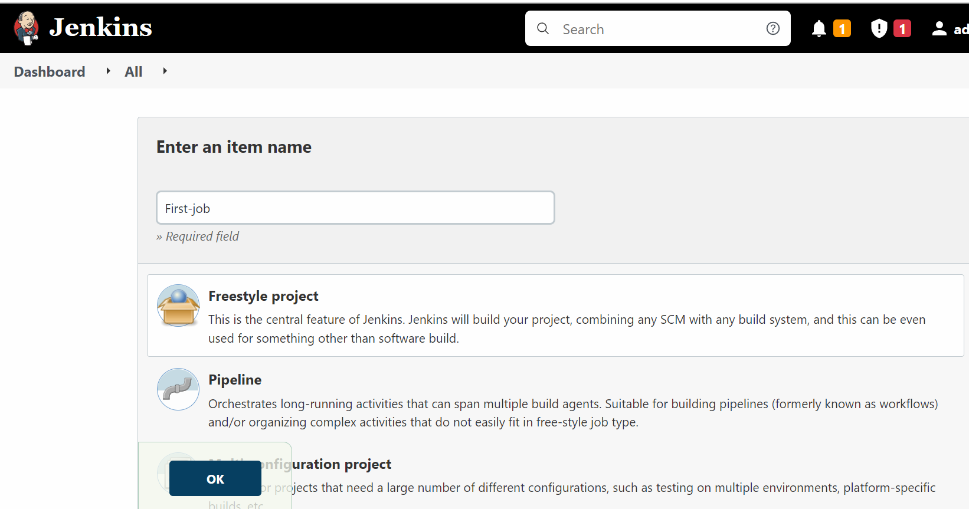

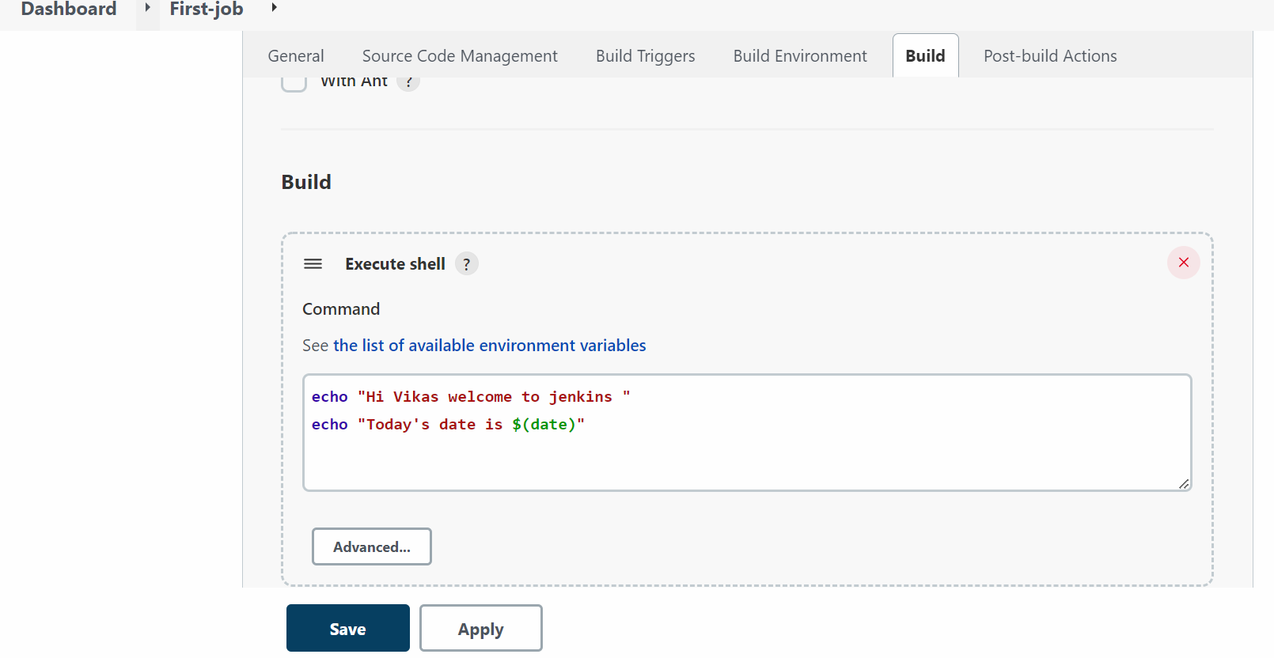

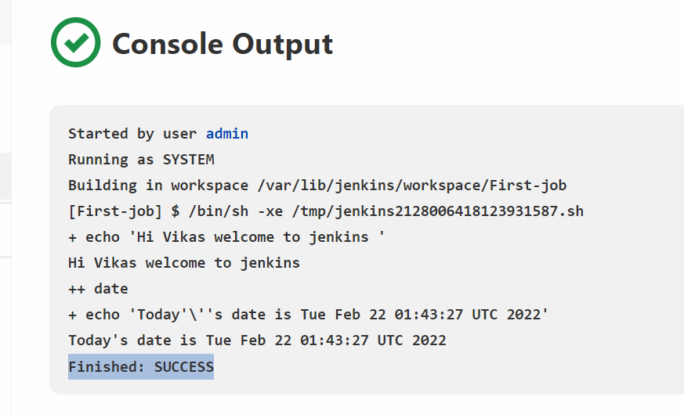

Installation