SOA CAN Module Architecture and Design

Version History

Number | Date | Author | Approver | Revision History | Status
V0.1 | 2026.4.27 | weizhichun |  | create initial version | draft
V0.1 | 2026.4.28 | weizhichun | Li Yijie | Reviewd by lisong and Liyijie | Approved
This document describes the current SOA CAN module architecture in the M-Core project. The focus is the active software path in the current code, not a future target architecture.

1. System Overview
The SOA CAN module is responsible for cyclic transmission and reception on FlexCAN0. In the current project, the active path is:
- PreOS initialization in main() completes FlexCAN controller startup and RX MB configuration.
- Runtime processing is driven by the unified 10 ms FreeRTOS task.
- DBC conversion is handled by the generated SOA_CANdbc_Generated layer.
- The current active cyclic function is AINFC_Can_Cyclic_10ms().
SoaAdapter_Init() is already called during initialization, but SoaAdapter_Main() is not scheduled in the current runtime path.

2. Module Architecture
The current CAN module can be understood as three layers:
- Application Data Layer
  - Uses the generated global structures g_tx_Standard_100_Tx and g_rx_Standard_200_Rx.
- CAN Service Layer
  - AINFC_Can_Cyclic_10ms() drives cyclic RX/TX.
  - FlexCAN_Message_Tx_pack() and FlexCAN_Message_Rx_unpack() connect DBC conversion with CAN send/receive.
  - AINFC_Can_TxMsg() and AINFC_Can_RxMsgL() provide the direct FlexCAN wrapper interface.
- Hardware Layer
  - NXP RTD FlexCAN_Ip APIs access FlexCAN0 message buffers.
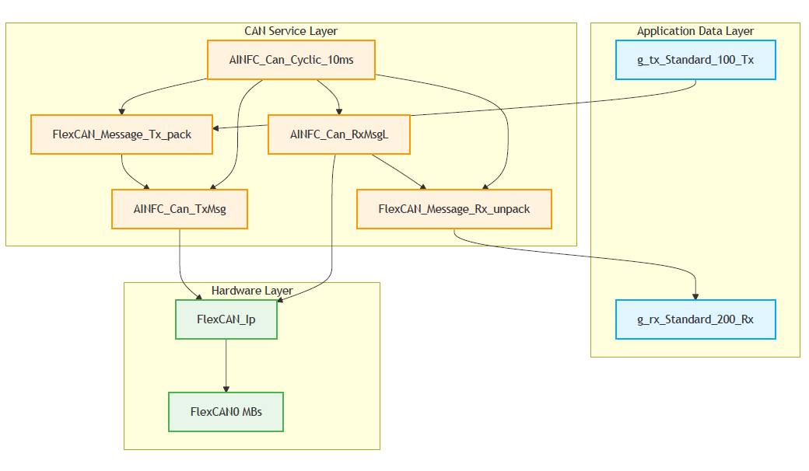

3. Runtime Flow

3.1 Initialization Flow
The CAN-related startup sequence in main() is:
- FlexCAN_Ip_Init()
- FlexCAN_Ip_SetStartMode()
- FlexCAN_Process_Init()
- PICC_PreOS_Init()
- SoaAdapter_Init()
- OsTask_Creation_All()
This means FlexCAN0 is fully initialized before the scheduler starts.

3.2 10ms Cyclic Flow
At runtime, the CAN module is executed from TASK_M0_10MS() inside the unified OS_10ms thread.
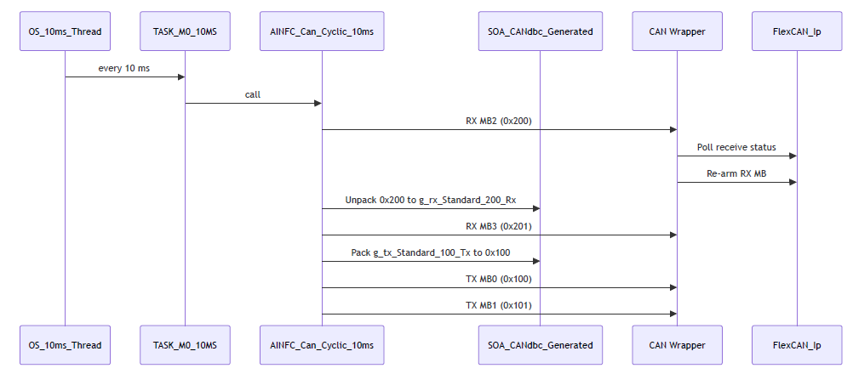
The current code executes this path every 10 ms.

4. Message and MB Mapping
Direction | MB | CAN ID | Usage
TX | MB0 | 0x100 | DBC TX message, source is g_tx_Standard_100_Tx
TX | MB1 | 0x101 | Raw debug frame
RX | MB2 | 0x200 | DBC RX message, target is g_rx_Standard_200_Rx
RX | MB3 | 0x201 | Raw RX frame
The current generated DBC layer only covers:
- 0x100 TX
- 0x200 RX
0x101 and 0x201 are not DBC messages in the current implementation.

5. Key Components and Files
- src/Ecum_Init_Main/EcuM_main_init.c
  - CAN startup entry.
  - Calls FlexCAN initialization and FlexCAN_Process_Init().
- src/Task/Ostask_main.c
  - Runtime scheduling entry.
  - Calls AINFC_Can_Cyclic_10ms() from TASK_M0_10MS().
- COM/FlexCAN_Ip/FlexCAN_Ip_main.c / .h
  - Main CAN business logic.
  - Provides MB mapping, RX/TX wrapper functions and cyclic processing.
- SWC/Soa_Adapter/SOA_CANdbc_Generated.c / .h
  - Generated DBC pack/unpack layer.
  - Provides the global TX/RX message structures.
- SWC/Soa_Adapter/SOA_Adapter.c / .h
  - Current SOA registration layer.
  - SoaAdapter_Init() is active, but SoaAdapter_Main() is not part of the current runtime flow.

6. Current Implementation Notes
- The active CAN runtime path is TASK_M0_10MS() -> AINFC_Can_Cyclic_10ms().
- SoaAdapter_Main() is not scheduled in the current code.
- The generated DBC metadata defines 0x100 and 0x200 as 100 ms messages, but the current runtime path executes every 10 ms.
- 0x100 is generated as a 2-byte DBC message, but the current FlexCAN TX data info is configured with DLC 8.
- FlexCAN_GetBusDiagStatus() exists as a diagnostic interface, but it is not yet integrated into the periodic runtime path.

