M-Core PICC Software Design
Version: 1.0
Date: 2026-01-14
Author: weizhichun (uix08649)
Scope: M-Core (S32G399A M7_0) Inter-Core Communication Implementation

1. Document Overview
This document describes the software architecture design of the M-Core Inter-Core Communication Middleware (PICC - Private Inter-Core Communication). The document adopts a top-down structure, progressing from the system global view to module details, enabling readers to quickly understand the overall architecture before diving into specific implementations.

1.1 Reading Guide
Chapter | Content | Target Audience
Chapter 2 | File List | All readers - Quick overview of involved files
Chapter 3 | System Global View | All readers - Quick overview of overall architecture
Chapter 4 | Layered Architecture | Developers - Understanding layer responsibilities
Chapter 5 | Core Process Diagrams | Developers - Understanding data flow and state transitions
Chapter 6 | Module Detailed Design | Developers - Implementation details reference
Chapter 7 | Task Scheduling Design | Developers - Understanding task execution mechanism

2. File List
File | Type | Description
picc_api.h/c | Header/Source | PICC Unified External Interface
picc_protocol.h/c | Header/Source | Protocol Packet Definition & Processing
picc_service.h/c | Header/Source | Event/Method Service Layer
picc_stack.h/c | Header/Source | Message Stacking & CRC Processing
picc_link.h/c | Header/Source | Application Layer Connection Management
picc_heartbeat.h/c | Header/Source | Channel Layer Heartbeat Detection
picc_trace.h/c | Header/Source | Debug Tracing
picc_pwr_main.h/c | Header/Source | Power Business Interface Layer
picc_pwr_cnf.h/c | Header/Source | Power Module Configuration
Pwsm/pwsm.h/c | Header/Source | Power State Machine
Pwsm/pwsm_cnf.h/c | Header/Source | Power State Machine Configuration
main.c | Source | Main Program Entry

3. System Global View

3.1 System Positioning
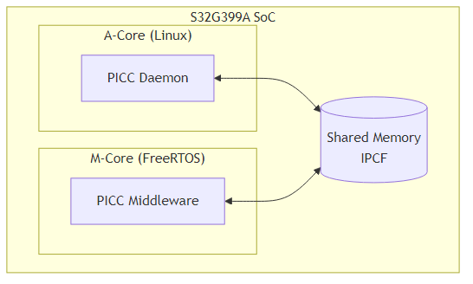
diagram

3.2 Core Concepts Overview
Concept | Description | Example
Provider | Service Provider (Server) | Power Management Module ProviderID=0x01
Consumer | Service Consumer (Client) | A-Core Power Middleware ConsumerID=0x06
Event | Unidirectional Notification (Server→Client) | Power State Notification EventID=1
Method | Request-Response (Client→Server) | Power State Confirmation MethodID=2
Link | Application Layer Connection Handshake | Establish/Disconnect Communication Link
Heartbeat | Channel Layer Health Detection | Ping/Pong Every 2 Seconds
Stack | Message Stacking for Transmission | 10ms Periodic Batch Transmission

3.3 Communication Channel Configuration
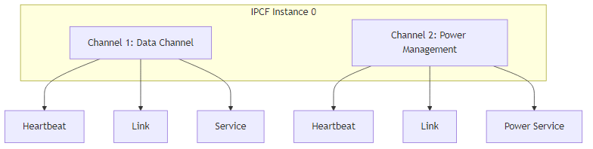
diagram

4. Layered Architecture Details

4.1 Software Layered Structure
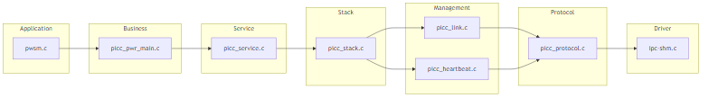
diagram

4.2 Module Responsibility Overview
Layer | Module | Main Responsibility | Key APIs
Application | pwsm.c | Power state machine logic | Pwsm_Main(), Pwsm_CommEvent()
Business Interface | picc_pwr_main.c | Power Event/Method wrapper | Pwr_SendStateNotify(), Pwr_MethodHandler()
Service | picc_service.c | Event/Method send & dispatch | PICC_SendEvent(), PICC_RegisterMethodHandler()
Stack | picc_stack.c | Message stacking, CRC check | PICC_StackAddMessageToChannel(), PICC_StackProcess()
Link | picc_link.c | App-layer connection mgmt | PICC_LinkInit(), PICC_LinkProcess()
Heartbeat | picc_heartbeat.c | Channel health detection | PICC_HeartbeatProcess(), PICC_HeartbeatSendPong()
Protocol | picc_protocol.c | Packet pack/unpack | PICC_PackMessage(), PICC_UnpackMessage()

5. Core Process Diagrams

5.1 System Initialization Process
System initialization uses a high-priority temporary task mode to ensure all modules complete initialization before system operation. The task automatically deletes itself after initialization, releasing resources.
Initialization Steps Description:
- Platform initialization: main() calls Platform_Init() to complete hardware platform initialization
- Create initialization task: Create PICC_Init_Task with priority 4 to ensure priority execution
- Start scheduler: vTaskStartScheduler() starts FreeRTOS scheduling
- Message queue creation: Initialization task first creates the receive message queue g_rxQueue
- IPCF driver initialization: Call ipc_shm_init() to initialize shared memory driver
- Channel initialization: Initialize Channel 1 and Channel 2 separately, Stack and Heartbeat modules for each channel start immediately
- Service layer initialization: PICC_Init() initializes service layer infrastructure
- Link registration: PICC_LinkRegister() registers power management’s application layer connection configuration
- Power module initialization: Pwr_Init() registers Method handler callback functions
- Task self-deletion: Delete self after initialization complete, release stack space
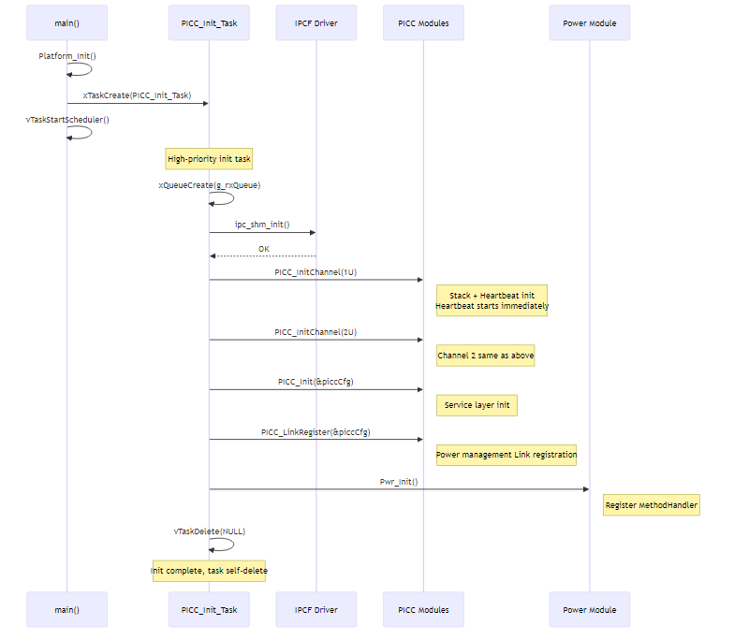
diagram

5.2 Message Send/Receive Process

5.2.1 Send Process (M-Core → A-Core)
Message sending uses a stacking buffer + periodic send mechanism to improve transmission efficiency by reducing the number of underlying calls.
Send Process Description:
- Application layer call: Application calls PICC_SendEvent() or PICC_ServiceMethodSend() to initiate send
- Message packing: Service layer calls PICC_PackMessage() to encapsulate data into protocol packet (8-byte header + Payload)
- Add to stacking buffer: Call PICC_StackAddMessageToChannel() to add message to the corresponding channel’s stacking buffer
- Trigger condition check:
  - If buffer not full: Wait for 10ms periodic task to trigger
  - If buffer nearly full: Trigger send immediately to avoid message loss
- Periodic send processing: PICC_StackProcess() executes every 10ms, calls PICC_StackDoSendForChannel()
- Remote ready check: Call ipc_shm_is_remote_ready() to check if A-Core is ready
- Acquire send buffer: Call ipc_shm_acquire_buf() to get IPCF shared memory send buffer
- Fill data: Fill in sequence: CRC_Enable(1B) + protocol data + Counter(2B) + CRC16(2B)
- Low-level send: Call ipc_shm_tx() to send complete stacked packet to shared memory
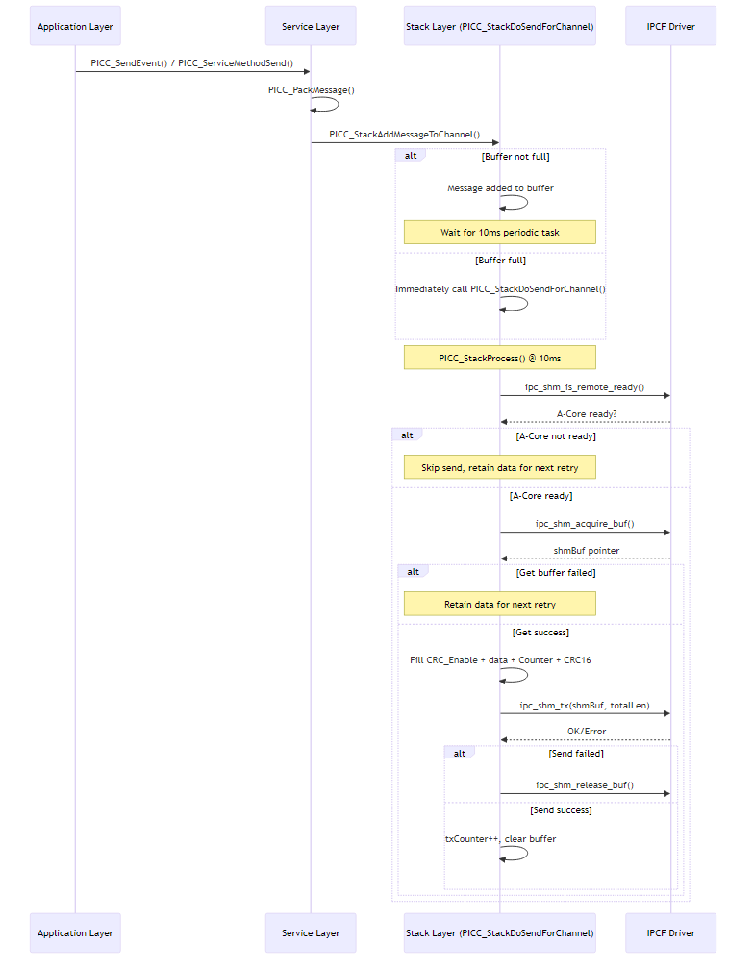
diagram

5.2.2 Receive Process (A-Core → M-Core)
Message receiving uses an interrupt-triggered + task processing mechanism to ensure real-time performance while avoiding complex operations in ISR.
Receive Process Description:
- Interrupt triggered: After A-Core sends data, IPCF driver triggers data_chan_rx_cb interrupt callback
- Message enqueue: In ISR, only encapsulate message pointer and metadata, push to FreeRTOS queue g_rxQueue, no complex processing
- Task wakeup: App_Rx_Msg_10ms_Task retrieves message from queue (blocking wait)
- Stacking unpack: PICC_StackProcessRx() first verifies CRC16 and Counter
- Layered processing:
  - Heartbeat (Stack layer): Heartbeat packets are directly identified and processed in PICC_StackProcessRx(), not passed to upper layer
  - Link (API layer): Intercepted in PICC_ProcessSingleMessage() and routed to PICC_LinkProcessMessage()
  - Service (Service layer): Other messages enter PICC_ServiceProcessMessage() for dispatch to application callbacks
- Release buffer: After processing, call ipc_shm_release_buf() to release shared memory buffer
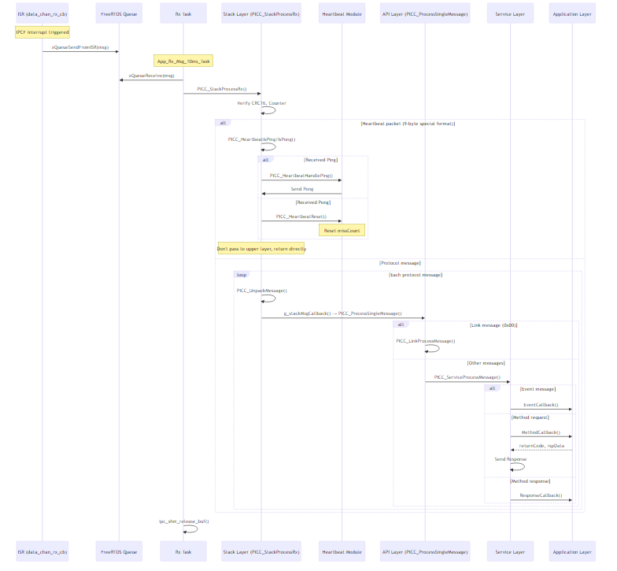
diagram

5.2.3 PICC_ServiceProcessMessage Message Dispatch Flow
PICC_ServiceProcessMessage() is the core message dispatch function of the service layer, routing messages to different handler functions based on MessageType.
Message Type to Handler Function Mapping:
[!NOTE] PICC_MSG_LINK_AVAILABLE (0x00) messages are intercepted in the upper layer PICC_ProcessSingleMessage() and routed to PICC_LinkProcessMessage(), they do not enter PICC_ServiceProcessMessage().
MessageType (Hex) | Message Type | Handler Function | M-Core Role | Description
0x05 | REQUEST | PICC_ServiceHandleRequest() | Server | Method request with response
0x06 | REQUEST_NO_RETURN_WITH_ACK | PICC_ServiceHandleRequest() | Server | Request without response but with ACK
0x07 | REQUEST_NO_RETURN_WITHOUT_ACK | PICC_ServiceHandleRequest() | Server | Request without response or ACK
0x08 | NOTIFICATION_WITH_ACK | PICC_ServiceHandleEvent() | Client | Event notification with ACK
0x09 | NOTIFICATION_WITHOUT_ACK | PICC_ServiceHandleEvent() | Client | Event notification without ACK
0x80 | RESPONSE | PICC_ServiceHandleResponse() | Client | Method response (async callback)
0x81 | ACK | Ignored | - | Method middleware confirmation
0x82 | EVENT_ACK | Ignored | - | Event middleware confirmation
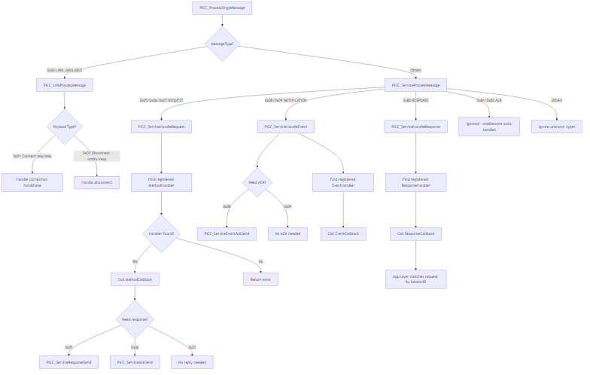
diagram
Detailed Description of Each Processing Branch:
- PICC_LinkProcessMessage (Link Management) - Called in PICC_ProcessSingleMessage
  - Handles connection request, connection response, disconnect notification, disconnect response
  - Maintains Link state machine (DISCONNECTED/CONNECTING/CONNECTED)
- PICC_ServiceHandleRequest (M-Core as Server)
  - Receives Method requests sent by A-Core Client
  - Calls the callback registered by the application layer via PICC_RegisterMethodHandler()
  - Determines reply method based on request type (Response/ACK/no reply)
- PICC_ServiceHandleEvent (M-Core as Client)
  - Receives Event notifications sent by A-Core Server
  - If message type is NOTIFICATION_WITH_ACK, automatically replies EVENT_ACK
  - Calls the callback registered by the application layer via PICC_RegisterEventHandler()
- PICC_ServiceHandleResponse (M-Core as Client)
  - Receives responses from A-Core Server to M-Core Method requests
  - Calls the callback registered by the application layer via PICC_RegisterResponseHandler()
  - Application layer matches original request by SessionID
[!NOTE] ACK type messages (0x81/0x82) are handled internally by middleware, not reported to application layer. Due to real-time requirements, M-Core does not block waiting for ACK return after sending messages with ACK.

5.3 Connection State Machine
The Link layer implements application-level connection management. M-Core can act as Client or Server, with different state machine behaviors for each role.
[!NOTE] M-Core’s role is determined by application layer configuration. For example, in the power management module, M-Core is configured as Server (ProviderID=0x01), and A-Core is Client (ConsumerID=0x06).

5.3.1 State Machine When M-Core Acts as Client
When M-Core acts as Client, it needs to actively initiate connection requests to A-Core (Server).
State Transition Trigger Conditions:
- Initialization → CONNECTING: When role == CLIENT is detected in PICC_LinkInit(), it is directly set to CONNECTING state
- CONNECTING → CONNECTED: Received connection confirmation from Server (ReturnCode=0x00)
- CONNECTING → DISCONNECTED: Received rejection response from Server (ReturnCode!=0x00)
- CONNECTED → CONNECTING: After receiving disconnect notification, immediately re-enter CONNECTING state for automatic reconnection
- CONNECTED → CONNECTING: Heartbeat timeout triggers PICC_LinkTriggerReconnect()
- CONNECTING (no response): Continuously send requests at 10ms period with exponential backoff (10→20→40→80→100 cycles)
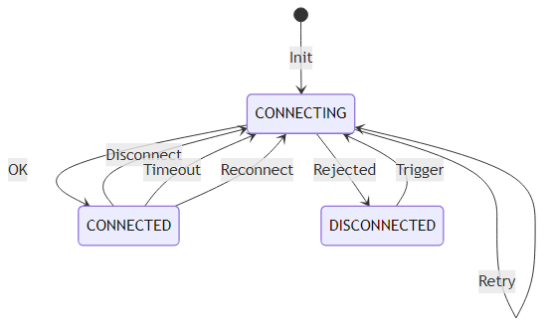
diagram
Client Mode Key Behaviors:
State | Behavior Description
CONNECTING | PICC_LinkProcess() calls PICC_LinkSendMessage() every 10ms to send connection request; exponential backoff enabled on send failure (100ms→200ms→400ms→800ms→1000ms)
CONNECTED | Can send Method requests, listen for Server’s Event notifications
DISCONNECTED | Wait for application layer to trigger reconnection (current code enters this state when Server rejects)
[!NOTE] Exponential Backoff Mechanism: When send buffer is full or send fails, PICC_LinkProcess() uses exponential backoff to avoid frequent retries. Sequence: 10→20→40→80→100 cycles (i.e., 100ms→200ms→400ms→800ms→1000ms).

5.3.2 State Machine When M-Core Acts as Server
When M-Core acts as Server, it is in a passive waiting state, waiting for A-Core (Client) to initiate connection requests.
State Transition Trigger Conditions:
- Initialization → DISCONNECTED: When role == SERVER is detected in PICC_LinkInit(), set to DISCONNECTED state
- DISCONNECTED → CONNECTED: Received connection request from Client, enter CONNECTED after sending confirmation
- CONNECTED → DISCONNECTED: Received disconnect notification or Heartbeat timeout
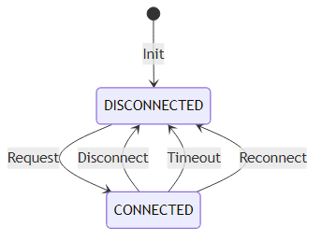
diagram
Server Mode Key Behaviors:
State | Behavior Description
DISCONNECTED | Passively wait for Client to initiate connection request, PICC_LinkHandleRequest() handles received requests
CONNECTED | Can send Event notifications, handle Client’s Method requests
[!IMPORTANT] In Server mode there is no CONNECTING state. After receiving Client request, PICC_LinkHandleRequest() sends confirmation response and directly enters CONNECTED state.

5.3.3 Link Message Subtypes
Subtype | Enum Value | Description
PICC_LINK_CONNECT | 0x01 | Connection request/response
PICC_LINK_DISCONNECT | 0x02 | Disconnect notification/response
PICC_LINK_RECONNECT | 0x03 | A-Core Server restart notification, triggers Client to reconnect

5.4 Heartbeat Detection Mechanism
The Heartbeat layer implements channel-level health detection, running independently of Link connection state. Heartbeat is always working regardless of whether the application layer is connected.
Heartbeat Mechanism Key Parameters:
Parameter | Value | Description
Period | 2000ms | Send Ping every 2 seconds
Timeout Threshold | 3 times | Fault determined after 3 consecutive missed Pongs
Packet Format | 9 bytes | Fixed format, does not follow standard protocol header
Heartbeat Workflow:
- Normal case: M-Core sends Ping every 2 seconds, A-Core immediately replies Pong upon receipt, M-Core resets miss_count after receiving Pong
- Anomaly detection: If Pong is not received after Ping is sent, miss_count increments
- Fault determination: When miss_count >= 3, channel fault is determined
- Fault handling:
  - Call PICC_LinkTriggerReconnect() to set Link state to DISCONNECTED
  - Notify application layer via callback
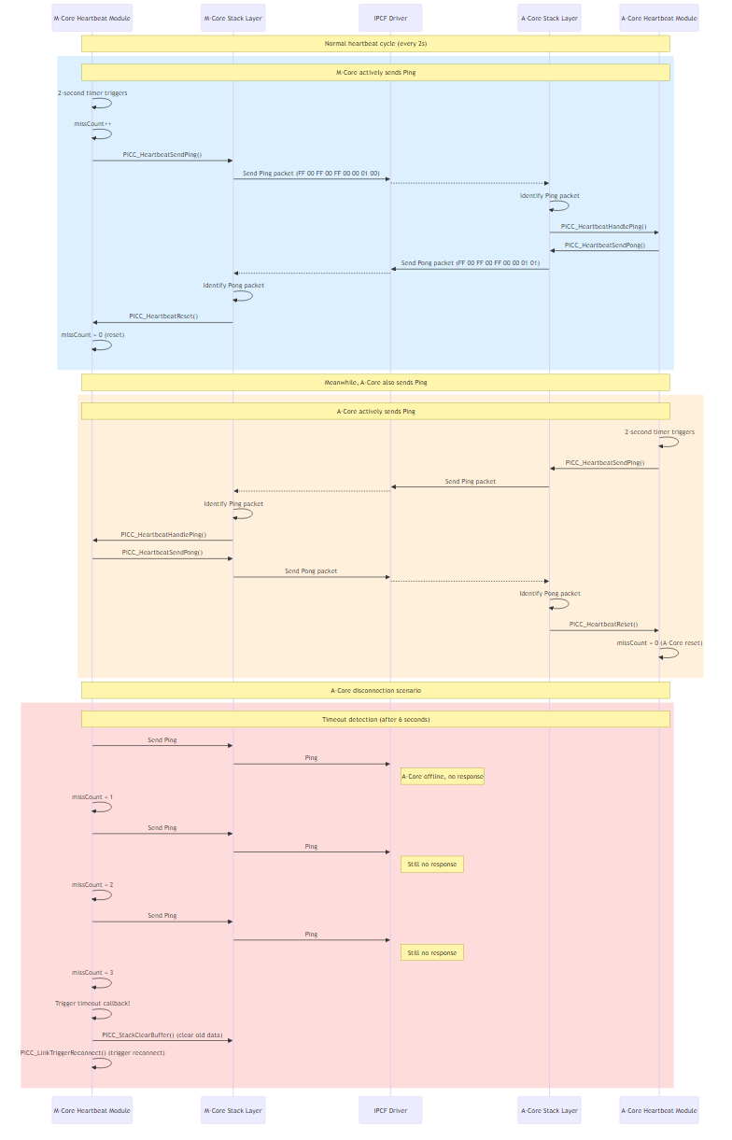 Key Notes: 1. M-Core sends Ping: Actively sends every 2 seconds, expecting Pong from A-Core 2. M-Core receives Ping: When A-Core sends Ping, M-Core immediately replies Pong (does not affect its own missCount) 3. M-Core receives Pong: Received A-Core’s reply to its own Ping, resets missCount=0 4. Independent counting: M-Core and A-Core each maintain their own missCount, not affecting each other 5. Timeout trigger: After 3 consecutive misses (6 seconds), clear buffer and reconnect —

6. Module Detailed Design

6.1 Protocol Packet Format

6.1.1 Protocol Header Structure (8 bytes)
diagram

6.1.2 Stacked Packet Format
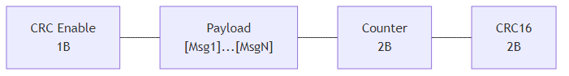
diagram
CRC Enable: 0x00 = Enable, 0x01 = Disable

6.1.3 Message Type Enumeration
Value (Hex) | Name | Direction | Description
0x00 | LINK_AVAILABLE | Bidirectional | Connection/disconnect handshake
0x05 | REQUEST | Client→Server | Method request with response
0x06 | REQUEST_NO_RETURN_WITH_ACK | Client→Server | No response but with ACK
0x07 | REQUEST_NO_RETURN_WITHOUT_ACK | Client→Server | No response no ACK
0x08 | NOTIFICATION_WITH_ACK | Server→Client | Event with ACK
0x09 | NOTIFICATION_WITHOUT_ACK | Server→Client | Event without ACK
0x80 | RESPONSE | Server→Client | Method response
0x81 | ACK | - | Method confirmation
0x82 | EVENT_ACK | Client→Server | Event confirmation

6.2 CRC16 Algorithm
/* Algorithm parameters (must be consistent with A-Core) */
#define xorValueCrc16 0x0000U
#define startValueCrc16 0xFFFFU
/* Lookup table in picc_protocol.c */
uint16 PICC_CRC16(const uint8 *data, uint32 len);

6.3 Key Data Structures

6.3.1 PICC Initialization Configuration
typedef struct {
uint8 linkLocalId; /* Local ID (Client=ConsumerID, Server=ProviderID) */
uint8 linkRemoteId; /* Remote ID (Client=ProviderID, Server=ConsumerID) */
PICC_Role_e linkRole; /* Role: PICC_ROLE_CLIENT / PICC_ROLE_SERVER */
uint8 channelId; /* IPCF Channel ID */
} PICC_InitConfig_t;

6.3.2 Link Context
typedef struct {
PICC_LinkConfig_t config; /* Link configuration */
volatile PICC_LinkState_e state; /* Current state */
boolean isInitialized; /* Whether initialized */
} PICC_LinkContext_t;

6.4 Asynchronous Send and Request Mechanism
Due to M-Core’s real-time requirements, synchronous blocking wait is not supported. All send operations are asynchronous, with results obtained via callbacks or flag polling.

6.4.1 Asynchronous Send Implementation Principle
M-Core’s asynchronous sending is based on message stacking + periodic flush mechanism:
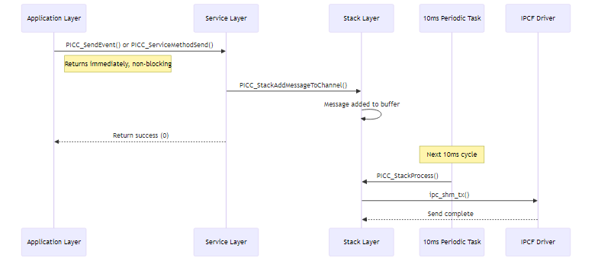
diagram
Key Function Descriptions:
Function | File | Functionality | Return Value
PICC_SendEvent() | picc_service.c | Send Event notification | 0=success, non-0=fail
PICC_ServiceMethodSend() | picc_service.c | Send Method request | SessionID (>0=success)
PICC_StackAddMessageToChannel() | picc_stack.c | Add message to stack buffer | 0=success
PICC_StackProcess() | picc_stack.c | Periodic buffer flush | None

6.4.2 Async Method Request and Response Matching
When M-Core acts as Client to send Method requests, it needs to match requests and responses via SessionID.
Request Flow:
- Call PICC_ServiceMethodSend() to send request
- Function returns auto-allocated SessionID (1~255 cycling)
- Application saves this SessionID for later matching
Response Receive Flow:
- Register response callback: PICC_RegisterResponseHandler(callback)
- When Response is received, middleware calls the callback function
- In the callback, match original request by sessionId parameter
/* Response callback function prototype */
typedef void (*PICC_ResponseCallback_t)(
uint8 providerId, /* Service Provider ID */
uint8 methodId, /* Method ID */
uint8 sessionId, /* Session ID for request matching */
uint8 returnCode, /* Return code */
const uint8 *rspData, /* Response data */
uint16 rspLen /* Response data length */
);

6.4.3 Asynchronous Receive Processing Mechanism
M-Core uses flag polling mode to receive messages:
diagram
Processing Stages: | Stage | Context | Function | Description | |——-|———|———-|————-| | 1 | ISR | data_chan_rx_cb | Enqueue message to FreeRTOS queue | | 2 | Rx Task | PICC_ServiceProcessMessage | Dispatch and call callback | | 3 | App Task | Pwsm_Main | Poll flag every 10ms |
Why not process business logic directly in callback:
- Callback executes in Rx task context with higher priority
- Complex state machine logic may cause unpredictable task execution time
- Flag decoupling ensures state machine executes in fixed 10ms cycle

6.5 Debug Diagnostic Variables
To facilitate problem analysis using TRACE32 or other debug tools, the system provides multiple global diagnostic variables.

6.5.1 Communication Trace Variables (g_piccTrace)
Location: picc_trace.c / picc_trace.h
Purpose: Record recent TX/RX messages for analyzing communication content.
extern PICC_ChannelTrace_t g_piccTrace;
Member | Type | Description
g_piccTrace.tx.data[row][0] | uint8 | Send channel ID
g_piccTrace.tx.data[row][1] | uint8 | Send data length
g_piccTrace.tx.data[row][2..] | uint8[] | Send data content
g_piccTrace.tx.writeIndex | uint8 | Current write row index (0~9 cycling)
g_piccTrace.rx.data[row][0] | uint8 | Receive channel ID
g_piccTrace.rx.data[row][1] | uint8 | Receive data length
g_piccTrace.rx.data[row][2..] | uint8[] | Receive data content
g_piccTrace.rx.writeIndex | uint8 | Current write row index (0~9 cycling)
Usage: Observe g_piccTrace.tx.data and g_piccTrace.rx.data arrays in TRACE32.

6.5.2 Power Module Diagnostic Variables (g_pwrDiag / g_pwsmDiag)
Location: picc_pwr_main.c
Purpose: Track key events and counts during power shutdown process.
Variable | Description
g_pwrDiag.methodHandlerCallCount | Pwr_MethodHandler() total call count
g_pwrDiag.doneHandlerCallCount | Method ID=8 process count
g_pwrDiag.stateAckHandlerCallCount | Method ID=2 process count
g_pwrDiag.ctrlAckHandlerCallCount | Method ID=11 process count
g_pwrDiag.phase1DonePayloadByte0 | Last ID=8 payload[0]
g_pwrDiag.phase1DoneFlagSetCount | Flag set count
g_pwrDiag.lastMethodId | Last processed MethodID
g_pwrDiag.lastSendCtrlCmdResult | Pwr_SendCtrlCmd() return value
g_pwsmDiag.commEventCallCount | Pwsm_CommEvent() call count
g_pwsmDiag.timeoutCounterAtFlagSet | Timeout counter value at flag set
g_pwsmDiag.transitionToTxId4 | Whether transitioned to send ID=4 state
g_pwsmDiag.transitionToShutdownDone | Whether transitioned to shutdown done state

6.5.3 Link/Stack State Variables
Location: picc_link.c / picc_stack.c
Variable | Description | Observation Method
g_linkContexts[i].state | Link connection state | View PICC_LinkState_e enum value
g_linkContexts[i].isInitialized | Whether initialized | TRUE/FALSE
g_linkContexts[i].config.role | Role (Client/Server) | View PICC_Role_e enum value
g_stackInstances[i].context.usedSize | Current pending send buffer length | Numeric value
g_stackInstances[i].context.txCounter | Send counter | Cumulative value
g_stackInstances[i].context.rxCounter | Receive counter | Cumulative value

6.5.4 Application Layer Statistics Variables (App_Data_t)
Location: main.c
Variable | Description
g_appData.rx_count | Receive message count
g_appData.tx_count | Send/process message count
g_appData.error_count | Error count
g_appData.last_error | Last error code
g_appData.link_state | Link connection state
g_appData.last_rx_ch | Last receive channel

7. Task Scheduling Design

7.1 FreeRTOS Task List
Task Name | Priority | Stack Size (words) | Stack Size (Bytes) | Function | Lifecycle
PICC_Init_Task | 4 (Highest) | 256 | 1024 (1KB) | One-time init | Self-delete after init
App_Rx_Msg_10ms_Task | 3 | 192 | 768 | Message RX process | Permanent
task_M7_0_10ms | 2 | 256 | 1024 (1KB) | Periodic task | Permanent

7.2 10ms Periodic Task Content
void task_M7_0_10ms(void *pvParameters)
{
for(;;) {
/* 1. Stack layer: Send stacked messages in buffer */
PICC_StackProcess();
/* 2. Heartbeat layer: Send Ping every 2000ms, check timeout */
PICC_HeartbeatProcess();
/* 3. Link layer: Send connection request every 10ms in Client mode */
PICC_LinkProcess();
/* 4. Power state machine */
Pwsm_Main();
vTaskDelayUntil(&xLastWakeTime, pdMS_TO_TICKS(10));
}
}

Appendix A: Packet Examples

A.1 Connection/Disconnection Packet Examples
Step | Direction | Description | Protocol Header (Hex) | Payload (Hex)
1 | Client→Server | Connection request | 01 00 06 0000 01 00 05 | 01 (Connect)
2 | Server→Client | Connection confirm | 01 00 06 0000 00 00 05 | 01 (Connect)
3 | Server→Client | Disconnect notify | 01 00 06 0000 01 00 01 | 02 (Disconnect)
4 | Client→Server | Disconnect confirm | 01 00 06 0000 00 00 01 | 02 (Disconnect)
[!NOTE]
Power Management Example: M-Core is SERVER, A-Core is Client. The following uses ProviderID=0x01, ConsumerID=0x06 as example values.
- ProviderID=0x01, ConsumerID=0x06
- MessageType=0x00 (LINK_AVAILABLE)
- ReturnCode: 0x01=Disagree/Requesting, 0x00=Agree
- Payload[0]: 0x01=Connect packet, 0x02=Disconnect packet
- Length: Connect=0x0005, Disconnect=0x0001

A.2 Heartbeat Packet Examples
Step | Direction | Description | Complete Packet (Hex)
1 | M→A | Ping | FF 00 FF 00 FF 00 00 01 00
2 | A→M | Pong | FF 00 FF 00 FF 00 00 01 01
[!NOTE] Heartbeat packets are fixed at 9 bytes and do not follow the standard protocol header. Last byte: 0x00=Ping, 0x01=Pong

Appendix B: Design Constraints and Notes
[!IMPORTANT] M-Core Real-time Constraint: M-Core does not support synchronous waiting, all operations must be asynchronous.
[!WARNING] Heartbeat Independence: Heartbeat starts immediately after channel initialization, independent of Link connection state.
[!CAUTION] Counter Non-reset: M-Core’s send counter (Stack layer) must not be reset to zero after disconnect and reconnect.
[!NOTE] SessionID Range: 0x01~0xFF, rolls back to 0x01 after reaching 0xFF, only used for Event with ACK and async Method.

End of Document

