MirTools – Uage Guide

Dev

Testable function:

Main tab in the ribbon, Library group, Open.

You can open one or multiple files to the MDI container (the main form).

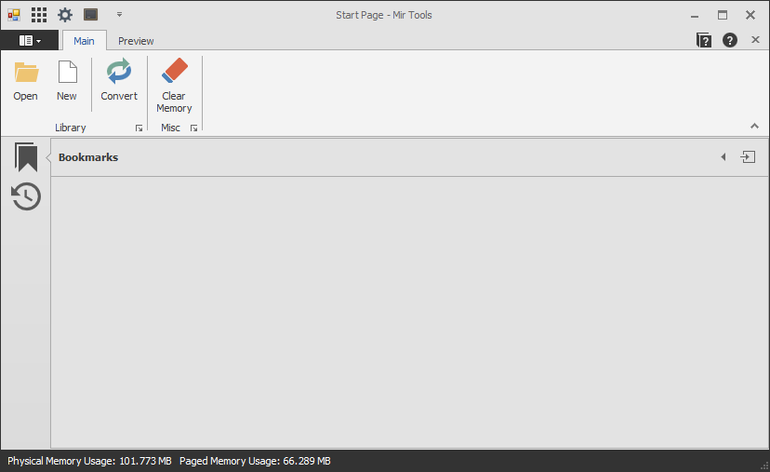

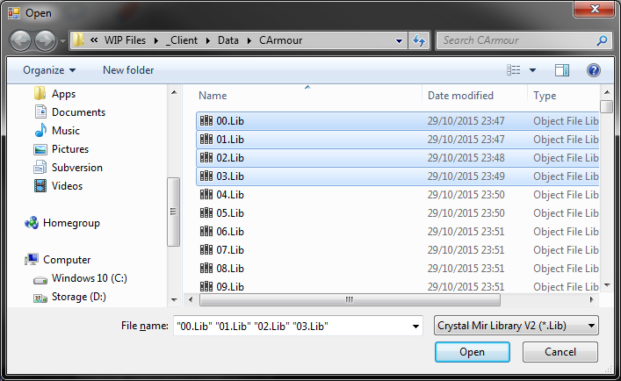

Currently it can open an unlimited number of files (in 64-Bit application, 2GB Max (RAM) in 32-Bit application) but the more you open in parallel the higher the chance the application may slow down during the opening process. In testing I have been able to push this to a 12GB RAM usage.

Preview tab on the ribbon, Folder:

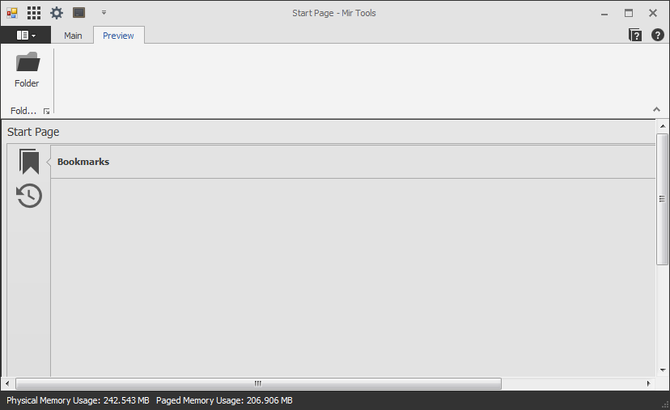

Click the ellipsis in the textbox next to ‘Library Folder’ and select a folder from the Clinet/Data folder

The ‘Library Type’ should generate the appropriate value, this will be user changeable incase they care looking at a nonstandard folder and would like it to load differently.

Under Additional:

**Crop Image**: If the image contains empty rows or columns they will be removed to just show the nonempty colour cells.  
Uncheck this for increased performance.

**Sleep Thread**: With the new optimized loading code the application can open and generate the preview box faster than the form can load which makes it look like the window is unresponsive. Sleeping the thread adds a 1.5 second delay before starting to load images and a 25ms wait before loading the next library, it makes the application run slower, but makes it look like it is running quick.  
Uncheck this for increased performance but lower visual aesthetics.

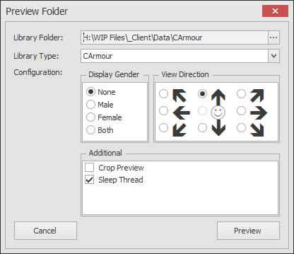

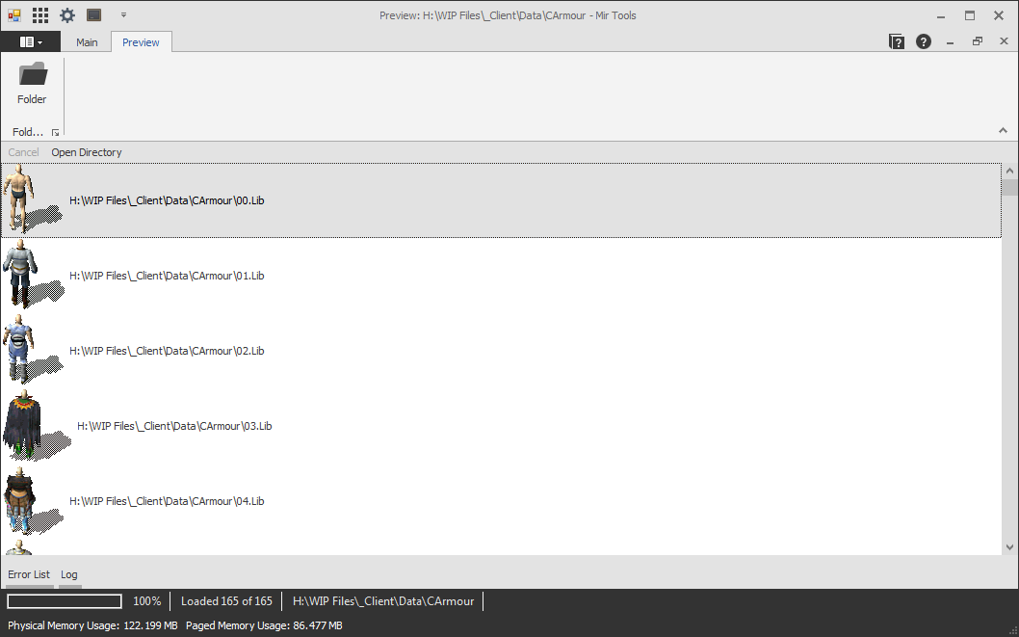

Once a folder has been loaded, double click an entry to open the library.

During load process (with Thread Sleep checked) there is a ‘Cancel’ button in the menu, this will cancel loading the remaining libraries.

Clicking the ‘Open Directory’ button on the menu, or the path in the footer will open the directory of the preview files