Version 2 Artisan 10D

Artisan

|  |  |
| --- | --- |
| Model 10D Operator’s Manual | **Artisan model 10D is the tenth design in the Sculptor series of tissue tightening devices manufactured by Aesthetic ProTools, Inc. It is the first design with two handpieces that can be used at the same time. Significant tissue tightening and thermal lipolysis are achievable using this device. Looking your best is now just a choice.**  Aesthetic ProTools, Inc.  (480)291-5880 |

**What can a Certified Artisan Technician (CAT) and an Artisan achieve?**

* Smoother skin appears more youthful
* Reduction of the appearance of rhytids (wrinkles)
* Reduction of loose, flaccid skin on the face
* Improvement in the appearance of acne scars and other hypertrophic scars
* Lip enhancements that last for years
* Reduction of enlarged pores improves the texture of the skin
* Provides a healthier, more youthful appearance
* Improved facial symmetry
* Reduction of flaccidity in the abdomen, back of the arm, on the buttocks, etc.
* Combined with solutions such as lipo-dissolve and technologies such as Endermologie, a significant improvement in the appearance of cellulite is possible.
* Along with collagen synthesis, Sculptor can help the appearance of sun damaged or aged hands, feet, faces, etc.
* Effective reduction treatment for most stretch marks
* Selective reduction of adipose tissue bulk (small areas)
* Reduction in scar structures resulting in improved appearance
* New collagen-based treatments are being developed for this device

**TECHNOLOGY**

**KEY POINTS**

1. Skin preparation is essential for maximizing energy efficacy and results
2. Optimal results can best be achieved when the body is well hydrated. Poor hydration can reduce results by up to 50%.
3. Taking doses of 1000 mg Vitamin C with Flavonoids twice a day assists in rebuilding collagen volume when performing collagen synthesis.
4. Near Infrared energy, 808 nm+ wavelength, is synergistically useful for creating new collagen growth resulting in improved dermal collagen density and some skin tightening (neocollagenesis/photocollagenesis)
5. High Frequency micro current energy can be used to modify selected skin areas producing a selective contouring also described as a "skin tightening" effect
6. HFMC energy can be used to stimulate the release of Free Fatty Acids from adipose tissue storage areas

Collagen synthesis and APT: Artisan™ technologies can be used together for a synergistic effect. Artisan’s tightening and remodeling effect is due to the action of High Frequency Micro Current (HFMC) energy on the water in the Glycine amino acid portion of the collagen fiber: there is immediate collagen fiber shrinkage and tissue compacting. A secondary effect of dermal tightening is caused by heating of collagen fibers in the extra cellular matrix by the HFMC Skin Tightening process in the dermal tissue. Repeated stimulation by thermal injury of the extra cellular matrix initiates a cascade of inflammatory processes including long term collagen remodeling and, potentially, fibroblast proliferation throughout the treatment area. This effect is more pronounced following 4-6 weeks of treatments when by cellular division additional fibroblasts may grow in the inflammatory area subsequent to the increased production demand for new collagen fibers.

***No heat:***

***If you are troubleshooting a no heat output problem, do the following:***

*Verify (+) positive to (+) positive connection on the back panel.*

*Verify (-) negative to (-) negative connection on the back panel.*

*The electrodes cannot be reversed and still work effectively*

*Remove each and reattach all electrodes. Push the BNC connector on and turn it ¼ turn clockwise to lock it.*

1. *Remove and reattach the electrode. Look at the center pin. Is it there? Did it unscrew? Is it stuck in the handpiece? If so, take it out with a needle nosed plier and screw it back on the electrode.*
2. *Does the electrode screw in far enough to be flush to the handpiece face? If not, change electrodes, for now, and contact APT Service for a replacement electrode.*
3. *Is the display working? Are there characters on the display? If not, you may have a fuse or other electrical problem.*

**Artisan terms and definitions**

**Treatment Patterns**

Small Circles- overlapping 10 percent to build heat.

**1. Circles**

**2. Lengthwise**

Lengthwise- This movement is used to spread heat.

Horizontal Movement. This movement is used to spread heat.

**3. Horizontal**

C Patterns- Are used around the eye area and mouth, ear lobe, breast sides, and under the buttocks, to shape or pull.

**4. C Patterns**

**5. Eraser**

Eraser Move- Quick up and down movements (foreheads).

**6. Triangles**

Filled Triangles- Make a triangle and fill it in with a vertical movement. Movement used to pull tissue directionally. Pull from an anchor point.

**7. Power Stroker**

Power Stroking- Using the dual ball E&L electrode you stroke down deep lines in one direction. Useful on rhytids, eyelifts, & lips.

7

Cone shaped movements- Using consecutive cone shapes connected together.

**8. Cone shaped Movements**

Empty Triangle- Making a triangle and not filling it in. Movement is used during the breast lift or anywhere movement of tissue without tissue reduction is needed.

**9. Empty triangle**

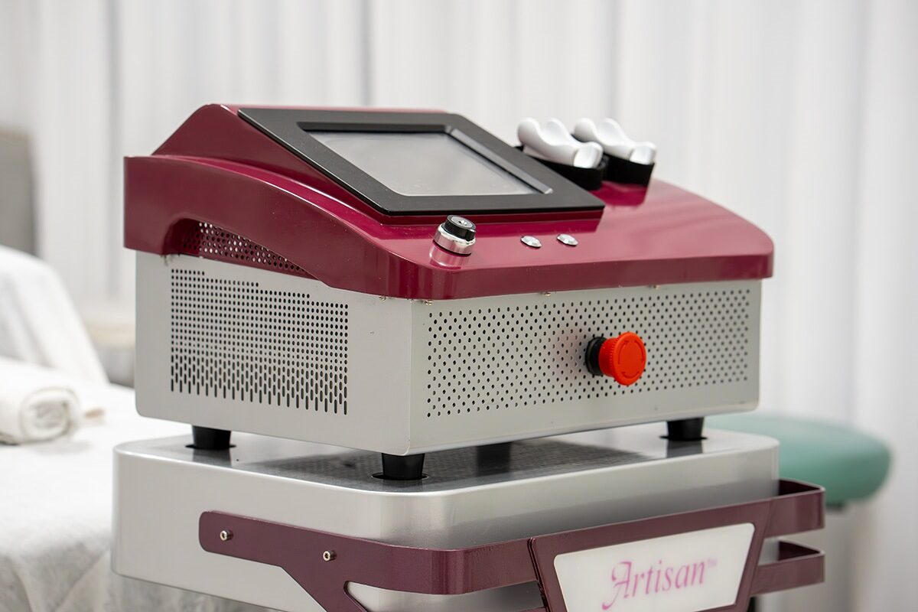

Version 2 Artisan Model:10D

Artisan model 10D in the dual handpiece configuration.

Artisan model 10D in the nonmetallic case

The specially designed hand pieces used on the Model 10D are all designed to be wiped down with disinfectant solution after a soap and water washing. Disinfect using hospital Grade Disinfectant wipes in the manner defined by the disinfectant manufacturer. Do not put the hand piece in the hospital grade disinfectant solution. Rinse with clear water after disinfection. Store in a dry, clean place that is covered until your next use. If storing the handpiece on the Model 10D, cover the cleaned handpiece with a clean towel between uses.

Electrodes and care

This electrode is a 45 mm diameter bi-polar electrode set for 1.5mm skin penetration. Use for large area skin reduction body treatments.

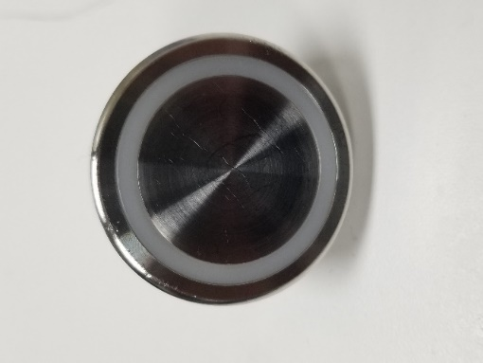

This electrode is a 45 mm diameter bi-polar electrode set for 3 mm skin penetration. Use for small area adipose tissue reduction body treatments.

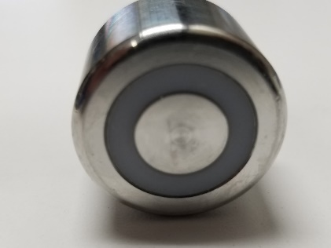

This hand piece includes a 20 mm diameter bi-polar electrode set for 1.5 mm skin penetration depth. Use for facial, small area or detailing treatments.

**

Disinfection of electrodes:

Use a hospital Grade Disinfectant (HGD), such as Barbicide. Set up a disinfection tray using the HGD and immerse the electrode in the HGD after soap and water wash. Follow manufacturer’s recommendations.

The electrode, on the left, is the monopolar electrode used for lip and eye treatments. When using this, and only this, electrode, connect the grounding cord to the negative (-) terminal on the Artisan instead of the bipolar cord negative BNC connector. Leave the bipolar negative hanging, unconnected. It will not be used with this setup. Connect the alligator end to the sticky grounding pad after it has been placed on the client’s left scapula with the tab pointed lateral, away from the client. Fold the tab and clamp the alligator on the tab.

This hand piece includes 2-4 mm diameter bi- polar electrode set for small area treatment. Use for eyes, lips, stretch marks, scars, or other detail treatments. It is also known as an “E&L” (Eyes & Lips)

**Facial Sculpting Protocol**

**APT: Artisan**

**Turning the machine on**

1. Verify the Emergency OFF button with a clockwise rotation.
2. Turn the key (right lower face panel) 90 degrees to the right to start the machine.
3. The software should start up on the display screen.
4. Press READY and the Green button to enable power output.
5. If it doesn’t start, check your power cord, the wall power and the fuse on the back of the machine.

**Paperwork**

1. First review the client ‘s expectations and goals. Establish realistic expectations.
2. Have the client sit on the treatment chair/table. Make sure they are comfortable (provide a drape, blanket, pillow, etc. if needed.)
3. Check to make sure the client has signed & dated the consent form.
4. Technician also sign and date consent form.
5. Review that medical history forms are completed and signed.
6. Review medical history forms with client; checking for any new medications, recent injectables or metal implants in the area, pregnancy and/or any recent doctor visits. Update medical information as needed.
7. Review the settings for the first treatment or review settings and treatment times for each area of the last treatment.
8. Photograph the area to be treated from frontal and angle views. Be sure to include the name label in the photograph.

**Preparation**

Skin preparation is a very important part of providing an effective treatment. If proper skin preparation is not completed, the applied energy may not penetrate the skin efficiently, reducing the treatments effectiveness. Absorption by attenuators on the skin could lead to possible burning or irritation, and certainly, a less effective treatment outcome.

1. Sanitize the treatment area before beginning the treatment.
2. Wash your hands with antibacterial soap and water. Dry your hands well.
3. Put your gloves on. (If using latex, make sure client has no latex allergies.)
4. Organize your tools for cleansing, your hand pieces, tongue blades for Sculptor compound application, timer and IR heat tester on the side table convenient to your work needs.
5. Apply mild skin cleanser to clean, wet 4”x4”gauze.
6. Cleanse area to be treated twice. First cleanse with the skin cleanser, (while cleanser is still on the skin) Use a skin scrubber for the second cleanse making a least two full passes over the skin.
7. Perform an IMAj Mini Facial, using the sculptor compound to relax the client. (5 min.)
8. Rinse and dry the treatment area.

**APT:Artisan Machine setup**

* The first screen gives you the option of setting your power level.
* Adjust the power to suit the electrode type chosen and the area to be treated.

**Settings for the face, neck & décolleté: Perform in the following order**

Décolleté /Side Fat 7j 10-15 minutes (20mm electrode)

Neck/platysma 7j  10-15 minutes right side /10-15 minutes left side (20mm electrode, time based on neck size)

Area directly under chin/platysma 7j 3-5 minutes (20mm electrode, time based on neck size)

Cheeks 6j 10 minutes /10 minutes (20mm electrode)

Forehead 4j 2-4 minutes (E&L, Closer or 20mm electrode)

Eyes 2-3j 8-10 minutes (E&L or Closer)

Lips 2-3j 8-10 minutes (E&L or Closer)

Choose an appropriate electrode. The small electrodes are used on the face and on body areas where heat concentration is desired. Larger electrodes are for use on large body areas or the neck. There is no application for the large electrode on the face. All stated settings are approximate, vary the power settings by skin temperature produced. Check temperature with IR sensor device. 106-108 degrees Fahrenheit is optimal.

1. Adjust the bed height, with the Client on it, to your comfort before starting the next step. Some Artisans perform the Décolleté /Side Fat part of the treatment with the Client sitting up so the tissues hang as they will with the Client standing, others prefer the Client in Supine position. If you choose sitting position, move the table to a sitting position now.
2. Apply sculptor compound with the wooden tongue blade to area planned for treatment. Start at décolleté, then the neck and move up the face.
3. Touch the black letters spelling,” OFF” on the top right corner of the screen. It should turn red and say ON. Begin sculpting. Be in motion when contacting the skin and continue to be in motion, always, when on the skin. Whenever necessary to pause when sculpting, dismount by lifting rapidly off the skin. Return the Sculptor to OFF setting by touching the red ON indicator.
4. Be sure to set your treatment timer
5. Maintain even contact and pressure on the skin. (Slightly indenting the skin.) Press into the skin for complete electrode contact. Maintain a 90 degree angle to the skin surface.
6. Divide the treatment time in each defined treatment area. (Customize as necessary)
7. When doing faces, start on the Décolleté /Side Fat since it is the lowest area of the treatment. Most of your Clients will have more issues in the lower face and neck than upper face. Put more time where it is needed. When you finish the Décolleté /Side Fat treatment area, you may want to return the Client to a supine position to continue the treatment.
8. Check the skin temperature using the IR heat tester often. The skin surface temperature should be reading near 106 F, for optimal results. The IR heat testers will read 10 degrees less, 96F on the tester is 106F in the dermis. Turn down the settings or move the electrode faster if the Client is complaining of a feeling of excessive heat or hot spots.

**Note: the electrode tips must maintain even continuous contact to the skin to be effective.**

1. After all the planned areas have been treated, go back and retreat the Client’s areas of concern for a second time for an additional 10-15 minutes. Keep the area lubricated with Sculptor Compound as you work. Expect to add additional Sculptor Compound.
2. Sit the Client up using the table controls. Check the Client for symmetry. Adjust as needed.
3. Change the hand piece to either the E&L (bipolar)or Closer(monopolar). If you choose the Closer, install the Closer grounding pad on the Client’s lower back with the tab facing outward. Clip the ground cable on the tab and attach to the (-) negative connector on the Artisan.
4. Perform the eye treatment, then the lip treatment, and last, the nose pores and/or cheek pores.
5. Turn off machine. (Turn the key switch to off, return hand piece to holder.)
6. Clean the Client using dry and steam towels. Apply SPF30 sunscreen to all treated areas.
7. “After” pictures taken should match the poses and lighting of the “before” pictures to provide the best analysis of any treatment benefit.
8. Review the Post Treatment Care and provide a written copy to the Client. Advise the client to call a.s.a.p. with any problems or concerns.
9. Assist client off of the treatment table/chair take post pictures and give post care instructions. Allow client to dress, walk the client to front desk and rebook next the treatment in 14 days.
10. Return to the treatment area and complete the Progress Record for the treatment in client’s file. Record power settings, treatment time and temperature, client’s reaction and skin response in the Client’s chart. Record observations of the treated area of pink or redness of the skin (erythema) and record any normal / abnormal post tissue response. (Inflammation, bruising, edema.)
11. Clean the room, disinfecting everything you or the Client touched. Perform the complete IMAj Treatment Room turn over procedure.

**Procedural Note: Always sanitize the machine hand piece before and after each use using a barbicidetm wipe or equivalent, leaving the disinfectant on the hand piece for 2-4 minutes.**

**TREATMENT NOTE:**

**A few Clients that have experienced high anxiety and excessive heat, at the time of the treatment, have appeared to have excellent procedures only to have the improvement disappear the next day. Our observation is, the failure of the procedure is caused by their lymph system has shutting down causing accumulation of water in the tissues treated. The accumulated water (edema, swelling) causes the appearance of tighter skin. After the Client calms down,(over the next 48 hours) the lymph system drains the fluids away along with your results. The accumulated water in the tissues defeats the Sculptor technology. What appears to be a great case disappoints the Client. Retreating with the Client when they are calmer and while reducing the maximum heat will provide a better result. See page 24 for additional information.**

Face, neck & Décolleté technique notes:

Most clients will get the most effective treatment using the 20mm diameter electrode. Beginning on the décolleté, trace a pattern from just inferior to the shoulder curved to separate the décolleté from the upper breasts and on to the opposite area inferior to the shoulder. The area inferior to the shoulder is often referred to as “Side Fat”. Continue the pattern just inferior to the clavicles and back to your starting point. Fill in with a patterned stroke in any comfortable direction. Continue the pattern, accenting the Side Fat area, until a depression has formed in the Side Fat area and the décolleté has begun to feel “bumpy” as the electrode passes over it. This indicates shrinking and tightening. Be cautious to maintain the curves of the upper breast, do not flatten the upper breasts. Continue the pattern for about 10 minutes. End with smoother looking skin, Side Fat depressions and a greater chest to breast definition.

When treating the neck area, divide the neck treatment area in half and, at 7 joules, perform power applications for 10 min. on each side of the neck using the vertical movement described below. Sculpt under the mandible using horizontal movements. Directly under the chin you would use the cone shaped movement.

Treat the cheeks at 6 joules for 10 min. per side using the C shaped pattern around the eyes and, mouth. Use the L shaped pattern above the jaw (mandible) and in front of the ear. The cheeks should appear smoother, and the nasal/labial folds should be decreased at the end of treatment. The second side will heat faster, observe your heat. The forehead is treated at a setting of 3-4 using the horizontal movement across the forehead for 2-4 minutes. If you are using the E. & L. or Closer electrode, you can power stroke the deep lines on the forehead to breakdown scar tissue in the bottom of the wrinkles.

The eyebrows are treated at a machine setting of 2-3. Placing the E. &L. Electrode on each side of the eyebrow you use power stokes from the beginning of the eyebrow to the end of the eyebrow leading with the active anode electrode contact tip. You can lift the electrodes off skin if you do it at the same time. If you are using the Closer, attach the ground pad to the Client’s back and connect the lead to the pad and the Sculptor Artisan. Stroke like you would with the E&L hand piece, but you can stroke both directions. Adjust the eyebrows being aware of symmetry.

Treating crow’s feet, you place the E.&L. electrode parallel to the crow’s feet and feather out to the temples for 2 min. You can also use the vertical eraser movement for 1-2 min on the temples to smooth the skin. Closer works similarly.

To get the best results on the lip enhancement artistic care is needed. At the bow of the lip, place the E. & L. Electrode on each side of the bow with the anode tip towards the center (medial). Move from the center outward along the vermillion line. Stay as close as possible to the vermillion line. Shrink the skin proximal to the vermillion line to cause the lip to roll up. Lower lip treatments are split into 3 sections. Using the E. & L. electrode power stroke the lip directly along the vermilion border being careful not to go onto the lip itself. Repeat until the lower lip area being treated shows enlargement. When the target increase is achieved, repeat on the other side. Use only straight strokes; do not curve under the lip. Use a straight-line stroke to drop the center as needed to create a “pout” look. Repeat these movements on all three sections of the bottom lip until symmetry and the design are achieved. Closer works similarly.

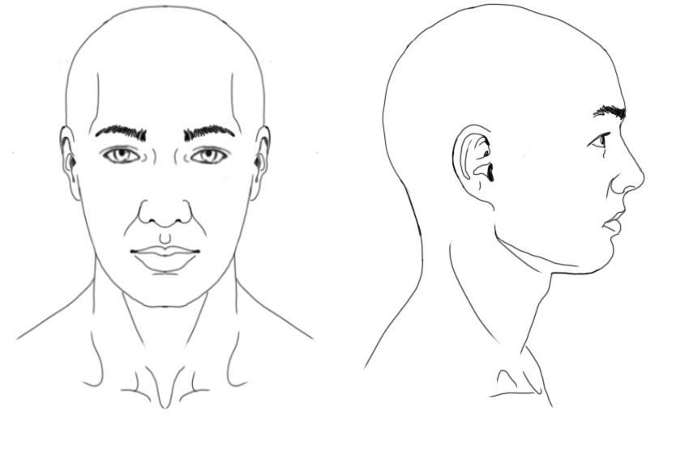

**Body Sculpting Protocol: Abdominal Reduction**

**Turning the machine on**

1. Turn on the power switch at the bottom of the machine. (if equipped)
2. Turn the key to the right to start the machine.
3. The software should start up on the display screen.
4. If it doesn’t start, check your power cord, the wall power and the fuse at the bottom of the machine.

**Paperwork**

1. First review the client ‘s expectations and goals. Establish realistic expectations.
2. Have the client sit on the treatment chair/table. Make sure they are comfortable (provide a drape, blanket, pillow, etc. if needed.)
3. Check to make sure the client has signed & dated the consent form.
4. Technician also sign and date consent form.
5. Review that medical history forms are completed and signed.
6. Review medical history forms with client; checking for any new medications, recent injectables or metal implants in the area, pregnancy and/or any recent doctor visits. Update medical information as needed.
7. Review the settings for the first treatment or review settings and treatment times for each area of the last treatment.
8. Photograph the area to be treated from frontal and angle views. Be sure to include the name label in the photograph.
9. Measure and record the circumference around the waist level with the navel. Repeat 2 inches superior and inferior.

**Preparation**

Skin preparation is a very important part of providing an effective treatment. If proper skin preparation is not completed, the applied energy may not penetrate the skin efficiently, reducing the treatments effectiveness. Absorption by attenuators on the skin could lead to possible burning or irritation, and certainly, a less effective treatment outcome.

1. Sanitize the treatment area before beginning the treatment.
2. Wash your hands with antibacterial soap and water. Dry your hands well.
3. Put your gloves on. (If using latex, make sure client has no latex allergies.)
4. Organize your tools for cleansing, your hand pieces, tongue blades for Sculptor compound application, timer and IR heat tester on the side table convenient to your work needs.
5. Apply mild skin cleanser to clean, wet 4”x4”gauze.
6. Cleanse area to be treated twice. First cleanse with the skin cleanser, (while cleanser is still on the skin) Use a Clarisonic skin scrubber for the second cleanse making a least two full passes over the skin.
7. Rinse and dry the treatment area.

**APT:Artisan Machine setup**

The first control panel screen gives you the option of setting your power level.

Adjust the power to suit the electrode type chosen and the area to be treated. The hydration of the Client’s skin and the adipose volume will affect the setting needed. The setting is not as important as the heat level of the skin. 106F (dermal) is an optimal heat value for skin reduction.

Abs Setting Time 90 minute total treatment time

Frontal 40-60 15minutes /15minutes (30 total) (40mm electrode)

Flanks 40 15 minutes /15 minutes (per side) (40mm electrode)

Lower back 40 30 minutes (40mm electrode)

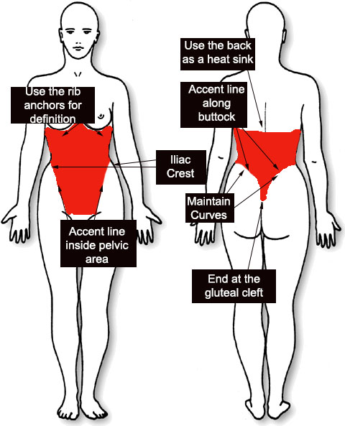

**Artisan Abdominal Treatment Pattern**

**Body Sculptor Treatment notes: Abdominal**

**Positioning:**

Begin the treatment on the fontal abdominals by having the Client lay supine on the treatment table. Drape appropriately using towels and/or sheets as needed to protect the Client’s clothes and modesty. Place a bolster under the Client’s knees for lower back comfort. Towels can be rolled into a pillow for their neck.

**Procedure:**

The drawing labeled “Artisan Abdominal Treatment Pattern” indicates in red the area to be included. This diamond shaped area needs to be heated to 106F and kept there for up to 30 minutes. If the Client is larger, divide the abdominal area in halves along the median of the body. If the Client is smaller, heat the entire abdominal area. The deciding point is the ability to attain and maintain the heat. If it is easy to maintain heat (106F), do all the abdomen, if not, divides the abdominal are in 2 parts to conserve heat.

**Step 1:** In the superior part of the pattern, along the ribs, overlap the ribs up to the lower breast to cause the skin to pull into the ribs for definition. Along the sides, do not treat inferior to the iliac crest of the pelvis. Create an accent depression just inside the pelvic line angling toward the pubic area. Cross over at the pubic area inferior to any fat bulge that may be present. Come back up staying inside the opposite pelvic pattern. Stay superior to the iliac crest to maintain the separation of the hip and abdomen. Fill in the pattern. Generally, treatments should be performed in a clock wise pattern so the massage part of the treatment is complimentary to the organ fluid flows. Skin reduction will begin as soon as 100 F is reached. It will continue if the temperature is maintained. Use an IR thermal gun as a heat gauge tool. As the pattern is developed, the skin should become smoother and silky looking. After this, textures will appear on the ribs and inside the pelvic border. Work to apply even heat. Judge by the radiated heat, as measured by the IR thermal gun, rather than the application pattern. If heat exceeds 110 F, move away from that area until it cools down to 100 F, then apply heat to bring tissue back to 106 F. Repeat this process for 30 minutes.

**Step 2:** Have the Client roll on one side and extend the arm that is on top over the head to expose the waist. Stand on either side of the Client and trace a pattern including the side ribs and back ribs, up to the same level as the front treatment. Trace toward the butt down the spine to the gluteal cleft. Curve up from the gluteal cleft around the hip (buttock) back to the waist just superior to the iliac crest of the pelvis. Fill in the pattern. The waist will be a focal point of this part of the procedure. It will get hot. Check the heat and add heat anywhere under 110 F. The quality of the treatment on the sides is critical to the success of the procedure. The sides provide most of the dimensional reduction of an abdominal procedure. Do this pattern for 15 minutes.

**Step 3:** Have the Client roll over into a prone position, face down. Adjust draping as needed. Expose the gluteal cleft enough to be positive of it’s location. Expose the back as high as the side treatment. If the Client is very small, expose the entire back. The pattern of the back treatment is curves around the buttocks into the gluteal cleft and back out. The lower side curves must end just superior to the iliac crests on both sides. The amount of back treated will relate to the heat produced. The treatment goal is to define the dividing line between the Gluteal (buttock) and the back, accent the line from superior to the iliac crest curved to the gluteal cleft and generally reduce the lower back. Doing so will enhance the difference between the buttocks and the lower back. Treat this area for 30 minutes. If the lower back area gets too hot, move up the back, as needed, to reduce the overheating.

**Step 4:** Have the Client roll again to expose the untreated side. Place the upper arm over the head. Replace drapes as needed and repeat step 2.

**Post procedure**

1. Observe treated area for pink or redness of the skin (erythema) and record any normal/abnormal post tissue response. (inflammation, bruising, edema.) Be aware of the possibility that the lymph system may have shut down evidenced by swelling due to lack of tissue drainage. (edema, see warning on page 24 for additional information)
2. Apply calming solution and post treatment protection SPF 30 to treated area.
3. “After” pictures should match the poses and lighting of the “before” pictures.
4. Review post treatment care with client and offer written instructions.
5. Advise the client to call a.s.a.p. with any problems or concerns.
6. Assist the client out of treatment, chair take post pictures and give post care instructions. Allow the client privacy to dress, walk the client to front desk and rebook the next treatment in 14 days.
7. Complete progress record for treatment in the clients file.
8. Always remove hand pieces, cap them to protect the connector, then wash them with soap and water. After cleaning, immerse the hand piece in disinfectant for the manufacturer’s prescribed time. Remove them from the disinfectant and rinse them. Dry and store in a closed container.
9. Always sanitize the machine before and after each use.
10. Clean out the bowl with antimicrobial soap and wipe down with Barbicide, or equivalent spray and wipe.
11. Sanitize sink, countertops, beds, and carts, bottles with Barbicide, or equivalent spray and wipe.
12. Push chairs and machines against walls; re-drape bed and making sure room is left in a presentable manner.
13. Remeasure and record the 3 points on the abdominal measurement and compare to pretreatment measurements.

**Body Sculpting Protocol: Thighs**

**Turning the machine on**

1. Turn on the power switch at the bottom of the machine. (if equipped)
2. Turn the key to the right to start the machine.
3. The software should start up on the display screen.
4. If it doesn’t start, check your power cord, the wall power and the fuse at the bottom of the machine.

**Paperwork**

1. First review the client ‘s expectations and goals. Establish realistic expectations.
2. Have the client sit on the treatment chair/table. Make sure they are comfortable (provide a drape, blanket, pillow, etc. if needed.)
3. Check to make sure the client has signed & dated the consent form.
4. Technician also sign and date consent form.
5. Review that medical history forms are completed and signed.
6. Review medical history forms with client; checking for any new medications, recent injectables or metal implants in the area, pregnancy and/or any recent doctor visits. Update medical information as needed.
7. Review the settings for the first treatment or review settings and treatment times for each area of the last treatment.
8. Photograph the area to be treated from frontal and angle views. Be sure to include the name label in the photograph.
9. Measure and record the circumference of the thigh 4 inches and 8 inches above the knee.

**Preparation**

Skin preparation is a very important part of providing an effective treatment. If proper skin preparation is not completed, the applied energy may not penetrate the skin efficiently, reducing the treatments effectiveness. Absorption by attenuators on the skin could lead to possible burning or irritation, and certainly, a less effective treatment outcome.

1. Sanitize the treatment area before beginning the treatment.
2. Wash your hands with antibacterial soap and water. Dry your hands well.
3. Put your gloves on. (If using latex, make sure client has no latex allergies.)
4. Organize your tools for cleansing, your hand pieces, tongue blades for Sculptor compound application, timer and IR heat tester on the side table convenient to your work needs.
5. Apply mild skin cleanser to clean, wet 4”x4”gauze.
6. Cleanse area to be treated twice. First cleanse with the skin cleanser, (while cleanser is still on the skin) Use a Clarisonic skin scrubber for the second cleanse making a least two full passes over the skin.
7. Rinse and dry the treatment area.

**APT:Artisan Machine setup**

The first control panel screen gives you the option of setting your power level.

Adjust the power to suit the electrode type chosen and the area to be treated. The hydration of the Client’s skin and the adipose volume will affect the setting needed. The setting is not as important as the heat level of the skin. 106F (dermal) is an optimal heat value for skin reduction.

Thigh 1 Setting Time 40 minutes total treatment time per thigh; Thigh 2 80 minutes for both thighs

Section 1:frontal 25-50 10minutes (40mm electrode)

Section 2: lateral 25-50 10 minutes (40mm electrode)

Section 3: medial 25-50 10 minutes (40mm electrode)

Section 4: rear 25-50 10 minutes (40 mm electrode)

The treatment time minimums indicate an 80-minute treatment time. The full scheduled time for this treatment is 120 minutes or 2 hours. The other 40 minutes should be spent in positioning, photographs, cleaning the Client after treatment and reviewing the Post Treatment Orders.

Most clients will receive the largest benefit from utilizing the 40 mm electrode at 25-50j for 40 or more minutes per thigh. Be sure to ask your client what areas concern them the most and accent that zone. The thighs can be split up into 4 sections. (Frontal, back, lateral (outside), medial (inside)). Treat the thighs using the vertical movement. (Caution: on inner thighs temperature may increase quickly)

Keep even pressure when working in curved areas such as above the knee.

**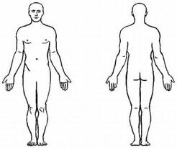  
Post procedure**

1. Observe treated area for pink or redness of the skin (erythema) and record any normal/abnormal post tissue response. (inflammation, bruising, edema.)
2. Apply calming solution and post treatment protection SPF 30 to treated area.
3. “After” pictures should match the poses and lighting of the “before” pictures.
4. Review post treatment care with client and offer written instructions.
5. Advise the client to call a.s.a.p. with any problems or concerns.
6. Assist the client out of treatment, chair take post pictures and give post care instructions. Allow the client privacy to dress, walk the client to front desk and rebook the next treatment in 14 days.
7. Complete progress record for treatment in the clients file.
8. Always remove hand pieces, cap them to protect the connector, then wash them with soap and water. After cleaning, immerse the hand piece in disinfectant for the manufacturer’s prescribed time. Remove them from the disinfectant and rinse them. Dry and store in a closed container.
9. Always sanitize the machine before and after each use.
10. Clean out the bowl with antimicrobial soap and wipe down with Barbicide, or equivalent spray and wipe.
11. Sanitize sink, countertops, beds, and carts, bottles with Barbicide, or equivalent spray and wipe.
12. Push chairs and machines against walls; re-drape bed and making sure room is left in a presentable manner.
13. Remeasure and record the circumference of each thigh. Note and document the changes in size and texture.

**Body Sculpting Protocol: Upper Arms**

**Turning the machine on**

1. Turn on the power switch at the bottom of the machine. (if equipped)
2. Turn the key to the right to start the machine.
3. The software should start up on the display screen.
4. If it doesn’t start, check your power cord, the wall power and the fuse at the bottom of the machine.

**Paperwork**

1. First review the client ‘s expectations and goals. Establish realistic expectations.
2. Have the client sit on the treatment chair/table. Make sure they are comfortable (provide a drape, blanket, pillow, etc. if needed.)
3. Check to make sure the client has signed & dated the consent form.
4. Technician also sign and date consent form.
5. Review that medical history forms are completed and signed.
6. Review medical history forms with client; checking for any new medications, recent injectables or metal implants in the area, pregnancy and/or any recent doctor visits. Update medical information as needed.
7. Review the settings for the first treatment or review settings and treatment times for each area of the last treatment.
8. Photograph the area to be treated from frontal and angle views. Be sure to include the name label in the photograph.
9. Measure and record each arm at the center of the bicep.

**Preparation**

Skin preparation is a very important part of providing an effective treatment. If proper skin preparation is not completed, the applied energy may not penetrate the skin efficiently, reducing the treatments effectiveness. Absorption by attenuators on the skin could lead to possible burning or irritation, and certainly, a less effective treatment outcome.

1. Sanitize the treatment area before beginning the treatment.
2. Wash your hands with antibacterial soap and water. Dry your hands well.
3. Put your gloves on. (If using latex, make sure client has no latex allergies.)
4. Organize your tools for cleansing, your hand pieces, tongue blades for Sculptor compound application, timer and IR heat tester on the side table convenient to your work needs.
5. Apply mild skin cleanser to clean, wet 4”x4”gauze.
6. Cleanse area to be treated twice. First cleanse with the skin cleanser, (while cleanser is still on the skin) Use a Clarisonic skin scrubber for the second cleanse making a least two full passes over the skin.
7. Rinse and dry the treatment area.

**APT:Artisan Machine setup**

The first control panel screen gives you the option of setting your power level.

Adjust the power to suit the electrode type chosen and the area to be treated. The hydration of the Client’s skin and the adipose volume will affect the setting needed. The setting is not as important as the heat level of the skin. 106F (dermal) is an optimal heat value for skin reduction.

Arm 1 Setting Time 30 minutes total treatment time per arms; Arm 2 60 minutes for both arms

Section 1:frontal 15 10minutes (40mm electrode)

Section 2: lateral 15 10 minutes (40mm electrode)

Section 3: medial 12-15 10 minutes (40mm electrode)

The treatment time minimums indicate a 60 minute treatment time. The full scheduled time for this treatment is 90 minutes or 1.5 hours. The other 30 minutes should be spent in positioning, photographs, cleaning the Client after treatment and reviewing the Post Treatment Orders.

Most clients will receive the largest benefit from utilizing the 40 mm electrode at 15j for 30 or more minutes per arm. Be sure to ask your client what areas concern them the most and accent that zone.

Some smaller bodied clients will get a more effective treatment using the 20 mm electrodes. Using the small electrode tip at 7 joules, perform the vertical pattern up and down the bicep muscle for 10 min. Next set your machine to 6-7 joules and treat the triceps using the vertical movement up and down. Adjust the Sculptor 7 to 7 joules and have your Client lay on their stomach ( prone). For the back part of the arm you will use the vertical movement down the triceps and up to the back of the shoulder. Use the anchors points between the muscle groups to reduce loose sagging skin. Following the edges of the muscle groups with your strokes to create better muscle definition. Sculpt the result you are trying to obtain.

Trace the edges of the muscles to create depressions that will enhance the muscle definition.

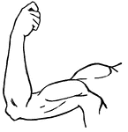 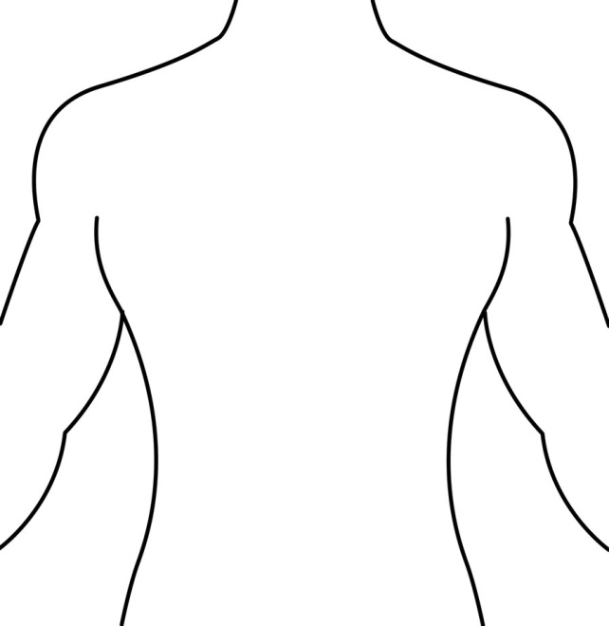

**Post procedure**

1. Observe treated area for pink or redness of the skin (erythema) and record any normal/abnormal post tissue response. (inflammation, bruising, edema.) Be aware of the possibility that the lymph system may have shut down evidenced by swelling due to lack of tissue drainage. (edema, see warning on page 24 for additional information)
2. Apply calming solution and post treatment protection SPF 30 to treated area.
3. “After” pictures should match the poses and lighting of the “before” pictures.
4. Remeasure and record the circumference at the center of the bicep.
5. Review post treatment care with client and offer written instructions.
6. Advise the client to call a.s.a.p. with any problems or concerns.
7. Assist the client out of treatment, chair take post pictures and give post care instructions. Allow the client privacy to dress, walk the client to front desk and rebook the next treatment in 14 days.
8. Complete progress record for treatment in the clients file.
9. Always remove hand pieces, cap them to protect the connector, then wash them with soap and water. After cleaning, immerse the hand piece in disinfectant for the manufacturer’s prescribed time. Remove them from the disinfectant and rinse them. Dry and store in a closed container.
10. Always sanitize the machine before and after each use.
11. Clean out the bowl with antimicrobial soap and wipe down with Barbicide, or equivalent spray and wipe.
12. Sanitize sink, countertops, beds, and carts, bottles with Barbicide, or equivalent spray and wipe.
13. Push chairs and machines against walls; re-drape bed and making sure room is left in a presentable manner.

**Body Sculptor Treatment: Butt compression**

**Turning the machine on**

1. Turn on the power switch at the bottom of the machine. (if equipped)
2. Turn the key to the right to start the machine.
3. The software should start up on the display screen.
4. If it doesn’t start, check your power cord, the wall power and the fuse at the bottom of the machine.

**Paperwork**

1. First review the client ‘s expectations and goals. Establish realistic expectations.
2. Have the client sit on the treatment chair/table. Make sure they are comfortable (provide a drape, blanket, pillow, etc. if needed.)
3. Check to make sure the client has signed & dated the consent form.
4. Technician also sign and date consent form.
5. Review that medical history forms are completed and signed.
6. 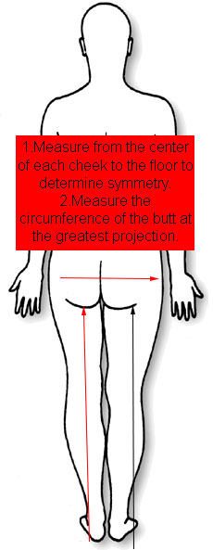Review medical history forms with client; checking for any new medications, recent injectables or metal implants in the area, pregnancy and/or any recent doctor visits. Update medical information as needed.
7. Review the settings for the first treatment or review settings and treatment times for each area of the last treatment.
8. Photograph the area to be treated from frontal and angle views. Be sure to include the name label in the photograph.
9. Measure and record the distance from the center of each buttock to the floor. Measure and record the circumference of the butt at it’s greatest point.

**Preparation**

Skin preparation is a very important part of providing an effective treatment. If proper skin preparation is not completed, the applied energy may not penetrate the skin efficiently, reducing the treatments effectiveness. Absorption by attenuators on the skin could lead to possible burning or irritation, and certainly, a less effective treatment outcome.

1. Sanitize the treatment area before beginning the treatment.
2. Wash your hands with antibacterial soap and water. Dry your hands well.
3. Put your gloves on. (If using latex, make sure client has no latex allergies.)
4. Organize your tools for cleansing, your hand pieces, tongue blades for Sculptor compound application, timer and IR heat tester on the side table convenient to your work needs.
5. Apply mild skin cleanser to clean, wet 4”x4”gauze.
6. Cleanse area to be treated twice. First cleanse with the skin cleanser, (while cleanser is still on the skin) Use a Clarisonic skin scrubber for the second cleanse making a least two full passes over the skin.
7. Rinse and dry the treatment area.

**APT :Artisan Machine setup**

The first control panel screen gives you the option of setting your power level.

Adjust the power to suit the electrode type chosen and the area to be treated. The hydration of the Client’s skin and the adipose volume will affect the setting needed. The setting is not as important as the heat level of the skin. 106F (dermal) is an optimal heat value for skin reduction.

Area Setting Time 30 minutes total treatment time per arms;

Section 1:left upper rear thigh 40-60 10minutes (40mm electrode)

Section 2: left buttock 40-60 10 minutes (40mm electrode)

Section 3: left lateral thigh 40-60 15minutes (40mm electrode)

Section 5:right upper rear thigh 40-60 10minutes (40mm electrode)

Section 6: right buttock 40-60 10 minutes (40mm electrode)

Section 7: right lateral thigh 40-60 15minutes (40mm electrode)

Section 4: Lower back 40-60 30 minutes (40 mm electrode)

The treatment time minimums indicate a 100 minute treatment time. The full scheduled time for this treatment is 120 minutes or 2 hours. The other 20 minutes should be spent in positioning, photographs, cleaning the Client after treatment and reviewing the Post Treatment Orders.

**Body Sculptor Treatment notes: Butt Compression**

Most clients will get the most effective treatment using the 40-mm electrode. Set the machine to 40 joules (adjust power level as needed) and using the vertical movement go vertical up and down the back of the thigh for 10 min. You should see a smoothing of the texture of the skin. Attempt to achieve 106-110 F. Next go up over the buttocks up and down for an additional 10 min. This is the time to also go right under the buttocks to help the lift and add definition in a horizontal direction. Repeat on the other side. Adjust your time based on the amount of lift needed as indicated from your initial measurements. Treat the lateral thigh (hip) by heating the side of the hip for 15 minutes to tighten and compress skin in the area. Repeat on both sides. Check for visual symmetry in hip with and lower buttock position as the Client is prone on the table. Check for buttock projection looking for texture and symmetry.

When treating the lower back, we want to create a “sea gull” shape to accentuate the top of the buttocks. This creates a compression effect adding to projection and shape. Avoid straight movements as they may “flatten” the butt upper curve. The textures and curves are very important to the result. Shape the butt from the top to create contrast between the back and butt. Check for visual symmetry in hip with and lower buttock position as the Client is prone on the table. Check for buttock projection looking for texture and symmetry.

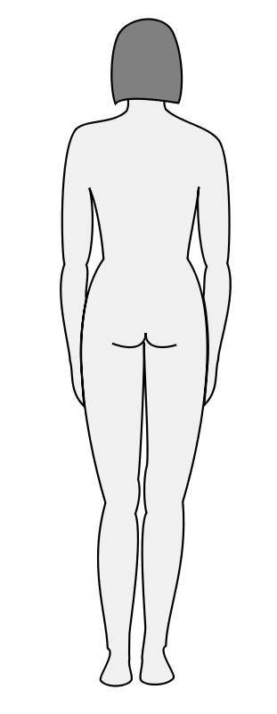 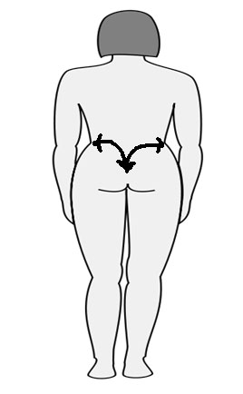

**Post procedure**

1. Observe treated area for pink or redness of the skin (erythema) and record any normal/abnormal post tissue response. (inflammation, bruising, edema.) Be aware of the possibility that the lymph system may have shut down evidenced by swelling due to lack of tissue drainage. (edema, see warning on page 24 for additional information)
2. Apply calming solution and post treatment protection SPF 30 to treated area.
3. “After” pictures should match the poses and lighting of the “before” pictures.
4. Measure the Client as you did pretreatment and record the change. One half to one inch of lift is possible as is one half to one inch of increased projection.
5. Review post treatment care with client and offer written instructions.
6. Advise the client to call a.s.a.p. with any problems or concerns.
7. Assist the client out of treatment, chair take post pictures and give post care instructions. Allow the client privacy to dress, walk the client to front desk and rebook the next treatment in 14 days.
8. Complete progress record for treatment in the clients file.
9. Always remove hand pieces, cap them to protect the connector, then wash them with soap and water. After cleaning, immerse the hand piece in disinfectant for the manufacturer’s prescribed time. Remove them from the disinfectant and rinse them. Dry and store in a closed container.
10. Always sanitize the machine before and after each use.
11. Clean out the bowl with antimicrobial soap and wipe down with Barbicide, or equivalent spray and wipe.
12. Sanitize sink, countertops, beds, and carts, bottles with Barbicide, or equivalent spray and wipe.
13. Push chairs and machines against walls; re-drape bed and making sure room is left in a presentable manner.

**Collagen Synthesis**

Collagen is the most abundant body protein accounting for about one-third of the body’s protein. Collagen functions to give the body structure and cohesion. All collagen fibers are composed of a basic polypeptide chain called the A chain (tropocollagen). Three of these A chains unite to form a single collagen molecule called a triple helix or fibril, which is composed of repeating triplex amino acids, glycine and two others, most of the proline (1/6th) and hydroxyproline. Glycine is always present in the structure of the collagen fiber; every third molecule is glycine. Collagen fibers are essentially a three amino acid unit occurring in triplet and twisted into a left-handed spiral called a helix. At the ends of this helical unit is a nontriple-helical domain called the globular domain. One A chain is in a left helix but when they unite to form a collagen molecule they form a right-handed super helical spiral, this is procollagen. Collagen is synthesized in the ribosomes of the cell cytoplasm as procollagen but then must be modified by enzymes in the rough endoplasmic reticulum of the fibroblast. This is called the post-translational modification stages. The terminal ends of the procollagen molecule are cleaved shortly after translation. Now the hydroxylation process occurs. Hydroxyproline and hydroxylysine are formed by the action of two enzymes, proline hydroxylase and lysine and require specific amounts of oxygen, iron molecules, a –ketoglutarate, and ascorbic acid. After the addition of a carbohydrate molecule to the procollagen molecule, Glycosylation begins with the addition of a galactosyl molecule. It is attached first to the collagen polypeptides and then glucose is attached to the galactosyl reside. At the same time the peptide extensions, one at each end of the molecule, receive complex carbohydrate structures consisting mainly of mannose. It is at this stage that the molecule is ready to form the triple helix configuration. The first step is the removal of the nonhelical chains, followed by disulfide bonds which is facilitated by the extension polypeptides that contain sulfur atoms. The enzyme that is responsible for this action is called protein disulfide isomerase. Now the triple helix forms and the molecule is secreted into the intercellular space.

Once in the intercellular space the terminal ends of the molecule are removed by other enzymes and the new collagen molecules will spontaneously assemble and form collagen fibrils. All collagen behaves in this manner but there are specific differences between collagen molecules that account for their functionality. Type 1 collagen, a structural collagen found in bone, skin, tendons, and other organs. It is the most common type. It is a fibrillar collagen with two identical chains and one different chain. The collagen fibril is made up of 2 A tropocollagens and 1 B tropocollagen.

**Performing a Collagen Synthesis procedure**

**Preparation**

1. Wash your hands with antimicrobial soap.
2. Apply gloves. (If using latex, make sure client has no latex allergies.)
3. Apply skin cleanser to wet gauze.
4. Cleanse area twice. The first cleanse should be with the wet gauze, followed by the second cleanse.
5. Rinse and pat dry.

Using a standard 808, 980 or 1064nm wavelength laser with a 4mm focal point, set the J\cm2 at 23-30 for the first treatment. Later treatments can be increased to 50 J\cm2, if needed and tolerated by the Client. Added energy increases the effect. Using a grid pattern shoot the laser ¼ of an inch apart. Shoot the areas of concern targeting deep lines and scars. Shoot the laser energy down the outer edges of the entire scar and then fill in using the grid pattern. When you are targeting deep lines shoot the laser using the grid pattern covering the areas of concern.

We recommend VADER as the best collagen synthesis laser. Use the 4mm x 4mm square optic. Set the treatment energy to 5 joules per centimeter squared. Increase to 8 joules, if well tolerated. Set the Hz to 6 shots per second. VADEr is faster and more efficient than any other similar laser available.

Following the Laser portion of the treatment, perform the Artisan with the E. & L. electrode tip at the appropriate setting for the body part being sculpted. Using the E. & L. electrode, begin with horizontal followed by vertical strokes across the area of concern. When using the E. & L. electrode watch the reaction of the skin. Check skin for erythema and edema.

**Care and Rebooking**

* Additional sessions may be needed to achieve the guest’s goals for the treatment series. **Have client rebook, if needed, exactly 14 days following the treatment.**
* Record on the clinical history the joules used, the skin's reaction, the pulse length of laser energy and the treated areas in each technique (ultrasound, laser, IPL and radiofrequency), this information is crucial to establish the parameters for the following sessions.
* Ask also about the positive skin changes he/ she noticed.
* Always ask the client about the last session, if he/she noticed some adverse effect such as inflammation, redness or discomfort and if so, how long it lasted
* Usually, the parameters used during the following sessions will stay the same. Sometimes it’s necessary to increase power density for superior results.
* Apply moisturizing Vitamin C cream every day. Ascorbic acid is the essential enzyme used by the fibroblasts for collagen formation.
* Avoid sun exposure or UV lamps for three weeks after any treatments. Use sun block with an 30 SPF or greater with UVA/UVB blocking components

**Contraindication for laser Collagen Synthesis**

* Pregnancy
* Metal Implants
* Diabetes not under control
* Cardiac pacemaker

Quick Settings Reference Chart

Abs 40j 30 minutes (large electrode)

Frontal 40-60j 15minutes /15minutes (large electrode)

Flanks 40j 15 minutes /15 minutes (large electrode

Butt texture 40j 20 minutes, as needed (large electrode)

Upper thigh 30j 13 minutes / 13 minutes (large electrode)

Buttocks 30j 13 minutes / 13 minutes (large electrode)

* + Forearm
    - Upper 15j 15 minutes (small or large electrode)
    - Under 15j 15 minutes (small or large electrode)
  + Thighs
    - Front 50j 15 minutes / 15 minutes (large electrode)
    - Back 50 j 15 minutes / 15 minutes (large electrode)
  + Arms
    - Bicep area 17-20j 15 minutes (small or large electrode)
    - Tricep area 15-17j 15 minutes (small or large electrode)
    - Underarm 15j 10 minutes (small or large electrode)
    - Back of arm 15j 10 minutes (small or large electrode)
  + Ankles
    - Circumference 15j 10-15 minutes (small electrode)

**ESSENTIAL RELATED SKIN TERMINOLOGY**

**The Fibroblast** - a protein synthesis factory

Fibroblast cells do not function as independent cells; they are directed or modulated by specific signals from other cells. Damaged cells, such as collagen, signal the fibroblasts to function using peptides formed from damaged collagen fiber pieces. The dermis consists of groups of fibrillar proteins: collagen, elastin and reticulum meshed in a ground substance making up the major dermal component.

**Collagen** - most abundant body protein

Collagen gives the body structure and accounts for one-third of the body's weight, consisting of twenty nine types of collagen. All collagens are composed of a basic polypeptide chain that forms a triple helix, which is composed of repeating triplet amino acids, glycine, proline and hydroxyproline that is twisted into a left handed spiral called a helix. When the chains unite to form a collagen molecule, they form a right-handed super helical spiral.

Collagen is a protein. Collagen plays a significant role in the structure of the skin physically representing most of skin’s structure. Both collagen and elastin are constantly being produced, destroyed and produced again in response to the body's needs. This allows a great deal of variability in structure as well as the hope of repair and restructuring the skin in aging. Glycine is 94% water making Collagen Synthesis treatments effective by producing shrinkage with a tightening and lifting effect to the skin.

**Elastin** - provides resiliency to the skin

Elastin works together with collagen to maintain resiliency. Elastin is a linear polypeptide of amino acids - chiefly glycine, valine, proline, lysine and alanine. Two key amino acids in elastin are involved in the cross-linking system that covalently bonds the elastin polypeptide chains into a fibrous network.

**Edema**- Edema is an accumulation of excess fluid between the cells of the body or within the various body cavities.

**Erythema** – Redness of the skin caused by dilated capillaries.

**Mannose**

Mannose is a sugar monomer of the aldohexose series of carbohydrates. Mannose is a C-2 epimer of glucose. Mannose is important in human metabolism, especially in the glycosylation of certain proteins.

**Contraindications for Sculptor Artisan treatments:**

* Pregnancy
* Recently tanned skin
* Keloid scarring; a client that has a history of keloid scarring
* Acute diseases evident in the treatment area
* Cardiac Pacemaker implant or other implantable electronics
* Metal bone implants
* Photosensitive Drugs

**Additional note about Lymph System Shutdown**

The lymphatic system is a network of tissues and organs. It is made up mainly of lymph vessels, lymph nodes and lymph. Lymph vessels, which are different from blood vessels, carry fluid called lymph throughout your body.

The lymphatic system collects excess fluid and proteins from body tissues and carries them back to the bloodstream. Edema, or swelling, may happen when there is an increase in the amount of fluid or because of a blockage in the lymphatic system. The accumulation of lymph is called lymphedema.

The lymph system can shut down when the Client experiences anxiety and/or extreme localized heat. Signs of the lymph system shutting down are edema. The Client’s skin will look smoother but body measurements will be slightly larger than when you started the procedure. If the body part is slightly larger than at the beginning of the case, this is a strong sign that the lymph system is shutting, or has shut down. Water is accumulating in the tissue and not draining away as normal.

On a face the Client may appear to have had a good procedure with the skin tight and smooth. On a face, it is difficult to discern lymph system shut down from normal results.

If this occurs, the Client will relax after a few hours and the water will drain away. The extra water in the tissues will have interfered with your treatment negating the usual results. The treatment will need to be repeated. This is a natural occurrence and not your Client’s fault. Neither is it your fault. The Client will not receive a satisfactory result. It is reasonable Customer Service event to repeat the procedure without charging the Client.

This can be avoided by keeping the client relaxed and calm during the procedure. You can do a mini facial or body massage to help ease the guest. The lymph system will usually return to normal within 24-48 hours of the treatment and flush out the excess fluids. Keeping your treatment room cooler than 74 degrees helps reduce excess heat problems. Relaxing music and lowered voices can help this type of Client.

Thank you for choosing the IMAj Technologies Sculptor Artisan Model10D for your use. Years of research at IMAj Institute including thousands of procedures has led to this design. Impressive results are attainable with this equipment. The era of Aesthetic Enhancements presenting a competitive services profile to traditional Plastic Surgery is here. Certainly, this machine is not a replacement for the fine skills available to the market provided by the Plastic Surgery experts that we rely on. However, the tissue reduction capability of the Artisan Model 10D combined with the skills of a well-trained operator can create astounding changes in the appearance of a appropriate Client.

Training is key to success with this equipment. IMAj Institute is very involved in research related to this process and presents an excellent resource to those committed to the advancement of this science.

**Contact information:**

**Aesthetic ProTools, Inc.**

8969 East Talking Stick Way

Suite C-5

Scottsdale, AZ

85250

(480)291-5880

www.aestheticprotools.com

Gary Begley

gary@aestheticprotools.com