**Estimation:**

1. **Mote Module - CM5000**

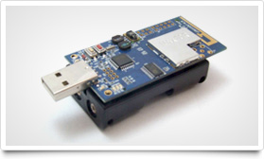

**Price: 77 Euros**

**Order Url :** <http://www.advanticsys.com/shop/mtmcm5000msp-p-14.html>

1. **CO1000 - Pressure, Vibration & Angle sensor board**

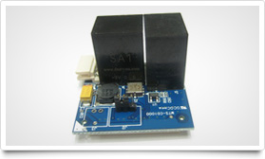

**Product Price : 116.00€**

**Order Url :** <http://www.advanticsys.com/shop/mtsco1000-p-17.html>

1. **EM1000 - Temperature, Humidity, Light & Accelerometer sensor board**

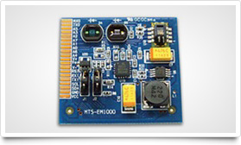

**Product Price : 53.00€**

**Order Url :** <http://www.advanticsys.com/shop/mtsem1000-p-12.html>

1. **USB1000 - Mote-PC USB interface board**

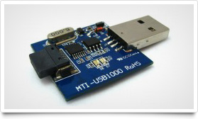

**Product Price : 21.00€**

**Order Url:** <http://www.advanticsys.com/shop/mtiusb1000-p-9.html>

1. **UD1000 - 802.15.4 compliant USB dongle**

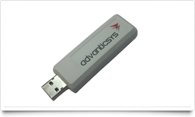

**Product Price :** 65.00€

**OrderUrl:** <http://www.advanticsys.com/shop/asud1000-p-25.html>

1. **Accelerometer**

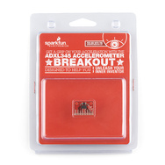

**Product Price: $28.95 Order Url:** <https://www.sparkfun.com/products/9885?>

**Tablet:**

1. **Samsung - Galaxy Tab 2 10.1 with 16GB Memory - Titanium Silver**

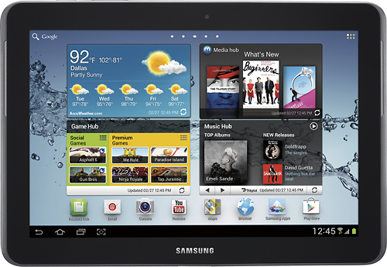

**Order Price: $399.99**

**Order Url:** <http://www.bestbuy.com/site/Samsung+-+Galaxy+Tab+2+10.1+with+16GB+Memory+-+Titanium+Silver/5215429.p?id=1218625359021&skuId=5215429>

1. **Apple® - The new iPad® with Wi-Fi - 16GB – White**

|  |  |  |
| --- | --- | --- |
| http://pisces.bbystatic.com/image/BestBuy_US/images/products/4881/4881142_sa.jpg;canvasHeight=280;canvasWidth=280 | **Order Price: $499.99** | **Order Url:** <http://www.bestbuy.com/site/Apple%26%23174%3B+-+The+new+iPad%26%23174%3B+with+Wi-Fi+-+16GB+-+White/4881142.p?id=1218572400461&skuId=4881142>  **Apple:** <http://store.apple.com/us/buy/home/shop_ipad/family/ipad/new_ipad> |

**Summary:**

|  |  |  |
| --- | --- | --- |
| **item** | **Description** | **Unit Price** |
| MTM-CM4000-MSP (CM4000) | 802.15.4 Mote Module with PCB antenna | 77.00€ |
| MTS-CO1000 (CO1000) | Pressure, Vibration & Angle sensor board | 116.00€ |
| MTS-EM1000 (EM1000) | Temperature, Humidity, Light & Accelerometer sensor... | 53.00€ |
| MTI-USB1000 (USB1000) | Mote-PC USB interface board | 21.00€ |
| AS-UD1000 (UD1000) | 802.15.4 compliant USB dongle | 65.00€ |
| Accelerometer |  |  |
| Samsung - Galaxy Tab 2 10.1 | Samsung - Galaxy Tab 2 10.1 with 16GB Memory - Titanium Silver | **$**399.99 |
| Apple® - The new iPod | White iPad | $499.99 |
|  | Total : |  |