Prediction of Building-Level Damage due to Tropical Cyclone Using Machine Learning and Easy Available Features

Yufeng Liu¹,Xingyu Chen¹,Shulun Gao²,Hong Tang^{1,*}
¹ Faculty of Geographical Science, Beijing Normal University, Beijing 100875, China
² School of Statistics, Beijing Normal University, Beijing 100875, China
*Corresponding author
E-mail address: hongtang@bnu.edu.cn

Abstract
Building-level pre-disaster damage prediction for tropical cyclones is important for emergency preparedness, resource allocation, and risk reduction in coastal regions. However, because publicly available exposure and building-attribute data are limited, existing studies have mainly focused on post-disaster damaged-building identification, while pre-disaster prediction of building damage remains relatively underexplored. This study investigates the feasibility of using easily available data and benchmark machine learning methods to predict building-level tropical cyclone damage before disaster impact. Tropical Cyclone Winston in Fiji was used as the main training and internal validation case; building damage survey labels were converted into a binary damaged-undamaged system, and simplified wind-field, spatial exposure, and selected building features were constructed from IBTrACS and building datasets. Seven machine learning models were compared under full-feature and Easy Available Features modes with one-hot encoding, hyperparameter optimization, robustness checks, and SHAP interpretation, while Tropical Cyclone Rai and Hurricane Ian were used as exploratory spatial generalization cases to test the framework under different regional and data-availability conditions. The results suggest that simplified wind-field features and accessible building information can support preliminary risk screening in data-limited areas, but robust cross-regional prediction still requires higher-quality building inventories, field-validated labels, and better representation of multi-hazard processes.
Keywords: Tropical cyclone disasters; Building damage prediction; Benchmark machine learning; Random Forest; AdaBoost; SHAP

1 Introduction
Natural disasters are major external disturbances that threaten urban safety and sustainable development. With rapid urbanization, populations, buildings, infrastructure, and socioeconomic activities have become increasingly concentrated in cities, making urban systems more exposed and vulnerable to extreme weather and geohazards. Urban disaster risk is closely related not only to natural hazards but also to exposure and physical and social vulnerability, and critical infrastructure worldwide is widely exposed to multiple hazards [1,2]. In coastal regions, strong winds, heavy rainfall, storm surges, and flooding often interact and cause building damage, traffic disruption, infrastructure failure, and casualties. The IPCC has noted that tropical cyclones and severe coastal storms can affect cities, housing, transport, and energy infrastructure through wind, hydrological, and coastal hazards [3]. NOAA also indicates that strong winds generated by tropical cyclones can directly damage buildings, while debris such as roofing materials may further aggravate structural damage and human injury [4]. Therefore, rapid preliminary assessment of building-level damage risk is essential for emergency preparedness, resource allocation, disaster assessment, and recovery planning.
Tropical cyclone-induced building damage is affected by storm intensity, track, wind field structure, and the spatial relationship between buildings and the cyclone center, as well as building attributes such as height, roof type, wall material, structural form, and maintenance condition. At the building scale, tropical cyclones may cause roof uplift, envelope failure, wall cracking, water ingress, or even complete collapse, directly affecting building functionality and habitability. Existing studies indicate that building damage is not caused by a single hazard variable but by the combined effects of tropical cyclone hazard intensity, building exposure, and structural vulnerability. Therefore, developing reliable pre-disaster building-level damage prediction models that jointly consider tropical cyclone wind field characteristics and building attributes is important for typhoon disaster risk assessment.
Current studies on pre-disaster building damage risk prediction for tropical cyclones mainly involve historical damage investigation, remote sensing- and GIS-based exposure assessment, and physical vulnerability or fragility analysis. Historical post-disaster damage records and field survey data provide essential information for understanding building damage states, failure mechanisms, construction characteristics, and the empirical relationship between hazard intensity and observed losses. These data are commonly used to train, calibrate, or validate pre-event risk models, because they help establish links among wind intensity, building vulnerability, and expected damage levels [5]. However, field investigation is usually labor-intensive and time-consuming, and the resulting datasets are often limited in spatial coverage, sample size, and regional representativeness, making them insufficient for rapid and large-scale pre-disaster prediction. Remote sensing and GIS-based spatial analysis provide another important basis for risk assessment by integrating satellite imagery, land-use data, building distribution, elevation information, and other exposure-related indicators. Previous studies have shown that geospatial methods can support tropical cyclone risk assessment by combining hazard, exposure, vulnerability, and mitigation-capacity indicators [6]. Nevertheless, such methods are constrained by the quality and update frequency of building inventories, image resolution, cloud cover, and the availability of detailed structural attributes. Moreover, spatial exposure indicators alone cannot fully represent the physical resistance of buildings to strong winds, wind-driven rain, or storm surge. Physical vulnerability and fragility analyses provide a more interpretable framework by describing damage probabilities under different hazard intensities, such as wind speed or storm surge depth. For example, the HAZUS hurricane model integrates hurricane hazard information, building inventory, and vulnerability functions to estimate damage and loss [5], while probabilistic wind vulnerability curves have also been developed for tropical cyclone-induced residential building damage assessment [7]. However, these methods usually require detailed structural parameters, reliable hazard intensity data, and sufficient observed damage records for calibration, which limits their applicability in regions with incomplete building attributes or when applying vulnerability functions across different regions.
In recent years, machine learning and deep learning have been increasingly applied to natural disaster risk assessment and building damage prediction. Compared with traditional empirical or physically based models, machine learning methods can learn complex and nonlinear relationships from multi-source data, thereby capturing interactions among building characteristics, hazard intensity, geographic location, remote sensing information, and socioeconomic variables. For tropical cyclones and hurricanes, pre-disaster risk prediction aims to estimate the potential damage or loss level of buildings before landfall, which is important for emergency preparedness, evacuation planning, and resource allocation [9,10]. Existing studies have shown that random forests, gradient boosting trees, ensemble learning, and deep neural networks can be used to predict building damage by integrating structural attributes, storm-track information, hazard indicators, geographic features, and exposure variables [9–11]. For example, machine learning frameworks have been used to predict hurricane-induced building damage states, and random forest models have shown good performance in qualitative structural damage prediction [9]. Deep learning has also been applied to estimate tropical cyclone-induced building loss ratios, showing potential for pre-disaster loss estimation and disaster risk management [10]. More recently, Leach and Paal proposed a machine-learning framework for predicting pre-hurricane structural damage, further demonstrating the potential of data-driven models in anticipatory damage assessment before extreme weather events [11]. In addition, recent remote sensing studies have advanced rapid building damage identification after natural disasters. Ge et al. developed an incremental learning framework that transfers historical disaster data to new events for rapid damaged-building identification, addressing the problem of limited labeled samples in emergency response [18]. Their later work further proposed a modified object-detection network using pre-disaster building distribution maps and post-disaster quasi-panchromatic images to identify collapsed buildings in near real time [19]. Chen et al. used multi-source data and a gradient boosting machine to rapidly assess earthquake-induced building damage at both pixel and microzone levels, demonstrating the value of combining remote sensing information with machine learning for regional damage assessment [20]. In terms of building exposure data, Liu et al. produced the China Building Rooftop Area dataset with 2.5 m resolution from Sentinel-2 imagery, showing that high-resolution building datasets derived from deep learning can support large-scale exposure and risk analysis [21]. Recent studies in 2024–2026 also indicate that post-disaster building damage assessment is increasingly moving toward multi-source data fusion, spatial generalization, automated feature extraction, and interdisciplinary integration of domain knowledge, 3D machine learning, and crowdsourcing [22,23]. However, most of these studies still focus on post-disaster damage detection or assessment based on post-event images, while relatively fewer studies address building-level damage prediction before tropical cyclone landfall using hazard process variables and limited but accessible building attributes. Therefore, developing a spatially generalizable pre-disaster building damage prediction model that combines tropical cyclone wind-field features, building exposure information, and interpretable machine learning remains necessary.
Despite these advances, several problems remain. First, many deep learning and remote sensing-based methods depend on large amounts of high-quality labeled samples, while post-disaster building damage labels usually require field surveys or manual visual interpretation, resulting in high cost and long annotation periods. Second, traditional empirical or rule-based methods are often unable to capture nonlinear relationships among tropical cyclone wind fields, building attributes, and spatial exposure, leading to limited accuracy and generalization ability. Third, many studies focus mainly on visible damage in post-disaster images, while less attention is paid to physically meaningful and spatially generalizable variables such as tropical cyclone process parameters, building height, and distance to the cyclone center. Therefore, developing a pre-disaster building damage risk prediction framework with interpretable performance and explicit spatial generalization assessment under limited building attribute information and publicly available disaster data remains necessary.
To address these limitations, this study proposes a pre-disaster prediction framework for building-level damage risk under tropical cyclone conditions by integrating hazard features and limited building attributes. Tropical Cyclone Winston in 2016 is selected as the main historical training and internal validation case because it provides building-level damage survey labels and relatively complete building attribute information. Based on track data, intensity parameters, and building damage survey data, a building-level dataset is constructed, and the original damage states are converted into a binary damaged-undamaged prediction system. By combining IBTrACS best-track data [12] with building locations [13,14], a simplified parametric wind field model inspired by the Holland approach is developed to extract estimated wind speed, distance to the cyclone center, and related hazard features. Several machine learning models, including logistic regression, Naive Bayes, support vector machines, decision tree, AdaBoost, XGBoost, and random forest, are compared to evaluate their applicability to tropical cyclone-induced building damage prediction under different feature conditions. SHAP is introduced to explain the model mechanism and identify key factors affecting building damage. Finally, Tropical Cyclone Rai in 2021 and Hurricane Ian in 2022 are used as two exploratory spatial generalization cases. The post-event damage assessment labels from the UNOSAT and DesignSafe datasets are used only as reference labels for performance assessment, whereas the prediction inputs are restricted to simplified pre-event or event-time variables, including building location, building height, distance between the building and the cyclone center, and tropical cyclone intensity and wind-field parameters. Therefore, the spatial generalization experiments are intended to examine the spatial generalization ability and limitations of models trained on the Winston dataset under uncertain labels, simplified inputs, and different regional hazard contexts, rather than to provide strict field-validated damaged-undamaged classification. This study provides methodological support for rapid pre-disaster building damage risk prediction, regional vulnerability assessment, and disaster risk management.

2 Study Area and Data

2.1. Tropical Cyclone Winston and Building Damage Survey Data
As shown in Fig. 1, Tropical Cyclone Winston in 2016 was a representative extreme wind disaster event in the South Pacific region, where it made landfall in Fiji on February 20, 2016, as a Category 5 tropical cyclone. Its path cut across northern Fiji, causing severe impacts on areas such as Taveuni, Savusavu, Koro, Tavua, Rakiraki, and Ba (see Fig. 1(b)). More than 30,000 buildings were damaged or destroyed in the disaster. Some examples of damaged buildings are shown in Fig. 1(c-f). The literature [13] also notes that multiple meteorological stations in Fiji observed 10-minute average sustained wind speeds exceeding 34 m/s during the event, with 3-second gusts possibly exceeding 70 m/s, indicating that Winston possessed extreme destructive power and serves as a typical case study for researching building damage mechanisms under extreme wind conditions.
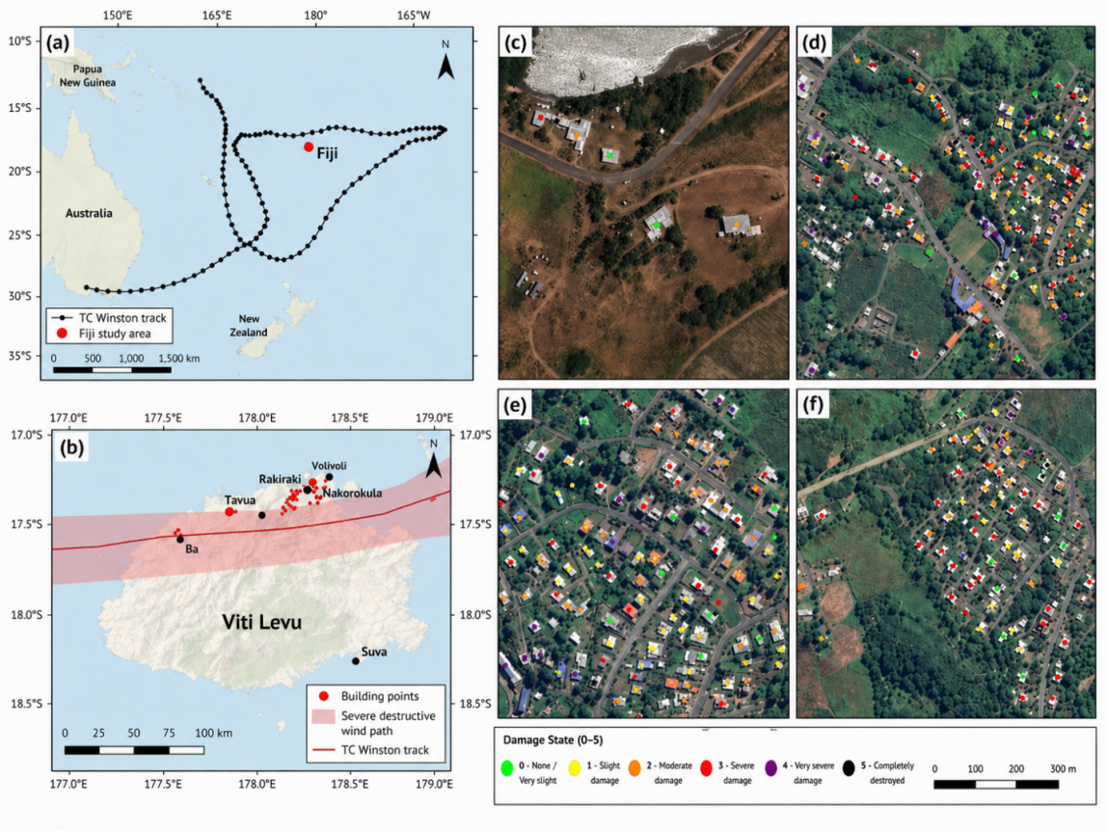
Fig 1 Spatial distribution of Tropical Cyclone Winston track points and building damage samples in Fiji.
Tropical Cyclone Winston was used as the main historical training and validation case because it provides building-level damage survey labels and relatively complete building attribute information. This paper utilizes the Fiji wind damage dataset for buildings from Tropical Cyclone Winston reported by Paulik et al. [13] to classify the building damage caused by Tropical Cyclone Winston. As listed in Table 1, this dataset categorizes the structural damage status of buildings into six levels, namely DS0-DS5. Given that the objective of this study is to predict whether a building is damaged, rather than to predict damage severity across multiple levels, the original damage grades were binary-coded during the modeling process. Specifically, DS0 (no damage) and DS1 (minor damage) were grouped into the “undamaged” category, while DS2, DS3, DS4, and DS5 were grouped into the “damaged” category. This approach was adopted because buildings corresponding to DS0 and DS1 typically retain good usability and exhibit minimal structural damage; whereas starting from DS2, buildings already exhibit noticeable roof damage, water ingress, or structural degradation, which better aligns with the definition of damaged buildings in this study. Based on this, a binary classification system for building damage prediction was ultimately established.
Table 1 Damage state classification system for buildings affected by Tropical Cyclone Winston.
Damage State (DS) | Damage State Classification | Damage Description | Condition of the structure | Reclassification
DS0 | None | No damage to building structure | Promptly reusable without repair or cleaning | 0 (no damage)
DS1 | Insignificant | Slight damages to external non-structural components | Promptly reusable without urgent repair or cleaning | 0 (no damage)
DS2 | Minor | Some damage to roof (< 10 % removed) and/or internal non-structural components due to water ingress | Possible use only after urgent damage repair and cleaning | 1 (damaged)
DS3 | Moderate | Heavy damage to roof (10 % to 100 % removed), major water ingress and damage to non-structural components. The structural integrity of external walls remains mostly intact. | Possible use after major damage repair and retrofitting of roof structure and non-structural components | 1 (damaged)
DS4 | Severe | Destructive damage to roof (>50 % removed), walls and openings (<50 % of all walls) and/or columns (several bent or destroyed). Major water ingress and damage to all non-structural components | Loss of functionality (system collapse). Only repairable at significant repair and retrofitting cost | 1 (damaged)
DS5 | Complete | Blown away, only foundation remaining on footprint | Loss of functionality (system collapse). Non-repairable or great cost for retrofitting | 1 (damaged)
In addition to structural damage status, the dataset records the building attributes used in this study, including foundation type, floor height, number of storeys, building condition, roof pitch, roof type, wall cladding, and building location (Table 2). Together with the derived tropical cyclone hazard variables, these predictors provide the basis for subsequent building damage prediction and vulnerability modeling.
Table 2 Summary of predictor variables and label-related fields used for model construction.
 | Variable | Types or Description | Data Type | Unit or Value | Column Heading
Location | Latitude | Latitude value in WGS84 (EPSG: 4326) | Decimal | Decimal degrees | Y_coord
 | Longitude | Longitude value in WGS84 (EPSG: 4326) | Decimal | Decimal degrees | X_coord
Building | Foundation Type | Concrete Slab; Pile; Solid wall with Earth Fill | Text | 4 classes | Foundation_Type
 | First Storey Floor Height | First finished floor level height in meters above ground in meters | Decimal | m | FS_Floor_Height
 | Second Storey Floor Height | Second finished floor level height in meters above ground in meters | Decimal | m | SS_Floor_Height
 | Storeys | Number of complete building floor levels | Integer | 1 to ∞ | Storeys
 | Condition | Good; Moderate; Poor | Text | 8 classes | Condition
 | Roof Pitch | Flat (0–2 degree); Near Flat (2–10 degree); Moderate (10–40 degree); Steep (greater than 40 degree) | Text | 4 classes | Roof_Pitch
 | Roof Type | 'Mono'; 'Hip'; 'Gable'; 'Complex' | Text | 4 classes | Roof_Type
 | Wall Cladding | 'Concrete Masonry', 'Corrugated Iron', 'Open', 'Plastic', 'Sheet Metal', 'Timber' | Text | 6 classes | Wall_Cladding
Damage | Damage State | 'DS0: None', 'DS1: Insignificant', 'DS2: Minor', 'DS3: Moderate', 'DS4: Severe', 'DS5: Complete' | Text | 6 classes | Damage_State

2.2. Tropical Cyclone Rai as an Exploratory Spatial Generalization Case
As shown in Fig. 2, Super Typhoon Rai, locally named Odette in the Philippines, was a major tropical cyclone event that affected the western North Pacific and the central-southern Philippines in December 2021. Rai formed over the western Pacific in mid-December and rapidly intensified as it approached the Philippine Area of Responsibility, developing into a very intense typhoon before landfall. On 16 December 2021, Rai first made landfall over Siargao Island, Surigao del Norte, bringing destructive winds, heavy rainfall, and severe coastal impacts to the northeastern part of Mindanao and nearby islands. Humanitarian reports indicate that the typhoon approached Siargao with maximum sustained winds of about 195 km/h, while other emergency reports recorded gusts reaching 260–270 km/h, reflecting its extremely high intensity at landfall.
In terms of the damage assessment dataset, the UNOSAT (United Nations Operational Satellite Applications Programme) product TC20211216PHL[15] focuses on Siargao Island, specifically General Luna in Surigao del Norte, Philippines. The assessment was based on very-high-resolution satellite imagery, including Pléiades imagery acquired on 26 December 2021 and WorldView-3 imagery acquired on 23 December 2021. Within the analyzed area of approximately 10 km², UNOSAT identified 1,769 damaged structures and 380 potentially damaged structures. This dataset therefore provides detailed post-disaster building-level damage information for one of the areas directly affected by Rai’s first landfall. However, UNOSAT noted that the results represent a preliminary satellite-based analysis and had not been validated through field investigation at the time of publication.
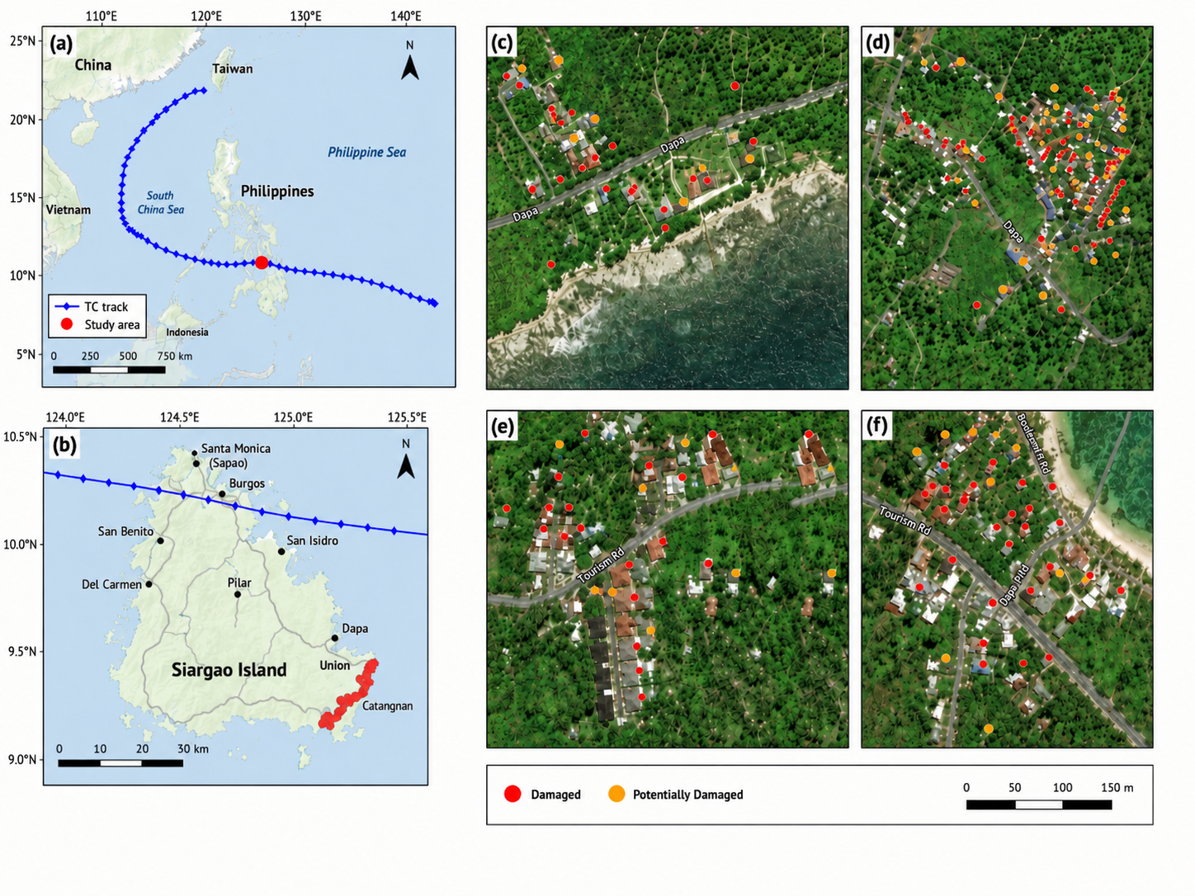
Fig 2 Track of Tropical Cyclone Rai and the exploratory spatial generalization area in Siargao Island, Philippines.
Compared with the Winston case discussed earlier in this paper, the Rai case shows clear differences in terms of tropical cyclone characteristics, geographical setting, disaster-affected environment, building composition, and data source characteristics. According to the best-track data used in this study, both Winston and Rai were extremely intense tropical cyclones and reached Category 5 intensity at their peak. Winston reached a maximum sustained wind speed of 155 kt, equivalent to approximately 287 km/h, with a minimum central pressure of 907 hPa, while Rai reached a maximum sustained wind speed of 150 kt, equivalent to approximately 278 km/h, with a minimum central pressure of 908 hPa. This indicates that the two events were comparable in terms of peak intensity and both represent severe wind hazard cases suitable for building-level damage analysis. However, they occurred in different ocean basins and affected different regional environments: Winston affected the Fijian archipelago in the South Pacific, whereas Rai affected Siargao Island in the Philippines in the western North Pacific. In addition, the Rai track data indicate that its wind intensity decreased to approximately 115-128 kt near landfall, while still maintaining strong destructive potential. In terms of disaster data, Winston was mainly based on field-surveyed building damage samples with relatively detailed structural attributes available for model training, while the Rai spatial generalization dataset was mainly derived from satellite-based UNOSAT damage assessment results, building spatial locations, and building height information. Therefore, Tropical Cyclone Rai was introduced as an exploratory spatial generalization case to examine whether models trained on the Winston dataset could generalize to another severe tropical cyclone event and a new regional context under limited feature availability.
Data on the heights of buildings were sourced from the 3D-GloBFP (3D Global Building Footprints) [14] dataset. This dataset is a three-dimensional building footprint dataset constructed at the global single-building scale, providing building footprints and corresponding height information (Fig. 3). It is stored in Shapefile format, with building heights recorded as attribute fields, thereby providing the basic spatial units and height characteristics required for building-level disaster assessment.
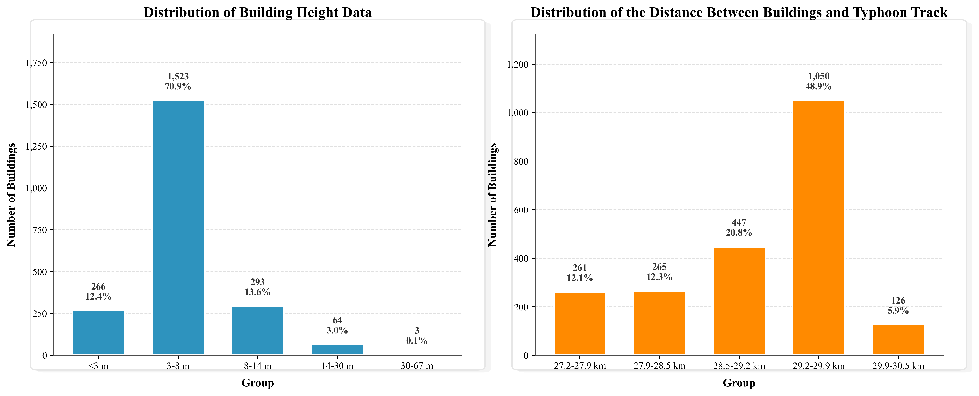
Fig 3 Building footprints and height information used for the Rai spatial generalization case from the 3D-GloBFP dataset.
According to the UNOSAT product description, analysts usually generate damage assessment datasets by closely reviewing satellite imagery, often comparing two or more images to identify notable changes(Fig. 4). For building damage assessments, these changes are manually documented by the analyst in vector data, and the resulting data are then loaded into a standardized UNOSAT geodatabase and exported as Shapefiles for dissemination.
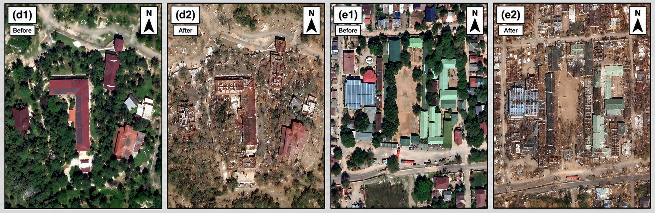
Fig 4 Examples of pre- and post-disaster satellite images used for visual interpretation of building damage in the Rai case.
In the UNOSAT damage assessment dataset, building damage information is provided in vector format with different interpretation categories. The “damaged” category refers to structures for which visible damage features could be identified from the post-disaster satellite imagery through image interpretation. In contrast, the “potentially damaged” category represents structures showing possible damage indications or uncertain image evidence, but for which the damage condition could not be confirmed with the same level of confidence. Therefore, these two categories differ in the reliability and certainty of the interpreted damage evidence.
For the exploratory spatial generalization evaluation in this study, the UNOSAT labels were reorganized with caution because the dataset does not provide a complete field-verified damaged-undamaged building inventory. Structures labelled as "damaged" were treated as positive samples. Structures labelled as "potentially damaged" were treated as reference negative samples because the product description indicates that these structures had no sufficiently confirmed evidence of definite damage. This treatment is also consistent with the binary reclassification strategy used in this study, in which no damage and very slight or uncertain damage states are grouped into the undamaged class. Nevertheless, this setting should not be interpreted as proof that all potentially damaged buildings were truly undamaged. Therefore, the Rai experiment evaluates the separation between high-confidence damaged structures and uncertain or unconfirmed potentially damaged structures, rather than a strict field-confirmed damaged-undamaged validation.
2.3 Tropical Cyclone Ian as an Exploratory Spatial Generalization Case
As shown in Fig. 5, Hurricane Ian was one of the most destructive tropical cyclone events to affect the United States in recent years. Ian developed over the Caribbean Sea in late September 2022, intensified rapidly over the Gulf of Mexico, and made landfall near Cayo Costa, Florida, on 28 September 2022 as a high-end Category 4 hurricane. At landfall, Ian had maximum sustained winds of approximately 150 mph, equivalent to about 241 km/h, producing catastrophic wind, storm surge, flooding, and wave impacts along the southwest coast of Florida. Fort Myers Beach, located on Estero Island in Lee County, was one of the areas most severely affected by Hurricane Ian, where many residential and coastal buildings experienced different degrees of structural and non-structural damage.
In terms of the damage assessment dataset, this study uses the DesignSafe dataset "Virtual Damage Assessment and First-floor Elevation Estimation: Application to Fort Myers Beach, Florida and Hurricane Ian (2022)" [24]. This dataset provides an integrated pre- and post-storm building-level damage assessment for Fort Myers Beach, Florida. It contains virtual damage assessment and first-floor elevation information for approximately 3,400 buildings affected by Hurricane Ian. The dataset was developed using multiple data sources, including publicly available street-level imagery, drone imagery, NOAA satellite imagery, USGS high-water-mark data, StEER reconnaissance information, and other building-related data sources. Although the dataset contains richer building and component-level information, these post-storm and damage-related fields were not used as prediction inputs in this study; they were used only for label construction, data description, and interpretation.
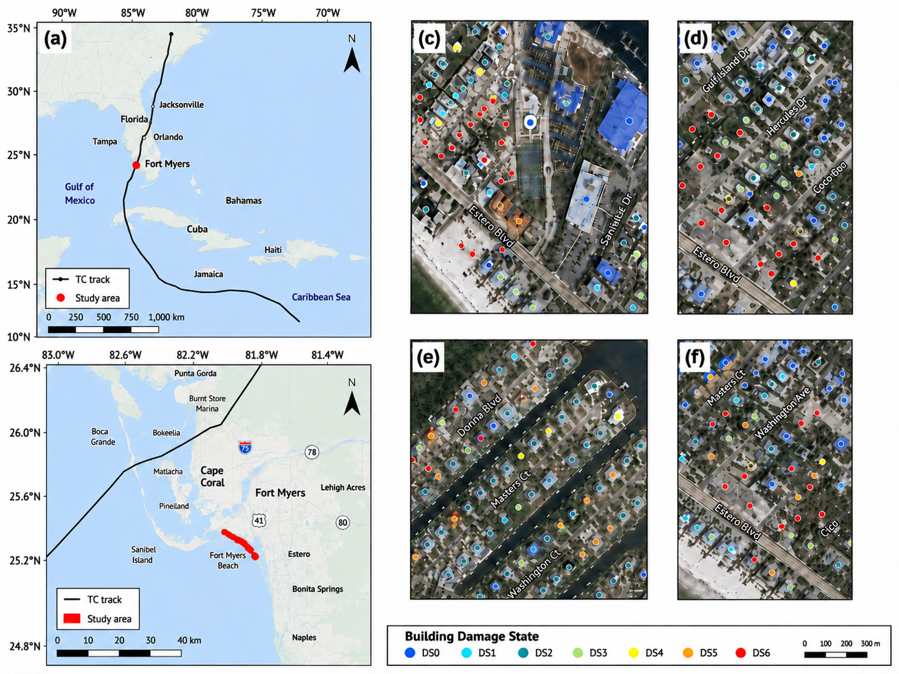
Fig 5 Track of Tropical Cyclone Ian and the exploratory spatial generalization area in Florida.
Compared with the Winston case used for model training and internal validation, the Ian dataset provides an exploratory spatial generalization case from a different ocean basin, regional environment, and hazard-impact context. According to the best-track data used in this study, both Winston and Ian were extremely intense tropical cyclones with strong destructive wind potential. Winston reached a maximum sustained wind speed of 155 kt, equivalent to approximately 287 km/h, with a minimum central pressure of 907 hPa, whereas Ian reached a maximum sustained wind speed of 140 kt, equivalent to approximately 259 km/h, with a minimum central pressure of 937 hPa. Although Ian was slightly weaker than Winston in peak intensity, it still represented a severe hurricane event suitable for testing spatial generalization ability. In terms of wind-field structure, Winston had a radius of maximum wind speed of approximately 12 nmi and an outer closed isobar radius of approximately 180 nmi, while Ian had larger corresponding values of approximately 20 nmi and 270 nmi, respectively. This indicates that Winston was a more compact and intense extreme-wind case, whereas Ian had a broader wind field and stronger storm-scale influence. In addition, Ian affected the southwest coast of Florida, where building damage was influenced not only by strong winds but also by storm surge, waves, coastal flooding, and local exposure conditions. Because the present model mainly represents simplified wind-related hazard variables, the Ian case should be regarded as a more challenging multi-hazard spatial generalization scenario rather than a pure wind-damage validation case.
According to the DesignSafe dataset description, the Ian building damage data were generated through a virtual damage assessment (VDA) approach. Analysts selected building coordinates and then reviewed multiple pre- and post-storm imagery sources, including street-level images, aerial or drone images, and satellite images, to identify visible damage characteristics and record building-level damage information. The dataset provides component-based damage assessment using a damage state (DS) scale from no damage (DS0) to complete damage (DS6), covering major building components such as roofs, walls, foundations, openings, and overall structural condition. To make the Ian dataset consistent with the binary prediction objective of this study, the original DS0-DS6 damage states were reclassified into damaged and undamaged categories. Specifically, DS0 and DS1 were treated as undamaged samples because they represent no or very slight visible damage, while DS2, DS3, DS4, DS5, and DS6 were treated as damaged samples because they indicate observable component or structural damage. Post-storm VDA information was used only to construct reference labels, while model predictors were restricted to simplified variables that could be obtained before or during the event, including building location, building height, distance to the cyclone center, and tropical cyclone intensity and wind-field parameters.

2.4. Tropical Cyclone Best-Track Data and Hazard-Related Variables
The tropical cyclone track and intensity data used in this paper are sourced from the International Best Track Archive for Climate Stewardship (IBTrACS) dataset, which is published by the National Centers for Environmental Information (NOAA NCEI) of the U.S. National Oceanic and Atmospheric Administration (NOAA) [12]. It is currently one of the most comprehensive and widely used archives of tropical cyclone best tracks worldwide [8]. A key feature of IBTrACS is its integration of historical and real-time tropical cyclone track data from multiple regional meteorological centers and operational agencies, creating a unified global database of tropical cyclone tracks that facilitates cross-regional and cross-event analysis and comparative studies of storm processes. According to official documentation, IBTrACS primarily provides information on the location, intensity, and certain structural parameters of tropical cyclones. Its time span dates back to the mid-19th century, with typhoon processes typically recorded at 3- or 6-hour intervals, making it a crucial foundational data source for current research on tropical cyclone disasters and risk analysis.
In line with the research objectives of this paper, the analysis focuses on the temporal and spatial locations of tropical cyclone track points, as well as intensity and structural variables. Specifically, ISO_TIME denotes the time of the track point, while lat and lon represent the latitude and longitude of the cyclone center, respectively; USA_WIND denotes the maximum sustained wind speed, USA_PRES denotes the central minimum pressure, USA_RMW denotes the radius of maximum wind speed, USA_ROCI denotes the radius of the outermost closed isobar, and USA_POCI denotes the ambient pressure at the periphery. These variables effectively characterize the intensity of the cyclone center and the scale features of the wind field, providing critical inputs for subsequent parameterized simplified wind field models based on the Holland parameterization approach.

3 Methodology
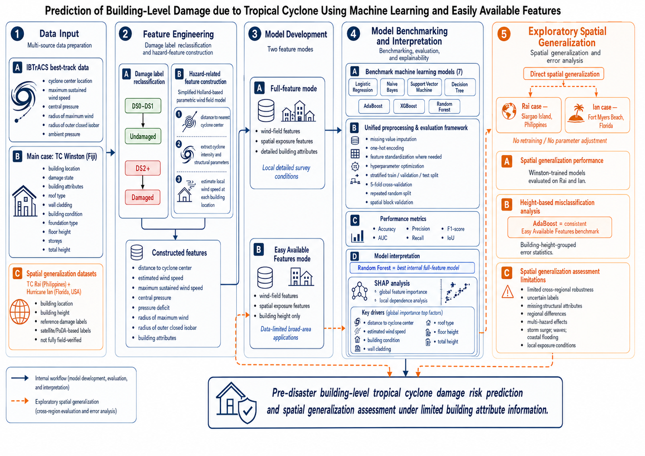
Fig 6 Research Flowchart.

This study follows the methodological workflow illustrated as Fig 6 shows. Briefly, the research process includes six main steps: (1) collecting tropical cyclone best-track data and building-level damage datasets; (2) reclassifying original damage states into a binary damaged–undamaged system; (3) constructing simplified wind-field and spatial exposure features based on the Holland-inspired parameterization; (4) comparing benchmark machine learning models under full-feature and Easy Available Features modes; (5) interpreting key damage-driving factors using SHAP; and (6) evaluating the spatial generalization ability of the Easy Available Features model using the Rai and Ian exploratory spatial generalization cases.

3.1. Parametric Wind Field Feature Construction Based on the Holland Model
To quantitatively characterize the local wind speed intensity experienced by buildings under tropical cyclone conditions, this paper constructs a simplified, parameterized wind field model based on the Holland parameterization approach [16]. The model uses parameters such as maximum sustained wind speed, central pressure, radius of maximum wind speed, radius of the outermost closed isobar, and ambient atmospheric pressure from tropical cyclone track data as inputs. Combined with the spatial distance between the building and the cyclone center, it estimates the wind speed at the building’s location. The model consists of three sequential steps: (1) distance calculation, (2) parameter extraction, and (3) segmented wind speed estimation.
First, the Haversine formula is used to calculate the great circle distance between the building and each point along the tropical cyclone track, and the track point with the shortest distance is selected as the nearest tropical cyclone impact location corresponding to the building. Because detailed time-resolved local wind observations were unavailable, this nearest-track-point matching was used as a simplified exposure approximation. Future work should estimate wind exposure across all available track points and use the maximum event-level local wind speed as a more physically representative hazard indicator. The calculation formula is:
$$d=2R\arcsin\left(\sqrt{\sin^{2}\left(\frac{φ_{2}−φ_{1}}{2}\right)+\cos{φ_{1}}\cos{φ_{2}}\sin^{2}\left(\frac{λ_{2}−λ_{1}}{2}\right)}\right)$$ | (1)
Where d represents the spherical distance between the building and the center of the typhoon, and R represents the radius of the Earth; in this paper, R is taken to be 6371 km. φ1 and φ2 are the latitudes of the building and the cyclone center, respectively, while λ1 and λ2 are their longitudes, respectively.
Second, to describe the influence of the typhoon’s outer pressure field on wind speed distribution, this paper draws on the Holland model and calculates the Holland-B parameter using the maximum wind speed and the pressure difference at the center. Its expression is:
$$B=\frac{ρeV_{\max{}}^{2}}{ΔP×100}$$ | (2)
where, B is the Holland parameter; ρ is the density of air, taken as 1.15 kg/m³ in this paper; e is the natural constant; Vmax is the maximum sustained wind speed of the typhoon, which must be converted from knots to m/s; and ΔP = Poci − Pc represents the difference between the ambient atmospheric pressure and the central pressure. When the ambient pressure is missing or the condition Poci > Pc is not satisfied, this paper sets B to the default value of 1.5; simultaneously, to avoid the influence of outliers, B is constrained within the range [1.0, 2.5].
After determining the distance r between the building and the center of the typhoon, the radius of maximum wind speed rmax, and the radius of the typhoon’s outer closed isobaric circle roci, this paper uses piecewise functions to estimate the wind speed V(r) at the building’s location. In this context, the radius of maximum wind speed and the radius of the outer closed isobaric circle are converted from nautical miles to kilometers:
$$r_{max}=1.852×RMW$$  $$r_{oci}=1.852×ROCI$$ | (3)
When relevant parameters are missing, the empirical default values rmax = 50 km and roci = 400 km are used.
Wind speeds at the building location are expressed in the following segmented form:
$$V(r)=\left\{\begin{matrix}0.2V_{\max{}}, & r<0.1r_{max} \\ V_{\max{}}{\left(\frac{r}{r_{max}}\right)}^{0.5}, & 0.1r_{max}≤r≤r_{max} \\ V_{\max{}}\sqrt{{\left(\frac{r_{max}}{r}\right)}^{B}\exp\left(1−{\left(\frac{r_{max}}{r}\right)}^{B}\right)}, & r_{max}<r≤r_{oci} \\ \max{(}15, 0.08V_{\max{}}), & r>r_{oci}\end{matrix}\right.$$ | (4)
where V(r) represents the estimated wind speed at the building’s location, and Vmax represents the maximum sustained wind speed at the cyclone center. The above segmentation scheme reflects the fundamental pattern of tropical cyclone wind fields, which gradually attenuate from the core region toward the periphery: a conservative reduction is applied in the immediate vicinity of the cyclone center; within the radius of maximum wind speed, wind speed is assumed to increase gradually with radius; outside the radius of maximum wind speed, a decay function based on Holland’s parameters is used; and beyond the outermost closed isobar, the peripheral area of weak influence is represented by a lower background wind speed.
Based on this model, this paper extracts tropical cyclone hazard-related features for each building sample, including the distance from the building to the nearest cyclone center, estimated wind speed, tropical cyclone maximum wind speed, central pressure, peripheral pressure, pressure deficit, radius of maximum wind speed, and radius of the outermost closed isobar. These wind field variables are then combined with the building’s structural attributes for subsequent damage prediction modeling.

3.2 Benchmark Machine Learning Models for Building Damage Prediction
To compare the suitability of different machine learning algorithms for the binary prediction task of identifying tropical cyclone-induced building damage, seven benchmark models were implemented within a unified preprocessing and evaluation framework. All models used the binary disaster-loss label as the output variable. The primary holdout experiment used stratified random sampling, with the training, validation, and test sets comprising approximately 70%, 15%, and 15% of the total data, respectively, and a random seed of 42 was used to ensure reproducibility. To reduce the instability associated with a single random split and to address the possibility that spatially clustered buildings may lead to optimistic internal validation results, three additional robustness checks were conducted: 5-fold stratified cross-validation, multi-seed repeated stratified holdout validation, and an exploratory spatial block split based on building coordinates. The spatial block split was generated by dividing the study area according to building coordinates and using one spatial block as the test region. Numeric missing values were imputed using the median value from the training set, and the same imputation rule was applied to the validation and test sets to prevent data leakage. For categorical building attributes, missing values were imputed with a separate "Missing" category and then transformed using OneHotEncoder, so that unordered categories such as roof type, wall cladding, foundation type, and building condition were not treated as ordinal numerical variables. Logistic regression, support vector machine, and naive Bayes models were further standardized using StandardScaler before training, while tree-based and ensemble tree models were trained without feature standardization.
Table 3 lists the seven benchmark machine learning models and their optimized key parameter settings. Hyperparameters were selected through GridSearchCV or RandomizedSearchCV using the training folds, with macro-F1 as the primary refitting metric and AUC and accuracy recorded as auxiliary evaluation indicators. The final selected models were then evaluated on the independent test set. This strategy was adopted to provide a more systematic and comparable benchmark than fixed empirical settings, and to avoid giving an unintended advantage to any single model family.

Table 3
Optimized key parameter settings of benchmark machine learning models for tropical cyclone-induced building damage prediction.
Model | Feature mode | Key Settings
Decision Tree | Full-feature | random_state=42, criterion='gini', max_depth=5, min_samples_split=20, min_samples_leaf=1, class_weight=None
Decision Tree | Easy Available Features | random_state=42, criterion='entropy', max_depth=12, min_samples_split=2, min_samples_leaf=1, class_weight=None
Logistic Regression | Full-feature | random_state=42, max_iter=3000, solver='lbfgs', C=1.0, class_weight=None
Logistic Regression | Easy Available Features | random_state=42, max_iter=3000, solver='lbfgs', C=10.0, class_weight='balanced'
Random Forest | Full-feature | n_estimators=200, random_state=42, n_jobs=-1, class_weight='balanced', max_depth=14, min_samples_split=8, min_samples_leaf=4, max_features=0.7
Random Forest | Easy Available Features | n_estimators=700, random_state=42, n_jobs=-1, class_weight=None, max_depth=6, min_samples_split=2, min_samples_leaf=2, max_features='log2'
Support Vector Machine | Full-feature | C=3.0, kernel='rbf', gamma=0.1, probability=True, class_weight='balanced', random_state=42, cache_size=1000
Support Vector Machine | Easy Available Features | C=10.0, kernel='rbf', gamma='scale', probability=True, class_weight='balanced', random_state=42, cache_size=1000
Naive Bayes | Full-feature | var_smoothing=1e-7
Naive Bayes | Easy Available Features | var_smoothing=1e-11
AdaBoost | Full-feature | Base classifier: DecisionTreeClassifier(max_depth=3, random_state=42); n_estimators=200, learning_rate=0.3, random_state=42
AdaBoost | Easy Available Features | Base classifier: DecisionTreeClassifier(max_depth=3, random_state=42); n_estimators=200, learning_rate=0.1, random_state=42
XGBoost | Full-feature | n_estimators=240, max_depth=4, learning_rate=0.01, subsample=0.85, colsample_bytree=0.7, min_child_weight=1, reg_lambda=5, scale_pos_weight=0.6838, eval_metric='logloss', random_state=42, n_jobs=1, tree_method='hist'
XGBoost | Easy Available Features | n_estimators=240, max_depth=3, learning_rate=0.03, subsample=1.0, colsample_bytree=0.7, min_child_weight=3, reg_lambda=5, scale_pos_weight=1.0, eval_metric='logloss', random_state=42, n_jobs=1, tree_method='hist'
Table 4 summarizes the evaluation metrics used to assess model performance, including AUC, accuracy, F1-score, precision, sensitivity, and IoU. Let TP denote true positives, i.e., the number of samples that are actually damaged and predicted to be damaged; TN denote true negatives, i.e., the number of samples that are actually undamaged and predicted to be undamaged; FP denote false positives, i.e., the number of samples that are actually undamaged but predicted to be damaged; and FN denote false negatives, i.e., the number of samples that are actually damaged but predicted to be undamaged.
Table 4
Evaluation metrics and calculation formulas for binary building damage prediction.
Indicators | Calculation formula | Explanation of Indicators
AUC | Area under the ROC curve | This metric measures the model's overall ability to distinguish between damaged and undamaged samples; the closer the AUC is to 1, the better the prediction performance.
Accuracy | Accuracy = (TP + TN) / (TP + TN + FP + FN) | The proportion of samples that were correctly classified
Precision | Precision = TP / (TP + FP) | The proportion of samples predicted to be damaged that are actually damaged
Sensitivity / Recall | Sensitivity = TP / (TP + FN) | The proportion of samples in the actual damaged set that were correctly identified by the model
F1-score | F1 = 2 x Precision x Sensitivity  / (Precision + Sensitivity) | Taking both Precision and Sensitivity into account, this metric is suitable for evaluating models in cases of class imbalance.
IoU | IoU = TP / (TP + FP + FN) | Indicates the degree of overlap between the predicted damage area and the actual damage area; in binary prediction tasks, it can also be used to measure the consistency of positive class predictions

3.3 SHAP-Based Model Interpretation and Feature Attribution
To further reveal the internal decision-making mechanisms of the Random Forest model, this paper introduces SHAP (SHapley Additive Explanations) method to perform interpretability analysis on the model. SHAP was proposed by Lundberg and Lee within a unified explanatory framework; its core idea is derived from the Shapley value in cooperative game theory, which treats the model’s prediction results as a problem of profit allocation resulting from the combined effects of input features, and thereby quantifies the marginal contribution of each feature to the prediction result of a single sample. This method possesses sound theoretical properties, such as consistency and local accuracy, and can provide unified and comparable feature attribution results for complex machine learning models.
For any sample x, SHAP represents the model’s predicted value as the sum of the baseline value and the contributions of each feature:
$f(x)=ϕ_{0}+\sum_{i=1}^{M}{ϕ_{i}}$. | (5)
where f(x) is the model’s predicted output for sample x, $ϕ_{0}$ is the model’s baseline output on the background samples, $ϕ_{i}$ represents the SHAP value of the i feature for the current sample’s prediction, and M is the total number of features. If $ϕ_{i}$ > 0, it indicates that the feature drives the model’s output toward the positive class; if $ϕ_{i}$ < 0, it indicates that the feature inhibits the model’s output from moving toward the positive class.
Theoretically, the Shapley value of the i feature can be expressed as the weighted average of its marginal contributions across all possible subsets of features:
$ϕ_{i}=\sum_{S⊆F∖\{i\}}{\frac{|S|!(M−|S|−1)!}{M!}}\left[f_{S∪\{i\}}(x_{S∪\{i\}})−f_{S}(x_{S})\right]$. | (6)
where F denotes the full feature set, and S denotes any feature subset that does not include feature i.$f_{S}$ represents the model output based solely on feature subset S. This expression illustrates that SHAP essentially examines the average incremental contribution of a given feature to the prediction result under different contextual combinations.
Since the core model used in this paper is a random forest, which is a typical tree-based model, SHAP analysis adopts an interpretation approach tailored for tree models. Relevant studies indicate that SHAP methods designed for tree models can compute local interpretation results more efficiently while maintaining consistency with Shapley value theory, and further support the extension from local sample interpretation to global feature importance analysis. Based on this, this paper conducts explanations at two levels: global importance ranking and local dependency relationships. First, the average absolute SHAP value of each feature is used to measure its overall contribution to the model output, and an importance ranking is established accordingly. Second, by combining SHAP summary plots with key feature dependency scatter plots, the distribution characteristics of SHAP values across different feature value ranges are analyzed, thereby revealing the role patterns of variables in model predictions.
By introducing the SHAP method, this paper not only identifies the input variables most critical for building damage classification but also explains, at the sample level, the direction of influence and magnitude of contribution of feature changes on model outputs. For visualization and interpretation, one-hot encoded categorical variables were aggregated back to their original variable groups by summing the mean absolute SHAP values of dummy variables belonging to the same original categorical attribute, so variables such as roof type, wall cladding, and building condition are discussed as categorical feature groups rather than ordered numerical variables. This provides crucial support for subsequent identification of key driving factors, comparison of differences in variable effects under different feature patterns, and validation of the model results’ validity.

4 Results

4.1 Model Performance using damage survey data of Tropical Cyclone Winston
The comprehensive comparison results in Table 5 indicate that Random Forest achieved the best overall internal performance under the full-feature setting. It obtained the highest F1-score (0.6978), AUC (0.7327), accuracy (0.7075), recall (0.6986), and IoU (0.5386). These results suggest that Random Forest was better able to capture nonlinear relationships among tropical cyclone hazard features, spatial exposure, and heterogeneous building attributes in the Winston dataset. Therefore, Random Forest was selected as the primary model for the subsequent SHAP-based interpretation analysis in Section 4.2. However, this selection was limited to internal interpretation; it does not imply that Random Forest is the most stable model for data-limited spatial generalization.
Table 5 Test-set performance of hyperparameter-tuned benchmark models under the full-feature input setting.
Model | F1 | Precision | AUC | Recall | IoU | Acc
Random Forest | 0.6978 | 0.6972 | 0.7327 | 0.6986 | 0.5386 | 0.7075
AdaBoost | 0.6254 | 0.6266 | 0.6940 | 0.6246 | 0.4596 | 0.6415
Naive Bayes | 0.5227 | 0.6830 | 0.6537 | 0.6117 | 0.3611 | 0.5472
Support Vector Machine | 0.5625 | 0.5645 | 0.6918 | 0.5622 | 0.3979 | 0.5849
XGBoost | 0.6438 | 0.6433 | 0.7060 | 0.6473 | 0.4768 | 0.6509
Decision Tree | 0.6224 | 0.6217 | 0.6641 | 0.6240 | 0.4546 | 0.6321
Logistic Regression | 0.5904 | 0.5940 | 0.6951 | 0.5897 | 0.4256 | 0.6132
To further examine the stability of the selected full-feature Random Forest model, additional robustness checks were conducted using stratified cross-validation, repeated stratified splitting, and an exploratory spatial block split. As shown in Table 6, the Random Forest model maintained broadly consistent internal performance across random validation settings, while the spatial block split provided a more conservative indication of spatial generalization.
Table 6. Robustness evaluation of the selected full-feature Random Forest model under different validation strategies.
Validation strategy | Model | Accuracy | F1 | AUC | Precision | Recall
Holdout test | RF | 0.7075 | 0.6978 | 0.7327 | 0.6972 | 0.6986
5-fold stratified CV | RF | 0.7332 | 0.7255 | 0.7817 | 0.7276 | 0.7287
Repeated stratified split | RF | 0.7128 | 0.7043 | 0.7552 | 0.7050 | 0.7067
Spatial block split | RF | 0.6604 | 0.6599 | 0.7866 | 0.6992 | 0.6921
The relatively high AUC but lower F1 under the spatial block split indicates that the model retained ranking ability, while the fixed classification threshold may not have generalized optimally across spatial blocks.

4.2 Feature Importance Analysis for Building Damage Prediction
This paper generates a feature importance ranking plot and a SHAP summary plot based on the full feature set, and then creates dependency scatter plots for key variables to illustrate the distribution characteristics between feature values and SHAP scores.
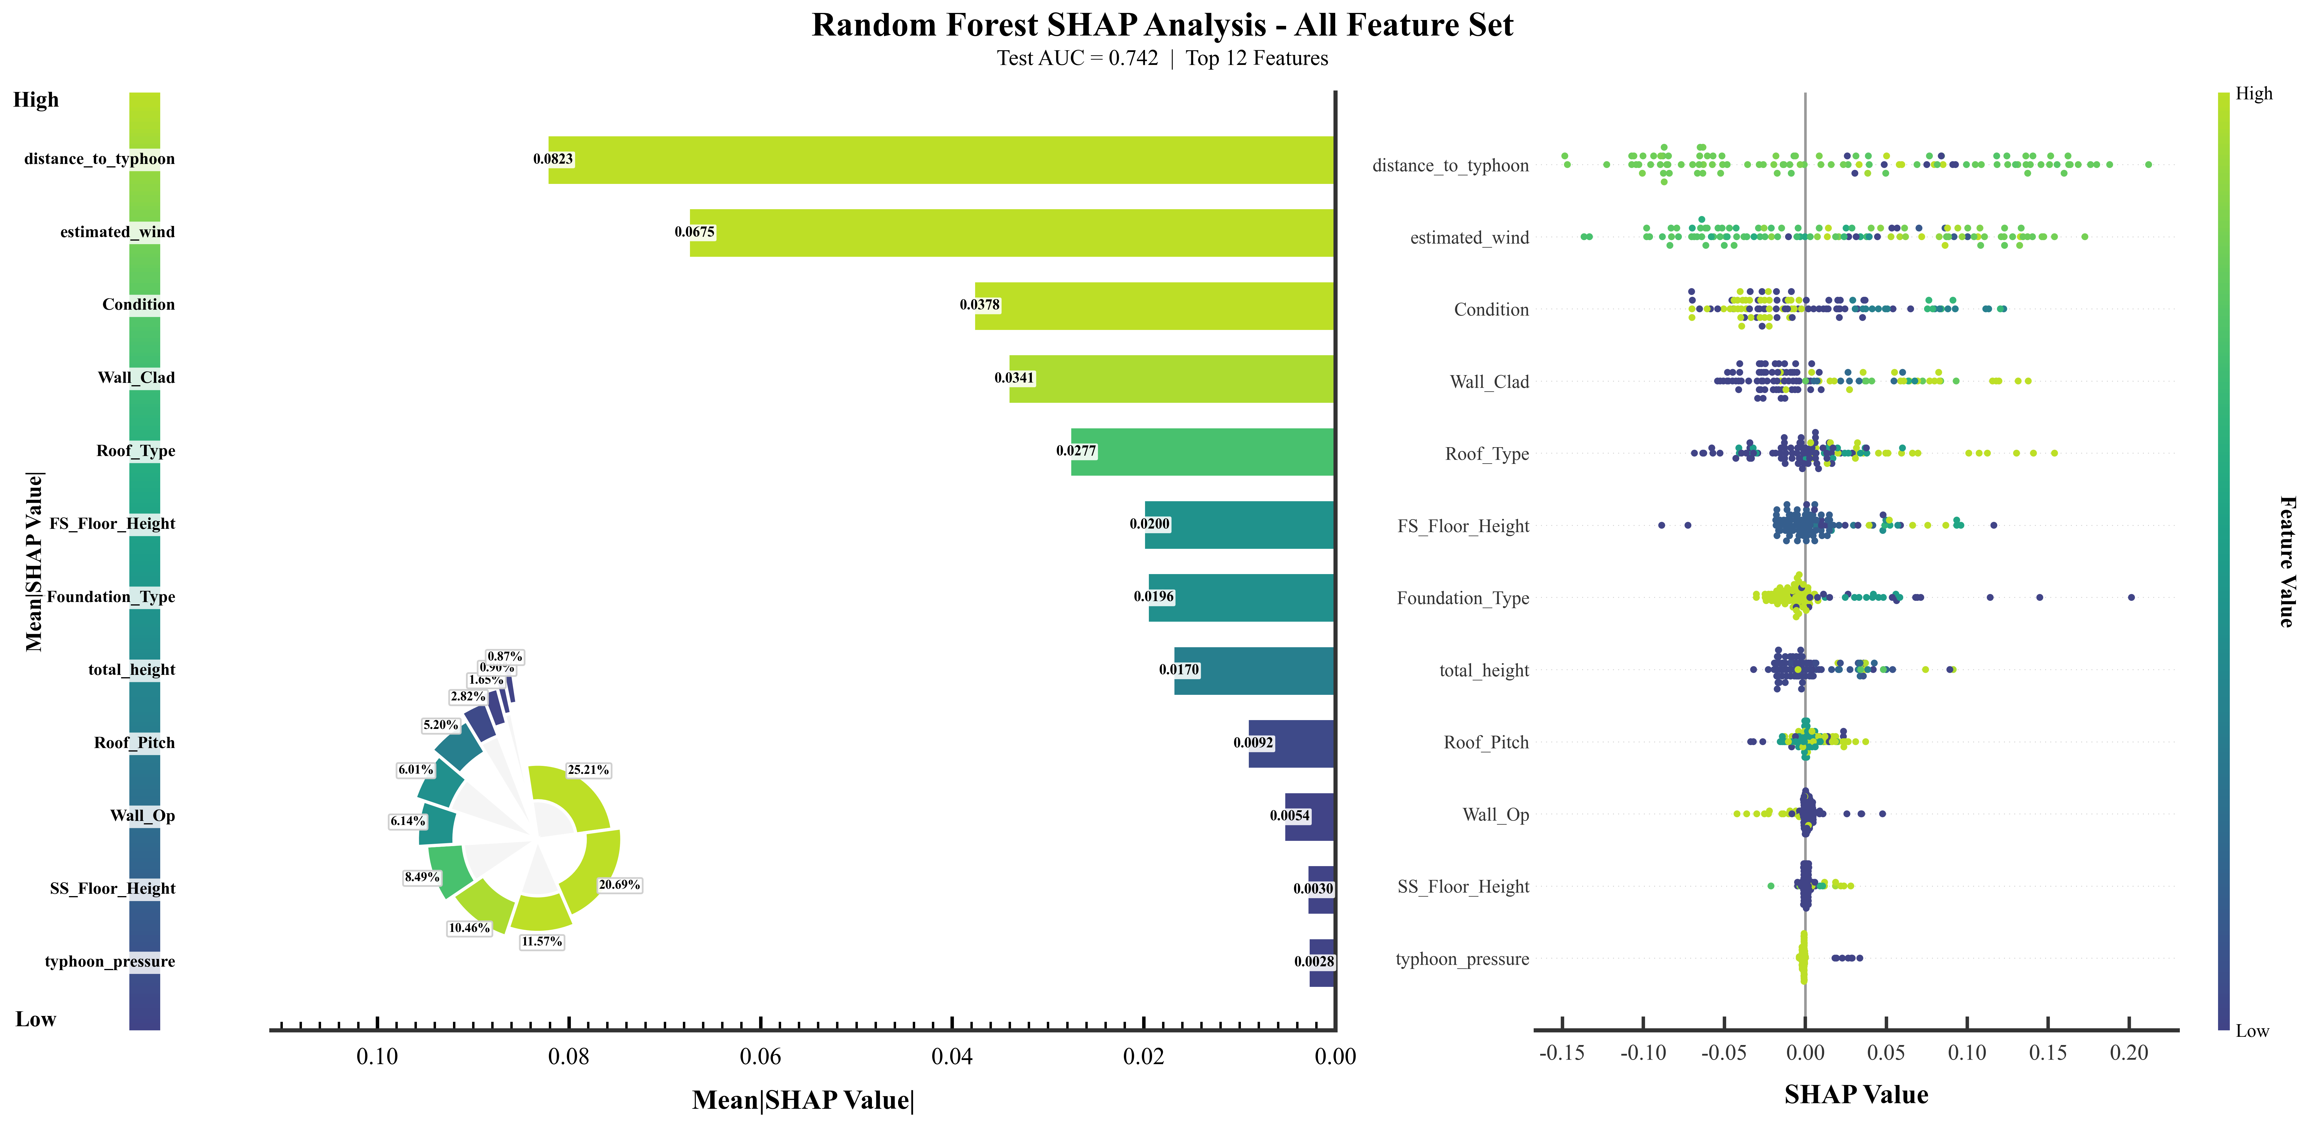
Fig 7 SHAP-based global interpretation of the full-feature Random Forest model for tropical cyclone-induced building damage prediction.
It can be seen from Fig. 7 that there are significant differences in the contributions of different features to the model’s predictions. When sorted by average absolute SHAP value, `distance_to_cyclone` and `estimated_wind` rank first and second, followed by variables such as `Condition`, `Wall_Clad`, `Roof_Type`, `FS_Floor_Height`, and `total_height`. The average absolute SHAP values for the top features in the figure are significantly higher than those for subsequent variables. Among them, the contribution values for `distance_to_cyclone` and `estimated_wind` are close to 0.09, placing them at the forefront; `Condition` and `Wall_Clad` follow, ranging from approximately 0.03 to 0.04; the remaining features show an overall gradual decline. The SHAP summary plot also indicates that the distribution width of sample points corresponding to different features varies along the x-axis. Variables ranked higher exhibit a greater range of SHAP value fluctuations, suggesting that these variables play a more significant role in the model’s output.
Combining the feature ranking results reveals that the distance of the building from the cyclone center (distance_to_cyclone) and the total building height (total_height) are the two key features of focus in this study. The former ranks first in overall contribution, while the latter, although not among the top two, still holds a high level of importance and exhibits a relatively clear distribution pattern in subsequent local dependency scatter plots. Furthermore, considering the global availability of data, these two features are the most readily accessible, making them worthy of further discussion.
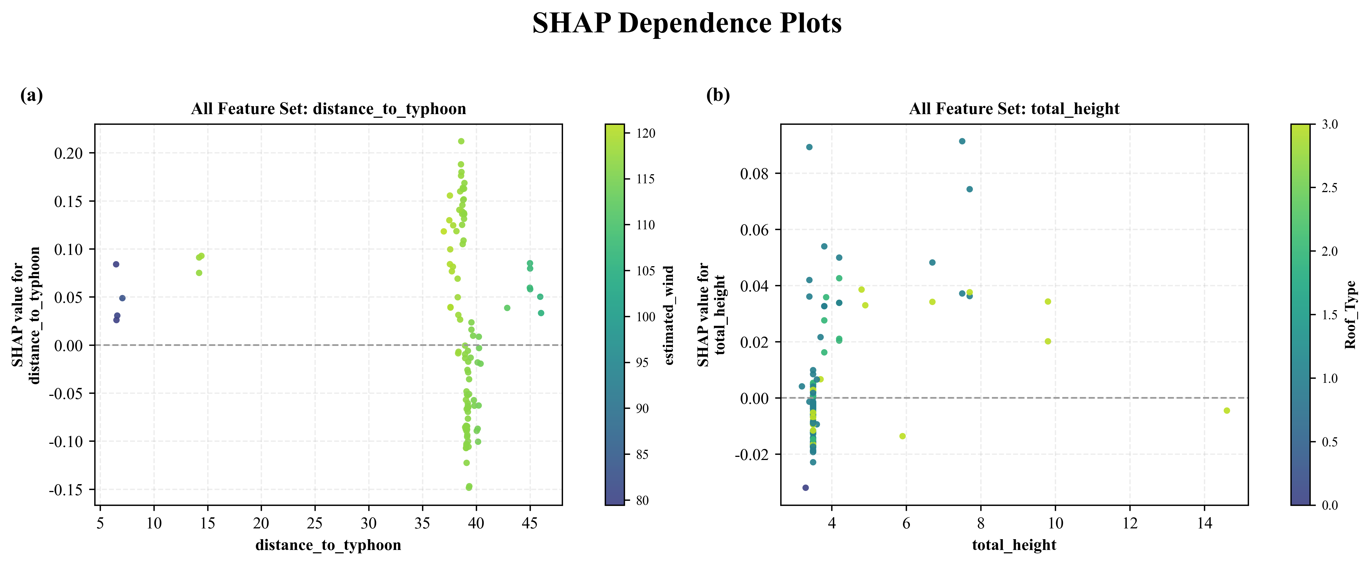
Fig 8 SHAP dependence analysis of key predictors for tropical cyclone-induced building damage prediction.
The SHAP dependence relationship for `distance_to_cyclone` (Fig. 8a) indicates that the spatial position of a building relative to the cyclone center is a key driver of predicted damage risk. In general, buildings located closer to the cyclone center or within stronger wind-field influence tend to receive larger positive SHAP contributions, meaning that this variable pushes the model output toward the damaged class. However, the dispersion of SHAP values at similar distance ranges also shows that distance alone cannot determine damage occurrence. Its effect is moderated by local wind intensity, building vulnerability, and other structural attributes. The interaction with `estimated_wind` further supports the physical mechanism that damage probability is jointly controlled by exposure position and wind intensity, rather than by a single distance threshold.
The dependence relationship for `total_height` (Fig. 8b) shows a weaker but still meaningful contribution of building height to damage prediction. Compared with cyclone-distance and wind-speed variables, the influence of height is more nonlinear and less dominant, which is reasonable because building height is only one component of structural vulnerability. Low- and medium-height buildings may still show positive SHAP contributions when they are combined with vulnerable roof types, wall materials, or poor building conditions, whereas taller buildings are not necessarily safer if their structural attributes and local exposure are unfavorable. Therefore, `total_height` was retained in the Easy Available Features mode not because it fully explains building vulnerability, but because it is one of the few building-level attributes that can be obtained relatively easily from global building footprint or remote sensing products. In addition, categorical variables in the SHAP plots should be interpreted as aggregated category-specific feature groups rather than ordered numerical gradients.

4.3 Model Performance using Easy Available Features
Given the significant variations in the availability of building attribute data across different regions and disaster events, we combine the results of feature importance analysis with actual data availability to classify model inputs into two modes for comparison (Fig 9 and Table 7). The first mode is the full-feature mode, which uses the complete set of available building attributes and tropical cyclone-related variables, including building condition, wall and roof characteristics, floor height, total height, foundation type, estimated wind speed, distance to the cyclone center, central pressure, pressure deficit, radius of maximum wind speed, and radius of the outermost closed isobar. These inputs jointly represent hazard process features, spatial exposure features, and building vulnerability features. The second mode is the Easy Available Features mode, which is designed for data-limited regions and therefore retains only simplified wind-field and spatial exposure variables, including estimated wind speed, distance to the cyclone center, central pressure, pressure deficit, radius of maximum wind speed, and radius of the outermost closed isobar, together with the relatively accessible building attribute of total building height. This comparison allows the study to evaluate both the optimal performance under detailed data conditions and the practical applicability of the framework when only broadly available building information can be obtained.
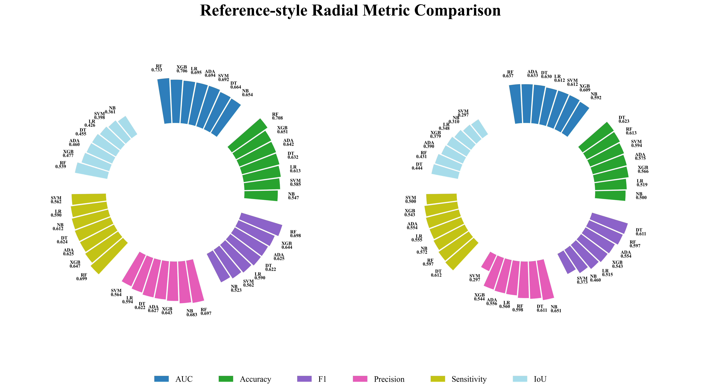
Fig. 9 Reference-style radial metric comparison between full-feature and Easy Available Features benchmark models.
To identify a representative model for data-limited Easy Available Features analysis, the benchmark comparison was interpreted under the same experimental protocol and predefined hyperparameter-search space. AdaBoost was retained as the selected Easy Available Features benchmark because it showed a comparatively smaller performance decline when detailed building attributes were removed, while still maintaining balanced Easy Available Features performance.
Table 7 Full-feature and Easy Available Features comparison using the selected AdaBoost benchmark model.
Mode | Application scenario | Input Feature Composition | Selected model | Accuracy | F1 | Precision | AUC
Full-feature mode | Local detailed survey | Wind-field + exposure + full building attributes | AdaBoost | 0.6415 | 0.6254 | 0.6266 | 0.6940
Easy Available Features mode | Data-limited broad area | Wind-field + exposure + building height | AdaBoost | 0.5755 | 0.5545 | 0.5557 | 0.6333
The robustness of the selected Easy Available Features AdaBoost model was then evaluated under additional validation strategies. Table 8 shows that the Easy Available Features AdaBoost model remained generally stable under repeated and cross-validation settings, although its performance still varied under different spatial validation conditions.

Table 8. Robustness evaluation of the selected Easy Available Features AdaBoost model under different validation strategies.
Validation strategy | Model | Accuracy | F1 | AUC | Precision | Recall
Holdout test | ADA | 0.5755 | 0.5545 | 0.6333 | 0.5557 | 0.5543
5-fold stratified CV | ADA | 0.6505 | 0.6292 | 0.6645 | 0.6355 | 0.6277
Repeated stratified split | ADA | 0.6457 | 0.6291 | 0.6669 | 0.6338 | 0.6289
Spatial block split | ADA | 0.7075 | 0.7069 | 0.7519 | 0.7184 | 0.7244
The higher spatial block performance of the Easy Available Features AdaBoost model may be related to the specific spatial composition and class distribution of the held-out block; therefore, this result should be interpreted as an exploratory spatial robustness check rather than definitive evidence of spatial generalization.
Under the same feature sets, preprocessing pipeline, data partitioning strategy, evaluation metrics, and hyperparameter-search protocol, the benchmark comparison provides a relatively fair assessment of model performance within the experimental setting of this study. Therefore, the results can be used to identify the best-performing models under the Fiji dataset, the adopted feature system, and the predefined validation and search strategies: Random Forest performed best in the full-feature internal test and was used for SHAP interpretation, whereas AdaBoost showed more stable Easy Available Features performance and was retained for subsequent data-limited analysis. However, because different algorithms have different hyperparameter sensitivities, search-space complexity, and assumptions about feature representation and class imbalance, this comparison should not be interpreted as proving the universal superiority of one algorithm over another.

4.4. Spatial generalization ability evaluation using Easy Available Features
To further evaluate the cross-regional spatial generalization ability of the proposed framework, two exploratory spatial generalization cases were considered: Tropical Cyclone Rai in the Philippines and Hurricane Ian in Florida. Rai represents a satellite-derived spatial generalization case, whereas Ian provides a DS-based virtual damage assessment case under a different coastal hurricane and multi-hazard impact context. For both cases, all models were trained using the Winston building damage dataset and then directly applied to the spatial generalization datasets without retraining or parameter adjustment. The spatial generalization samples were used only for independent performance evaluation rather than for model training or parameter refitting. Based on the full-feature versus Easy Available Features comparison in Section 4.3, AdaBoost was used as the consistent model for the subsequent height-based misclassification analysis in both spatial generalization cases.
For the spatial generalization tests, the input variables were limited to the Easy Available Features mode that could be obtained before or during a storm event.
Following the Easy Available Features benchmark comparison in Section 4.3, AdaBoost was used for the subsequent height-based error analysis, while the spatial generalization performance of all optimized benchmark models was still reported for comparison.
Table 9 Spatial generalization performance of optimized benchmark models trained on the Winston dataset and tested on the exploratory Rai reference dataset.
Model | Acc | F1_macro | Precision_macro | Recall_macro | AUC
Random Forest | 0.8232 | 0.4515 | 0.4116 | 0.5000 | 0.4924
AdaBoost | 0.8008 | 0.4999 | 0.5461 | 0.5143 | 0.5062
Naive Bayes | 0.8232 | 0.4515 | 0.4116 | 0.5000 | 0.5000
Support Vector Machine | 0.8232 | 0.4515 | 0.4116 | 0.5000 | 0.5000
XGBoost | 0.8232 | 0.4515 | 0.4116 | 0.5000 | 0.4909
Decision Tree | 0.6729 | 0.5195 | 0.5217 | 0.5286 | 0.5326
Logistic Regression | 0.1768 | 0.1503 | 0.0884 | 0.5000 | 0.4915
The spatial generalization performance of the optimized benchmark models is summarized in Table 9. In this experiment, all models were trained using the Winston building damage dataset from Fiji and then directly applied to the exploratory Rai spatial generalization dataset without retraining or parameter adjustment. Several models achieved relatively high overall accuracy, including Random Forest, Naive Bayes, Support Vector Machine, and XGBoost, but these high accuracy values should be interpreted with caution because the Rai samples were strongly imbalanced and the labels were derived from preliminary satellite interpretation rather than field verification.
Most models produced AUC values close to 0.5, indicating limited discriminative ability in the Rai case. Decision Tree obtained the highest macro-F1 and AUC values among the spatially generalized models, whereas AdaBoost achieved the highest macro-precision (0.5461) and a comparatively balanced macro-recall (0.5143). Although AdaBoost was not the single best model on every Rai metric, it was retained for height-based error analysis because it had already been selected from the internal full-feature versus Easy Available Features comparison as the more stable spatial-generalization-oriented benchmark. This provides a consistent analytical basis for comparing height-related error patterns across Rai and Ian.
Overall, the results in Table 9 indicate that the optimized baseline models trained on the Winston dataset did not generalize robustly to the Rai case. The low macro-F1 and near-random AUC values suggest that the models had difficulty separating high-confidence damaged structures from uncertain or unconfirmed potentially damaged structures under the new regional context. This limited spatial generalization ability may be related to differences between the Winston and Rai cases in regional environment, building composition, damage-label generation method, and available input features. In particular, the Rai spatial generalization experiment relied only on simplified and broadly available variables, while detailed structural attributes such as roof type, wall material, foundation type, and building condition were unavailable.

Table 10 Height-based misclassification statistics of AdaBoost in the exploratory Rai spatial generalization case.
Building Height Range (m) | Total sample size | Number of misclassified samples | Error rate
0–3 | 266 | 40 | 15.04%
3–5 | 772 | 137 | 17.75%
5–7 | 488 | 74 | 15.16%
7–10 | 416 | 80 | 19.23%
10–15 | 152 | 57 | 37.50%
>15 | 55 | 40 | 72.73%
To further examine the error pattern of the spatially generalized AdaBoost model, the misclassified samples were grouped by building height range, as shown in Table 10. The results indicate that the misclassification rate varied substantially across different building height groups. The 3-5 m group contained the largest number of samples and also had the highest number of misclassified samples, with 137 errors among 772 buildings and an error rate of 17.75%. The >15 m group showed the highest error rate of 72.73%, but this group contained only 55 samples, so this result may be affected by the small sample size. The 10-15 m group also showed a relatively high error rate of 37.50%, followed by the 7-10 m group with 19.23%. In contrast, the 0-3 m and 5-7 m groups had lower error rates, at 15.04% and 15.16%, respectively.
This height-based error pattern suggests that building height has a certain influence on the spatial generalization result, but height alone cannot fully explain the classification uncertainty in the Rai case. Errors were not concentrated only in the lowest buildings; instead, relatively high error rates appeared in the higher-height groups above 10 m, especially in the small >15 m group. This indicates that buildings with similar heights may still differ substantially in roof type, wall material, structural condition, construction quality, and local exposure environment, none of which were available in the Easy Available Features mode for spatial generalization. Therefore, although building height is an accessible and useful variable for cross-regional spatial generalization, it is insufficient to represent the full vulnerability differences of buildings affected by Rai.
The spatial generalization performance on the Ian dataset is summarized in Table 11. In this experiment, all models were trained using the Winston dataset and then directly applied to the Ian spatial generalization dataset without retraining or parameter adjustment. Overall, the results indicate that the spatial generalization performance on Ian remained limited, although AdaBoost showed the best class-balance behavior among the spatially generalized models. AdaBoost achieved the highest macro-F1 score of 0.5346 and also showed relatively balanced macro-precision and macro-recall values of 0.5444 and 0.5380, respectively. Logistic Regression obtained the highest AUC value of 0.5787, indicating relatively better ranking ability, but its accuracy was only 0.3841 and its macro-F1 score remained low. Therefore, AdaBoost was retained as the most suitable model for height-based error analysis under the Ian Easy Available Features mode for spatial generalization.
Table 11 Spatial generalization performance of optimized benchmark models trained on the Winston dataset and tested on the exploratory Ian reference dataset.
Model | Acc | F1_macro | Precision_macro | Recall_macro | AUC
Random Forest | 0.6092 | 0.3793 | 0.3267 | 0.4947 | 0.5177
AdaBoost | 0.5866 | 0.5346 | 0.5444 | 0.5380 | 0.5093
Naive Bayes | 0.6159 | 0.3812 | 0.3080 | 0.5000 | 0.5000
Support Vector Machine | 0.6159 | 0.3812 | 0.3080 | 0.5000 | 0.5000
XGBoost | 0.6159 | 0.3812 | 0.3080 | 0.5000 | 0.4000
Decision Tree | 0.6127 | 0.3897 | 0.4873 | 0.4994 | 0.4994
Logistic Regression | 0.3841 | 0.2775 | 0.1920 | 0.5000 | 0.5787
Overall, the results in Table 11 show that the optimized baseline models trained on Winston did not generalize robustly to the Ian case. Compared with the Rai spatial generalization experiment, the Ian dataset provides clearer DS-based damaged-undamaged labels, but its hazard and damage mechanisms are more complex because building damage in Fort Myers Beach was influenced by the combined effects of wind, storm surge, waves, coastal flooding, and local exposure conditions. Therefore, the relatively low macro-F1 values and AUC values close to random classification for most models indicate that simplified wind-field variables, distance to the cyclone center, and building height alone are still insufficient to capture building vulnerability under a different coastal hurricane environment.
To further examine the error distribution of the spatially generalized AdaBoost model in the Ian case, the misclassified samples were grouped by building height range, as shown in Table 12. The 6-10 m group had the lowest error rate, with 8 misclassified samples among 30 buildings, corresponding to an error rate of 26.67%. The 10-12 m group showed an error rate of 33.40%, with 328 misclassified samples among 982 buildings. Error rates increased in the higher groups, reaching 44.29% in the 12-13 m group, 44.24% in the 13-14 m group, 45.10% in the 14-16 m group, and 46.60% in the >16 m group. This pattern suggests that height-related spatial generalization uncertainty in the Ian case differed from the Rai case and may reflect differences in local building composition, coastal exposure, and multi-hazard damage mechanisms.
Table 12 Height-based misclassification statistics of AdaBoost in the exploratory Ian spatial generalization case.
Building Height Range (m) | Total sample size | Number of misclassified samples | Error rate
6–10 | 30 | 8 | 26.67%
10–12 | 982 | 328 | 33.40%
12–13 | 849 | 376 | 44.29%
13–14 | 651 | 288 | 44.24%
14–16 | 572 | 258 | 45.10%
>16 | 324 | 151 | 46.60%

However, this height-related trend should not be interpreted as evidence that building height alone determines hurricane damage risk. In the Ian case, coastal buildings may have experienced complex damage processes related to storm surge, wave action, first-floor elevation, foundation type, opening failure, and local exposure, none of which were fully represented in the Easy Available Features mode for spatial generalization. The relatively higher error rates in the taller height groups may also be influenced by sample composition, local construction characteristics, and the fact that height was used without detailed structural descriptors. Therefore, the height-based error analysis further confirms that building height is a useful but incomplete vulnerability indicator. For spatial generalization under the Ian coastal hurricane context, more detailed building attributes, such as foundation type, first-floor elevation, roof condition, wall system, opening protection, and flood-related exposure variables, are needed to improve model spatial generalization ability and reduce classification uncertainty.

5 Conclusion
This study proposed a tropical cyclone-induced building damage prediction framework by integrating simplified wind field features and selected building attributes in machine learning models. Tropical Cyclone Winston in Fiji was used as the main case to construct a binary damaged-undamaged classification dataset based on building damage survey data. Tropical cyclone hazard variables, including estimated wind speed, distance to the cyclone center, central pressure, pressure deficit, and wind-field structural parameters, were derived from IBTrACS best-track data using a simplified parametric wind field model. Several machine learning models were compared to evaluate their applicability to building-level tropical cyclone damage prediction under different feature conditions. SHAP analysis was introduced to interpret the contribution of key factors. Tropical Cyclone Rai in 2021 and Hurricane Ian in 2022 were further used as two exploratory spatial generalization cases to examine the cross-regional applicability and limitations of the proposed framework under different label reliability, data availability, and hazard-impact conditions.
The results show that Random Forest achieved the strongest internal full-feature performance among the benchmark models and was therefore used as the main model for SHAP-based interpretation. The full-feature model performed better than the Easy Available Features model, indicating that detailed building attributes can improve damage classification. However, the Easy Available Features mode, which mainly used simplified wind-field variables, spatial exposure features, and building height, still maintained a certain level of predictive capability, suggesting its potential for rapid assessment in data-limited regions. SHAP results indicated that distance to the cyclone center and estimated wind speed were the dominant predictors, while building condition, wall cladding, roof type, floor height, and total height also contributed to damage classification. In the spatial generalization experiments, no single model achieved robust cross-regional generalization. Based on the internal comparison between full-feature and Easy Available Features modes, AdaBoost was selected as the consistent model for height-based error analysis because it retained comparatively stable performance under the Easy Available Features mode. The Rai and Ian error analyses both showed that misclassification varied across building height ranges, confirming that building height is useful but insufficient to represent full vulnerability differences. These findings indicate that tropical cyclone-induced building damage is jointly controlled by hazard intensity, spatial exposure, and building vulnerability, and that simplified wind field features combined with accessible building information may support preliminary risk screening in data-limited settings. Nevertheless, direct cross-regional spatial generalization remains strongly affected by regional differences, missing structural attributes, uncertain satellite-derived labels, and unrepresented multi-hazard processes such as storm surge, waves, coastal flooding, and local exposure conditions.
Future work should further improve the physical representation of tropical cyclone hazard processes and expand the applicability of the proposed framework. First, more refined wind field modeling should be introduced by considering terrain effects, surface roughness, wind direction, rainfall, storm surge, waves, coastal flooding, and local exposure conditions. Second, more tropical cyclone events and building damage datasets from different regions should be incorporated to improve model robustness and reduce regional bias. Third, future studies should integrate higher-quality building inventory data, multi-source remote sensing information, and field-verified damage labels to improve sample reliability. Although this study added stratified cross-validation, repeated random splits, and an exploratory spatial block split as robustness checks, broader spatially independent validation across multiple regions is still needed to more rigorously evaluate spatial generalization performance. Finally, domain adaptation, transfer learning, and uncertainty analysis could be further explored to enhance the accuracy, interpretability, and operational value of tropical cyclone-induced building damage prediction in data-limited coastal regions.

Acknowledgements

This study was supported by the National Natural Science Foundation of China under Grant 42571380.

CRediT authorship contribution statement

Yufeng Liu: Writing – review & editing, Writing – original draft, Software, Methodology. Xingyu Chen: Conceptualization. Shulun Gao: Data Organization. Hong Tang: Supervision, Conceptualization, review & editing,

Reference
[1] UNDRR. Hazards and Drivers of Urban Risk. United Nations Office for Disaster Risk Reduction, 2020.
[2] Koks, E. E., Rozenberg, J., Zorn, C., Tariverdi, M., Vousdoukas, M., Fraser, S. A., Hall, J. W., & Hallegatte, S. (2019b). A global multi-hazard risk analysis of road and railway infrastructure assets. Nature Communications, 10(1), 2677. https://doi.org/10.1038/s41467-019-10442-3
[3] IPCC. Climate information relevant for Cities, Buildings, and Transport. Sixth Assessment Report, Working Group I, 2021.
[4] NOAA. Hurricane Safety Tips and Resources. National Weather Service, 2023.
[5] Vickery, P. J., Skerlj, P. F., Lin, J., Twisdale, L. A., Young, M. A., & Lavelle, F. M. (2006). HAZUS-MH Hurricane Model Methodology. II: Damage and loss Estimation. Natural Hazards Review, 7(2), 94–103. https://doi.org/10.1061/(asce)1527-6988(2006)7:2(94).
[6] Hoque, M. A., Phinn, S., Roelfsema, C., & Childs, I. (2018). Assessing tropical cyclone risks using geospatial techniques. Applied Geography, 98, 22–33. https://doi.org/10.1016/j.apgeog.2018.07.004
[7] Zhang, S., Nishijima, K., & Maruyama, T. (2013). Reliability-based modeling of typhoon induced wind vulnerability for residential buildings in Japan. Journal of Wind Engineering and Industrial Aerodynamics, 124, 68–81. https://doi.org/10.1016/j.jweia.2013.11.004
[8] Knapp, K. R., Kruk, M. C., Levinson, D. H., Diamond, H. J., & Neumann, C. J. (2009). The International Best Track Archive for Climate Stewardship (IBTRACS). Bulletin of the American Meteorological Society, 91(3), 363–376. https://doi.org/10.1175/2009bams2755.1
[9] Klepac, S., Subgranon, A., & Olabarrieta, M. (2022). A case study and parametric analysis of predicting hurricane-induced building damage using data-driven machine learning approach. Frontiers in Built Environment, 8. https://doi.org/10.3389/fbuil.2022.1015804
[10] Kim, J., Bae, J., Adhikari, M. D., & Yum, S. (2023). A study of deep learning algorithm usage in predicting building loss ratio due to typhoons: the case of southern part of the Korean Peninsula. Frontiers in Earth Science, 11. https://doi.org/10.3389/feart.2023.1136346
[11] Leach, S., & Paal, S. (2024). Machine learning for predicting prehurricane structural damage. Natural Hazards Review, 25(4). https://doi.org/10.1061/nhrefo.nheng-1950
[12]International Best Track Archive for Climate Stewardship (IBTrACS) | National Centers for Environmental Information (NCEI)
[13] Paulik, R., Williams, S., Funaki, M., & Turner, R. (2025). Wind damage dataset for buildings from 2016 tropical cyclone Winston in Fiji. Data in Brief, 60, 111463. https://doi.org/10.1016/j.dib.2025.111463
[14] Che, Y., Li, X., Liu, X., Wang, Y., Liao, W., Zheng, X., Zhang, X., Xu, X., Shi, Q., Zhu, J., Zhang, H., Yuan, H., & Dai, Y. (2024). 3D-GloBFP: the first global three-dimensional building footprint dataset. Earth System Science Data, 16(11), 5357–5374. https://doi.org/10.5194/essd-16-5357-2024;Data source:https://doi.org/10.5281/zenodo.11319912
[15]UN Operational Satellite Applications Programme (UNOSAT) (2022). Damage assessment in Siargao Island, General Luna, Surigao del Norte of Philippines as of 26 December 2021. Humanitarian Data Exchange. https://data.humdata.org/dataset/3ecc6b0e-2928-497f-a28c-938358dbda82 (dataset)
[16] Holland, G. J. (1980). An analytic model of the wind and pressure profiles in hurricanes. Monthly Weather Review, 108(8), 1212–1218. https://doi.org/10.1175/1520-0493(1980)108
[17] Lundberg, S. M., & Lee, S.-I. (2017). A unified approach to interpreting model predictions. Advances in Neural Information Processing Systems, 30 (NeurIPS 2017).
[18] Ge, J., Tang, H., Yang, N., & Hu, Y. (2022). Rapid identification of damaged buildings using incremental learning with transferred data from historical natural disaster cases. ISPRS Journal of Photogrammetry and Remote Sensing, 195, 105–128. https://doi.org/10.1016/j.isprsjprs.2022.11.010
[19] Ge, J., Wang, Q., & Tang, H. (2024). Real-time identification of collapsed buildings triggered by natural disasters using a modified object-detection network with quasi-panchromatic images. European Journal of Remote Sensing, 57(1). https://doi.org/10.1080/22797254.2024.2318357
[20] Chen, J., Tang, H., Ge, J., & Pan, Y. (2022). Rapid assessment of building damage using Multi-Source data: a case study of April 2015 Nepal earthquake. Remote Sensing, 14(6), 1358. https://doi.org/10.3390/rs14061358
[21] Liu, Z., Tang, H., Feng, L., & Lyu, S. (2023). China Building Rooftop Area: the first multi-annual (2016–2021) and high-resolution (2.5 m) building rooftop area dataset in China derived with super-resolution segmentation from Sentinel-2 imagery. Earth System Science Data, 15(8), 3547–3572. https://doi.org/10.5194/essd-15-3547-2023
[22] Leach, S., & Paal, S. (2024b). Machine learning for predicting prehurricane structural damage. Natural Hazards Review, 25(4). https://doi.org/10.1061/nhrefo.nheng-1950
[23] Kohns, J., Zahs, V., Klonner, C., Höfle, B., Stempniewski, L., & Stark, A. (2025). Building damage assessment in natural disasters: A trans- and interdisciplinary approach combining domain knowledge, 3D machine learning, and crowdsourcing. Progress in Disaster Science, 26, 100427. https://doi.org/10.1016/j.pdisas.2025.100427
[24] Amini, M., D. Cox, A. Barbosa, S. Appleton Figueira (2024). " An integrated Pre and Post Storm Dataset for Hurricane Ian (2022)", in Virtual Damage Assessment and First-floor Elevation Estimation: Application to Fort Myers Beach, Florida and Hurricane Ian (2022). DesignSafe-CI. https://doi.org/10.17603/ds2-c1g8-qy41

