RGB-Anchored Multimodal Instance Segmentation of Retrogressive Thaw Slumps With Spectral-Terrain Evidence and Replay Refinement
Abstract
Accurate instance-level delineation of retrogressive thaw slumps (RTSs) from Arctic remote-sensing imagery is challenging because RTSs vary strongly in size and shape and are easily confused with water margins, exposed ground, snow, shadows, and terrain breaks. We develop an RGB-anchored multimodal instance-segmentation framework that preserves an ImageNet-initialized ResNet-50-FPN visual backbone while incorporating NIR, NDVI, NDWI, relative elevation, and shaded relief through multiscale auxiliary branches. The complete configuration is designed to combine appearance, vegetation, wetness, and terrain evidence while retaining RGB as the pretrained semantic anchor. The historically developed staged implementation also includes boundary-oriented components and replay-based final-stage refinement; it is evaluated as a traceable pipeline rather than as an exhaustively selected optimal architecture. To separate multimodal, optimization-time, and replay effects, we use RGB-only counterparts, fixed-schedule continuation controls, matched-budget random replay, a common 32-epoch training-budget-controlled comparison, and paired image-level bootstrap analysis. Under five-fold out-of-fold (OOF) COCO mask evaluation with maxDets=10, M6-8ch achieves 31.98 AP, 67.03 AP50, and 25.02 AP75. Its observed pooled advantage over M6-RGB is +3.08 AP, with a paired-bootstrap 95% percentile CI of [+1.82, +4.24]. Relative to Cascade Mask R-CNN with MViTv2-T, the strongest RGB comparator under the common 32-epoch training budget, the observed advantage is +2.51 AP (95% CI [+0.85, +4.27]). Under a fixed 512 x 512 single-image PyTorch-profiler protocol, M6-8ch requires 97.02 G operator-accounted forward FLOPs compared with 903.53 G for the MViTv2-T cascade, approximately 9.3 times lower under this profiling convention. Replay refinement exceeds continued optimization without replay by +0.66 AP (95% CI [+0.21, +1.20]), whereas its +0.39 AP difference from matched random replay remains unresolved because the CI includes zero. The continuation analysis further shows that the historical M1-to-M5 increase cannot be assigned to the boundary module alone. The strongest supported conclusion is therefore a statistically supported within-benchmark advantage for the complete RGB-anchored multimodal configuration, accompanied by a smaller replay-refinement benefit and a favorable accuracy-efficiency profile under the controlled protocol.
Keywords: Arctic remote sensing; retrogressive thaw slump; instance segmentation; multimodal remote sensing; spectral-terrain inputs; replay-based refinement
Introduction
Retrogressive thaw slumps (RTSs) are thermokarst mass-movement features that develop when ice-rich permafrost thaws and fails. Their growth can reorganize hillslopes, mobilize sediment and previously frozen carbon, and alter downstream aquatic environments. Because many RTSs occur in remote Arctic settings and can change rapidly, high-resolution Earth observation has become central to regional inventory and monitoring [1]-[4].
Instance-level RTS mapping is more demanding than binary foreground segmentation. Individual chips may contain small, elongated, fragmented, adjacent, or partly obscured slumps with highly irregular boundaries. Visually similar backgrounds include lakeshores, exposed mineral substrate, snow and ice, deep shadow, and abrupt terrain transitions. These ambiguities make multiscale localization, high-IoU mask delineation, and control of recurrent false positives important. They also motivate the use of information beyond RGB: NIR and vegetation-water indices can characterize disturbed surface cover and moisture context, while relative elevation and shaded relief provide complementary geomorphic structure [2]-[4], [11].
Methodologically, RTS mapping sits at the intersection of remote-sensing multimodal learning and modern instance segmentation. Mask R-CNN established a strong two-stage detection-and-mask formulation [5], while feature pyramids improve multiscale representation [12] and Cascade R-CNN refines high-quality detections through staged IoU targets [13]. Mask2Former and Mask DINO represent modern query-based mask-prediction frameworks [6], [7], and recent remote-sensing methods adapt visual foundation models to instance segmentation [8]-[10]. MViTv2 provides a strong multiscale transformer representation [14]. Most directly, Li et al. [4] proposed a multimodal MViTv2-based GeoAI framework for Arctic permafrost-thaw mapping using residual cross-modality fusion.
This study addresses four linked questions under a leakage-controlled, chip-level five-fold OOF protocol. First, can an RGB-anchored heterogeneous eight-channel formulation improve an otherwise matched RGB instance segmenter while preserving pretrained RGB semantics? Second, does the broader combination of appearance, vegetation, wetness, and terrain evidence provide a measurable within-benchmark advantage? Third, can this formulation remain competitive with a strong MViTv2-T cascade while using substantially lower profiled forward computation under the same 32-epoch training budget? Fourth, does replay refinement add value beyond simply continuing optimization for the same number of epochs and optimizer steps? RGB-only counterparts, continuation controls, matched random replay, computational profiling, and paired bootstrap intervals are used to answer these questions without treating the historical M1-to-M5-to-M6 development path as causal evidence by itself.
The main contributions are fourfold. First, we develop an asymmetric RGB-anchored multimodal RTS representation in which the pretrained RGB backbone remains the primary semantic pathway and heterogeneous spectral-terrain variables enter through dedicated multiscale auxiliary branches rather than equally heavyweight modality encoders. Second, the full eight-channel formulation integrates complementary physical evidence spanning appearance, vegetation disturbance, water-moisture context, and local terrain morphology by combining RGB, NIR, NDVI, NDWI, relative elevation, and shaded relief. Third, we quantify an accuracy-efficiency tradeoff under a training-budget-controlled protocol: M6-8ch exceeds the MViTv2-T Cascade RGB comparator by an observed +2.51 AP (95% CI [+0.85, +4.27]) while using a similar number of parameters and approximately 9.3 times lower operator-accounted forward FLOPs under the fixed PyTorch-profiler convention. Fourth, we evaluate replay-based staged refinement with fixed-schedule continuation and strictly matched random-replay controls, allowing gains from replay to be separated from additional optimization time and sampling volume. This mechanism-controlled analysis also identifies effects that are not independently supported, preventing the historical pipeline from being interpreted as an exhaustively optimized sequence of individually beneficial components.
Methodology
In this section, we describe the proposed multimodal instance-segmentation framework for retrogressive thaw slumps (RTSs). Section III-A gives an overview of the complete pipeline and its staged development. Section III-B presents the RGB-anchored multimodal representation, in which spectral and terrain information is introduced through dedicated auxiliary encoders and conditional residual gates. Section III-C describes the RTS-oriented Mask R-CNN detector and the boundary-oriented extension used in the later training stage. Finally, Section III-D introduces the outer-fold-training replay strategy used for the final model. Importantly, the replay stage modifies only the training distribution; the inference architecture of the final model is identical to that of the preceding boundary-enhanced model.
A. Overview
The input to the network is an eight-channel remote-sensing chip
$$\text{X}\text{=[}\text{R}\text{,}\text{G}\text{,}\text{B}\text{,}\text{NDVI}\text{,}\text{RE}\text{,}\text{Relief}\text{,}\text{NIR}\text{,}\text{NDWI}\text{],}$$
which is reorganized into three physically distinct groups:
$${\text{X}}_{\text{R}}\text{=[}\text{R}\text{,}\text{G}\text{,}\text{B}\text{], }{\text{X}}_{\text{S}}\text{=[}\text{NIR}\text{,}\text{NDVI}\text{,}\text{NDWI}\text{], }{\text{X}}_{\text{T}}\text{=[}\text{RE}\text{,}\text{Relief}\text{]}$$
where ${\text{X}}_{\text{R}}$, ${\text{X}}_{\text{S}}$, and ${\text{X}}_{\text{T}}$ denote the RGB, spectral, and terrain inputs, respectively. RGB provides the primary visual representation of RTS appearance, texture, and morphology. The spectral variables provide complementary evidence related to vegetation disturbance, wetness, exposed substrate, and water adjacency, while relative elevation and shaded relief describe local geomorphic variation.
To prevent information leakage during cross-validation, all channel-wise preprocessing statistics are estimated independently from the outer-training partition of each fold. For channel k, valid training pixels are used to obtain the 1st and 99th percentiles, ${\text{q}}_{\text{1,}\text{k}}$ and ${\text{q}}_{\text{99,}\text{k}}$, and the training-fold median m_{k}. Invalid values are first replaced by m_{k}, after which the channel is normalized as
$${\tilde{\text{x}}}_{\text{k}}\text{=}\text{clip}\left(\frac{{\text{x}}_{\text{k}}\text{−}{\text{q}}_{\text{1,}\text{k}}}{{\text{q}}_{\text{99,}\text{k}}\text{−}{\text{q}}_{\text{1,}\text{k}}\text{+ϵ}}\text{,0,1}\right)$$
No statistic from the held-out outer fold is used during preprocessing. The complete network architecture and the historical M1-M5-M6 training sequence are summarized in Fig. 1.
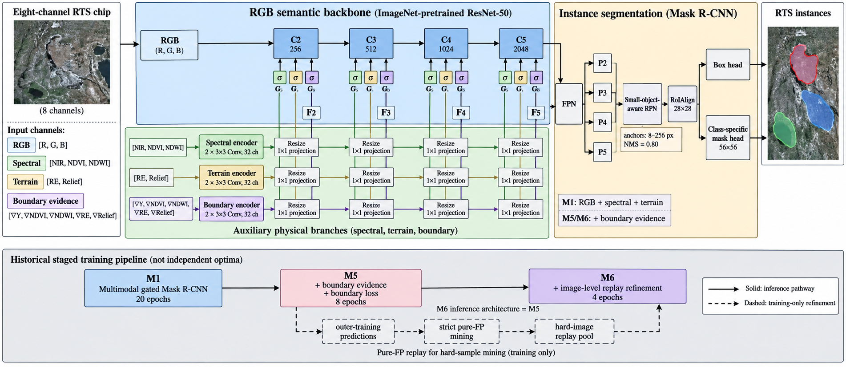
Figure 1. Overall architecture of the proposed RGB-anchored multimodal RTS instance-segmentation framework. RGB is processed by an ImageNet-pretrained ResNet-50 backbone, while spectral, terrain, and boundary evidence are introduced through multiscale auxiliary branches and RGB-conditioned gated residual fusion. The fused C2-C5 features are passed to the FPN, small-object-aware RPN, and class-specific Mask R-CNN heads. The lower panel summarizes the historical M1-M5-M6 training sequence; dashed arrows denote training-only pure-FP replay, and M6 retains the M5 inference architecture.
As shown in Fig. 1, the inference pathway is organized around an ImageNet-pretrained ResNet-50-FPN Mask R-CNN: RGB forms the semantic backbone, whereas spectral, terrain, and, from M5 onward, boundary evidence enter as auxiliary residual features at the C2-C5 levels. The lower panel separates this solid inference pathway from the historical training-only progression from M1 to M5 and M6, making explicit that the final M6 stage changes image sampling rather than adding an inference-time branch. Sections III-B-III-D describe these components in detail.
The model was developed through three historical stages. The first stage, denoted M1, establishes the multimodal gated Mask R-CNN. M5 initializes from M1 and augments the feature hierarchy with multimodal gradient evidence and an RoI-level boundary loss. The final stage, M6, retains the M5 inference architecture but modifies training through replay of images containing strictly defined pure false-positive detections:$\text{M1→M5→M6}$.
These stages represent the historical development of the implemented system rather than an exhaustive search for an independently optimal combination of all components.
B. RGB-Anchored Multimodal Gated Representation
1) RGB Backbone
The RGB channels are processed by an ImageNet-1K pretrained ResNet-50. Let
$${\text{F}}_{\text{i}}^{\text{R}}\text{=}{\text{ℛ}}_{\text{i}}\text{(}{\text{X}}_{\text{R}}\text{), }\text{i}\text{∈\{2,3,4,5\}}$$
denote the output features from stages C₂–C₅, whose channel dimensions are [256,512,1024,2048].
The RGB stream therefore remains the semantic anchor of the network. Auxiliary modalities do not replace the pretrained visual representation; instead, they provide additional evidence through residual feature modulation before construction of the feature pyramid.
2) Spectral and Terrain Encoders
The spectral branch receives
$${\text{X}}_{\text{S}}\text{=[}\text{NIR}\text{,}\text{NDVI}\text{,}\text{NDWI}\text{]}$$
and applies two 3×3 convolutional layers with 32 channels:
$${\text{F}}_{\text{S}}\text{=}\text{GELU}\left[{\text{Conv}}_{\text{3×3}}^{\text{32→32}}\left(\text{GELU}\left[{\text{Conv}}_{\text{3×3}}^{\text{3→32}}\text{(}{\text{X}}_{\text{S}}\text{)}\right]\right)\right]$$
Similarly, the terrain branch receives
$${\text{X}}_{\text{T}}\text{=[}\text{RE}\text{,}\text{Relief}\text{]}$$
and uses an independent encoder with the same topology:
$${\text{F}}_{\text{T}}\text{=}\text{GELU}\left[{\text{Conv}}_{\text{3×3}}^{\text{32→32}}\left(\text{GELU}\left[{\text{Conv}}_{\text{3×3}}^{\text{2→32}}\text{(}{\text{X}}_{\text{T}}\text{)}\right]\right)\right]$$
For each ResNet level i, the auxiliary features are bilinearly resized to the spatial resolution (H_{i},W_{i}) of ${\text{F}}_{\text{i}}^{\text{R}}$, followed by a 1×1 projection to match the number of channels:
$${\text{S}}_{\text{i}}\text{=}{\text{P}}_{\text{i}}^{\text{S}}\left[\text{Resize}\text{(}{\text{F}}_{\text{S}}\text{,}{\text{H}}_{\text{i}}\text{,}{\text{W}}_{\text{i}}\text{)}\right]$$
$${\text{T}}_{\text{i}}\text{=}{\text{P}}_{\text{i}}^{\text{T}}\left[\text{Resize}\text{(}{\text{F}}_{\text{T}}\text{,}{\text{H}}_{\text{i}}\text{,}{\text{W}}_{\text{i}}\text{)}\right]$$
This asymmetric design treats spectral and terrain variables as auxiliary physical evidence rather than passing all eight channels through an equally heavyweight backbone.
3) Conditional Residual Fusion
At each backbone level, separate spectral and terrain gates are inferred jointly from the RGB and corresponding auxiliary feature:
$${\text{G}}_{\text{i}}^{\text{S}}\text{=}\text{σ}\left[{\text{Conv}}_{\text{1×1}}\left(\text{[}{\text{F}}_{\text{i}}^{\text{R}}\text{,}{\text{S}}_{\text{i}}\text{]}\right)\right]$$
$${\text{G}}_{\text{i}}^{\text{T}}\text{=}\text{σ}\left[{\text{Conv}}_{\text{1×1}}\left(\text{[}{\text{F}}_{\text{i}}^{\text{R}}\text{,}{\text{T}}_{\text{i}}\text{]}\right)\right]$$
where [·,·]denotes channel concatenation and $\text{σ}$(·) is the sigmoid function.
The multimodal representation is then obtained as
$${\text{F}}_{\text{i}}\text{=}{\text{F}}_{\text{i}}^{\text{R}}\text{+}{\text{G}}_{\text{i}}^{\text{S}}\text{⊙}{\text{S}}_{\text{i}}\text{+}{\text{G}}_{\text{i}}^{\text{T}}\text{⊙}{\text{T}}_{\text{i}}$$
where $\text{⊙}$ denotes element-wise multiplication.
Equation (13) preserves the pretrained RGB representation as an explicit residual path while allowing spectral and terrain information to be modulated spatially and channel-wise. The fused C₂–C₅ features are subsequently passed to the standard FPN to construct the multiscale features used for proposal generation and RoI prediction.
It should be noted that the gated formulation is the historical fusion design used by the final model. The controlled experiments described in Section IV do not interpret it as universally superior to alternative fusion strategies. Figure 2 expands this representation-level design by showing the RGB backbone stages, the scale-matched spectral and terrain projections, the RGB-conditioned gates, and the boundary-evidence pathway introduced from M5 onward.
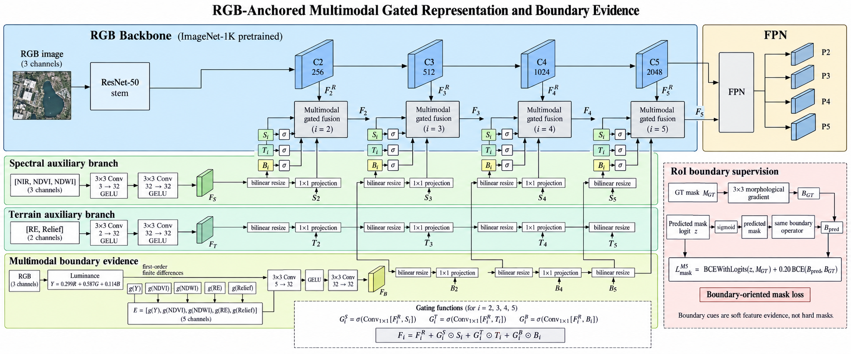
Figure 2. Detailed architecture of the RGB-anchored multimodal gated representation and boundary-oriented supervision. The ImageNet-pretrained RGB pathway provides C2-C5 features, while spectral, terrain, and gradient-based boundary evidence are independently encoded, resized, and projected to each backbone scale before RGB-conditioned gated residual fusion. The fused F2-F5 features feed the FPN. The inset summarizes the RoI-level boundary loss used from M5 onward; this supervision adds no separate inference-time boundary decoder.
With the multiscale representation defined, the fused F2-F5 features are passed to the FPN and RTS-oriented Mask R-CNN heads. The next subsection therefore details proposal generation, RoI box and mask prediction, and the boundary-oriented mask supervision associated with the M5/M6 inference architecture.
C. RTS-Oriented Instance Segmentation With Boundary Evidence
1) Small-Object-Oriented Proposal and Mask Prediction
The fused features are transformed by the FPN and supplied to a Mask R-CNN detection head. Because RTS instances include many small and spatially adjacent objects, proposal generation retains the high-resolution P₂ feature and uses relatively small anchor sizes. Across the five FPN levels, the anchor-size sets are
$$\text{A}\text{=\{(8,16),(16,32),(32,64),(64,128),(128,256)\}}$$
with aspect ratios
$$R=\{0.5,1,2\}$$
During training, the RPN retains 4000 proposals before nonmaximum suppression (NMS) and 1500 afterward. During inference, the corresponding numbers are 3000 and 1000. The RPN NMS threshold is set to 0.80, while the final detection NMS threshold is 0.60.
RoIAlign pools FPN features to 28×28. The mask predictor then upsamples the RoI representation and produces 56×56 mask logits. The task contains one foreground RTS category. The implementation nevertheless retains the class-specific Mask R-CNN formulation with ${\text{N}}_{\text{cls}}\text{=2}$ corresponding to background and RTS, and the RTS-specific mask logit is selected during mask supervision.
For the initial M1 stage, the optimization objective follows the standard Mask R-CNN formulation:
$${\text{ℒ}}_{\text{M1}}\text{=}{\text{ℒ}}_{\text{rpn−cls}}\text{+}{\text{ℒ}}_{\text{rpn−box}}\text{+}{\text{ℒ}}_{\text{roi−cls}}\text{+}{\text{ℒ}}_{\text{roi−box}}\text{+}{\text{ℒ}}_{\text{mask}}$$
M1 is trained for 20 epochs with AdamW using an initial learning rate of 2×10⁻⁴, weight decay 10⁻⁴, batch size 1, and gradient clipping at 1.0. Spatial augmentation consists of horizontal and vertical flipping and rotations of 0°, 90°, 180°, and 270°. RGB-only radiometric augmentation is performed using
$$\text{X}{\text{'}}_{\text{R}}\text{=}\text{clip}\text{(}\text{a}{\text{X}}_{\text{R}}\text{+}\text{b}\text{,0,1)}$$
where
$$\text{a}\text{∼}\text{U}\text{(0.9,1.1), }\text{b}\text{∼}\text{U}\text{(−0.03,0.03)}$$
The auxiliary physical variables are not subjected to RGB radiometric perturbation.
2) Multimodal Boundary Evidence
The subsequent M5 stage augments the representation with gradient-based boundary evidence. RGB is first converted to luminance
$$Y=0.299R+0.587G+0.114B$$
For an input map Z, the implementation uses first-order finite differences rather than a Sobel operator:
$$\text{g}\text{(}\text{Z}\text{)=}\sqrt{\text{|}{\text{Δ}}_{\text{x}}\text{Z}{\text{|}}^{\text{2}}\text{+|}{\text{Δ}}_{\text{y}}\text{Z}{\text{|}}^{\text{2}}\text{+ϵ}}$$
The complete boundary-evidence tensor is
$$\text{E}\text{=[}\text{g}\text{(}\text{Y}\text{),}\text{g}\text{(}\text{NDVI}\text{),}\text{g}\text{(}\text{NDWI}\text{),}\text{g}\text{(}\text{RE}\text{),}\text{g}\text{(}\text{Relief}\text{)]}$$
NIR gradients are not included in the implemented boundary branch.
The five-channel evidence tensor is encoded as
$${\text{F}}_{\text{B}}\text{=}{\text{Conv}}_{\text{3×3}}^{\text{32→32}}\left[\text{GELU}\left({\text{Conv}}_{\text{3×3}}^{\text{5→32}}\text{(}\text{E}\text{)}\right)\right]$$
For each backbone scale,
$${\text{B}}_{\text{i}}\text{=}{\text{P}}_{\text{i}}^{\text{B}}\left[\text{Resize}\text{(}{\text{F}}_{\text{B}}\text{,}{\text{H}}_{\text{i}}\text{,}{\text{W}}_{\text{i}}\text{)}\right]$$
and an RGB-conditioned boundary gate is computed by
$${\text{G}}_{\text{i}}^{\text{B}}\text{=}\text{σ}\left[{\text{Conv}}_{\text{1×1}}\text{([}{\text{F}}_{\text{i}}^{\text{R}}\text{,}{\text{B}}_{\text{i}}\text{])}\right]$$
The feature representation used by M5 and M6 therefore becomes
$${\text{F}}_{\text{i}}\text{=}{\text{F}}_{\text{i}}^{\text{R}}\text{+}{\text{G}}_{\text{i}}^{\text{S}}\text{⊙}{\text{S}}_{\text{i}}\text{+}{\text{G}}_{\text{i}}^{\text{T}}\text{⊙}{\text{T}}_{\text{i}}\text{+}{\text{G}}_{\text{i}}^{\text{B}}\text{⊙}{\text{B}}_{\text{i}}$$
The gradient features are thus used as learnable soft evidence of possible transitions rather than as thresholded boundaries or deterministic masks.
3) Boundary-Oriented Mask Loss
For a ground-truth RoI mask ${\text{M}}_{\text{gt}}$, its narrow boundary region is obtained by a morphological gradient:
$${\text{B}}_{\text{gt}}\text{=}\text{Dilate}\text{(}{\text{M}}_{\text{gt}}\text{)−}\text{Erode}\text{(}{\text{M}}_{\text{gt}}\text{)}$$
where dilation is implemented using 3×3 max pooling and erosion using negative max pooling.

Let $\text{z}$ be the predicted RoI mask logits and
$$\hat{\text{M}}\text{=}\text{σ}\text{(}\text{z}\text{)}$$
the corresponding probability map. Applying the same boundary operator gives
$${\text{B}}_{\text{pred}}\text{=}\text{Boundary}\text{(}\hat{\text{M}}\text{)}$$
The mask objective in M5 is
$${\text{ℒ}}_{\text{mask}}^{\text{M5}}\text{=}\text{BCEWit}\text{h}\text{Logits}\text{(}\text{z}\text{,}{\text{M}}_{\text{gt}}\text{)+}{\text{λ}}_{\text{b}}\text{BCE}\text{(}{\text{B}}_{\text{pred}}\text{,}{\text{B}}_{\text{gt}}\text{)}$$
Where ${\text{λ}}_{\text{b}}\text{=0.20}$.
The complete M5 objective is therefore
$${\text{ℒ}}_{\text{M5}}\text{=}{\text{ℒ}}_{\text{rpn−cls}}\text{+}{\text{ℒ}}_{\text{rpn−box}}\text{+}{\text{ℒ}}_{\text{roi−cls}}\text{+}{\text{ℒ}}_{\text{roi−box}}\text{+}{\text{ℒ}}_{\text{mask}}^{\text{M5}}$$
M5 is initialized from the corresponding fold-specific final M1 checkpoint and fine-tuned for eight additional epochs with a learning rate of 6×10-5. No point-based refinement decoder, 112×112 residual mask refiner, or separate boundary-prediction head is used.
The boundary stage is retained as part of the historically developed final pipeline. As shown by the continuation controls in Section IV, its independent contribution should not be inferred from the raw M1-to-M5 performance increase alone.
D. Failure-Context Replay Refinement
The final M6 stage retains exactly the same inference architecture and loss formulation as M5:
$${\text{A}}_{\text{M6}}\text{=}{\text{A}}_{\text{M5}}$$
Its only modification is the sampling distribution used during the final four training epochs.
For outer fold f, the corresponding M5 model is first applied only to images belonging to that fold's outer-training partition. The held-out outer-validation images are never used for mining or replay construction.
For a predicted instance p, let $\text{s}\text{(}\text{p}\text{)}$ denote its confidence score and $\text{G}$ the set of ground-truth RTS masks in the image. The prediction is considered a strict pure false positive when
$$\text{s}\text{(}\text{p}\text{)≥0.50}$$
$$\underset{\text{g}\text{∈}\text{G}}{\text{max}}{\text{IoU}}\text{(}\text{p}\text{,}\text{g}\text{)<0.05}$$
and
$$\text{p}\text{∩}\text{Dilate}\left(\bigcup_{\text{g}\text{∈}\text{G}}{\text{g}}\text{,10 pixels}\right)\text{=∅}$$
The exclusion condition in (36) prevents predictions caused primarily by boundary spillover, small localization offsets, or nearby-instance merging from being treated as pure background errors. An image enters the replay pool when it contains at least one prediction satisfying (34)–(36).
Before failure-context replay is applied, the historical sampler assigns a base weight
$${\text{w}}_{\text{i}}^{\text{base}}\text{=}\left\{\begin{aligned}\text{3,}{\text{a}}_{\text{i}}^{\text{min}}\text{<300,} \\ \text{2,}{\text{n}}_{\text{i}}\text{>1,} \\ \text{1,otherwise,}\end{aligned}\right.$$
where ${\text{a}}_{\text{i}}^{\text{min}}$ is the area of the smallest RTS instance in image i, and ${\text{n}}_{\text{i}}$ is the number of RTS instances.
Let ${\text{h}}_{\text{i}}\text{∈\{0,1\}}$ indicate whether image i belongs to the pure-FP replay pool. During M6 training, its epoch-dependent sampling weight is
$${\text{w}}_{\text{i}}^{\text{(}\text{e}\text{)}}\text{=}{\text{w}}_{\text{i}}^{\text{base}}\left[\text{1−}{\text{h}}_{\text{i}}\text{+}{\text{h}}_{\text{i}}{\text{α}}_{\text{e}}\right]$$
where
$${\text{α}}_{\text{e}}\text{=}\left\{\begin{aligned}\text{1.20,}\text{e}\text{∈\{1,2\},} \\ \text{1.50,}\text{e}\text{∈\{3,4\}.}\end{aligned}\right.$$
The resulting probability of selecting image i at epoch e is
$${\text{P}}_{\text{i}}^{\text{(}\text{e}\text{)}}\text{=}\frac{{\text{w}}_{\text{i}}^{\text{(}\text{e}\text{)}}}{\sum_{\text{j}\text{∈}{\text{D}}_{\text{train}}^{\text{f}}}{{\text{w}}_{\text{j}}^{\text{(}\text{e}\text{)}}}}$$
Sampling is performed with replacement, while the number of optimization steps per epoch remains equal to the number of images in the corresponding outer-training partition. M6 is initialized from the final M5 checkpoint and trained for four epochs with a learning rate of ${\text{η}}_{\text{M6}}\text{=2×1}{\text{0}}^{\text{−5}}$.
Accordingly, the final refinement operates at the image-sampling level, not at the proposal or RoI level. It does not relabel the false-positive regions as explicit pseudo-background masks and does not introduce additional inference-time modules. The term outer-fold-training pure-FP replay is therefore used throughout this article to distinguish the implemented procedure from inner-OOF or nested cross-fitted hard-negative mining.
Matched-random replay experiments in Section IV are used to determine whether the particular pure-FP selection rule provides an advantage beyond replay itself; consequently, the methodology described here does not assume such an advantage a priori.
Experiments
We first describe the released benchmark and the leakage-controlled fold construction, then specify the training settings and evaluation metrics, followed by the controlled comparison protocol and the ablation/continuation experiments used to separate multimodal, optimization-time, and replay effects.
A. Dataset
The released training collection contains 756 co-registered image chips from the 2026 GeoAI Arctic Challenge [11]. Each chip stores eight channels in H x W x 8 form: Maxar red, green, and blue imagery; challenge-provided NDVI and NDWI; Planet NIR; and ArcticDEM-derived relative elevation and shaded relief. The source dataset spans multiple Canadian and Russian Arctic subregions, but the competition release removes chip geolocation metadata. Training labels are provided in COCO instance-segmentation format after deterministic conversion of the source semantic RTS mask: 8-connected foreground components are treated as instances and components smaller than 10 pixels are removed. Consequently, spatially touching RTS regions in the source semantic mask are represented as a single benchmark instance rather than independently delineated geomorphic objects.
The five outer folds are fixed and stratified by maximum instance area per chip. Their held-out partitions are mutually disjoint and together cover all 756 labeled chips. For every fold, channel-normalization statistics, model fitting, and replay-pool construction use only the corresponding outer-training partition. Because chip geolocation is unavailable in the released benchmark, this protocol is leakage-controlled at the chip level but is not geographically independent. The reported scores therefore estimate held-out-chip performance within the released benchmark and are not interpreted as direct evidence of cross-region or pan-Arctic transfer.
B. Experimental Settings and Evaluation Metrics
1) Experimental Settings
All faithful proposed-model experiments preserve the historical single-foreground class-specific mask head, the fixed five-fold split, fold-specific normalization, and the final-epoch checkpoint policy; no validation-AP-based checkpoint selection is used. The staged model is trained for 32 epochs in total: M1 is optimized for 20 epochs, M5 is initialized from the corresponding M1 final checkpoint and fine-tuned for eight additional epochs, and M6 is initialized from the corresponding M5 final checkpoint and fine-tuned for four additional epochs. Table 1 summarizes the staged configuration and checkpoint policy. The external comparator runs use the same five target folds, labels, and 32-epoch training budget, while retaining architecture-specific internal designs, optimizers, and initialization choices documented in Supplementary Table S2.
Table 1. Staged training protocol and fixed checkpoint policy
Stage | Epochs | Added configuration | Evaluation checkpoint
M1 | 20 | RGB backbone, auxiliary encoders and gates; P2-P5; RTS-specific proposals; 56 × 56 masks | Final-epoch last.pt
M5 | 8 | M1 plus five gradient cues, edge injection, and boundary BCE (weight 0.20) | Final-epoch last.pt
M6 | 4 | M5 plus outer-fold-training pure-FP replay (1.20 to 1.50) | Final-epoch last.pt
Note: Historical M1, M5, and M6 assets remain unchanged. M1/M5/M6 use AdamW with 20/8/4 epochs, learning rates 2e-4/6e-5/2e-5, batch size 1, synchronized geometric augmentation, fold-specific normalization, and final-epoch last.pt. No validation-AP checkpoint selection was used. M2-M4 were integrated design stages rather than separately evaluated models.
2) Evaluation Metrics and Statistical Analysis
Development performance is reported using five-fold out-of-fold (OOF) COCO mask evaluation. The primary metric is mask AP averaged over IoU thresholds from 0.50 to 0.95 in steps of 0.05, with AP50 and AP75 reported separately. The challenge-specific area ranges are small [0, 300] pixels, medium [300, 2000] pixels, and large [2000, 1e10] pixels, and maxDets is fixed at 10. Pooled OOF predictions from the five disjoint held-out folds are used for all primary quantitative comparisons.
Paired uncertainty analysis uses 500 image/chip-level bootstrap resamples with replacement and random seed 20260913. The two models in each comparison use exactly the same resampling indices. When a chip is sampled more than once, each repetition is assigned a new synthetic COCO image ID so that repeated observations are not collapsed by the evaluator, and the complete COCO AP statistic is recomputed for every bootstrap sample. We report the observed pooled Delta AP together with the 95% percentile interval from the paired bootstrap distribution. Intervals that include zero are treated as unresolved. These intervals are descriptive effect-size uncertainty intervals, are not adjusted for multiple comparisons, and condition on the fitted fold models; they therefore quantify image-sampling uncertainty rather than stochastic variation from repeated model training.
C. Comparison Methods and Controlled Training Protocol
1) Comparison Methods
We compare the proposed model with representative two-stage convolutional, query-based transformer, cascade, and multiscale-transformer instance-segmentation methods. The primary comparison contains five RGB comparators spanning these architecture families. The compared methods are summarized below.
(a) Mask R-CNN [5]. This classical two-stage anchor-based baseline uses a ResNet-50-FPN backbone, an RPN for candidate generation, and separate RoI box and mask heads. It provides the most direct reference for the proposed Mask R-CNN-based formulation and is trained here from the archived torchvision implementation under the common RTS protocol.
(b) Mask2Former [6]. Mask2Former represents the modern query-based mask-classification paradigm. With a ResNet-50 backbone, masked attention links a fixed set of learned queries to multiscale image features and directly predicts class-labeled masks without the proposal-and-RoI decomposition used by Mask R-CNN.
(c) Mask DINO [7]. Mask DINO is a transformer framework that unifies detection and segmentation through DINO-style object queries, set prediction, and mask decoding. The ResNet-50 version is included to test whether a stronger end-to-end query formulation transfers efficiently to the RTS benchmark under the same training-duration budget.
(d) Cascade Mask R-CNN [13]. Cascade Mask R-CNN extends the two-stage detector with sequential box-refinement stages trained at increasingly strict IoU criteria. The ResNet-50-FPN implementation is included to test whether cascade-style localization refinement alone improves RTS instance segmentation under the controlled schedule.
(e) Cascade Mask R-CNN + MViTv2-T [14]. This comparator replaces the conventional CNN backbone with the MViTv2-T multiscale vision transformer while retaining the Cascade Mask R-CNN detection and mask heads. It serves as the strongest RGB architecture-level control and reflects the core transformer-cascade direction used in recent RTS GeoAI work [4]; it is not a reproduction of the complete multimodal method of Li et al. [4].
The proposed method is reported in two matched final-stage variants. M6-RGB removes the non-RGB auxiliary branches and regenerates its replay pool from the corresponding RGB-only M5 model, whereas M6-8ch uses the full RGB, NIR, NDVI, NDWI, relative-elevation, and shaded-relief configuration. Reporting both variants makes the same-input RGB comparison and the additional contribution of the complete multimodal configuration visible in the same experiment.
2) Controlled Training Protocol
The external comparison is designed as a training-budget-controlled transfer experiment rather than an architecture-specific hyperparameter competition. All primary rows use the same 756-chip dataset, the same five OOF target folds, the same instance labels, a common 32-epoch training budget, the same final-checkpoint reporting rule, and the same COCO mask evaluator with maxDets=10. Most primary models use 512 x 512 inputs. Architecture-specific internal structures, initialization schemes, optimizers, and native inference logic are otherwise preserved, as detailed in Supplementary Table S2. The experiment therefore measures how effectively each frozen implementation transfers to RTS segmentation under the same epoch/image-exposure budget; it is not intended to estimate the fully optimized upper bound of every architecture under individually tuned schedules.
Validation AP was not logged at each epoch, so the comparator scores are interpreted strictly as fixed-training-budget results. The available end-of-schedule optimization audit is summarized in Supplementary Table S1, and the complete frozen comparator configurations are listed in Supplementary Table S2. The MViTv2-T cascade remains an RGB architecture-level control rather than a reproduction of the complete multimodal method of Li et al. [4].
D. Ablation and Control Experiments
All faithful ablations preserve the historical single-foreground class-specific mask head, fixed folds, fixed training schedules, and final-epoch checkpoint rule. The M1-M5-M6 sequence reflects the historical development of the system and is retained for traceability; it was not selected through an exhaustive cross-combination search and is not presented as an optimal architecture in which every stage is necessary. M1-RGB removes all non-RGB branches rather than zero-filling inputs; M5-RGB retains only RGB-luminance boundary evidence; and M6-RGB regenerates its replay pool from the corresponding M5-RGB model. Architecture and mechanism controls include 8-channel early fusion, additive multimodal fusion without learned gates, a 28 x 28 mask decoder, boundary-loss-only and gradient-evidence-only variants, matched-budget random replay, and fixed-weight pure-FP replay.
Two continuation controls isolate training-time confounding. M1-Continue starts from M1 and follows the eight-epoch M5 optimization schedule without adding boundary evidence or boundary loss. M5-Continue starts from M5 and follows the four-epoch M6 schedule with ordinary sampling and no replay. Historical M1, M5, and M6 checkpoints remain unchanged; the controls are used to delimit which effects are supported rather than to retroactively redefine the archived final model.
For the matched random-replay control, images are sampled without replacement from each fold's outer-training partition, with pool sizes exactly matched to the corresponding pure-FP hard-image counts: 138, 216, 107, 76, and 148 images for folds 1-5, respectively. Random-replay and pure-FP runs use the same M5 parent, four-epoch schedule, learning rate, batch size, base sampling weights, 1.20-to-1.50 replay-weight schedule, and len(training) weighted draws per epoch, so the total number of optimizer steps is identical. Assertions verify that no outer-validation image enters either replay pool. This matched design separates the effect of replay itself from the effect of the pure-FP selection rule.
Results
A. Comparison Under a Common 32-Epoch Training Budget
Table 2 compares all primary methods under the common 32-epoch training-budget-controlled protocol. M6-8ch achieves the highest pooled OOF AP at 31.98, with AP50 and AP75 of 67.03 and 25.02, respectively. Among RGB-only methods, Cascade Mask R-CNN with MViTv2-T is strongest at 29.47 AP, followed closely by M6-RGB at 28.89 AP. The observed pooled M6-8ch minus MViTv2-T difference is +2.51 AP, with a paired-bootstrap 95% percentile CI of [+0.85, +4.27]. M6-8ch also obtains the highest AP50, AP75, and AP_S in the table, whereas MViTv2-T remains higher for AP_M and AP_L. Mask R-CNN, Mask2Former, Mask DINO, and Cascade Mask R-CNN reach 20.22, 13.02, 11.56, and 5.82 AP, respectively, under the same 32-epoch training budget. These lower values are interpreted as controlled fixed-budget transfer results rather than architecture-specific performance ceilings.
Table 2. Training-budget-controlled five-fold OOF comparison under the common 32-epoch protocol (%, maxDets=10)
Method | Backbone | Input | AP | AP50 | AP75 | AP_S | AP_M | AP_L
Mask R-CNN | ResNet-50 FPN | RGB | 20.22 | 47.71 | 13.20 | 16.68 | 26.40 | 30.77
Mask2Former | ResNet-50 | RGB | 13.02 | 33.83 | 8.40 | 7.09 | 20.37 | 36.53
Mask DINO | ResNet-50 | RGB | 11.56 | 32.86 | 5.24 | 6.84 | 18.80 | 16.20
Cascade Mask R-CNN | ResNet-50 FPN | RGB | 5.82 | 16.85 | 1.60 | 4.33 | 8.68 | 15.91
Cascade Mask R-CNN + MViTv2-T (RGB control) | MViTv2-T | RGB | 29.47 | 64.14 | 23.43 | 22.29 | 41.42 | 43.66
M6-RGB (Ours) | ResNet-50 FPN | RGB | 28.89 | 62.06 | 21.01 | 24.87 | 35.65 | 34.81
M6-8ch (Ours) | R50-FPN + spectral/terrain encoders | 8-channel | 31.98 | 67.03 | 25.02 | 29.39 | 36.77 | 39.19
Note: AP is COCO mask AP averaged over IoU 0.50:0.95. All rows use the same five OOF target partitions, final-checkpoint rule, and maxDets=10 under the common 32-epoch training budget. AP_S, AP_M, and AP_L use the challenge area ranges [0, 300], [300, 2000], and [2000, 1e10] pixels, respectively. The table is a training-budget-controlled comparison, not a claim about fully optimized architecture-specific upper bounds. M6-RGB provides the same-input RGB control for the proposed model, whereas M6-8ch uses the complete eight-channel configuration.
Figure 3 presents qualitative OOF predictions for six randomly selected held-out cases spanning small, medium, large, multiple-instance, near-water, and high-RGB-texture scenes. The visual comparison is consistent with the quantitative ranking but also shows important case-level variation. In the large-RTS example, M6-8ch recovers most of the reference footprint, while several RGB baselines miss the target or return only small fragments. In the multiple-instance and near-water cases, M6-8ch generally avoids the very large spurious masks visible for Mask R-CNN and the ResNet-50 Cascade model while retaining several separate RTS instances. The MViTv2-T cascade remains visually competitive in several rows, consistent with its strong RGB-only AP. These examples are descriptive rather than performance-selected and are not used for statistical inference.
Figure 4 further decomposes a second randomly selected six-case set into pixel-level true-positive, false-positive, and false-negative foreground regions. Relative to several RGB baselines, M6-8ch often suppresses broad false-positive regions in small, medium, multiple-instance, and nearby-RTS scenes, while retaining substantial overlap with the reference masks. At the same time, the error maps expose residual boundary omissions and false positives, particularly in the high-RGB-texture case, where the proposed model still produces substantial spurious foreground. The qualitative panels therefore illustrate both the practical advantage and the remaining failure modes of the final multimodal model.

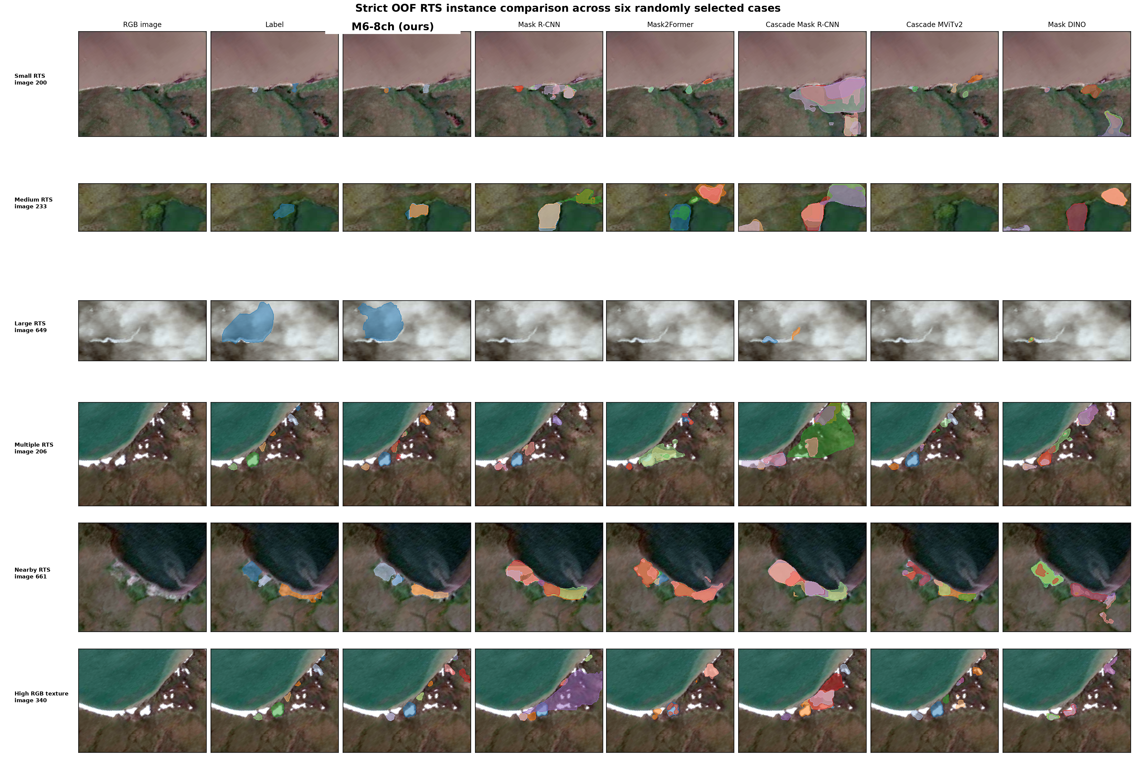
Figure 3. OOF RTS instance-prediction comparison across six randomly selected held-out cases. Cases were selected without conditioning on relative model performance; the row descriptors summarize the selected scenes and were not used to rank models. From left to right: RGB image, reference instance masks, M6-8ch, Mask R-CNN, Mask2Former, Cascade Mask R-CNN, Cascade Mask R-CNN with MViTv2-T, and Mask DINO. The panels are qualitative illustrations only; all comparative claims are based on the quantitative OOF evaluation.

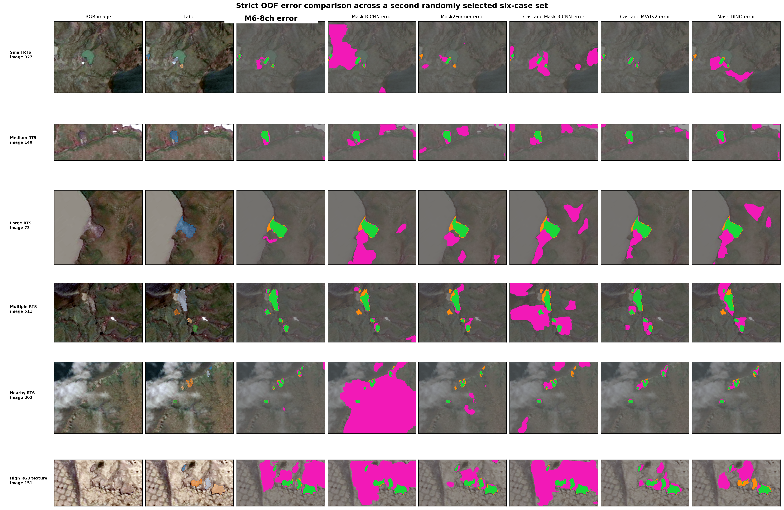
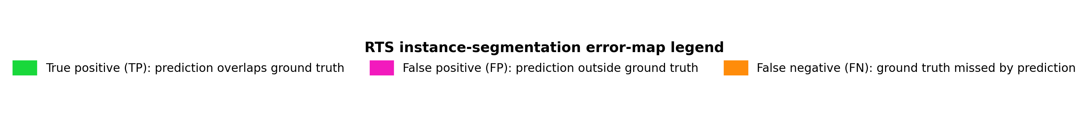

Figure 4. OOF error-map comparison on a second randomly selected six-case set. Cases were selected without conditioning on relative model performance. Green, magenta, and orange indicate pixel-level true-positive, false-positive, and false-negative foreground regions, respectively. Columns use the same model order as Figure 3. The maps illustrate both improvements and residual errors around terrain, water, and nearby-instance boundaries; they are not used to estimate comparative performance.

B. Ablation Studies
Table 3 reports the RGB-only and full-multimodal variants at each historical stage, allowing the contribution of the complete eight-channel configuration to be examined consistently rather than only at the final model. At M1, adding the spectral and terrain branches raises AP from 16.07 to 18.64 (+2.57), with gains in AP50 (+4.27), AP_S (+2.63), AP_M (+1.80), and especially AP_L (+9.60). The same pattern persists after the boundary-oriented stage: M5-8ch reaches 28.85 AP versus 26.09 for M5-RGB (+2.76), together with gains of +3.94 AP50, +3.44 AP75, +3.96 AP_S, +1.16 AP_M, and +3.97 AP_L. At the final stage, M6-RGB reaches 28.89 AP whereas M6-8ch reaches 31.98; the observed paired pooled difference is +3.08 AP with a 95% percentile CI of [+1.82, +4.24]. M6-8ch also improves AP50, AP75, AP_S, AP_M, and AP_L by 4.97, 4.01, 4.52, 1.12, and 4.38 points, respectively, relative to the RGB-only final model. The repeated RGB-versus-eight-channel advantage across M1, M5, and M6 shows that the complete multimodal configuration contributes beyond the RGB pathway throughout the staged pipeline, while the particularly strong final contrast provides the clearest controlled evidence.
Table 3. RGB-only and full-multimodal comparison of the proposed staged model (%, five-fold OOF)
Method | Primary input | Auxiliary inputs | RGB boundary | Physical boundary | AP | AP50 | AP75 | AP_S | AP_M | AP_L
M1-RGB | RGB | None | No | No | 16.07 | 41.12 | 9.75 | 13.43 | 21.11 | 20.71
M1-8ch | RGB | NIR, NDVI, NDWI; RE, relief | No | No | 18.64 | 45.39 | 10.65 | 16.06 | 22.91 | 30.31
M5-RGB | RGB | None | Luminance | No | 26.09 | 58.61 | 17.55 | 22.58 | 32.16 | 31.67
M5-8ch | RGB | NIR, NDVI, NDWI; RE, relief | Luminance | NDVI, NDWI, RE, relief | 28.85 | 62.55 | 20.99 | 26.54 | 33.32 | 35.64
M6-RGB | RGB | None | Luminance | No | 28.89 | 62.06 | 21.01 | 24.87 | 35.65 | 34.81
M6-8ch | RGB | NIR, NDVI, NDWI; RE, relief | Luminance | NDVI, NDWI, RE, relief | 31.98 | 67.03 | 25.02 | 29.39 | 36.77 | 39.19
The component interpretation is intentionally narrower than the aggregate gain. M1-8ch adds NIR, NDVI, NDWI, relative elevation, and shaded relief together with the associated auxiliary encoders; M5-8ch additionally uses the corresponding physical gradient cues; and M6-8ch retains those branches during replay refinement. Consequently, Table 3 supports the joint contribution of the full spectral-wetness-terrain configuration, not an isolated causal effect for any individual band, for spectral versus terrain information separately, or for model capacity alone. The fact that both RGB-only and eight-channel variants improve during the later stages also indicates that multimodal evidence and staged optimization/replay are complementary sources of performance rather than interchangeable explanations.
Tables 4 and 5 further dissect the architecture, boundary, optimization-time, and replay contributions. Table 4 reports direct component controls under the archived training schedules, while Table 5 uses paired bootstrap intervals and duration-matched continuation controls to distinguish mechanism effects from gains caused by simply training for additional epochs.
Table 4. Primary architecture, boundary, and replay controls (%, five-fold OOF)
ID | Configuration | AP | AP50 | AP75 | AP_S | AP_M | AP_L
M1-8ch | Gated 8-channel base | 18.64 | 45.39 | 10.65 | 16.06 | 22.91 | 30.31
P4 | 8-channel early fusion | 24.64 | 56.53 | 16.49 | 20.67 | 30.71 | 34.78
P5 | 8-channel additive fusion without learned gates | 17.65 | 43.55 | 9.68 | 15.17 | 23.25 | 22.16
P6 | M1 with 28 × 28 output mask | 20.03 | 47.03 | 12.62 | 17.37 | 24.21 | 27.88
P7 | M1 + boundary loss only | 29.05 | 63.58 | 21.60 | 26.27 | 33.88 | 36.30
P8 | M1 + gradient evidence only | 29.43 | 63.57 | 21.05 | 26.53 | 34.58 | 33.78
M5-8ch | Gradient evidence + boundary loss | 28.85 | 62.55 | 20.99 | 26.54 | 33.32 | 35.64
P9 | M5 + matched-budget random replay | 31.59 | 66.80 | 24.12 | 28.86 | 36.22 | 38.96
P10 | M5 + pure-FP replay, fixed 1.50 | 32.07 | 67.10 | 25.52 | 29.28 | 36.79 | 38.80
M6-8ch | M5 + pure-FP replay, 1.20 to 1.50 | 31.98 | 67.03 | 25.02 | 29.39 | 36.77 | 39.19
Note: All rows preserve the historical class-specific single-foreground mask head and fixed final-checkpoint policy. P7-P8 begin from M1 and continue for eight epochs; P9-P10 begin from M5 and continue for four epochs. Continuation controls with identical added optimization but without the stage-specific mechanism are evaluated through paired comparisons in Table 5.
Table 5. Observed pooled AP differences with paired image-level bootstrap 95% percentile intervals
Comparison | Delta AP | 95% CI
M6-8ch vs M6-RGB | +3.08 | [+1.82, +4.24]
M6-8ch vs Cascade MViTv2-T (RGB) | +2.51 | [+0.85, +4.27]
M6-8ch vs M5-Continue | +0.66 | [+0.21, +1.20]
M6-8ch vs matched random replay | +0.39 | [-0.14, +0.98]
M5 vs M1-Continue | -0.57 | [-1.46, +0.27]
Note: Delta AP is the observed difference between pooled OOF AP values. Confidence intervals use 500 paired image/chip bootstrap resamples with replacement (seed 20260913), identical resampling indices for each model pair, synthetic COCO image IDs for repeated chips, and full COCO AP recomputation. The intervals are descriptive effect-size uncertainty intervals and were not adjusted for multiple comparisons; intervals spanning zero are treated as unresolved.
The architecture controls in Table 4 show that the historical implementation should not be interpreted as a sequence of independently optimal choices. Early eight-channel fusion (P4) reaches 24.64 AP, 6.00 points above the gated M1 base, whereas simple additive multimodal fusion without learned gates (P5) falls to 17.65 AP. The gate therefore improves over unweighted additive fusion in this experiment but is not superior to early fusion. Similarly, reducing the mask output from 56 x 56 to 28 x 28 (P6) yields 20.03 AP, above the 18.64 AP of historical M1, so the 56 x 56 decoder is retained as part of the archived pipeline rather than claimed as an independently validated advantage. For the boundary stage, boundary loss alone (P7) and gradient evidence alone (P8) reach 29.05 and 29.43 AP, respectively, while their historical combination in M5 reaches 28.85 AP. Thus, the two boundary mechanisms are individually compatible with strong later-stage performance, but their combination does not show an additive or synergistic AP advantage under the fixed protocol.
The continuation controls in Table 5 clarify why the large historical stage-to-stage gains cannot be read directly as module effects. M1-Continue reaches 29.42/63.97/21.84 AP/AP50/AP75 after the same additional eight epochs used for M5, whereas M5 reaches 28.85/62.55/20.99. The observed M5 minus M1-Continue difference is -0.57 AP with a 95% CI of [-1.46, +0.27], so the raw M1-to-M5 increase is largely explained by additional optimization and cannot be causally assigned to the boundary module. Proposal diagnostics are consistent with improved strict localization along the historical path: overall RPN recall at IoU 0.50 is already 96.58% for M1 (89.36/98.89/99.30% for small/medium/large instances), while recall at IoU 0.75 rises from 59.39% to 74.20% overall and from 43.02% to 60.53% for small instances. Because the duration-matched continuation control was not evaluated with an independent proposal-recall attribution experiment, these localization changes are descriptive and are not assigned specifically to the boundary components.
The replay experiments provide a more specific supported effect. M5-Continue reaches 31.32 AP after four additional epochs with ordinary sampling, whereas M6 reaches 31.98 AP; the observed difference is +0.66 AP with a 95% CI of [+0.21, +1.20], indicating a modest benefit from replay-based refinement beyond continued optimization. Matched random replay (P9) reaches 31.59 AP, only 0.39 below M6, and the corresponding CI [-0.14, +0.98] includes zero. The evidence therefore supports replay as a training refinement but does not establish that pure-FP selection is superior to generic matched replay. Likewise, fixed pure-FP replay at 1.50 (P10) reaches 32.07 AP, essentially the same as the 1.20-to-1.50 curriculum M6 at 31.98 AP, so the curriculum schedule is not treated as an independently supported source of gain.
C. Baseline Transfer Audit and Computational Profile
The external baselines were evaluated under the common 32-epoch training budget with final-checkpoint reporting, and validation AP was not recorded at every epoch. Supplementary Table S1 therefore documents end-of-schedule optimization behavior rather than proving validation convergence. Mask DINO retains a downward loss trend near the final epoch, whereas Cascade Mask R-CNN shows no clearly improving loss trajectory. Their lower AP values are consequently reported as outcomes of the common training-budget-controlled protocol, not as evidence that the corresponding architectures are intrinsically unsuitable for RTS segmentation or as estimates of their fully optimized performance. Detailed implementation, initialization, optimizer, learning-rate, inference, and convergence-audit settings are listed in Supplementary Table S2.
Table 6. Computational profile of the key RGB and multimodal models
Model | Params (M) | Trainable params (M) | FLOPs (G, approx.)
M6-RGB | 55.21 | 55.21 | 75.19
M6-8ch | 77.77 | 77.77 | 97.02
Cascade Mask R-CNN + MViTv2-T | 75.58 | 75.58 | 903.53
As summarized in Table 6, M6-8ch increases model capacity relative to M6-RGB (77.77 M versus 55.21 M parameters), which is why the RGB-versus-multimodal contrast is interpreted as the effect of the full configuration rather than input information alone. Relative to the MViTv2-T cascade, M6-8ch has a similar parameter count (77.77 M versus 75.58 M). Under the fixed 512 x 512 single-image PyTorch-profiler protocol, using batch size 1 and fold-0 final checkpoints in evaluation/inference forward mode, M6-8ch records 97.02 G operator-accounted forward FLOPs compared with 903.53 G for the MViTv2-T cascade, approximately 9.3 times lower under this profiling convention. The forward pass includes the backbone, FPN, RPN, and RoI box/mask heads, while data loading, CPU/GPU transfer, COCO encoding, and postprocessing time are excluded. Unsupported or custom operations are not manually added, and no additional MAC-to-FLOP conversion is applied; the values are therefore approximate implementation-specific operator-accounted FLOPs rather than hardware-independent theoretical FLOPs. Further profiling details are provided in the Supplementary Material.
Discussion
The experiments provide several insights into multimodal RTS instance segmentation that extend beyond the final AP ranking. First, the most consistent result is the value of the complete multimodal configuration. Across the historical M1, M5, and M6 stages, adding the spectral and terrain pathways improves AP relative to the matched RGB-only variant, and the final M6 contrast reaches +3.08 AP with a paired-bootstrap 95% percentile interval of [+1.82, +4.24]. This agrees with earlier RTS studies showing that vegetation-sensitive, near-infrared, and topographic information can complement optical appearance [2]-[4]. Li et al. [4], in particular, reported systematic gains when RGB was combined with NDVI and NIR and found feature-level residual cross-modality fusion to outperform data-level fusion in their setting. Our results support the same broader principle of complementary multimodal evidence, but they do not support a universal ranking of fusion operators: the early-fusion control outperforms the historical gated M1, whereas unweighted additive feature fusion underperforms it. The supported contribution is therefore the RGB-anchored eight-channel system as a whole—appearance, vegetation, wetness, and terrain evidence together—rather than the gate itself or any single auxiliary band.
Second, the results indicate a useful accuracy-efficiency design point relative to a strong multiscale-transformer cascade. Under RGB-only input, M6-RGB reaches 28.89 AP and remains close to Cascade Mask R-CNN with MViTv2-T at 29.47 AP; the advantage appears only after the full physical evidence set is introduced, with M6-8ch reaching 31.98 AP and exceeding the RGB MViTv2-T comparator by +2.51 AP (95% CI [+0.85, +4.27]). Li et al. [4] addressed multimodal efficiency through unimodal pretraining followed by multimodal fine-tuning of MViTv2-based branches. Our configuration explores a complementary route: retain a pretrained RGB CNN as the semantic anchor and attach smaller modality-specific branches. Table 6 shows that M6-8ch and the MViTv2-T cascade have similar parameter counts (77.77 M and 75.58 M), while the fixed PyTorch-profiler audit records 97.02 G versus 903.53 G operator-accounted forward FLOPs. This implementation-specific ratio should not be read as a hardware-independent complexity theorem, but it suggests that heterogeneous physical evidence can be integrated without requiring a large transformer backbone for every modality. It also does not imply that ResNet-50 is intrinsically superior to MViTv2 [14], or that the complete multimodal model of Li et al. [4] has been reproduced and surpassed.
Third, the continuation and replay controls change how the staged pipeline should be interpreted. Progressive or staged adaptation is common in remote-sensing segmentation because it can separate representation learning from later task-specific refinement; SAM-RSIS, for example, adapts different parts of the segmentation pipeline in successive stages [9]. In the present experiments, however, M1-Continue reaches 29.42 AP and is slightly above M5 at 28.85 AP, with an unresolved M5 minus M1-Continue interval. The large raw M1-to-M5 gain is therefore dominated by additional optimization and cannot be assigned to the boundary module alone. By contrast, M6 exceeds the duration-matched M5-Continue control by +0.66 AP (95% CI [+0.21, +1.20]), supporting replay as a modest final-stage refinement. The comparison with matched random replay remains unresolved, so the evidence does not establish that pure-FP selection is intrinsically better than generic replay. This distinction is important in the broader hard-example-mining literature [15]: repeated exposure to difficult contexts can be useful even when a particular hard-example selector has not been shown to be uniquely effective.
Fourth, the localization diagnostics suggest that the remaining RTS problem is not simply one of proposal discovery. M1 already attains 96.58% overall RPN recall at IoU 0.50, whereas recall at the stricter IoU 0.75 rises from 59.39% in M1 to 74.20% in M6 and from 43.02% to 60.53% for small instances. Together with the AP75 increase and the qualitative error maps, this pattern points to strict localization, mask delineation, and background confusion near water, textured ground, and adjacent instances as persistent error sources. The highest AP_S in the main comparison (29.39 for M6-8ch) is encouraging because small, irregular objects are a recurring difficulty in remote-sensing instance segmentation and motivated the use of multiscale and higher-resolution representations in methods such as SAM-RSIS [9]. At the same time, the continuation controls prevent the stricter localization gains from being attributed specifically to the boundary branch, and the MViTv2-T comparator remains stronger for medium and large objects. The final model should therefore be viewed as improving the overall RTS error balance rather than dominating every object scale or every localization mechanism.
Finally, the scope of the present evidence is narrower than the cross-region claims made in studies with explicit geographic evaluation. Li et al. [4] evaluated multimodal RTS mapping across multiple Arctic sites and also examined the transferability of their fusion strategy on a separate geospatial dataset, while SAM-RSIS explicitly contrasted interpolation and geographically disjoint extrapolation settings [9]. The released GeoAI Arctic Challenge chips used here do not provide geolocation metadata [11], so the five-fold OOF protocol is leakage-controlled at the chip level but cannot establish pan-Arctic transfer. Future evaluation should therefore prioritize geographically identified external scenes or site-held-out tests, repeated training seeds, and leave-one-modality-out experiments that separate NIR, vegetation, wetness, and terrain contributions. Other limitations remain: connected-component conversion can merge touching RTSs into one benchmark instance; the RGB-versus-eight-channel comparison changes both information content and auxiliary capacity; the historical M1-M5-M6 sequence was not selected by exhaustive architecture search; and the fixed 32-epoch external-baseline protocol does not estimate architecture-specific convergence ceilings. These limitations do not alter the within-benchmark result, but they define the evidence required before the method can be interpreted as a geographically transferable Arctic mapping system.
Conclusions
This study presents an RGB-anchored multimodal RTS instance-segmentation pipeline that integrates NIR, vegetation-water indices, and terrain information through multiscale auxiliary branches and applies replay-based refinement in the final training stage. Under five-fold OOF evaluation, M6-8ch reaches 31.98 AP, 67.03 AP50, and 25.02 AP75. The clearest supported result is the complete multimodal configuration: its observed advantage over M6-RGB is +3.08 AP with a 95% paired-bootstrap percentile CI of [+1.82, +4.24]. Under RGB-only input, M6-RGB remains competitive with the MViTv2-T cascade (28.89 versus 29.47 AP), while the full eight-channel configuration reaches 31.98 AP and exceeds that RGB comparator by +2.51 AP (95% CI [+0.85, +4.27]). With comparable parameter counts, the fixed 512 x 512 PyTorch-profiler audit records 97.02 G versus 903.53 G operator-accounted forward FLOPs, approximately 9.3 times lower for M6-8ch under the stated profiling convention. Replay refinement provides a smaller gain over continued optimization without replay (+0.66 AP, 95% CI [+0.21, +1.20]). In contrast, the continuation and matched-replay controls do not support attributing the historical M1-to-M5 increase to the boundary module or claiming superiority of pure-FP sampling or curriculum weighting over simpler replay alternatives. The M1-M5-M6 sequence is therefore retained as a historically developed, traceable staged pipeline rather than presented as an exhaustively optimized architecture. The four principal contributions are the RGB-anchored heterogeneous multimodal representation, the integration of broader spectral-wetness-terrain evidence, the statistically supported accuracy-efficiency result under a common 32-epoch training budget, and a mechanism-controlled replay refinement analysis that separates supported effects from additional optimization.
Data availability
The input data are distributed by the GeoAI Arctic Challenge under the organizers' access terms [11]. The study uses the released benchmark without redistributing the source imagery. Fold definitions, configuration records, checkpoint hashes, OOF predictions, and evaluation outputs are retained with the project artifacts to support auditability of the reported comparisons.
Acknowledgment
During preparation of this manuscript, the authors used ChatGPT (OpenAI) to assist with language editing and with drafting and restructuring portions of the title, Abstract, Introduction, Results, Discussion, and Conclusion. The tool was not used to generate experimental data or determine model configurations. All methodological decisions, numerical results, statistical analyses, references, and scientific interpretations were independently checked and revised by the authors, who take full responsibility for the content of the article.
References
[1] L. Huang, J. Luo, Z. Lin, F. Niu, and L. Liu, "Using deep learning to map retrogressive thaw slumps in the Beiluhe region (Tibetan Plateau) from CubeSat images," Remote Sensing of Environment, vol. 237, Art. no. 111534, 2020.
[2] Y. Yang et al., "Mapping retrogressive thaw slumps using deep neural networks," Remote Sensing of Environment, vol. 288, Art. no. 113495, 2023.
[3] L. Huang et al., "Identifying active retrogressive thaw slumps from ArcticDEM," ISPRS Journal of Photogrammetry and Remote Sensing, vol. 205, pp. 301-316, 2023.
[4] W. Li et al., "A multiscale vision transformer-based multimodal GeoAI model for mapping Arctic permafrost thaw," IEEE Journal of Selected Topics in Applied Earth Observations and Remote Sensing, vol. 18, pp. 12209-12223, 2025, doi: 10.1109/JSTARS.2025.3564310.
[5] K. He, G. Gkioxari, P. Dollár, and R. Girshick, "Mask R-CNN," in Proceedings of the IEEE International Conference on Computer Vision, 2017, pp. 2961-2969.
[6] B. Cheng, I. Misra, A. G. Schwing, A. Kirillov, and R. Girdhar, "Masked-attention mask transformer for universal image segmentation," in Proceedings of the IEEE/CVF Conference on Computer Vision and Pattern Recognition, 2022, pp. 1290-1299.
[7] F. Li et al., "Mask DINO: Towards a unified transformer-based framework for object detection and segmentation," in Proceedings of the IEEE/CVF Conference on Computer Vision and Pattern Recognition, 2023, pp. 3041-3050.
[8] K. Chen et al., "RSPrompter: Learning to prompt for remote sensing instance segmentation based on visual foundation model," IEEE Transactions on Geoscience and Remote Sensing, vol. 62, 2024, doi: 10.1109/TGRS.2024.3356074.
[9] M. Luo, T. Zhang, S. Wei, and S. Ji, "SAM-RSIS: Progressively adapting SAM with box prompting to remote sensing image instance segmentation," IEEE Transactions on Geoscience and Remote Sensing, vol. 62, 2024, doi: 10.1109/TGRS.2024.3460085.
[10] A. Kirillov et al., "Segment Anything," in Proceedings of the IEEE/CVF International Conference on Computer Vision, 2023, pp. 4015-4026.
[11] Cyber2A, "2026 GeoAI Arctic Challenge Dataset," dataset release, 2026. Available through the official GeoAI Arctic Challenge data repository.
[12] T.-Y. Lin, P. Dollar, R. Girshick, K. He, B. Hariharan, and S. Belongie, "Feature Pyramid Networks for Object Detection," in Proceedings of the IEEE Conference on Computer Vision and Pattern Recognition, 2017, pp. 2117-2125, doi: 10.1109/CVPR.2017.106.
[13] Z. Cai and N. Vasconcelos, "Cascade R-CNN: Delving Into High Quality Object Detection," in Proceedings of the IEEE Conference on Computer Vision and Pattern Recognition, 2018, pp. 6154-6162.
[14] Y. Li, C.-Y. Wu, H. Fan, K. Mangalam, B. Xiong, J. Malik, and C. Feichtenhofer, "MViTv2: Improved Multiscale Vision Transformers for Classification and Detection," in Proceedings of the IEEE/CVF Conference on Computer Vision and Pattern Recognition, 2022, pp. 4804-4814.
[15] A. Shrivastava, A. Gupta, and R. Girshick, "Training Region-Based Object Detectors With Online Hard Example Mining," in Proceedings of the IEEE Conference on Computer Vision and Pattern Recognition, 2016, pp. 761-769, doi: 10.1109/CVPR.2016.89.

