Pre-onset satellite condition predicts drought recovery after coherent multi-product loss across East African open ecosystems
[Author names, affiliations, corresponding author and funding to be added before submission]

Abstract
Drought recovery is not the inverse of drought impact: in recurrent-drought systems, ecosystems may recover, encounter a new drought before recovery, or remain below their reference state. We combined FVC, LAI, MOD17 GPP and PML GPP with SPI-3 drought events to quantify these competing post-drought fates in a geographically stratified sample of East African open ecosystems. Among 5,504 events with coherent multi-product loss, the estimated 12-month cumulative incidence was 0.723 for recovery and 0.138 for recurrent drought before recovery. Under 200-km spatially buffered validation, 12-month IPCW AUC increased from 0.584 for drought exposure alone (M0) to 0.592 after adding satellite-observed impact (M1) and 0.662 after adding antecedent satellite state (M2); retrospectively assembled environmental context increased AUC only marginally to 0.665 (M3). Relaxing the coherent-loss screen from impact z <= -0.5 to <= -0.3 preserved this contrast (M0, 0.589; M1, 0.595; M2, 0.662). Ablation showed that the M2 gain was concentrated in immediately pre-onset standardized satellite anomalies rather than longer-window means, variability or trends. Because these pre-event anomalies and the recovery endpoint share product-specific standardization frameworks, we interpret the signal as predictive state information rather than a separable ecological-memory mechanism. These results support recovery-oriented drought monitoring that combines competing post-drought fates with pre-onset satellite condition.
Keywords: drought recovery; pre-onset satellite condition; competing risks; satellite time series; spatial transferability; open ecosystems; East Africa

1. Introduction
Drought stability has at least two separable dimensions: the ability to maintain ecosystem structure or function during stress and the ability to recover afterwards. Satellite and flux-based studies increasingly show that resistance and recovery need not covary and can even exhibit contrasting spatial patterns or trade-offs (Ingrisch and Bahn, 2018; Requena-Mullor et al., 2023; Shao et al., 2024; Wang et al., 2026). This distinction becomes especially important where recurrent drought creates a finite recovery opportunity: a new drought can arrive before the preceding disturbance has recovered, while other systems may remain below reference conditions even without a recurrent event. Treating all non-recovered observations as a single binary class therefore conflates interruption by a competing disturbance with persistent recovery debt (Schwalm et al., 2017).
Satellite time series can observe complementary components of this process. FVC and LAI primarily describe canopy structure, whereas MOD17 and PML GPP represent ecosystem functioning. These measurements should not be assumed interchangeable: physiological suppression can precede visible structural loss, and structural greening need not imply complete functional recovery. Multi-product analysis therefore provides an evidence chain across structural and functional responses rather than independent votes from interchangeable sensors (Wagle et al., 2014; Zhang et al., 2024). Recent remote-sensing studies likewise show that recovery depends on vegetation type, environmental context and the response variable used to define disturbance and recovery (von Keyserlingk et al., 2021; Requena-Mullor et al., 2023; Wang et al., 2026).
An additional uncertainty is whether the magnitude of observed damage contains the same information as the ecosystem state from which the disturbance begins. Drought legacies can persist after climate conditions improve, and satellite observations have detected post-drought anomalies in greenness, phenology and climate sensitivity that are not captured by impact magnitude alone (Anderegg et al., 2015; Goncalves et al., 2020; Wu et al., 2022). This motivates a state-dependent prediction question: once coherent multi-product loss has already occurred, does the remaining variation in impact magnitude distinguish subsequent recovery, or is more transferable information carried by the satellite-observed condition immediately before drought onset? Because antecedent standardized anomalies and the recovery endpoint can share a common seasonal reference framework, any predictive advantage must be interpreted as state information rather than automatically as a separable ecological-memory mechanism.
East Africa provides a demanding test of this question because recurrent drought intersects strong rainfall seasonality, pastoral rangelands and heterogeneous open ecosystems. Regional monitoring illustrates why impact and recovery must be distinguished in practice. In northern Somalia, below-average rainfall in 2015 produced very poor pasture and water availability and elevated livestock mortality (FEWS NET, 2016). By early 2020, favorable Deyr rains had regenerated pasture and browse across much of Somalia, yet many poor households were still recovering from losses associated with the 2016/2017 and 2018/2019 droughts (FEWS NET, 2020a). Later in 2020, rainfall improved pasture and surface-water resources across Somalia, southern and southeastern Ethiopia and northern Kenya while localized deficits persisted elsewhere (FEWS NET, 2020b). These reports are contextual rather than validation data, but they illustrate the coexistence of rapid vegetation improvement, incomplete recovery and renewed exposure that motivates an event-based competing-risk framework.
We address four questions: (1) how are meteorological drought exposure and post-drought recovery opportunities distributed across the study domain; (2) do structural and functional satellite products show coherent lagged responses to severe drought; (3) within the stratified analytical sample, how often is recovery completed, interrupted by recurrent drought, or still incomplete after 12 months; and (4) which event-end satellite information and retrospectively assembled environmental context support spatial discrimination in held-out regions? We hypothesized that, among events already showing coherent multi-product loss, residual impact magnitude would add limited discrimination, whereas antecedent satellite condition would provide additional predictive information. We further distinguish the event-end relevance of M2 from the retrospective environmental context added in M3. The study combines multi-product event-scale observations, DLNMs, competing-risk inference and spatially buffered competing-risk random survival forests; the prediction experiment evaluates retrospective spatial transferability rather than historical real-time forecasting.

2. Materials and methods

2.1 Study domain, grid and data sources
The study used a common 0.05° geographic grid across Kenya, Tanzania, Uganda, Rwanda, Burundi, Ethiopia, South Sudan, Somalia, Eritrea, Djibouti and Congo (Kinshasa). The 0.05° grid is a common analytical support rather than the native resolution of all inputs. The primary domain was fixed from the 2001 MCD12Q1 IGBP open-vegetation classes (classes 6-10), restricted to land pixels (LW=2) and to grid cells with open fraction >=0.50. This avoids using future land-cover information to define the baseline domain. The ecological-response analysis used 2,397 stratified cells selected to span the study-domain environmental gradients. Primary recovery, DLNM and prediction analyses are estimands of this stratified analytical sample rather than area-weighted continental prevalence. Figure 1 summarizes the geographic setting, fixed domain, sample and buffered outer-fold design.

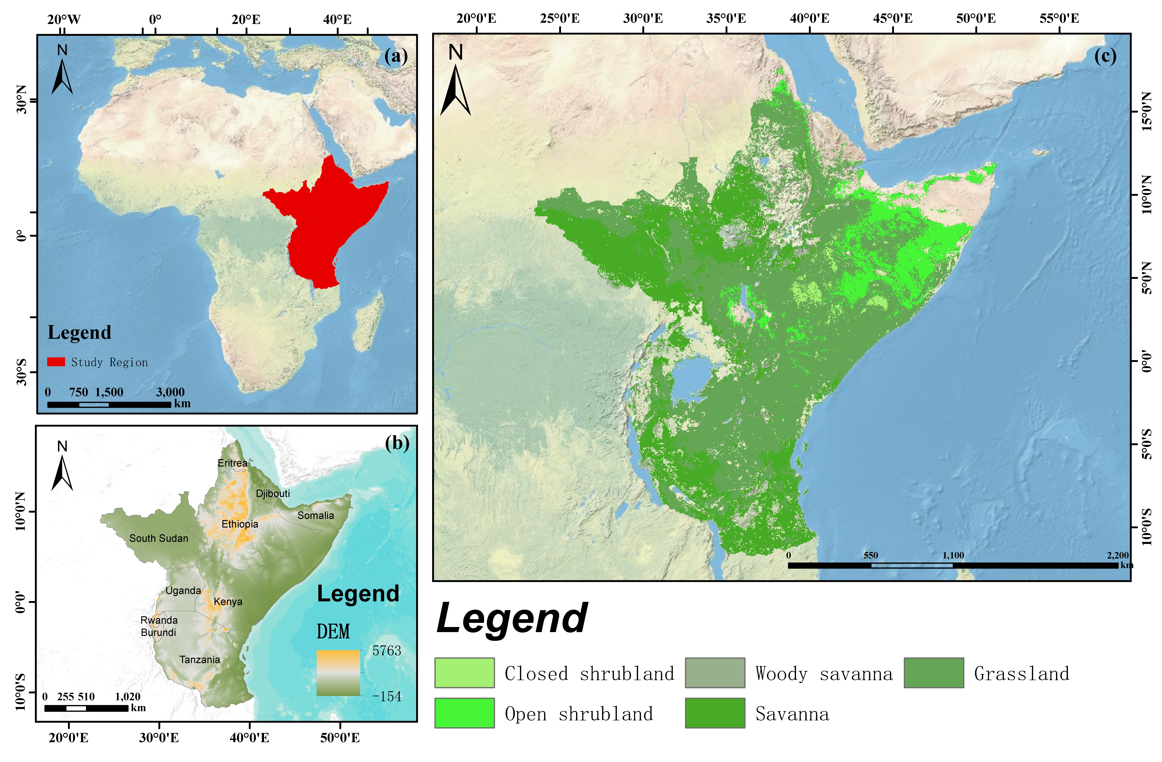
Figure 1. Study domain, analytical support and spatial-validation design. Panels show (a) the location of the East African study region, (b) national boundaries and topographic context, (c) the fixed 2001 open-ecosystem domain with the 2,397 stratified analytical cells, and (d) the five outer spatial folds with 200-km exclusion buffers. The stratified cells define the ecological-response development sample and are not a wall-to-wall estimate of recovery incidence.
Development analyses used 2,397 cells sampled with a fixed random seed from 16 non-empty strata of a 5 x 4 geographic stratification, with up to 150 cells per stratum. Fifteen strata contributed 150 cells and one non-empty stratum was fully enumerated at 147 cells. The sample was not self-weighting. Inverse inclusion-probability weights, w_{h}=N_{h}/n_{h}, were used only for the design-weighted Aalen-Johansen sensitivity and not for RSF discrimination, whose target was held-out spatial ranking. A 20,000-cell full-domain reference sample was used to audit representativeness: after design weighting, absolute standardized mean differences were <=0.02 for MAP, VPD, elevation, sand, clay, open fraction and long-term satellite summaries, and the maximum weighted IGBP-composition difference was 0.64 percentage points (Supplementary Table S1).
Table 1. Remote-sensing, climate and ancillary data used in the analysis. The 0.05° grid is a common analytical support; native spatial information content is not assumed to increase through resampling or aggregation.
Product/source | Native support | Quality control and monthly processing | Role
MODIS MOD13A2 C6.1 | 1 km; 16-day | DetailedQA screened; monthly mean NDVI; FVC=(NDVI-0.05)/0.85, clipped to [0,1]; spatial mean to common grid | Structural response
MODIS MOD15A2H C6.1 | 500 m; 8-day | FparLai_QC screened; LAI scale factor 0.1; monthly mean; spatial mean to common grid | Structural response
MODIS MOD17A2H C6 (legacy archived branch) | 500 m; 8-day | Psn_QC screened; GPP scaled to g C m-2 per 8 d; overlap-day weighted monthly accumulation; QA-valid overlap-day coverage reconstructed for 50% and 75% sensitivity screens | Functional response
PML-V2.2a | 500 m; 8-day | GPP scaled by 0.01 to g C m-2 d-1; range screened to 0-50; overlap-day weighted monthly accumulation | Functional response
CHIRPS v2 daily | 0.05°; daily | Daily precipitation summed to monthly totals; rolling 3-month accumulation; grid- and calendar-month-specific Gamma SPI using the fixed 1981-2010 reference | Drought detection/climate
ERA5-Land Monthly Aggregated | ~0.1°; monthly | Temperature converted to °C; VPD derived from mean temperature and dew point; wind from 10-m u/v components; resampled only for common-grid alignment | Atmospheric context
MCD12Q1 C6.1 | 500 m; annual | 2001 LC_Type1 classes 6-10 and LW=2 define fixed domain; open fraction aggregated to 0.05°; annual class retained for sensitivity/context | Domain/vegetation
SRTM + SoilGrids | 30 m / 250 m; static | Elevation, slope and 0-5 cm sand, clay and soil organic carbon aggregated to the common analysis grid | M3 static context
GOSIF v2 | 0.05°; monthly | Publisher fill/no-data removed; monthly values used only for external consistency; calendar-month robust z scores based on the 2001-2020 record | External consistency
Pixel-level quality screening followed the exported Earth Engine workflow and the product-specific QA layers of the MODIS vegetation-index, LAI and productivity products (Huete et al., 2002; Myneni et al., 2002; Zhao et al., 2005). MOD13A2 NDVI was retained when MODLAND QA indicated good or marginal quality (bits 0-1 <= 1), VI usefulness was <= 2, aerosol quantity was <= 2, adjacent-cloud and mixed-cloud flags were absent, the pixel was classified as land, and snow/ice and shadow flags were absent; raw NDVI was additionally restricted to -2000 to 10000 before applying the 0.0001 scale factor. MOD15A2H LAI required MODLAND_QC = 0, no dead detector, clear cloud state, SCF_QC <= 1 and raw LAI between 0 and 100 before applying the 0.1 scale factor. MOD17 GPP used the analogous Psn_QC requirements (MODLAND_QC = 0, no dead detector, clear cloud state and SCF_QC <= 1), with raw GPP restricted to 0-3000. PML-V2.2a GPP (Zhang et al., 2019) was scaled by 0.01 and range screened to 0-50 g C m-2 d-1; negative CHIRPS precipitation was excluded. Monthly QA observation-count bands were retained for NDVI, LAI, MOD17 and PML to audit temporal completeness.
Monthly composites were constructed before analysis-grid harmonization. QA-screened NDVI and LAI observations were averaged within calendar months. MOD17 8-day GPP was allocated to months in proportion to the number of overlapping days, whereas PML daily-rate GPP was multiplied by the number of overlapping days before monthly summation. CHIRPS precipitation (Funk et al., 2015) was summed from daily values by month. ERA5-Land (Munoz-Sabater et al., 2021) supplied mean and maximum 2-m temperature, dew-point temperature and 10-m wind components; vapour-pressure deficit was derived with the Tetens saturation-vapour-pressure formulation and wind speed from vector magnitude. Fine-resolution continuous fields were spatially averaged to the common grid, categorical land cover was aggregated by mode, and coarser meteorological fields were resampled only for spatial alignment; resampling was not interpreted as an increase in native information content. SRTM terrain (Farr et al., 2007) and SoilGrids 0-5 cm properties (Poggio et al., 2021) were aggregated to the same analytical support. All monthly response bands were finally restricted to open_fraction_2001 >= 0.50.
MOD17 monthly totals require particular caution because QA-invalid 8-day composites are masked before monthly accumulation and are not temporally gap-filled. The pre-specified Collection 6 branch was retained as the archived product stream used to construct the original 2001-2020 event record, preserving one internally consistent product-generation and QA pathway across impact, recovery and predictor construction. The Collection 6.1 MOD17 user guide states that the core science algorithm was unchanged from Collection 6 and that differences arise principally from upstream Collection 6.1 calibration and reprocessing (Running and Zhao, 2021). Collection 6 has since been retired from operational distribution, so its use here is treated as a legacy-product limitation rather than evidence of a distinct GPP algorithm. We did not substitute the year-end gap-filled HGF branch because HGF first temporally fills poor-quality FPAR/LAI inputs before GPP generation, whereas the present study explicitly retained the non-gap-filled branch and evaluated temporal completeness through QA screening (NASA LP DAAC, 2019). For the coverage sensitivity, QA-valid temporal coverage was reconstructed for each grid-month as valid composite overlap days divided by calendar-month days. Monthly MOD17 GPP below >=50% or >=75% coverage was treated as missing rather than rescaled or gap-filled; antecedent references, impacts, recovery timing, cohort construction, MOD17 DLNM and M3 prediction were then rebuilt from the screened series (Supplementary Table S5).

2.2 Analytical framework
The overall analytical workflow is summarized in Figure 2. Following study-domain definition and data preparation, the analysis proceeds through drought-event identification and multi-product recovery assessment to lagged-response analysis, competing-risk inference and spatially buffered prediction, with robustness checks and complementary GOSIF comparisons.
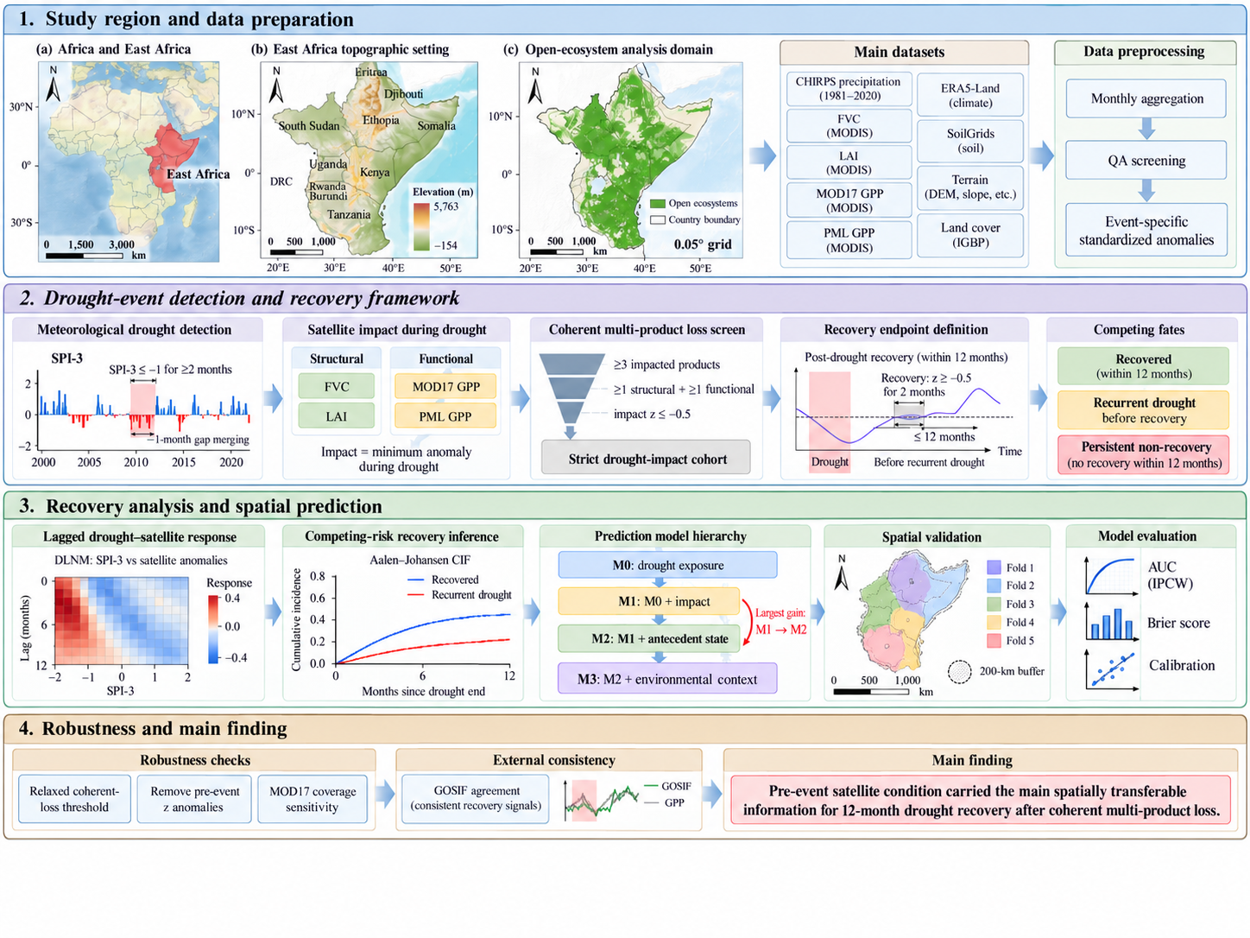

Figure 2. Overall analytical workflow for multi-product drought-recovery assessment and spatial prediction in East African open ecosystems. The four stages comprise study-domain definition and data preparation; SPI-3 drought-event detection, coherent-loss screening and consensus-recovery assessment; lagged-response and competing-risk analyses with nested M0-M3 random survival forests and buffered spatial validation; and robustness checks with complementary GOSIF consistency assessment. The inset analytical plots and fold map are schematic illustrations.

2.2.1 Event detection, satellite anomalies and consensus recovery
Meteorological drought was characterized from monthly CHIRPS precipitation using the 3-month Standardized Precipitation Index (SPI-3). Daily precipitation was first aggregated to calendar-month totals. For grid cell g, year y, and calendar month m, the 3-month accumulated precipitation was
$$\begin{aligned}{\text{X}}_{\text{g}\text{,}\text{y}\text{,}\text{m}}^{\text{(3)}}\text{=}{\text{P}}_{\text{g}\text{,}\text{y}\text{,}\text{m}}\text{+}{\text{P}}_{\text{g}\text{,}\text{y}\text{,}\text{m}\text{−1}}\text{+}{\text{P}}_{\text{g}\text{,}\text{y}\text{,}\text{m}\text{−2}}\#(1)\end{aligned}$$
provided that all three monthly precipitation totals were available.
SPI parameters were estimated separately for each grid cell and calendar month using the fixed 1981–2010 reference period. Positive ${\text{X}}_{}^{\text{(3)}}$ values were fitted to a Gamma distribution by the method of moments,
$$\begin{aligned}\text{α}\text{=}\frac{{\text{μ}}^{\text{2}}}{{\text{σ}}^{\text{2}}}\text{, }\text{θ}\text{=}\frac{{\text{σ}}^{\text{2}}}{\text{μ}}\#(2)\end{aligned}$$
where $\text{μ}$ and ${\text{σ}}^{\text{2}}$ are the mean and variance of positive reference-period accumulations. The empirical probability of zero precipitation was
$$\begin{aligned}{\text{p}}_{\text{0}}\text{=}\frac{\text{n}\left({\text{X}}^{\text{(3)}}\text{=0}\right)}{\text{n}\left({\text{X}}^{\text{(3)}}\text{finite}\right)}\#(3)\end{aligned}$$
The corresponding mixed cumulative probability was
$$\begin{aligned}\text{H}\text{(}\text{x}\text{)=}{\text{p}}_{\text{0}}\text{+(1−}{\text{p}}_{\text{0}}\text{)}\text{G}\text{(}\text{x}\text{;}\text{α}\text{,}\text{θ}\text{)}\#\text{(4)}\end{aligned}$$
where $\text{G}\text{(}\text{·}\text{)}$ is the Gamma cumulative distribution function. SPI was obtained from
$$\begin{aligned}\text{SP}{\text{I}}_{\text{g}\text{,}\text{y}\text{,}\text{m}}\text{=}{\text{Φ}}^{\text{−1}}\left[\text{clip}\left(\text{H}\left({\text{X}}_{\text{g}\text{,}\text{y}\text{,}\text{m}}^{\text{(3)}}\right)\text{,1}{\text{0}}^{\text{−6}}\text{,1−1}{\text{0}}^{\text{−6}}\right)\right]\#(5)\end{aligned}$$
where ${\text{Φ}}^{\text{−1}}$ is the inverse standard-normal cumulative distribution function (Guttman, 1999). Calculations were implemented using scipy.stats.gamma and scipy.stats.norm.
A drought event consisted of at least two consecutive months with $\text{SPI}\text{−3≤−1.0}$.Two qualifying runs separated by a single month were merged when the intervening month remained at $\text{SPI}\text{−3≤}\text{-0.5}$. Event duration was the number of months in the resulting run. Event severity and cumulative SPI deficit were respectively defined as
$$\begin{aligned}{\text{S}}_{\text{e}}\text{=−}\underset{\text{t}\text{∈}\text{e}}{\text{min}}{\text{(}}\text{SP}{\text{I}}_{\text{3,}\text{t}}\text{)}\#\text{(6)}\end{aligned}$$
and
$$\begin{aligned}{\text{D}}_{\text{e}}\text{=}\sum_{\text{t}\text{∈}\text{e}}{\underset{}{\text{max}}{\text{(0,−}\text{SP}{\text{I}}_{\text{3,}\text{t}}\text{)}}}\#(7)\end{aligned}$$
Satellite responses were evaluated independently for FVC, LAI, MOD17 GPP and PML GPP. To remove strong seasonal differences, each observation was expressed relative to an event-specific calendar-month reference distribution. For product p, event year y, and calendar month m,
$$\begin{aligned}{\text{z}}_{\text{p}\text{,}\text{y}\text{,}\text{m}}\text{=}\frac{{\text{X}}_{\text{p}\text{,}\text{y}\text{,}\text{m}}\text{−}\text{median}\left({\text{ℛ}}_{\text{p}\text{,}\text{m}}^{\text{<}\text{y}}\right)}{\text{MAD}\left({\text{ℛ}}_{\text{p}\text{,}\text{m}}^{\text{<}\text{y}}\right)}\#(8)\end{aligned}$$
where${ \text{ℛ}}_{\text{p}\text{,}\text{m}}^{\text{<}\text{y}}$ contains QA-qualified, non-drought observations from the same calendar month in years preceding the event. A reference distribution required at least five observations and a non-zero MAD.
For drought event e, satellite impact for product p was defined as
$$\begin{aligned}{\text{I}}_{\text{p}\text{,}\text{e}}\text{=}\underset{\text{t}\text{∈}\text{e}}{\text{min}}{{\text{z}}_{\text{p}\text{,}\text{t}}}\#(9)\end{aligned}$$
An event was classified as exhibiting coherent multi-product loss when at least three of the four products satisfied
$$\begin{aligned}{\text{I}}_{\text{p}\text{,}\text{e}}\text{≤−0.5}\#\text{(10)}\end{aligned}$$
with at least one qualifying structural product (FVC or LAI) and one functional product (MOD17 GPP or PML GPP).
Post-drought recovery was evaluated from the first month following meteorological drought termination. Product p was considered recovered at the earliest month r satisfying ${\text{z}}_{\text{p}\text{,}\text{r}}\text{≥−0.5 }\text{and} {\text{z}}_{\text{p}\text{,}\text{r}\text{+1}}\text{≥−0.5}$ provided that this occurred before recurrent drought and within the available 12-month follow-up period. Consensus recovery required at least three recovered products spanning both structural and functional product families.
The initial development sample contained 14,447 meteorological drought events. Of these, 7,070 had sufficient satellite information for impact assessment, 5,514 met the coherent multi-product loss criterion, and 5,504 had positive post-event follow-up and formed the primary competing-risk cohort. Because event-specific anomaly references required at least five preceding same-calendar-month observations, the strict cohort effectively began in 2007. Follow-up was administratively censored on 31 December 2020.

2.2.2 Lagged drought responses and competing recovery pathways
Lagged associations between meteorological drought and satellite-observed ecosystem response were quantified using distributed lag nonlinear models (DLNMs; Gasparrini et al., 2010). For satellite product p, the general model can be written as
$$\begin{aligned}{\text{z}}_{\text{p}\text{,}\text{g}\text{,}\text{t}}\text{=}{\text{α}}_{\text{g}}\text{+}{\text{γ}}_{\text{t}}\text{+}\text{CB}\text{(}\text{SP}{\text{I}}_{\text{3,}\text{g}\text{,}\text{t}}\text{, }\text{l}\text{)+}{\text{ε}}_{\text{g}\text{,}\text{t}}\#(11)\end{aligned}$$
where ${\text{α}}_{\text{g}}$denotes grid-cell fixed effects, ${\text{γ}}_{\text{t}}$ denotes year-month fixed effects, and $\text{CB}\text{(}\text{·}\text{)}$ is the two-dimensional cross-basis describing the nonlinear SPI-3 response across lags $\text{l}$=0,....,12.
The exposure dimension used a natural spline with two internal knots positioned at the empirical SPI-3 tertiles and boundary knots at the 1st and 99th percentiles. The lag dimension used two logarithmically spaced internal knots at 1.18 and 3.76 months and boundary knots at 0 and 12 months.
The principal cumulative drought-response contrast was
$$\begin{aligned}{\text{Δ}}_{\text{p}}\text{(−2,0)=}\sum_{\text{l}\text{=0}}^{\text{12}}{\text{[}}{\text{f}}_{\text{p}}\text{(−2,}\text{l}\text{)−}{\text{f}}_{\text{p}}\text{(0,}\text{l}\text{)]}\#\text{(12)}\end{aligned}$$
where ${\text{f}}_{\text{p}}\text{(}\text{x}\text{,}\text{l}\text{)}$ denotes the fitted lag-specific response for exposure x. Standard errors were clustered within 133 approximately 200-km equal-area spatial blocks. Models additionally including concurrent Tmax and VPD anomalies were used as co-exposure sensitivities.
Post-drought recovery was analysed in a competing-risk framework. Let T_{e} denote the time from drought termination to the first post-drought event and J_{e} its type,
$$\begin{aligned}{\text{J}}_{\text{e}}\text{=}\left\{\begin{aligned}\text{1,}\text{consensus} \text{recovery}\text{,} \\ \text{2,}\text{recurrent} \text{droug}\text{h}\text{t} \text{before} \text{recovery}\text{.}\end{aligned}\right.\#(13)\end{aligned}$$
Events experiencing neither transition during follow-up were right-censored. For cause k, the cumulative incidence function was
$$\begin{aligned}{\text{F}}_{\text{k}}\text{(}\text{t}\text{)=}\text{P}\text{(}{\text{T}}_{\text{e}}\text{≤}\text{t}\text{, }{\text{J}}_{\text{e}}\text{=}\text{k}\text{)}\#\text{(14)}\end{aligned}$$
and was estimated non-parametrically using the Aalen–Johansen estimator. Recovery and recurrent-drought CIFs were reported at 3, 6 and 12 months. Uncertainty was obtained from 1,000 bootstrap resamples of approximately 200-km spatial blocks.
Cause-specific Cox models were used as complementary association analyses,
$$\begin{aligned}{\text{h}}_{\text{k}}\text{(}\text{t}\text{|}\text{x}\text{)=}{\text{h}}_{\text{0}\text{k}}\text{(}\text{t}\text{)}\text{exp}\left({\text{β}}_{\text{k}}^{\text{⊤}}\text{x}\right)\#(15)\end{aligned}$$
where k denotes recovery or recurrent drought. Because global proportional-hazards tests indicated time-varying associations, models were summarized separately for 0–3, 3–6 and 6–12 month intervals.
For visualization of the competing pathways, satellite observations were aligned relative to drought termination from −3 to +12 months. Structural-family state was defined within event \(e\) as
$$\begin{aligned}{\text{Z}}_{\text{e}\text{,}\text{t}}^{\text{S}}\text{=}\text{median}\left({\text{z}}_{\text{FVC}\text{,}\text{e}\text{,}\text{t}}\text{, }{\text{z}}_{\text{LAI}\text{,}\text{e}\text{,}\text{t}}\right)\#(16)\end{aligned}$$
and functional-family state as
$$\begin{aligned}{\text{Z}}_{\text{e}\text{,}\text{t}}^{\text{F}}\text{=}\text{median}\left({\text{z}}_{\text{MOD}\text{17,}\text{e}\text{,}\text{t}}\text{, }{\text{z}}_{\text{PML}\text{,}\text{e}\text{,}\text{t}}\right)\#(17)\end{aligned}$$
For each terminal fate, these event-level trajectories were summarized by their across-event median and interquartile range. They were used descriptively and did not enter endpoint construction or model fitting.

2.2.3 Spatial prediction of post-drought recovery
Competing-risk random survival forests (RSFs; Ishwaran et al., 2008) were used to quantify how different information sets contributed to spatial discrimination of post-drought recovery. Four nested predictor sets were constructed:
$$\begin{aligned}\begin{matrix}{\text{M}}_{\text{0}} & \text{=}{\text{X}}_{\text{droug}\text{h}\text{t}}\text{,} \\ {\text{M}}_{\text{1}} & \text{=}{\text{M}}_{\text{0}}\text{∪}{\text{X}}_{\text{impact}}\text{,} \\ {\text{M}}_{\text{2}} & \text{=}{\text{M}}_{\text{1}}\text{∪}{\text{X}}_{\text{antecedent}}\text{,} \\ {\text{M}}_{\text{3}} & \text{=}{\text{M}}_{\text{2}}\text{∪}{\text{X}}_{\text{context}}\text{.}\end{matrix}\#(18)\end{aligned}$$
${\text{M}}_{\text{0}}$ contained drought exposure and concurrent meteorological characteristics; ${\text{M}}_{\text{1}}$ added satellite-observed drought impacts; ${\text{M}}_{\text{2}}$ added immediately pre-onset standardized anomalies together with longer-window pre-onset mean, variability and trend metrics; and ${\text{M}}_{\text{3}}$ added drought history, retrospective climate summaries, land cover, open fraction, terrain and surface-soil properties. The complete predictor matrix is provided in Supplementary Table S6.
The primary RSF contained 400 trees and used competing-risk log-rank splitting (logrankCR) with recovery as the event of interest. The number of candidate predictors at each split was
$$\begin{aligned}{\text{m}}_{\text{try}}\text{=}\left\lfloor \sqrt{\text{p}}\right\rfloor \#(19)\end{aligned}$$
where p is the number of predictors. Terminal node size was 25 and 10 candidate split points were evaluated. Continuous missing values were imputed using medians estimated exclusively from the corresponding training data.
Spatial transferability was evaluated using five outer spatial folds generated by spatial k-means clustering (Roberts et al., 2017). All events from the same 0.05° grid cell were assigned to the same fold. In each outer iteration, cells located within 200 km of the test region were excluded from model training. Exclusion distances of 100 and 300 km were additionally evaluated.
Prediction performance was assessed using the 12-month recovery cumulative-incidence prediction
$$\begin{aligned}{\hat{\text{F}}}_{\text{1}}\text{(12|}{\text{x}}_{\text{i}}\text{)}\#\text{(20)}\end{aligned}$$
Time-dependent discrimination was evaluated using inverse-probability-of-censoring-weighted AUC, and overall prediction error using the IPCW Brier score (Gerds et al., 2012; Blanche et al., 2013). Conceptually, the latter is
$$\begin{aligned}\text{BS}\text{(}\text{t}\text{)=}\frac{\text{1}}{\text{n}}\sum_{\text{i}\text{=1}}^{\text{n}}{{\text{w}}_{\text{i}}}\text{(}\text{t}\text{)}{\left[{\text{Y}}_{\text{i}}\text{(}\text{t}\text{)−}{\hat{\text{F}}}_{\text{1}}\text{(}\text{t}\text{|}{\text{x}}_{\text{i}}\text{)}\right]}^{\text{2}}\#(21)\end{aligned}$$
where ${\text{Y}}_{\text{i}}\text{(}\text{t}\text{)}$ indicates whether recovery occurred by time t, and w_{i}(t) denotes the censoring weight. AUC and Brier scores were calculated separately for each held-out fold at 3, 6 and 12 months.
A sparse linear benchmark was constructed using separate cause-specific Cox models for recovery and recurrent drought. For cause k,
$$\begin{aligned}{\text{h}}_{\text{k}}\text{(}\text{t}\text{|}\text{x}\text{)=}{\text{h}}_{\text{0}\text{k}}\text{(}\text{t}\text{)}\text{exp}\left({\text{β}}_{\text{k}}^{\text{⊤}}\text{x}\right)\#(22)\end{aligned}$$
with coefficients estimated under an L₁ penalty,
$$\begin{aligned}\hat{\text{β}}\text{=}\text{arg}{\underset{\text{β}}{\text{min}}\left[\text{−ℓ(}\text{β}\text{)+}\text{λ}\text{‖}\text{β}{\text{‖}}_{\text{1}}\right]}\#(23)\end{aligned}$$
The penalty parameter $\text{λ}$ was selected using four-group spatial cross-validation within the outer-training data.
Environmental extrapolation was summarized using a training environmental-support domain, following the logic of spatial applicability diagnostics (Meyer and Pebesma, 2021). After standardization using outer-training statistics, the support distance for held-out observation i was
$$\begin{aligned}{\text{d}}_{\text{i}}\text{=}\underset{\text{j}\text{∈}\text{T}}{\text{min}}{\text{‖}}{\text{z}}_{\text{i}}\text{−}{\text{z}}_{\text{j}}{\text{‖}}_{\text{2}}\#(24)\end{aligned}$$
where $\text{T}$ denotes the buffered training sample. The support threshold was
$$\begin{aligned}{\text{d}}^{\text{∗}}\text{=}{\text{Q}}_{\text{0.95}}\left({\text{d}}_{\text{j}}^{\text{LOO}}\right)\#(25)\end{aligned}$$
where ${\text{d}}_{\text{j}}^{\text{LOO}}$ is the leave-one-out nearest-neighbour distance among training observations. Test events with d_{i}>${\text{d}}^{\text{∗}}$ were classified as outside training environmental support.
Accumulated local effects were used to visualize fitted relationships between the immediately pre-onset standardized satellite anomalies and 12-month recovery predictions. For predictor x_{j}, ALE can be expressed generally as
$$\begin{aligned}\text{AL}{\text{E}}_{\text{j}}\text{(}\text{x}\text{)=}\int{\text{E}}\left[\left.\frac{\text{∂}\hat{\text{f}}\text{(}\text{x}\text{)}}{\text{∂}{\text{x}}_{\text{j}}}\right|{\text{x}}_{\text{j}}\text{=}\text{z}\right]\text{dz}\text{−}\text{C}\#\text{(26)}\end{aligned}$$
where C centers the ALE function at zero. In practice, predictors were divided into 20 empirical-quantile intervals and local prediction differences were accumulated across bins. ALE curves were interpreted as fitted predictive associations rather than causal response functions.

2.2.4 Sensitivity analyses and complementary cross-product evaluation
Sensitivity analyses varied the meteorological drought threshold, minimum event duration, recovery threshold, recovery persistence, SPI accumulation period, product composition and open-ecosystem domain definition.
To test whether the M1–M2 contrast resulted from conditioning on a strongly impacted cohort, the coherent-loss threshold was relaxed from ${\text{I}}_{\text{p}\text{,}\text{e}}\text{≤−0.}$5 to ${\text{I}}_{\text{p}\text{,}\text{e}}\text{≤−0.3}$ while retaining the same endpoint, predictor definitions, RSF configuration and 200-km outer spatial-validation protocol.
A second sensitivity isolated the contribution of immediately pre-onset satellite condition by defining
$$\begin{aligned}{\text{M}}_{\text{2,}\text{nopre}\text{−−}\text{z}}\text{=}{\text{M}}_{\text{2}}\text{∖\{}\text{pre}\text{_}{\text{z}}_{\text{FVC}}\text{,}\text{pre}\text{_}{\text{z}}_{\text{LAI}}\text{,}\text{pre}\text{_}{\text{z}}_{\text{MOD}\text{17}}\text{,}\text{pre}\text{_}{\text{z}}_{\text{PML}}\text{\}}\#\text{(27)}\end{aligned}$$
while retaining all pre-onset-window means, coefficients of variation and temporal slopes.
MOD17 temporal completeness was evaluated from QA-valid overlap days. For native MOD17 pixel q and calendar month m,
$$\begin{aligned}{\text{C}}_{\text{q}\text{,}\text{m}}\text{=}\frac{\sum_{\text{i}}{\text{I}}\text{(}\text{Q}{\text{A}}_{\text{q}\text{,}\text{i}}\text{=}\text{valid}\text{) }{\text{d}}_{\text{i}\text{,}\text{m}}}{{\text{D}}_{\text{m}}}\#(28)\end{aligned}$$
where ${\text{d}}_{\text{i}\text{,}\text{m}}$ is the number of days for which composite i overlaps month m, and ${\text{D}}_{\text{m}}$ is the number of calendar days in that month. Grid-level coverage was then
$$\begin{aligned}{\text{C}}_{\text{g}\text{,}\text{m}}\text{=}\frac{\text{1}}{{\text{N}}_{\text{g}}}\sum_{\text{q}\text{∈}\text{g}}{{\text{C}}_{\text{q}\text{,}\text{m}}}\#(29)\end{aligned}$$
over native open-vegetation MODIS pixels within analysis grid cell g. Monthly MOD17 GPP was treated as missing when ${\text{C}}_{\text{g}\text{,}\text{m}}\text{<0.}\text{50}$ or, in the stricter sensitivity, ${\text{C}}_{\text{g}\text{,}\text{m}}\text{<0.75}$.
The affected MOD17 anomaly references, drought impacts, recovery timing, cohort membership, DLNM estimates and prediction models were subsequently reconstructed.
GOSIF v2 (Li and Xiao, 2019) was used as complementary cross-product evidence. Unlike the event-specific antecedent reference used for the primary satellite products, GOSIF was standardized independently by calendar month over the full 2001–2020 record:
$$\begin{aligned}{\text{z}}_{\text{y}\text{,}\text{m}}^{\text{G}}\text{=}\frac{{\text{G}}_{\text{y}\text{,}\text{m}}\text{−}\text{median}\left({\text{G}}_{\text{⋅,}\text{m}}\right)}{\text{MAD}\left({\text{G}}_{\text{⋅,}\text{m}}\right)}\#(30)\end{aligned}$$
GOSIF event impact was
$$\begin{aligned}{\text{I}}_{\text{e}}^{\text{G}}\text{=}\underset{\text{t}\text{∈}\text{e}}{\text{min}}{{\text{z}}_{\text{e}\text{,}\text{t}}^{\text{G}}}\#(31)\end{aligned}$$
and GOSIF recovery required ${\text{z}}_{\text{e}\text{,}\text{t}}^{\text{G}}\text{≥−0.5} \text{and} {\text{z}}_{\text{e}\text{,}\text{t}\text{+1}}^{\text{G}}\text{≥−0.5}$ before recurrent drought or administrative censoring and within 12 months of drought termination.
Continuous agreement between GOSIF and each primary product was quantified using Spearman's rank correlation,
$$\begin{aligned}{\text{ρ}}_{\text{s}}\text{=}\text{cor}\left[\text{R}\text{(}{\text{I}}_{\text{e}}^{\text{G}}\text{), }\text{R}\text{(}{\text{I}}_{\text{p}\text{,}\text{e}}\text{)}\right]\#(32)\end{aligned}$$
where $\text{R}\text{(}\text{·}\text{)}$ denotes ranks. Binary recovery consistency was evaluated using observed agreement and Cohen's $\text{κ}$,
$$\begin{aligned}\text{κ}\text{=}\frac{{\text{P}}_{\text{o}}\text{−}{\text{P}}_{\text{e}}}{\text{1−}{\text{P}}_{\text{e}}}\#(33)\end{aligned}$$
where ${\text{P}}_{\text{o}}$ is the observed agreement and ${\text{P}}_{\text{e}}$ is the agreement expected from the marginal recovery frequencies.
GOSIF was not used in drought-event definition, consensus endpoint construction or RSF prediction. Because its anomaly reference differs from that of the four primary products and it shares MODIS and meteorological information with several inputs, these comparisons were interpreted as complementary cross-product consistency rather than independent ground-truth validation.

3. Results

3.1 Spatial drought exposure and recovery-opportunity geography
Figure 3 shows pronounced spatial heterogeneity in meteorological drought exposure across the fixed open-ecosystem domain. Drought-event frequency varied from only a few events in some western and southern cells to more than 15–20 events in localized parts of the central and eastern domain, with comparatively dense event occurrence across portions of Ethiopia, Kenya and the eastern Horn. Median drought duration was much less spatially variable: most open-ecosystem cells were characterized by events lasting approximately 2–4 months, while longer median durations of about 5–7 months occurred only in scattered patches, particularly in parts of the western and northwestern domain. Median event severity also formed a spatially heterogeneous mosaic, with stronger negative SPI-3 minima interspersed with areas of relatively moderate drought severity. Cumulative SPI-3 deficit was generally low to moderate over much of the domain but reached substantially higher values in localized western, central and northern patches, indicating that high event frequency, long duration and large cumulative deficit were not spatially coincident everywhere.
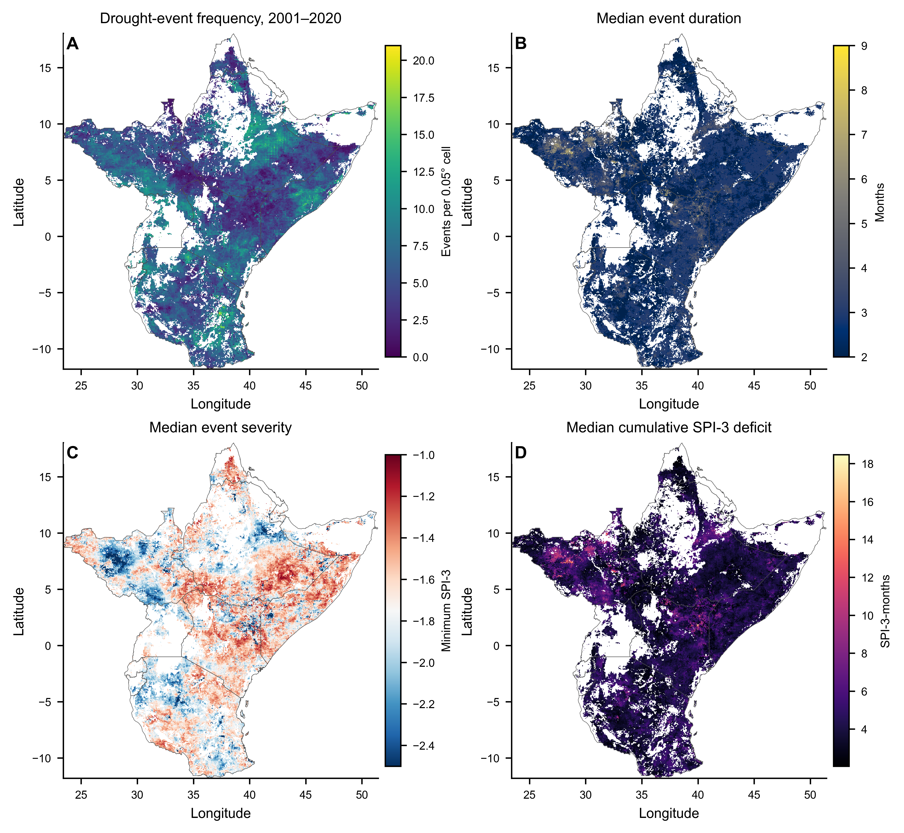
Figure 3. Wall-to-wall meteorological drought-event climatology across the fixed 2001 open-ecosystem domain for 2001-2020. Panels show (a) drought-event frequency, (b) median event duration, (c) median event severity and (d) median cumulative SPI-3 deficit.
Within the stratified ecological-response sample, product-consistent drought events were unevenly distributed (Fig. 4a). Event density reached approximately 6–8 events per sampled 0.05° cell in several clusters across Ethiopia and the Kenya–Ethiopia sector, whereas much of the western and southern sampled domain contained only one to three coherent-loss events per cell. Recovery by month 12 was spatially widespread (Fig. 4b), with many supported cells showing recovery fractions above 0.6 and numerous cells approaching 0.8–1.0. High recovery fractions occurred across parts of Ethiopia, Kenya, Tanzania and the eastern Horn, but were interspersed with cells showing substantially lower recovery incidence. Recurrent drought before recovery was generally less frequent (Fig. 4c), with most supported cells below approximately 0.3–0.4, although localized fractions above 0.5 occurred in parts of the eastern Horn, eastern Kenya and scattered interior locations. Persistent non-recovery by month 12 showed the sparsest spatial pattern (Fig. 4d): most supported cells had low fractions, while isolated higher-value clusters occurred along parts of the eastern domain and in several southern locations. Because the fate maps include only cells with at least three events of known 12-month status, these patterns describe the sampled event geography rather than wall-to-wall recovery incidence.
Figure 4. Geography of drought exposure and finite recovery opportunities within the stratified analytical sample. Panel (a) shows product-consistent drought-event density per sampled 0.05° cell. Panels (b-d) show, respectively, the fraction of events recovered by month 12, experiencing recurrent drought before recovery, and remaining in persistent non-recovery by month 12. Fate fractions are displayed only where at least three events had a known 12-month fate; panel (a) provides the corresponding event-count support, so local fractions should not be interpreted as equally precise across cells. These are descriptive summaries of the stratified analytical sample rather than wall-to-wall incidence estimates.

3.2 Competing post-drought recovery pathways
The strict event-end cohort comprised 5,504 coherent-loss events across 2,022 sampled grid cells. The Aalen–Johansen recovery cumulative incidence increased progressively from 0.321 at 3 months to 0.540 at 6 months and 0.723 at 12 months, whereas recurrent drought before recovery increased from 0.038 to 0.083 and 0.138 over the same intervals. The event-history raster in Fig. 5b shows that completed recovery represented the dominant 12-month fate, but recovery timing was distributed throughout the follow-up period rather than concentrated immediately after drought termination. Recurrent-drought events formed a smaller but clearly distinguishable pathway, with most recurrent events occurring after several months of post-drought opportunity and a longer tail extending toward month 12. A further subset of events remained unrecovered without recurrent drought at the end of the observation window.
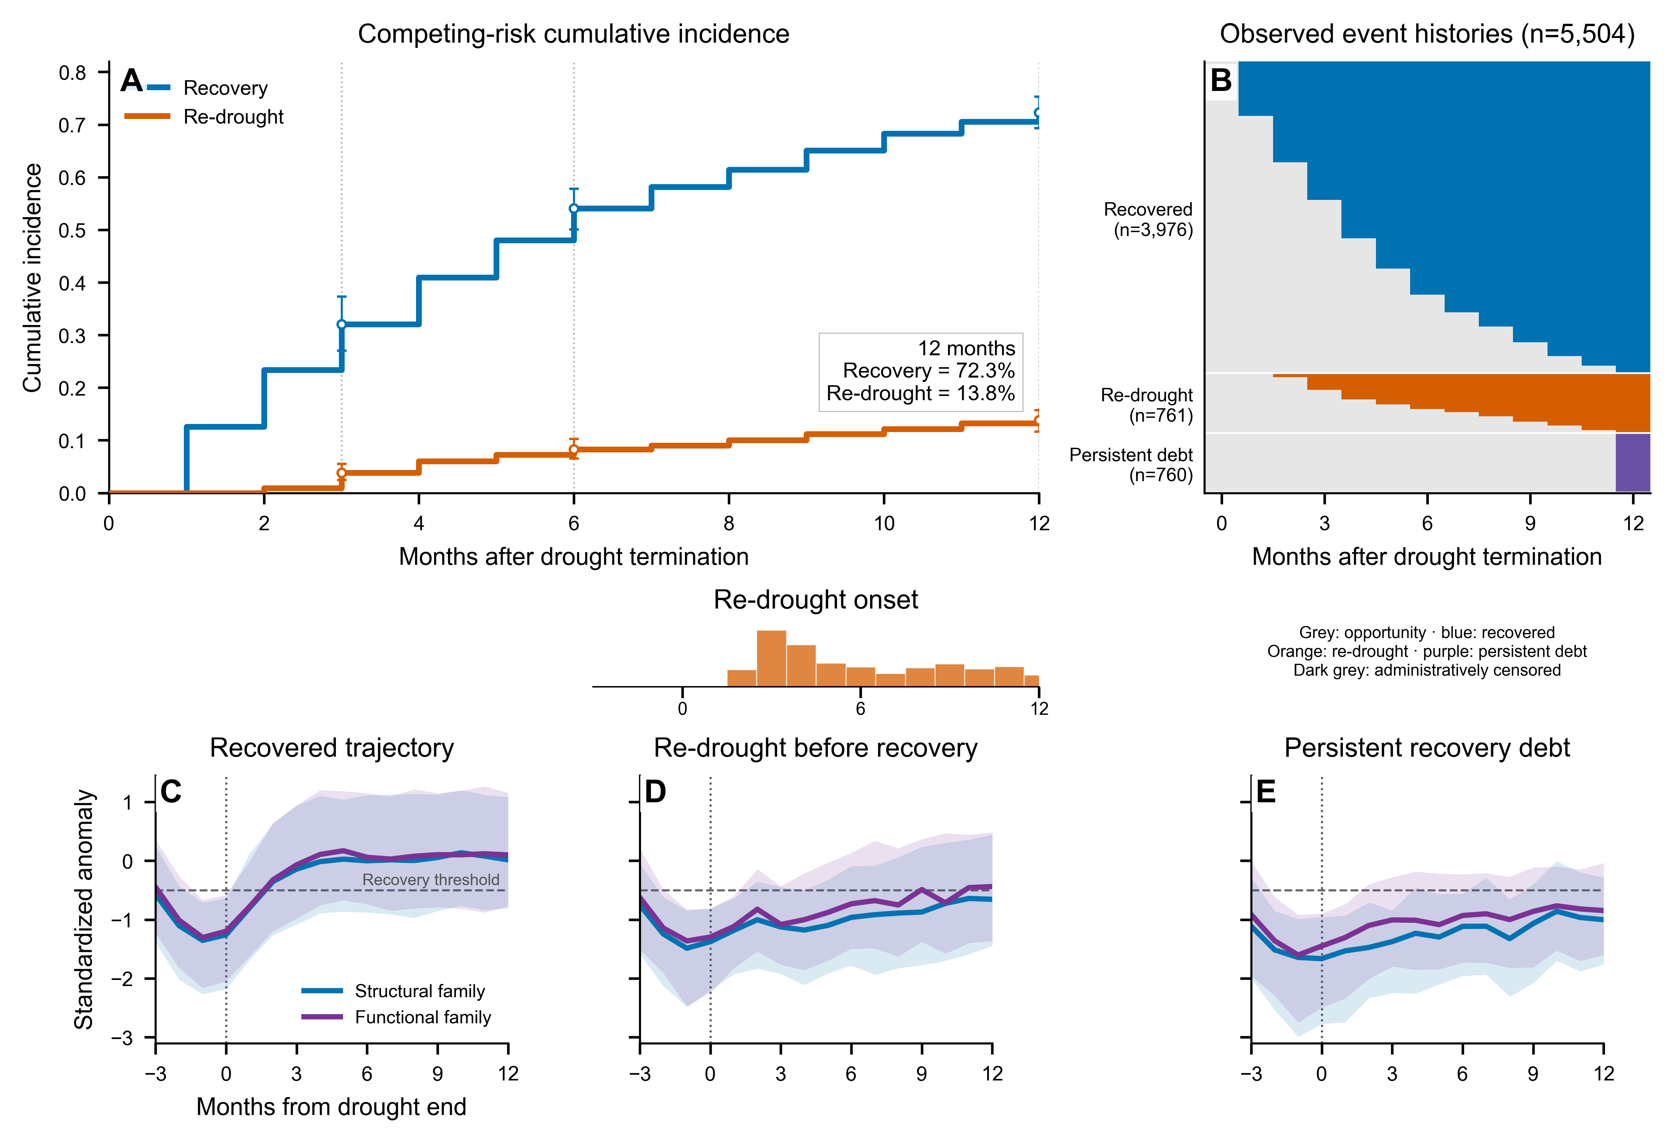
Figure 5. Competing post-drought recovery pathways within the stratified analytical sample. (a) Aalen-Johansen cumulative incidence functions for consensus recovery and recurrent drought before recovery. (b) Observed event histories across the 12-month follow-up window, ordered by post-drought fate and timing. (c-e) Event-aligned median structural- and functional-family standardized-anomaly trajectories for recovered events, recurrent-drought-before-recovery events and persistent-non-recovery events, respectively. Shading denotes the interquartile range; the horizontal dashed line marks the recovery threshold and the vertical line marks drought termination.
The event-aligned trajectories further distinguish these three pathways (Fig. 5c–e). Among recovered events, both structural and functional anomalies declined to their lowest levels around drought termination and then rose rapidly during the first several post-drought months; the median trajectories crossed the −0.5 recovery threshold within the early part of the follow-up window and approached the seasonal reference level thereafter. Events that subsequently experienced recurrent drought showed a more incomplete recovery trajectory: structural and functional anomalies initially increased after drought termination but remained predominantly below or close to the recovery threshold over much of the 12-month period. In contrast, events classified as persistent non-recovery remained below −0.5 throughout most of the follow-up window, with only gradual upward movement and median structural and functional conditions still below the recovery criterion at month 12. Across all three fates, the interquartile envelopes remained broad, showing substantial event-to-event variation around the median pathway.

3.3 Multi-product lagged drought associations
Figure 6(a-d) displays product-specific lag-response estimates for SPI-3 = -2 relative to SPI-3 = 0, and Figure 6(e) summarizes the cumulative 0-12-month estimates. The cumulative standardized associations were FVC, -0.703 (95% CI -0.853 to -0.553); LAI, -0.493 (-0.667 to -0.318); MOD17 GPP, -0.756 (-0.938 to -0.574); and PML GPP, -0.558 (-0.687 to -0.430). Co-exposure adjustment for concurrent Tmax and VPD anomalies gave FVC -0.713, LAI -0.493, MOD17 GPP -0.759 and PML GPP -0.558. Under MOD17 overlap-day coverage screens of >=50% and >=75%, the MOD17 cumulative estimates were -0.969 (-1.320 to -0.618) and -0.915 (-1.122 to -0.709), respectively; FVC, LAI and PML estimates were unchanged to the displayed precision. Full nonlinear exposure-response curves are provided in Supplementary Figure S1.
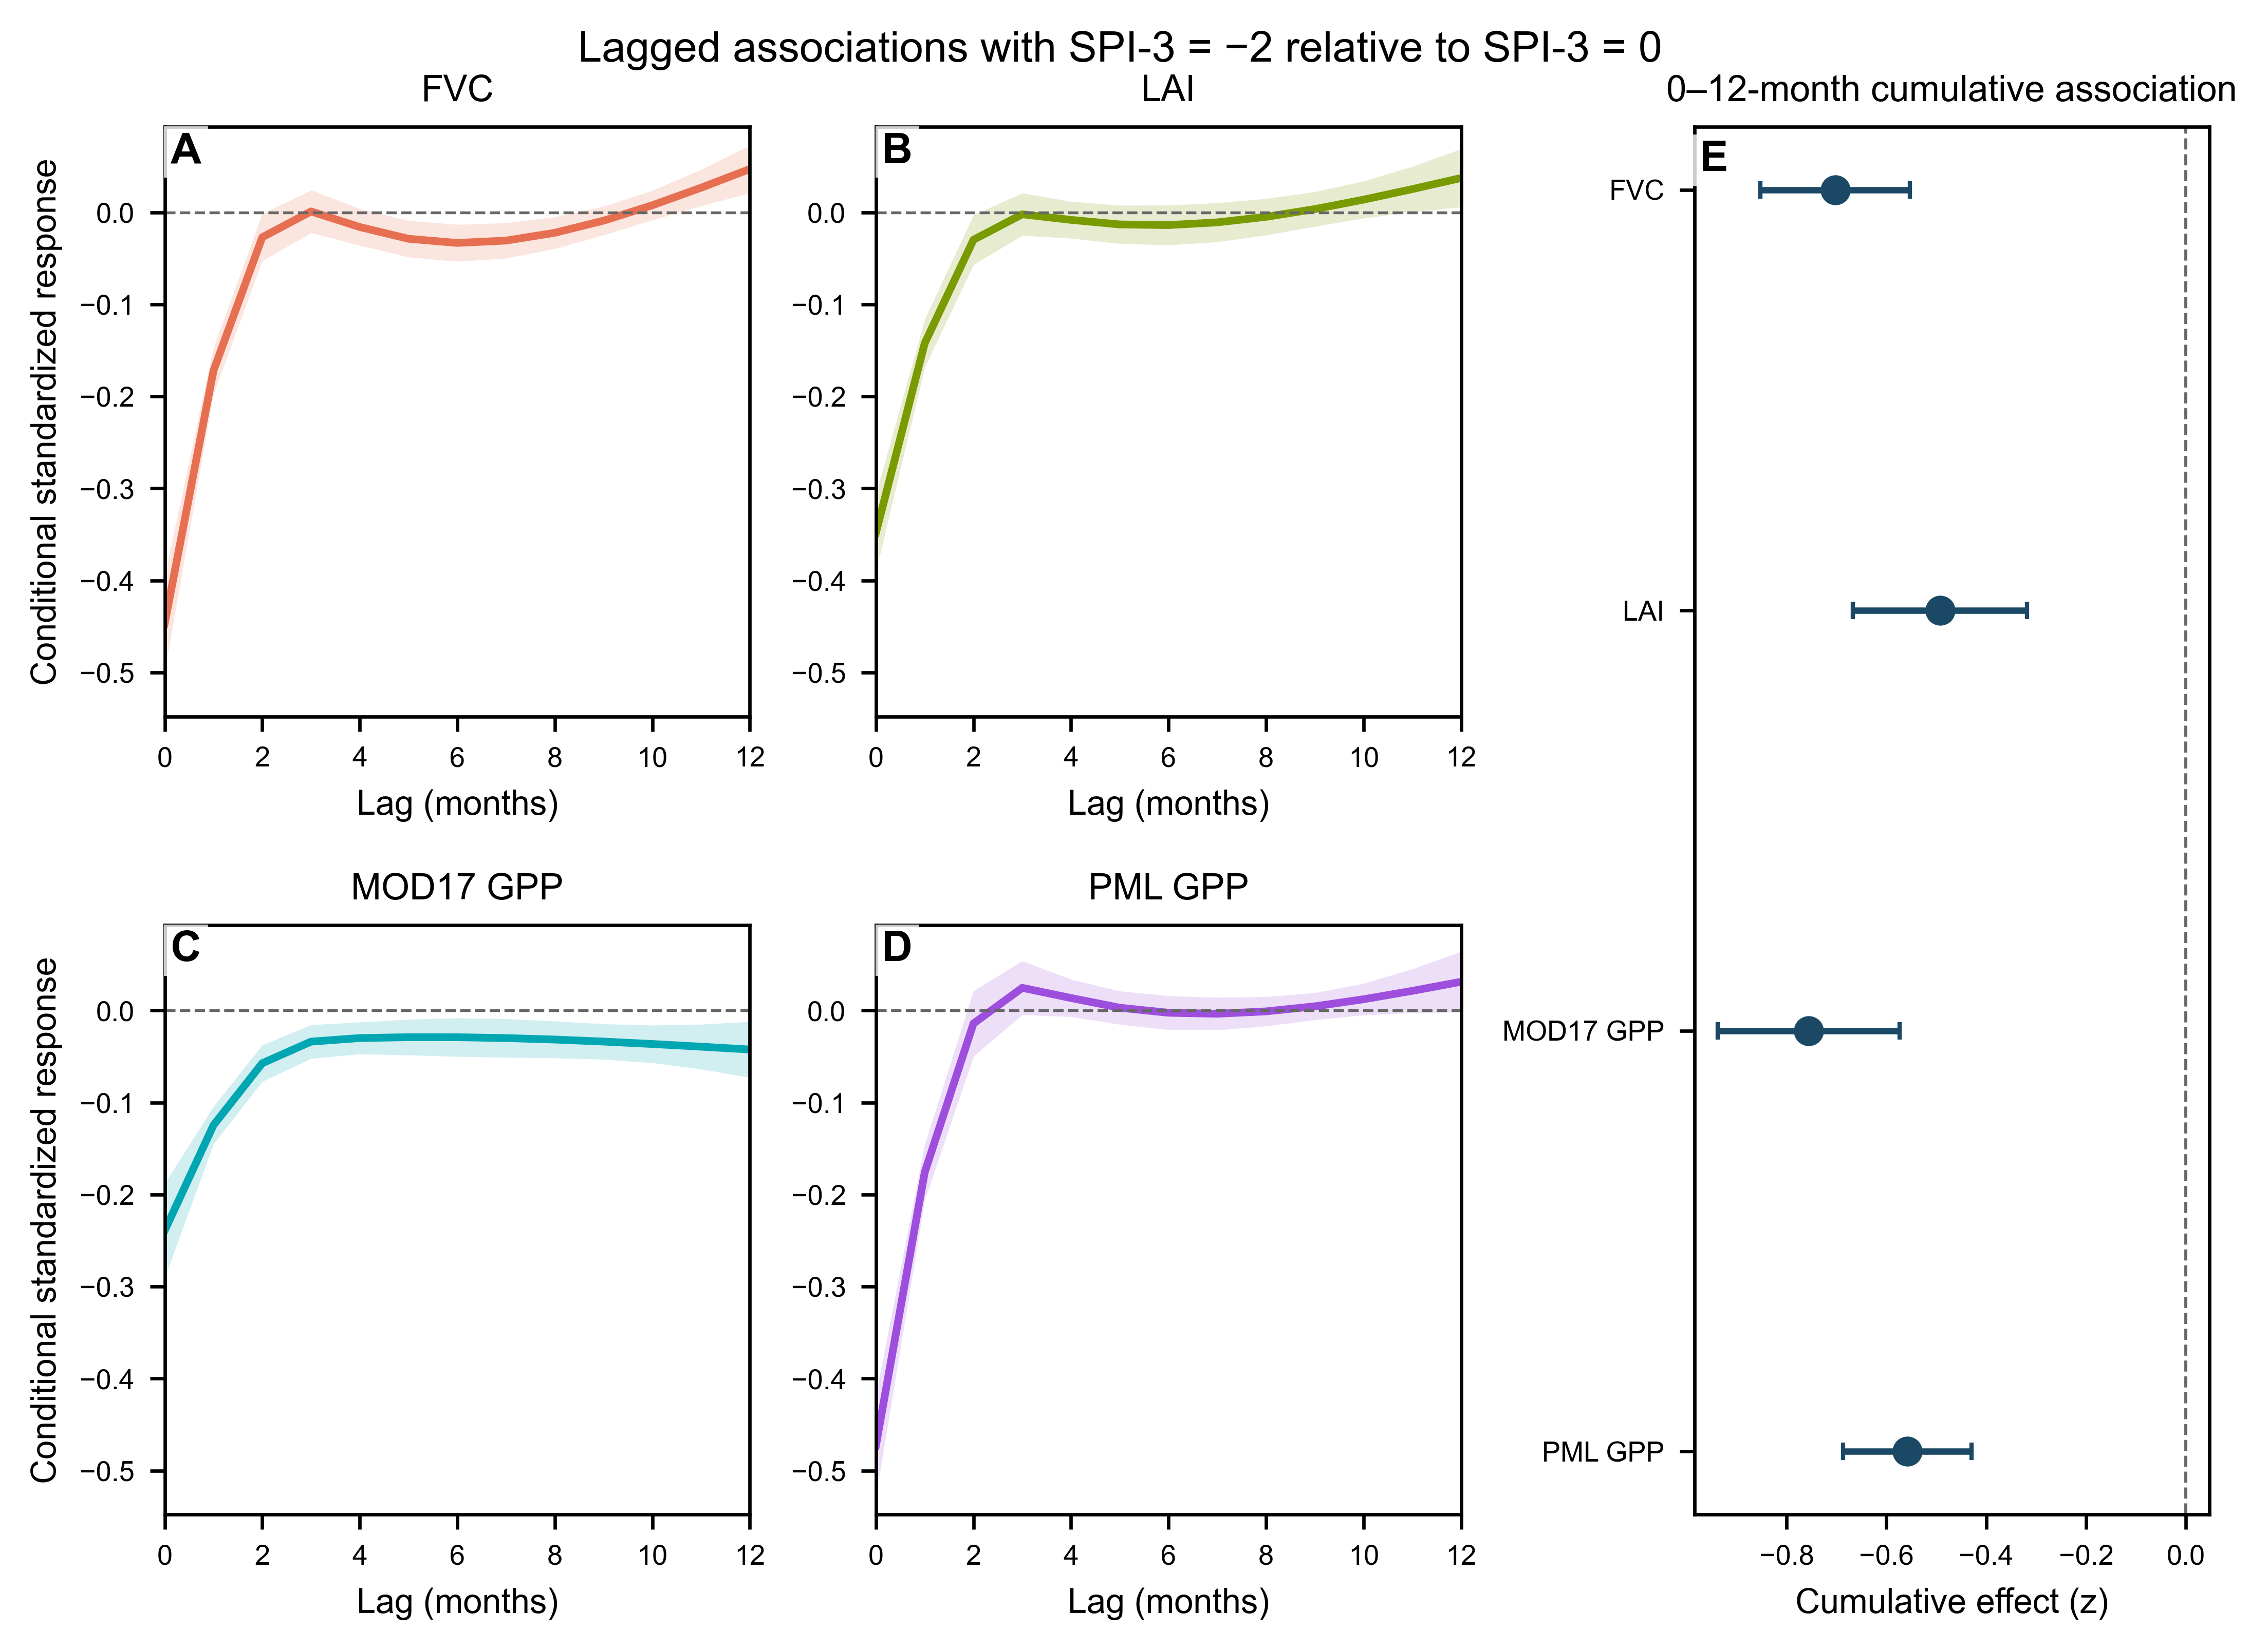
Figure 6. Product-specific DLNM estimates for SPI-3 = -2 relative to SPI-3 = 0. Panels (a-d) show standardized lag-response estimates over 0-12 months for FVC, LAI, MOD17 GPP and PML GPP, and panel (e) shows the corresponding cumulative 0-12-month estimates with 95% confidence intervals. Uncertainty is based on 200-km spatial-block clustering.

3.4 Immediate pre-onset satellite condition and spatial competing-risk prediction
Table 2 summarizes spatially buffered competing-risk prediction. Under the primary 200-km exclusion buffer, mean AUC12 increased from 0.584 in M0 to 0.592 in M1, 0.662 in M2 and 0.665 in M3, while the corresponding Brier12 values decreased from 0.129 to 0.128, 0.120 and 0.118. The largest increase in discrimination occurred between M1 and M2, whereas the retrospective context added in M3 produced little further change. Figure 7 complements these nested-model results with direct ablation and relaxed-screen comparisons, together with descriptive ALE relationships for the immediately pre-onset anomalies.
Table 2. Spatial competing-risk RSF performance.
Section | Scenario | Information set | AUC12 mean | AUC12 outer-fold range | Brier12 mean | Brier12 outer-fold range
Feature ablation (200-km buffer) | M0 | Drought exposure | 0.584 | 0.528-0.629 | 0.129 | 0.109-0.150
Feature ablation (200-km buffer) | M1 | M0 + satellite-observed impact | 0.592 | 0.564-0.616 | 0.128 | 0.106-0.152
Feature ablation (200-km buffer) | M2 | M1 + antecedent ecosystem state | 0.662 | 0.639-0.737 | 0.120 | 0.096-0.148
Feature ablation (200-km buffer) | M3 | M2 + drought history and environmental context | 0.665 | 0.631-0.750 | 0.118 | 0.098-0.146
Spatial-buffer sensitivity (M3) | 100-km exclusion buffer | M3 | 0.674 | 0.637-0.750 | 0.117 | 0.097-0.144
Spatial-buffer sensitivity (M3) | 200-km exclusion buffer | M3 | 0.665 | 0.631-0.750 | 0.118 | 0.098-0.146
Spatial-buffer sensitivity (M3) | 300-km exclusion buffer | M3 | 0.656 | 0.626-0.729 | 0.118 | 0.099-0.145
Environmental support (M3) | Outside training environmental support | n=1,586 | 0.645 | Not applicable | 0.111 | Not applicable
Environmental support (M3) | Inside training environmental support | n=3,918 | 0.656 | Not applicable | 0.124 | Not applicable
Notes: AUC and Brier values are inverse-probability-of-censoring weighted at 12 months. Fold ranges are the minimum-maximum across the five held-out outer spatial folds; the folds are evaluation partitions, not independent replicate experiments. The inside/outside training environmental-support rows are calculated from pooled held-out predictions across the five outer folds. Because Brier scores depend on outcome prevalence, the environmental-support-stratified Brier values are reported descriptively and are not interpreted as a direct comparison of predictive quality between support strata.
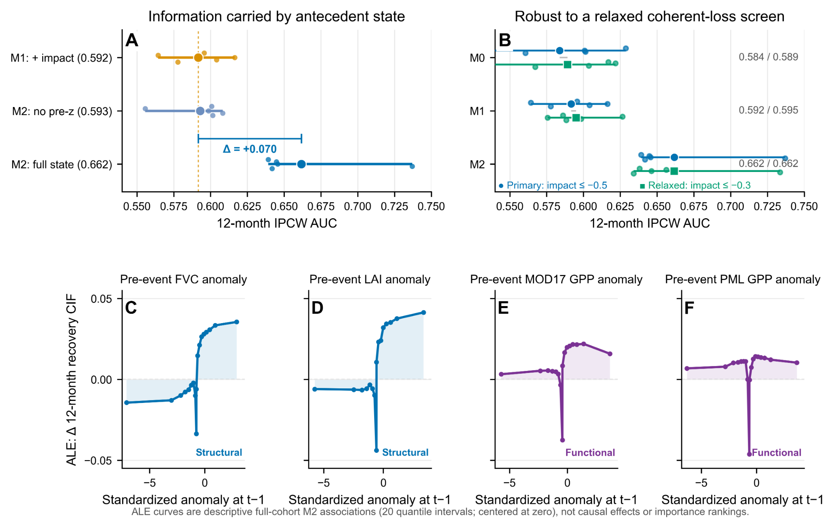
Figure 7. Contribution of immediate pre-onset satellite condition to spatial discrimination of 12-month recovery. (a) Outer-fold IPCW AUC for M1, M2 without the four pre_z variables, and full M2. (b) Outer-fold AUC under the primary coherent-loss screen (impact z <= -0.5) and the relaxed screen (impact z <= -0.3) for M0-M2. (c-f) Accumulated local effect (ALE) relationships for the immediately pre-onset standardized anomalies of FVC, LAI, MOD17 GPP and PML GPP in the strict-cohort M2 model. ALE curves use 20 empirical-quantile intervals and are centered at zero; they describe fitted predictive associations rather than causal effects or variable-importance rankings.
Figure 7A shows that the M1-to-M2 discrimination gain was concentrated in the four immediately pre-onset standardized-anomaly variables. Removing these variables reduced M2 AUC12 from 0.662 to 0.593 and increased Brier12 from 0.120 to 0.125, leaving only a +0.001 mean AUC difference from M1. Under the relaxed coherent-loss screen (z <= -0.3), the prediction cohort increased from 5,504 to 5,822 events, while M1-M0 remained small (+0.006; outer-fold range -0.031 to +0.039) and M2-M1 remained positive in all five folds (+0.067; +0.030 to +0.135; Fig. 7B). Figure 7C-F shows ALE relationships for the immediately pre-onset standardized anomalies of FVC, LAI, MOD17 GPP and PML GPP. M3 AUC12 was 0.674, 0.665 and 0.656 under 100-, 200- and 300-km exclusion buffers, respectively; pooled held-out AUC12 was 0.656 inside the training environmental-support domain (n = 3,918) and 0.645 outside it (n = 1,586).

3.5 Calibration across nested recovery models
Figure 8 compares pooled held-out predicted 12-month recovery CIF with Aalen-Johansen estimates within prediction deciles for M0-M3. For M0 and M1 (Fig. 8A-B), predicted CIFs occupied a relatively narrow range, whereas observed recovery incidence was compressed around approximately 0.65-0.85; the lowest predicted deciles therefore lay well above the 1:1 line. After antecedent satellite state was added, M2 (Fig. 8C) showed a wider separation of predicted risk and a more monotonic alignment between predicted and observed deciles, spanning approximately 0.50-0.86 in predicted CIF and 0.46-0.88 in observed CIF. M3 (Fig. 8D) retained a similar ordering, with only small changes relative to M2. Across models, the event-level prediction distributions remained concentrated toward the upper half of the CIF range, as shown by the marginal histograms and rugs. The accompanying performance summaries were AUC12/Brier12 = 0.584/0.129 for M0, 0.592/0.128 for M1, 0.662/0.120 for M2 and 0.665/0.118 for M3. Additional domain, event-definition and product-composition sensitivities are reported in Supplementary Table S4. Additional MOD17 temporal-completeness sensitivity is reported in Supplementary Table S5.

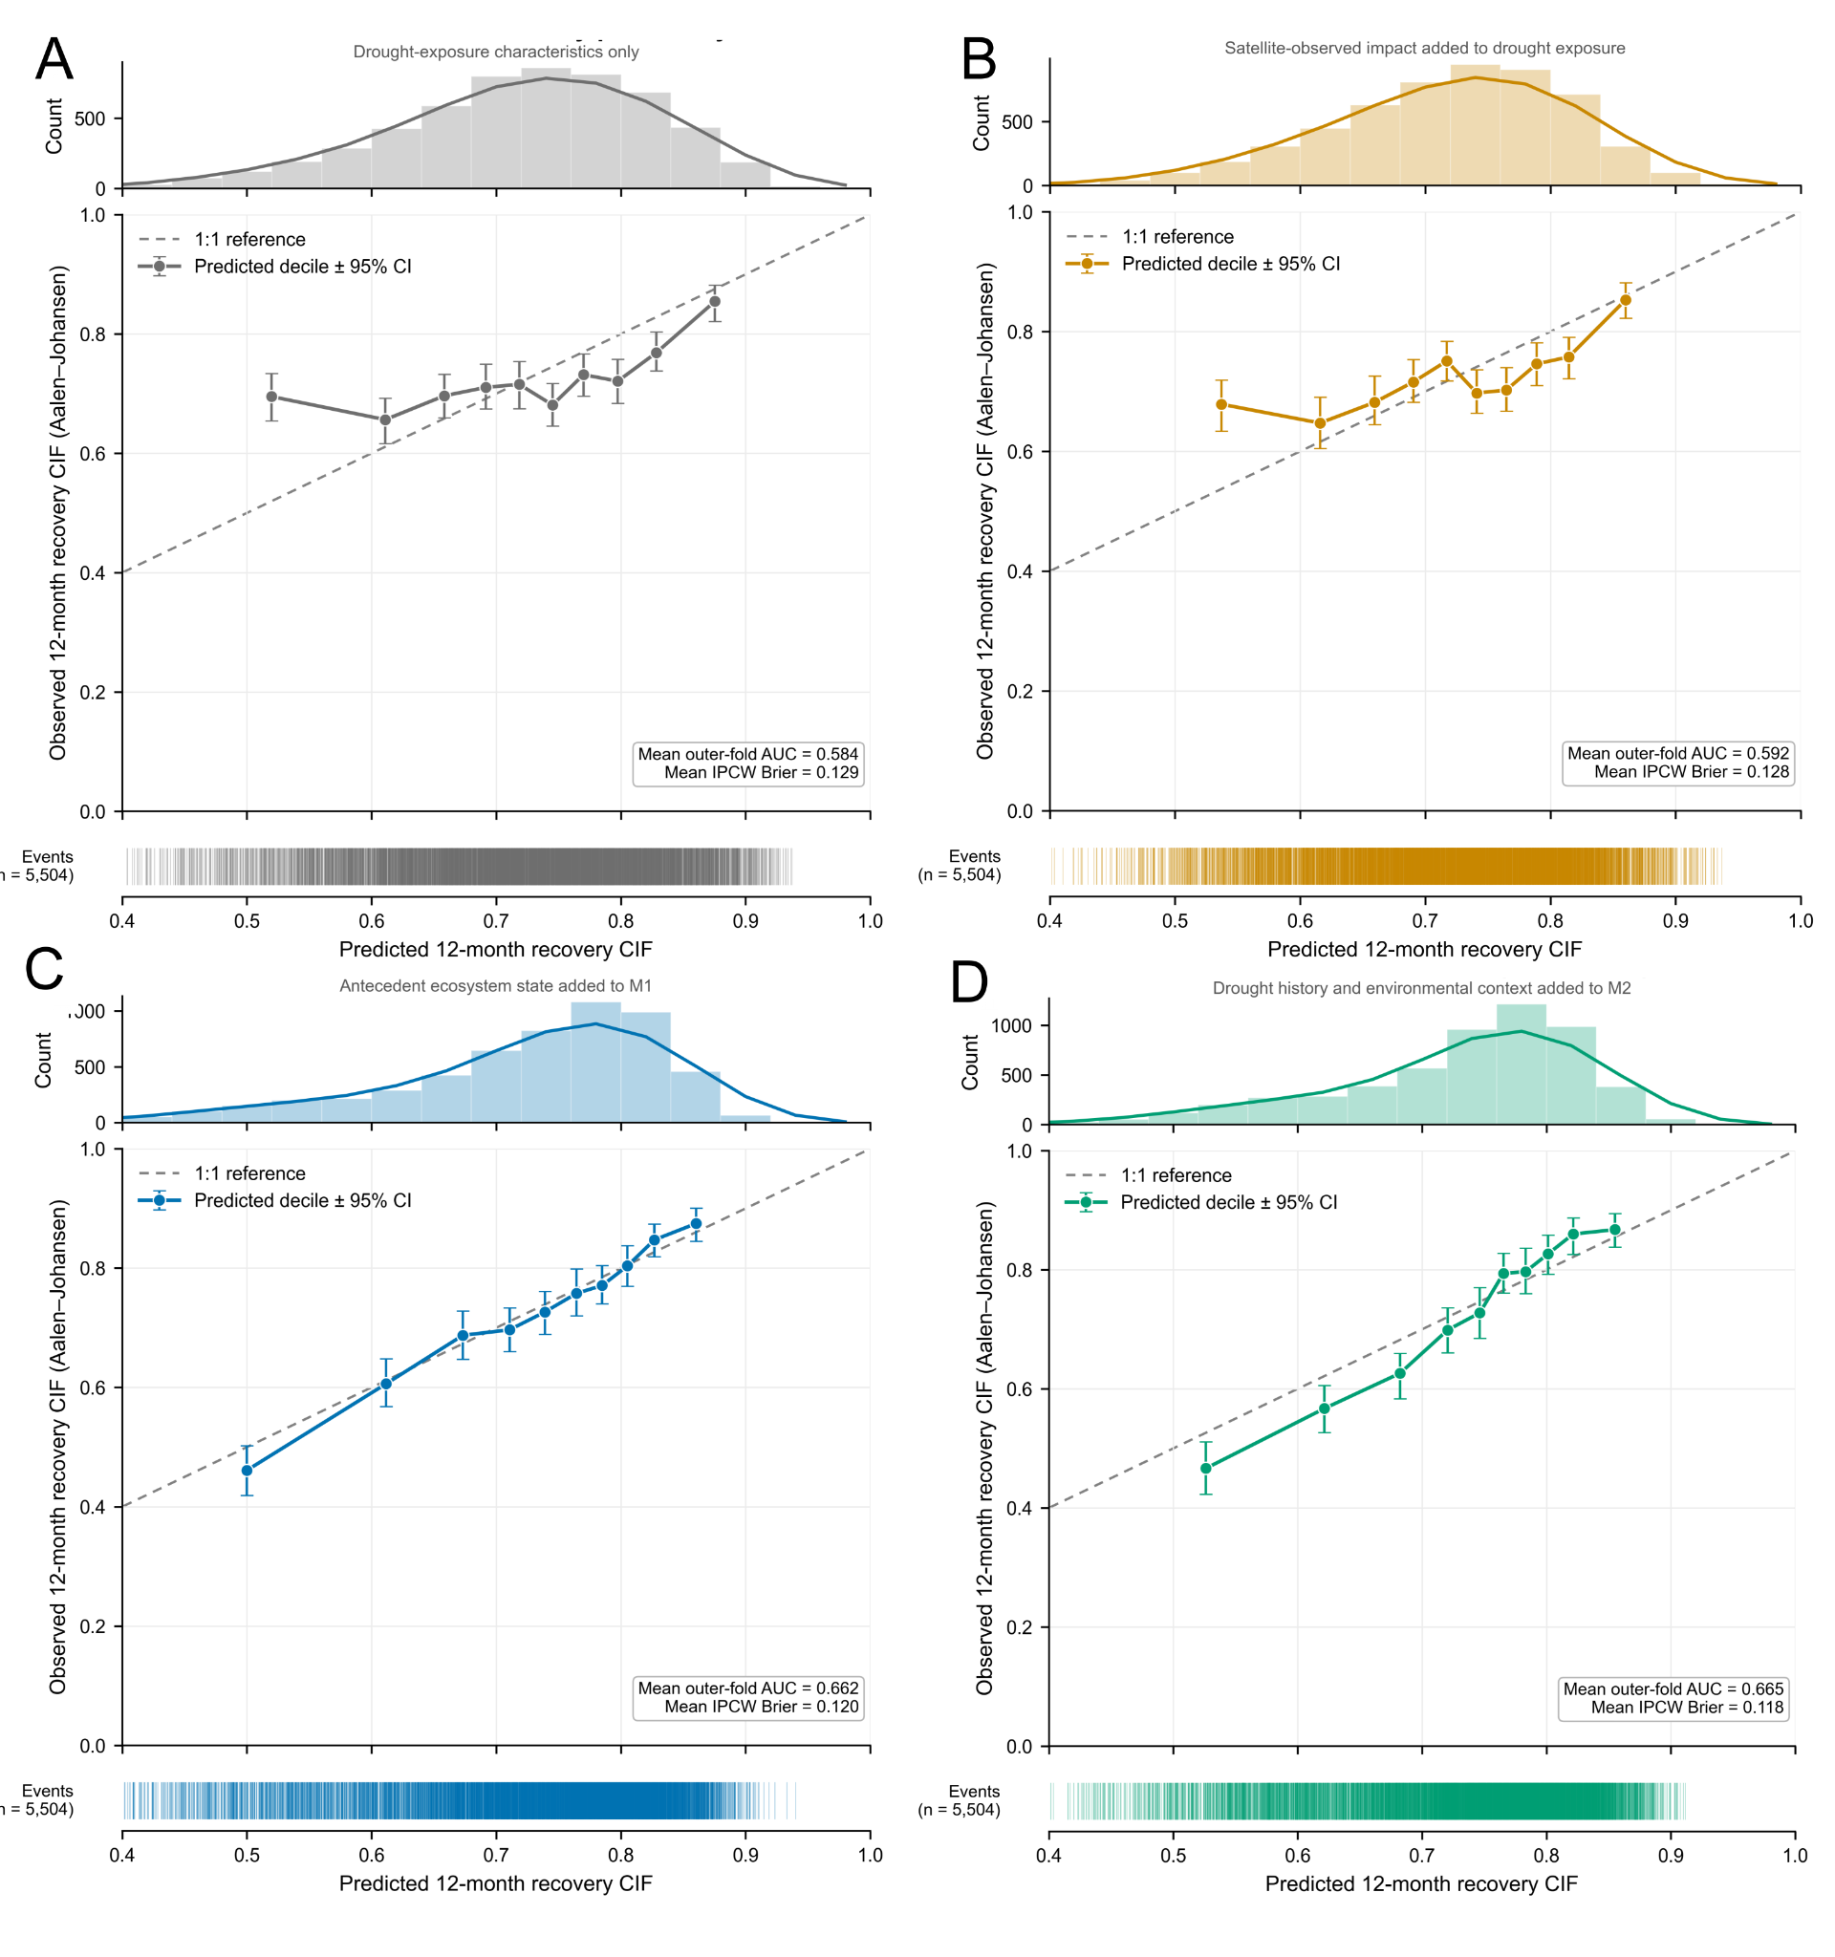
Figure 8. Calibration of 12-month recovery predictions across the four nested competing-risk RSF models in the strict cohort (n = 5,504). Panels show (a) M0, containing drought-exposure characteristics; (b) M1, adding satellite-observed impact; (c) M2, adding antecedent satellite state; and (d) M3, adding drought history and retrospective environmental context. For each model, the upper histogram shows the distribution of pooled held-out predicted 12-month recovery CIF, the central panel compares mean predicted CIF within each decile with the corresponding Aalen-Johansen estimate and 95% confidence interval, and the lower rug shows the distribution of event-level predictions. The dashed line denotes perfect 1:1 calibration. Insets report mean outer-fold AUC12 and IPCW Brier12.

3.6 Complementary GOSIF cross-product consistency
Figure 9 compares GOSIF with the four primary satellite indicators. Spearman correlations between event-scale GOSIF impact and FVC, LAI, MOD17 GPP and PML GPP impacts were 0.37 (n = 5,238), 0.34 (n = 5,270), 0.26 (n = 5,292) and 0.36 (n = 5,289), respectively. Observed binary recovery agreement was 81.3%, 77.0%, 78.1% and 85.3%, with corresponding Cohen's kappa values of 0.317, 0.265, 0.253 and 0.370. GOSIF remained excluded from event definition, consensus endpoints and RSF predictors; these comparisons therefore quantify complementary cross-product consistency rather than independent validation.
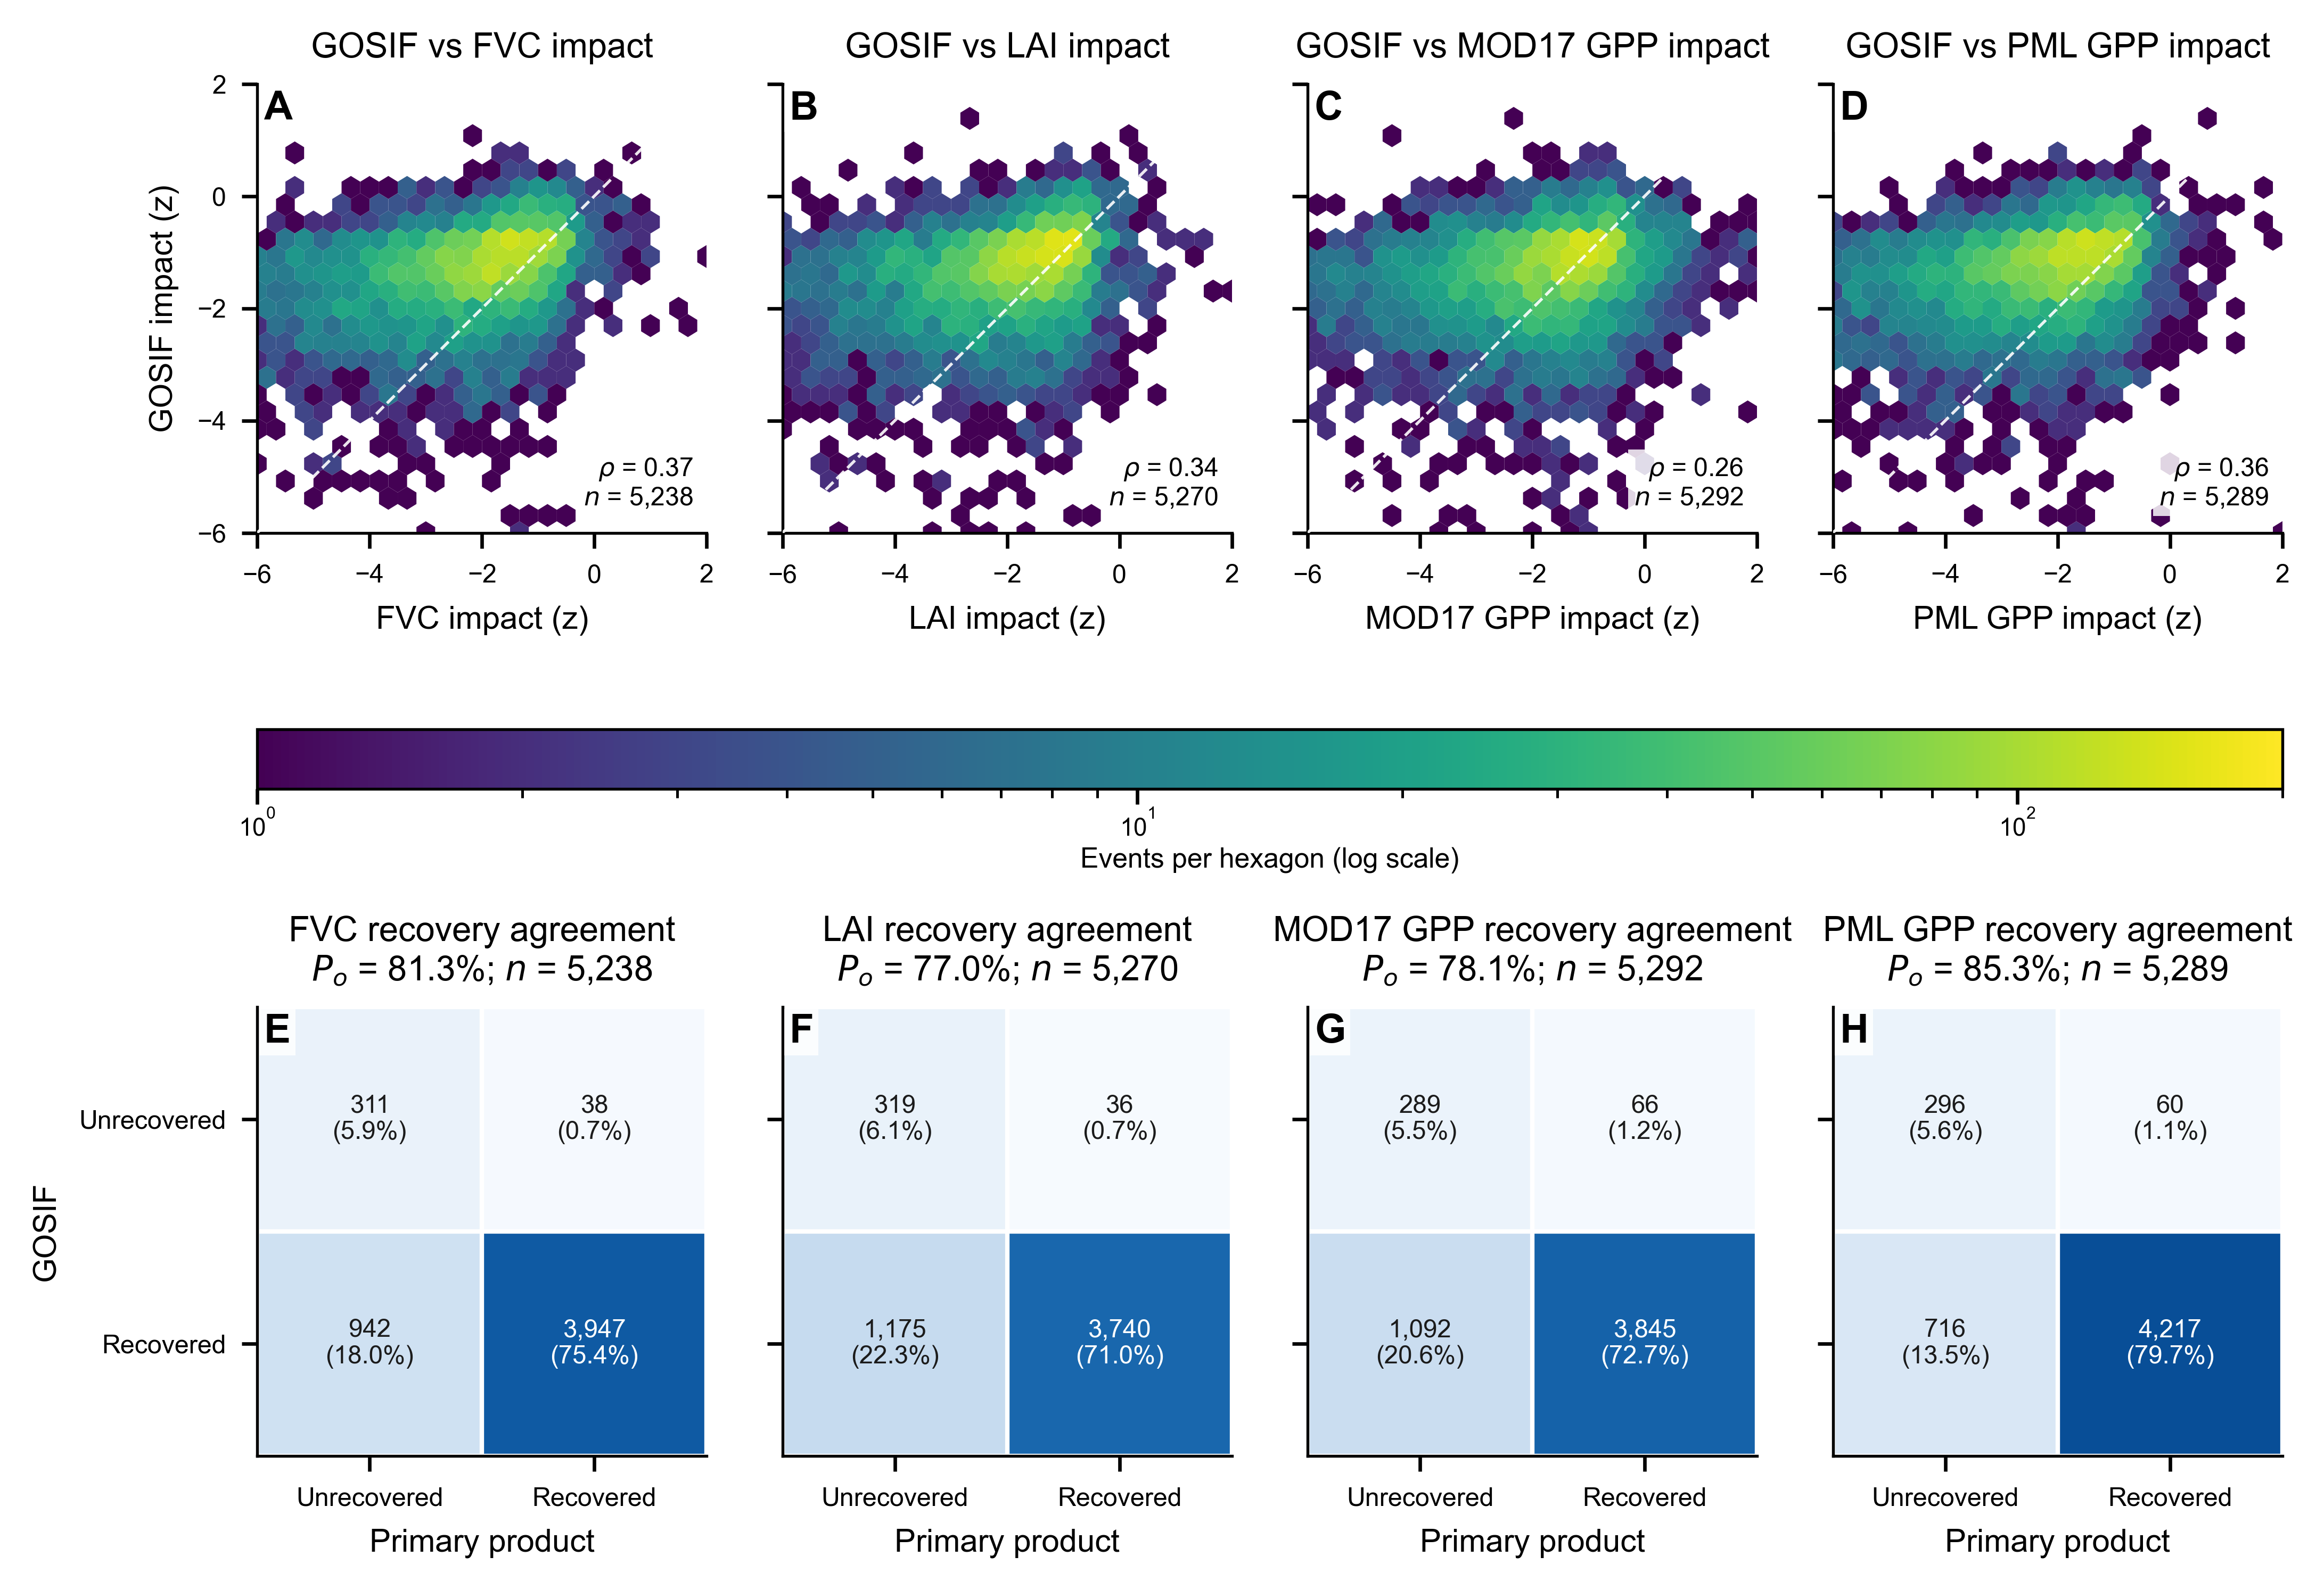Figure 9. Cross-product consistency of drought impact and post-drought recovery between GOSIF and the four primary satellite indicators. (a-d) Hexbin-density comparisons of event-scale GOSIF impact with FVC, LAI, MOD17 GPP and PML GPP impacts; dashed lines denote the 1:1 relationship and panels report Spearman correlation and paired sample size. (e-h) Binary recovery-agreement matrices for the same products, with cell counts and percentages. Observed agreement was 81.3%, 77.0%, 78.1% and 85.3%, and Cohen's kappa was 0.317, 0.265, 0.253 and 0.370, respectively. GOSIF was excluded from event definition, consensus endpoints and prediction and is used here as complementary cross-product evidence.

4. Discussion

4.1 Competing recovery pathways revealed by multi-product satellite observations
The competing-risk results show that post-drought ecosystem trajectories cannot be represented adequately by a binary recovered/unrecovered endpoint. At 12 months, the estimated recovery cumulative incidence was 0.723, while recurrent drought before recovery accounted for 0.138 and a further proportion of events remained unrecovered without a recurrent meteorological drought. These outcomes represent distinct post-disturbance pathways: recurrent drought truncates the available recovery opportunity, whereas persistent non-recovery reflects continued departure from the satellite reference state in the absence of a new drought. This distinction is consistent with the broader view that drought resistance and recovery are separable dimensions of ecosystem stability rather than opposite expressions of the same process (Ingrisch and Bahn, 2018; Shao et al., 2024; Yao et al., 2024; Wang et al., 2026).
The multi-product results further indicate that these recovery pathways are expressed coherently across structural and functional observations, but not identically. FVC and LAI characterize canopy state, whereas MOD17 and PML GPP provide complementary information on ecosystem functioning. All four products showed negative cumulative associations with severe drought, with the strongest departures concentrated at short lags, while the magnitude of the MOD17 response remained sensitive to temporal-completeness screening. The moderate GOSIF agreement likewise supports cross-product consistency without implying independence among the products. Together, these results support treating structural and functional satellite observations as complementary evidence of post-drought state rather than interchangeable indicators.

4.2 Immediate pre-onset satellite condition carries the main transferable recovery signal
The clearest predictive result was that recovery discrimination depended much more on satellite-observed state immediately before formal drought onset than on the remaining variation in drought-impact magnitude. Once coherent multi-product loss had already been established, adding impact information increased AUC12 only from 0.584 to 0.592, whereas adding the M2 antecedent-state feature set increased it to 0.662. This contrast persisted when the coherent-loss threshold was relaxed from z <= -0.5 to z <= -0.3, indicating that the result was not specific to the primary impact-screen threshold. More importantly, the M2_no_pre_z sensitivity showed that removing the four immediately pre-onset standardized anomalies reduced AUC12 to 0.593, while retaining longer-window means, variability and slopes produced almost no improvement over M1. The transferable information was therefore concentrated in departures from each product's seasonal reference state immediately before formal drought onset rather than in longer-term background summaries.
This finding should nevertheless be interpreted as predictive state information rather than direct evidence of ecological memory or pre-existing resilience. The immediately pre-onset anomaly variables and the recovery endpoint occupy the same product-specific standardized-anomaly space, so part of the discrimination may reflect proximity to the recovery threshold itself: events beginning farther below the seasonal reference state may require longer to re-enter the recovery range. In addition, because SPI-3 is a three-month accumulation, the month immediately preceding formal SPI-3 drought onset may already contain vegetation responses to developing moisture stress. The signal may therefore combine pre-existing stress, unresolved legacy effects, threshold proximity and incipient response to the current drought. It should be interpreted as an immediately pre-onset monitoring signal, not as evidence that a separable ecological-memory mechanism determines recovery.
Spatial validation further showed that this information transferred with moderate skill across held-out regions. M3 reached an AUC12 of 0.665 under the primary 200-km exclusion buffer, compared with 0.662 for M2, indicating that retrospective climate, terrain and soil context added little additional discrimination. Performance also changed only modestly across the 100–300 km buffer sensitivity and inside versus outside the training environmental-support domain. Calibration improved substantially from M0/M1 to M2/M3, although residual departures from the 1:1 line and the modest Brier Skill indicate that the predictions are better interpreted as relative recovery potential than as fully calibrated event-specific probabilities.

4.3 Implications, limitations and outlook for drought-recovery monitoring
The results suggest that satellite drought monitoring can be extended from mapping impact severity toward identifying differential post-drought recovery potential. A practical monitoring framework could combine immediate departures from seasonal vegetation and productivity baselines with the finite recovery window after meteorological drought termination. Events characterized by unfavorable pre-onset satellite states could then be prioritized for closer monitoring, while competing recurrent drought should be treated explicitly rather than merged with persistent non-recovery. Such information is most appropriate for screening and prioritization rather than causal diagnosis.
Several limitations define the scope of this interpretation. The prediction experiment is retrospective because SPI climatology and some M3 climate summaries use fixed historical archives, and the strict cohort begins only in 2007 because event-specific anomaly references require sufficient antecedent observations. The main state-versus-impact result is conditional on drought events already exhibiting coherent multi-product loss and therefore does not imply that impact magnitude is unimportant across all meteorological droughts. MOD17 Collection 6 is also a legacy product, although temporal-completeness sensitivities preserved the principal recovery and ranking conclusions. Finally, the geographically stratified sample supports inference to the analytical sample rather than direct wall-to-wall prevalence, and GOSIF provides complementary consistency rather than fully independent validation.
Future work should therefore focus less on increasing model complexity and more on testing the transferability of these recovery-state relationships across other drought-prone ecosystems, newer productivity products and prospectively constructed monitoring archives. In particular, separating pre-existing ecosystem condition from the early development of the current drought would help clarify whether the immediate pre-onset satellite signal reflects pre-existing stress, unresolved legacy effects, incipient drought response, threshold proximity, or a combination of these processes.

5. Conclusions
Multi-product satellite time series reveal post-drought recovery as a set of competing fates rather than a binary outcome. In the stratified East African sample of 5,504 coherent-loss events, the estimated 12-month Aalen-Johansen cumulative incidence was 0.723 for recovery and 0.138 for recurrent drought before recovery. Spatially buffered prediction showed little incremental discrimination from residual impact magnitude (M0 AUC12 = 0.584; M1 = 0.592), but a substantially larger gain after the M2 antecedent-state feature set was added (M2 = 0.662); retrospective environmental context increased AUC only to 0.665. This pattern persisted under a relaxed coherent-loss screen, whereas removal of the immediately pre-onset standardized anomalies reduced M2 AUC12 to 0.593. The dominant transferable signal therefore resides in immediate pre-onset departures from seasonal satellite reference conditions rather than in impact magnitude or longer-window antecedent summaries. Because the immediate pre-onset predictors and recovery endpoint share the same product-specific standardized-anomaly framework, this signal is interpreted as predictive state information rather than a causal or separable ecological-memory mechanism. Together, these results support a shift from impact-only drought mapping toward recovery-oriented monitoring that combines competing post-drought fates with pre-onset satellite condition and uses model output primarily to rank relative recovery potential.

Data and code availability
Derived event tables, fold assignments, model summaries, figure source data and reproducible scripts are organized in the accompanying project package. Large raw climate, satellite and ancillary rasters remain available from their cited source repositories or Earth Engine collections and are not redistributed. The accompanying release includes the machine-readable sampling-stratum manifest used for inclusion-probability weights and session information recording R/Python package versions, together with data identifiers, QA logic, SPI construction, event construction, spatial folds and model workflows. GOSIF is used only for complementary cross-product consistency. MOD17 QA-valid overlap-day coverage fields, 50%/75% screening outputs, matched-event identifiers and the corresponding recovery, DLNM and prediction sensitivity summaries are included with the supplementary audit files.

Ethics declaration
This study used remote-sensing, climate and openly archived environmental data. It did not involve human participants, personal data or animal experimentation.

Author contributions (CRediT)
To be completed after author order and roles are confirmed. Suggested roles to specify: conceptualization; methodology; software; validation; formal analysis; investigation; data curation; writing - original draft; writing - review and editing; visualization; supervision; project administration; funding acquisition.

Funding
Funding information to be supplied by the authors before submission.

Conflict of interest
The authors declare no competing interests, subject to author confirmation.

Use of generative AI
During preparation of this work, the authors used ChatGPT (OpenAI) to assist with language organization and document formatting. The authors reviewed and edited all AI-assisted text as needed and take full responsibility for the content of the manuscript.

References
Aalen, O. O., & Johansen, S. (1978). An empirical transition matrix for non-homogeneous Markov chains based on censored observations. Scandinavian Journal of Statistics, 5, 141-150.
Anderegg, W. R. L., Schwalm, C., Biondi, F., et al. (2015). Pervasive drought legacies in forest ecosystems and their implications for carbon cycle models. Science, 349, 528-532. https://doi.org/10.1126/science.aab1833
Blanche, P., Dartigues, J.-F., & Jacqmin-Gadda, H. (2013). Estimating and comparing time-dependent areas under receiver operating characteristic curves for censored event times with competing risks. Statistics in Medicine, 32, 5381-5397. https://doi.org/10.1002/sim.5958
Farr, T. G., Rosen, P. A., Caro, E., et al. (2007). The Shuttle Radar Topography Mission. Reviews of Geophysics, 45, RG2004. https://doi.org/10.1029/2005RG000183
FEWS NET. (2016). Northern regions of Somalia face deteriorating access to food and water, increasing food insecurity. Alert, 11 February 2016. https://fews.net/east-africa/somalia/alert/february-2016
FEWS NET. (2020a). Despite improvements, up to 1.3 million people in Somalia face acute food security Crisis (IPC Phase 3) or worse outcomes. Key Message Update, 3 February 2020. https://fews.net/east-africa/somalia/key-message-update/february-3-2020
FEWS NET. (2020b). Uneven rainfall improves rangeland resources but reduces cropping prospects in eastern Horn. East Africa Seasonal Monitor, 19 December 2020. https://fews.net/east-africa/seasonal-monitor/december-2020
Funk, C., Peterson, P., Landsfeld, M., et al. (2015). The climate hazards infrared precipitation with stations-a new environmental record for monitoring extremes. Scientific Data, 2, 150066. https://doi.org/10.1038/sdata.2015.66
Gasparrini, A., Armstrong, B., & Kenward, M. G. (2010). Distributed lag non-linear models. Statistics in Medicine, 29, 2224-2234. https://doi.org/10.1002/sim.3940
Gerds, T. A., Scheike, T. H., & Andersen, P. K. (2012). Absolute risk regression for competing risks: interpretation, link functions, and prediction. Statistics in Medicine, 31, 3921-3930. https://doi.org/10.1002/sim.5459
Goncalves, N. B., Lopes, A. P., Dalagnol, R., Wu, J., Pinho, D. M., & Nelson, B. W. (2020). Both near-surface and satellite remote sensing confirm drought legacy effect on tropical forest leaf phenology after 2015/2016 ENSO drought. Remote Sensing of Environment, 237, 111489. https://doi.org/10.1016/j.rse.2019.111489
Guttman, N. B. (1999). Accepting the standardized precipitation index: a calculation algorithm. Journal of the American Water Resources Association, 35, 311-322. https://doi.org/10.1111/j.1752-1688.1999.tb03592.x
Huete, A., Didan, K., Miura, T., Rodriguez, E. P., Gao, X., & Ferreira, L. G. (2002). Overview of the radiometric and biophysical performance of the MODIS vegetation indices. Remote Sensing of Environment, 83, 195-213. https://doi.org/10.1016/S0034-4257(02)00096-2
Ingrisch, J., & Bahn, M. (2018). Towards a comparable quantification of resilience. Trends in Ecology & Evolution, 33, 251-259. https://doi.org/10.1016/j.tree.2018.01.013
Ishwaran, H., Kogalur, U. B., Blackstone, E. H., & Lauer, M. S. (2008). Random survival forests. The Annals of Applied Statistics, 2, 841-860. https://doi.org/10.1214/08-AOAS169
Li, X., & Xiao, J. (2019). A global, 0.05-degree product of solar-induced chlorophyll fluorescence derived from OCO-2, MODIS, and reanalysis data. Remote Sensing, 11, 517. https://doi.org/10.3390/rs11050517
Meyer, H., & Pebesma, E. (2021). Predicting into unknown space? Estimating the area of applicability of spatial prediction models. Methods in Ecology and Evolution, 12, 1620-1633. https://doi.org/10.1111/2041-210X.13650
Munoz-Sabater, J., Dutra, E., Agusti-Panareda, A., et al. (2021). ERA5-Land: a state-of-the-art global reanalysis dataset for land applications. Earth System Science Data, 13, 4349-4383. https://doi.org/10.5194/essd-13-4349-2021
Myneni, R. B., Hoffman, S., Knyazikhin, Y., et al. (2002). Global products of vegetation leaf area and fraction absorbed PAR from year one of MODIS data. Remote Sensing of Environment, 83, 214-231. https://doi.org/10.1016/S0034-4257(02)00074-3
NASA LP DAAC. (2019). NASA's Gap-Filled Collection 6 MODIS Gross and Net Primary Production Data Products: MOD17A2HGF, MOD17A3HGF, MYD17A2HGF and MYD17A3HGF. Technical note. https://lpdaac.usgs.gov/documents/601/MOD17HGF_vs_NTSG.pdf
Poggio, L., de Sousa, L. M., Batjes, N. H., Heuvelink, G. B. M., Kempen, B., Ribeiro, E., & Rossiter, D. (2021). SoilGrids 2.0: producing soil information for the globe with quantified spatial uncertainty. SOIL, 7, 217-240. https://doi.org/10.5194/soil-7-217-2021
Requena-Mullor, J. M., et al. (2023). Tradeoffs in forest resilience to satellite-based estimates of water and productivity losses. Remote Sensing of Environment, 285, 113414. https://doi.org/10.1016/j.rse.2022.113414
Roberts, D. R., Bahn, V., Ciuti, S., et al. (2017). Cross-validation strategies for data with temporal, spatial, hierarchical, or phylogenetic structure. Ecography, 40, 913-929. https://doi.org/10.1111/ecog.02881
Running, S. W., & Zhao, M. (2021). User's Guide: Daily GPP and Annual NPP (MOD17A2H/A3H) and Year-end Gap-Filled (MOD17A2HGF/A3HGF) Products, Collection 6.1, Version 1.1. NASA MODIS Land Algorithm. https://lpdaac.usgs.gov/documents/972/MOD17_User_Guide_V61.pdf
Schwalm, C. R., et al. (2017). Global patterns of drought recovery. Nature, 548, 202-205. https://doi.org/10.1038/nature23021
Shao, X., Zhang, Y., Ma, N., et al. (2024). Drought-induced ecosystem resistance and recovery observed at 118 flux tower stations across the globe. Agricultural and Forest Meteorology, 356, 110170. https://doi.org/10.1016/j.agrformet.2024.110170
Virtanen, P., Gommers, R., Oliphant, T. E., et al. (2020). SciPy 1.0: fundamental algorithms for scientific computing in Python. Nature Methods, 17, 261-272. https://doi.org/10.1038/s41592-019-0686-2
von Keyserlingk, J., de Hoop, M., Mayor, A. G., Dekker, S. C., Rietkerk, M., & Foerster, S. (2021). Resilience of vegetation to drought: Studying the effect of grazing in a Mediterranean rangeland using satellite time series. Remote Sensing of Environment, 255, 112270. https://doi.org/10.1016/j.rse.2020.112270
Wagle, P., et al. (2014). Sensitivity of vegetation indices and gross primary production of tallgrass prairie to severe drought. Remote Sensing of Environment, 152, 1-14. https://doi.org/10.1016/j.rse.2014.05.010
Wang, H., Xie, Q., Thompson, S. E., Moore, C. E., Miller, D. L., Veneklaas, E. J., Silberstein, R. P., Li, X., Xiao, J., Medlyn, B. E., & Smith, W. K. (2026). Satellite observations reveal ecosystem resistance and resilience to short-term water stress driven by dominant vegetation along a rainfall gradient in Australia. Remote Sensing of Environment, 332, 115046. https://doi.org/10.1016/j.rse.2025.115046
Wu, M., Manzoni, S., Vico, G., Bastos, A., de Vries, F. T., & Messori, G. (2022). Drought legacy in sub-seasonal vegetation state and sensitivity to climate over the Northern Hemisphere. Geophysical Research Letters, 49, e2022GL098700. https://doi.org/10.1029/2022GL098700
Yao, Y., Liu, Y., Song, J., et al. (2024). Declining tradeoff between resistance and resilience of ecosystems to drought. Earth's Future, 12, e2024EF004665. https://doi.org/10.1029/2024EF004665
Zhang, Y., Kong, D., Gan, R., Chiew, F. H. S., McVicar, T. R., Zhang, Q., & Yang, Y. (2019). Coupled estimation of 500 m and 8-day resolution global evapotranspiration and gross primary production in 2002-2017. Remote Sensing of Environment, 222, 165-182. https://doi.org/10.1016/j.rse.2018.12.031
Zhang, Y., et al. (2024). Immediate and lagged vegetation responses to dry spells revealed by continuous solar-induced chlorophyll fluorescence observations in a tall-grass prairie. Remote Sensing of Environment, 305, 114080. https://doi.org/10.1016/j.rse.2024.114080
Zhao, M., Heinsch, F. A., Nemani, R. R., & Running, S. W. (2005). Improvements of the MODIS terrestrial gross and net primary production global data set. Remote Sensing of Environment, 95, 164-176. https://doi.org/10.1016/j.rse.2004.12.011

