Urban-context residual learning for multimodal land use/land cover mapping in high-density mountainous coastal cities
Abstract
Fine-scale urban land use/land cover (LULC) mapping must distinguish physical surface properties from built-up functions. We developed a multimodal fully convolutional neural network (FCNN) for Hong Kong on a common 10 m grid using Sentinel-1/2, VIIRS nighttime lights, building function and height, OSM roads, points of interest (POIs), areas of interest (AOIs), and patch-level text semantics. The model combines a direct pixel-classification path with an urban-context residual that returns local semantic and socioeconomic cues to the class logits. Conditional hierarchical probabilities organize the output and are combined with the direct path through class-wise global gates. On the main spatially blocked test set, the seed-42 model achieved OA=0.8789, macro mIoU=0.5946, and macro-F1=0.7338. Under the same 47-epoch maximum horizon, FCNN reached OA=0.8794, macro mIoU=0.5885, and macro-F1=0.7295, while Boundary F1 was 0.5832 for the proposed model and 0.5763 for FCNN-47. Removing the urban-context residual reduced macro mIoU by 0.0210 and remained significant after Holm correction (p=0.0420); the hierarchy and class-wise gates did not. An independent CSDI building-use check of 12,570 buildings gave the proposed model 0.881 agreement, higher than the five comparison models. These results identify urban-context residual learning as the main empirically supported contribution. The hierarchical probability organization functions mainly as a structured auxiliary constraint.
Keywords: land use/land cover; urban-context residual; conditional hierarchical probability fusion; multimodal FCNN
1. Introduction
Cities concentrate population, infrastructure, economic activity, and environmental pressures within relatively small areas. Reliable land use/land cover (LULC) information is therefore essential for tracking urban growth, evaluating environmental change, and supporting spatial planning. Yet land cover and land use are not the same problem. Land cover describes what is physically present at the surface—vegetation, water, bare ground, or artificial materials—whereas land use describes how that space is used, for example for housing, industry, public services, or transport. The distinction becomes especially important in compact cities, where different functions can occupy surfaces with very similar spectral and morphological characteristics. Hong Kong is a clear example: steep vegetated hillslopes, reservoirs, coastal water, reclaimed land, dense residential districts, industrial areas, and transport infrastructure occur within short distances of one another. A useful fine-scale map must therefore resolve both physical cover and urban function within a common spatial framework.
Remote sensing has long provided the physical basis for urban LULC mapping, and the growing availability of complementary sensors has substantially expanded that capability. Sentinel-2 provides multispectral information from the visible to the shortwave-infrared region and is well suited to distinguishing vegetation, water, soil, and impervious surfaces [16]. Sentinel-1 adds all-weather microwave observations that respond to surface structure, roughness, and moisture [17]. Their complementarity has encouraged a shift from single-sensor mapping toward multimodal analysis, supported by benchmark datasets and fusion studies that combine optical and SAR information [18,19]. More recently, multimodal architectures have shown that coordinated Sentinel-1/2 learning can improve large-scale LULC mapping beyond either modality alone [4]. Even so, optical and SAR observations mainly describe the physical expression of the city. They do not directly tell us whether a spectrally similar built-up area is residential, industrial, institutional, or transport-related.
Deep learning has changed how these observations are used. Fully convolutional networks and encoder-decoder models brought spatial context and dense prediction into remote-sensing classification [13,25]. Residual learning and hierarchical vision Transformers further strengthened deep feature extraction and multiscale representation [26,27]. Recent studies have applied these ideas to high-resolution land-cover mapping and satellite-based LULC classification, showing clear gains over conventional pixel-wise classifiers [1,2]. Similar progress has been reported for Sentinel-based deep-learning classification [3]. Broader reviews likewise show that deep learning has become a central tool in remote sensing because it can learn spatial, spectral, and contextual representations jointly [32,33]. However, better image features do not remove a fundamental ambiguity: urban function is only partly visible in the image itself.
This limitation has encouraged urban-mapping studies to incorporate geospatial information that is more closely related to human activity. POIs can indicate the presence and composition of services, commerce, education, transport, and other facilities, while building footprints and morphology describe the physical organization of those activities. Recent studies have combined remote sensing with POIs, LiDAR, or building footprints to identify urban functional zones more accurately [5,6]. Spatial-semantic representations of POIs and multi-feature fusion have further improved the characterization of mixed urban areas [7,8]. Multi-scale functional-zone frameworks continue this trend by combining heterogeneous urban features across different spatial supports [9]. At the building level, recent mapping products have also demonstrated that remote sensing, building morphology, nighttime activity, and geospatial semantics can be combined to infer building function over large urban areas [10]. These advances move urban remote sensing closer to functional interpretation, but they also expose an important scale problem: most functional-zone products are defined for buildings, parcels, blocks, or regular grids, whereas conventional LULC mapping is usually evaluated pixel by pixel.
Several issues remain unresolved. First, open geospatial data are informative but imperfect. OpenStreetMap is volunteered geographic information, and its completeness and thematic detail vary across space [23,29]. Derived urban products may also share source information, meaning that nominally different inputs do not necessarily provide statistically independent evidence [10,11]. Second, spatially random train-test splits can give optimistic results when nearby samples share land-cover composition, urban morphology, or mapping artifacts. Spatially structured cross-validation has therefore become increasingly important for geospatial prediction [22,30]. Predictor selection can likewise determine whether a model reproduces local spatial patterns or generalizes beyond the training area [31]. Accuracy assessment also needs to account for class imbalance and the sampling structure of reference data rather than relying on overall accuracy alone [21]. In semantic segmentation, IoU-oriented objectives have similarly been developed to align optimization more closely with overlap-based evaluation [28].
A further issue concerns how physical and functional classes are organized inside the model. A flat classifier treats residential land, industrial land, vegetation, agriculture, and water as unrelated labels, although some distinctions are primarily physical while others are functional. Hierarchical classification provides a natural way to represent such relationships [20]. A hard cascade, however, can propagate an early mistake: once a pixel enters the wrong coarse branch, the correct leaf class may no longer be reachable. For fine-scale urban mapping, the question is therefore not simply whether a hierarchy should be used, but how functional structure can be introduced without sacrificing direct pixel-wise prediction. The same concern applies to multimodal fusion. When all sources are mixed only once at the input, strong spectral and textural patterns may dominate deeper convolutional representations, while relatively sparse urban-function cues become progressively weaker. This suggests that urban semantics may be more useful if they can be reintroduced close to the classification layer rather than being expected to survive unchanged through the entire encoder.
Against this background, we develop an eight-class, 10 m LULC framework for Hong Kong that combines Sentinel-1/2 observations, VIIRS nighttime lights, building function and morphology, OSM roads, POIs, AOIs, and patch-level OSM text. Raster and text information are first transcoded into a common representation and processed by a multiscale FCNN. An urban-context residual then re-encodes local semantic, morphological, transport, and socioeconomic information and adds class-specific corrections to the FCNN logits. A conditional hierarchy organizes built-up land, natural surfaces, and water, while class-wise probability gates combine the hierarchical and direct prediction paths without imposing a hard cascade.
The study addresses three questions. First, can the late reintroduction of urban context improve class-balanced pixel-wise LULC mapping when training and testing are spatially separated? Second, how much information is contributed by AOIs, roads, POIs, and patch-level text when these correlated semantic sources are examined individually and jointly? Third, do the resulting maps remain credible under boundary-sensitive evaluation, alternative spatial validation protocols, and an external building-use assessment independent of model training? We address these questions using structural and source-specific ablations, a training-horizon control, spatial blocking and leave-region-out experiments, Boundary F1, and independent CSDI building-use validation. The aim is not to replace remote sensing with open urban data, but to use urban semantics as contextual evidence that helps bridge the gap between what the surface looks like and how urban space is used.
2. Study area and data
2.1 Study area
Hong Kong lies on the southeastern coast of China, east of the Pearl River Estuary and facing the South China Sea. The territory includes Hong Kong Island, the Kowloon Peninsula, the New Territories, and numerous outlying islands. The modelling extent follows valid coverage of the Hong Kong reference raster. It includes the terrestrial territory and the adjacent coastal waters required by the common raster grid (Fig. 1).
Hong Kong has rugged terrain, extensive vegetated uplands, and compact urban development along coastal plains, reclaimed land, valleys, and major transport corridors. Woodland, shrubland, grassland, wetland, fragmented agricultural land, reservoirs, channels, and coastal water can occur close to dense built-up areas. This creates substantial physical and functional heterogeneity at fine spatial scales and makes Hong Kong a demanding setting for pixel-level LULC mapping that uses both remote-sensing observations and urban semantic information.
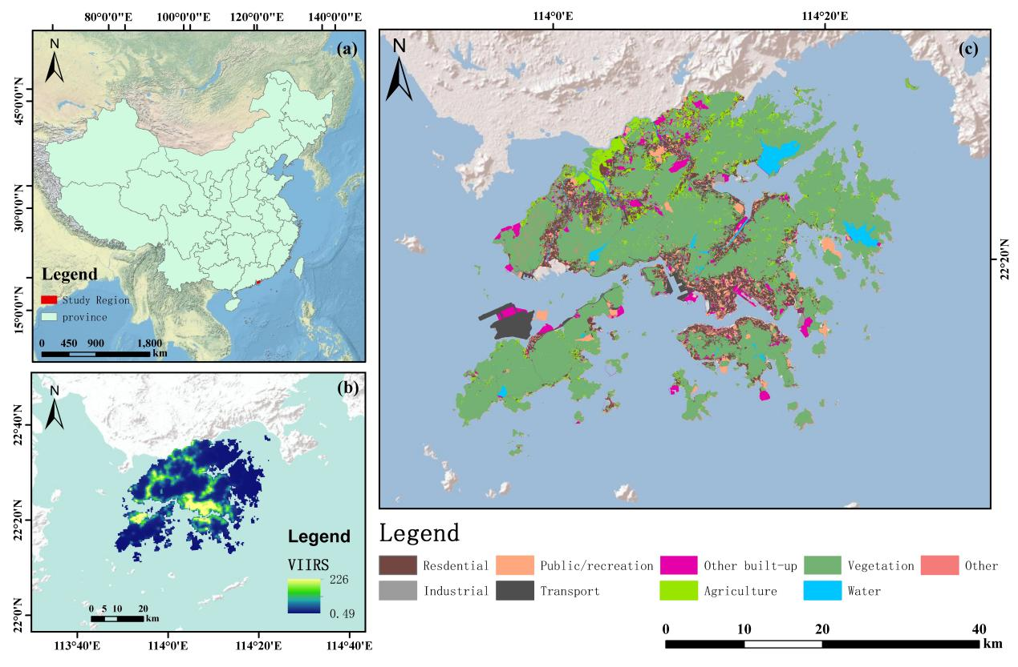
Fig. 1. Location and spatial extent of the study area in Hong Kong.
2.2 Data sources and preprocessing
Sentinel-1, Sentinel-2, and VIIRS data were obtained through Google Earth Engine (GEE); Table 1 summarizes the other sources. We selected Sentinel-2 Level-2A surface reflectance (COPERNICUS/S2_SR_HARMONIZED) for 13 January 2025 (03:11:42). SCL masking removed invalid pixels, cloud shadow, medium/high-probability cloud, cirrus, and snow/ice. Same-date MGRS tiles were mosaicked. Twelve reflectance bands (B1–B9, B8A, B11, B12; excluding B10) were retained.Training uses the upstream raster on a common EPSG:32650 10 m grid. Native 20 m and 60 m Sentinel-2 bands were aligned upstream, and training applies no further reprojection. The common 10 m grid provides computational alignment; it does not create native 10 m information for the coarser bands.
Sentinel-1 GRD (COPERNICUS/S1_GRD) was restricted to IW, dual VV/VH polarization, and 10 m pixel spacing [17]. Acquisitions within ±7 days of Sentinel-2 were prioritized when coverage exceeded 95%, with ±15 days as fallback; the final acquisition was 12 January 2025 (10:25:26). Same-date scenes were mosaicked and VV, VH, and VV−VH retained. The standard GEE preprocessing includes orbit, noise, calibration, and terrain correction; no additional speckle filter or single-scene layover/shadow mask was applied.
Nighttime lights were derived from NOAA VIIRS DNB monthly stray-light-corrected composites (NOAA/VIIRS/DNB/MONTHLY_V1/VCMSLCFG) for November 2024–March 2025. Mean radiance, log1p radiance, and valid-coverage fraction were bilinearly reprojected with rasterio.warp.reproject to the 10 m reference grid. This interpolation supplies regional urban-activity context and is not treated as genuine 10 m texture.
OpenStreetMap (OSM) supplied POIs, polygonal AOIs, roads, and text semantics. Nodes, ways, and relations within the Sentinel-2 extent were retrieved through Overpass QL for 12 January 2025, matching Sentinel-1 and preceding Sentinel-2 by one day. OSM is volunteered geographic information with heterogeneous completeness [23, 29], so it is used only as auxiliary context.
POIs were queried from common amenity, shop, office, tourism, leisure, transport, building, land-use, and man-made tags, deduplicated by OSM identifier and, for named records, by normalized name, subtype, and 10 m grid cell. They were grouped into 14 top-level categories and six urban-function groups. AOIs retained repaired way/relation polygons larger than 100 m² and were mapped to six functional classes; overlapping polygons followed fixed priority rules and all_touched=False rasterization.
Roads were filtered to remove proposed, construction, abandoned, and razed features and grouped into nine classes. Width used the OSM width tag where available, otherwise lane-based or class-default estimates. Centerline, surface, width, class, and proximity rasters were aligned to the 10 m grid; road proximity was defined as R_{prox(d)}=exp(−d/250). Detailed preprocessing rules were fixed before model training.
Building height came from 3D-GloBFP [12] and was used to derive coverage, mean/max height, height range, and a floor-area-ratio proxy. Building-function semantics came from the urban China individual-building product of Li et al. [10]. Both products were repaired, clipped, matched, projected to EPSG:32650, and rasterized to the common grid. The floor-area-ratio proxy measures development intensity only; it is not the statutory planning floor-area ratio.
Supervisory labels were obtained from the Raster Grids on Land Utilization released through the Hong Kong Common Spatial Data Infrastructure (CSDI) Geoportal [15] and are referred to as BLU labels. Labels were nearest-neighbor reprojected to the 10 m grid and mapped to eight targets: residential; industrial/warehouse; public/institutional and recreation; transportation; other built-up; agriculture; woodland/shrubland/grassland/wetland; and water (Table S1). Commercial/office (0.424% of labeled pixels) and barren/rocky shore (0.558%) were defined a priori as outside the eight-class scope and recoded, together with BLU=0, to the ignore index. Their spatial support is reported in Table S2.
Independent building-use validation was constructed from the CSDI Building Outline Public dataset [15]. Building footprints were linked to the corresponding structure and permit records using the official relational information provided with the dataset, rather than by spatial proximity alone. Where multiple structure records were associated with the same building, non-empty building-use descriptions were aggregated at the building level. The original use descriptions were then normalized and harmonized into four validation classes using predefined semantic rules: residential uses were mapped to Residential; industrial, factory, warehouse, and related uses to Industrial/warehouse; explicit transport-related uses to Transportation; and other clearly identifiable built-up uses to Other built-up. Ambiguous or unmapped records were excluded rather than being assigned inferred labels. Of 52,886 buildings with linked structure or permit records, 13,502 contained explicit building-use information, and 13,467 remained after strict class mapping, including 11,027 Residential, 244 Industrial/warehouse, 44 Transportation, and 2,152 Other built-up buildings. For comparison with the 10 m LULC maps, each building footprint was overlaid with each prediction raster and assigned the modal predicted class among valid pixels whose centers fell within the footprint. Buildings without valid raster support were excluded, and only buildings with valid predictions from all six models were retained to ensure an identical evaluation sample across models, resulting in a common validation set of 12,570 buildings. These labels were used exclusively for external building-level validation and were not involved in model training, hyperparameter tuning, or checkpoint selection.
Table 1. Main data sources, acquisition/version information, spatial processing, and model use.
Data type | Data source | Time/version | Spatial processing | Model use
Sentinel-2 optical imagery | COPERNICUS/S2_SR_HARMONIZED | 2025-01-13 03:11:42 | SCL masking; same-date MGRS mosaic; common EPSG:32650 10 m grid; native 20/60 m bands pre-aligned upstream | 12 reflectance bands, NDVI, and spectral indices
Sentinel-1 SAR | COPERNICUS/S1_GRD, IW, VV/VH | 2025-01-12 10:25:26 | Same-date mosaic; EPSG:32650, 10 m; seven SAR channels formed for the model | Dual-polarization backscatter and structure/roughness
VIIRS nighttime lights | NOAA/VIIRS/DNB/MONTHLY_V1/VCMSLCFG | Nov 2024–Mar 2025 | Native-grid export; three continuous channels bilinearly reprojected to the 10 m reference grid | Regional nighttime activity and socioeconomic context
BLU supervisory reference labels | Hong Kong CSDI Geoportal land-utilization raster | 2024 | Nearest-neighbor reprojection to 10 m; eight-class mapping in Table S1 | Supervisory reference for training, validation, and testing
OSM POI/AOI/roads | OpenStreetMap via Overpass API | 2025-01-12  (aligned with Sentinel-1) | POI counts, AOI one-hot layers, and road class/surface/width/proximity aligned to 10 m | Auxiliary urban-function semantics and transport structure
Building height | 3D-GloBFP global 3D building-footprint dataset | Che et al. (2025) | Height screening, missing-value imputation, clipping, and aggregation to 10 m | Building coverage, height, height range, and development-intensity proxy
Building function | Urban China individual-building function mapping product | Li et al. (2026); heterogeneous source dates | Geometry repair, study-area clipping, function matching, and rasterization | Building-function semantics including residential, commercial, industrial, and public-service uses
External OP validation | Hong Kong CSDI Building Outline Public (Building/OPStructure; OPBuildingUses) | Last updated:20260819 | Strict explicit-use records; four mapped built-up classes; missing uses left unlabeled | Independent validation only
3. Methods
3.1 Feature extraction
3.1.1 Spectral and radar features
The Sentinel-2 input contains 12 spectral bands, NDVI, and six additional indices (SAVI, BSI, NDRGRI, NBR2, NDBI, and MNDWI), for 19 optical channels. We use standard definitions for these indices. SAVI is clipped to [−1.5,1.5] before scaling, and the remaining indices are clipped to [−1,1]. Channel-normalization statistics are estimated from training patches only and then reused for validation, testing, and Hong Kong-wide inference.
The Sentinel-1 input contains seven channels: standardized VV_{dB}, VH_{dB}, and VV_{dB}−VH_{dB}, together with normalized total power P*, normalized polarization difference D_{pol}, scaled dual-polarization radar vegetation index RVI*_{dual}, and dual-polarization entropy H_{pol}. Before the derived features are calculated, backscatter is clipped to [−60, 40] dB and converted to linear intensity:
$$\begin{aligned}{\text{I}}_{\text{VV}}\text{=}{\text{10}}^{\text{clip}\left(\text{V}{\text{V}}_{\text{dB}}\text{,−60,40}\right)\text{/10}}\text{, }{\text{I}}_{\text{VH}}\text{=}{\text{10}}^{\text{clip}\left(\text{V}{\text{H}}_{\text{dB}}\text{,−60,40}\right)\text{/10}}\text{.}\#\text{(1,2)}\end{aligned}$$
Let ε=10−⁸. Linear total power P=I_{VV}+I_{VH} is used only as an intermediate quantity; the total-power channel supplied to the network is:
$$\begin{aligned}{\text{P}}^{\text{∗}}\text{=}\frac{\text{clip}\left(\text{10}{\text{log}}_{\text{10}}\left(\text{P}\text{+}\text{ε}\right)\text{+20,−30,30}\right)}{\text{10}}\text{.}\#\text{(3)}\end{aligned}$$
The remaining three derived channels are:
$$\begin{aligned}{\text{D}}_{\text{pol}}\text{=}\frac{{\text{I}}_{\text{VV}}\text{−}{\text{I}}_{\text{VH}}}{{\text{I}}_{\text{VV}}\text{+}{\text{I}}_{\text{VH}}\text{+}\text{ε}}\text{,}\#\text{(4)}\end{aligned}$$
$$\begin{aligned}\text{RV}{\text{I}}_{\text{dual}}\text{=}\frac{\text{4}{\text{I}}_{\text{VH}}}{{\text{I}}_{\text{VV}}\text{+}{\text{I}}_{\text{VH}}\text{+}\text{ε}}\text{, }\text{RV}{\text{I}}_{\text{dual}}^{\text{∗}}\text{=}\frac{\text{RV}{\text{I}}_{\text{dual}}}{\text{2}}\text{−1,}\#\text{(5,6)}\end{aligned}$$
$$\begin{aligned}{\text{p}}_{\text{VV}}\text{=}\frac{{\text{I}}_{\text{VV}}}{\text{P}\text{+}\text{ε}}\text{, }{\text{p}}_{\text{VH}}\text{=}\frac{{\text{I}}_{\text{VH}}}{\text{P}\text{+}\text{ε}}\text{,}\#\text{(7,8)}\end{aligned}$$
$$\begin{aligned}{\text{H}}_{\text{pol}}\text{=−}{\text{p}}_{\text{VV}}{\text{log}}_{\text{2}}\left({\text{p}}_{\text{VV}}\text{+}\text{ε}\right)\text{−}{\text{p}}_{\text{VH}}{\text{log}}_{\text{2}}\left({\text{p}}_{\text{VH}}\text{+}\text{ε}\right)\text{.}\#\text{(9)}\end{aligned}$$
The three original SAR channels are clipped to the 1st and 99th percentiles of the training pixels and then standardized:
$$\begin{aligned}\text{x}\text{′=}\frac{\text{clip}\left(\text{x}\text{,}{\text{q}}_{\text{0.01}}\text{,}{\text{q}}_{\text{0.99}}\right)\text{−}\text{μ}}{\text{σ}}\text{.}\#\text{(10)}\end{aligned}$$
For VV, the 1st and 99th percentile clipping values are −30.9653 and 5.3445 dB, with mean −11.8165 and standard deviation 7.3966. For VH, the corresponding values are −45.3008 and −4.2191 dB, with mean −18.9063 and standard deviation 7.7736. For VV−VH, the clipping values are −1.5361 and 20.8063 dB, with mean 7.0774 and standard deviation 3.8303. The four derived channels are not subsequently standardized by training-set mean and standard deviation; their ranges are controlled by the clipping or scaling embedded in the definitions above.
3.1.2 Urban morphology, socioeconomic, and road features
VIIRS contributes mean radiance, log1p radiance, and valid-coverage fraction. Fixed-range clipping reduces the influence of its heavy-tailed distribution.
The POI/AOI rasters contain 20 channels. The 14 POI-count channels represent food and drink, retail, commercial/office, accommodation, education, healthcare, government and public services, transportation, industry and logistics, leisure and sport, culture and tourism, residential, personal services, and utilities/other built-up uses. The six AOI channels represent residential, commercial/office, industrial/warehouse, public/institutional and recreation, transportation facilities, and other built-up land. The pre-generated POI count rasters are transformed channel-wise as follows:
$$\begin{aligned}{\text{X}}_{\text{POI}}\text{=clip}\left[\frac{\text{ln}\left(\text{1+}{\text{N}}_{\text{POI}}\right)}{\text{ln10}}\text{,0,2}\right]\text{.}\#\text{(11)}\end{aligned}$$
Categories within a pixel are stored in separate channels, and same-class POIs are represented by their count. In the original AOI label raster, 0 denotes no AOI and labels 1–6 are converted to six one-hot channels. POI deduplication, boundary-point handling, AOI overlap priority, and rasterization are completed upstream and are not repeated during model loading.
Building input comprises nine functional and five morphology channels. Functional channels represent residential, commercial, industrial, education, healthcare, administration, public service, sports/culture, and unknown; morphology channels represent coverage, mean and maximum height, floor-area-ratio proxy, and height range. Invalid or non-positive heights are filled with the valid-height median (10.2912 m) and clipped to 1–300 m. After geometry repair, merging, clipping, and matching, 335,041 buildings are retained, including 220,269 with matched function labels. Because SinoBF-1 used OSM land-use/AOI, nighttime lights, and building height in its source workflow [10], it is treated as a derived semantic feature rather than an independent observation. Fixed-geometry split ablations separately zero the nine function channels, five morphology/height channels, or all 14 building channels.
The floor-area-ratio proxy equals building coverage multiplied by the estimated number of floors, which is approximated as mean building height divided by 3 m. It measures three-dimensional development intensity and is not equivalent to the statutory planning floor-area ratio.
Road input comprises 13 channels: nine road classes (motorway/trunk, primary, secondary, tertiary, residential/local, service/unclassified, foot/cycle, rural/track, and other), plus road-surface mask, road-centerline mask, road width, and road proximity. Road width is clipped to 0–30 m during upstream preprocessing and quantized to 0–255; it is restored to 0–1 when loaded by the model. Road proximity is defined as:
$$\begin{aligned}{\text{R}}_{\text{prox}}\left(\text{d}\right)\text{=exp}\left(\text{−}\frac{\text{d}}{\text{250}}\right)\text{,}\#\text{(12)}\end{aligned}$$
where d is the Euclidean distance from a pixel to the nearest road centerline in meters; at d=250 m, R_{prox}=e⁻¹. Default road-width mappings and the treatment of overlapping roads are fixed during upstream road-raster generation.
3.2 Multimodal feature transcoding and hierarchical prediction
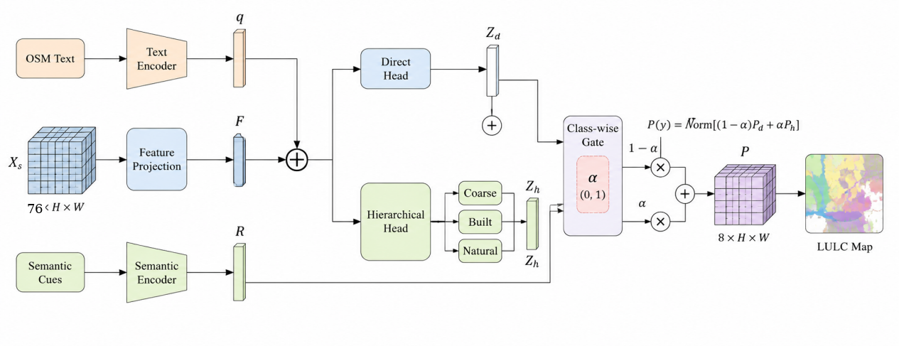
Fig. 2. Multimodal feature transformation and conditional hierarchical probability-fusion module.
Figure 2 summarizes themodel. An FCNN spatial encoder converts continuous multisource rasters into multiscale pixel features [13, 25], and a Transformer encodes patch-level OSM POI/AOI semantics [14]. Raster and text features are combined in a convolutional transcoding head. The urban-context residual then re-encodes local POI/AOI, road, building, and socioeconomic cues with shallow FCNN features to generate class-logit corrections. Conditional hierarchical probabilities and class-wise fusion produce the final outputs.
3.2.1 OSM text and multimodal input transcoding
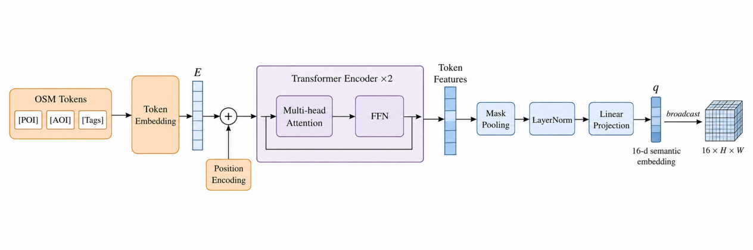
Fig. 3. Internal processing pipeline of the OSM Text Encoder.
As shown in Fig. 3, one OSM text sequence is constructed independently for each 128×128-pixel patch. The sequence primarily includes the 24 most frequent POI semantics and the 16 AOI semantics with the largest intersecting areas, together with POI-count and AOI-area levels. The maximum sequence length is 96 tokens and the training vocabulary contains 478 tokens. Tokens are mapped to 128-dimensional embeddings, augmented with learnable positional encodings, and passed through two Transformer Encoder layers. Each layer contains four-head self-attention, a 512-dimensional feed-forward network, GELU activation, and dropout of 0.1.
Transformer outputs are mask-averaged over valid token positions and normalized by LayerNorm, producing a 128-dimensional patch-level representation. A learnable linear layer projects it to the 16-dimensional text vector q. This standard pooling-and-projection operation does not require a separate equation.
The text representation describes the full 128×128 patch, so q is broadcast to a 16×H×W feature map before fusion with pixel-level raster features. It supplies patch-scale context rather than a separate semantic label for each 10 m pixel. Pixel-level variation is represented mainly by the POI-count, AOI one-hot, road, and other raster channels.
The patch-level text representation is combined with 76 raster channels: 19 Sentinel-2, 7 Sentinel-1, 3 VIIRS, 14 building, 13 road, and 20 POI/AOI channels.
Sentinel-2, Sentinel-1, VIIRS, building, road, and POI/AOI rasters are concatenated channel-wise to form the 76-channel spatial input.
After concatenation with the broadcast 16-channel text representation, a unified 92-channel input is obtained:
$$\begin{aligned}\text{X}\text{=}\text{Cat}\left({\text{X}}_{\text{r}}\text{,}\text{B}\text{(}\text{q}\text{)}\right)\text{∈}{\text{R}}^{\text{95×}\text{H}\text{×}\text{W}}\text{,}\#\text{(13)}\end{aligned}$$
where B(q) denotes spatial broadcasting.
The unified input is first mapped from 92 to 96 channels using a 1×1 convolution, followed by spatial dropout and a 3×3 convolution to produce the 48-channel initial fused feature:
$$\begin{aligned}{\text{F}}_{\text{0}}\text{=}{\text{ϕ}}_{\text{3×3}}\left[\text{Dropout}\left({\text{ϕ}}_{\text{1×1}}\text{(}\text{X}\text{)}\right)\right]\text{,}\#\text{(14)}\end{aligned}$$
Here, φ denotes convolution followed by GroupNorm and GELU activation. The 1×1 convolution learns cross-source channel combinations, and the 3×3 convolution captures local cross-modal relations. This head performs the first fusion stage; the urban-context residual later adds class-logit-oriented semantic fusion.
3.2.2 FCNN multiscale encoding and urban-context residual
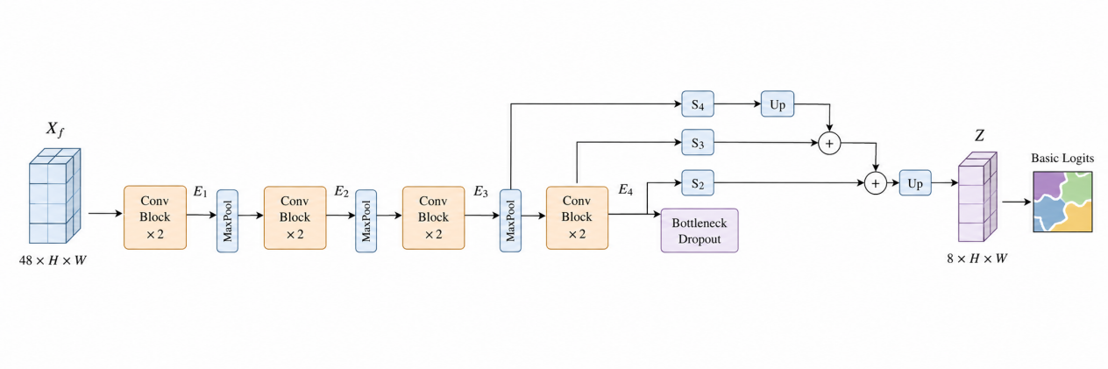
Fig. 4. Multiscale spatial encoding module of the fully convolutional neural network.
As shown in Fig. 4, the 48-channel fused feature is passed to the FCNN spatial encoder. The encoder contains four scales, each composed of two 3×3 Conv–GroupNorm–GELU blocks, with 2×2 max pooling used for progressive downsampling. The four stages contain 64, 128, 256, and 384 channels at spatial resolutions H×W, H/2×W/2, H/4×W/4, and H/8×W/8, respectively.
A spatial dropout rate of 0.1 is applied at the bottleneck. The direct classification path uses FCN-8s-style multiscale scoring skip connections, progressively upsampling deeper semantic features and adding them to intermediate-scale class scores:
$$\begin{aligned}{\text{Z}}_{\text{base}}\text{=}\text{Up}\left[\text{Up}\left(\text{Up}\text{(}{\text{S}}_{\text{4}}\text{(}{\text{E}}_{\text{4}}\text{))+}{\text{S}}_{\text{3}}\text{(}{\text{E}}_{\text{3}}\text{)}\right)\text{+}{\text{S}}_{\text{2}}\text{(}{\text{E}}_{\text{2}}\text{)}\right]\text{,}\#\text{(15)}\end{aligned}$$
where S2, S3, and S4 are 1×1 class-scoring convolutions and Up denotes bilinear upsampling. The output is an eight-class base logit map at the original input size.
We add an urban-context residual to the multiscale FCNN representation so that functional semantics remain available after deep spatial encoding. With only the unified input-transcoding path, spectral and textural features may dominate deep convolutional representations, weakening cues from POIs, AOIs, building morphology, nighttime lights, and roads. The residual retains the base FCNN and converts local urban semantics into a learnable additive correction before the direct class logits are formed.
The model separately transcodes the 20-channel POI/AOI input, the 17-channel urban morphology-socioeconomic input, and the 13-channel road input. Each branch uses two 3×3 Conv–GroupNorm–GELU blocks and outputs 32 channels. The urban branch contains 3 VIIRS and 14 building channels.
The three 32-channel semantic representations are concatenated with the 64-channel first-stage FCNN feature E1 to form a 160-channel joint urban-context representation.
The concatenated feature is passed through 160→96 and 96→64 convolutional blocks and then through a 1×1 convolution to produce an eight-class semantic residual:
$$\begin{aligned}{\text{R}}_{\text{sem}}\text{=}{\text{C}}_{\text{1×1}}\left[{\text{ϕ}}_{\text{96→64}}\left(\text{Dropout}\left[{\text{ϕ}}_{\text{160→96}}\text{(}\text{S}\text{)}\right]\right)\right]\text{.}\#\text{(16)}\end{aligned}$$
The direct classification logits are obtained by adding the semantic residual to the base FCNN output:
$$\begin{aligned}{\text{Z}}_{\text{dir}}\text{=}{\text{Z}}_{\text{base}}\text{+}\text{softplus}\text{(}\text{α}\text{)}{\text{R}}_{\text{sem}}\text{,}\#\text{(17)}\end{aligned}$$
where α is a learnable scalar and softplus constrains the residual weight to be positive. The residual output layer is zero-initialized so that the added module does not disrupt the already converged multimodal FCNN at the beginning of training. At the final checkpoint:
$$\begin{aligned}\text{softplus}\text{(}\text{α}\text{)=0.4236.}\#\text{(18)}\end{aligned}$$
POI/AOI, roads, buildings, and nighttime lights contribute to the initial multimodal transcoding and to a second class-specific correction through the urban-context residual. We evaluate its conditional marginal effect by retraining without the residual branch.
3.2.3 Conditional hierarchical prediction and class-wise probability fusion
The conditional hierarchical branch reuses multiscale FCNN features E1–E4. Channel projection, bilinear upsampling, and convolutional fusion form a 64-channel hierarchical representation Fh. This dec_{o}der constructs a shared hierarchical classification representation; the conditional probability chain is the subsequent mechanism of interest.
The eight labels are mapped to three coarse categories. Built-up land contains residential, industrial/warehouse, public/institutional and recreation, transportation facilities, and other built-up land; natural surfaces contain agriculture and woodland/shrubland/grassland/wetland; water is a single leaf node. The pure conditional hierarchical probability P^{h} is therefore defined as:
$$\begin{aligned}{\text{P}}_{\text{h}}\left(\text{y}\text{∣}\text{x}\right)\text{=}\left\{\begin{matrix}\text{P}\left(\text{c}\text{=built∣}\text{x}\right)\text{P}\left(\text{y}\text{∣}\text{c}\text{=built,}\text{x}\right)\text{,} & \text{y}\text{∈}{\text{Y}}_{\text{built}}\text{,} \\ \text{P}\left(\text{c}\text{=natural∣}\text{x}\right)\text{P}\left(\text{y}\text{∣}\text{c}\text{=natural,}\text{x}\right)\text{,} & \text{y}\text{∈}{\text{Y}}_{\text{natural}}\text{,} \\ \text{P}\left(\text{c}\text{=water∣}\text{x}\right)\text{,} & \text{y}\text{=water.}\end{matrix}\right.\#\text{(19)}\end{aligned}$$
Water has no additional conditional classification head. Because the probability chain has no hard threshold, coarse-class uncertainty can propagate continuously to leaf classes. We call this output the conditional hierarchical probability, or hierarchical chained probability, to distinguish its organization of class relationships from the later class-wise probability fusion.
The hierarchical path is combined with the direct path through class-wise probability fusion rather than a hard cascade. The direct path produces P^{d(y|x)}, whereas the conditional hierarchical path produces P^{h(y|x)}. Each class uses one learnable scalar gate shared across the training set:
$$\begin{aligned}{\text{g}}_{\text{y}}\text{=}\text{σ}\left({\text{a}}_{\text{y}}\right)\text{.}\#\text{(20)}\end{aligned}$$
The unnormalized class-wise gated mixture is:
$$\begin{aligned}\tilde{\text{P}}\left(\text{y}\text{∣}\text{x}\right)\text{=}\left(\text{1−}{\text{g}}_{\text{y}}\right){\text{P}}_{\text{d}}\left(\text{y}\text{∣}\text{x}\right)\text{+}{\text{g}}_{\text{y}}{\text{P}}_{\text{h}}\left(\text{y}\text{∣}\text{x}\right)\text{.}\#\text{(21)}\end{aligned}$$
Because the gate differs by class, the mixture is renormalized across classes:
$$\begin{aligned}{\text{P}}_{\text{comb}}\left(\text{y}\text{∣}\text{x}\right)\text{=}\frac{\tilde{\text{P}}\left(\text{y}\text{∣}\text{x}\right)}{\sum_{\text{j}\text{=0}}^{\text{7}}{\tilde{\text{P}}}\left(\text{j}\text{∣}\text{x}\right)}\text{, }\text{y}\text{=0,…,7.}\#\text{(22)}\end{aligned}$$
The implementation performs this computation in log space:
$$\begin{aligned}\text{log}{\tilde{\text{P}}}_{\text{y}}\text{=logaddexp}\left[\text{log}\left(\text{1−}{\text{g}}_{\text{y}}\right)\text{+log}{\text{P}}_{\text{d}\text{,}\text{y}}\text{, log}{\text{g}}_{\text{y}}\text{+log}{\text{P}}_{\text{h,}\text{y}}\right]\text{,}\#\text{(23)}\end{aligned}$$
The result is normalized with logsumexp. The eight class-wise gate values are learned during training and shared across the training set. They are not input-modality attention weights, pixel-adaptive gates, or mixture-of-experts routing. We therefore call the final output class-wise probability fusion. The direct multimodal FCNN remains the main pixel-prediction path, while the conditional hierarchical branch supplies structured probabilistic information.
3.2.4 Hong Kong-wide sliding-window inference
Hong Kong-wide inference uses 128×128-pixel input windows with a 16-pixel context margin on each side; only the central 96×96 region is written for each window, using a stride of 96 pixels. Adjacent central output blocks do not overlap, and no probability averaging or weighted blending is applied. Out-of-bounds padding is used at image edges. After standardization, missing values in continuous imagery are effectively filled by the training mean, while auxiliary rasters are padded with zero. The current implementation does not rebuild OSM text for every 96-pixel inference step; instead, the text unit is retrieved from the original 128-pixel-grid manifest according to the output-window location.
Adjacent sliding windows may therefore reuse the same original patch-level text. Central cropping reduces convolutional edge effects but cannot fully remove the local dependence caused by this reuse. The text is best interpreted as window-level context rather than pixel-local evidence. Future implementations could reconstruct text for each inference window, use local cross-attention, or blend overlapping predictions to reduce window dependence.
3.3 Model training and spatially blocked validation
Training proceeds in stages: we pretrain the full-modality FCNN, train the conditional hierarchy, train the urban-context residual and gates, and then fine-tune the complete network end to end. Structural and input variants use the corresponding same-modality FCNN initialization, validation-based checkpoint selection, and the same test mask.
3.3.1 Label processing and spatial sample partitioning
BLU labels are nearest-neighbor aligned to the 10 m grid; BLU=0 and excluded classes use ignore index 255 and contribute neither loss nor metrics. The study area is divided into 128×128-pixel patches (~1.28 km), grouped into 512×512-pixel (5.12 km) spatial blocks for the main train/validation/test split (Table 2). Alternative 2.56, 5.12, and 10.24 km blocks, a 1.28 km exclusion buffer, and western leave-region-out validation assess spatial sensitivity. Normalization statistics and the OSM vocabulary are re-estimated from each training subset only. The main split and class support are shown in Fig. 5.
Table 2. Spatial sample partitioning for the main training, validation, and test sets.
Subset | No. of patches | No. of spatial groups
Training | 627 | 62
Validation | 123 | 13
Test | 125 | 14
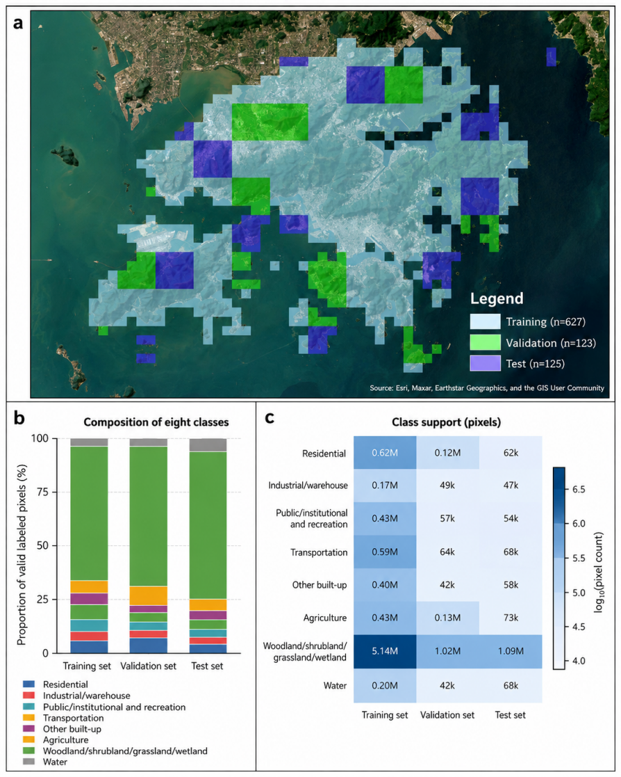
Fig. 5. Pixel distribution for the eight LULC classes under the spatially blocked train-validation-test split. (a) 128×128-pixel patches assigned to training, validation, and test sets using 5.12 km spatial blocks; blocking is intended to reduce, not to claim complete elimination of, spatial leakage. (b) Class composition of valid labeled pixels in the three subsets. (c) Pixel support by class; colors denote log10 pixel counts. The test set contains 1,518,543 valid labeled pixels, and all classification-accuracy metrics are computed pixel-wise over these pixels.
Class weights are calculated as the inverse square root of training-pixel frequency:
$$\begin{aligned}{\text{w}}_{\text{c}}\text{=}{\left(\frac{\sum_{\text{k}}{{\text{n}}_{\text{k}}}}{\text{K}{\text{n}}_{\text{c}}}\right)}^{\text{1/2}}\text{,}\#\text{(24)}\end{aligned}$$
Training patches are sampled with replacement using WeightedRandomSampler. The sampling weight for patch i is:
$$\begin{aligned}{\text{s}}_{\text{i}}\text{=0.05+}\sum_{\text{c}}{\frac{\text{I}\text{(}\text{c}\text{∈}\text{i}\text{)}}{\sqrt{{\text{m}}_{\text{c}}}}}\#\text{(25)}\end{aligned}$$
where m_{c} is the number of training patches containing class c. Each epoch draws 627 patches, equal to the number of patches in the training set. The scheme increases the sampling probability of patches containing rare classes but does not enforce equal class counts. Data augmentation consists only of horizontal flipping with probability 0.5 and vertical flipping with probability 0.5.
3.3.2 Training and optimization
The optimization begins with full-modality FCNN pretraining, which establishes the base pixel classifier before the additional branches are introduced. Class weights are defined as:
$$\begin{aligned}{\text{w}}_{\text{c}}\text{=clip}\left[{\left(\frac{\text{N}}{\text{C}{\text{n}}_{\text{c}}}\right)}^{\text{1/2}}\text{,0.25,6.0}\right]\text{.}\#\text{(26)}\end{aligned}$$
Weighted cross-entropy is defined as:
LCE=−1Ωi∈Ω​wyilogPyi∣xi,#(27)
where Ω excludes ignored pixels. These weights are applied to the cross-entropy terms for the direct path, the final class-wise fused probability, and the pure hierarchical leaf probability. The coarse-level classifier uses weights computed separately from coarse-class frequencies. Class weights are not applied to conditional-classification cross-entropy or Dice loss.
For the set of classes present in the current batch, soft Dice is defined as:
Dicec=2i∈Ω​picyic+1i∈Ω​pic+i∈Ω​yic+1,#(28)
LDice=1−1CBc∈CB​Dicec.#(29)
The smoothing constant is 1. Ignored pixels are removed from both numerator and denominator, and the eight-class task has no background-class Dice term. The FCNN baseline loss is Lba_{se=0}.7LCE₊₀.3LDi_{ce.}AdamW uses an initial learning rate and weight decay of 10−4. Cosi^{ne}AnnealingLR has a minimum learning rate of 0 and no warm-up. Batch size is 4, training runs for at most 20 epochs with early-stopping patience of 5, and the checkpoint with the highest validation macro mIoU is retained. For seed 42, the best FCNN checkpoint occurs at epoch 20. The spatial FCNN, text Transformer, and 92→96→48-channel fusion head are trained jointly at this stage.
After the same-modality FCNN checkpoint is obtained, the direct path is frozen and the hierarchical decoder, coarse classifier, and two conditional classifiers are optimized. The hierarchical-stage objective is:
$$\begin{aligned}{\text{L}}_{\text{h}\text{ier}}\text{=0.7}{\text{L}}_{\text{h}\text{ier}\text{-}\text{CE}}\text{+0.3}{\text{L}}_{\text{h}\text{ier}\text{-}\text{Dice}}\text{+0.35}{\text{L}}_{\text{coarse}}\text{+0.25}\left({\text{L}}_{\text{built}}\text{+}{\text{L}}_{\text{natural}}\right)\text{.}\#\text{(30)}\end{aligned}$$
L_{hier-CE} and L_{hier-Dice} act directly on the pure conditional hierarchical probability P^h and not on the final gated mixture. L_{coarse} supervises the three coarse classes. L_{built} is evaluated only on pixels belonging to the five built-up classes, and L_{natural} only on agriculture and woodland/shrubland/grassland/wetland; both are unweighted conditional cross-entropy terms. If a batch contains no eligible pixels, the corresponding conditional term returns a differentiable zero loss. Water is a single leaf node and therefore has no conditional loss. Gate parameters are frozen during this stage; the learning rate is 10⁻⁴ and training lasts 8 epochs.
The urban-context residual and class-wise gates are then optimized with the FCNN backbone and conditional hierarchical classifiers fixed. The gate-stage loss is applied to the final class-wise fused probability P_comb:
$$\begin{aligned}{\text{L}}_{\text{gate}}\text{=0.7}{\text{L}}_{\text{comb}\text{-}\text{CE}}\text{+0.3}{\text{L}}_{\text{comb}\text{-}\text{Dice}}\text{.}\#\text{(31)}\end{aligned}$$
The learning rate is 3×10⁻⁴ for the urban-context residual and 2×10⁻² for the gates; this stage is trained for 12 epochs. The higher gate learning rate allows the eight classes to rapidly adjust the relative weighting of the two probability paths, while zero initialization of the residual output layer starts optimization near the FCNN checkpoint.
Finally, the entire network is unfrozen and fine-tuned end to end:
$$\begin{aligned}{\text{L}}_{\text{joint}}\text{=}{\text{L}}_{\text{gate}}\text{+0.20}{\text{L}}_{\text{direct}}\text{+0.30}{\text{L}}_{\text{h}\text{ier}}\text{,}\#\text{(32)}\end{aligned}$$
Here, L_{direct}=0.7L_{direct}-CE+0.3L_{direct-Dice}. The hierarchical modules, urban-context residual, and gates use a learning rate of 10⁻⁴, whereas the pretrained FCNN, text Transformer, and input-fusion head use 10⁻⁵. AdamW is used with weight decay 10⁻⁴, gradient-norm clipping at 5.0, and bfloat16 automatic mixed precision. Joint fine-tuning runs for 7 epochs, and the best validation checkpoint occurs at epoch 3.
The maximum schedule is 20+8+12+7=47 epochs. Because the original baselines stop at 20 epochs, differences from the proposed model reflect both architecture and training horizon. FCNN-47 controls the maximum epoch count but does not equalize GPU time or optimization steps; we therefore do not use FLOP/runtime claims as evidence of architectural superiority. Random seeds are fixed for Python, NumPy, PyTorch CPU/CUDA, and the weighted sampler, without forcing all CUDA operations to deterministic mode.
3.3.3 Robustness and fairness experiments
Structural ablations remove the hierarchy, remove the urban-context residual, or replace the eight class-specific gates with one shared gate. Each variant is retrained with the same inputs, FCNN initialization, split, and checkpoint rule. We interpret differences as conditional marginal effects, not additive causal contributions. FCNN-47 provides a supplementary training-horizon control.
Training stability is assessed with seeds 42, 43, and 44 for the proposed model and five original baselines; mean±SD and exploratory 95% t intervals are reported, with paired seed-wise tests and Holm correction. OSM ablations separately remove POIs, AOIs, roads, text, or all four together. Spatial robustness uses distance-binned label-composition correlation, alternative blocking scales, a 1.28 km buffer, and western leave-region-out validation.
3.4 Baseline models and multimodal input adaptation
Five baselines assess the same multimodal input: CNN, FCNN, Transformer, FCN-ResNet50, and VGG-UNet-Transformer. All use the 92-channel input (76 raster + 16 broadcast text channels), the same 92→96→48 transcoding head, eight-class output, train/validation/test masks, 0.7LCE+0.3LDice loss, and validation macro mIoU for checkpoint selection.
The CNN uses five dilated Conv–GroupNorm–GELU blocks; the FCNN uses the four-scale encoder described above; and the Transformer uses 4×4 tokenization, three four-head self-attention layers, and a lightweight convolutional decoder. FCN-ResNet50 and VGG-UNet-Transformer use ImageNet-pretrained ResNet50 and VGG16-BN backbones, respectively.
For the original pretrained-backbone baselines, the 48-channel fused representation is compressed to three channels before ResNet50 or VGG16-BN. Supplementary direct-48 variants remove this bottleneck. Their first pretrained RGB kernels are averaged, replicated to 48 inputs, scaled by 3/48, and kept trainable; all other pretrained backbone weights are retained. This separates input adaptation from backbone identity without treating the first layer as randomly initialized.
Batch size is 4 for CNN, FCNN, Transformer, and FCNN-47, and 2 for both FCN-ResNet50 and VGG-UNet-Transformer variants because of memory limits. The five original baselines otherwise share the same sampler, flips, ignore mask, class weights, AdamW (learning rate and weight decay 10−4), cosine annealing, 20-epoch maximum, patience 5, and validation-based checkpoint selection. Because batch size 2 produces more optimization steps per epoch and no gradient accumulation is used, equal epoch counts are not equal computational budgets; FCNN-47 controls only maximum training horizon.
3.5 Evaluation metrics and statistical tests
Performance is evaluated over valid BLU pixels using OA, class-wise IoU and F1, macro mIoU, macro-F1, producer's accuracy, user's accuracy, and Cohen's κ. Ignored pixels are excluded from all confusion-matrix terms. Macro metrics give each of the eight classes equal weight and are the main measures under class imbalance. Validation macro mIoU is used for checkpoint selection.
OA is the proportion of all valid test pixels that are correctly classified:
$$\begin{aligned}\text{OA}\text{=}\frac{\sum_{\text{c}\text{=1}}^{\text{K}}{{\text{TP}}_{\text{c}}}}{\sum_{\text{c}\text{=1}}^{\text{K}}{\left({\text{TP}}_{\text{c}}\text{+}{\text{FN}}_{\text{c}}\right)}}\text{,}\#\text{(35)}\end{aligned}$$
where K=8 is the number of LULC classes. OA summarizes overall classification correctness but can be dominated by large majority classes under strong class imbalance and is therefore not used alone.
For class c, IoU is the ratio of the intersection between the prediction and reference to their union:
$$\begin{aligned}{\text{IoU}}_{\text{c}}\text{=}\frac{{\text{TP}}_{\text{c}}}{{\text{TP}}_{\text{c}}\text{+}{\text{FP}}_{\text{c}}\text{+}{\text{FN}}_{\text{c}}}\text{.}\#\text{(36)}\end{aligned}$$
Macro mIoU is the unweighted mean of class-wise IoU:
$$\begin{aligned}\text{mIoU}\text{=}\frac{\text{1}}{\text{K}}\sum_{\text{c}\text{=1}}^{\text{K}}{{\text{IoU}}_{\text{c}}}\text{.}\#\text{(37)}\end{aligned}$$
Precision and recall for class c are defined as:
$$\begin{aligned}{\text{Precision}}_{\text{c}}\text{=}\frac{{\text{TP}}_{\text{c}}}{{\text{TP}}_{\text{c}}\text{+}{\text{FP}}_{\text{c}}}\text{,}\#\text{(38)}\end{aligned}$$
$$\begin{aligned}{\text{Recall}}_{\text{c}}\text{=}\frac{{\text{TP}}_{\text{c}}}{{\text{TP}}_{\text{c}}\text{+}{\text{FN}}_{\text{c}}}\text{,}\#\text{(39)}\end{aligned}$$

$$\begin{aligned}{\text{F}\text{1}}_{\text{c}}\text{=}\frac{\text{2 }{\text{Precision}}_{\text{c}} {\text{Recall}}_{\text{c}}}{{\text{Precision}}_{\text{c}}\text{+}{\text{Recall}}_{\text{c}}}\text{=}\frac{\text{2 }{\text{TP}}_{\text{c}}}{\text{2 }{\text{TP}}_{\text{c}}\text{+}{\text{FP}}_{\text{c}}\text{+}{\text{FN}}_{\text{c}}}\text{.}\#\text{(40)}\end{aligned}$$
Macro-F1 is defined as the unweighted mean of the eight class-wise F1 scores:
$$\begin{aligned}\text{macro}\text{−}\text{F}\text{1=}\frac{\text{1}}{\text{K}}\sum_{\text{c}\text{=1}}^{\text{K}}{{\text{F}\text{1}}_{\text{c}}}\text{.}\#\text{(41)}\end{aligned}$$
Row-normalized confusion matrices identify dominant class confusions. Boundary F1 uses one-pixel morphological-gradient boundaries with a one-pixel (10 m) tolerance and is macro-averaged over supported classes, complementing area-based metrics [24]. It measures agreement with BLU boundaries, not independent parcel-survey accuracy.
Spatial uncertainty is estimated by resampling the 14 test spatial groups, rather than pixels, 5,000 times with replacement to obtain percentile 95% intervals. Training stochasticity is reported separately across three seeds. Alternative spatial protocols use their own test groups.
Model comparisons on the fixed test set use two-sided exact label-swap tests over paired spatial groups, with Holm correction across the five original baselines within each metric. Structural ablations (three comparisons) and OSM ablations (five) are separate correction families, and both raw and adjusted p values are reported. Multi-seed comparisons use paired t tests with Holm correction. We interpret effect sizes and directional consistency alongside p values.
4. Results
4.1 Model performance and comparison
All six models use the same spatially blocked test set: 125 patches in 14 non-overlapping 5.12 km groups. Seed-42 point estimates use checkpoints selected only by validation macro mIoU. Label-composition correlation first falls below 0.1 at 6.40–7.68 km, so the main protocol is described as spatially blocked rather than fully independent. Buffer and leave-region-out experiments provide stricter checks.
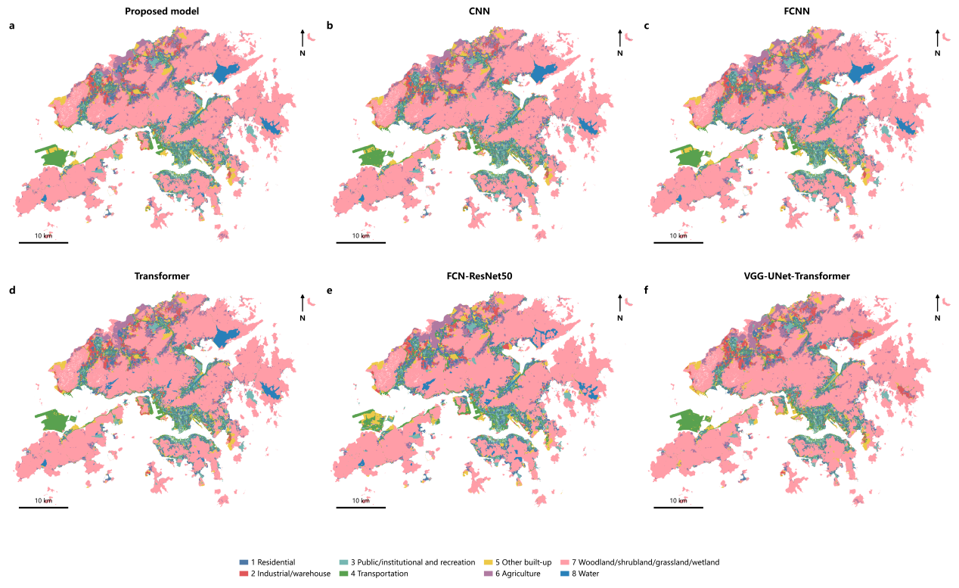
Fig. 6. Hong Kong-wide 10 m LULC maps produced by six models using the unified full-modality input. Areas with original BLU value 0 are not included in the prediction display.
Hong Kong-wide mapping results for the six models are shown in Fig. 6. All models recover the extensive woodland/shrubland/grassland/wetland cover and the built-up classes along the main urban corridors, but differ locally in industrial/warehouse land, other built-up land, agriculture, and land-water transition zones.
Table 3. Overall results of the proposed model, original baselines, and supplementary fairness baselines on the spatial test set.
Model | Input/training setting | macro mIoU | macro-F1 | OA | Best epoch | κ
Proposed model | Full-modality hierarchical fusion | 0.5946 | 0.7338 | 0.8789 | Joint stage 3 | 0.7486
FCNN | Original 20 epochs | 0.5796 | 0.7211 | 0.8733 | 20 | 0.7374
FCNN | 47-epoch control | 0.5885 | 0.7295 | 0.8794 | 37 | 0.7476
Transformer | Original 20 epochs | 0.5775 | 0.7185 | 0.8714 | 18 | 0.7332
CNN | Original 20 epochs | 0.5698 | 0.7123 | 0.8679 | 19 | 0.7266
FCN-ResNet50 | 48→3 channels | 0.4239 | 0.5724 | 0.8189 | 15 | 0.6133
FCN-ResNet50 | Direct 48 channels | 0.4143 | 0.5647 | 0.8124 | 16 | 0.5898
VGG-UNet-Transformer | 48→3 channels | 0.4255 | 0.6351 | 0.8233 | 18 | 0.6263
VGG-UNet-Transformer | Direct 48 channels | 0.5467 | 0.6940 | 0.8640 | 18 | 0.7114
The proposed model achieves macro mIoU=0.5946, macro-F1=0.7338, and OA=0.8789 (Table 3). Compared with FCNN-20, it gains +0.0150 mIoU and +0.0127 macro-F1. FCNN-47 reaches slightly higher OA (0.8794), while the proposed model is +0.0061 in mIoU and +0.0043 in macro-F1. These results support the highest point estimate on class-balanced metrics, not universal superiority.
After Holm correction, the proposed model's mIoU and macro-F1 advantages over CNN and FCNN-20 remain significant, while differences from Transformer and VGG-UNet-Transformer do not. FCNN-47 also shows that training horizon changes the ranking. We therefore interpret cross-model results together with the structural ablations and external validation.
Table 4. Class-wise IoU and F1 of the proposed model on the spatially blocked test set.
Class | Test pixels | Producer's accuracy (PA) | User's accuracy (UA) | F1 | IoU
Residential | 61,908 | 0.7279 | 0.7248 | 0.7264 | 0.5703
Industrial/warehouse | 46,925 | 0.6552 | 0.6641 | 0.6596 | 0.4921
Public/institutional & recreation | 53,851 | 0.7689 | 0.7371 | 0.7526 | 0.6034
Transportation facilities | 67,956 | 0.7465 | 0.7550 | 0.7507 | 0.6009
Other built-up land | 57,587 | 0.6918 | 0.5252 | 0.5971 | 0.4256
Agriculture | 72,506 | 0.5905 | 0.5499 | 0.5695 | 0.3981
Woodland/shrubland/  grassland/wetland | 1,090,198 | 0.9430 | 0.9601 | 0.9515 | 0.9074
Water | 67,612 | 0.8288 | 0.9000 | 0.8630 | 0.7589
Class-wise performance is summarized in Table 4. Woodland/shrubland/grassland/wetland achieves IoU=0.9074 and water 0.7589; public/institutional and recreation, transportation, and residential reach 0.6034, 0.6009, and 0.5703, whereas industrial/warehouse, other built-up, and agriculture remain more difficult (0.4921, 0.4256, and 0.3981). The corresponding confusion matrices are shown in Fig. 7.
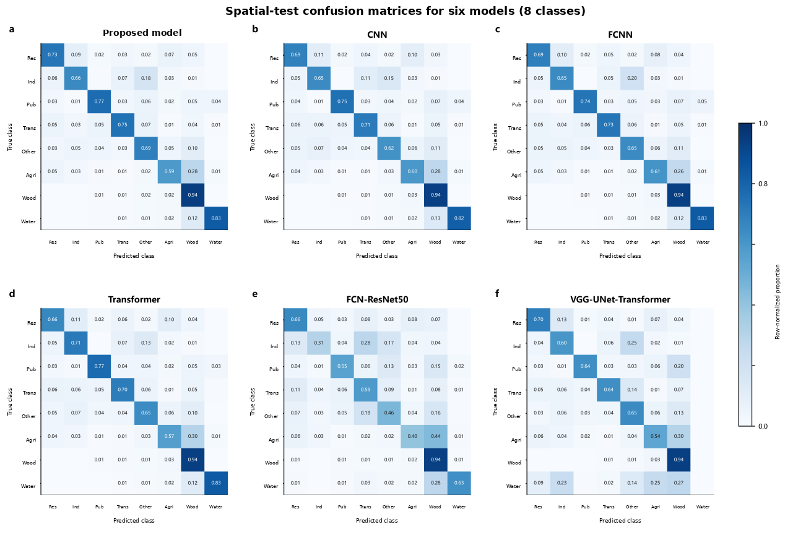
Fig. 7. Row-normalized confusion matrices for six models using the unified full-modality input. Each row gives the predicted proportions for one true class.
Independent CSDI OP-building-use validation provides a second test separate from the BLU supervisory raster. Among 12,570 strictly labeled buildings with predictions from all six maps, the proposed model achieved the highest exact building-use agreement (0.881), compared with CNN (0.861), FCNN (0.858), Transformer (0.837), FCN-ResNet50 (0.732), and VGG-UNet-Transformer (0.856) (Fig. 8). The strict OP reference contains only four mapped built-up classes and is dominated by residential buildings, so this agreement is neither a class-balanced eight-class accuracy metric nor directly comparable with pixel-wise OA or mIoU. It nevertheless offers independent evidence that the proposed urban-context representation transfers to official building-use records.
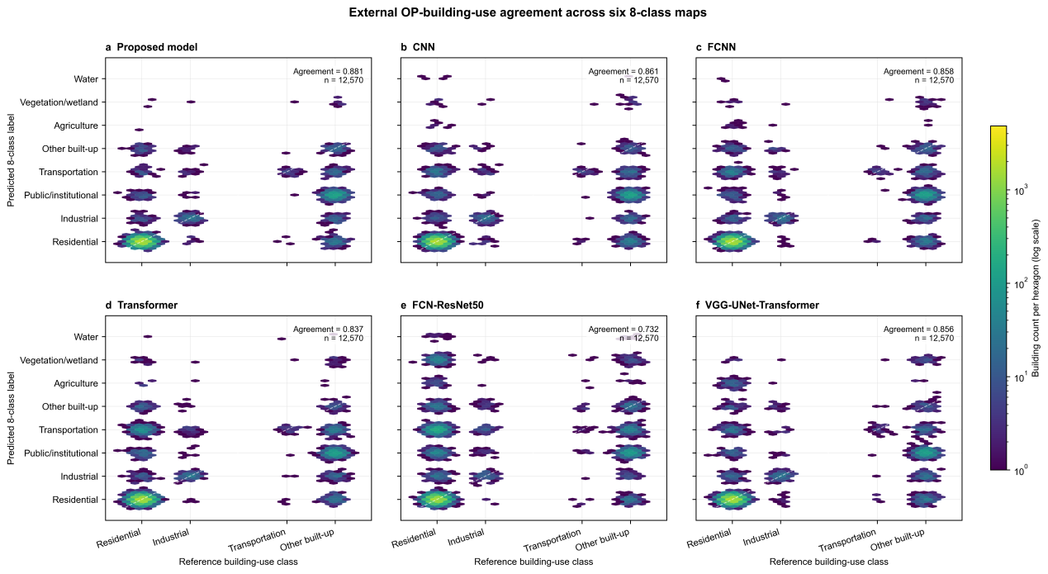
Fig. 8. External agreement between CSDI OPBuildingUses labels and six 8-class LULC maps. Hexagon color indicates building count on a logarithmic scale; n=12,570 buildings are common to the six-map comparison.
Boundary-sensitive evaluation complements the area-based metrics in Table 3. With the same one-pixel (10 m) tolerance for all models, the proposed model achieves the highest macro Boundary F1, 0.5832, compared with 0.5763 for FCNN-47, 0.5518 for FCNN-20, 0.5347 for CNN, 0.5096 for Transformer, 0.4407 for VGG-UNet-Transformer, and 0.3321 for FCN-ResNet50(Table 5). The margin is 0.0069 over the budget-controlled FCNN-47; it is 0.0314, 0.0485, and 0.0736 over FCNN-20, CNN, and Transformer, respectively. Boundary agreement improves across several baselines, although FCNN-47 remains a close competitor. This metric measures agreement with BLU supervisory boundaries and may be affected by boundary generalization in the reference labels.
Table 5. Boundary agreement of the proposed model and comparison models on the test patches.
Model | Macro Boundary F1 (1-pixel/10 m tolerance)
Proposed model | 0.5832
CNN | 0.5347
FCNN (20 epochs) | 0.5518
FCNN (47 epochs) | 0.5763
Transformer | 0.5096
FCN-ResNet50 | 0.3321
VGG-UNet-Transformer | 0.4407
Note: Class boundaries are extracted from prediction and BLU reference labels within each test patch, and macro Boundary F1 is calculated with a one-pixel (10 m) tolerance. The metric describes boundary agreement with the supervisory reference labels and is not an independent field-surveyed parcel-boundary accuracy measure.
Bootstrap intervals quantify spatial heterogeneity among test groups; training variation is assessed separately across seeds. Table 3 should therefore be interpreted together with the budget-controlled FCNN, structural ablations, and the independent building-use validation.
4.2 Ablation and robustness experiments
This section reports modality-group and structural ablations, source-specific OSM ablations, building lineage checks, multi-seed stability, and spatial robustness. Each trainable variant is retrained and selected by its own validation macro mIoU; the test set is never used for model selection.
Table 6. Extended modality-group ablation results for the proposed model and five baselines. All variants use the same spatial split.
Model | Configuration | OA (%) | mIoU | ΔmIoU
Proposed model | Full modality | 87.89 | 0.5946 | —
Proposed model | Sentinel-2 only | 82.53 | 0.4392 | −0.1554
Proposed model | −POI/AOI/roads/text | 84.70 | 0.4835 | −0.1111
Proposed model | −Building | 86.94 | 0.5795 | −0.0151
Proposed model | −Sentinel-1 | 87.27 | 0.5914 | −0.0031
Proposed model | −Nighttime lights | 87.23 | 0.5781 | −0.0165
CNN | Full modality | 86.79 | 0.5698 | —
CNN | Sentinel-2 only | 81.73 | 0.4036 | −0.1662
CNN | −POI/AOI/roads/text | 83.54 | 0.4476 | −0.1222
CNN | −Building | 85.91 | 0.5341 | −0.0357
CNN | −Sentinel-1 | 85.37 | 0.5496 | −0.0202
CNN | −Nighttime lights | 86.26 | 0.5492 | −0.0206
FCNN | Full modality | 87.33 | 0.5796 | —
FCNN | Sentinel-2 only | 82.65 | 0.4374 | −0.1422
FCNN | −POI/AOI/roads/text | 84.39 | 0.4781 | −0.1015
FCNN | −Building | 86.49 | 0.5511 | −0.0285
FCNN | −Sentinel-1 | 86.92 | 0.5657 | −0.0139
FCNN | −Nighttime lights | 86.57 | 0.5569 | −0.0227
Transformer | Full modality | 87.14 | 0.5775 | —
Transformer | Sentinel-2 only | 81.51 | 0.3944 | −0.1832
Transformer | −POI/AOI/roads/text | 83.74 | 0.4531 | −0.1245
Transformer | −Building | 85.29 | 0.5319 | −0.0457
Transformer | −Sentinel-1 | 85.70 | 0.5438 | −0.0337
Transformer | −Nighttime lights | 85.77 | 0.5341 | −0.0434
FCN-ResNet50 | Full modality | 81.89 | 0.4239 | —
FCN-ResNet50 | Sentinel-2 only | 79.44 | 0.3437 | −0.0802
FCN-ResNet50 | −POI/AOI/roads/text | 79.41 | 0.3469 | −0.0770
FCN-ResNet50 | −Building | 79.77 | 0.3961 | −0.0278
FCN-ResNet50 | −Sentinel-1 | 79.22 | 0.3761 | −0.0478
FCN-ResNet50 | −Nighttime lights | 77.31 | 0.2978 | −0.1261
VGG-UNet-Transformer | Full modality | 82.33 | 0.4255 | —
VGG-UNet-Transformer | Sentinel-2 only | 78.07 | 0.3445 | −0.0810
VGG-UNet-Transformer | −POI/AOI/roads/text | 80.79 | 0.3504 | −0.0751
VGG-UNet-Transformer | −Building | 84.38 | 0.4800 | +0.0545
VGG-UNet-Transformer | −Sentinel-1 | 82.94 | 0.4283 | +0.0028
VGG-UNet-Transformer | −Nighttime lights | 82.59 | 0.4155 | −0.0100
4.2.1 Modality-group ablations
As shown in Table 6, all modalities increase the proposed model's mIoU from 0.4392 (Sentinel-2 only) to 0.5946. Joint removal of POIs, AOIs, roads, and OSM text lowers mIoU by 0.1111. The original all-building ablation changes mIoU by −0.0151 but also changes the input combination; the fixed-geometry experiment in Table S5 is therefore the primary building evidence, where zeroing all 14 building channels lowers mIoU by only 0.0030.
OSM-related inputs also improve class-balanced performance across the five baselines (Table 6): joint removal lowers mIoU by 0.1222, 0.1015, 0.1245, 0.0770, and 0.0751 for CNN, FCNN, Transformer, FCN-ResNet50, and VGG-UNet-Transformer, respectively. Other modality effects are architecture-dependent, including non-monotonic responses to building or Sentinel-1 removal, so individual ablations are interpreted as conditional rather than additive causal contributions.
4.2.2 Structural ablations
The complete model achieves OA=0.8789, mIoU=0.5946, and macro-F1=0.7338 (Table 7). Relative to the retrained ablations, mIoU changes by −0.0093 without the hierarchy, −0.0210 without the urban-context residual, and −0.0040 with a shared gate. Across the 14 paired test groups, the complete model outperforms the no-hierarchy variant in only 6/14 groups, indicating an unstable direction. It outperforms the shared-gate and no-residual variants in 10/14 groups. After Holm correction, only removal of the urban-context residual remains significant (raw p=0.0140; adjusted p=0.0420). The residual is therefore the only structural component with confirmed family-wise evidence in this experiment. The hierarchy and class-wise gate remain effect estimates and structured modeling choices, not independently proven performance sources. Table S4 reports path decomposition and gate values.
Table 7. Structural ablation results for the proposed model.
Structural variant | OA | mIoU | macro-F1 | ΔmIoU | Raw p | Holm-adjusted p
Proposed model | 0.8789 | 0.5946 | 0.7338 | +0.0000 | — | —
No hierarchical probability | 0.8747 | 0.5853 | 0.7254 | -0.0093 | 0.1129 | 0.1480
No urban-context residual | 0.8718 | 0.5736 | 0.7160 | -0.0210 | 0.0140 | 0.0420
Shared gate (instead of class-wise gates) | 0.8780 | 0.5906 | 0.7301 | -0.0040 | 0.0740 | 0.1480
4.2.3 Source-specific OSM ablations
Table 8 reports source-specific OSM results. Removing POI, text, roads, and AOI changes mIoU by −0.0025, −0.0201, −0.0185, and −0.0656, respectively; joint removal changes it by −0.1111. The AOI point estimate is large, but the complete model is better in only 10/14 paired groups and the effect is heterogeneous, with Holm-adjusted p=0.0508. Road removal has a more consistent direction (12/14 groups favor the complete model) but a smaller effect and does not remain significant after correction. Joint OSM removal is the strongest result: 13/14 groups favor the complete model and the effect remains significant after Holm correction (raw p=0.0083; adjusted p=0.0415). POI and text remain effect estimates rather than confirmed individual sources. The evidence supports a significant joint contribution of OSM semantics, while single-source effects are trends within correlated inputs rather than targets for forcing p<0.05.
Table 8. Source-specific and joint OSM ablation results for the proposed model.
OSM variant | OA | mIoU | macro-F1 | ΔmIoU | Raw p | Holm-adjusted p
Full modality | 0.8789 | 0.5946 | 0.7338 | +0.0000 | — | —
−POI | 0.8782 | 0.5921 | 0.7314 | -0.0025 | 0.2598 | 0.2652
−AOI | 0.8614 | 0.5290 | 0.6733 | -0.0656 | 0.0127 | 0.0508
−Roads | 0.8724 | 0.5761 | 0.7166 | -0.0185 | 0.0924 | 0.2652
−OSM text | 0.8731 | 0.5745 | 0.7149 | -0.0201 | 0.0884 | 0.2652
−POI/AOI/roads/text | 0.8470 | 0.4835 | 0.6304 | -0.1111 | 0.0083 | 0.0415
4.2.4 Multi-seed training stability
Table S3 reports the three-seed stability results. Across independent seeds 42, 43, and 44, the proposed model achieves OA=0.8772±0.0019, mIoU=0.5866±0.0071, and macro-F1=0.7264±0.0065 (mean±SD). The original 20-epoch FCNN has mIoU=0.5776±0.0087 and Transformer 0.5672±0.0090. The mean mIoU difference between the proposed model and the original 20-epoch FCNN is +0.0091, with a 95% t interval of −0.0125 to 0.0306 and Holm-adjusted p=0.2538. With n=3, the intervals are wide and test power is limited. We therefore treat these results as exploratory evidence of training stability, not as a significant cross-seed model advantage.
4.2.5 Spatial correlation scale, exclusion buffer, and leave-region-out validation
The mean standardized spatial correlation of the eight-class label composition declines from 0.673 in the 0–1.28 km distance bin to 0.106 at 5.12–6.40 km and first falls below 0.1 at 6.40–7.68 km (Fig. 9c). The original 5.12 km blocks capture most short-range correlation but cannot fully remove dependence near block boundaries. This motivates buffer-based and stricter leave-region-out evaluation. With a 1.28 km exclusion buffer, the proposed model achieves OA=0.8628, mIoU=0.5491, and macro-F1=0.6937. Under western leave-region-out validation, the values are 0.8018, 0.4297, and 0.5723 (Table 9). These protocol differences reflect spatial separation, reduced training data, changes in test-set class composition, and regional distribution shift. We use them to delimit spatial generalization rather than compare them through paired significance tests across different test sets.
Table 9. Performance of the proposed model under alternative spatial validation protocols with spatial-block bootstrap intervals.
Spatial protocol | Test groups | OA (95% CI) | mIoU (95% CI) | F1 (95% CI)
5.12 km (main protocol) | 14 | 0.8789 (0.8430–0.9088) | 0.5946 (0.4622–0.6183) | 0.7338 (0.5938–0.7529)
2.56 km blocks | 41 | 0.8537 (0.8203–0.8841) | 0.5790 (0.4867–0.6128) | 0.7215 (0.6224–0.7483)
10.24 km blocks | 5 | 0.8669 (0.7879–0.9328) | 0.5576 (0.3939–0.5632) | 0.6967 (0.5000–0.7045)
5.12 km + 1.28 km buffer | 14 | 0.8628 (0.8265–0.8933) | 0.5491 (0.4306–0.5738) | 0.6937 (0.5609–0.7150)
Western leave-region-out | 22 | 0.8018 (0.6741–0.8887) | 0.4297 (0.3244–0.5294) | 0.5723 (0.4405–0.6702)
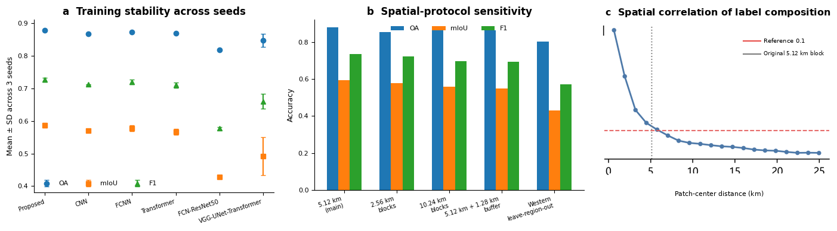
Fig. 9. Training and spatial robustness. (a) Mean±SD across three random seeds for six models. (b) Overall metrics for the proposed model under alternative spatial validation protocols. (c) Mean standardized correlation of eight-class label composition as a function of patch-center distance.
5. Discussion
The results point to the urban-context residual, rather than hierarchical probability fusion alone, as the architectural contribution with the strongest support. Removing the residual lowers mIoU by 0.0210 and remains significant after Holm correction (p=0.0420), with 10/14 spatial groups favoring the complete model. In contrast, the no-hierarchy comparison favors the complete model in only 6/14 groups, and the shared-gate effect is small despite a 10/14 directional advantage. Together with the small gate coefficients in Table S4, this suggests that the hierarchy mainly acts as a training-time semantic constraint, whereas the residual provides a more direct correction at inference. The external CSDI building-use test is consistent with this interpretation: the proposed model reaches 0.881 agreement on 12,570 buildings, above all five comparison models. Because that set contains only four built-up reference classes and is strongly residential-dominated, it supports but does not replace the pixel-wise eight-class evaluation.
OSM ablations indicate that semantic sources operate at different spatial support scales. AOI removal has the largest single-source point estimate (−0.0656 mIoU), but only 10/14 paired groups favor the complete model and the Holm-adjusted p value is 0.0508. It should therefore be described as a strong trend, not a confirmed individual effect. Roads show a smaller loss (−0.0185) but a more consistent direction (12/14 groups). POIs provide sparse facility-level evidence and have a small conditional effect (−0.0025), plausibly because their information overlaps with AOIs, roads, and building function. Patch-level OSM text aggregates POI/AOI composition over ~1.28 km and has a larger effect estimate (−0.0201), consistent with neighborhood-scale context. Joint OSM removal lowers mIoU by 0.1111, favors the complete model in 13/14 groups, and remains significant after Holm correction (p=0.0415). The results support OSM semantics as a joint information system without requiring every correlated component to be individually significant [5–8].
Building and pretrained-backbone experiments raise a related issue: multimodal sources are correlated, and their value depends on representation compatibility. The building-function product shares lineage with OSM land-use/AOI, nighttime lights, and building height, so fixed-geometry building ablations are non-monotonic. Likewise, removing the 48→3 bottleneck improves VGG-UNet-Transformer but not FCN-ResNet50. These ablations should not be read as independent causal decompositions. They quantify conditional information value for a particular feature set and optimization scheme.
Residual errors reflect the mismatch between 10 m physical observations and socioeconomic land-use labels. Vegetation/wetland and water depend largely on surface properties and are mapped more accurately, whereas agriculture is fragmented and spectrally overlaps other vegetation. Residential, industrial, and public/institutional uses can share materials and morphology, so semantic context reduces but cannot eliminate ambiguity. The decline under western leave-region-out validation also indicates regional distribution shift. Future work should emphasize object/parcel-aware reasoning, mixed-use uncertainty, dynamic local text, and broader cross-city transfer rather than network depth alone.
Several limitations remain. The main 5.12 km split reduces but does not eliminate spatial dependence, and external OP validation is limited to four mapped built-up classes with strong residential imbalance. BLU remains the supervisory raster rather than field-surveyed pixel truth, and the building products and VIIRS composite have heterogeneous temporal support. Fixed-patch evaluation also differs slightly from Hong Kong-wide sliding-window deployment because adjacent windows may reuse manifest-level OSM text. Training stability uses only three seeds. These constraints motivate independent multi-city validation and deployment-aware contextual encoding.
6. Conclusions
We developed a Hong Kong-wide 10 m LULC framework that combines multimodal FCNN transcoding, an urban-context residual, conditional hierarchical probability organization, and class-wise probability fusion. On the main spatially blocked test set, the seed-42 model achieved OA=0.8789, macro mIoU=0.5946, and macro-F1=0.7338. FCNN-47 had slightly higher OA but lower mIoU and macro-F1, while the proposed model had the highest Boundary F1 (0.5832). Removing the urban-context residual produced the only significant structural degradation after Holm correction (adjusted p=0.0420). Joint OSM removal reduced mIoU by 0.1111, favored the complete model in 13/14 groups, and remained significant (adjusted p=0.0415). We interpret individual POI, AOI, road, text, hierarchy, and gate effects as estimates or trends rather than confirmed significant sources. Independent CSDI OPBuildingUses validation gave the proposed model the highest building-level agreement (0.881; n=12,570). The evidence supports late urban-context reinjection and jointly represented geospatial semantics for bridging physical cover and urban function, while broader cross-city and independent-reference validation remain necessary.
Declaration of generative AI and AI-assisted technologies in the manuscript preparation process
During the preparation of this work, the authors used ChatGPT (OpenAI) solely for language polishing and improvement of English expression, and use it to assist the preparation of Figures 2–4. The authors reviewed and edited the text and take full responsibility for the content of the publication.
References
[1] Li, Z., Hu, J., Wu, K., Miao, J., Zhao, Z., et al. (2024). Local feature acquisition and global context understanding network for very high-resolution land cover classification. Scientific Reports, 14, 12597. https://doi.org/10.1038/s41598-024-63363-7
[2] Khan, M., Hanan, A., Kenzhebay, M., Gazzea, M., & Arghandeh, R. (2024). Transformer-based land use and land cover classification with explainability using satellite imagery. Scientific Reports, 14, 16744. https://doi.org/10.1038/s41598-024-67186-4
[3] Sawant, S., & Ghosh, J. K. (2024). Land use land cover classification using Sentinel imagery based on deep learning models. Journal of Earth System Science, 133, 101. https://doi.org/10.1007/s12040-024-02298-z
[4] Yu, H., Li, G., Liu, H., Zhu, S., Xu, J., Dong, W., Li, C., & Shi, J. (2025). Synergistic fusion of Sentinel-1 and Sentinel-2 for global LULC mapping: The multimodal network LULC-Former and Dynamic World+ dataset. IEEE Journal of Selected Topics in Applied Earth Observations and Remote Sensing, 19, 2511–2524. https://doi.org/10.1109/JSTARS.2025.3641788
[5] Mo, Y., Guo, Z., Zhong, R., Song, W., & Cao, S. (2024). Urban functional zone classification using light-detection-and-ranging point clouds, aerial images, and point-of-interest data. Remote Sensing, 16(2), 386. https://doi.org/10.3390/rs16020386
[6] Qiao, H., Jiang, H., Yang, G., Jing, F., Sun, W., Lu, C., & Meng, X. (2024). A multisource dynamic fusion network for urban functional zone identification on remote sensing, POI, and building footprint. IEEE Journal of Selected Topics in Applied Earth Observations and Remote Sensing, 17, 10583–10599. https://doi.org/10.1109/JSTARS.2024.3404094
[7] Yang, X., & Ma, X. (2024). A spatial semantic feature extraction method for urban functional zones based on POIs. ISPRS International Journal of Geo-Information, 13(7), 220. https://doi.org/10.3390/ijgi13070220
[8] Wang, Z., Bai, J., & Feng, R. (2024). A multi-feature fusion method for urban functional regions identification: A case study of Xi’an, China. ISPRS International Journal of Geo-Information, 13(5), 156. https://doi.org/10.3390/ijgi13050156
[9] Wang, Y., Jia, H., Zhang, Y., Zhang, T., Wang, L., & Guo, W. (2026). A multi-scale feature fusion framework for urban functional zone identification using automatic ensemble learning method. Frontiers in Sustainable Cities, 8, 1736773. https://doi.org/10.3389/frsc.2026.1736773
[10] Li, Z., Li, L., Hu, T., Cheng, M., He, W., Qiu, T., Zhang, L., & Zhang, H. (2026). Satellite mapping of every building’s function in urban China reveals deep built environment disparities. Nature Communications, 17, 2827. https://doi.org/10.1038/s41467-026-69589-5
[11] Koldasbayeva, D., Tregubova, P., Gasanov, M., Zaytsev, A., Petrovskaia, A., & Burnaev, E. (2024). Challenges in data-driven geospatial modeling for environmental research and practice. Nature Communications, 15, 10700. https://doi.org/10.1038/s41467-024-55240-8
[12] Che, Y., Li, X., Liu, X., Wang, Y., Liao, W., Zheng, X., Zhang, X., Xu, X., Shi, Q., Zhu, J., Zhang, H., Yuan, H., & Dai, Y. (2025). 3D-GloBFP: The first global three-dimensional building footprint dataset [Dataset]. Zenodo. https://doi.org/10.5281/zenodo.15459025
[13] Long, J., Shelhamer, E., & Darrell, T. (2015). Fully convolutional networks for semantic segmentation. Proceedings of the IEEE Conference on Computer Vision and Pattern Recognition (CVPR), 3431–3440. https://doi.org/10.1109/CVPR.2015.7298965
[14] Vaswani, A., Shazeer, N., Parmar, N., Uszkoreit, J., Jones, L., Gomez, A. N., Kaiser, Ł., & Polosukhin, I. (2017). Attention is all you need. Advances in Neural Information Processing Systems, 30, 5998–6008.
[15] Common Spatial Data Infrastructure (CSDI) Geoportal, Government of the Hong Kong Special Administrative Region: https://portal.csdi.gov.hk/geoportal/#metadataInfoPanel
[16] Drusch, M., Del Bello, U., Carlier, S., Colin, O., Fernandez, V., Gascon, F., et al. (2012). Sentinel-2: ESA’s optical high-resolution mission for GMES operational services. Remote Sensing of Environment, 120, 25–36. https://doi.org/10.1016/j.rse.2011.11.026
[17] Torres, R., Snoeij, P., Geudtner, D., Bibby, D., Davidson, M., Attema, E., et al. (2012). GMES Sentinel-1 mission. Remote Sensing of Environment, 120, 9–24. https://doi.org/10.1016/j.rse.2011.05.028
[18] Schmitt, M., Hughes, L. H., Qiu, C., & Zhu, X. X. (2019). SEN12MS: A curated dataset of georeferenced multi-spectral Sentinel-1/2 imagery for deep learning and data fusion. ISPRS Annals, IV-2/W7, 153–160. https://doi.org/10.5194/isprs-annals-IV-2-W7-153-2019
[19] Audebert, N., Le Saux, B., & Lefèvre, S. (2018). Beyond RGB: Very high resolution urban remote sensing with multimodal deep networks. ISPRS Journal of Photogrammetry and Remote Sensing, 140, 20–32. https://doi.org/10.1016/j.isprsjprs.2017.11.011
[20] Silla, C. N., Jr., & Freitas, A. A. (2011). A survey of hierarchical classification across different application domains. Data Mining and Knowledge Discovery, 22, 31–72. https://doi.org/10.1007/s10618-010-0175-9
[21] Olofsson, P., Foody, G. M., Herold, M., Stehman, S. V., Woodcock, C. E., & Wulder, M. A. (2014). Good practices for estimating area and assessing accuracy of land change. Remote Sensing of Environment, 148, 42–57. https://doi.org/10.1016/j.rse.2014.02.015
[22] Roberts, D. R., Bahn, V., Ciuti, S., Boyce, M. S., Elith, J., Guillera-Arroita, G., et al. (2017). Cross-validation strategies for data with temporal, spatial, hierarchical, or phylogenetic structure. Ecography, 40, 913–929. https://doi.org/10.1111/ecog.02881
[23] Haklay, M. (2010). How good is volunteered geographical information? A comparative study of OpenStreetMap and Ordnance Survey datasets. Environment and Planning B, 37, 682–703. https://doi.org/10.1068/b35097
[24] Cheng, B., Girshick, R., Dollár, P., Berg, A. C., & Kirillov, A. (2021). Boundary IoU: Improving object-centric image segmentation evaluation. Proceedings of CVPR, 15334–15342. https://doi.org/10.1109/CVPR46437.2021.01508
[25] Ronneberger, O., Fischer, P., & Brox, T. (2015). U-Net: Convolutional networks for biomedical image segmentation. MICCAI, 234–241. https://doi.org/10.1007/978-3-319-24574-4_28
[26] He, K., Zhang, X., Ren, S., & Sun, J. (2016). Deep residual learning for image recognition. Proceedings of CVPR, 770–778. https://doi.org/10.1109/CVPR.2016.90
[27] Liu, Z., Lin, Y., Cao, Y., Hu, H., Wei, Y., Zhang, Z., Lin, S., & Guo, B. (2021). Swin Transformer: Hierarchical vision transformer using shifted windows. Proceedings of ICCV, 10012–10022. https://doi.org/10.1109/ICCV48922.2021.00986
[28] Berman, M., Rannen Triki, A., & Blaschko, M. B. (2018). The Lovász-Softmax loss: A tractable surrogate for the optimization of the intersection-over-union measure in neural networks. Proceedings of CVPR, 4413–4421.
[29] Goodchild, M. F. (2007). Citizens as sensors: The world of volunteered geography. GeoJournal, 69, 211–221. https://doi.org/10.1007/s10708-006-9111-y
[30] Ploton, P., Mortier, F., Réjou-Méchain, M., Barbier, N., Picard, N., Rossi, V., et al. (2020). Spatial validation reveals poor predictive performance of large-scale ecological mapping models. Nature Communications, 11, 4540. https://doi.org/10.1038/s41467-020-18321-y
[31] Meyer, H., Reudenbach, C., Wöllauer, S., & Nauss, T. (2019). Importance of spatial predictor variable selection in machine learning applications—Moving from data reproduction to spatial prediction. Ecological Modelling, 411, 108815. https://doi.org/10.1016/j.ecolmodel.2019.108815
[32] Zhu, X. X., Tuia, D., Mou, L., Xia, G.-S., Zhang, L., Xu, F., & Fraundorfer, F. (2017). Deep learning in remote sensing: A comprehensive review and list of resources. IEEE Geoscience and Remote Sensing Magazine, 5(4), 8–36. https://doi.org/10.1109/MGRS.2017.2762307
[33] Ma, L., Liu, Y., Zhang, X., Ye, Y., Yin, G., & Johnson, B. A. (2019). Deep learning in remote sensing applications: A meta-analysis and review. ISPRS Journal of Photogrammetry and Remote Sensing, 152, 166–177. https://doi.org/10.1016/j.isprsjprs.201

