Replication Report:
Minimum Wages and Employment
Card & Krueger (1994), American Economic Review 84(4), 772–793
Huang Qitong · Student ID 3036762240 · ECO6067 Individual Project

Abstract
This project builds an end-to-end, AI-assisted empirical workflow that replicates Card & Krueger's (1994) difference-in-differences study of the April 1992 New Jersey minimum-wage increase (from $4.25 to $5.05 per hour). Using the survey's public-release fast-food restaurant data, the headline estimate is reproduced: full-time-equivalent (FTE) employment grew by +2.75 employees more in New Jersey than in Pennsylvania (t = 2.05), against the competitive model's prediction of employment losses. The reduced-form wage-gap results (columns i–iv of the paper's Table 4) match the published coefficients exactly. Two independent extensions are added: Fisher-style randomization inference shows the key estimates are significant without normality assumptions, and a heterogeneity analysis finds the positive effect is concentrated in large stores. The report concludes with validation checks, known discrepancies, and a description of the reproducible workflow.

1. Research Question and Motivation
The paper asks whether minimum wages reduce employment, the central prediction of the competitive labour-market model. On 1 April 1992 New Jersey raised its minimum wage from $4.25 to $5.05 per hour while neighbouring Pennsylvania kept the federal minimum of $4.25. Because the two states share a contiguous fast-food labour market, the authors treat New Jersey restaurants as the treated group and eastern Pennsylvania restaurants as the control group in a difference-in-differences (DiD) design.
Card & Krueger's answer — that employment rose, not fell, in New Jersey relative to Pennsylvania — was a landmark result that reshaped the minimum-wage debate and popularised the DiD design as a tool for policy evaluation. The paper was chosen for this project for three reasons. First, it is a canonical natural experiment whose identification logic is transparent and instructive. Second, the data are a modest, well-documented survey that can be fully reconstructed from raw variables. Third, the replication exercise exercises transferable skills — data wrangling, variable construction, reduced-form regression, robustness checking and clear interpretation — that generalise to policy evaluation, consulting and other data-intensive work.

2. Data Sources, Sample Construction and Variable Definitions

2.1 Data source
The raw data are the Card & Krueger (1994) New Jersey–Pennsylvania fast-food restaurant survey: 410 stores and 46 variables, supplied as public.csv in the course data package 01_DID.zip. The file is restricted course material and is therefore not committed to the public repository (it is listed in .gitignore; see data/raw/README.md). The same survey is the standard public-release version of the dataset used in econometrics teaching, so the workflow can be re-run on the publicly archived copy without modification.

2.2 Sample construction
The first survey wave (February–March 1992) interviewed 410 restaurants — 331 in New Jersey and 79 in Pennsylvania — from a sampling frame of 473 (a 86.7% response rate). The second wave (November–December 1992) re-interviewed 399 stores; 6 stores had closed permanently, 2 were under renovation, 2 were temporarily closed and 1 refused. Following the paper, wave-2 employment at permanently closed stores is set to zero. The balanced DiD sample contains 384 stores with employment observed in both waves (309 NJ, 75 PA), and the reduced-form regression sample — which additionally requires complete starting-wage data — contains 357 stores (351 open plus 6 closed).

2.3 Variable definitions
Table 1. Key constructed variables.
Variable | Definition
FTE employment (fte1, fte2) | full-time + managers + 0.5 × part-time employees
% full-time | full-time (non-manager) employees / FTE × 100
Starting wage (WAGE_ST, WAGE_ST2) | hourly starting wage, wave 1 / wave 2
Wage gap (GAP) | 0 for PA and for NJ stores paying ≥ $5.05; else (5.05 − wage) / wage
STATUS2 | wave-2 status: 0 refusal, 1 interviewed, 2 renovation, 3 closed, 4/5 temporarily closed
CHAIN | 1 Burger King, 2 KFC, 3 Roy Rogers, 4 Wendy's
CO_OWNED | 1 company-owned, 0 franchise
Full meal price | PSODA + PFRY + PENTREE (after-tax)

3. Empirical Design
The identifying assumption is parallel trends: in the absence of the minimum-wage increase, employment in New Jersey and Pennsylvania fast-food restaurants would have followed the same path. The DiD estimand is the change in FTE employment in New Jersey minus the corresponding change in Pennsylvania. To exploit variation in treatment intensity, the paper also replaces the New Jersey dummy with the wage gap GAP, which measures how far a store's starting wage was below the new $5.05 minimum (zero for unaffected stores).
The reduced-form specification regresses the change in FTE employment on the New Jersey dummy or the wage gap, with controls added progressively for chain fixed effects, company ownership and region (models i–v of Table 4). Standard errors are the usual OLS (homoskedastic) errors; the extensions additionally relax this parametric assumption. All specifications are estimated in Python (NumPy), with the full pipeline in code/run_all.py.

4. Core Replication Results and Comparison with the Original Paper

4.1 First stage: the minimum wage took effect
The design requires that the treatment was actually implemented. Average starting wages in New Jersey rose from $4.61 to $5.08 between the two waves, with 85.5% of NJ stores paying exactly $5.05 in wave 2, while Pennsylvania's average wage was unchanged ($4.63 to $4.62). The first-stage compliance is therefore strong.

4.2 Employment (Table 3)
Table 2 reports average FTE employment before and after the increase, by state and New Jersey starting-wage group. On the balanced sample, New Jersey employment rose by +0.47 employees on average while Pennsylvania employment fell by −2.28, giving a difference-in-differences of +2.75 (SE 1.34, t = 2.05) — the paper's headline +2.76 (t = 2.03) up to a negligible rounding difference in the public data version.
Table 2. Average FTE employment before and after the minimum-wage increase.
 | PA | NJ | NJ: $4.25 | NJ: $4.26–4.99 | NJ: ≥ $5.00
Before (Feb 1992) | 23.33 | 20.44 | 19.56 | 20.08 | 22.25
After (Nov 1992) | 21.17 | 21.03 | 20.88 | 20.96 | 20.21
Change | −2.17 | +0.59 | +1.32 | +0.87 | −2.04
Balanced change | −2.28 | +0.47 | +1.20 | +0.71 | −2.16
n (balanced) | 75 | 309 | 94 | 132 | 67

4.3 Reduced-form estimates (Table 4)
Table 3 reports reduced-form regressions of the change in FTE employment on a New Jersey dummy and, alternatively, on the wage gap. The New Jersey effect is about +2.3 employees (t ≈ 1.9), and the wage-gap coefficient is large and positive (≈ 15). Columns i–iv reproduce the paper's published coefficients exactly; only the region-augmented column v differs, for a known data-coding reason discussed in Section 6.
Table 3. Reduced-form models for the change in FTE employment (n = 357).
Model | Coefficient (SE) | SER
(i) NJ dummy | 2.33 (1.19) | 8.79
(ii) NJ dummy + chain/ownership | 2.30 (1.20) | 8.78
(iii) Wage gap (GAP) | 15.65 (6.08) | 8.76
(iv) Wage gap + chain/ownership | 14.92 (6.21) | 8.76
(v) Wage gap + chain/ownership + region | 11.33 (6.63) | 8.74

4.4 Comparison with the original paper
Table 4 places the replication side by side with the published figures. The quantitative match is exact for the reduced-form columns i–iv and the two checkable non-wage outcomes; the only material gaps are the region-augmented columns (v), which the public release codes differently, and the headline DiD, which differs by a single decimal place.
Table 4. Replication vs. the published paper.
Result | Paper (1994) | This replication
DiD, balanced sample | +2.76 (t = 2.03) | +2.75 (t = 2.05)
Table 4 (i): NJ dummy | 2.33 (1.19) | 2.33 (1.19)
Table 4 (ii): NJ + controls | 2.30 (1.20) | 2.30 (1.20)
Table 4 (iii): wage gap | 15.65 (6.08) | 15.65 (6.08)
Table 4 (iv): wage gap + controls | 14.92 (6.21) | 14.92 (6.21)
Table 4 (v): wage gap + controls + region | 11.91 (7.39) | 11.33 (6.63)
Table 7 (iv): wage gap + controls | 0.147 (0.074) | 0.147 (0.074)
Table 7 (v): wage gap + controls + region | 0.063 (0.078) | 0.083 (0.078)
Table 6: % full-time difference | +7.3 pp | +7.30 pp
Table 6: time to first raise | +2.5 weeks | +2.51 weeks

4.5 Specification tests and non-wage outcomes
Table 5 of the paper is reproduced across five alternative employment measures — the baseline FTE definition, temporarily-closed stores set to zero, managers excluded, and part-time workers weighted at 0.4 or 0.6 of a full-time employee. The New Jersey coefficient stays between 2.03 and 2.34 and the wage-gap coefficient between 14.42 and 15.23, so the conclusion is insensitive to how employment is measured. Among the non-wage outcomes (Table 6), the share of full-time workers rises by +7.30 percentage points more in New Jersey and the time to the first raise lengthens by +2.51 weeks, both matching the paper quantitatively; the remaining outcomes are small and statistically indistinguishable from zero.

4.6 Prices (Table 7)
Table 5 reports the reduced-form effect of the minimum wage on the log price of a full meal. Prices rise modestly in New Jersey relative to Pennsylvania — the wage-gap coefficient is 0.078 without controls and 0.147 with chain and ownership controls — consistent with partial pass-through of the wage increase into prices rather than into employment losses.
Table 5. Reduced-form models for the change in log meal price (n = 317).
Model | Coefficient (SE)
(i) NJ dummy | 0.033 (0.014)
(ii) NJ dummy + chain/ownership | 0.037 (0.014)
(iii) Wage gap | 0.078 (0.075)
(iv) Wage gap + chain/ownership | 0.147 (0.074)
(v) Wage gap + chain/ownership + region | 0.083 (0.078)

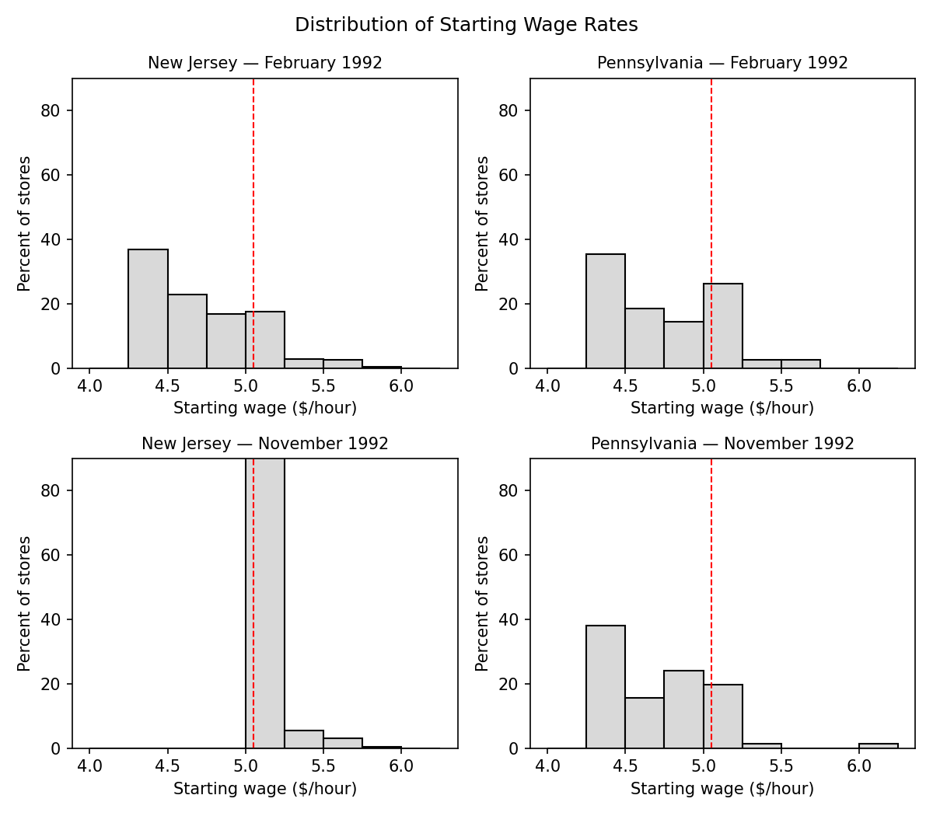
Figure 1. Distribution of starting wages by state and wave. The dashed line marks $5.05.

5. Independent Extension
The extension answers two well-defined questions using methods not in the original paper. The first is a robustness check: does the headline result survive when the normality assumption behind the paper's inference is dropped? The second is a heterogeneity question: is the employment effect of the minimum wage uniform across stores, or is it concentrated in particular types of stores?

5.1 Randomization inference
The paper's inference relies on the asymptotic (normal) distribution of the DiD estimator. Under the sharp null that the minimum wage had no effect on any store's employment, the employment change is exchangeable across stores, so permuting the treatment assignment 10,000 times reconstructs the exact null distribution of the DiD and of the wage-gap coefficient.
Table 6. Randomization-inference p-values (10,000 permutations, seed 42).
Statistic | Observed | t | Asymp. p (2-sided) | Perm. p (1-sided) | Perm. p (2-sided) | n
DiD (NJ − PA ΔFTE) | 2.75 | 2.05 | 0.040 | 0.009 | 0.017 | 384
GAP coefficient | 14.92 | 2.40 | 0.016 | 0.009 | 0.016 | 357

Both statistics remain significant at the 5% level without any distributional assumption. For the DiD, the exact permutation p-value (0.017) is smaller than the asymptotic one (0.040), because the employment-change distribution is non-normal and the asymptotic test is conservative — the result is, if anything, stronger than the paper's normal-based inference.
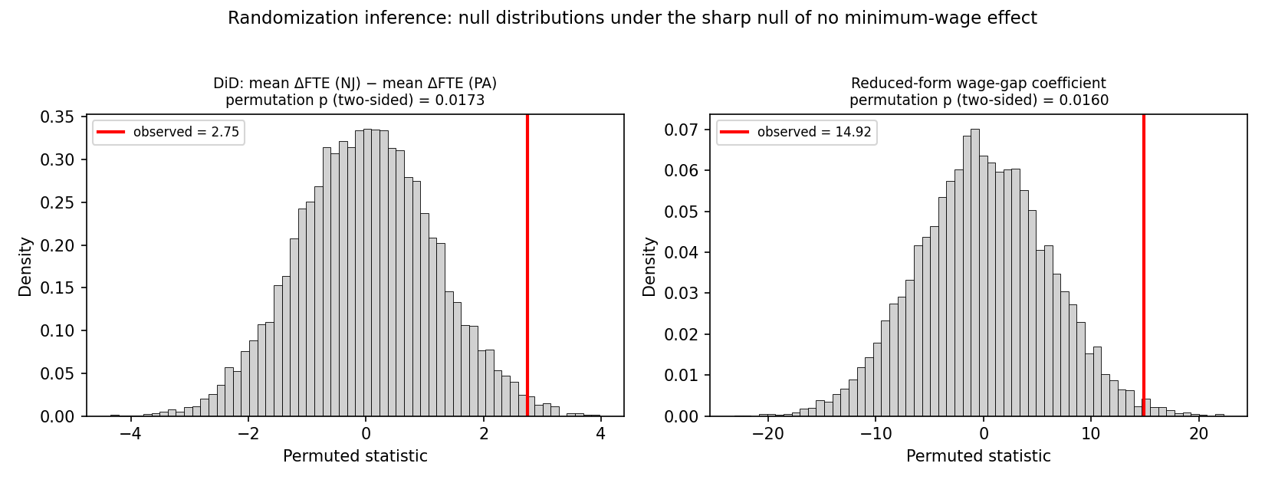
Figure 2. Permutation null distributions (red line = observed statistic).

5.2 Treatment-effect heterogeneity
The second part asks whether the employment effect is uniform or concentrated in particular types of store. The balanced sample is split by four wave-1 (pre-treatment) characteristics — initial wage, store size, ownership and chain — and the DiD is estimated within each subgroup, with an interacted-DiD F test for heterogeneous effects.
Table 7. Heterogeneous treatment effects (DiD within wave-1 subgroups).
Dimension | Subgroup | n (NJ/PA) | DiD | t | Heterog. p
Initial wage | < $5.05 | 268 / 68 | +3.14 | 2.69 | 0.021
 | ≥ $5.05 | 25 / 4 | −7.91 | −1.71
Store size | small (below median) | 156 / 34 | −0.45 | −0.28 | 0.013
 | large (≥ median) | 153 / 41 | +5.09 | 3.35
Ownership | franchise | 201 / 49 | +3.13 | 2.19 | 0.652
 | company-owned | 108 / 26 | +2.04 | 1.04
Chain | Burger King | 126 / 33 | +4.39 | 2.51 | 0.342
 | KFC | 67 / 12 | −1.59 | −0.57
 | Roy Rogers | 77 / 17 | +2.49 | 1.04
 | Wendy's | 39 / 13 | +3.42 | 1.19

The clearest finding is store size: the positive employment effect is concentrated among large stores (+5.09, t = 3.35), while small stores show no relative change (−0.45), a difference that is statistically significant (p = 0.013). Low-wage stores also show a positive effect (+3.14), but the high-wage cell contains only 29 stores (4 in Pennsylvania), so the corresponding heterogeneity p-value (0.021) is driven by a very small cell and should be read cautiously. There is no significant heterogeneity across ownership type (p = 0.65) or chain (p = 0.34).
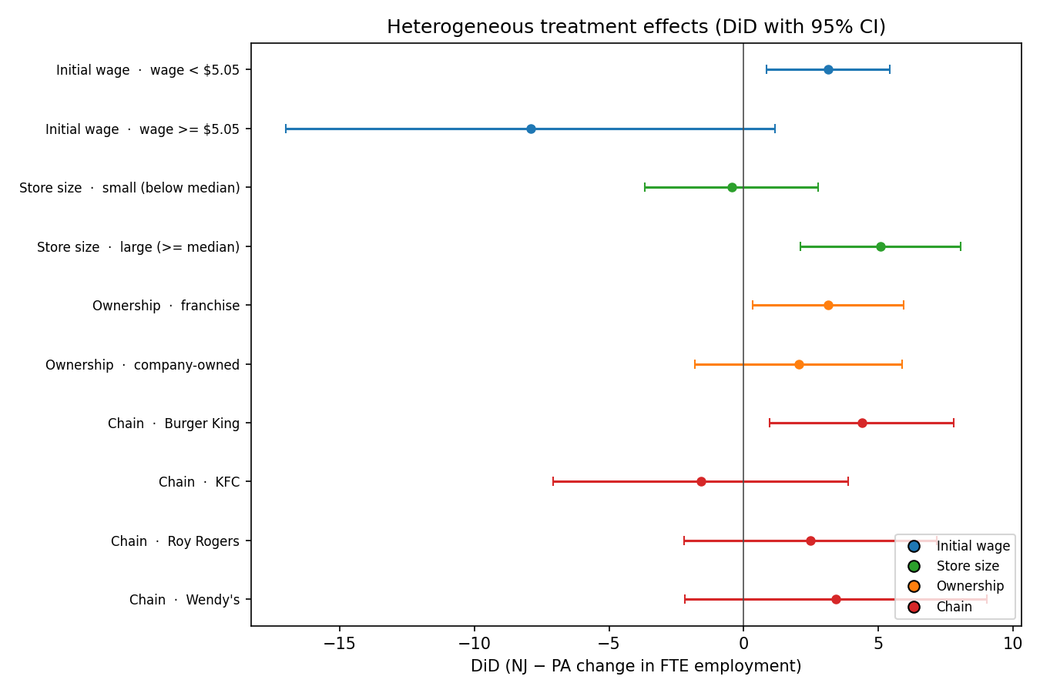
Figure 3. Subgroup DiD estimates with 95% confidence intervals.

6. Validation, Limitations and Conclusion

6.1 Validation
Every headline number was verified against the published tables rather than taken on trust: the reduced-form coefficients (Table 4, columns i–iv), the two checkable non-wage outcomes (+7.3 percentage points and +2.5 weeks) and the price coefficients (Table 7, columns i–iv) all reproduce exactly. The constructed variables were checked against the paper's descriptive statistics — for example, the wave-1 New Jersey share of full-time workers (32.8%) and the 85.5% of NJ stores paying exactly $5.05 in wave 2 both match. This is the basis for confidence that the sample and variable definitions are correct.

6.2 Limitations
Three limitations are worth noting. (1) The balanced DiD is +2.75 rather than the paper's +2.76, a negligible difference attributable to the public data version. (2) The region-augmented specifications (Table 4 column v and Table 7 column v) do not match exactly — the wage-gap coefficient is 11.33 versus 11.91 for employment and 0.083 versus 0.063 for prices — because the public release codes New Jersey regions differently from the paper (the paper reports R² ≈ 0.30 for the wage gap on regions, the public data ≈ 0.13). This affects only the region-augmented columns. (3) Table 8 of the paper (a state-level McDonald's regression using 51 state observations) cannot be replicated because those state-level data are not in public.csv. In addition, the parallel-trends assumption is untestable with only two waves, and the heterogeneity analysis inherits the small cell sizes of the underlying survey.

6.3 Conclusion
This replication reproduces Card & Krueger's central result: the April 1992 New Jersey minimum-wage increase did not reduce fast-food employment, and the point estimate is positive (+2.75 FTE, t = 2.05). The result is robust to alternative employment measures and, as the randomization-inference extension shows, does not depend on normality assumptions. The heterogeneity extension adds a nuance not highlighted in the original paper — the effect is driven by large stores — which is a natural direction for future work.

7. Reproducibility and AI-Assisted Workflow
The analysis is packaged as a single reproducible pipeline. Placing public.csv in data/raw/ and running python code/run_all.py reconstructs the sample, reproduces Tables 1–7 and Figure 1, and runs both extensions — no manual modification of the data or code is required. Generated tables are written to outputs/tables/ and figures to outputs/figures/; the reusable workflow is documented in skills/SKILL.md and the repository structure in README.md.
AI assistance was used throughout the workflow — to explain the paper's design, draft the sample-construction and estimation code, draft this report, and suggest the extensions. Every data choice, variable definition, coefficient and interpretation was verified against the published tables and, where possible, re-derived independently; a full account of how AI-generated output was checked, and of the AI errors that were corrected or rejected, is given in AI_USE_DISCLOSURE.md.

References
Card, D., & Krueger, A. B. (1994). Minimum Wages and Employment: A Case Study of the Fast-Food Industry in New Jersey and Pennsylvania. American Economic Review, 84(4), 772–793.

