

**By:**

**Abdullah Basalamah (****372027433)**

**Abdallah Abu El Soud (****372029223)**

**Abdulkader Al Bai (****372029793)**

**December-2020**

**eMurshid- A platform for academic advising for IU students**

**Graduation Project-1 ( 4932 CCS )**



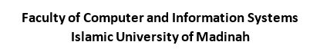

**A c k n o w l e d g m e n t**

What we have done until now, required collaborative work from many people to help build the initial steps of the application, so we would like to thank them for their help.

We thank Dr. Muhammad Shoaib Siddiqui for his supervision on this project, his time that he spent with us to make the steps easier for us. We thank Dr. Mohamed Benaida, Head of AAU, for his time to meet us and to tolerate our many questions. We also thank the students and advisors who helped us, filled the questionnaire, and gave us the right impression of the system.

We thank the presenters of the seminars, Dr. Waqas Nawaz, Dr. Toqeer Ali Syed and Mr. Majed Hariri for their efforts in helping us using their expertise in different areas and enlighten us about the graduation project.

**D E C L A R A T I O N**

We, hereby, certify that this material, which we now submit for assessment on the program of study leading to the award of Bachelor of Science in Computer Science is entirely our own work, that we have exercised reasonable care to ensure that the work is original, and does not, to the best of our knowledge, breach any laws of copyright, and has not been taken from the work of others save and to the extent that such work has been cited and acknowledged within the text of our work.

|  |  |  |
| --- | --- | --- |
| Student ID: 372027433 | Name: Abdullah Basalamah | Signature WhatsApp Image 2020-10-07 at 11.06.11 AM |
| Student ID: 372029223 | Name: Abdallah Abu El Soud | Signature |
| Student ID: 372029793 | Name: Abdulkader Al Bai | Signature WhatsApp Image 2020-10-07 at 11.13.22 AM |
| Date: March 14th 2021 | | |

**A B S T R A C T**

Academic advising is an important and influential process in the student’s academic career, which consists of various tools and approaches to make it an effective and efficient process. In the current academic advising system at the Faculty of Computer and Information Systems, there are various issues, such as, communication gap between students and their advisors, dependency on a lot of paperwork and personal meetings, and the unavailability of a consistent methodology to maintain advising related information, which makes the current academic advising process less effective, inconvenient, inconsistent, and unscalable.

This report describes the analysis, design and development of a platform that supports the process of academic advising. The objective of the system is to minimize paper use, reduce the communication gap, decrease repetitive tasks performed by the students and the advisors, make advising related information available in a single place in electronic format, and to make the advising process scalable and more consistent.

The system supports different user types (advisors, students, advising unit, deans), each of which has different privileges. The users may use the system to access advising related information, contact advisors or students, set appointments, and resolve academic issues.

# **T a b l e** **o f** **C o n t e n t s**

T a b l e o f C o n t e n t s 4

L i s t o f F i g u r e s 5

L i s t o f T a b l e s 6

L I S T OF AC R O N Y M S /AB B R E V I AT I O N S 7

1- C h a p t e r O n e : 8

1.1 Introduction 8

1.2 Problem Statement 9

1.3 Objectives 9

1.4 Scope 10

1.5 Methodology 10

1.6 Project Plan 11

1.7 TimeLine 12

Chapter 2: Information Gathering 13

2.1 Gathering Information about the Current System 13

**2.1.1 Interview** 14

**2.1.2 Surveys** 16

**2.1.3 Current System Review** 28

2.2 Literature Review: Similar Applications and Research Papers 29

2.3 Description of Each Application 30

**2.3.1 Application Name: PSAU - Academic Transaction [4]** 30

**2.3.2 Application Name: King Khaled Univ – Academia [5]** 31

**2.3.3 Application Name: Student Counsellor [6]** 32

**2.3.4 Application Name: ConexED [7]** 33

**2.3.5 Application Name: Navigate [8]** 33

**2.3.6 Research Paper Title: AdviseMe: An Intelligent Web-Based Application for Academic Advising [1]** 33

**2.3.7 Research Paper Title: Development of Academic Advising System [2]** 33

**2.3.8 Research Paper Title: HE-Advisor: A multidisciplinary web-based higher education advisory system [3]** 34

2.4 Feature Analysis of the Reviewed Applications 35

Chapter 3: Requirement Analysis: 36

3.1 Functional Requirement 36

3.2 Non-Functional Requirement 38

3.3 System Requirement 39

**3.3.1 Hardware** 39

**3.3.2 Software** 39

Conclusion: 40

References: 41

# **L i s t o f F i g u r e s**

Figure 1 - Objectives of the eMurshid Project 9

Figure 2- Methodology used in this project is based on the Waterfall model 10

Figure 3- Timeline view of the project plan’s GANTT Chart 12

Figure 4 The methods used to gather requirement specifications 13

Figure 5 - Actual Note taken from our meeting with Dr. Mohamed Benaida 15

Figure 6 - choose the language -Student 16

Figure 7 - is Academic Advising useful ? - Student 17

Figure 8 – the benefit of Academic Advising - Student 17

Figure 9 – Is the current System is useful? - Student 18

Figure 10 – Did you know your Academic Advisor? - Student 18

Figure 11- How you Tried to Contact With AA? - Student 19

Figure 12 – The Issues of AAS : - Student 20

Figure 13 -Is The APP will Reduce the Issues - Student 21

Figure 14- The functionalities that you want to Add - Student 21

Figure 15 – Is it beneficial to use the App for communication?  - Student 22

Figure 16 – Is Academic Advising useful? - Doctors 23

Figure 17 – Do you know benefits of Academic Advising? - Doctor 23

Figure 18 – Is the current AAS useful? - Doctor 24

Figure 19 – Do you know which students do you have?- Doctor 24

Figure 20 – Have you tried to contact your students? - Doctor 25

Figure 21 – What are the issues in AAS? - Doctor 26

Figure 22- Do you think an App would be beneficial? - Doctor 26

Figure 23- What functionalities should be in AAS? - Doctor 27

Figure 24 - Is it beneficial to use the App for communication? - Doctors 28

Figure 25 - Sample pictures from the PSAU App showing Academic Transactions 30

Figure 26 - Sample pictures from the King Khaled Univ – Academia App showing Academic Transactions 31

Figure 27 - Sample pictures from the Student Counsellor App showing Academic Transactions 32

Figure 28 - Requirement Analysis Hierarchy 36

Figure 29 - Non-Functional Requirements of the eMurshid Project 38

# **L i s t** **o f** **T a b l e s**

Table 1 - Project Plan 11

Table 2 - Student Questionnaire 16

Table 3 - Doctors Questionnaire 23

Table 4 - Similar Applications and Related Search Papers 29

Table 5 - Feature Analysis of the Reviewed Application 35

Table 6 - Types of Users in the System 37

Table 7 - Functional Requirement 37

# **L I S T OF AC R O N Y M S /AB B R E V I AT I O N S**

AAS: Academic Advising System.

AA: Academic Advisor.

A.M.B: Abdulkader Mohammed Al Bai.

A.H.S: Abdullah Hasan Abu El-Soud.

A.S.B: Abdullah Salim Basalamah.

AAU: Academic Advising Unit

FCIS: Faculty of Computer and Information System

IU: Islamic University

PSAU: Prince Sattam bin Abdulaziz University

# **1- C h a p t e r O n e :**

## 1.1 Introduction

Academic Advising System (AAS) is a common service that is provided in most universities. This service connects a group of students with an advisor who helps the students grow in different educational areas. The advisor can guide the student until he finishes graduation requirements and even after the graduation as a career counsellor.

Students are aided by advisors whom they have experience in the educational field so they can provide solid information which helps students make right decisions. When the student faces issues and needs help, the Advisor can help him pass these difficulties and maintain his performance. Adding to that, the advisor can help students achieve long-term pursuits as well.

For AAS to work properly, every participant has responsibilities he has to do. For the advisor, he is entrusted with following:

* Provide support to students in a time of need.
* Keep track of students’ performance.
* Help students pick their majors.
* Illustrate program requirements for students.
* Explain university and college regulations.
* Give students a boost to increase their study level.
* Help students on their long-term plans.

As for the responsibilities that lies on the student, he must do the following:

* He must meet his advisor 3 times each semester, at the start of the semester, after midterms and during/before final exams.
* He must know his advisor.
* He must know when his advisor is available.
* Fill the required forms at its time.
* Your first person to go to is the advisor then you can escalate to the Advising Unit, Vice Dean, or the Dean (if necessary).
* In case of an excuse (for absence in class or exam) the student must get recommendation from his advisor.

As for the advising unit they have the following responsibilities:

* They should monitor the process between advisors and their students.
* In case of any conflicts, they should interfere to provide solutions.
* They should arrange meet-ups for newer students and raise awareness about academic advising.

## 1.2 Problem Statement

There is a communication gap between the students and their academic advisor, which is a hurdle in monitoring the progress of the students and providing them with guidance and support. Sometimes, a student does not arrive at the counselors' offices until the middle of the semester. Counselors cannot begin diagnosing and correcting communication problems if students do not interact with them.

The new students are unaware of the advising System and its benefits and with each start of a new semester, a student is given a list of tasks to perform, which increases the paperwork, and he must do the same list for each semester because there is no platform for storing information.

The current academic advising system is not scalable as the information related to academic advising is not available at a single place and in some cases, if the student needs to meet the academic advisor, it is not possible to know if he is available or not.

## 1.3 Objectives

The Objectives of the project are as follows:

1. To minimize paper use,
2. To reduce the communication gap,
3. To decrease repetitive tasks performed by the students and the advisors,
4. To make advising related information available in a single place in electronic format, and
5. To make the advising process scalable and more consistent.

## 

Figure - Objectives of the eMurshid Project

## 1.4 Scope

An application that provides a communication platform for the students and their advisors with a centralized database of academic and advising information, which can facilitate both the students and advisor to benefit from the academic advising system. The app would also reduce the paperwork and introduce scalability and consistency to the advisory process.

## 1.5 Methodology

In our project, waterfall model methodology was chosen, due to the clarity of the project’s features and its full dimensions in all its main and subsidiary stages. These reasons all mentioned are consistent with how the waterfall methodology works.

Waterfall model is based on dividing the work into fixed, sequenced stages, so that each stage. Starts Carrying out its tasks and after completion it will be available to move to the next stage. One of the reasons for choosing is also the work environment at the university that depends on the clarity of its projects before deciding on them, and the context is based on systems used as a communication system or a messenger system, all of which are in line with the waterfall model, perspective in terms of planning, requirements, analysis, design, implementation, verification, and therefore selection, is the compatibility of all these requirements with the system being manufactured and university system.

Figure - Methodology used in this project is based on the Waterfall model

## 1.6 Project Plan

Table - Project Plan

|  |  |  |  |  |  |  |
| --- | --- | --- | --- | --- | --- | --- |
| **Task ID** | **Task Name** | **Assigned To** | **Start Date** | **Due Date** | **Duration** | **Status** |
| 1 | Project Conception and initiation |  | 17/01/2021 | 05/02/2021 | 20 |  |
| 1.1 | Problem Statement | A.HS | 17/01/2021 | 19/01/2021 | 3 | COMPLETED |
| 1.2 | Goal | A.HS | 20/01/2021 | 23/01/2021 | 4 | COMPLETED |
| 1.3 | Project Objectives | A.HS | 24/01/2021 | 28/01/2021 | 5 | COMPLETED |
| 1.4 | Project Planning | A.MB | 29/01/2021 | 04/02/2021 | 7 | COMPLETED |
| 1.5 | Methodology | A.MB | 04/02/2021 | 05/02/2021 | 1 | COMPLETED |
| 2 | Analysis & Requirement Specification |  | 06/02/2021 | 12/03/2021 | 35 |  |
| 2.1 | Requirement Gathering |  | 06/02/2021 | 20/02/2021 | 19 | COMPLETED |
| 2.1.1 | Literature Review | A.HS, A.SB, A.MB | 06/02/2021 | 14/02/2021 | 9 | COMPLETED |
| 2.1.1.1 | Review Similar Apps | A.HS, A.SB, A.MB | 06/02/2021 | 2/10/2021 | 5 | COMPLETED |
| 2.1.1.2 | Gather Related Research Papers | A.MB, A.SB | 11/02/2021 | 14/02/2021 | 4 | COMPLETED |
| 2.1.2 | Survey (Students/Faculty Members) | A.MB, A.HS, A.SB | 15/02/2021 | 23/02/2021 | 9 | COMPLETED |
| 2.1.3 | Interview the Head of AAU | A.MB, A.HS, A.SB | 24/02/2021 | 24/02/2021 | 1 | COMPLETED |
| 2.2 | Requirement Analysis | A.HS, A.SB, A.MB | 25/02/2021 | 03/03/2021 | 7 | COMPLETED |
| 2.3 | Requirement Specifications | A.MB - A.SB | 04/03/2021 | 13/03/2021 | 9 | COMPLETED |
| 2.3.1 | Functional Requirements | A.SB | 04/03/2021 | 08/03/2021 | 6 | COMPLETED |
| 2.3.2 | Non-Functional Requirements | A.MB | 09/03/2021 | 12/03/2021 | 3 | COMPLETED |
| 3 | Design |  | 19/03/2021 | 07/04/2021 | 20 |  |
| 3.1 | Use-Case Diagrams | A.SB - A.HS | 19/03/2021 | 25/03/2021 | 7 | TO-DO |
| 3.2 | Sequence Diagrams | A.MB | 19/03/2021 | 23/03/2021 | 5 | TO-DO |
| 3.3 | Data Base Diagrams | A.SB - A.MB | 24/03/2021 | 30/03/2021 | 7 | TO-DO |
| 3.4 | Class Diagrams | A.HS - A.MB | 25/03/2021 | 31/03/2021 | 7 | TO-DO |
| 3.5 | Deployment Diagrams | A.SB | 31/03/2021 | 06/04/2021 | 7 | TO-DO |
| 3.6 | Interface Diagrams | A.HS | 01/04/2021 | 07/04/2021 | 7 | TO-DO |
| 4 | Implementation |  | 04/8/2021 | 04/29/2021 | 22 |  |
| 4.1 | Interfaces | A.HS - A.MB | 04/8/2021 | 04/16/2021 | 9 | TO-DO |
| 4.2 | Navigation | ِA.SB - A.HS | 04/17/2021 | 04/24/2021 | 8 | TO-DO |
| 4.3 | Database Tables | A.MB -A.SB | 04/25/2021 | 04/29/2021 | 5 | TO-DO |

## 1.7 TimeLine

The following figure shows a glance of the GANTT chart of our project plan, which is presented in the Table above.

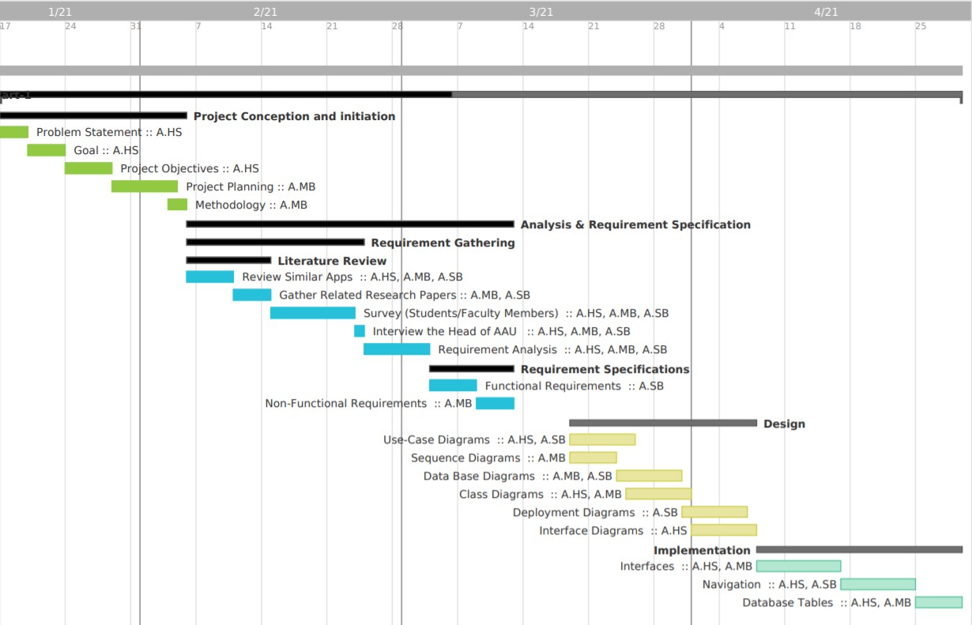

Figure 3- Timeline view of the project plan’s GANTT Chart

# **Chapter 2: Information Gathering**

In this chapter, we discussed the details of how we performed information gathering for identifying the requirement specification of our project. Information gathering is one of the most important steps in software development phase and as we are using a waterfall model as the software development lifecycle, we are required to finalize our requirements before we could continue to the design phase. If we miss any functional requirement in our information gathering phase, then we would not be able to incorporate it in our design later on.

Figure The methods used to gather requirement specifications

## 2.1 Gathering Information about the Current System

Gathering information is a very crucial phase in knowing the details of the system, which will strongly affect other phases since we are using the waterfall methodology, to get a better understanding of the system we had to gather information about it, so that our analysis could be correct and complete. In order to gather information of the system we had to communicate with all entities involved the academic advising process to get their point of view of how the current system is running and how the system could be improved. We used two techniques to perform information gathering:

1. Interviews
2. Questionnaire and Surveying

### **2.1.1 Interview**

We have consulted with Dr. Mohamed Benaida, who is the Head of the Academic Advising Unit (AAU) in the Faculty of Computer & Information Systems (FCIS) in the Islamic University of Madinah. An Interview was conducted with him during the information gathering phase in which, the following questions were asked:

* Who are the main actors in the academic advising process? And what is the role of each of them?
* How does the current system work?
* What are the most common problems in the current system?
* Is the advising related information is easily accessible and transferable?
* Is the current system scalable?

According to Dr. Mohamed Benaida:

* The academic advising process consists of four actors: students, advisors, academic advising unit, and the Dean or Vice Dean.
* In the current system most tasks are repetitive and done manually and require coordination between actors and face to face meetings
* The current system is inconsistent and not scalable.
* Files are saved in paper form in various places and not easily accessible and in some cases, some files are lost due to change of an advisor.

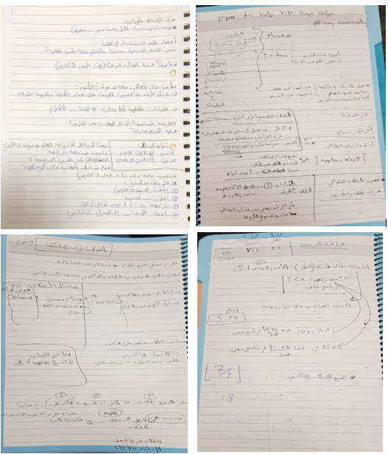

Figure - Actual Note taken from our meeting with Dr. Mohamed Benaida

### **2.1.2 Surveys**

Two surveys were conducted, one was dedicated to the students and the other one to the advisors. The surveys contained questions that targeted the main and crucial points that affect the academic advising process, the responses confirmed that there is a need for a system to facilitate the process of academic advising system.

We conducted a survey for the student and doctors, and these tables show the analysis of the answers.

##### **2.1.2.1 Analysis for Student Responses:**

Table - Student Questionnaire

|  |  |  |
| --- | --- | --- |
| The Question | Choices | The Statistics |
| Choose the language | English        Arabic | Figure - choose the language -Student |
| Do you think Academic Advising is useful? | Yes      No | Figure - is Academic Advising useful ? - Student |
| Do you know the benefits of Academic Advising? | Yes      No | Figure – the benefit of Academic Advising - Student |
| Do you think the current Academic Advising system at FCIS-IU is useful? | Maybe    Yes      No | Figure – Is the current System is useful? - Student |
| Do you know who is your academic advisor? | Yes      No | Figure – Did you know your Academic Advisor? - Student |
| Have you tried to find/contact your Advisor? | I never tried  I went to his office  I tried to contact him on Phone  I tried to contact him on WhatsApp | Figure - How you Tried to Contact With AA? - Student |
| Has your Advisor tried to contact you? | No – Never   Yes: He contacted me in my class   Yes: He tried to contact me on Phone   Yes: He tried to contact me on WhatsApp  Yes: He tried to contact me on Email | Figure 11- Has the Advisor contact With You ? – Student |
| What are the issues in the current Academic Advising system at FCIS-IU? | Advisor is not available      Advising system is not beneficial     Advisor doesn’t help me      It’s hard to find my advisor     There is no appointment system for meeting my advisor | Figure – The Issues of AAS : - Student |
| Do you think a web or mobile application can reduce issues of the current Academic Advising system at FCIS-IU? | Yes  No | Figure -Is The APP will Reduce the Issues - Student |
| What functionalities do you think should be available in the Academic Advising App? | Inform the student who is his Advisor  Send/ Receive messages to the Advisor  Submit Documents online  Apply for Absent Excuse  Apply for Make-up Exam  Ask for an advice from the faculty member  Make an appointment with the advisor | Figure - The functionalities that you want to Add - Student |
| Do you think using the App for communication with the Advisor would make the system easier to use/ beneficial? | Yes      No | Figure – Is it beneficial to use the App for communication?  - Student |

##### **2.1.2.2 Analysis for Doctors’ Responses:**

Table - Doctors Questionnaire

|  |  |  |
| --- | --- | --- |
| The Question | Choices | The Statistics |
| Do you think Academic Advising is useful for students? | Yes      No | Figure – Is Academic Advising useful? - Doctors |
| Do you know the benefits of Academic Advising? | Yes      No | Figure – Do you know benefits of Academic Advising? - Doctor |
| Do you think the current Academic Advising system at FCIS-IU is useful? | Yes    Maybe      No | Figure – Is the current AAS useful? - Doctor |
| Do you know who the students are under your academic advising? | Yes      No | Figure – Do you know which students do you have?- Doctor |
| Have you tried to contact your students? | No – Never  Yes: I contacted them in my class  Yes: I tried to contact them on Phone  Yes: I tried to contact them on WhatsApp  Yes: I tried to contact them on Email | Figure – Have you tried to contact your students? - Doctor |
| What are the issues in the current Academic advising system at FCIS-IU? | Students are not available    Advising system is not beneficial    Students don’t need help    It’s hard to find/contact my students    The details of students are not available    There is no appointment system for meeting your students | Figure – What are the issues in AAS? - Doctor |
| Do you think a web or mobile application can reduce issues with the current Academic Advising system at FCIS-IU? | Yes      No | Figure - Do you think an App would be beneficial? - Doctor |
| What functionalities do you think should be available in the Academic Advising App? | Inform the student who is his Advisor  Send/Receive messages to the Students  Student should be able to submit Documents online  Student should be able to Apply for Absent Excuse, Make-up Exam, etc. through the App  Student should be able to ask for an advice through the App | Figure - What functionalities should be in AAS? - Doctor |
| Do you think using the App for communication with the Student would make the system easier to use/ beneficial? | Yes      No | Figure - Is it beneficial to use the App for communication? - Doctors |

### **2.1.3 Current System Review**

The current system that is implemented in the faculty of computer science is manual. Each students’ submission requires the face-to-face meeting. And in some cases, it needs to be reviewed by the advising unit and advising committee.

In case any part could not attend the meeting then the advising process is delayed. This alone stands as a hurdle in the academic process and requires the necessary information about the student status. Whenever a student has difficulties with filling this information, the advisor will not be able to track the student's progress which will prevent him from seeing any problem that can be avoided.

Another important aspect is the responsibility that lies in the academic advising unit since they need to collect academic information for each student and then make a full report about it. Which makes it a time and effort consuming process.

## 2.2 Literature Review: Similar Applications and Research Papers

In the following section, we will discuss similar application that is close to our idea which is AAS. In addition to the application there are some other research papers that discusses this problem in other universities like Taiba university. The following Table shows the different applications and research papers. Then we will review each app with its functionalities. After that we will show a comparison of each application including ours.

Table - Similar Applications and Related Search Papers

|  |  |  |  |
| --- | --- | --- | --- |
| **S.No.** | **Application Name / Research Paper Title** | **Developer/writer** | **Main Functions** |
| 1 | PSAU - Academic Transaction [4] | ATS (Adaptive TechSoft) | login, see information, His student plan, Course withdrawal, His registered courses, Offered courses |
| 2 | King Khaled Univ – Academia [5]  ‏ | ATS (Adaptive TechSoft) | login, see registered courses, can see detailed course information |
| 3 | Student Counsellor[6] | Tetrasoft Development | Login, take exams to determine his major, see list of available universities. |
| 4 | ConexED [7] | Conex corporate | Appointment scheduling, Virtual meetings, Instant messaging, Student success plans, Data and analytics for reporting. |
| 5 | Navigate [8] | University of Houston | Make Appointments, Resolve enrollment issues, degree planner, list of to-dos, events remainder |
| 6 | AdviseMe: An Intelligent Web-Based Application for Academic Advising [1] | Henderson, L., K., & Goodridge, W | View list of guessed courses, one place to view student’s data by advisors, request an advisor, view student graduation status, place comments on student file for future use |
| 7 | Development of Academic Advising System [2] | Gharaibeh, Natheer K | view information about student and student’s study plan, students to send and receive reports about their academic problems, advisors give guidance to students, managers check inbox messages, assign advisors for each student, student contact the academic unit |
| 8 | HE-Advisor: A multidisciplinary web-based higher education advisory system [3] | Ishak, Isma B., and Mohd Lezam B. Lehat | Student see Transcript, Timetable, next semester courses, graduation progress, profile, students rank, study plan  Advisor can see list of students, expected graduates and graduates and his profile |

## 2.3 Description of Each Application

This section discusses each application with some of its features and interfaces.

### **2.3.1 Application Name: PSAU - Academic Transaction [4]**

**Publisher**: ATS (Adaptive TechSoft)

**Link**: <https://play.google.com/store/apps/details?id=com.ats.android.sau.student.app&hl=en_US&gl=US>

**Description**: this mobile application allows the student to see his academic information together with some other information that are related to his education. It adds other features like seeing the courses that he is currently enrolled in.

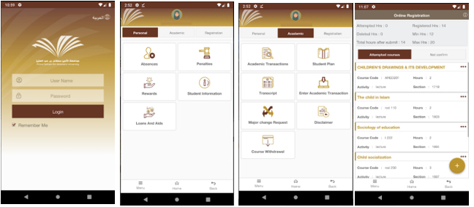

Figure - Sample pictures from the PSAU App showing Academic Transactions

### **2.3.2 Application Name: King Khaled Univ – Academia [5]**

**Publisher:** ATS (Adaptive TechSoft)

**Link**: <https://play.google.com/store/apps/details?id=com.ats.android.kku.student.app&hl=en_US&gl=US>

**Description**: this app allow the student to see his personal information is similar to PSAU - Academic Transaction since the same company has developed both applications.

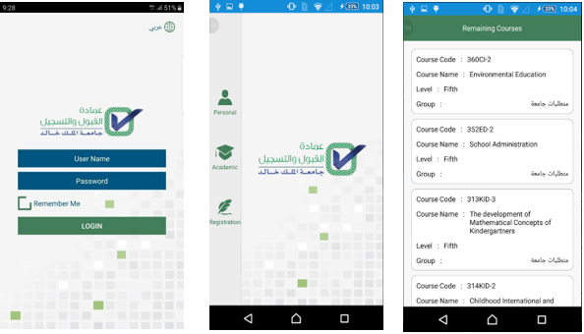

Figure - Sample pictures from the King Khaled Univ – Academia App showing Academic Transactions

### **2.3.3 Application Name: Student Counsellor [6]**

**Publisher:** Tetrasoft Development

**Link:** <https://play.google.com/store/apps/details?id=com.tetra.asad.myapplication&hl=en_US&gl=US>

**Description**: This app allow a student to take exams to determine his path and passion. It provides a set of universities and their majors they teach. The test is used as a guiding method for the student to order they take the right direction for themselves. There is no a person advisor except for the test.

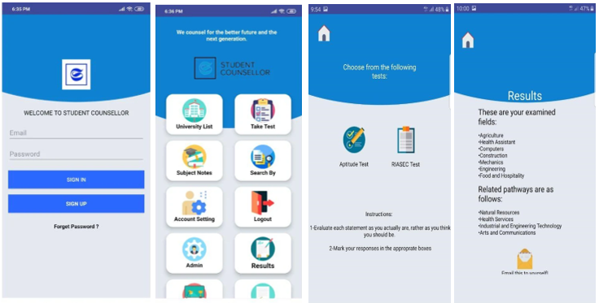

Figure - Sample pictures from the Student Counsellor App showing Academic Transactions

### **2.3.4 Application Name: ConexED [7]**

**publisher:** ConexED corporate

**Link:** <https://www.conexed.com/>

**Description:** this app provides meeting rooms that works like zoom, skype.. Etc. , messaging services, appointment system,queue management service, data analytics.

### **2.3.5 Application Name: Navigate [8]**

**publisher: University of Houston**

**Link:** [**https://uh.edu/ussc/navigate/**](https://uh.edu/ussc/navigate/)

**Description:** this app provides To-Dos lists, appointment system where students can make appointments with advisors and other support offices, academic calendar, Academic Planner where students can plan their degree, get feedback from their advisor, ability to integrate class schedules, data analytics.

### **2.3.6 Research Paper Title: AdviseMe: An Intelligent Web-Based Application for Academic Advising [1]**

**Description**: present an intelligent web-based application that provides a reliable, user-friendly interface for handling of general advisory cases in special degree programs offered by the Faculty of Science and Technology (FST) at the University of the West Indies (UWI), St. Augustine campus. In addition, it grants information on handling basic student problems, the system’s core features are course advising, along with information of graduation status and oral exam qualifications. The researchers build an overview of the solution, with decent attention being paid to the inference system exposed via its restful Java Web Server (JWS).

### **2.3.7 Research Paper Title: Development of Academic Advising System [2]**

**Description**: constructs a spreadsheet-based Decision Support Tool for Academic Advising. To better apply technology in the advising process and to make the repetitive tasks in advising students automated. The researcher built the tool using VBA scripts and Microsoft Excel, the system automates some repetitive tasks in the advising process by operating functions such as GPA calculation., the system operation demand two excel documents to be given access to by the department; the first is a full schedule of the study program and the second is a translation of the student transcript, since the system is not integrated with the student information system.

### **2.3.8 Research Paper Title: HE-Advisor: A multidisciplinary web-based higher education advisory system [3]**

**Description**: introduces a web-based multidisciplinary advising system that can be used by students, advisors, course timetable planners, and heads of departments. Students are given educational advice through web-based services to help them take the right decisions in thier academic career. Services, like applying for courses; a dependency graph illustrating their progress in their degree plan; a GPA calculator to help students on probation determine the grades they should attain in the newly registered semester; information associated to their graduation requirements; their expected graduation term; and other services. Advisors and heads of departments can keep track on students’ progress towards their graduation and can to generate a collection of beneficial reports and statistics.

## 2.4 Feature Analysis of the Reviewed Applications

The following table provides comparison of features available in each of the reviewed application or research paper. We have considered the presented features and compared it with our application.

Table - Feature Analysis of the Reviewed Application

|  |  |  |  |  |  |  |  |  |
| --- | --- | --- | --- | --- | --- | --- | --- | --- |
| **No.** | **Application Name** | **AAU can**  **Add students or advisors** | **Advisor can start discussion with a student** | **Student can reserve an appointment with his advisor** | **Student can start discussion with the advisor** | **Student / advisor can edit his profile** | **Initialize reports about student status** | **Adding courses to**  **the schedule** |
| 1 | PSAU - Academic Transaction [4] | N | N | Y | N | Y | N | Y |
| 2 | King Khaled Univ – Academia [5] | N | N | Y | N | Y | N | Y |
| 3 | Student Counsellor [6] | N | N | N | N | Y | N | N |
| 4 | ConexED [7] | N | Y | Y | Y | N | Y | N |
| 5 | Navigate [8] | N | N | Y | N | N | Y | Y |
| 6 | AdviseMe: An Intelligent Web-Based Application for Academic Advising[1] | Y | N | Y | N | Y | Y | Y |
| 7 | Development of Academic Advising System[2] | Y | Y | Y | Y | N | N | N |
| 8 | HE-Advisor: A multidisciplinary web-based higher education advisory system[3] | N | N | N | N | Y | Y | Y |
| 9 | eMurshid | Y | Y | Y | Y | Y | Y | N |

# **Chapter 3: Requirement Analysis**:

Requirement Analysis is an essential part in specifying what are the real needs of the customer. During this phase we analyzed the data that we gathered, then we come with functionalities that the system should implement. The Functional Requirements are the core services of the system which the system cannot operate without it while the Non-Functional Requirements are relative improvements to the system.

Figure - Requirement Analysis Hierarchy

## 3.1 Functional Requirement

The eMurshid application would allow the users to perform the following functionalities in the system:

* Users can login and logout to and from their accounts.
* Student can contact his advisor.
* Student can update his academic data through the application.
* Advisors can see the students’ data (marks, attendance status, etc. ).
* Advisors can initiate a message to all students or a specific student.
* Advising Unit can assign advisors to students.
* Student can apply for absence/exam excuse.
* Application generates reports for the advising unit.

The eMurshid app would have four types of users:

Table - Types of Users in the System

|  |  |
| --- | --- |
| Users of the system | Student |
| Advisor |
| Admins/(AAU) |
| Vice Dean/ Dean |

The following table shows the detailed information of the functional requirement of each user present in the system:

Table - Functional Requirement

|  |  |
| --- | --- |
| Admins/(AAU) | **-** Can add advisors to the system  **-** Can add students to the system  **-** Can assign student to an advisor  **-** Can approve registration of student/advisor  - Can show complaints from student/advisor  **-** Can resolve complaints |
| Student | **-** Can create user / register into the system  **-** Can edit his profile  **-** Can submit his marks to the system  **-** Can submit his attendance report  **-** Can request / cancel appointment  **-** Can submit query or start discussion  - Can search query discussion  - Can create compliant against advisor to AAU  - Can create excuse (absence, exam, etc.) |
| Advisor | **-** Can create use / register  **-** Can edit profile  - Can show students (details, SPI, academic)  - Can request attendance report  - Can request Marks/ results  - Can create, approve, edit, cancel appointment  - Can start discussion / submit query  - Can search query discussion  - Can create complaint against student to AAU  - Can recommend excuse (absence, exam, etc.) |
| Dean/ Vice Dean | - Can search/show excuses requested by students  - Can approve/disapprove excuse  - Can show/search complaints from student/advisor  **-** Can resolve complaints |

## 3.2 Non-Functional Requirement

1. **Authorization:** Users are authorized using an ID and password to access the system.
2. **Efficiency:** The system should be quick at responding to the various requests of the user.
3. **Reliability:** the capability of an application to execute its expected functions and operations in a system's environment, without facing failure (system crash).
4. **Availability:** The system would be accessible during any time.
5. **Security:** The users would be authenticated and authorized using their ids and passwords; while data integrity and confidentiality would be supported.
6. **Performance**: The system should have high performance in dealing with different user requests.

Figure - Non-Functional Requirements of the eMurshid Project

## 3.3 System Requirement

### **3.3.1 Hardware**

To use the system, the user should use a

* Laptop or PC
* Browser of his/her choice, and
* Internet connection

### **3.3.2 Software**

* User requirements:

User can access the system using an Internet connection and Laptop or pc

* Developer requirements:

Development of the application would be done through:

* HTML, CSS, JavaScript as the frontend
* NodeJS as the Backend
* NoSQL DB: mongo DB for the database

# **Conclusion:**

Academic Advising System (AAS) is a common service that is provided in most universities. This service connects a group of students with an advisor who helps the students grow in different educational areas. The advisor can guide the student until he finishes graduation requirements and even after the graduation as a career counsellor.

In the current academic advising system at the Faculty of Computer and Information Systems, there are various issues, such as, communication gap between students and their advisors, dependency on a lot of paperwork and personal meetings, and the unavailability of a consistent methodology to maintain advising related information, which makes the current academic advising process less effective, inconvenient, inconsistent, and unscalable.

In this report, we discuss the analysis, and requirement specification of our project eMurshid platform that would support the process of academic advising. The objective of the system is to minimize paper use, reduce the communication gap, decrease repetitive tasks performed by the students and the advisors, make advising related information available in a single place in electronic format, and to make the advising process scalable and more consistent.

Currently, we have completed the Analysis and requirement specification of the project and focusing on the design of the system. Till the end of the semester, we are targeting 10-20 percent completion of implementation phase.

# **References:**

1. Henderson, L., K., & Goodridge, W., " AdviseMe: An Intelligent Web-Based Application for Academic Advising", International Journal of Advanced Computer Science and Applications (IJACSA), Vol. 6, No. 8, 2015.
2. Gharaibeh, Natheer K. "Development of Academic Advising System."
3. Albalooshi, Fawzi, and Safwan Shatnawi. "HE-Advisor: A multidisciplinary web-based higher education advisory system." *Global Journal of Computer Science and Technology* (2010).
4. “PSAU - Academic Transaction - Apps on Google Play.” Google. Google. Accessed March 13, 2021. https://play.google.com/store/apps/details?id=com.ats.android.sau.student.app&hl=en_US&gl=US.
5. “King Khaled Univ - Academia - Apps on Google Play.” Google. Google. Accessed March 13, 2021. https://play.google.com/store/apps/details?id=com.ats.android.kku.student.app&hl=en_US&gl=US.
6. “Student Counsellor - Apps on Google Play.” Google. Google. Accessed March 13, 2021. https://play.google.com/store/apps/details?id=com.tetra.asad.myapplication&hl=en_US&gl=US.
7. “ConexED Student Services Communications Platform.” Student Services Communications Platform, March 10, 2021. https://www.conexed.com/.
8. “UH EAB Navigate Resources.” University of Houston, November 3, 2020. https://www.uh.edu/ussc/navigate/.