1. (STEP 11) Take a screenshot showing you scored 100% on mini-quiz - refresh screen if you scored lower to try again

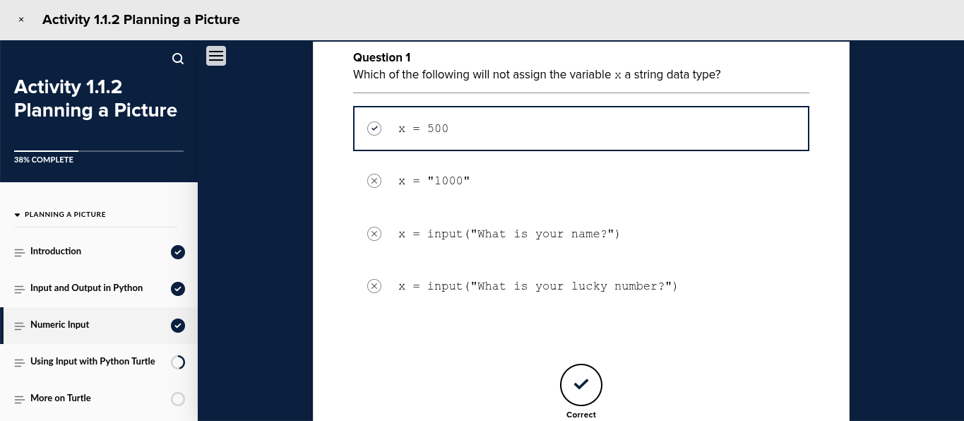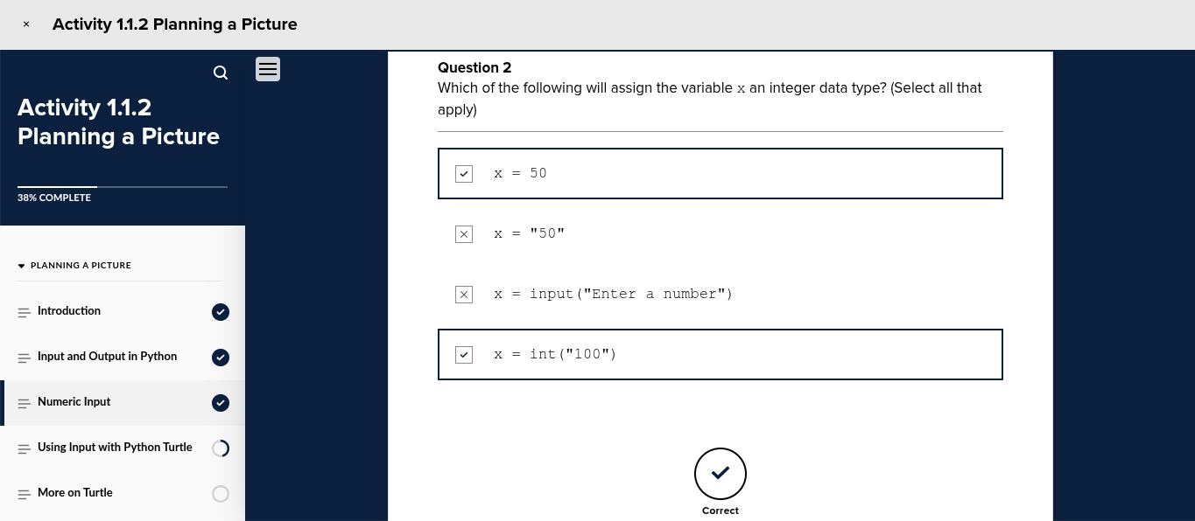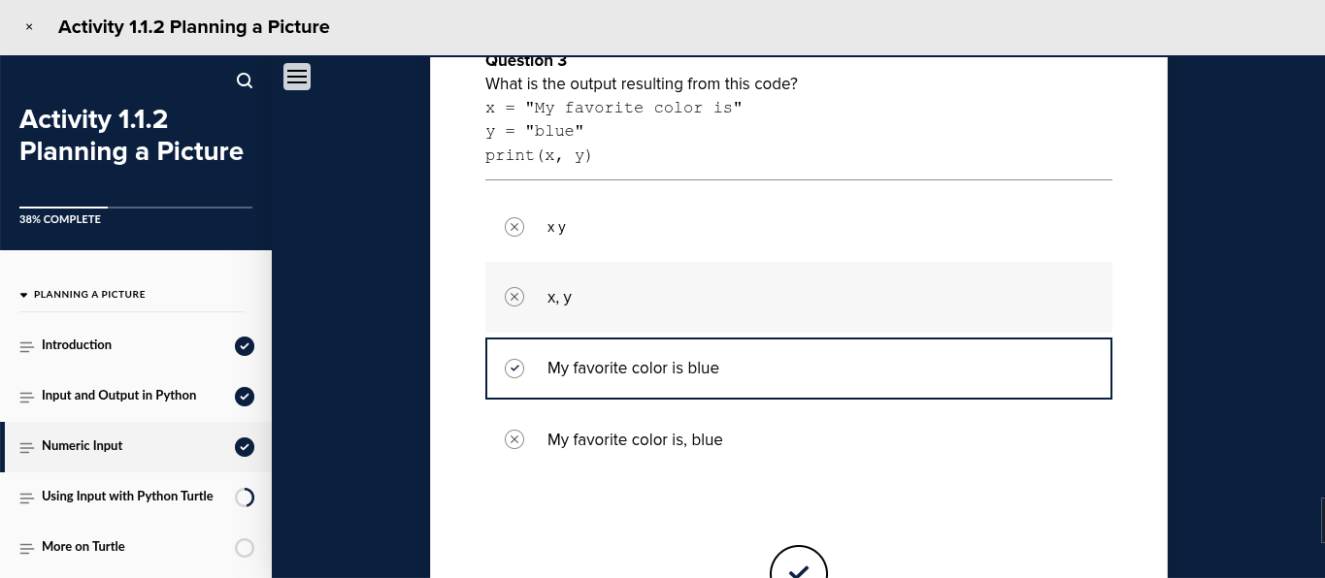
2. (STEP 12) Take a screenshot (or make a screencast) showing the code drawing a circle from a user input for radius and line color

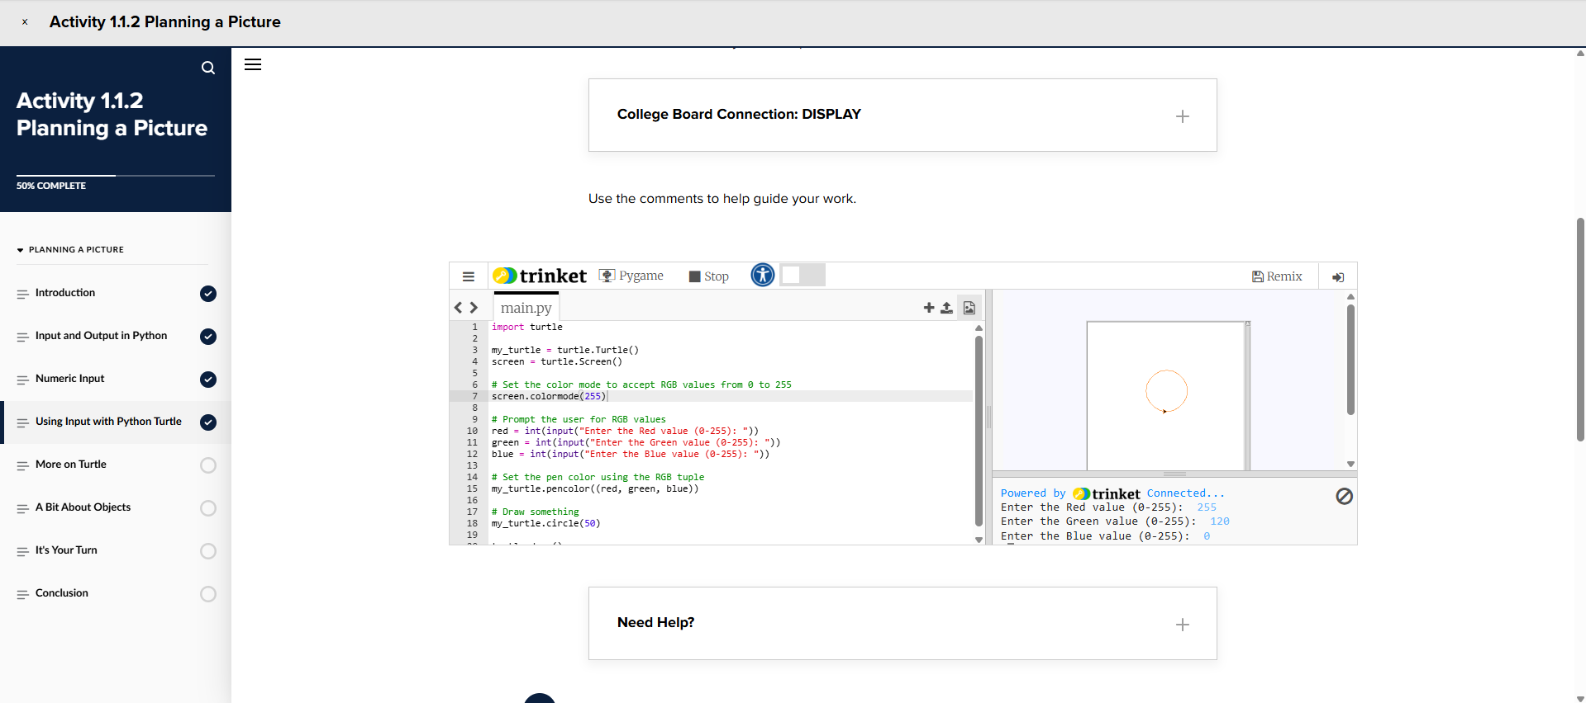

3. (STEP 15) Take a screenshot showing you scored 100% on mini-quiz

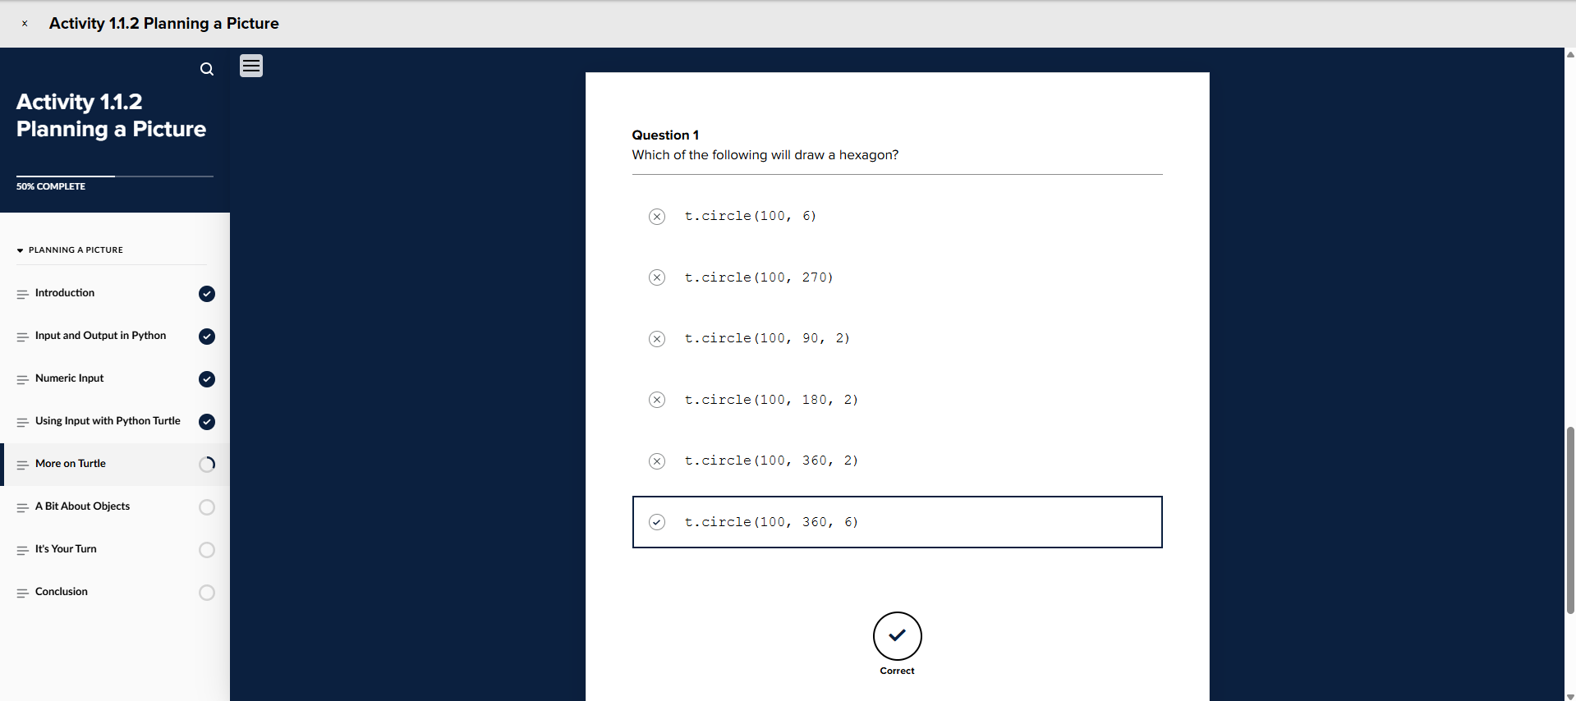
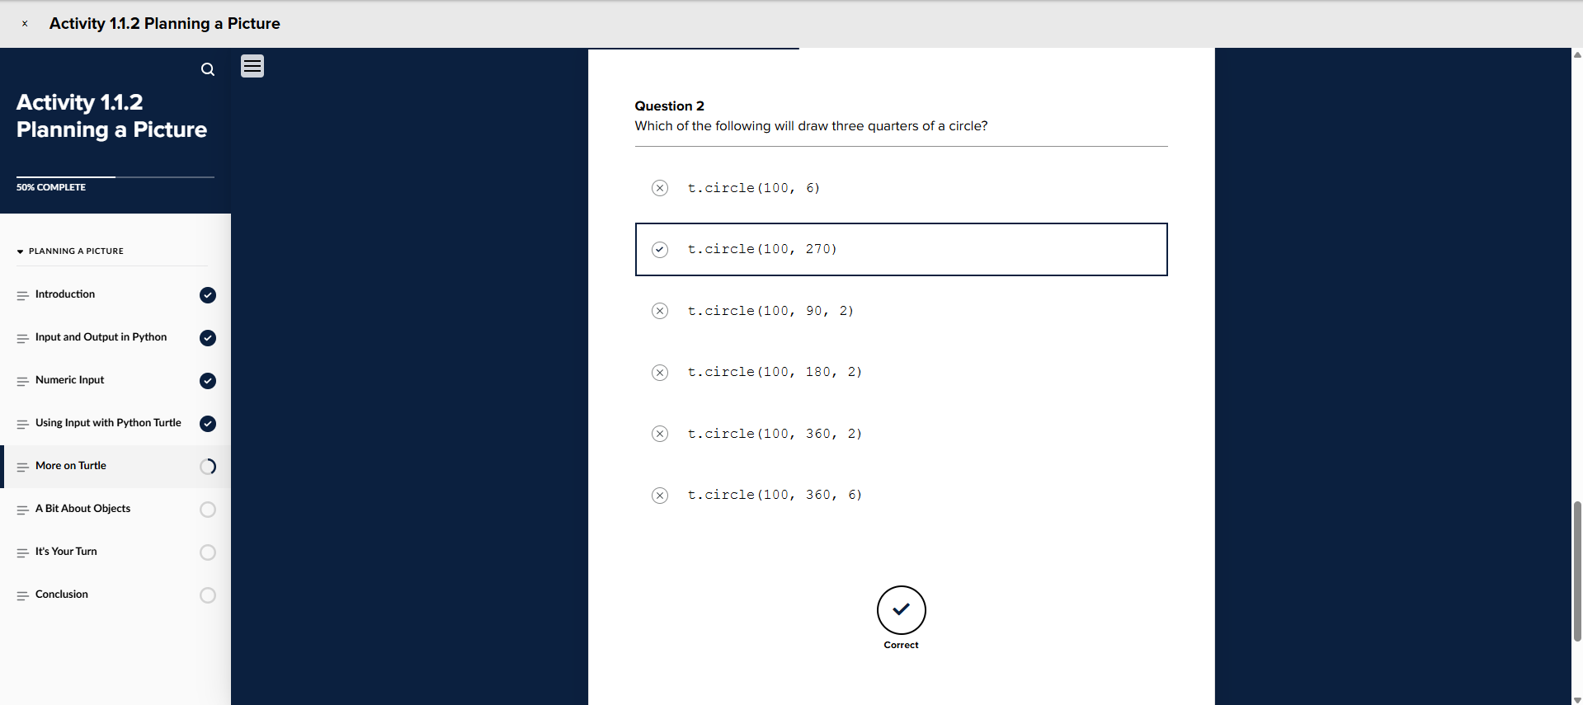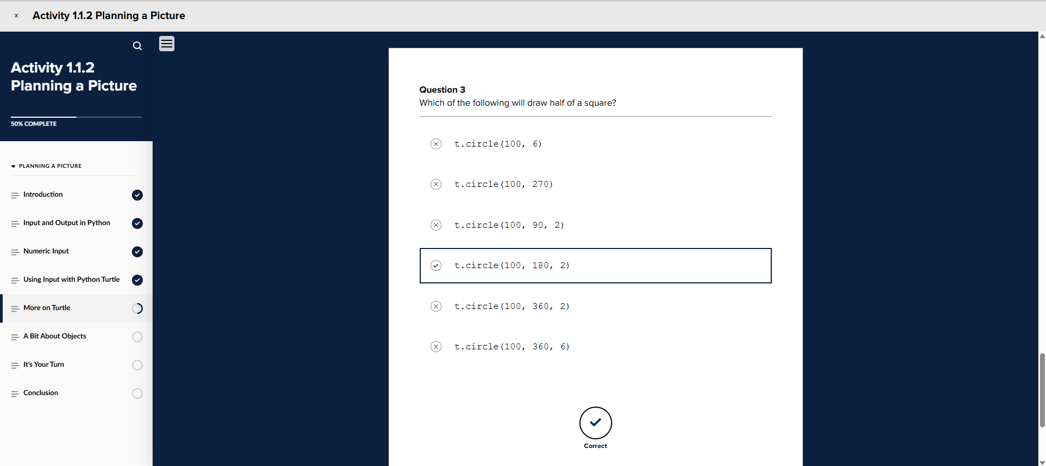
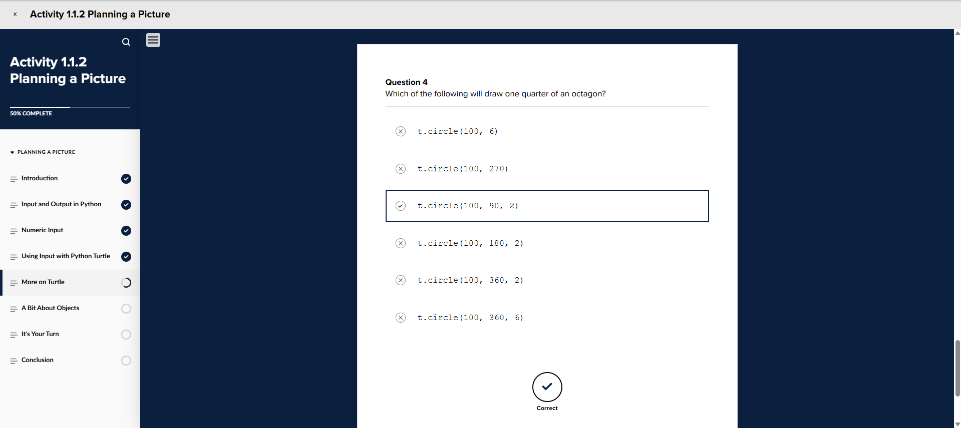

4. (STEP 16) Take a screenshot (or make a screencast) of code and successful running of it that fulfills each of the instructions in the comments of the code

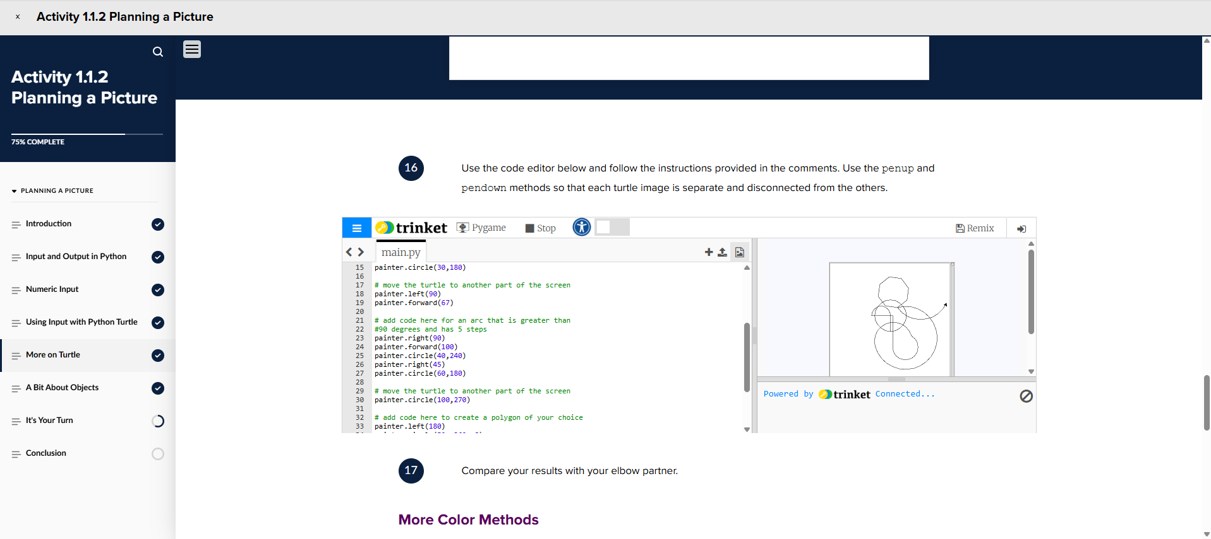

5. (STEP 18) Take a screenshot (or make a screencast) of code and successful running of it that fulfills each of the instructions in the comments of the code

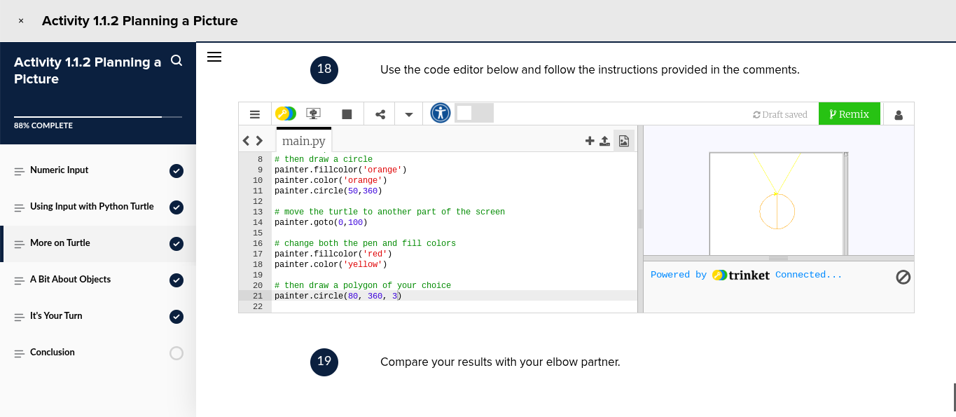

6. (STEP 21) Take a screenshot (or make a screencast) creating your own picture asking for user input at some point. Creativity is highly encouraged.

