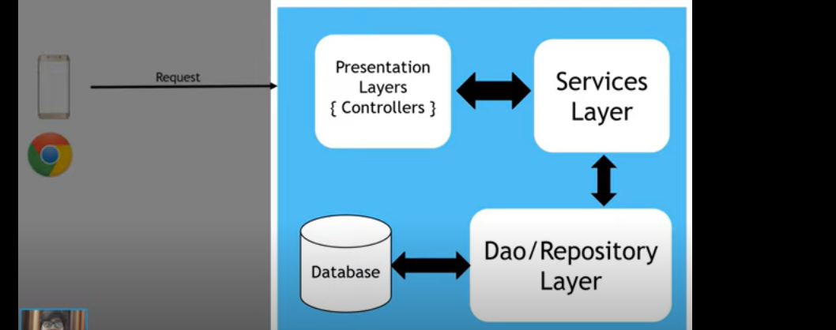

create spring project using initializer

all dependencies can be added in spring

pom.xml contains all dependencies.

All the configurations will be mentioned in application.properties

RestController vs Controller

The system should be loosely coupled so we’re using above architecture

Autowired – will inject the interface class with child object instance with dependency injection rule

Service – will be the service layer

Requestapping will be used as a mvc

The below tags are must for hibernate project

@Entity

@Id

