React js a simple js library used for SPA

SPA – a website will have more pages when we switch the pages the websites will have performance issues. Ajax can be used to reload the page without refreshing the page

React removes the unnecessary loading

React is library and Angular is framework. it increase performance and UX experience.



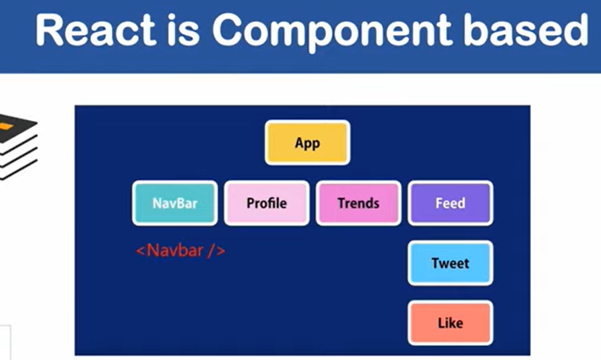

npx create-react-app reactspring-project

functional component & class component

passing values to a component is called prop

installing libraries and adding dependency :

instal reactstrap

<https://reactstrap.github.io/components/card/>

contains all the UI used for the webpage.

React axios for using the dependencies

Simple react snippets plugin for command promptings

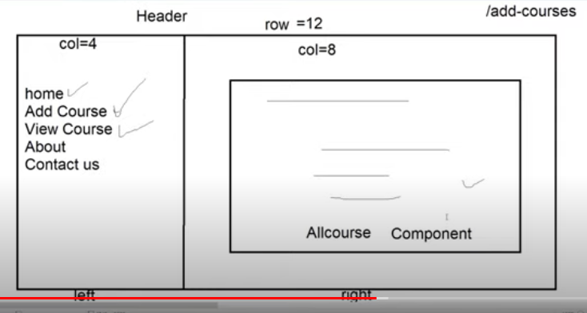

Router – to change from different component

1. delete node_module, npm cache clean;
2. modify package.json

"react": "~15.4.1","react-native": "0.42.3","react-test-renderer": "~15.4.1",

1. npm install all module;

npm install react-router-dom

npm install reactstrap bootstrap jquery react-dom react-router-dom react-toastify axios

ListGroupItem and href will cause refresh on navigation

We’ll replace them with Link and to

To use class based component functionality we use in function based component than we use hook

    // similar to componentdidmount and componentdidupdate

    useEffect(()=>{

    })

Passing empty array in second param will avoid componentdidupdate

// similar to componentdidmount and componentdidupdate

    useEffect(()=>{

    }, []);