PROCESS FLOW DIAGRAMS
UML Activity Diagrams with Swim Lanes
Twelve implementation-aligned workflows for StockSense
Prepared from the current .NET 8 StockSense solution and Gemini chatbot service
Compared with SWIMLANE.docx | August 2026

Diagram Set and Notation
The diagrams follow the twelve processes listed in Swimlane Prompt.docx. Rounded rectangles are actions, diamonds are decisions, circles are start/end nodes, peach boxes are error outcomes, and green boxes are database persistence. Each diagram includes labeled lanes, branches, error handling, and a defined endpoint.
No. | Required process | Swim lanes
1 | Customer Account Registration | Customer, StockSense System, Database, Email Service
2 | Customer Login | Customer, StockSense System, Database
3 | POS Transaction | Employee, StockSense System, Database
4 | Stock-In Process (Receiving Order) | Employee/Admin, StockSense System, Database
5 | Stock-Out Process (Point of Sale) | Employee, StockSense System, Database
6 | Appointment Booking | Customer, StockSense System, Database
7 | Appointment Management | Employee/Admin, StockSense System, Database
8 | Motorcycle Build Creation | Customer, StockSense System, Database
9 | Motorcycle Build Management | Employee/Admin, StockSense System, Database
10 | Safety Stock and Reorder Point Calculation | Employee/Admin, StockSense System, Database
11 | Order Slip Generation | Employee/Admin, StockSense System, Database, Email / Supplier
12 | AI-Assisted Support Interaction | Any Authenticated User, StockSense System, AI Service, Database / Approved Sources

Figure 1. Customer Account Registration
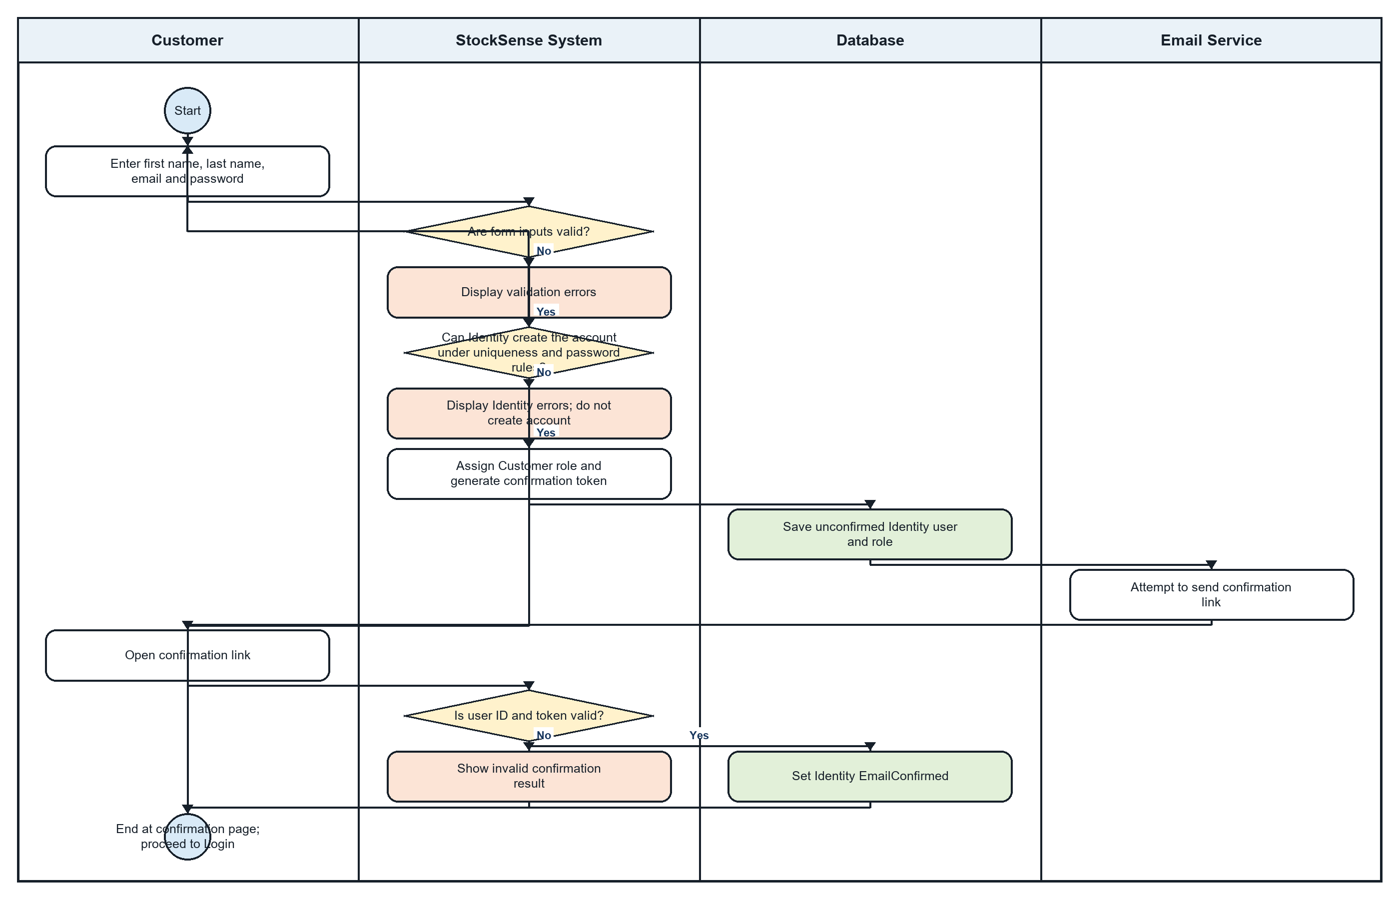

1. Customer Account Registration - Step-by-Step Textual Flow
Lanes: Customer / StockSense System / Database / Email Service
- Customer: Open the StockSense registration page and enter first name, last name, email address, password, and password confirmation.
- System: Validate the required fields, email format, password rules, and matching password confirmation.
- System: If validation fails, display the field errors and allow the Customer to correct the form.
- System: Submit the account to ASP.NET Core Identity, which applies uniqueness and password rules.
- System: If Identity rejects the account, display its errors and do not create a user record.
- Database: If creation succeeds, save the unconfirmed Identity user and assign the Customer role.
- System: Generate an email-confirmation token and confirmation URL.
- Email Service: Attempt to send the confirmation link. A mail failure is logged and does not erase the newly created account.
- Customer: Open the confirmation link received by email.
- System: Validate the user identifier and confirmation token.
- System: If the link is invalid, display an unsuccessful confirmation result.
- Database: If valid, set the Identity EmailConfirmed value for the account.
- Customer: Proceed to the Login page; registration does not automatically sign the Customer in.

Flow Explanation
The registration flow separates form validation, Identity account creation, email confirmation, and database persistence. An invalid form or Identity rejection creates no account. Successful registration creates an unconfirmed Customer account, after which the emailed token must be validated before EmailConfirmed is set. The Customer then signs in separately.

Figure 2. Customer Login
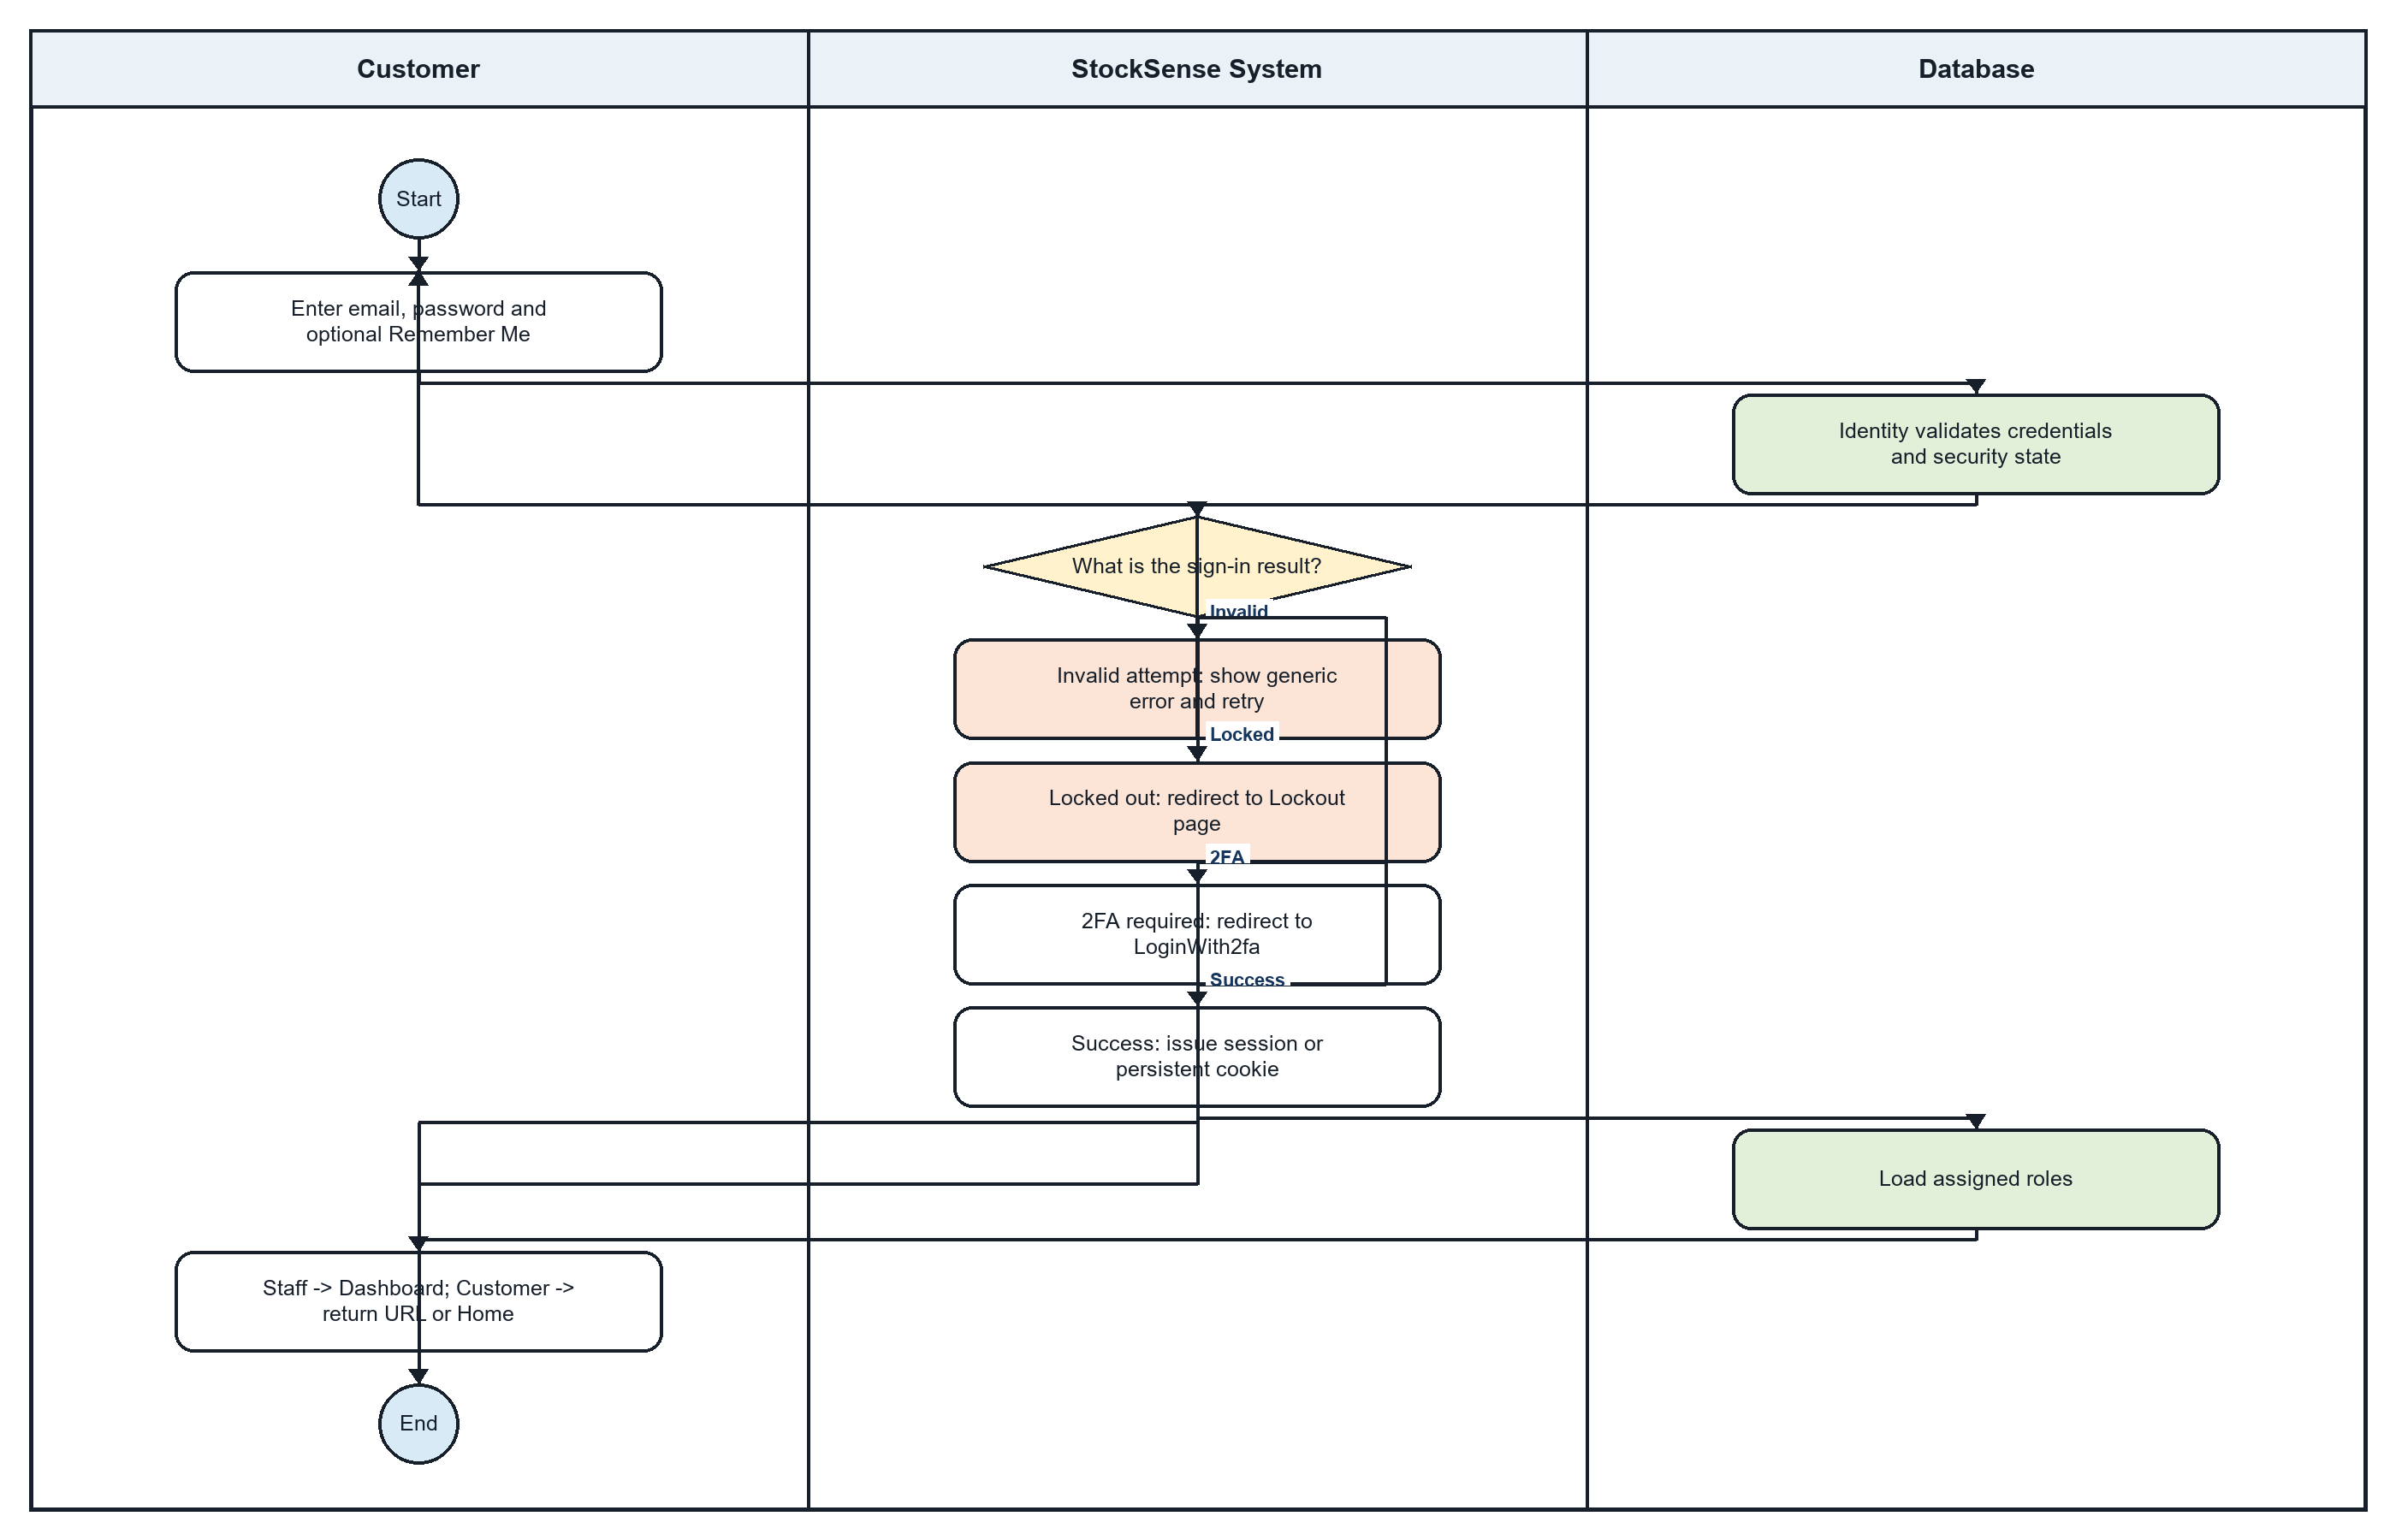

2. Customer Login - Step-by-Step Textual Flow
Lanes: Customer / StockSense System / Database
- Customer: Open the StockSense Login page. The system clears any temporary external-authentication cookie.
- Customer: Enter the registered email and password and optionally select Remember Me.
- System: Validate the submitted form and ask ASP.NET Core Identity to sign the user in with lockout-on-failure enabled.
- Database: Identity checks the stored account, password hash, lockout state, and other security information.
- System: If the login is invalid, display a generic invalid-login message and allow another attempt.
- System: If the account is locked, redirect to the Lockout page.
- System: If two-factor authentication is required, redirect to LoginWith2fa with the return URL and Remember Me choice.
- System: If authentication succeeds, issue a normal or persistent cookie according to Remember Me.
- Database: Load the roles assigned to the authenticated user.
- System: Redirect Admin and Employee accounts to the Dashboard. Redirect a Customer to the requested return URL or the Home page.
- Customer: The authorized page opens and the login flow ends.

Flow Explanation
The login flow delegates credential and lockout handling to ASP.NET Core Identity. Its major outcomes are invalid credentials, lockout, two-factor authentication, or success. A successful session uses Remember Me to determine cookie persistence and then routes the user according to assigned roles.

Figure 3. POS Transaction
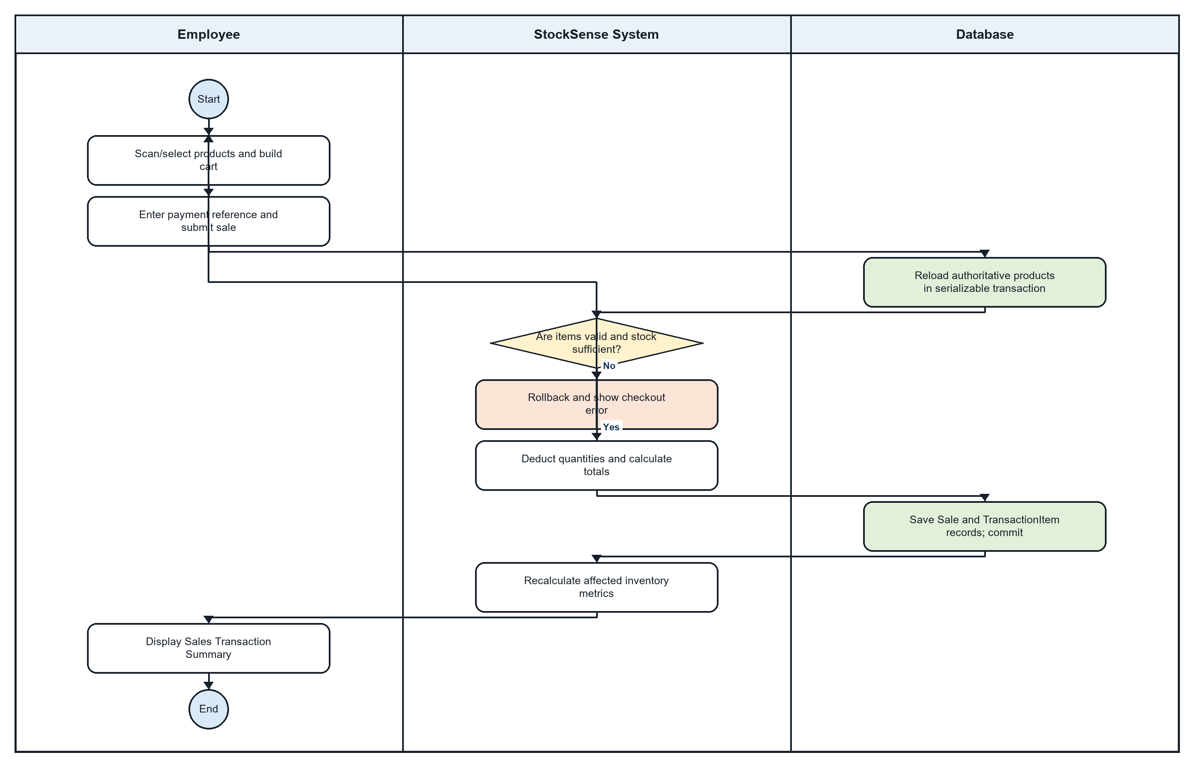

3. POS Transaction - Step-by-Step Textual Flow
Lanes: Employee / StockSense System / Database
- Employee: Open the POS page and browse, search, or scan the active product catalog.
- Employee: Add products to the cart, edit quantities or discounts, select Cash or Online, and enter any payment reference or remarks.
- Employee: Click Complete Sale.
- System: Validate that the cart is nonempty, product identifiers are unique, quantities are positive, discounts are valid, and the payment method is supported.
- Database: Start a serializable transaction and reload the authoritative product records.
- System: Check that every product exists, is active, and has enough current stock. Also ensure discounts do not exceed the gross value.
- System: If validation or stock checking fails, roll back, show the checkout error, and retain the cart for correction.
- System: For a valid sale, calculate totals and deduct each quantity through the domain inventory rule.
- Database: Create the Sale transaction and TransactionItem records, including stock-before and stock-after values, and commit them together.
- System: After commit, recalculate the affected inventory metrics. A calculation failure is logged without reversing the completed sale.
- Employee: View the Sales Transaction Summary, after which the cart is cleared and the product catalog is refreshed.

Flow Explanation
The POS flow treats the database as authoritative at checkout. Cart values are validated again inside a serializable transaction so simultaneous activity cannot silently oversell a product. Stock deductions and transaction lines commit together, followed by the Sales Transaction Summary.

Figure 4. Stock-In Process (Receiving Order)
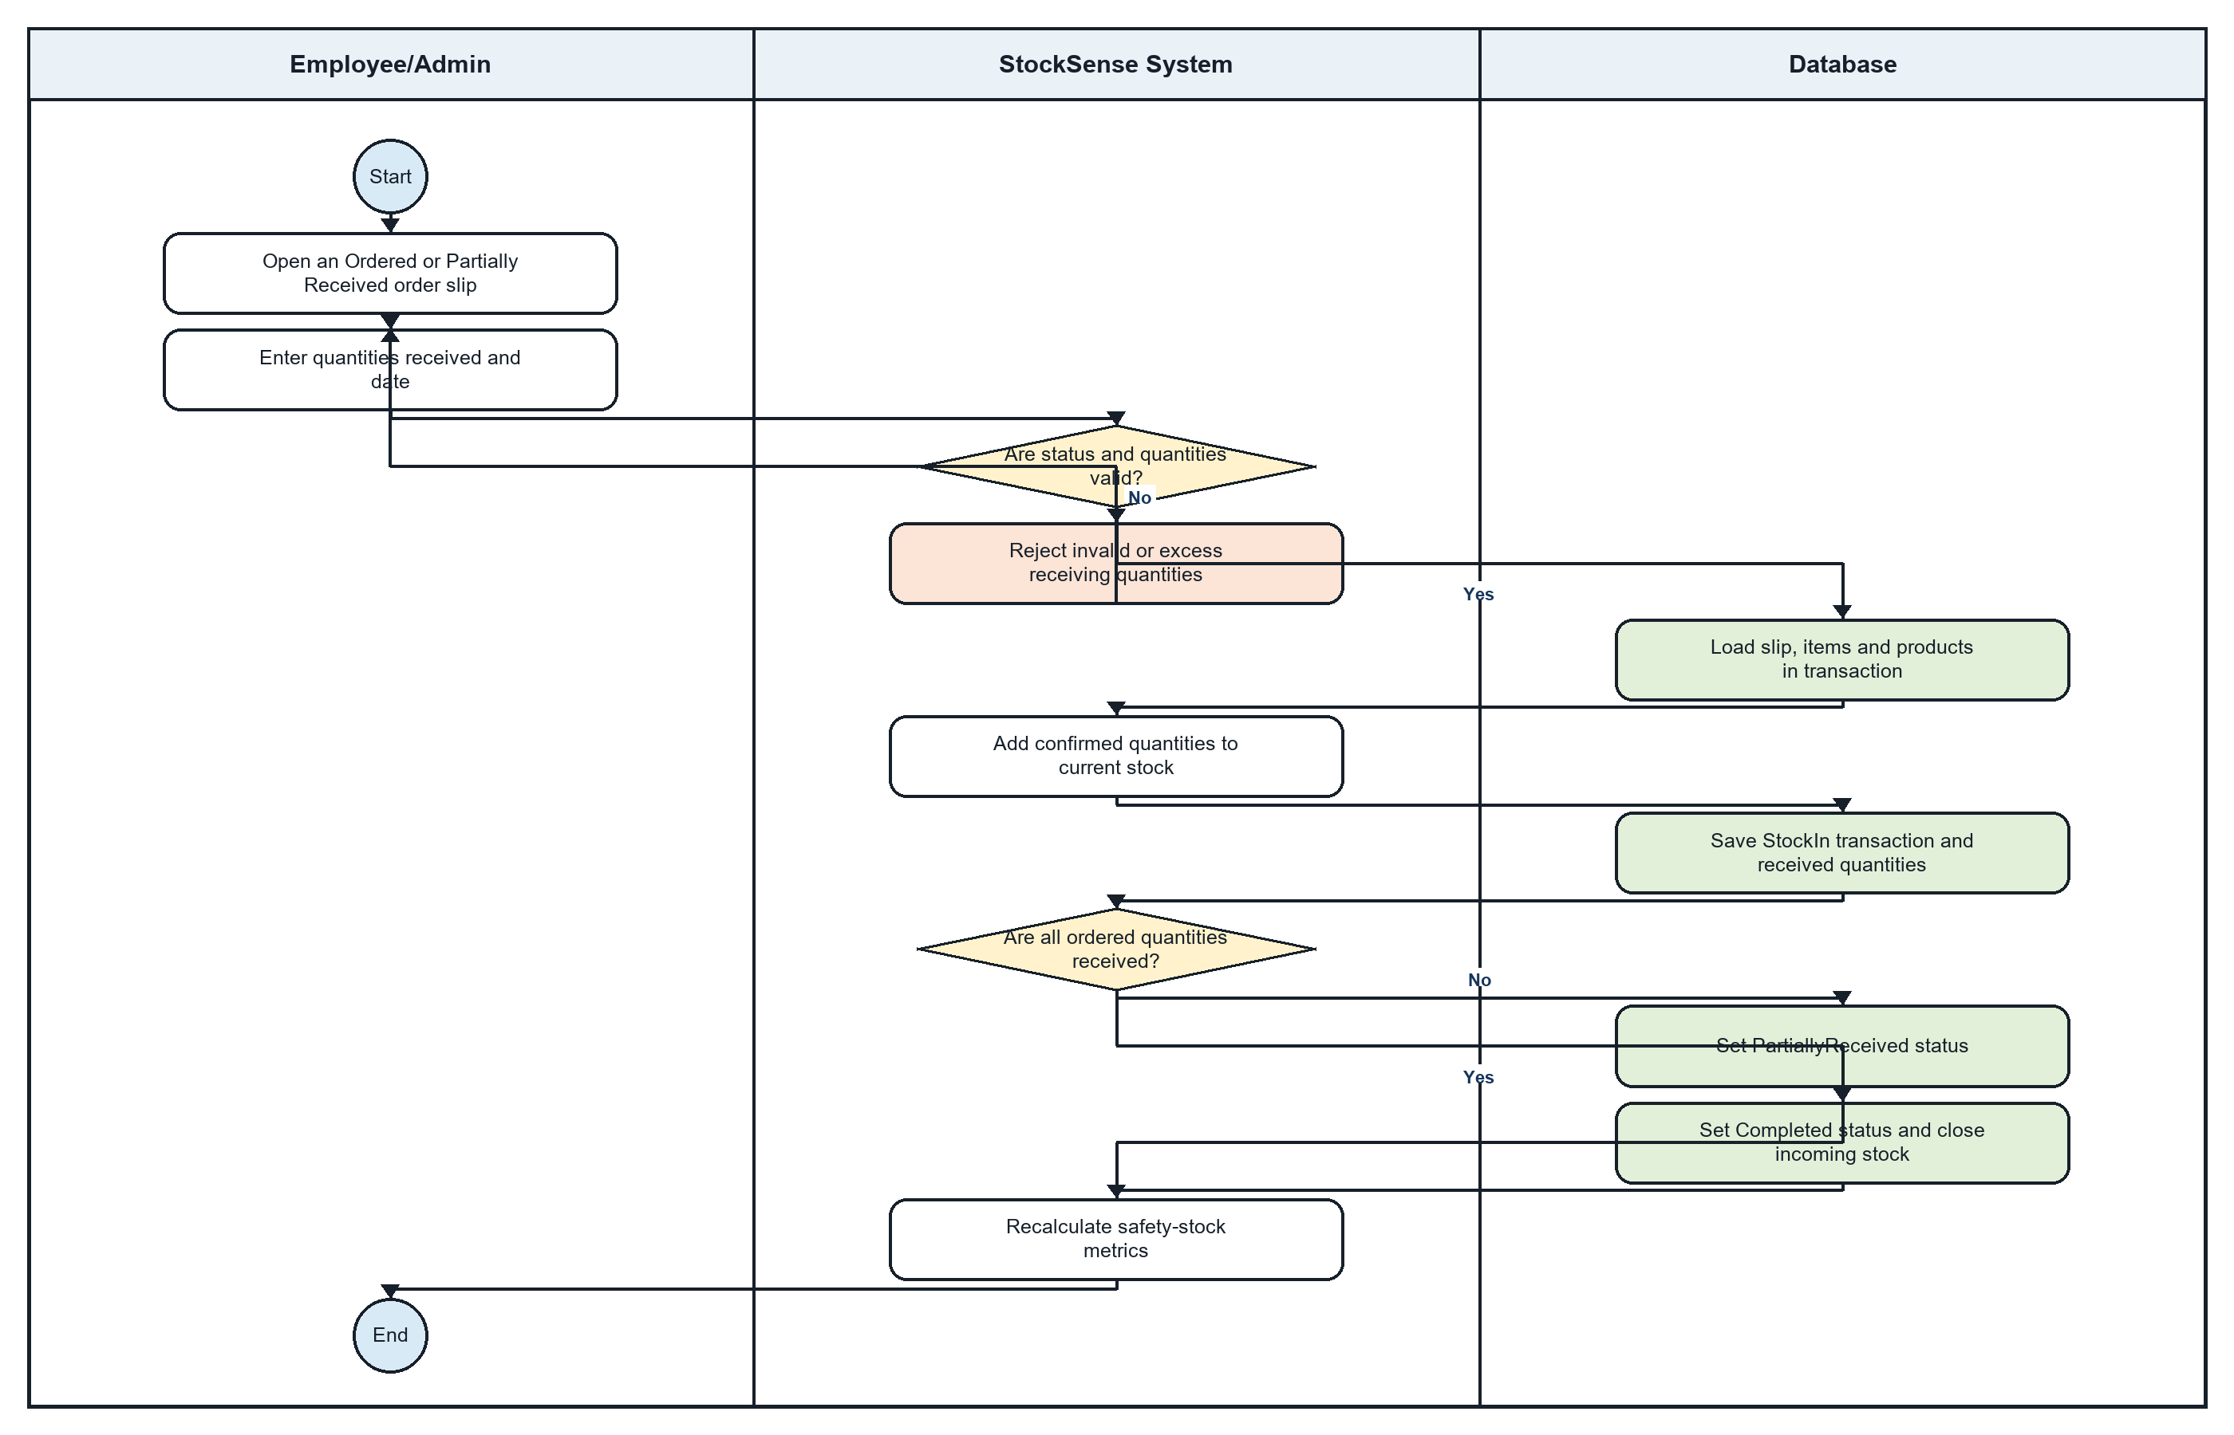

4. Stock-In Process (Receiving Order) - Step-by-Step Textual Flow
Lanes: Employee/Admin / StockSense System / Database
- Employee/Admin: Open an order slip whose status is Ordered or PartiallyReceived.
- System: Load its supplier, line items, quantities already received, and remaining quantities.
- Employee/Admin: Enter the received date, optional supplier reference and remarks, and the quantity received for each line.
- System: Reject negative quantities, quantities above the remaining balance, or an all-zero receiving submission.
- Database: Reload the order slip, items, and products inside a serializable transaction.
- System: Validate the slip status, location, row version, date, requested items, and remaining quantities.
- System: If any validation fails, roll back and display the receiving error.
- System: Add each confirmed quantity to the corresponding product's current stock.
- Database: Create a PurchaseReceipt/StockIn transaction and line-item audit showing stock before and after.
- Database: Increase each OrderSlipItem received quantity.
- System: If every ordered quantity has been received, set the slip to Completed; otherwise set it to PartiallyReceived.
- Database: Commit the stock, receiving transaction, quantities, and order-slip status together.
- System: Recalculate safety-stock metrics for affected products and return to the order-slip details.

Flow Explanation
The stock-in flow accepts partial deliveries and validates cumulative receiving against the original ordered quantities. Inventory, purchase-receipt audit lines, received quantities, and the resulting PartiallyReceived or Completed status are committed as one protected operation.

Figure 5. Stock-Out Process (Point of Sale)
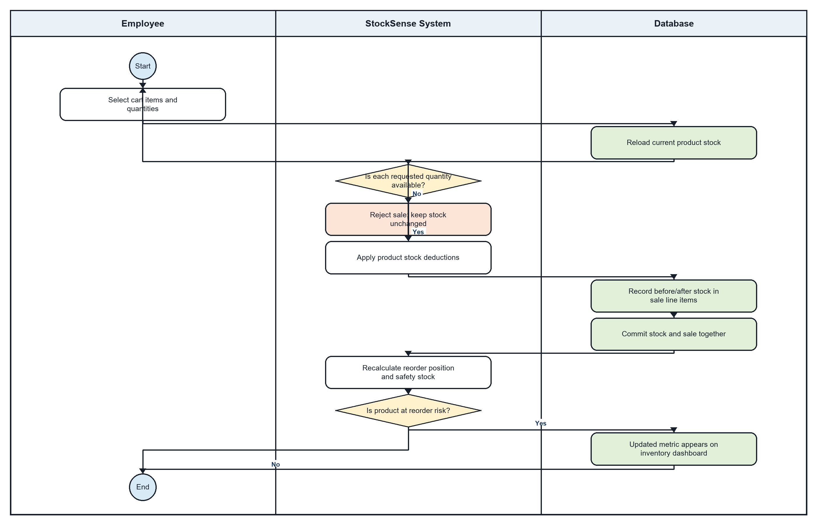

5. Stock-Out Process (Point of Sale) - Step-by-Step Textual Flow
Lanes: Employee / StockSense System / Database
- Employee: Select the products and quantities to sell through the POS cart.
- System: Perform initial UI checks so inactive or visibly out-of-stock products cannot normally be added.
- Database: At checkout, reload current committed stock instead of trusting the browser values.
- System: Check whether every requested quantity remains available.
- System: If any product is missing, inactive, insufficient, or concurrently changed, reject the sale and leave stock unchanged.
- System: If all checks pass, deduct each sold quantity.
- Database: Record the stock-before and stock-after values in the sale line items.
- Database: Commit the inventory deductions and the Sale transaction atomically.
- System: Recalculate the reorder position and safety-stock metric of each affected product.
- System: If a product is now at reorder risk, its recalculated metric appears in the inventory dashboard; no separate alert message is dispatched.
- Employee: View the Sales Transaction Summary and end the stock-out process.

Flow Explanation
The stock-out flow emphasizes inventory integrity inside a POS sale. The server reloads current products, rejects insufficient stock, records before-and-after quantities, and recalculates replenishment metrics only after the sale commits.

Figure 6. Appointment Booking
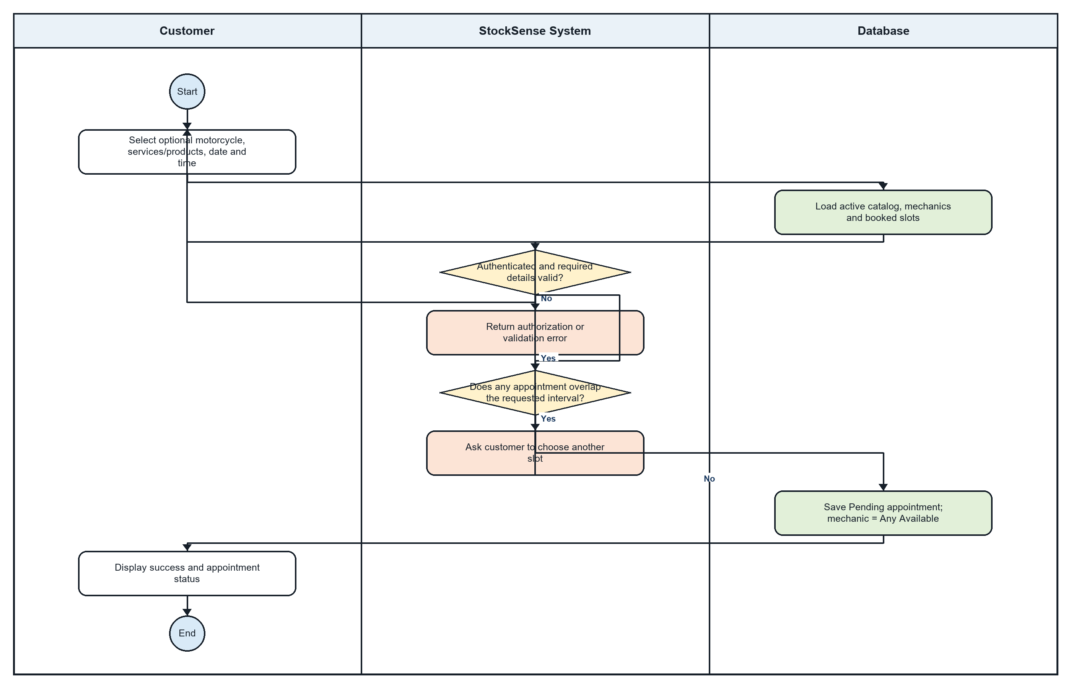

6. Appointment Booking - Step-by-Step Textual Flow
Lanes: Customer / StockSense System / Database
- Customer: Open the booking page while authenticated.
- System: Load the signed-in profile, active services, optional products, active mechanics, motorcycles, and already booked time slots.
- Customer: Select an optional motorcycle, one or more services/products, a date, and a time.
- Customer: Review the calculated duration and amount, then submit the booking.
- System: Derive the Customer identity from the authenticated account instead of trusting a submitted name.
- System: Validate the motorcycle, selected services, products, and required booking fields.
- System: If authentication or validation fails, return an appropriate error and keep the booking form available.
- Database: Check the requested interval against all appointments on that date.
- System: If an overlap exists, return a conflict and ask the Customer to select another time.
- Database: If available, save the appointment as Pending under the Customer account with the mechanic value Any Available.
- Customer: View the success message and the new appointment in My Appointments.

Flow Explanation
The booking flow uses the authenticated account as the Customer identity. StockSense validates the request and checks overlapping appointments across the date. Accepted requests are stored as Pending with Any Available as the mechanic until staff assignment.

Figure 7. Appointment Management
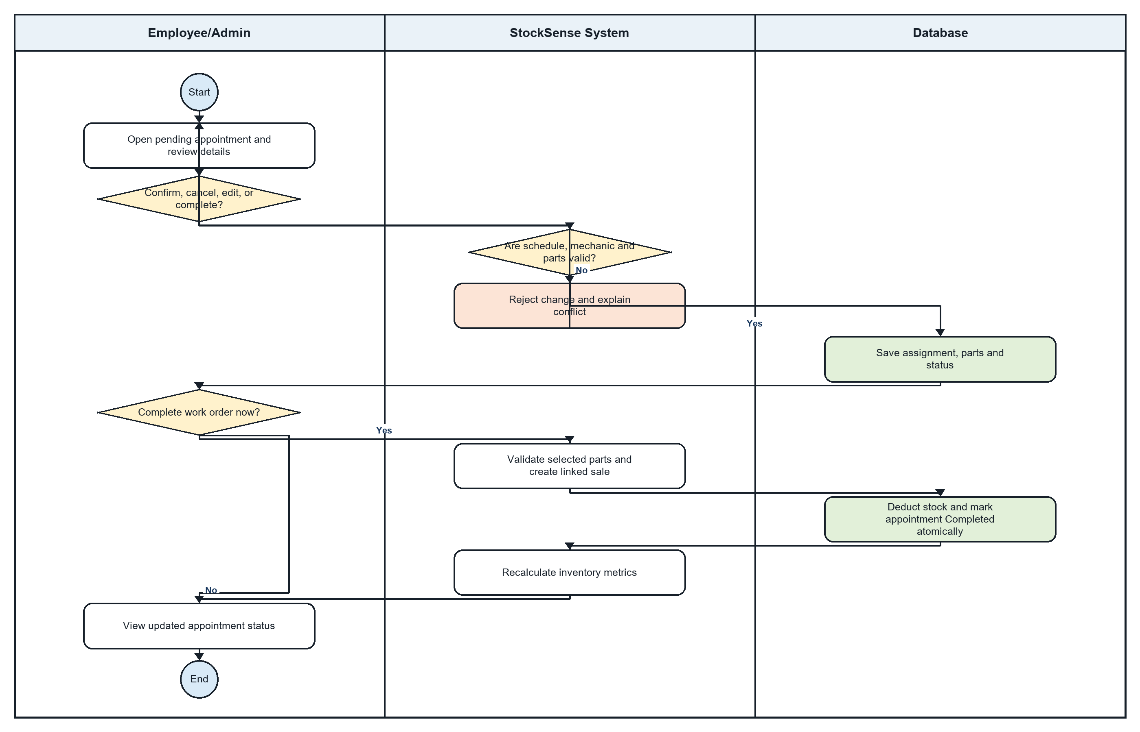

7. Appointment Management - Step-by-Step Textual Flow
Lanes: Employee/Admin / StockSense System / Database
- Employee/Admin: Open the staff appointment page and select a Pending or Confirmed appointment.
- Employee/Admin: Review the Customer, requested schedule, selected services/products, motorcycle, and current assignment.
- Employee/Admin: Choose to confirm, cancel, edit, return to Pending, assign a mechanic, or complete the appointment.
- System: Validate the requested status transition and block changes that are not permitted for the current state.
- Database: When applicable, save mechanic, duration, parts, reservations, and the new Pending/Confirmed/Cancelled status.
- System: If validation or a conflict fails, preserve the prior state and explain the error.
- Employee/Admin: For completion, open the dedicated checkout action rather than changing the status directly.
- System: Require Confirmed status, validate the selected parts and payment information, and begin an atomic work-order checkout.
- Database: Create the linked Sale transaction, deduct stock, store the TransactionId, and mark the appointment Completed.
- System: If stock or concurrency validation fails, roll back and leave the appointment uncompleted.
- System: After success, recalculate affected inventory metrics.
- Employee/Admin: View the updated appointment. Completed/Cancelled items remain database records; the 30-day rule is only a history display filter, not automatic archiving.

Flow Explanation
Appointment management covers the complete staff lifecycle, including confirmation, cancellation, editing, assignment, completion checkout, and protected inventory deduction. Completion is not a simple status edit; it creates a linked sale and commits the stock change atomically.

Figure 8. Motorcycle Build Creation
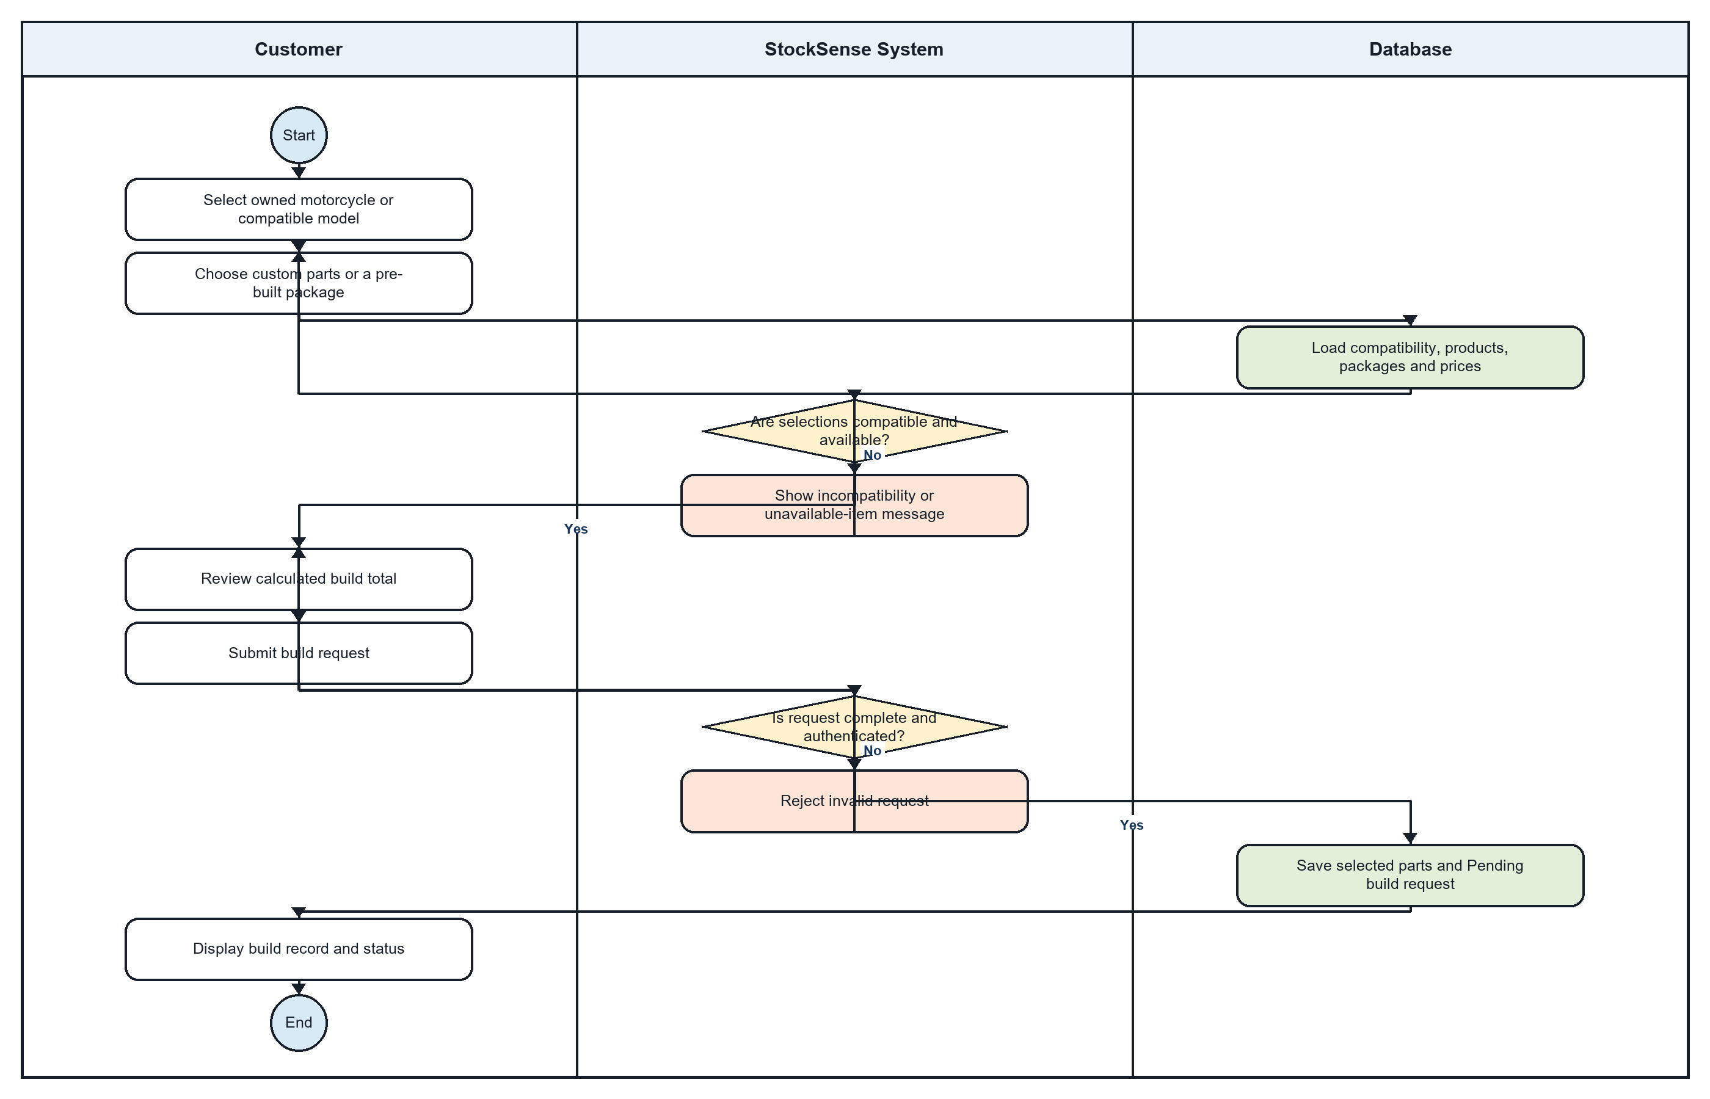

8. Motorcycle Build Creation - Step-by-Step Textual Flow
Lanes: Customer / StockSense System / Database
- Customer: Open Build Your Motor and select Pre-Built or Custom mode.
- System: Load active products, pre-built packages, motorcycles, compatibility information, and current prices.
- Customer: Select an optional motorcycle and choose a package or individual parts.
- System: Prevent inactive or unavailable catalog products from being selected and show compatibility guidance.
- Customer: Review the selected parts and calculated build total.
- Customer: Click Submit Build to Shop. At least one part must be selected.
- System: Verify authentication, parse the submitted selection, and require valid product identifiers.
- Database: Reload active products and the optional motorcycle.
- System: If JSON, product, availability, or motorcycle validation fails, reject the request and show the error.
- System: Replace client product details and prices with authoritative database values and recalculate the total.
- Database: Save the selected parts and a Pending BuildRequest under the signed-in Customer.
- Customer: View the success dialog and the new build record. Any installation appointment is a separate follow-on action.

Flow Explanation
Build creation is Customer-driven. Although the browser presents packages, parts, compatibility, and prices, the API reloads active products and recalculates authoritative details before storing the Pending request.

Figure 9. Motorcycle Build Management
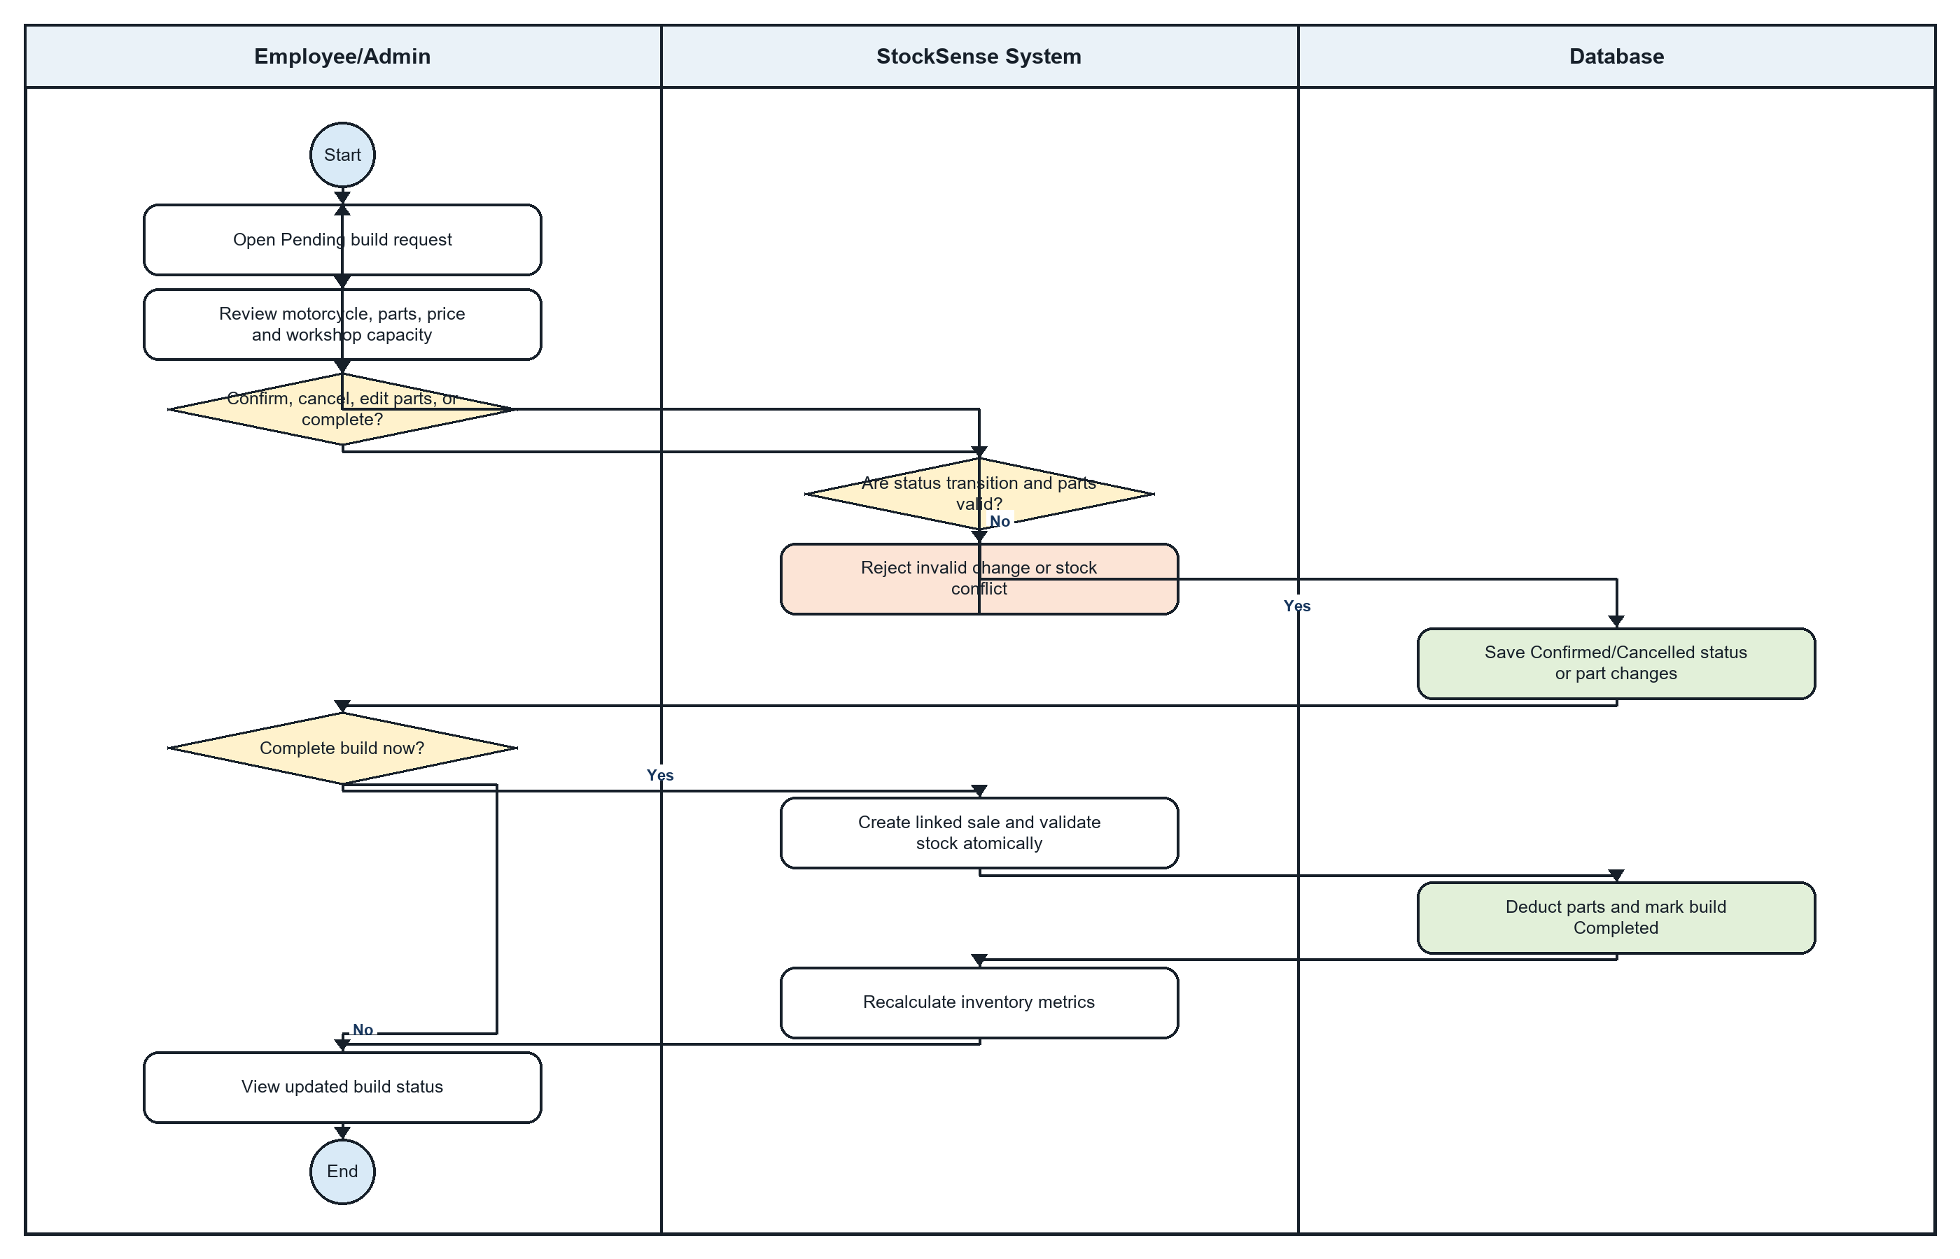

9. Motorcycle Build Management - Step-by-Step Textual Flow
Lanes: Employee/Admin / StockSense System / Database
- Employee/Admin: Open the build-management page and select a Pending or Confirmed build request.
- Employee/Admin: Review the Customer, motorcycle, selected parts, authoritative price, and current status.
- Employee/Admin: Choose to edit parts, confirm, return to Pending, cancel, reopen, or complete the build.
- System: Validate the requested transition. A build cannot move directly from Pending to Completed.
- Database: Save allowed part changes and Pending, Confirmed, or Cancelled status updates; reservation behavior is applied where implemented.
- System: If the transition, parts, or stock state is invalid, reject the change and preserve the prior record.
- Employee/Admin: To complete a Confirmed build, open the dedicated checkout and provide the required transaction information.
- System: Validate selected parts and stock inside the work-order checkout.
- Database: Create the linked Sale transaction, deduct component stock, and mark the build Completed with its TransactionId.
- System: If checkout or concurrency fails, roll back and leave the build uncompleted.
- System: Recalculate affected inventory metrics after a successful commit.
- Employee/Admin: View the updated build. The Customer sees the persisted status in My Builds; the 30-day setting only filters history in the UI.

Flow Explanation
Build management follows controlled state transitions. Staff may prepare or confirm a build, but completion requires a dedicated checkout that validates stock, creates a linked transaction, deducts components, and marks the request Completed together.

Figure 10. Safety Stock and Reorder Point Calculation
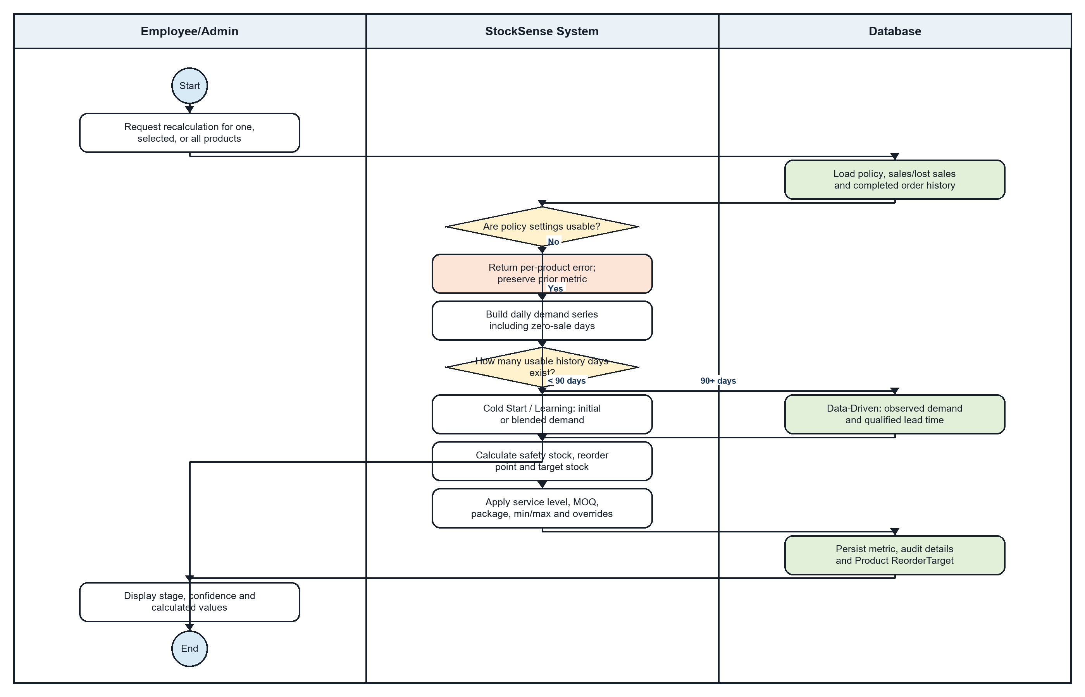

10. Safety Stock and Reorder Point Calculation - Step-by-Step Textual Flow
Lanes: Employee/Admin / StockSense System / Database
- Employee/Admin: Open Manage Safety Stock and request recalculation for one product, selected products, or all products.
- Database: Load each product's inventory setting, sales and lost-sales history, and completed supplier-order lead times.
- System: Validate that the policy values, service level, lead time, minimums, maximums, package size, and overrides are usable.
- System: If settings are missing or invalid, return a per-product failure and preserve the previous metric.
- System: Build a complete daily demand series that includes days with zero sales.
- System: Count usable history days and select the calculation stage.
- System: For fewer than 30 days, use Cold Start. For 30–59 days, blend observed and initial demand 50/50. For 60–89 days, use a 70/30 blend.
- System: For at least 90 days, use Data-Driven demand. Use observed lead-time variability only after enough completed supplier orders exist.
- System: Calculate lead-time demand, safety stock, reorder point, and target stock.
- System: Apply the service-level factor, manual overrides, minimum/maximum stock, MOQ, and package rounding.
- Database: Persist ProductInventoryMetric, audit details, confidence/stage, and Product.ReorderTarget.
- Employee/Admin: View the updated stage, confidence, safety stock, reorder point, and target stock or any per-product error.

Flow Explanation
Safety-stock calculation is a staged deterministic policy rather than Azure AutoML forecasting. StockSense gradually moves from an initial estimate to observed demand and supplier lead-time evidence, then persists the resulting safety stock, reorder point, target, stage, and confidence.

Figure 11. Order Slip Generation
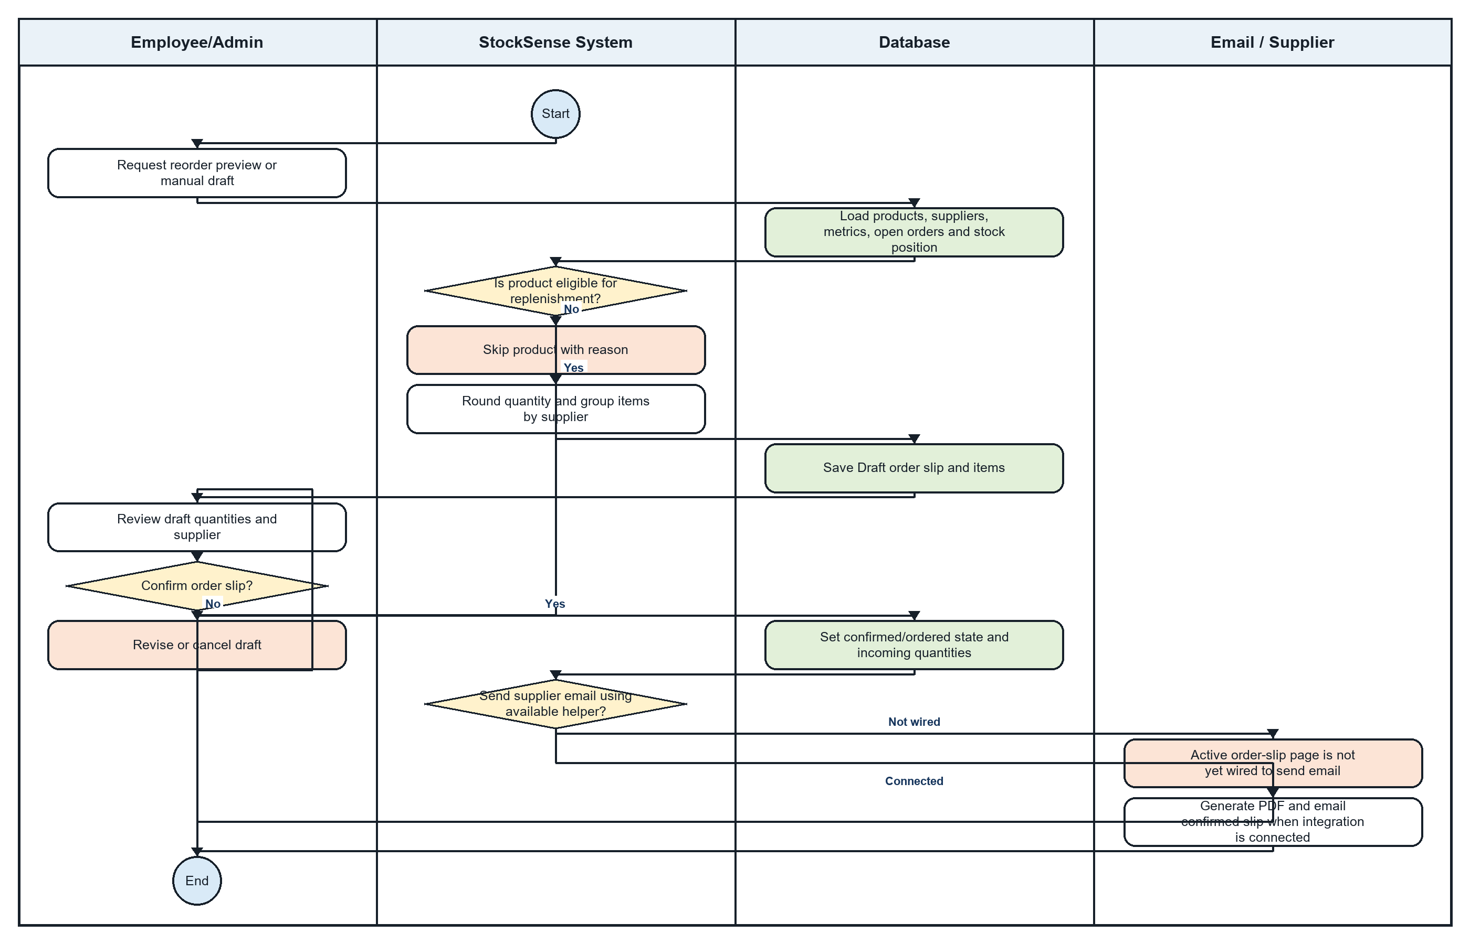

11. Order Slip Generation - Step-by-Step Textual Flow
Lanes: Employee/Admin / StockSense System / Database / Email / Supplier
- Employee/Admin: Open Order Slips and request a reorder preview or create a manual draft.
- Database: Load current stock, reserved stock, incoming quantities, suppliers, inventory settings, metrics, and open order slips.
- System: Compute inventory position as current stock plus incoming stock minus reserved stock.
- System: Check whether a product is eligible: policy enabled, supplier and metric available, no covering open order, and position at or below the reorder threshold.
- System: Skip ineligible products and retain the reason for review.
- System: Calculate the suggested quantity, respect target/max stock, and round for MOQ or package size.
- System: Group eligible items by supplier.
- Database: Save a Draft order slip and item snapshots for each supplier group.
- Employee/Admin: Review the draft supplier, quantities, and items and either revise/cancel it or confirm it.
- System: Validate the status transition and row version, then move the confirmed slip through Approved to Ordered as permitted.
- Database: Record approval/order timestamps, acting user, and incoming quantities.
- System: A PDF generator and supplier-email helper exist, but the active order-slip page/controller currently has no call site that sends the confirmed slip.
- Employee/Admin: Until that integration is connected, download the PDF or complete the intended email wiring; an email failure must not delete the confirmed order record.

Flow Explanation
Order-slip generation converts inventory metrics into supplier-grouped drafts. Staff remain responsible for review and confirmation. The current code contains PDF and email helper capabilities, but supplier sending is not connected to the active order-slip workflow and is therefore identified as an integration gap.

Figure 12. AI-Assisted Support Interaction
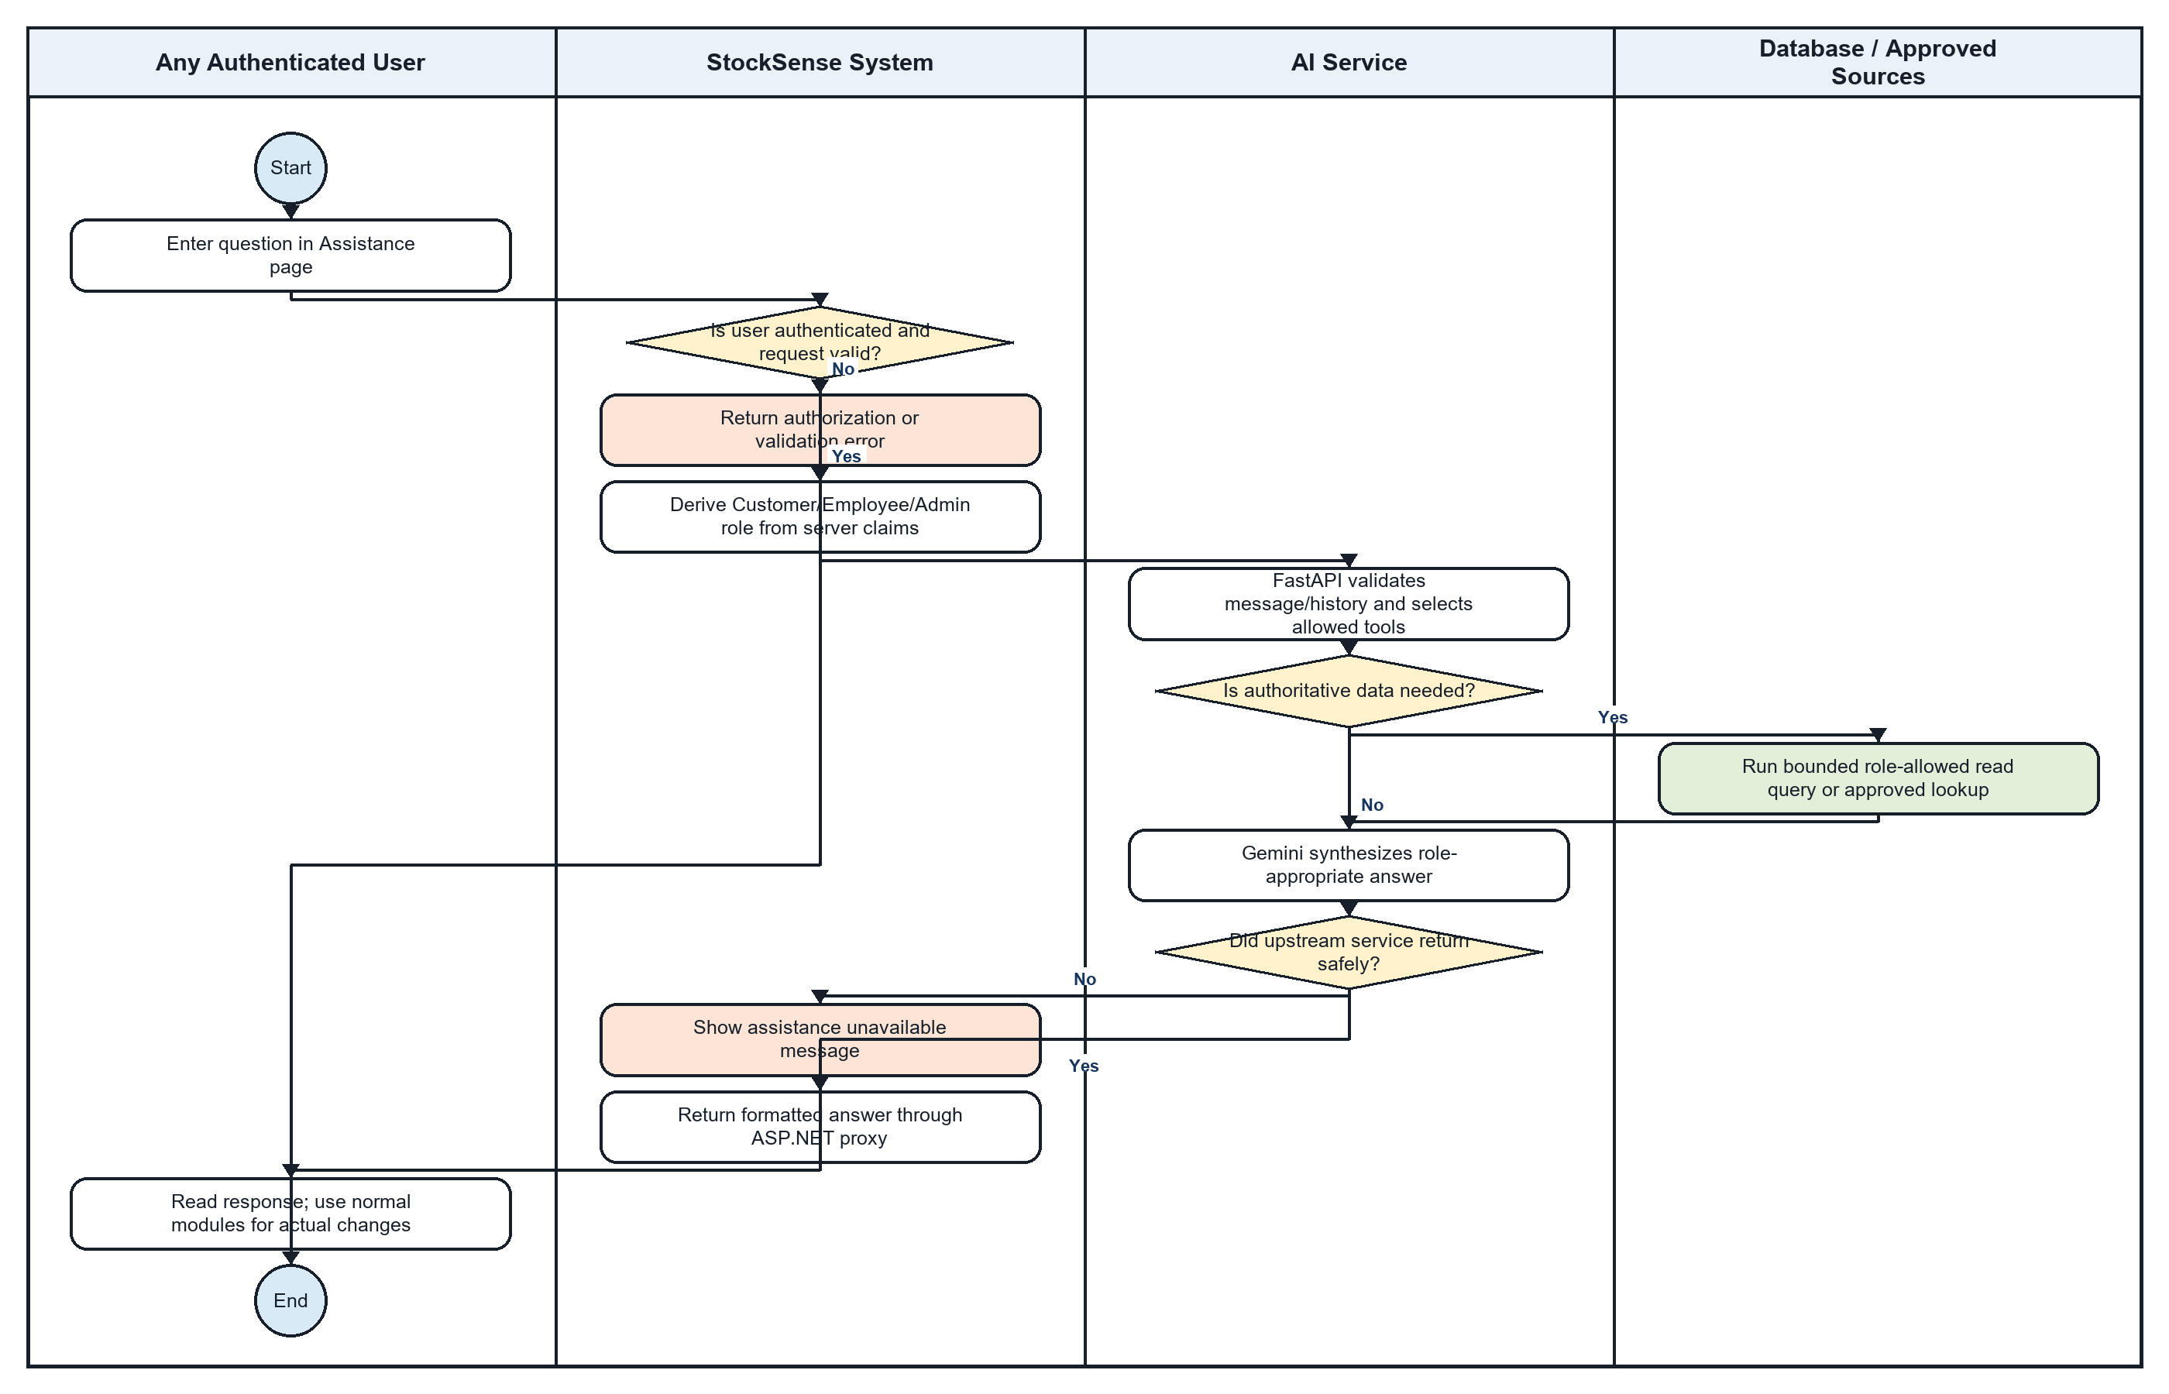

12. AI-Assisted Support Interaction - Step-by-Step Textual Flow
Lanes: Any Authenticated User / StockSense System / AI Service / Database / Approved Sources
- Any Authenticated User: Open the Assistance page and enter a question.
- StockSense System: Validate authentication, message length, and bounded conversation history.
- StockSense System: If the request is unauthorized or invalid, return a safe error without calling the AI service.
- StockSense System: Derive Customer, Employee, or Admin from trusted server claims rather than accepting a browser-selected role.
- AI Service: FastAPI validates the request and chooses only the tools permitted for that role.
- AI Service: Decide whether the question requires current shop information or can be answered directly.
- Database / Approved Sources: When required, execute a bounded role-allowed read query or approved lookup. The chatbot does not book, sell, or change inventory.
- AI Service: Return the sanitized tool result to Gemini, with tool executions and conversation history limited.
- AI Service: Gemini synthesizes a role-appropriate answer without exposing private fields, raw SQL, or secrets.
- AI Service: If a tool, model, timeout, or upstream failure occurs, return a deterministic safe failure instead of fabricated data.
- StockSense System: Return and safely format the answer through the ASP.NET assistance proxy.
- Any Authenticated User: Read the response and use the normal StockSense modules for any actual booking, account, inventory, or transaction change.

Flow Explanation
AI assistance passes through authenticated StockSense and a separate FastAPI/Gemini service. Role-specific tools retrieve only permitted read-only information, while limits, sanitization, and safe error handling prevent the assistant from becoming an unrestricted database or transaction interface.

Comparison with SWIMLANE.docx
The existing SWIMLANE.docx contains useful workflow notes and several diagrams, but it does not map cleanly to the twelve required processes and includes legacy assumptions. The table below compares it with this implementation-aligned set.
Required process | SWIMLANE.docx | Implementation-aligned result
Customer Account Registration | Narrative steps exist, but no embedded registration swimlane diagram is present before the BUILD section. | Added a complete Customer/System/Database/Email flow with validation, duplicate email, confirmation token, and error paths.
Customer Login | Narrative steps exist, but no embedded login swimlane diagram is present. | Added credentials, lockout/unconfirmed decisions, session creation, and invalid-login loop.
POS Transaction | Existing Stock OUT diagram partly covers POS but centers on threshold alerts. | Separated the complete commercial transaction, atomic database commit, and Sales Transaction Summary.
Stock-In Receiving | Existing receiving diagram is broadly related but uses simpler threshold behavior. | Aligned to Ordered/PartiallyReceived states, quantity validation, StockIn record, partial completion, and metric recalculation.
Stock-Out POS | Existing diagram overlaps POS and treats low stock as a simple flag. | Focused on authoritative stock reload, atomic deduction, before/after audit values, and recalculated reorder metrics.
Appointment Booking | Existing booking diagram contains useful availability decisions but assumes details not consistently enforced. | Aligned booking to authenticated ownership, active service/mechanic data, conflict checks, Pending storage, and validation errors.
Appointment Management | Existing file splits setup, booking, management, and completion across multiple diagrams and introduces a 30-day soft-retention rule. | Consolidated staff management and atomic completion; removed the unsupported retention rule.
Motorcycle Build Creation | Existing file duplicates Build Your Motor narratives and sometimes calls the Customer an Admin. | Corrected actor ownership and added compatibility, pricing, authentication, validation, and Pending persistence.
Motorcycle Build Management | Existing status diagram includes unsupported 30-day soft retention. | Aligned status transitions and completion to the actual linked sale/stock checkout workflow.
Safety Stock / Reorder Point | Existing file substitutes Azure AutoML/LightGBM predictive analytics. | Replaced it with the implemented staged Cold Start/Learning/Data-Driven calculation and persisted metrics.
Order Slip Generation | Existing draft/finalization/history diagrams are scattered and overstate active email automation. | Consolidated eligibility, grouping, draft review and confirmation. PDF/email helper code exists, but the active page/controller does not currently call it.
AI-Assisted Support | No matching AI interaction swimlane diagram was found. | Added authenticated ASP.NET proxy, server-derived role, FastAPI tool routing, bounded data retrieval, Gemini synthesis, and upstream error path.

Key Corrections from the Existing Document
- Azure AutoML and LightGBM forecasting are not part of the current implementation; StockSense uses deterministic staged safety-stock and reorder calculations.
- The AI module is a separate FastAPI service using Google Gemini and is accessed through an authenticated ASP.NET assistance proxy.
- No automatic 30-day soft-retention/archive process was found for completed appointments or builds.
- Order-slip processing creates a draft and allows staff confirmation. PDF/email helper code exists for supplier dispatch, but the active order-slip page/controller does not currently call it; the diagram marks this integration gap.
- The POS ends with a Sales Transaction Summary, while inventory deduction and transaction records commit together.
- Registration/login must include Database and email/token interactions; prose alone does not satisfy the requested diagram requirement.
- Database persistence is shown as its own lane where required instead of being implied inside the System lane.

Coverage Conclusion
This document satisfies all twelve processes named in Swimlane Prompt.docx, exceeding the minimum of eight. Each required process has one readable UML-style activity diagram with labeled lanes, start/end nodes, decisions, branches, and relevant error handling. SWIMLANE.docx remains useful as an early workflow reference, but it should not be submitted unchanged because several required diagrams are absent or duplicated and multiple behaviors no longer match the current StockSense codebase.

