Supplementary Material: Data, Feature Selection, Single-Omics and Multi-Omics Modeling Results
Organization. This supplement is organized into three parts. Part I (S1-S8) contains the primary reproducible experiments under leak-free five-fold cross-validation. Part II (S9-S20) contains methodological sensitivity and robustness analyses, including paired tests, ablations, nested cross-validation, and statistical controls. Part III (S21-S23) contains exploratory biological and external-validation analyses, including METABRIC replication and gene-interaction analysis; S24 lists the data and script files. Tables and figures labelled Exploratory or cohort-level pre-selected features are hypothesis-generating rather than confirmatory.
Supplementary Index
Section | Analysis | Validation type | Tables/Figures
S1 | Data sources and sample manifest | Alignment QC | -
S2 | Feature-selection algorithms | 5-fold CV (leak-free) | Table S2
S4 | Single-omics (full sample) | 5-fold CV (leak-free) | Table S4
S5 | Single-omics (intersection) | 5-fold CV (leak-free) | Table S5
S6 | Triple-omics fusion | 5-fold CV (leak-free) | Table S6
S7 | Pairwise-omics fusion | 5-fold CV (leak-free) | Table S7
S8-S9 | Stacking / complex methods | 5-fold CV (exploratory) | Tables S8-S9
S10 | Imaging ablation / structures | 5-fold CV | Tables S11-S13, Figs S1-S2
S11 | Interpretability | SHAP / saliency | Figs S5-S9
S12-S14 | Functional-category masking | 5-fold CV (mask-retrain) | Tables S16-S21, Figs S10-S13
S16 | Pathway enrichment / prognosis | Fisher / Kruskal-Wallis / Cox | Table S22, Fig S14
S17 | PAM50 50-gene exclusion | 5-fold CV | Table S23, Fig S15
S18 | Nested CV / strict exclusion | Nested 5x5 / 5-fold | Tables S24-S25
S19 | FullSizeCNN-Cox | 5-fold CV | Table S26
S21 | METABRIC external validation | External test | Tables S29, S32
S22 | Gene interaction / reordering | Network analysis | Table S30
S23 | Perturbation-fidelity evaluation | Deletion AUC / paired test | Table S31, Fig S16

S1. Data sources and sample manifest
Data were obtained from the public TCGA-BRCA platforms GDC and UCSC Xena [S1,S2]. mRNA used the HiSeqV2 gene-expression matrix; CNV was rebuilt from GDC Gene Level Copy Number files with integer copy-number discretization (0→-2, 1→-1, 2→0, 3→+1, ≥4→+2; missing→0), showing 50.6% exact agreement with Xena GISTIC2 thresholded calls [S3]; miRNA used the miRNA expression matrix. Primary tumor samples were prioritized and aligned by TCGA barcode.
Table S1. Sample sizes by omics and intersections
Task | mRNA | CNV | miRNA | Triple intersection | mRNA∩CNV | mRNA∩miRNA | CNV∩miRNA
PAM50 | 832 | 826 | 492 | 486 | 825 | 492 | 486
Survival | 1072 | 1067 | 734 | 725 | 1064 | 732 | 727

Table S1 reports sample counts only. The complete sample-level provenance (case ID, sample type, mRNA/CNV/miRNA sample IDs, PAM50 subtype, vital status, OS time/event, and per-omics availability) is provided in data/sample_level_provenance.tsv (1,098 cases in total).

S2. Feature-selection algorithms
Four base feature-selection methods and their pairwise combinations were compared [S4]. Low-variance filtering (V) removes near-constant features; the F-statistic (ANOVA F) measures the linear discriminative power of continuous features against class labels; L1-regularized linear SVM (LinearSVC) performs embedded selection through its sparse coefficients [S19]; JSD is based on the Jensen–Shannon divergence between class-wise binned histograms.
JSD is defined as D_JSD(P||Q)=0.5 Σ_x [P(x) log2(2P(x)/(P(x)+Q(x))) + Q(x) log2(2Q(x)/(P(x)+Q(x)))]. In practice, P and Q are ε-smoothed and normalized class histograms; binary tasks compute the two-class JSD directly. PAM50 mRNA and the survival data used average pairwise JSD, PAM50 CNV used one-vs-rest max JSD, and PAM50 miRNA first used pairwise JSD for coarse screening followed by L1 refinement.
Combinations included V, V_F, V_L1, V_JSD, V_F_L1, V_F_JSD, V_L1_F, V_L1_JSD, V_JSD_F, and V_JSD_L1, where V denotes low-variance pre-filtering and the order after the underscore indicates coarse screening followed by fine screening or embedded selection.
Table S2. Feature-selection algorithm combinations
Method | Description
V | Low-variance filter
V_F | Low-variance + ANOVA F
V_L1 | Low-variance + L1 SVM
V_JSD | Low-variance + JSD
V_F_L1 | Low-variance + F coarse + L1 fine
V_F_JSD | Low-variance + F coarse + JSD fine
V_L1_F | Low-variance + L1 coarse + F fine
V_L1_JSD | Low-variance + L1 coarse + JSD fine
V_JSD_F | Low-variance + JSD coarse + F fine
V_JSD_L1 | Low-variance + JSD coarse + L1 fine

S3. Final feature counts and datasets
Final PAM50 feature counts: mRNA 400, CNV 50, miRNA 600. Final survival feature counts: mRNA 200, CNV 150, miRNA 600. All feature names were retained; data files are in data/final_datasets/.
Table S3. Final feature counts and JSD image sizes
Task | Omics | Final features | Image size | Grid capacity | Zero-padded
PAM50 | mRNA | 400 | 20×20 | 400 | 0
PAM50 | CNV | 50 | 8×8 | 64 | 14
PAM50 | miRNA | 600 | 25×25 | 625 | 25
Survival | mRNA | 200 | 15×15 | 225 | 25
Survival | CNV | 150 | 13×13 | 169 | 19
Survival | miRNA | 600 | 25×25 | 625 | 25

S4. Full single-omics model results
Table S4 reports full-sample single-omics 5-fold CV results with feature selection and JSD ordering inside each training fold (leak-free). Per-class precision, recall, and F1 for the mRNA PAM50 models, together with the aggregated five-fold confusion matrices, are provided in data/results/pam50_mrna_perclass_metrics.tsv and data/results/pam50_mrna_confusion_matrices.tsv (summarized in Table S4b). FullSizeCNN per-class F1 was 0.926 (Basal-like), 0.791 (HER2-enriched), 0.900 (Luminal A), and 0.787 (Luminal B); the largest confusions were Luminal A versus Luminal B and Basal-like versus HER2-enriched. As a CNV encoding sensitivity check, the rebuilt integer-discretized CNV matrix was re-run through the same leak-free pipeline; results were consistent with the GISTIC2-based primary analysis (see data/results/leakfree_cnv_rebuilt_integer_results.tsv), confirming that the weak CNV signal is not a preprocessing artifact.
Figure S17. mRNA PAM50 confusion matrices under leak-free five-fold cross-validation. Left: LogisticRegression (accuracy 0.822); right: FullSizeCNN (accuracy 0.869). Each cell lists the count with the row-normalized percentage in parentheses. The largest confusions occur between Luminal A and Luminal B and between Basal-like and HER2-enriched.
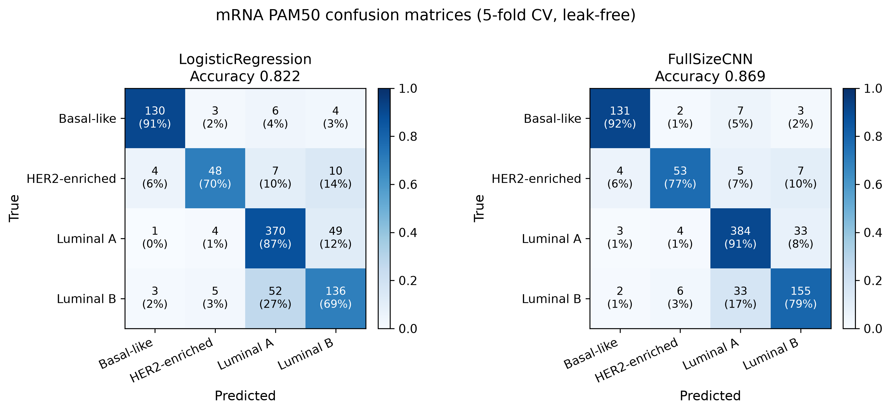
Table S4. Single-omics full-sample 5-fold CV results (mean±SD; features selected within each training fold, leak-free)
omics | task | model | metric | mean | std
mRNA | PAM50 | LogisticRegression | accuracy | 0.8221 | 0.0186
mRNA | PAM50 | LogisticRegression | macro_f1 | 0.805 | 0.0199
mRNA | PAM50 | RandomForest | accuracy | 0.8666 | 0.0046
mRNA | PAM50 | RandomForest | macro_f1 | 0.847 | 0.0164
mRNA | PAM50 | GradientBoosting | accuracy | 0.8629 | 0.029
mRNA | PAM50 | GradientBoosting | macro_f1 | 0.8432 | 0.0332
mRNA | PAM50 | SVC | accuracy | 0.8053 | 0.0083
mRNA | PAM50 | SVC | macro_f1 | 0.7932 | 0.021
mRNA | PAM50 | KNN | accuracy | 0.8089 | 0.0202
mRNA | PAM50 | KNN | macro_f1 | 0.7886 | 0.023
mRNA | PAM50 | MLP | accuracy | 0.8653 | 0.0184
mRNA | PAM50 | MLP | macro_f1 | 0.8493 | 0.029
mRNA | PAM50 | FullSizeCNN | accuracy | 0.869 | 0.0169
mRNA | PAM50 | FullSizeCNN | macro_f1 | 0.8508 | 0.017
mRNA | PAM50 | Dense | accuracy | 0.8593 | 0.0231
mRNA | PAM50 | Dense | macro_f1 | 0.8438 | 0.0293
mRNA | Survival | LogisticRegression | roc_auc | 0.5991 | 0.0461
mRNA | Survival | LogisticRegression | c_index | 0.5863 | 0.0816
mRNA | Survival | RandomForest | roc_auc | 0.6177 | 0.064
mRNA | Survival | RandomForest | c_index | 0.6181 | 0.0499
mRNA | Survival | GradientBoosting | roc_auc | 0.5996 | 0.0418
mRNA | Survival | GradientBoosting | c_index | 0.5849 | 0.0468
mRNA | Survival | SVC | roc_auc | 0.6139 | 0.0374
mRNA | Survival | SVC | c_index | 0.5968 | 0.0875
mRNA | Survival | KNN | roc_auc | 0.5924 | 0.0517
mRNA | Survival | KNN | c_index | 0.5675 | 0.0757
mRNA | Survival | MLP | roc_auc | 0.6007 | 0.0566
mRNA | Survival | MLP | c_index | 0.5894 | 0.0807
mRNA | Survival | FullSizeCNN | roc_auc | 0.5966 | 0.0622
mRNA | Survival | FullSizeCNN | c_index | 0.5823 | 0.0836
mRNA | Survival | Dense | roc_auc | 0.6047 | 0.0638
mRNA | Survival | Dense | c_index | 0.594 | 0.0747
mRNA | Survival | CoxPH | roc_auc | 0.5745 | 0.0759
mRNA | Survival | CoxPH | c_index | 0.5855 | 0.0324
miRNA | PAM50 | LogisticRegression | accuracy | 0.7643 | 0.0418
miRNA | PAM50 | LogisticRegression | macro_f1 | 0.6922 | 0.0636
miRNA | PAM50 | RandomForest | accuracy | 0.7602 | 0.0257
miRNA | PAM50 | RandomForest | macro_f1 | 0.6019 | 0.0301
miRNA | PAM50 | GradientBoosting | accuracy | 0.7969 | 0.0481
miRNA | PAM50 | GradientBoosting | macro_f1 | 0.7509 | 0.0682
miRNA | PAM50 | SVC | accuracy | 0.7643 | 0.0168
miRNA | PAM50 | SVC | macro_f1 | 0.7068 | 0.0409
miRNA | PAM50 | KNN | accuracy | 0.5672 | 0.0293
miRNA | PAM50 | KNN | macro_f1 | 0.3678 | 0.0506
miRNA | PAM50 | MLP | accuracy | 0.7928 | 0.0201
miRNA | PAM50 | MLP | macro_f1 | 0.7415 | 0.0357
miRNA | PAM50 | FullSizeCNN | accuracy | 0.7785 | 0.0186
miRNA | PAM50 | FullSizeCNN | macro_f1 | 0.7284 | 0.0374
miRNA | PAM50 | Dense | accuracy | 0.7989 | 0.0363
miRNA | PAM50 | Dense | macro_f1 | 0.7468 | 0.0344
miRNA | Survival | LogisticRegression | roc_auc | 0.5908 | 0.0531
miRNA | Survival | LogisticRegression | c_index | 0.5251 | 0.0955
miRNA | Survival | RandomForest | roc_auc | 0.6288 | 0.0461
miRNA | Survival | RandomForest | c_index | 0.6205 | 0.0559
miRNA | Survival | GradientBoosting | roc_auc | 0.5746 | 0.0548
miRNA | Survival | GradientBoosting | c_index | 0.5334 | 0.0795
miRNA | Survival | SVC | roc_auc | 0.5646 | 0.0493
miRNA | Survival | SVC | c_index | 0.5014 | 0.086
miRNA | Survival | KNN | roc_auc | 0.6406 | 0.0913
miRNA | Survival | KNN | c_index | 0.599 | 0.0892
miRNA | Survival | MLP | roc_auc | 0.6261 | 0.0241
miRNA | Survival | MLP | c_index | 0.5487 | 0.0548
miRNA | Survival | FullSizeCNN | roc_auc | 0.6302 | 0.022
miRNA | Survival | FullSizeCNN | c_index | 0.5647 | 0.0357
miRNA | Survival | Dense | roc_auc | 0.6452 | 0.0251
miRNA | Survival | Dense | c_index | 0.5662 | 0.0476
miRNA | Survival | CoxPH | roc_auc | 0.632 | 0.0635
miRNA | Survival | CoxPH | c_index | 0.6236 | 0.0469
CNV | PAM50 | LogisticRegression | accuracy | 0.5908 | 0.0309
CNV | PAM50 | LogisticRegression | macro_f1 | 0.4459 | 0.0498
CNV | PAM50 | RandomForest | accuracy | 0.5775 | 0.0424
CNV | PAM50 | RandomForest | macro_f1 | 0.4454 | 0.0483
CNV | PAM50 | GradientBoosting | accuracy | 0.5884 | 0.028
CNV | PAM50 | GradientBoosting | macro_f1 | 0.4693 | 0.0485
CNV | PAM50 | SVC | accuracy | 0.5884 | 0.0147
CNV | PAM50 | SVC | macro_f1 | 0.4094 | 0.0458
CNV | PAM50 | KNN | accuracy | 0.5872 | 0.0407
CNV | PAM50 | KNN | macro_f1 | 0.4549 | 0.0358
CNV | PAM50 | MLP | accuracy | 0.6005 | 0.0233
CNV | PAM50 | MLP | macro_f1 | 0.4513 | 0.0293
CNV | PAM50 | FullSizeCNN | accuracy | 0.5945 | 0.0411
CNV | PAM50 | FullSizeCNN | macro_f1 | 0.4375 | 0.0642
CNV | PAM50 | Dense | accuracy | 0.5848 | 0.0256
CNV | PAM50 | Dense | macro_f1 | 0.4191 | 0.0413
CNV | Survival | LogisticRegression | roc_auc | 0.5278 | 0.0428
CNV | Survival | LogisticRegression | c_index | 0.5513 | 0.0623
CNV | Survival | RandomForest | roc_auc | 0.4823 | 0.0324
CNV | Survival | RandomForest | c_index | 0.5423 | 0.025
CNV | Survival | GradientBoosting | roc_auc | 0.52 | 0.0446
CNV | Survival | GradientBoosting | c_index | 0.5423 | 0.0562
CNV | Survival | SVC | roc_auc | 0.5125 | 0.0446
CNV | Survival | SVC | c_index | 0.5284 | 0.0428
CNV | Survival | KNN | roc_auc | 0.4844 | 0.0713
CNV | Survival | KNN | c_index | 0.4947 | 0.0793
CNV | Survival | MLP | roc_auc | 0.5063 | 0.0514
CNV | Survival | MLP | c_index | 0.5175 | 0.0501
CNV | Survival | FullSizeCNN | roc_auc | 0.5187 | 0.0413
CNV | Survival | FullSizeCNN | c_index | 0.5298 | 0.0464
CNV | Survival | Dense | roc_auc | 0.5067 | 0.0335
CNV | Survival | Dense | c_index | 0.5246 | 0.0392

S5. Single-omics baselines on intersection samples
For fair comparison with multi-omics fusion, single-omics baselines were recomputed on the unified intersection samples.
Table S5. Single-omics baselines on triple-omics intersection samples (mean±SD; features selected within each training fold, leak-free)
omics | task | model | metric | mean | std | n
mRNA | PAM50 | LogisticRegression | accuracy | 0.784 | 0.0308 | 486
mRNA | PAM50 | LogisticRegression | macro_f1 | 0.7513 | 0.03 | 486
mRNA | PAM50 | RandomForest | accuracy | 0.8519 | 0.0285 | 486
mRNA | PAM50 | RandomForest | macro_f1 | 0.8389 | 0.039 | 486
mRNA | PAM50 | GradientBoosting | accuracy | 0.8438 | 0.0391 | 486
mRNA | PAM50 | GradientBoosting | macro_f1 | 0.8101 | 0.0414 | 486
mRNA | PAM50 | SVC | accuracy | 0.7531 | 0.0204 | 486
mRNA | PAM50 | SVC | macro_f1 | 0.7176 | 0.0152 | 486
mRNA | PAM50 | KNN | accuracy | 0.7841 | 0.0297 | 486
mRNA | PAM50 | KNN | macro_f1 | 0.7426 | 0.0354 | 486
mRNA | PAM50 | MLP | accuracy | 0.8334 | 0.0352 | 486
mRNA | PAM50 | MLP | macro_f1 | 0.8111 | 0.0455 | 486
mRNA | PAM50 | FullSizeCNN | accuracy | 0.8478 | 0.0325 | 486
mRNA | PAM50 | FullSizeCNN | macro_f1 | 0.8164 | 0.0485 | 486
mRNA | PAM50 | Dense | accuracy | 0.8313 | 0.0285 | 486
mRNA | PAM50 | Dense | macro_f1 | 0.8023 | 0.0395 | 486
CNV | PAM50 | LogisticRegression | accuracy | 0.611 | 0.0313 | 486
CNV | PAM50 | LogisticRegression | macro_f1 | 0.4552 | 0.0638 | 486
CNV | PAM50 | RandomForest | accuracy | 0.5987 | 0.0481 | 486
CNV | PAM50 | RandomForest | macro_f1 | 0.4407 | 0.0585 | 486
CNV | PAM50 | GradientBoosting | accuracy | 0.6254 | 0.0356 | 486
CNV | PAM50 | GradientBoosting | macro_f1 | 0.4975 | 0.0557 | 486
CNV | PAM50 | SVC | accuracy | 0.6029 | 0.0273 | 486
CNV | PAM50 | SVC | macro_f1 | 0.441 | 0.058 | 486
CNV | PAM50 | KNN | accuracy | 0.6069 | 0.0491 | 486
CNV | PAM50 | KNN | macro_f1 | 0.4447 | 0.0387 | 486
CNV | PAM50 | MLP | accuracy | 0.609 | 0.0131 | 486
CNV | PAM50 | MLP | macro_f1 | 0.4513 | 0.0409 | 486
CNV | PAM50 | FullSizeCNN | accuracy | 0.6151 | 0.0392 | 486
CNV | PAM50 | FullSizeCNN | macro_f1 | 0.4624 | 0.0265 | 486
CNV | PAM50 | Dense | accuracy | 0.609 | 0.0307 | 486
CNV | PAM50 | Dense | macro_f1 | 0.4335 | 0.0618 | 486
miRNA | PAM50 | LogisticRegression | accuracy | 0.7591 | 0.0474 | 486
miRNA | PAM50 | LogisticRegression | macro_f1 | 0.702 | 0.0699 | 486
miRNA | PAM50 | RandomForest | accuracy | 0.7429 | 0.0245 | 486
miRNA | PAM50 | RandomForest | macro_f1 | 0.5841 | 0.0443 | 486
miRNA | PAM50 | GradientBoosting | accuracy | 0.7552 | 0.0336 | 486
miRNA | PAM50 | GradientBoosting | macro_f1 | 0.679 | 0.0656 | 486
miRNA | PAM50 | SVC | accuracy | 0.7694 | 0.0469 | 486
miRNA | PAM50 | SVC | macro_f1 | 0.7095 | 0.0439 | 486
miRNA | PAM50 | KNN | accuracy | 0.5659 | 0.0274 | 486
miRNA | PAM50 | KNN | macro_f1 | 0.3634 | 0.0499 | 486
miRNA | PAM50 | MLP | accuracy | 0.7714 | 0.0473 | 486
miRNA | PAM50 | MLP | macro_f1 | 0.7155 | 0.0444 | 486
miRNA | PAM50 | FullSizeCNN | accuracy | 0.7631 | 0.0606 | 486
miRNA | PAM50 | FullSizeCNN | macro_f1 | 0.6918 | 0.0679 | 486
miRNA | PAM50 | Dense | accuracy | 0.7632 | 0.0494 | 486
miRNA | PAM50 | Dense | macro_f1 | 0.6946 | 0.0351 | 486
mRNA | Survival | LogisticRegression | roc_auc | 0.6258 | 0.0746 | 725
mRNA | Survival | LogisticRegression | c_index | 0.6132 | 0.0776 | 725
mRNA | Survival | RandomForest | roc_auc | 0.5841 | 0.0542 | 725
mRNA | Survival | RandomForest | c_index | 0.5884 | 0.0915 | 725
mRNA | Survival | GradientBoosting | roc_auc | 0.6075 | 0.034 | 725
mRNA | Survival | GradientBoosting | c_index | 0.573 | 0.0646 | 725
mRNA | Survival | SVC | roc_auc | 0.6189 | 0.0554 | 725
mRNA | Survival | SVC | c_index | 0.5953 | 0.061 | 725
mRNA | Survival | KNN | roc_auc | 0.6349 | 0.061 | 725
mRNA | Survival | KNN | c_index | 0.5849 | 0.0575 | 725
mRNA | Survival | MLP | roc_auc | 0.658 | 0.0583 | 725
mRNA | Survival | MLP | c_index | 0.6293 | 0.0552 | 725
mRNA | Survival | FullSizeCNN | roc_auc | 0.6401 | 0.0564 | 725
mRNA | Survival | FullSizeCNN | c_index | 0.6074 | 0.054 | 725
mRNA | Survival | Dense | roc_auc | 0.6559 | 0.0417 | 725
mRNA | Survival | Dense | c_index | 0.636 | 0.0417 | 725
mRNA | Survival | CoxPH | roc_auc | 0.6199 | 0.0365 | 725
mRNA | Survival | CoxPH | c_index | 0.6472 | 0.0412 | 725
CNV | Survival | LogisticRegression | roc_auc | 0.5648 | 0.0243 | 725
CNV | Survival | LogisticRegression | c_index | 0.5527 | 0.0551 | 725
CNV | Survival | RandomForest | roc_auc | 0.5698 | 0.0179 | 725
CNV | Survival | RandomForest | c_index | 0.5522 | 0.0835 | 725
CNV | Survival | GradientBoosting | roc_auc | 0.5768 | 0.0216 | 725
CNV | Survival | GradientBoosting | c_index | 0.542 | 0.0765 | 725
CNV | Survival | SVC | roc_auc | 0.5737 | 0.0161 | 725
CNV | Survival | SVC | c_index | 0.5481 | 0.0456 | 725
CNV | Survival | KNN | roc_auc | 0.5353 | 0.0779 | 725
CNV | Survival | KNN | c_index | 0.5213 | 0.0282 | 725
CNV | Survival | MLP | roc_auc | 0.5427 | 0.0525 | 725
CNV | Survival | MLP | c_index | 0.5057 | 0.0658 | 725
CNV | Survival | FullSizeCNN | roc_auc | 0.5558 | 0.035 | 725
CNV | Survival | FullSizeCNN | c_index | 0.5155 | 0.0513 | 725
CNV | Survival | Dense | roc_auc | 0.5698 | 0.0205 | 725
CNV | Survival | Dense | c_index | 0.5329 | 0.0497 | 725
CNV | Survival | CoxPH | roc_auc | 0.5524 | 0.0229 | 725
CNV | Survival | CoxPH | c_index | 0.5405 | 0.0938 | 725
miRNA | Survival | LogisticRegression | roc_auc | 0.5683 | 0.0344 | 725
miRNA | Survival | LogisticRegression | c_index | 0.5189 | 0.0419 | 725
miRNA | Survival | RandomForest | roc_auc | 0.6634 | 0.0909 | 725
miRNA | Survival | RandomForest | c_index | 0.6382 | 0.0664 | 725
miRNA | Survival | GradientBoosting | roc_auc | 0.594 | 0.0656 | 725
miRNA | Survival | GradientBoosting | c_index | 0.5676 | 0.0677 | 725
miRNA | Survival | SVC | roc_auc | 0.5542 | 0.028 | 725
miRNA | Survival | SVC | c_index | 0.5116 | 0.039 | 725
miRNA | Survival | KNN | roc_auc | 0.6445 | 0.0338 | 725
miRNA | Survival | KNN | c_index | 0.5911 | 0.0298 | 725
miRNA | Survival | MLP | roc_auc | 0.5925 | 0.0312 | 725
miRNA | Survival | MLP | c_index | 0.5322 | 0.0421 | 725
miRNA | Survival | FullSizeCNN | roc_auc | 0.6021 | 0.0462 | 725
miRNA | Survival | FullSizeCNN | c_index | 0.566 | 0.0662 | 725
miRNA | Survival | Dense | roc_auc | 0.6106 | 0.0483 | 725
miRNA | Survival | Dense | c_index | 0.5406 | 0.0405 | 725
miRNA | Survival | CoxPH | roc_auc | 0.596 | 0.0891 | 725
miRNA | Survival | CoxPH | c_index | 0.5623 | 0.0887 | 725

S6. Triple-omics fusion results
Table S6. Triple-omics fusion 5-fold CV results (mean±SD; features selected within each training fold, leak-free)
scheme | task | metric | mean | std
Concat_LR | PAM50 | accuracy | 0.8085 | 0.0653
Concat_MLP | PAM50 | accuracy | 0.8353 | 0.0316
CNN_LateAvg | PAM50 | accuracy | 0.8415 | 0.0327
CNN_Gated | PAM50 | accuracy | 0.8003 | 0.0539
Concat_LR | Survival | roc_auc | 0.6234 | 0.0382
Concat_MLP | Survival | roc_auc | 0.641 | 0.0504
CNN_LateAvg | Survival | roc_auc | 0.6742 | 0.0385
CNN_Gated | Survival | roc_auc | 0.6255 | 0.0399

S7. Pairwise-omics fusion results
Table S7. Pairwise-omics fusion 5-fold CV results (mean±SD; features selected within each training fold, leak-free)
pair | task | scheme | metric | mean | std | n
mRNA+CNV | PAM50 | Concat_LR | accuracy | 0.8255 | 0.029 | 825
mRNA+CNV | PAM50 | Concat_SVC | accuracy | 0.8109 | 0.0269 | 825
mRNA+CNV | PAM50 | Concat_MLP | accuracy | 0.863 | 0.0062 | 825
mRNA+CNV | PAM50 | CNN_LateAvg | accuracy | 0.8667 | 0.0184 | 825
mRNA+CNV | Survival | Concat_LR | roc_auc | 0.6117 | 0.0241 | 1064
mRNA+CNV | Survival | Concat_SVC | roc_auc | 0.6025 | 0.0245 | 1064
mRNA+CNV | Survival | Concat_MLP | roc_auc | 0.6161 | 0.0297 | 1064
mRNA+CNV | Survival | CNN_LateAvg | roc_auc | 0.6158 | 0.0487 | 1064
mRNA+miRNA | PAM50 | Concat_LR | accuracy | 0.8149 | 0.0507 | 492
mRNA+miRNA | PAM50 | Concat_SVC | accuracy | 0.8251 | 0.0425 | 492
mRNA+miRNA | PAM50 | Concat_MLP | accuracy | 0.823 | 0.0573 | 492
mRNA+miRNA | PAM50 | CNN_LateAvg | accuracy | 0.8414 | 0.0537 | 492
mRNA+miRNA | Survival | Concat_LR | roc_auc | 0.625 | 0.0428 | 732
mRNA+miRNA | Survival | Concat_SVC | roc_auc | 0.6096 | 0.0474 | 732
mRNA+miRNA | Survival | Concat_MLP | roc_auc | 0.6538 | 0.0412 | 732
mRNA+miRNA | Survival | CNN_LateAvg | roc_auc | 0.6342 | 0.0704 | 732
CNV+miRNA | PAM50 | Concat_LR | accuracy | 0.7879 | 0.0464 | 486
CNV+miRNA | PAM50 | Concat_SVC | accuracy | 0.7756 | 0.044 | 486
CNV+miRNA | PAM50 | Concat_MLP | accuracy | 0.7592 | 0.0316 | 486
CNV+miRNA | PAM50 | CNN_LateAvg | accuracy | 0.7735 | 0.0562 | 486
CNV+miRNA | Survival | Concat_LR | roc_auc | 0.6063 | 0.0827 | 727
CNV+miRNA | Survival | Concat_SVC | roc_auc | 0.5932 | 0.0809 | 727
CNV+miRNA | Survival | Concat_MLP | roc_auc | 0.6511 | 0.0775 | 727
CNV+miRNA | Survival | CNN_LateAvg | roc_auc | 0.6608 | 0.0497 | 727

S8. Nine-model Stacking and complex methods
Table S8. Nine-model Stacking and base-model results (mean±SD; features selected within each training fold, leak-free). PAM50 n=486; Survival n=725.
model | task | metric | mean | std
mRNA_ML | PAM50 | accuracy | 0.784 | 0.0308
mRNA_ML | PAM50 | macro_f1 | 0.7513 | 0.03
mRNA_MLP | PAM50 | accuracy | 0.8334 | 0.0352
mRNA_MLP | PAM50 | macro_f1 | 0.8111 | 0.0455
mRNA_CNN | PAM50 | accuracy | 0.8478 | 0.0325
mRNA_CNN | PAM50 | macro_f1 | 0.8164 | 0.0485
CNV_ML | PAM50 | accuracy | 0.611 | 0.0313
CNV_ML | PAM50 | macro_f1 | 0.4552 | 0.0638
CNV_MLP | PAM50 | accuracy | 0.609 | 0.0131
CNV_MLP | PAM50 | macro_f1 | 0.4513 | 0.0409
CNV_CNN | PAM50 | accuracy | 0.6151 | 0.0392
CNV_CNN | PAM50 | macro_f1 | 0.4624 | 0.0265
miRNA_ML | PAM50 | accuracy | 0.7591 | 0.0474
miRNA_ML | PAM50 | macro_f1 | 0.702 | 0.0699
miRNA_MLP | PAM50 | accuracy | 0.7714 | 0.0473
miRNA_MLP | PAM50 | macro_f1 | 0.7155 | 0.0444
miRNA_CNN | PAM50 | accuracy | 0.7631 | 0.0606
miRNA_CNN | PAM50 | macro_f1 | 0.6918 | 0.0679
Stacking_9 | PAM50 | accuracy | 0.8518 | 0.0339
Stacking_9 | PAM50 | macro_f1 | 0.8218 | 0.027
mRNA_ML | Survival | roc_auc | 0.6258 | 0.0746
mRNA_ML | Survival | c_index | 0.6132 | 0.0776
mRNA_MLP | Survival | roc_auc | 0.658 | 0.0583
mRNA_MLP | Survival | c_index | 0.6293 | 0.0552
mRNA_CNN | Survival | roc_auc | 0.6401 | 0.0564
mRNA_CNN | Survival | c_index | 0.6074 | 0.054
CNV_ML | Survival | roc_auc | 0.5648 | 0.0243
CNV_ML | Survival | c_index | 0.5527 | 0.0551
CNV_MLP | Survival | roc_auc | 0.5427 | 0.0525
CNV_MLP | Survival | c_index | 0.5057 | 0.0658
CNV_CNN | Survival | roc_auc | 0.5558 | 0.035
CNV_CNN | Survival | c_index | 0.5155 | 0.0513
miRNA_ML | Survival | roc_auc | 0.5683 | 0.0344
miRNA_ML | Survival | c_index | 0.5189 | 0.0419
miRNA_MLP | Survival | roc_auc | 0.5925 | 0.0312
miRNA_MLP | Survival | c_index | 0.5322 | 0.0421
miRNA_CNN | Survival | roc_auc | 0.6021 | 0.0462
miRNA_CNN | Survival | c_index | 0.566 | 0.0662
Stacking_9 | Survival | roc_auc | 0.6683 | 0.0435
Stacking_9 | Survival | c_index | 0.61 | 0.0561

Table S9. Advanced integration-method results (mean±SD). Transformer and DeepSurv use leak-free features selected within each training fold; Multi-task, low-rank bilinear, and GNN are exploratory (features pre-selected on the full cohort; n not re-estimated).
method | task | metric | mean | std | n
Transformer | PAM50 | accuracy | 0.8106 | 0.0476 | 486
Transformer | PAM50 | macro_f1 | 0.7854 | 0.044 | 486
Transformer | Survival | roc_auc | 0.5746 | 0.0505 | 725
Transformer | Survival | c_index | 0.5677 | 0.0649 | 725
DeepSurv | Survival | roc_auc | 0.6222 | 0.0625 | 725
DeepSurv | Survival | c_index | 0.6252 | 0.0569 | 725
Multi-task | PAM50 | accuracy | 0.8683 | 0.0322 | —
Multi-task | PAM50 | macro_f1 | 0.8522 | 0.0461 | —
Multi-task | Survival | roc_auc | 0.6992 | 0.0626 | —
Multi-task | Survival | c_index | 0.6519 | 0.1053 | —
Low-rank bilinear | PAM50 | accuracy | 0.7221 | 0.0248 | —
Low-rank bilinear | PAM50 | macro_f1 | 0.6726 | 0.0173 | —
Low-rank bilinear | Survival | roc_auc | 0.6150 | 0.0590 | —
Low-rank bilinear | Survival | c_index | 0.6304 | 0.0269 | —
GNN | PAM50 | accuracy | 0.8702 | 0.0245 | —
GNN | PAM50 | macro_f1 | 0.8635 | 0.0177 | —
GNN | Survival | roc_auc | 0.6771 | 0.0603 | —
GNN | Survival | c_index | 0.6493 | 0.0360 | —

S9. Paired tests
Table S10. Paired tests between best fusion and best single-omics on the same folds (leak-free out-of-fold predictions; 5-fold CV). The best single-omics model per task is the highest mean metric among single-omics models on the same intersection: mRNA RandomForest for PAM50 Accuracy and miRNA RandomForest for Survival ROC AUC.
Task | Fusion | Fusion mean | Single-omics mean | Mean diff | Paired t p | Wilcoxon p | n
PAM50 | CNN LateAvg | 0.8415 | 0.8519 | -0.0104 | 0.6531 | 0.6250 | 486
PAM50 | Concat MLP | 0.8353 | 0.8519 | -0.0166 | 0.5412 | 0.6250 | 486
Survival | CNN LateAvg | 0.6742 | 0.6634 | +0.0107 | 0.8519 | 1.0000 | 725
Survival | Concat MLP | 0.6410 | 0.6634 | -0.0224 | 0.6333 | 0.8125 | 725

S10. Imaging ablation and architecture comparisons
FullSizeCNN results across ordering schemes, classical full-size convolutional structures, and WGAN-GP data augmentation are summarized below. WGAN-GP augmentation follows GAN, Wasserstein GAN, and gradient-penalty training strategies [S6-S8].
Table S11. JSD spiral ordering vs functional-reordering schemes (PAM50; mean±SD; features pre-selected on the full cohort)
variant | category | task | metric | mean | std
baseline | Baseline | PAM50 | accuracy | 0.9244 | 0.0124
baseline | Baseline | PAM50 | macro_f1 | 0.9069 | 0.0133
mask_category_0 | Development / Epithelium | PAM50 | accuracy | 0.922 | 0.0152
mask_category_0 | Development / Epithelium | PAM50 | macro_f1 | 0.9086 | 0.0191
mask_category_1 | Signaling / Transport | PAM50 | accuracy | 0.9136 | 0.0145
mask_category_1 | Signaling / Transport | PAM50 | macro_f1 | 0.9057 | 0.0174
mask_category_2 | Hormone / Metabolism | PAM50 | accuracy | 0.9256 | 0.0155
mask_category_2 | Hormone / Metabolism | PAM50 | macro_f1 | 0.9099 | 0.0182
mask_category_3 | Immune / Inflammation | PAM50 | accuracy | 0.916 | 0.0137
mask_category_3 | Immune / Inflammation | PAM50 | macro_f1 | 0.8948 | 0.0198
mask_category_4 | Cell cycle / Proliferation | PAM50 | accuracy | 0.9171 | 0.0239
mask_category_4 | Cell cycle / Proliferation | PAM50 | macro_f1 | 0.9071 | 0.0285
mask_category_5 | Other | PAM50 | accuracy | 0.8967 | 0.0311
mask_category_5 | Other | PAM50 | macro_f1 | 0.8826 | 0.0393
baseline | Baseline | Survival | roc_auc | 0.665 | 0.0784
baseline | Baseline | Survival | c_index | 0.6984 | 0.0756
mask_category_0 | Development / Epithelium | Survival | roc_auc | 0.6797 | 0.0496
mask_category_0 | Development / Epithelium | Survival | c_index | 0.7184 | 0.0456
mask_category_1 | Signaling / Transport | Survival | roc_auc | 0.6661 | 0.075
mask_category_1 | Signaling / Transport | Survival | c_index | 0.6967 | 0.0674
mask_category_2 | Hormone / Metabolism | Survival | roc_auc | 0.6745 | 0.0794
mask_category_2 | Hormone / Metabolism | Survival | c_index | 0.7071 | 0.0795
mask_category_3 | Immune / Inflammation | Survival | roc_auc | 0.6736 | 0.0737
mask_category_3 | Immune / Inflammation | Survival | c_index | 0.707 | 0.0691
mask_category_4 | Cell cycle / Proliferation | Survival | roc_auc | 0.676 | 0.0628
mask_category_4 | Cell cycle / Proliferation | Survival | c_index | 0.7187 | 0.0477
mask_category_5 | Other | Survival | roc_auc | 0.6054 | 0.0492
mask_category_5 | Other | Survival | c_index | 0.6514 | 0.0444

Table S12. Classical full-size convolutional structures (mean±SD; features pre-selected on the full cohort)
variant | task | metric | mean | std
FullSizeCNN | PAM50 | accuracy | 0.9316 | 0.0071
FullSizeCNN | PAM50 | macro_f1 | 0.9205 | 0.0097
GroupNorm_Mish_FullSizeCNN | PAM50 | accuracy | 0.9183 | 0.0274
GroupNorm_Mish_FullSizeCNN | PAM50 | macro_f1 | 0.9047 | 0.0301
FCN_FullSize | PAM50 | accuracy | 0.9100 | 0.0309
FCN_FullSize | PAM50 | macro_f1 | 0.9081 | 0.0254
ResNet_FullSize | PAM50 | accuracy | 0.9207 | 0.0345
ResNet_FullSize | PAM50 | macro_f1 | 0.9010 | 0.0484
MultiBranch_SE_FullSize | PAM50 | accuracy | 0.9064 | 0.0249
MultiBranch_SE_FullSize | PAM50 | macro_f1 | 0.8936 | 0.0260
FullSizeCNN | Survival | roc_auc | 0.6768 | 0.0549
FullSizeCNN | Survival | c_index | 0.7125 | 0.0303
GroupNorm_Mish_FullSizeCNN | Survival | roc_auc | 0.6424 | 0.0658
GroupNorm_Mish_FullSizeCNN | Survival | c_index | 0.6844 | 0.0397
FCN_FullSize | Survival | roc_auc | 0.6340 | 0.0399
FCN_FullSize | Survival | c_index | 0.6630 | 0.0529
ResNet_FullSize | Survival | roc_auc | 0.6897 | 0.0455
ResNet_FullSize | Survival | c_index | 0.7250 | 0.0259
MultiBranch_SE_FullSize | Survival | roc_auc | 0.6774 | 0.0616
MultiBranch_SE_FullSize | Survival | c_index | 0.6991 | 0.0666

Table S13. WGAN-GP augmentation (baseline vs 1x/5x/10x) with FullSizeCNN across mRNA, CNV, and miRNA (5-fold CV, mean±SD; features pre-selected on the full cohort)
omics | task | variant | metric | mean | std
mRNA | PAM50 | baseline | accuracy | 0.9316 | 0.0071
mRNA | PAM50 | baseline | macro_f1 | 0.9205 | 0.0097
mRNA | PAM50 | aug_1x | accuracy | 0.9195 | 0.0204
mRNA | PAM50 | aug_1x | macro_f1 | 0.9120 | 0.0248
mRNA | PAM50 | aug_5x | accuracy | 0.9352 | 0.0259
mRNA | PAM50 | aug_5x | macro_f1 | 0.9209 | 0.0355
mRNA | PAM50 | aug_10x | accuracy | 0.9208 | 0.0175
mRNA | PAM50 | aug_10x | macro_f1 | 0.8989 | 0.0174
CNV | PAM50 | baseline | accuracy | 0.7164 | 0.0246
CNV | PAM50 | baseline | macro_f1 | 0.6727 | 0.0352
CNV | PAM50 | aug_1x | accuracy | 0.7201 | 0.0210
CNV | PAM50 | aug_1x | macro_f1 | 0.6806 | 0.0317
CNV | PAM50 | aug_5x | accuracy | 0.7103 | 0.0330
CNV | PAM50 | aug_5x | macro_f1 | 0.6589 | 0.0385
CNV | PAM50 | aug_10x | accuracy | 0.7079 | 0.0209
CNV | PAM50 | aug_10x | macro_f1 | 0.6560 | 0.0250
miRNA | PAM50 | baseline | accuracy | 0.8230 | 0.0227
miRNA | PAM50 | baseline | macro_f1 | 0.7785 | 0.0338
miRNA | PAM50 | aug_1x | accuracy | 0.8451 | 0.0259
miRNA | PAM50 | aug_1x | macro_f1 | 0.8178 | 0.0475
miRNA | PAM50 | aug_5x | accuracy | 0.7987 | 0.0391
miRNA | PAM50 | aug_5x | macro_f1 | 0.7822 | 0.0259
miRNA | PAM50 | aug_10x | accuracy | 0.8129 | 0.0216
miRNA | PAM50 | aug_10x | macro_f1 | 0.7704 | 0.0343
mRNA | Survival | baseline | roc_auc | 0.6768 | 0.0549
mRNA | Survival | baseline | c_index | 0.7125 | 0.0303
mRNA | Survival | aug_1x | roc_auc | 0.6758 | 0.0510
mRNA | Survival | aug_1x | c_index | 0.7132 | 0.0288
mRNA | Survival | aug_5x | roc_auc | 0.6769 | 0.0529
mRNA | Survival | aug_5x | c_index | 0.7082 | 0.0438
mRNA | Survival | aug_10x | roc_auc | 0.6814 | 0.0553
mRNA | Survival | aug_10x | c_index | 0.7128 | 0.0521
CNV | Survival | baseline | roc_auc | 0.6244 | 0.0428
CNV | Survival | baseline | c_index | 0.6199 | 0.0591
CNV | Survival | aug_1x | roc_auc | 0.6111 | 0.0287
CNV | Survival | aug_1x | c_index | 0.6027 | 0.0671
CNV | Survival | aug_5x | roc_auc | 0.6026 | 0.0235
CNV | Survival | aug_5x | c_index | 0.6070 | 0.0519
CNV | Survival | aug_10x | roc_auc | 0.5754 | 0.0371
CNV | Survival | aug_10x | c_index | 0.5738 | 0.0650
miRNA | Survival | baseline | roc_auc | 0.6301 | 0.0401
miRNA | Survival | baseline | c_index | 0.6067 | 0.0703
miRNA | Survival | aug_1x | roc_auc | 0.6389 | 0.0576
miRNA | Survival | aug_1x | c_index | 0.6084 | 0.0726
miRNA | Survival | aug_5x | roc_auc | 0.6328 | 0.0436
miRNA | Survival | aug_5x | c_index | 0.6084 | 0.0704
miRNA | Survival | aug_10x | roc_auc | 0.6461 | 0.0482
miRNA | Survival | aug_10x | c_index | 0.6139 | 0.0718

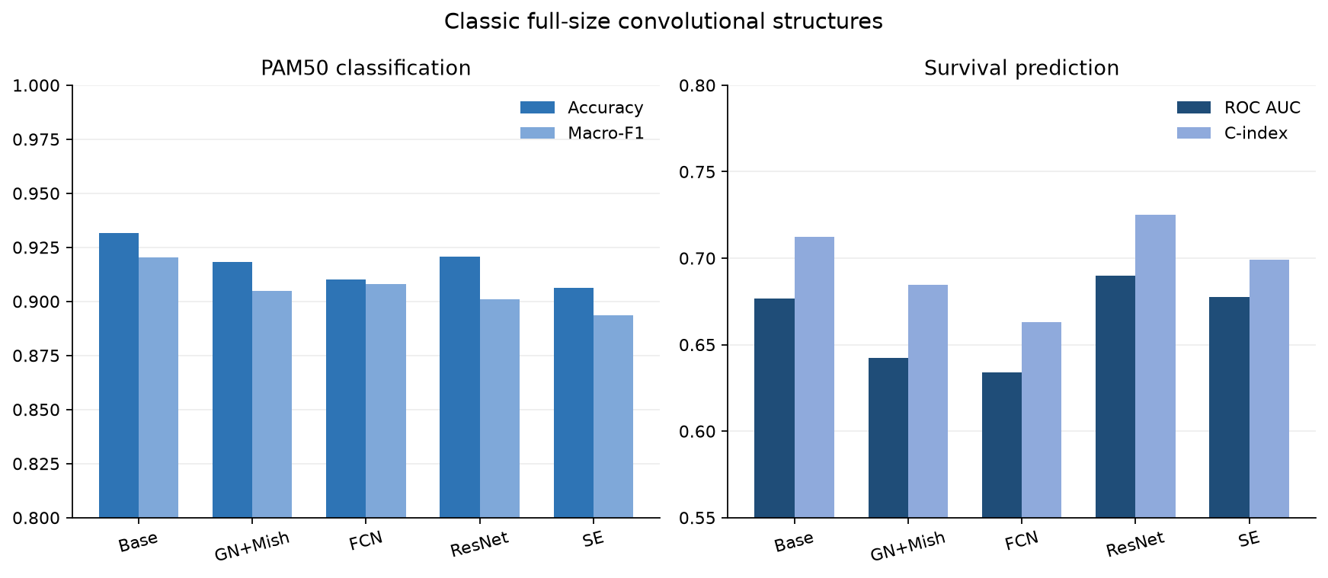
Figure S1. Classical full-size convolutional structures. Accuracy/Macro-F1 and ROC AUC/C-index are compared for FullSizeCNN, GroupNorm+Mish, FCN, ResNet, and multi-branch SE; error bars show 5-fold CV SD.
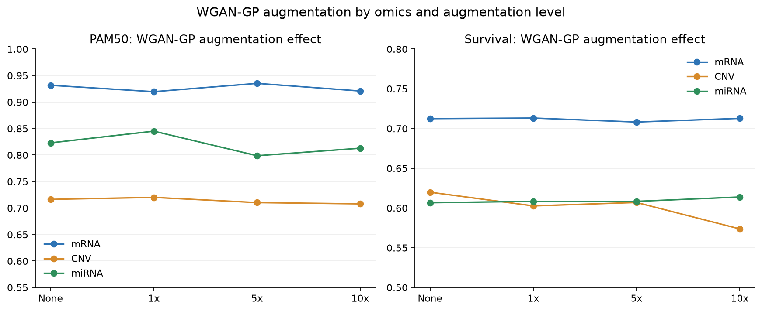
Figure S2. WGAN-GP augmentation for single-omics prediction. Comparisons include no augmentation, 1x, 5x, and 10x for mRNA, CNV, and miRNA; error bars show 5-fold CV SD.
To test whether the two-dimensional spatial structure provides additional gain, we trained a Dense-equivalent baseline with the same first-layer parameter count as FullSizeCNN (Flatten→Dense(32)→Dense(64)→output). Per-omics, per-task, and per-metric comparisons between the Dense-equivalent baseline and FullSizeCNN are in Table S14 and Figure S3.
Table S14. Dense-equivalent baseline vs FullSizeCNN (5-fold CV, mean±SD; features selected within each training fold, leak-free).
Omics | Task | Metric | Dense-equivalent mean±SD | FullSizeCNN mean±SD
mRNA | PAM50 | accuracy | 0.8593±0.0231 | 0.8690±0.0169
mRNA | PAM50 | macro_f1 | 0.8438±0.0293 | 0.8508±0.0170
mRNA | Survival | roc_auc | 0.6047±0.0638 | 0.5966±0.0622
mRNA | Survival | c_index | 0.5940±0.0747 | 0.5823±0.0836
CNV | PAM50 | accuracy | 0.5848±0.0256 | 0.5945±0.0411
CNV | PAM50 | macro_f1 | 0.4191±0.0413 | 0.4375±0.0642
CNV | Survival | roc_auc | 0.5067±0.0335 | 0.5187±0.0413
CNV | Survival | c_index | 0.5246±0.0392 | 0.5298±0.0464
miRNA | PAM50 | accuracy | 0.7989±0.0363 | 0.7785±0.0186
miRNA | PAM50 | macro_f1 | 0.7468±0.0344 | 0.7284±0.0374
miRNA | Survival | roc_auc | 0.6452±0.0251 | 0.6302±0.0220
miRNA | Survival | c_index | 0.5662±0.0476 | 0.5647±0.0357

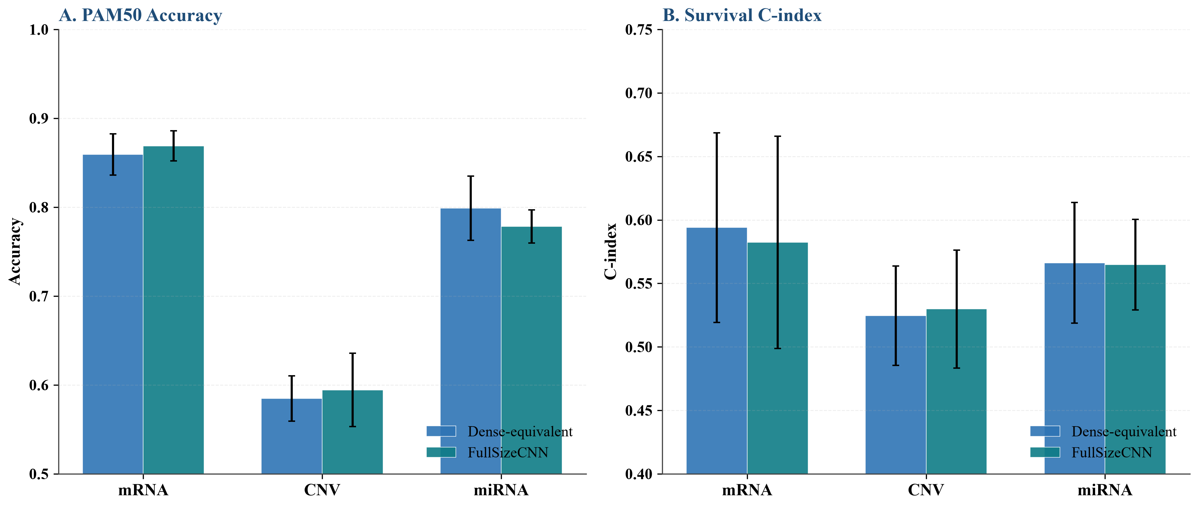
Figure S3. Dense-equivalent baseline vs FullSizeCNN. A: PAM50 Accuracy; B: Survival C-index. The dense network with an identical first-layer parameter count performs comparably to, or better than, FullSizeCNN, indicating that the 2-D spatial arrangement does not itself provide a consistent predictive gain; error bars show 5-fold CV SD.
To test whether JSD spiral ordering outperforms random ordering, 20 random gene permutations were generated for mRNA together with a mean-expression ordering as a deterministic control. Distributions of random permutations, mean-expression ordering, and JSD spiral ordering are compared in Table S15 and Figure S4; the empirical p-value is the proportion of the 20 random permutations with performance no worse than JSD.
Table S15. Random-permutation ordering control for mRNA (5-fold CV; JSD spiral vs 20 random orders vs mean-expression ordering; exploratory, cohort-level pre-selected features, superseded by the leak-free main analyses)
Task | Metric | JSD spiral | Mean expression | Random mean | Random std | Random min | Random max | p(random ≥ JSD)
PAM50 | accuracy | 0.9316 | 0.9316 | 0.9267 | 0.0075 | 0.9112 | 0.9400 | 0.2500
PAM50 | macro_f1 | 0.9205 | 0.9232 | 0.9168 | 0.0076 | 0.9004 | 0.9298 | 0.4000
Survival | roc_auc | 0.6768 | 0.6604 | 0.6698 | 0.0124 | 0.6393 | 0.6853 | 0.3500
Survival | c_index | 0.7125 | 0.6914 | 0.7055 | 0.0124 | 0.6796 | 0.7237 | 0.3500

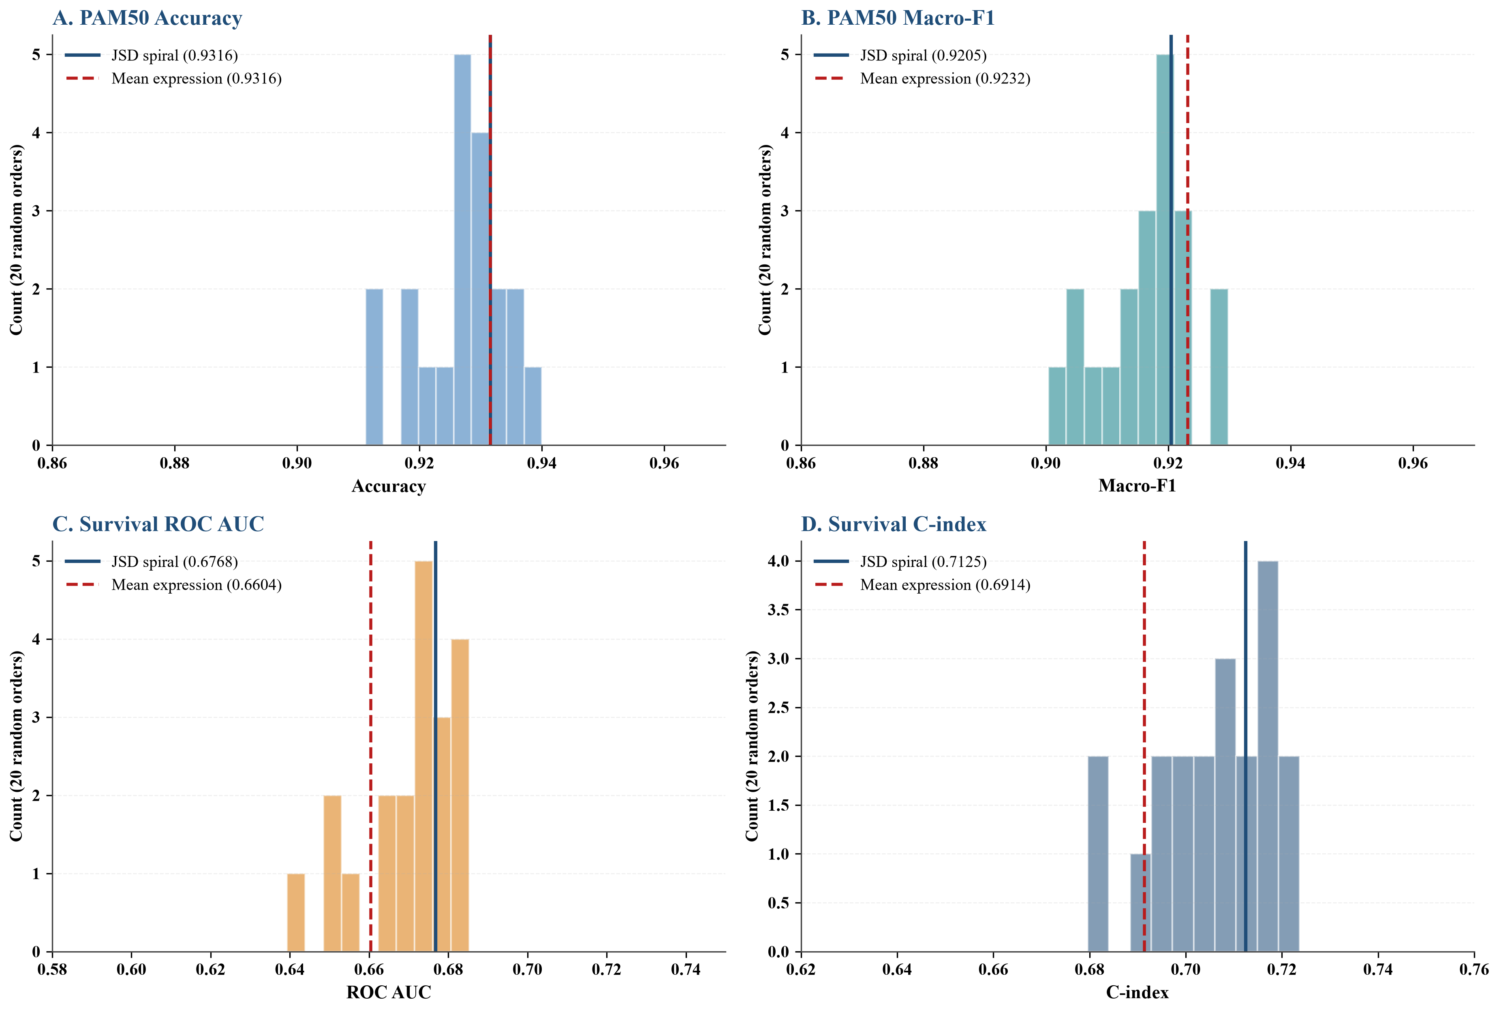
Figure S4. Random-permutation ordering control. A: PAM50 Accuracy; B: PAM50 Macro-F1; C: Survival ROC AUC; D: Survival C-index. Histograms show the distribution over 20 random gene orders; the JSD spiral and mean-expression orderings fall within the null, so the spatial ordering does not itself improve prediction.

S11. Supplementary interpretability figures
SHAP, gradient saliency, and Grad-CAM were used for global feature attribution, per-sample pixel/gene importance explanation, and convolutional gradient localization, respectively [S9-S11].
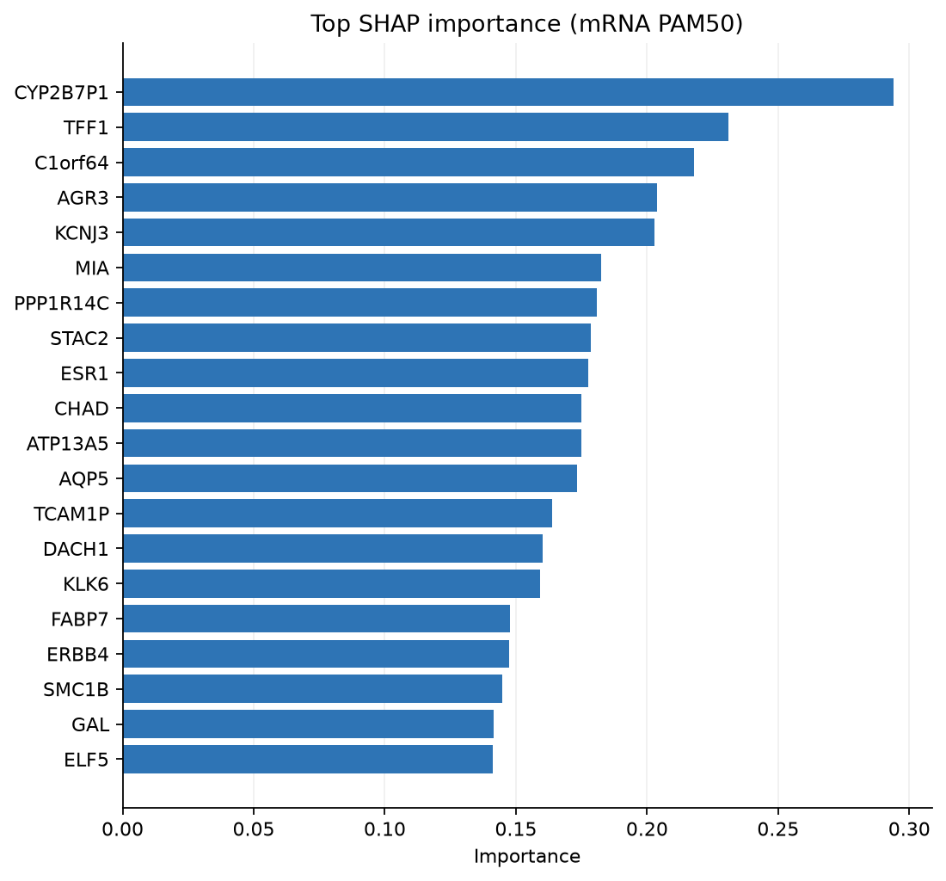
Figure S5. Top-20 SHAP genes for mRNA PAM50 LogisticRegression. The x-axis is mean absolute SHAP contribution; the y-axis is gene name.
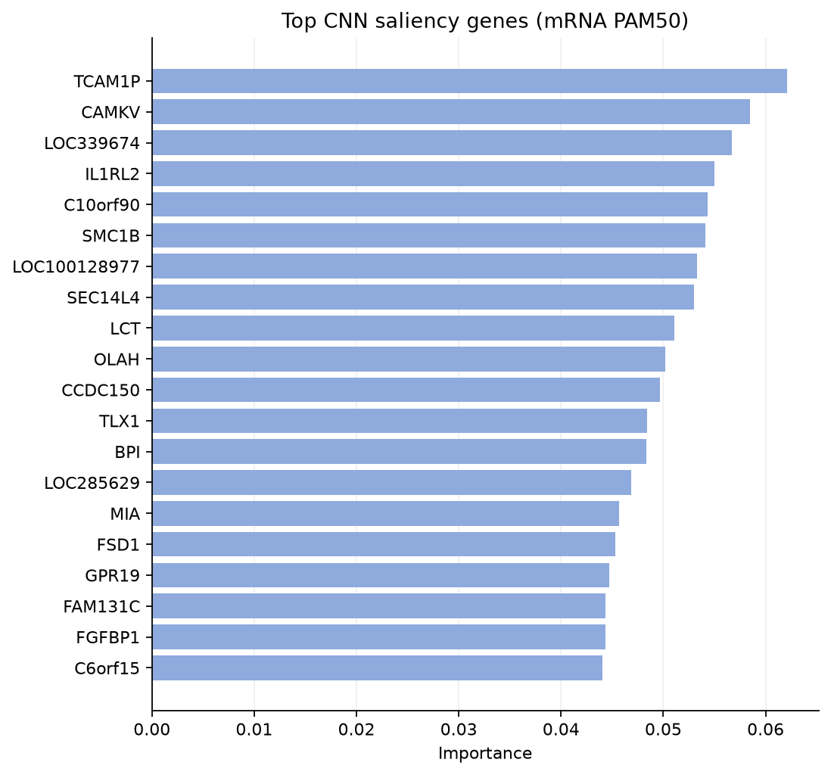
Figure S6. Top-20 CNN saliency genes for mRNA PAM50. Gradient-based saliency ranks input pixels/genes and highlights the most attended image regions.
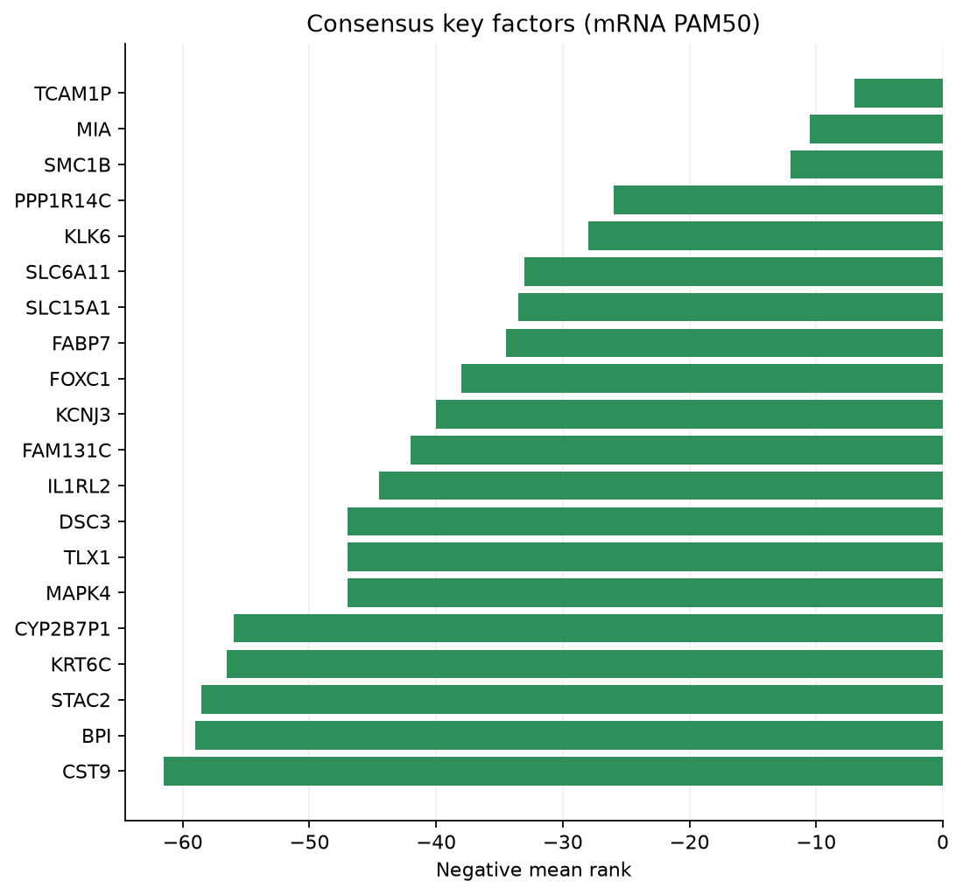
Figure S7. Top-20 consensus genes between SHAP and CNN saliency.
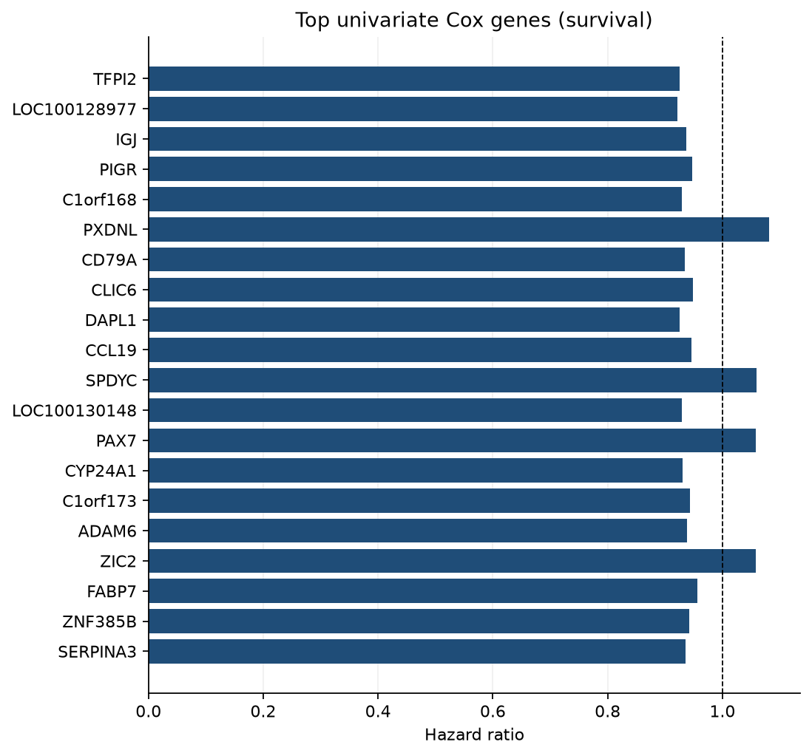
Figure S8. Top univariate Cox hazard ratios for survival genes. HR<1 indicates association with better survival; HR>1 indicates worse survival.
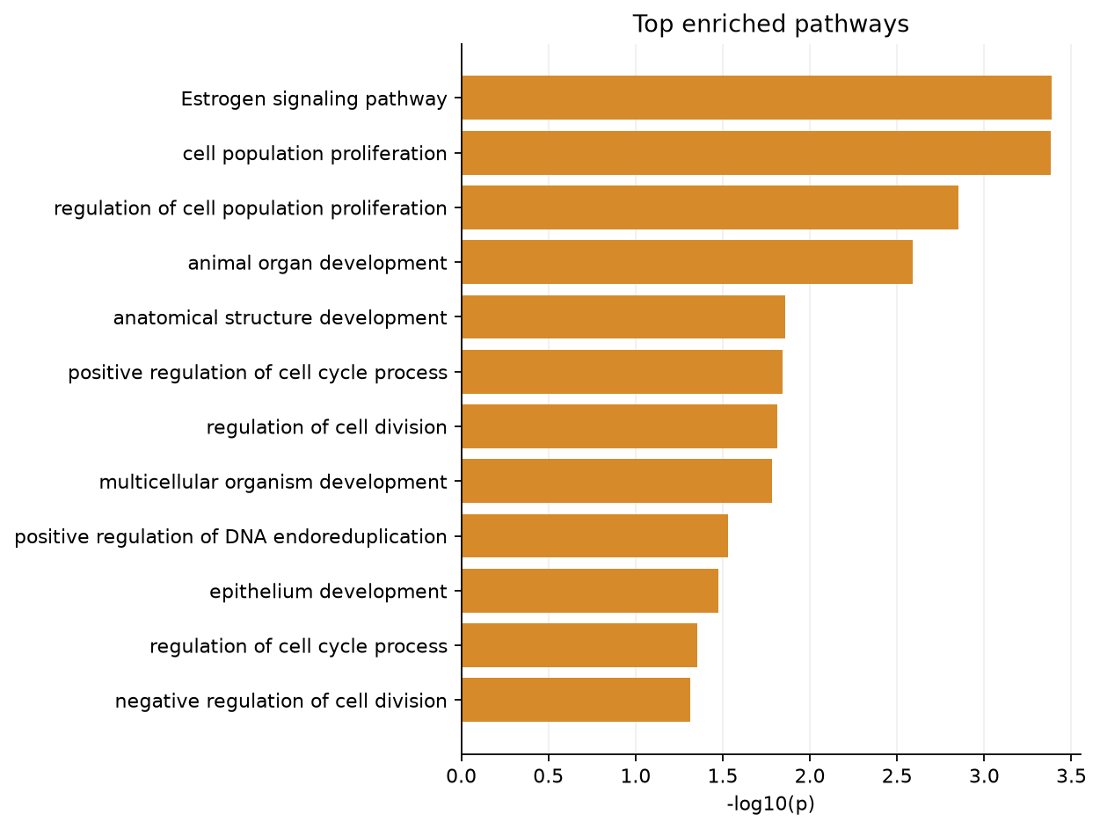
Figure S9. Pathway enrichment of consensus genes.

S12. Scheme 2 functional-category masking experiments
To assess the contribution of functional modules, each functional category was masked in turn on Scheme 2 images, and FullSizeCNN performance was compared for PAM50 classification and survival-risk modeling. Masking set the target category pixels to zero while leaving all other categories unchanged.
Table S16. mRNA Scheme 2 functional-category masking results (mean±SD; features pre-selected on the full cohort)
variant | category | task | metric | mean | std
baseline | Baseline | PAM50 | accuracy | 0.9244 | 0.0124
baseline | Baseline | PAM50 | macro_f1 | 0.9069 | 0.0133
mask_category_0 | Development / Epithelium | PAM50 | accuracy | 0.9112 | 0.0087
mask_category_0 | Development / Epithelium | PAM50 | macro_f1 | 0.9005 | 0.0097
mask_category_1 | Signaling / Transport | PAM50 | accuracy | 0.9268 | 0.0254
mask_category_1 | Signaling / Transport | PAM50 | macro_f1 | 0.9148 | 0.0334
mask_category_2 | Hormone / Metabolism | PAM50 | accuracy | 0.9112 | 0.0348
mask_category_2 | Hormone / Metabolism | PAM50 | macro_f1 | 0.8967 | 0.0412
mask_category_4 | Cell cycle / Proliferation | PAM50 | accuracy | 0.9160 | 0.0166
mask_category_4 | Cell cycle / Proliferation | PAM50 | macro_f1 | 0.8961 | 0.0130
mask_category_5 | Other | PAM50 | accuracy | 0.9100 | 0.0135
mask_category_5 | Other | PAM50 | macro_f1 | 0.8819 | 0.0210
baseline | Baseline | Survival | roc_auc | 0.6650 | 0.0784
baseline | Baseline | Survival | c_index | 0.6984 | 0.0756
mask_category_0 | Development / Epithelium | Survival | roc_auc | 0.6887 | 0.0421
mask_category_0 | Development / Epithelium | Survival | c_index | 0.7239 | 0.0349
mask_category_1 | Signaling / Transport | Survival | roc_auc | 0.6689 | 0.0666
mask_category_1 | Signaling / Transport | Survival | c_index | 0.7082 | 0.0433
mask_category_2 | Hormone / Metabolism | Survival | roc_auc | 0.6637 | 0.0706
mask_category_2 | Hormone / Metabolism | Survival | c_index | 0.6970 | 0.0509
mask_category_4 | Cell cycle / Proliferation | Survival | roc_auc | 0.6709 | 0.0537
mask_category_4 | Cell cycle / Proliferation | Survival | c_index | 0.7070 | 0.0543
mask_category_5 | Other | Survival | roc_auc | 0.6375 | 0.0764
mask_category_5 | Other | Survival | c_index | 0.6757 | 0.0715

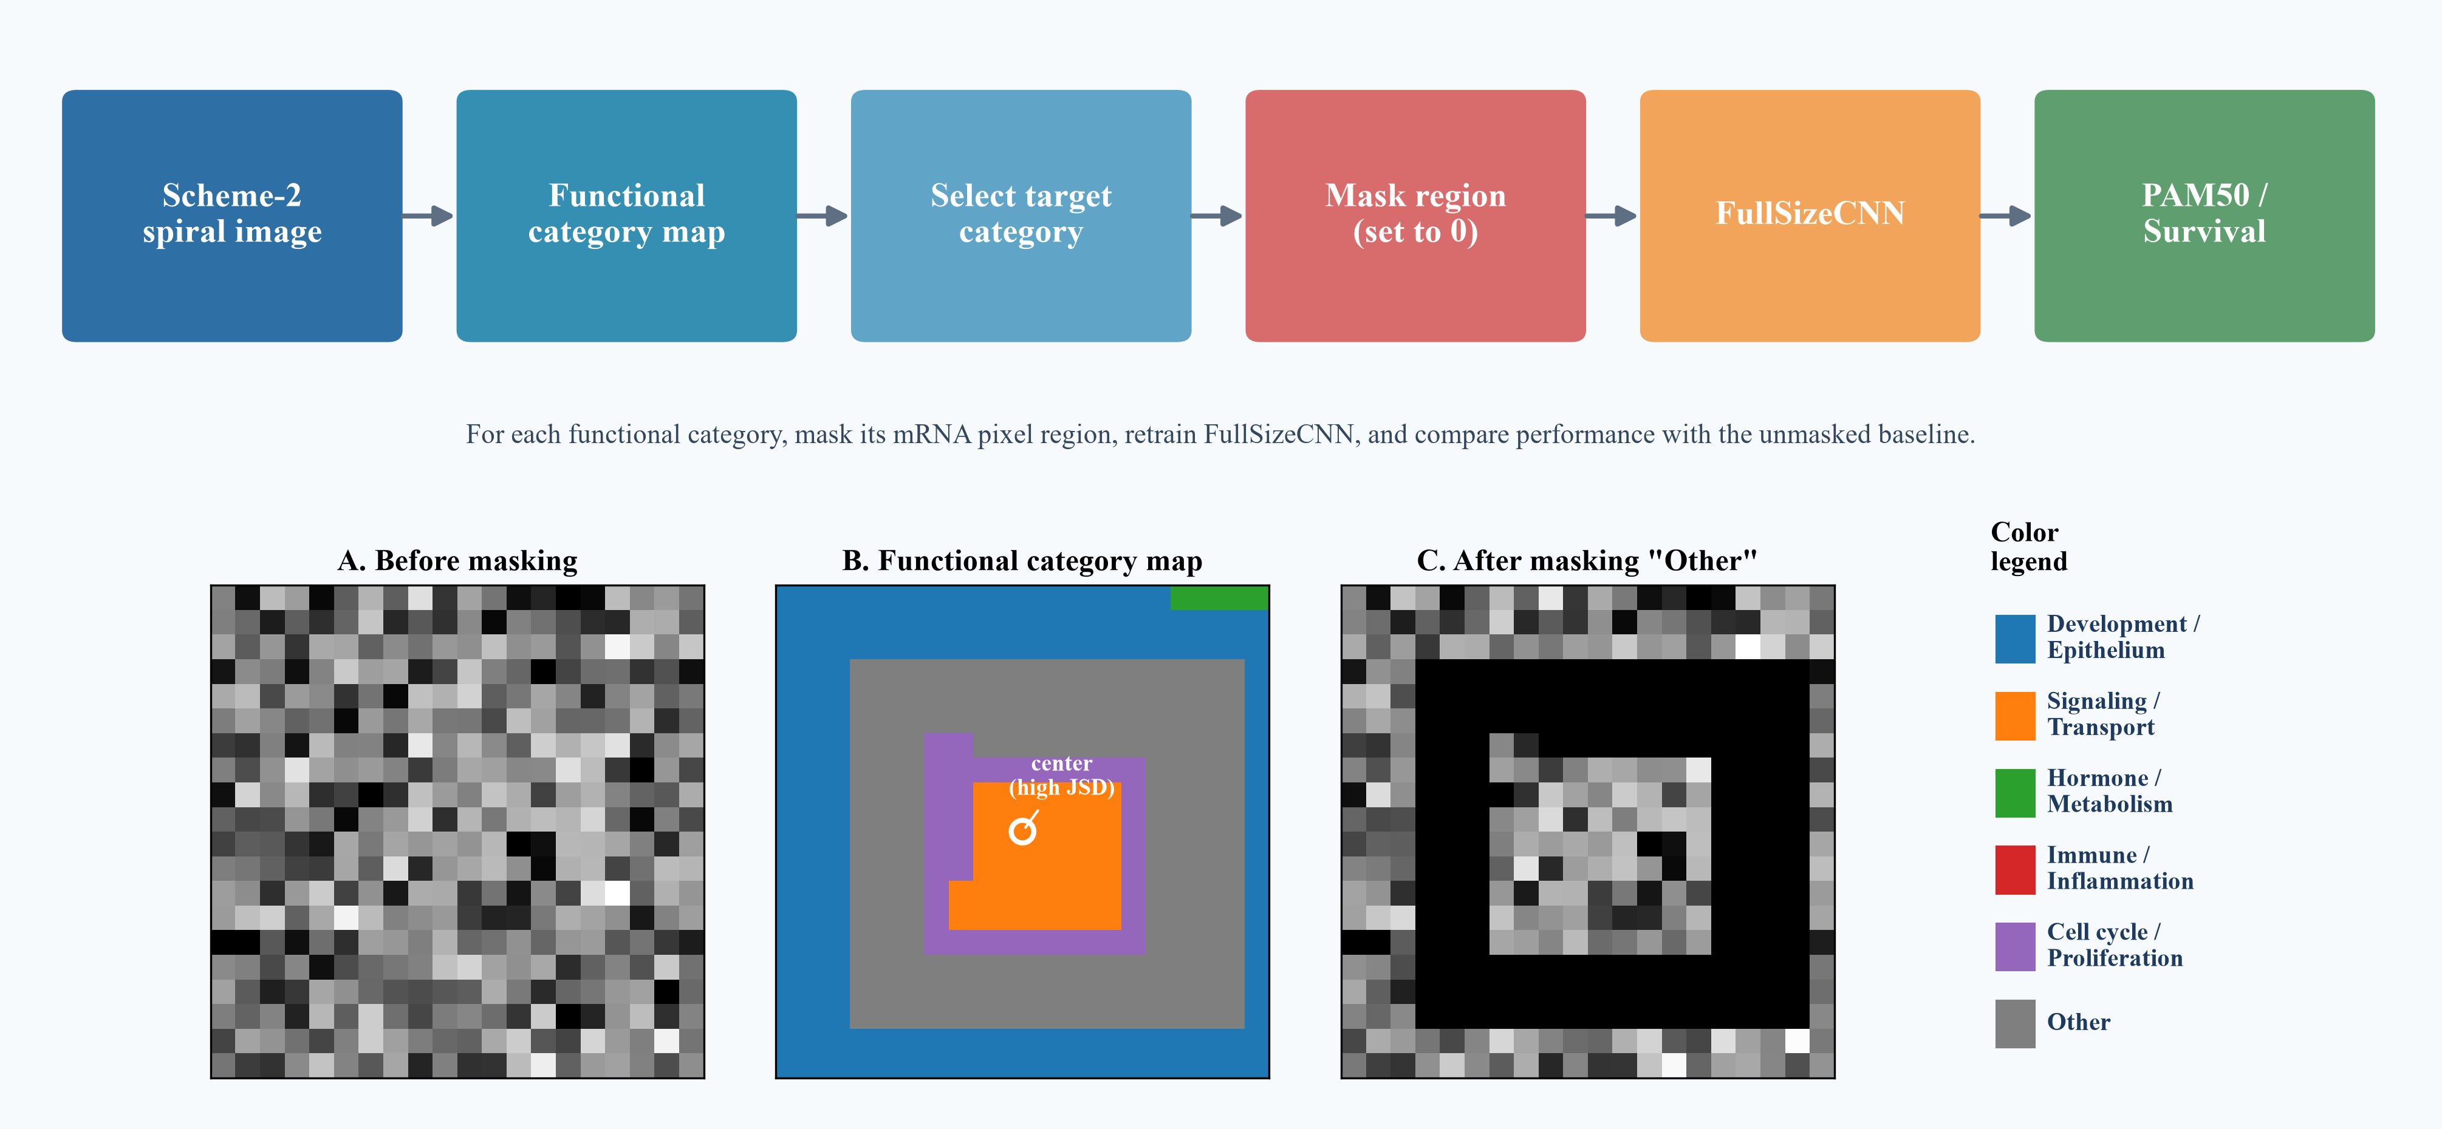
Figure S10. Scheme 2 functional-category masking workflow. A: before masking; B: functional category map; C: after masking Other.
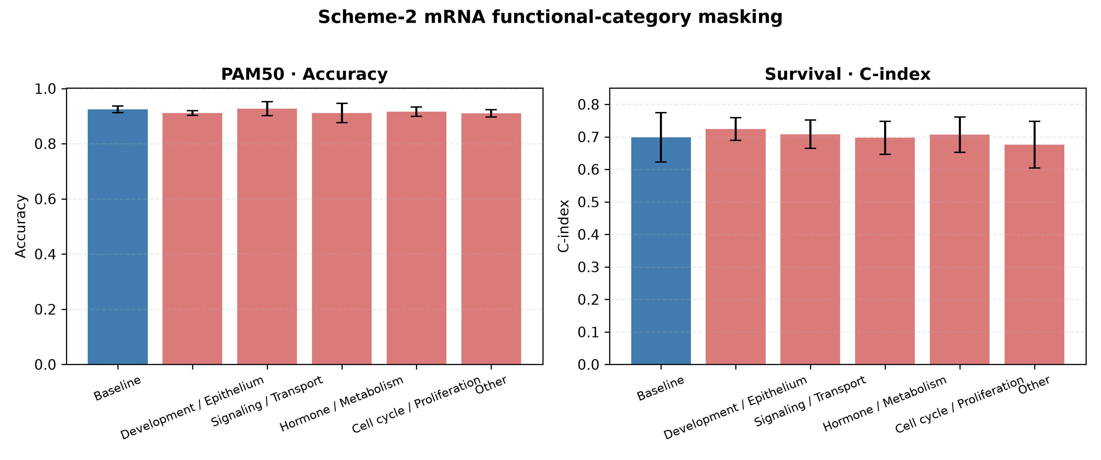
Figure S11. mRNA Scheme 2 functional-category masking performance. A: PAM50 Accuracy; B: Survival C-index; error bars show 5-fold CV SD.

S13. CNV and miRNA functional-category masking experiments
Note that CNV and miRNA functional categories are heuristic annotations rather than mutually exclusive biological ontologies. CNV was assigned to six categories by keyword rules on gene symbols; miRNA was first mapped from MIMAT to hsa-miR names and then assigned to the same six categories by family/known function [S12]. These rules cover only a subset of features and many features fall into Other; the masking results should therefore be regarded as directional evidence rather than definitive biological conclusions. The complete feature-to-category annotation is in data/omics_functional_category_annotation.tsv. Both omics used the same mask-retrain-evaluate pipeline as mRNA.
Table S17. CNV and miRNA functional-category masking results (mean±SD; features pre-selected on the full cohort)
omics | task | variant | category | metric | mean | std
CNV | PAM50 | baseline | Baseline | accuracy | 0.7176 | 0.0202
CNV | PAM50 | baseline | Baseline | macro_f1 | 0.6659 | 0.0319
CNV | PAM50 | mask_category_0 | Development/Epithelium | accuracy | 0.7091 | 0.0239
CNV | PAM50 | mask_category_0 | Development/Epithelium | macro_f1 | 0.6616 | 0.0328
CNV | PAM50 | mask_category_1 | Signaling/Transport | accuracy | 0.7128 | 0.0240
CNV | PAM50 | mask_category_1 | Signaling/Transport | macro_f1 | 0.6589 | 0.0391
CNV | PAM50 | mask_category_2 | Hormone/Metabolism | accuracy | 0.7164 | 0.0256
CNV | PAM50 | mask_category_2 | Hormone/Metabolism | macro_f1 | 0.6617 | 0.0332
CNV | PAM50 | mask_category_3 | Immune/Inflammation | accuracy | 0.7164 | 0.0193
CNV | PAM50 | mask_category_3 | Immune/Inflammation | macro_f1 | 0.6641 | 0.0225
CNV | PAM50 | mask_category_4 | Cell cycle/Proliferation | accuracy | 0.7152 | 0.0215
CNV | PAM50 | mask_category_4 | Cell cycle/Proliferation | macro_f1 | 0.6651 | 0.0309
CNV | PAM50 | mask_category_5 | Other | accuracy | 0.6737 | 0.0436
CNV | PAM50 | mask_category_5 | Other | macro_f1 | 0.5904 | 0.0645
CNV | Survival | baseline | Baseline | roc_auc | 0.6642 | 0.0248
CNV | Survival | baseline | Baseline | c_index | 0.6679 | 0.0471
CNV | Survival | mask_category_0 | Development/Epithelium | roc_auc | 0.6653 | 0.0247
CNV | Survival | mask_category_0 | Development/Epithelium | c_index | 0.6642 | 0.0479
CNV | Survival | mask_category_1 | Signaling/Transport | roc_auc | 0.6694 | 0.0343
CNV | Survival | mask_category_1 | Signaling/Transport | c_index | 0.6718 | 0.0601
CNV | Survival | mask_category_2 | Hormone/Metabolism | roc_auc | 0.6620 | 0.0213
CNV | Survival | mask_category_2 | Hormone/Metabolism | c_index | 0.6692 | 0.0508
CNV | Survival | mask_category_3 | Immune/Inflammation | roc_auc | 0.6604 | 0.0292
CNV | Survival | mask_category_3 | Immune/Inflammation | c_index | 0.6572 | 0.0520
CNV | Survival | mask_category_4 | Cell cycle/Proliferation | roc_auc | 0.6631 | 0.0226
CNV | Survival | mask_category_4 | Cell cycle/Proliferation | c_index | 0.6717 | 0.0488
CNV | Survival | mask_category_5 | Other | roc_auc | 0.5799 | 0.0814
CNV | Survival | mask_category_5 | Other | c_index | 0.5688 | 0.0633
miRNA | PAM50 | baseline | Baseline | accuracy | 0.8088 | 0.0230
miRNA | PAM50 | baseline | Baseline | macro_f1 | 0.7783 | 0.0441
miRNA | PAM50 | mask_category_0 | Development/Epithelium | accuracy | 0.8028 | 0.0328
miRNA | PAM50 | mask_category_0 | Development/Epithelium | macro_f1 | 0.7659 | 0.0570
miRNA | PAM50 | mask_category_1 | Signaling/Transport | accuracy | 0.8028 | 0.0138
miRNA | PAM50 | mask_category_1 | Signaling/Transport | macro_f1 | 0.7670 | 0.0251
miRNA | PAM50 | mask_category_2 | Hormone/Metabolism | accuracy | 0.8129 | 0.0267
miRNA | PAM50 | mask_category_2 | Hormone/Metabolism | macro_f1 | 0.7752 | 0.0315
miRNA | PAM50 | mask_category_3 | Immune/Inflammation | accuracy | 0.8048 | 0.0263
miRNA | PAM50 | mask_category_3 | Immune/Inflammation | macro_f1 | 0.7685 | 0.0384
miRNA | PAM50 | mask_category_4 | Cell cycle/Proliferation | accuracy | 0.8008 | 0.0228
miRNA | PAM50 | mask_category_4 | Cell cycle/Proliferation | macro_f1 | 0.7540 | 0.0328
miRNA | PAM50 | mask_category_5 | Other | accuracy | 0.7264 | 0.0194
miRNA | PAM50 | mask_category_5 | Other | macro_f1 | 0.5314 | 0.0365
miRNA | Survival | baseline | Baseline | roc_auc | 0.6056 | 0.0588
miRNA | Survival | baseline | Baseline | c_index | 0.5807 | 0.0768
miRNA | Survival | mask_category_0 | Development/Epithelium | roc_auc | 0.6051 | 0.0615
miRNA | Survival | mask_category_0 | Development/Epithelium | c_index | 0.5737 | 0.0825
miRNA | Survival | mask_category_1 | Signaling/Transport | roc_auc | 0.5994 | 0.0722
miRNA | Survival | mask_category_1 | Signaling/Transport | c_index | 0.5752 | 0.0848
miRNA | Survival | mask_category_2 | Hormone/Metabolism | roc_auc | 0.5985 | 0.0442
miRNA | Survival | mask_category_2 | Hormone/Metabolism | c_index | 0.5824 | 0.0633
miRNA | Survival | mask_category_3 | Immune/Inflammation | roc_auc | 0.6005 | 0.0518
miRNA | Survival | mask_category_3 | Immune/Inflammation | c_index | 0.5684 | 0.0811
miRNA | Survival | mask_category_4 | Cell cycle/Proliferation | roc_auc | 0.6041 | 0.0629
miRNA | Survival | mask_category_4 | Cell cycle/Proliferation | c_index | 0.5685 | 0.0795
miRNA | Survival | mask_category_5 | Other | roc_auc | 0.5218 | 0.0553
miRNA | Survival | mask_category_5 | Other | c_index | 0.5640 | 0.0649

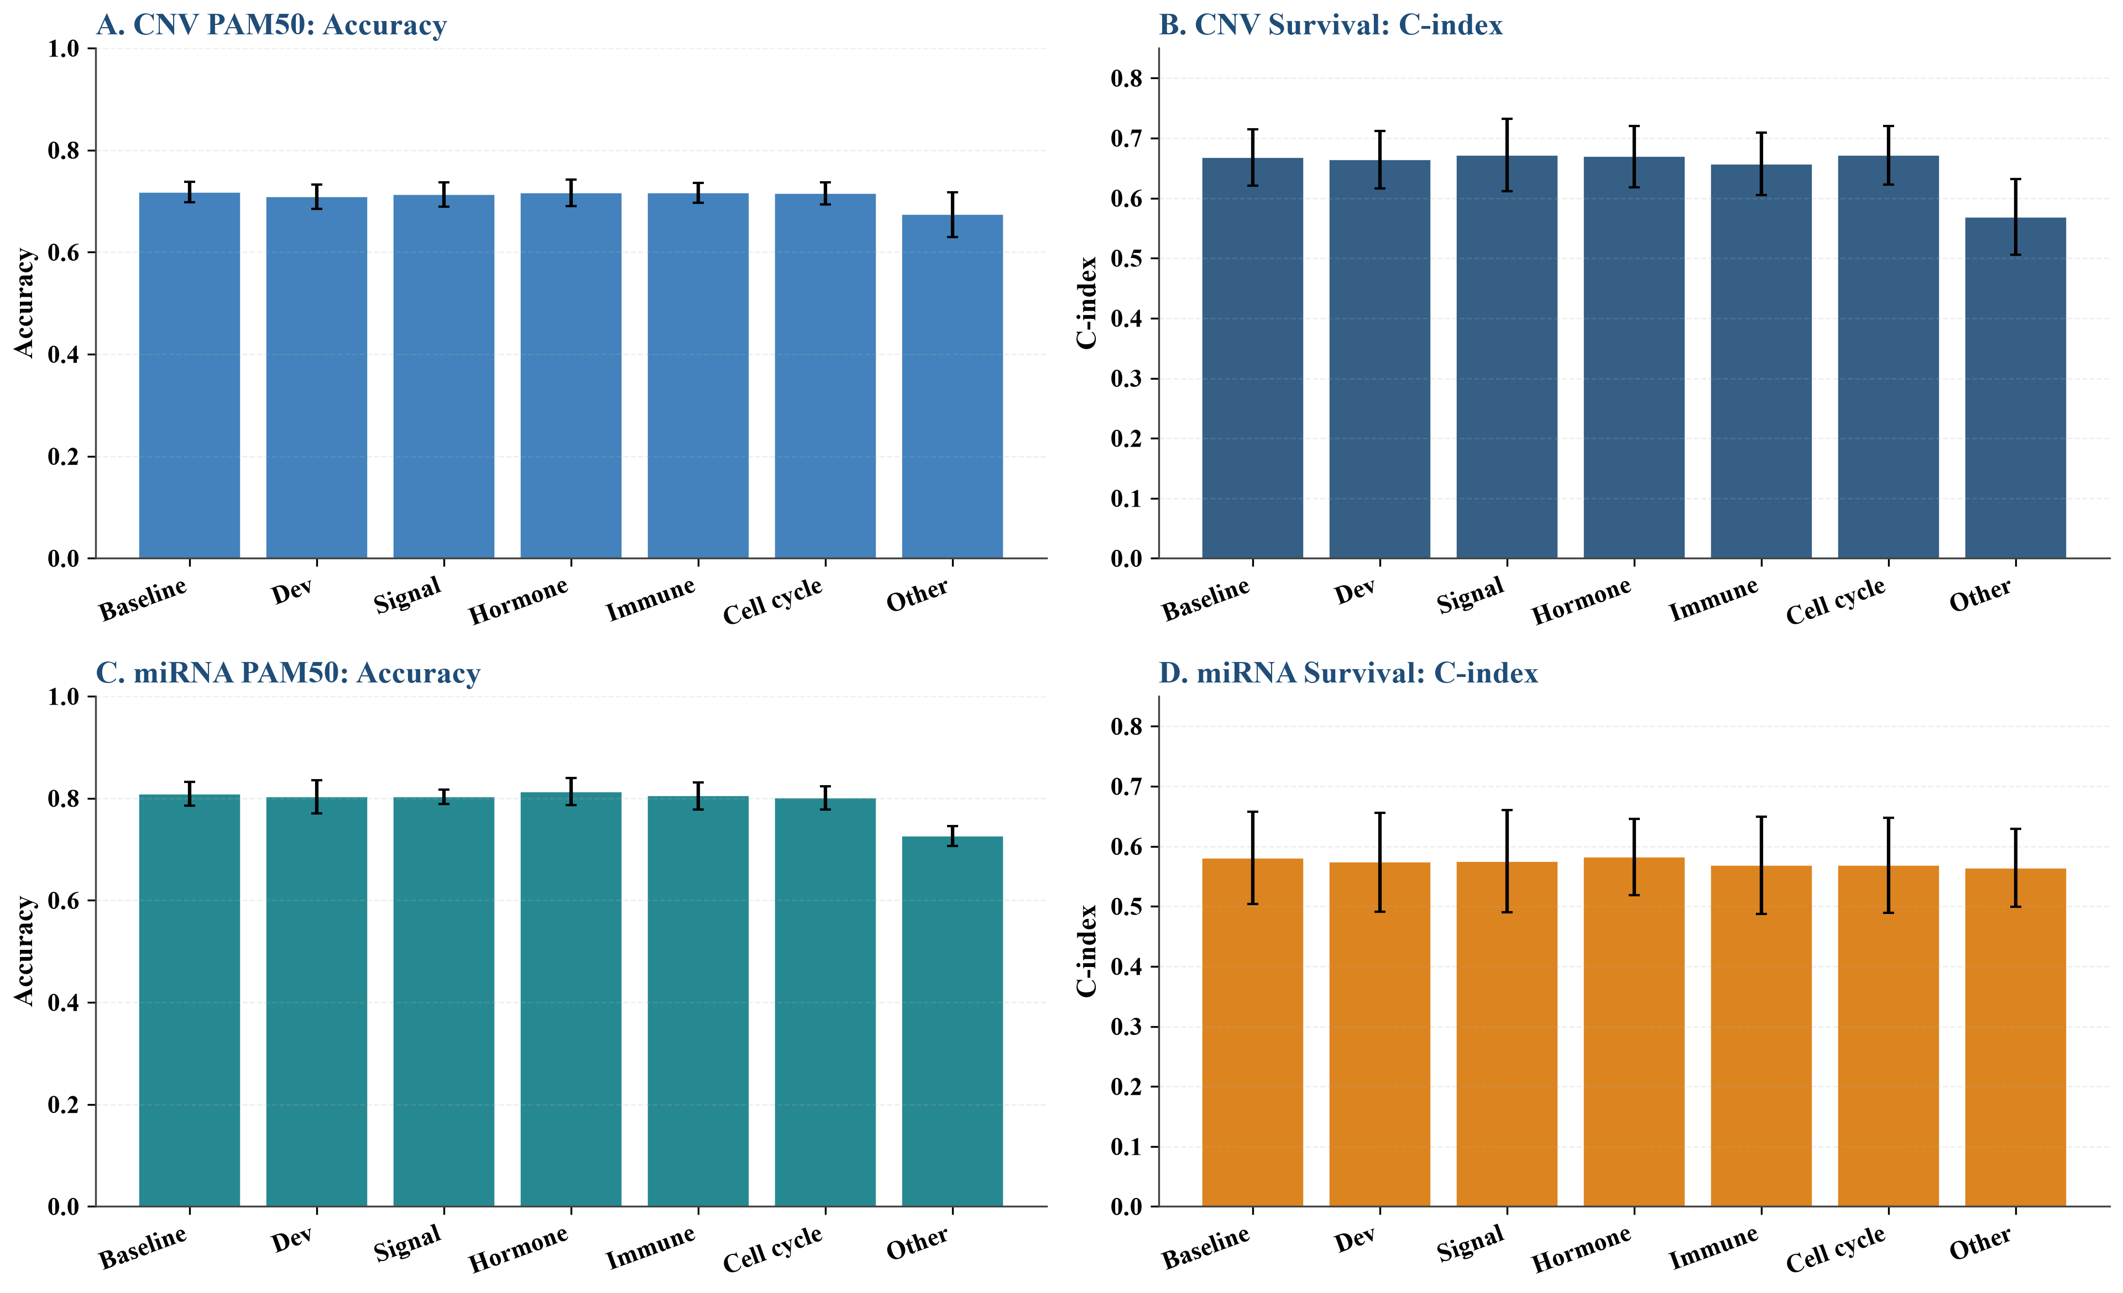
Figure S12. CNV and miRNA functional-category masking performance. A-D: CNV PAM50, CNV Survival, miRNA PAM50, and miRNA Survival.

S14. Equal-size random-masking controls and statistical tests
To control for feature-number and region-size effects, equal-number random-gene masking controls were generated for each mRNA functional category. Fold-level metrics are in the supplementary files, and paired t-test and Wilcoxon test results are in the table below.
Table S18. Fold-level metrics for mRNA equal-size random masking controls
task | fold | variant | metric | value
PAM50 | 0 | baseline | accuracy | 0.8982
PAM50 | 0 | baseline | macro_f1 | 0.8814
PAM50 | 0 | mask_category_0 | accuracy | 0.9341
PAM50 | 0 | mask_category_0 | macro_f1 | 0.9032
PAM50 | 0 | random_equal_0 | accuracy | 0.9162
PAM50 | 0 | random_equal_0 | macro_f1 | 0.8925
PAM50 | 0 | mask_category_1 | accuracy | 0.9162
PAM50 | 0 | mask_category_1 | macro_f1 | 0.8938
PAM50 | 0 | random_equal_1 | accuracy | 0.9102
PAM50 | 0 | random_equal_1 | macro_f1 | 0.8870
PAM50 | 0 | mask_category_2 | accuracy | 0.9162
PAM50 | 0 | mask_category_2 | macro_f1 | 0.8944
PAM50 | 0 | random_equal_2 | accuracy | 0.9162
PAM50 | 0 | random_equal_2 | macro_f1 | 0.8820
PAM50 | 0 | mask_category_4 | accuracy | 0.8982
PAM50 | 0 | mask_category_4 | macro_f1 | 0.8693
PAM50 | 0 | random_equal_4 | accuracy | 0.9102
PAM50 | 0 | random_equal_4 | macro_f1 | 0.8981
PAM50 | 0 | mask_category_5 | accuracy | 0.9042
PAM50 | 0 | mask_category_5 | macro_f1 | 0.8805
PAM50 | 0 | random_equal_5 | accuracy | 0.8982
PAM50 | 0 | random_equal_5 | macro_f1 | 0.8820
PAM50 | 1 | baseline | accuracy | 0.9521
PAM50 | 1 | baseline | macro_f1 | 0.9476
PAM50 | 1 | mask_category_0 | accuracy | 0.9521
PAM50 | 1 | mask_category_0 | macro_f1 | 0.9457
PAM50 | 1 | random_equal_0 | accuracy | 0.9401
PAM50 | 1 | random_equal_0 | macro_f1 | 0.9310
PAM50 | 1 | mask_category_1 | accuracy | 0.9701
PAM50 | 1 | mask_category_1 | macro_f1 | 0.9661
PAM50 | 1 | random_equal_1 | accuracy | 0.9401
PAM50 | 1 | random_equal_1 | macro_f1 | 0.9329
PAM50 | 1 | mask_category_2 | accuracy | 0.9521
PAM50 | 1 | mask_category_2 | macro_f1 | 0.9385
PAM50 | 1 | random_equal_2 | accuracy | 0.9341
PAM50 | 1 | random_equal_2 | macro_f1 | 0.9224
PAM50 | 1 | mask_category_4 | accuracy | 0.9401
PAM50 | 1 | mask_category_4 | macro_f1 | 0.9329
PAM50 | 1 | random_equal_4 | accuracy | 0.9581
PAM50 | 1 | random_equal_4 | macro_f1 | 0.9484
PAM50 | 1 | mask_category_5 | accuracy | 0.9281
PAM50 | 1 | mask_category_5 | macro_f1 | 0.9140
PAM50 | 1 | random_equal_5 | accuracy | 0.9581
PAM50 | 1 | random_equal_5 | macro_f1 | 0.9466
PAM50 | 2 | baseline | accuracy | 0.8443
PAM50 | 2 | baseline | macro_f1 | 0.8436
PAM50 | 2 | mask_category_0 | accuracy | 0.8982
PAM50 | 2 | mask_category_0 | macro_f1 | 0.8933
PAM50 | 2 | random_equal_0 | accuracy | 0.8683
PAM50 | 2 | random_equal_0 | macro_f1 | 0.8894
PAM50 | 2 | mask_category_1 | accuracy | 0.8802
PAM50 | 2 | mask_category_1 | macro_f1 | 0.8754
PAM50 | 2 | random_equal_1 | accuracy | 0.9102
PAM50 | 2 | random_equal_1 | macro_f1 | 0.8954
PAM50 | 2 | mask_category_2 | accuracy | 0.8563
PAM50 | 2 | mask_category_2 | macro_f1 | 0.8687
PAM50 | 2 | random_equal_2 | accuracy | 0.8563
PAM50 | 2 | random_equal_2 | macro_f1 | 0.8679
PAM50 | 2 | mask_category_4 | accuracy | 0.8563
PAM50 | 2 | mask_category_4 | macro_f1 | 0.8579
PAM50 | 2 | random_equal_4 | accuracy | 0.8743
PAM50 | 2 | random_equal_4 | macro_f1 | 0.8655
PAM50 | 2 | mask_category_5 | accuracy | 0.8503
PAM50 | 2 | mask_category_5 | macro_f1 | 0.8489
PAM50 | 2 | random_equal_5 | accuracy | 0.8743
PAM50 | 2 | random_equal_5 | macro_f1 | 0.8796
PAM50 | 3 | baseline | accuracy | 0.8795
PAM50 | 3 | baseline | macro_f1 | 0.8536
PAM50 | 3 | mask_category_0 | accuracy | 0.8795
PAM50 | 3 | mask_category_0 | macro_f1 | 0.8639
PAM50 | 3 | random_equal_0 | accuracy | 0.8614
PAM50 | 3 | random_equal_0 | macro_f1 | 0.8344
PAM50 | 3 | mask_category_1 | accuracy | 0.8735
PAM50 | 3 | mask_category_1 | macro_f1 | 0.8379
PAM50 | 3 | random_equal_1 | accuracy | 0.8795
PAM50 | 3 | random_equal_1 | macro_f1 | 0.8674
PAM50 | 3 | mask_category_2 | accuracy | 0.8795
PAM50 | 3 | mask_category_2 | macro_f1 | 0.8536
PAM50 | 3 | random_equal_2 | accuracy | 0.8976
PAM50 | 3 | random_equal_2 | macro_f1 | 0.8780
PAM50 | 3 | mask_category_4 | accuracy | 0.9096
PAM50 | 3 | mask_category_4 | macro_f1 | 0.9053
PAM50 | 3 | random_equal_4 | accuracy | 0.8795
PAM50 | 3 | random_equal_4 | macro_f1 | 0.8784
PAM50 | 3 | mask_category_5 | accuracy | 0.9096
PAM50 | 3 | mask_category_5 | macro_f1 | 0.9102
PAM50 | 3 | random_equal_5 | accuracy | 0.8976
PAM50 | 3 | random_equal_5 | macro_f1 | 0.8891
PAM50 | 4 | baseline | accuracy | 0.9157
PAM50 | 4 | baseline | macro_f1 | 0.8957
PAM50 | 4 | mask_category_0 | accuracy | 0.9036
PAM50 | 4 | mask_category_0 | macro_f1 | 0.8818
PAM50 | 4 | random_equal_0 | accuracy | 0.8916
PAM50 | 4 | random_equal_0 | macro_f1 | 0.8514
PAM50 | 4 | mask_category_1 | accuracy | 0.9157
PAM50 | 4 | mask_category_1 | macro_f1 | 0.8872
PAM50 | 4 | random_equal_1 | accuracy | 0.9337
PAM50 | 4 | random_equal_1 | macro_f1 | 0.9175
PAM50 | 4 | mask_category_2 | accuracy | 0.9096
PAM50 | 4 | mask_category_2 | macro_f1 | 0.8899
PAM50 | 4 | random_equal_2 | accuracy | 0.8916
PAM50 | 4 | random_equal_2 | macro_f1 | 0.8769
PAM50 | 4 | mask_category_4 | accuracy | 0.9157
PAM50 | 4 | mask_category_4 | macro_f1 | 0.8872
PAM50 | 4 | random_equal_4 | accuracy | 0.9217
PAM50 | 4 | random_equal_4 | macro_f1 | 0.9019
PAM50 | 4 | mask_category_5 | accuracy | 0.9217
PAM50 | 4 | mask_category_5 | macro_f1 | 0.8884
PAM50 | 4 | random_equal_5 | accuracy | 0.9217
PAM50 | 4 | random_equal_5 | macro_f1 | 0.9177
Survival | 0 | baseline | roc_auc | 0.6856
Survival | 0 | baseline | c_index | 0.7502
Survival | 0 | mask_category_0 | roc_auc | 0.6816
Survival | 0 | mask_category_0 | c_index | 0.7077
Survival | 0 | random_equal_0 | roc_auc | 0.6930
Survival | 0 | random_equal_0 | c_index | 0.7522
Survival | 0 | mask_category_1 | roc_auc | 0.6649
Survival | 0 | mask_category_1 | c_index | 0.7366
Survival | 0 | random_equal_1 | roc_auc | 0.6996
Survival | 0 | random_equal_1 | c_index | 0.7375
Survival | 0 | mask_category_2 | roc_auc | 0.6802
Survival | 0 | mask_category_2 | c_index | 0.7346
Survival | 0 | random_equal_2 | roc_auc | 0.6825
Survival | 0 | random_equal_2 | c_index | 0.7581
Survival | 0 | mask_category_4 | roc_auc | 0.6800
Survival | 0 | mask_category_4 | c_index | 0.7498
Survival | 0 | random_equal_4 | roc_auc | 0.6705
Survival | 0 | random_equal_4 | c_index | 0.7248
Survival | 0 | mask_category_5 | roc_auc | 0.6751
Survival | 0 | mask_category_5 | c_index | 0.7033
Survival | 0 | random_equal_5 | roc_auc | 0.7029
Survival | 0 | random_equal_5 | c_index | 0.7463
Survival | 1 | baseline | roc_auc | 0.5858
Survival | 1 | baseline | c_index | 0.6177
Survival | 1 | mask_category_0 | roc_auc | 0.6546
Survival | 1 | mask_category_0 | c_index | 0.6855
Survival | 1 | random_equal_0 | roc_auc | 0.6247
Survival | 1 | random_equal_0 | c_index | 0.6865
Survival | 1 | mask_category_1 | roc_auc | 0.6040
Survival | 1 | mask_category_1 | c_index | 0.6532
Survival | 1 | random_equal_1 | roc_auc | 0.6625
Survival | 1 | random_equal_1 | c_index | 0.6758
Survival | 1 | mask_category_2 | roc_auc | 0.6115
Survival | 1 | mask_category_2 | c_index | 0.6655
Survival | 1 | random_equal_2 | roc_auc | 0.5955
Survival | 1 | random_equal_2 | c_index | 0.6310
Survival | 1 | mask_category_4 | roc_auc | 0.6092
Survival | 1 | mask_category_4 | c_index | 0.6358
Survival | 1 | random_equal_4 | roc_auc | 0.6011
Survival | 1 | random_equal_4 | c_index | 0.6268
Survival | 1 | mask_category_5 | roc_auc | 0.5613
Survival | 1 | mask_category_5 | c_index | 0.6003
Survival | 1 | random_equal_5 | roc_auc | 0.6332
Survival | 1 | random_equal_5 | c_index | 0.6574
Survival | 2 | baseline | roc_auc | 0.6885
Survival | 2 | baseline | c_index | 0.7147
Survival | 2 | mask_category_0 | roc_auc | 0.7458
Survival | 2 | mask_category_0 | c_index | 0.7726
Survival | 2 | random_equal_0 | roc_auc | 0.6557
Survival | 2 | random_equal_0 | c_index | 0.6866
Survival | 2 | mask_category_1 | roc_auc | 0.6769
Survival | 2 | mask_category_1 | c_index | 0.6996
Survival | 2 | random_equal_1 | roc_auc | 0.6607
Survival | 2 | random_equal_1 | c_index | 0.6944
Survival | 2 | mask_category_2 | roc_auc | 0.6951
Survival | 2 | mask_category_2 | c_index | 0.7270
Survival | 2 | random_equal_2 | roc_auc | 0.6926
Survival | 2 | random_equal_2 | c_index | 0.7311
Survival | 2 | mask_category_4 | roc_auc | 0.6973
Survival | 2 | mask_category_4 | c_index | 0.7335
Survival | 2 | random_equal_4 | roc_auc | 0.6775
Survival | 2 | random_equal_4 | c_index | 0.7112
Survival | 2 | mask_category_5 | roc_auc | 0.6485
Survival | 2 | mask_category_5 | c_index | 0.6979
Survival | 2 | random_equal_5 | roc_auc | 0.7124
Survival | 2 | random_equal_5 | c_index | 0.7675
Survival | 3 | baseline | roc_auc | 0.6397
Survival | 3 | baseline | c_index | 0.7521
Survival | 3 | mask_category_0 | roc_auc | 0.6757
Survival | 3 | mask_category_0 | c_index | 0.7541
Survival | 3 | random_equal_0 | roc_auc | 0.6414
Survival | 3 | random_equal_0 | c_index | 0.7541
Survival | 3 | mask_category_1 | roc_auc | 0.6308
Survival | 3 | mask_category_1 | c_index | 0.7441
Survival | 3 | random_equal_1 | roc_auc | 0.6181
Survival | 3 | random_equal_1 | c_index | 0.7231
Survival | 3 | mask_category_2 | roc_auc | 0.6248
Survival | 3 | mask_category_2 | c_index | 0.7341
Survival | 3 | random_equal_2 | roc_auc | 0.6384
Survival | 3 | random_equal_2 | c_index | 0.7451
Survival | 3 | mask_category_4 | roc_auc | 0.6382
Survival | 3 | mask_category_4 | c_index | 0.7566
Survival | 3 | random_equal_4 | roc_auc | 0.6431
Survival | 3 | random_equal_4 | c_index | 0.7501
Survival | 3 | mask_category_5 | roc_auc | 0.6211
Survival | 3 | mask_category_5 | c_index | 0.7336
Survival | 3 | random_equal_5 | roc_auc | 0.6565
Survival | 3 | random_equal_5 | c_index | 0.7426
Survival | 4 | baseline | roc_auc | 0.7768
Survival | 4 | baseline | c_index | 0.7343
Survival | 4 | mask_category_0 | roc_auc | 0.7446
Survival | 4 | mask_category_0 | c_index | 0.7488
Survival | 4 | random_equal_0 | roc_auc | 0.8156
Survival | 4 | random_equal_0 | c_index | 0.7616
Survival | 4 | mask_category_1 | roc_auc | 0.7848
Survival | 4 | mask_category_1 | c_index | 0.7308
Survival | 4 | random_equal_1 | roc_auc | 0.7413
Survival | 4 | random_equal_1 | c_index | 0.6873
Survival | 4 | mask_category_2 | roc_auc | 0.7779
Survival | 4 | mask_category_2 | c_index | 0.7153
Survival | 4 | random_equal_2 | roc_auc | 0.7904
Survival | 4 | random_equal_2 | c_index | 0.7388
Survival | 4 | mask_category_4 | roc_auc | 0.7601
Survival | 4 | mask_category_4 | c_index | 0.6980
Survival | 4 | random_equal_4 | roc_auc | 0.7701
Survival | 4 | random_equal_4 | c_index | 0.7267
Survival | 4 | mask_category_5 | roc_auc | 0.7832
Survival | 4 | mask_category_5 | c_index | 0.7602
Survival | 4 | random_equal_5 | roc_auc | 0.7516
Survival | 4 | random_equal_5 | c_index | 0.7028

Table S19. Paired tests between mRNA functional-category masks and baseline. P values are unadjusted and should be interpreted descriptively because of the small number of folds and multiple comparisons.
task | variant | metric | ttest_stat | ttest_p | wilcoxon_stat | wilcoxon_p
PAM50 | mask_category_0 | accuracy | -1.2432 | 0.2817 | 1.0000 | 0.5000
PAM50 | mask_category_0 | macro_f1 | -1.2120 | 0.2922 | 4.0000 | 0.4375
PAM50 | random_equal_0 | accuracy | 0.2498 | 0.8150 | 6.0000 | 0.8125
PAM50 | random_equal_0 | macro_f1 | 0.3035 | 0.7766 | 6.0000 | 0.8125
PAM50 | mask_category_1 | accuracy | -1.7707 | 0.1513 | 1.0000 | 0.2500
PAM50 | mask_category_1 | macro_f1 | -0.8798 | 0.4287 | 4.0000 | 0.4375
PAM50 | random_equal_1 | accuracy | -1.2614 | 0.2757 | 1.5000 | 0.3750
PAM50 | random_equal_1 | macro_f1 | -1.4369 | 0.2241 | 3.0000 | 0.3125
PAM50 | mask_category_2 | accuracy | -1.0859 | 0.3386 | 1.0000 | 0.5000
PAM50 | mask_category_2 | macro_f1 | -0.7308 | 0.5054 | 3.0000 | 0.6250
PAM50 | random_equal_2 | accuracy | -0.1295 | 0.9032 | 7.0000 | 1.0000
PAM50 | random_equal_2 | macro_f1 | -0.1022 | 0.9235 | 7.0000 | 1.0000
PAM50 | mask_category_4 | accuracy | -0.8466 | 0.4449 | 1.5000 | 0.7500
PAM50 | mask_category_4 | macro_f1 | -0.4913 | 0.6490 | 7.0000 | 1.0000
PAM50 | random_equal_4 | accuracy | -2.0945 | 0.1043 | 0.0000 | 0.1250
PAM50 | random_equal_4 | macro_f1 | -3.0661 | 0.0374 | 0.0000 | 0.0625
PAM50 | mask_category_5 | accuracy | -0.5634 | 0.6032 | 4.0000 | 0.3750
PAM50 | mask_category_5 | macro_f1 | -0.2724 | 0.7988 | 7.0000 | 1.0000
PAM50 | random_equal_5 | accuracy | -2.2398 | 0.0886 | 0.0000 | 0.1250
PAM50 | random_equal_5 | macro_f1 | -2.3043 | 0.0826 | 2.0000 | 0.1875
Survival | mask_category_0 | roc_auc | -1.3270 | 0.2552 | 3.0000 | 0.3125
Survival | mask_category_0 | c_index | -0.9980 | 0.3748 | 3.0000 | 0.3125
Survival | random_equal_0 | roc_auc | -0.8080 | 0.4644 | 3.0000 | 0.3125
Survival | random_equal_0 | c_index | -0.8884 | 0.4245 | 4.0000 | 0.4375
Survival | mask_category_1 | roc_auc | 0.4268 | 0.6915 | 5.0000 | 0.6250
Survival | mask_category_1 | c_index | 0.1019 | 0.9238 | 5.0000 | 0.6250
Survival | random_equal_1 | roc_auc | -0.0573 | 0.9571 | 6.0000 | 0.8125
Survival | random_equal_1 | c_index | 0.5659 | 0.6017 | 5.0000 | 0.6250
Survival | mask_category_2 | roc_auc | -0.3880 | 0.7178 | 6.0000 | 0.8125
Survival | mask_category_2 | c_index | -0.1146 | 0.9143 | 6.0000 | 0.8125
Survival | random_equal_2 | roc_auc | -1.4573 | 0.2188 | 3.0000 | 0.3125
Survival | random_equal_2 | c_index | -1.7187 | 0.1608 | 2.0000 | 0.1875
Survival | mask_category_4 | roc_auc | -0.2505 | 0.8146 | 7.0000 | 1.0000
Survival | mask_category_4 | c_index | -0.0929 | 0.9304 | 6.0000 | 0.8125
Survival | random_equal_4 | roc_auc | 0.5168 | 0.6326 | 6.0000 | 0.8125
Survival | random_equal_4 | c_index | 1.0499 | 0.3530 | 4.0000 | 0.4375
Survival | mask_category_5 | roc_auc | 2.2770 | 0.0851 | 1.0000 | 0.1250
Survival | mask_category_5 | c_index | 1.2662 | 0.2741 | 4.0000 | 0.4375
Survival | random_equal_5 | roc_auc | -1.3694 | 0.2427 | 4.0000 | 0.4375
Survival | random_equal_5 | c_index | -0.6021 | 0.5796 | 6.0000 | 0.8125

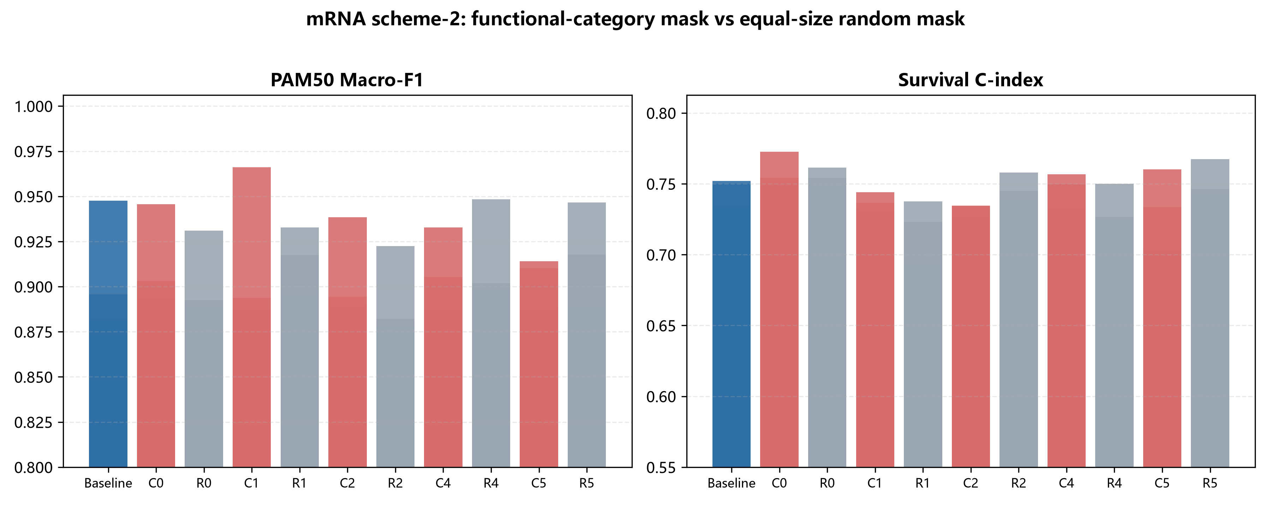
Figure S13. mRNA functional-category masks vs equal-size random masks.

S15. Secondary enrichment of Other and consensus-gene cross-validation
Other-category genes for mRNA PAM50 were re-analyzed with GO/KEGG/Reactome enrichment and cross-validated against the SHAP/CNN-saliency Top50 consensus genes by functional category [S13-S15].
Table S20. Secondary functional enrichment of mRNA PAM50 Other genes (top 12)
source | term_id | term_name | p_value | intersection_size
GO:BP | GO:0030855 | epithelial cell differentiation | 0.0000 | 22
GO:BP | GO:0060429 | epithelium development | 0.0000 | 28
GO:BP | GO:0009888 | tissue development | 0.0000 | 36
KEGG | KEGG:04915 | Estrogen signaling pathway | 0.0002 | 9
GO:BP | GO:0009653 | anatomical structure morphogenesis | 0.0092 | 37
GO:BP | GO:0009913 | epidermal cell differentiation | 0.0103 | 10
GO:BP | GO:0032501 | multicellular organismal process | 0.0206 | 72
GO:BP | GO:0048856 | anatomical structure development | 0.0218 | 62
GO:BP | GO:0032502 | developmental process | 0.0266 | 66
GO:BP | GO:0008283 | cell population proliferation | 0.0309 | 29
GO:BP | GO:0030216 | keratinocyte differentiation | 0.0333 | 8
GO:BP | GO:0030154 | cell differentiation | 0.0346 | 50

Table S21. Overlap between SHAP/CNN saliency Top50 consensus genes and mRNA functional categories
category | category_size | consensus_overlap | overlap_genes
Development/Epithelium | 19 | 3 | FOXC1, KRT6C, KRT17
Signaling/Transport | 32 | 3 | SLC6A11, SLC15A1, MAPK4
Hormone/Metabolism | 18 | 4 | CYP2B7P1, HSD17B2, PGR, ESR1
Immune/Inflammation | 6 | 1 | IL1RL2
Cell cycle/Proliferation | 13 | 4 | MYBL2, CCDC150, E2F8, BIRC5
Other | 312 | 35 | TCAM1P, MIA, SMC1B, PPP1R14C, KLK6, FABP7, KCNJ3, FAM131C, DSC3, TLX1, STAC2, BPI, CST9, ATP10B, PLA2G10, FGFBP1, OGN, LCT, C10orf90, FLJ45983, MAG, SYT8, KCNH1, ZBTB16, NAV3, OSR1, GPR19, AMY1A, MAPT, TPSG1, FSD1, PTX3, AQP5, ANKRD30A, C1orf173

S16. Pathway-level enrichment and prognostic analysis
As a pathway-level biological annotation, eight pathways—Hypoxia, ROS, OXPHOS, UPR, mTORC1, Glycolysis, EMT, and DNA repair—were explored across the full transcriptome (TCGA-BRCA HiSeqV2, 20,530 genes). These pathways used manually curated compact marker-gene signatures representing classical cancer-relevant biological programs rather than full MSigDB Hallmark or Reactome gene sets; genes were selected a priori from classical markers in the literature and were not post-hoc selected from the TCGA results of this study. The complete pathway–gene lists are in data/stress_pathway_gene_sets.tsv, including evidence_source, database_ID, and selection_rule fields. Per-sample pathway scores were computed from the marker signatures; Fisher's exact test assessed their enrichment among the top 500 JSD high-importance genes, Kruskal–Wallis tests assessed association with PAM50 subtype, and univariate Cox regression assessed association with overall survival. All p-values are raw unadjusted p-values, with Benjamini–Hochberg FDR q-values also reported.
Table S22. Pathway-level enrichment and prognostic analysis over the full mRNA transcriptome (Fisher enrichment in top-500 JSD genes; Kruskal-Wallis for PAM50; univariate Cox for overall survival). P values are raw and BH-FDR q-values are also shown.
Pathway | Genes in transcriptome | Genes in top-500 | Enrichment OR | Fisher p | Fisher BH-q | PAM50 Kruskal-Wallis p | PAM50 BH-q | Survival HR | HR 95% lower | HR 95% upper | Cox p | Cox BH-q
Hypoxia | 21 | 1 | 2.0050 | 0.4043 | 0.5391 | <0.0001 | <0.0001 | 1.0630 | 0.8350 | 1.3520 | 0.6201 | 0.9427
ROS | 18 | 1 | 2.3590 | 0.3585 | 0.5391 | <0.0001 | <0.0001 | 0.9700 | 0.6670 | 1.4130 | 0.8751 | 0.9427
OXPHOS | 18 | 0 | 0.0000 | 1.0000 | 1.0000 | <0.0001 | <0.0001 | 0.9760 | 0.7780 | 1.2260 | 0.8373 | 0.9427
UPR | 17 | 1 | 2.5070 | 0.3425 | 0.5391 | <0.0001 | <0.0001 | 0.9160 | 0.6830 | 1.2270 | 0.5547 | 0.9427
mTORC1 | 17 | 2 | 5.3590 | 0.0633 | 0.5061 | <0.0001 | <0.0001 | 0.9600 | 0.7140 | 1.2910 | 0.7862 | 0.9427
Glycolysis | 16 | 1 | 2.6740 | 0.3261 | 0.5391 | <0.0001 | <0.0001 | 0.9910 | 0.7850 | 1.2520 | 0.9427 | 0.9427
EMT | 18 | 0 | 0.0000 | 1.0000 | 1.0000 | <0.0001 | <0.0001 | 1.0230 | 0.8130 | 1.2870 | 0.8467 | 0.9427
DNA repair | 21 | 1 | 2.0050 | 0.4043 | 0.5391 | <0.0001 | <0.0001 | 0.7890 | 0.5920 | 1.0500 | 0.1043 | 0.8344

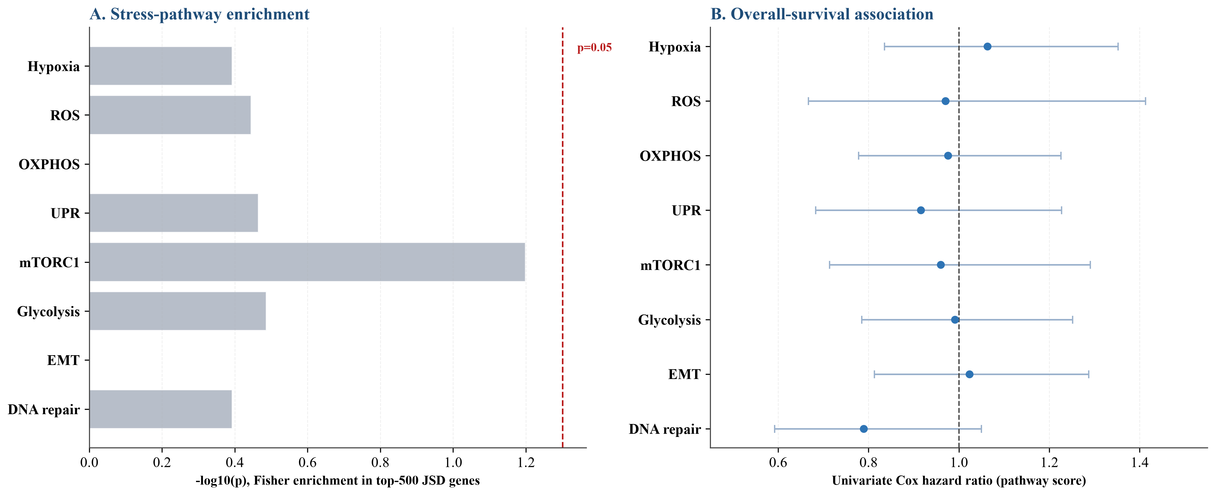
Figure S14. Pathway-level enrichment and prognostic analysis. A: Fisher enrichment (-log10 p) of eight pathways among the top-500 JSD genes; B: univariate Cox hazard ratios for overall survival. No pathway is significantly enriched or prognostic; error bars show 95% confidence intervals.

S17. PAM50 50-gene exclusion sensitivity analysis
To test whether the discriminative signal of the mRNA PAM50 task mainly comes from the canonical PAM50 50-gene panel, an exclusion sensitivity analysis was performed on the final 400 JSD-ranked mRNA PAM50 features. Three configurations were: Full 400 genes (all 400 features), Exclude PAM50 genes (removing the 21 features overlapping the PAM50 50-gene panel, leaving 379 features), and PAM50 genes only (retaining only the 21 overlapping genes). JSD ordering was recomputed for each configuration and grayscale images of the corresponding size were generated; Accuracy and Macro-F1 were evaluated with LogisticRegression, MLP, and FullSizeCNN under a unified 5-fold stratified cross-validation.
Table S23. PAM50 50-gene exclusion sensitivity analysis for mRNA PAM50 (5-fold CV, mean±SD; exploratory, features pre-selected on the full cohort; superseded by the strict Table S25)
Configuration | Model | Accuracy | Macro-F1
Full 400 genes | LogisticRegression | 0.9628±0.0167 | 0.9575±0.0199
Full 400 genes | MLP | 0.9183±0.0179 | 0.9023±0.0199
Full 400 genes | FullSizeCNN | 0.9316±0.0071 | 0.9205±0.0097
Exclude PAM50 genes (379 genes) | LogisticRegression | 0.9628±0.0138 | 0.9590±0.0185
Exclude PAM50 genes (379 genes) | MLP | 0.9232±0.0292 | 0.9065±0.0332
Exclude PAM50 genes (379 genes) | FullSizeCNN | 0.9171±0.0177 | 0.9068±0.0153
PAM50 genes only (21 genes) | LogisticRegression | 0.9220±0.0076 | 0.9134±0.0144
PAM50 genes only (21 genes) | MLP | 0.8980±0.0173 | 0.8864±0.0243
PAM50 genes only (21 genes) | FullSizeCNN | 0.9003±0.0169 | 0.8861±0.0186

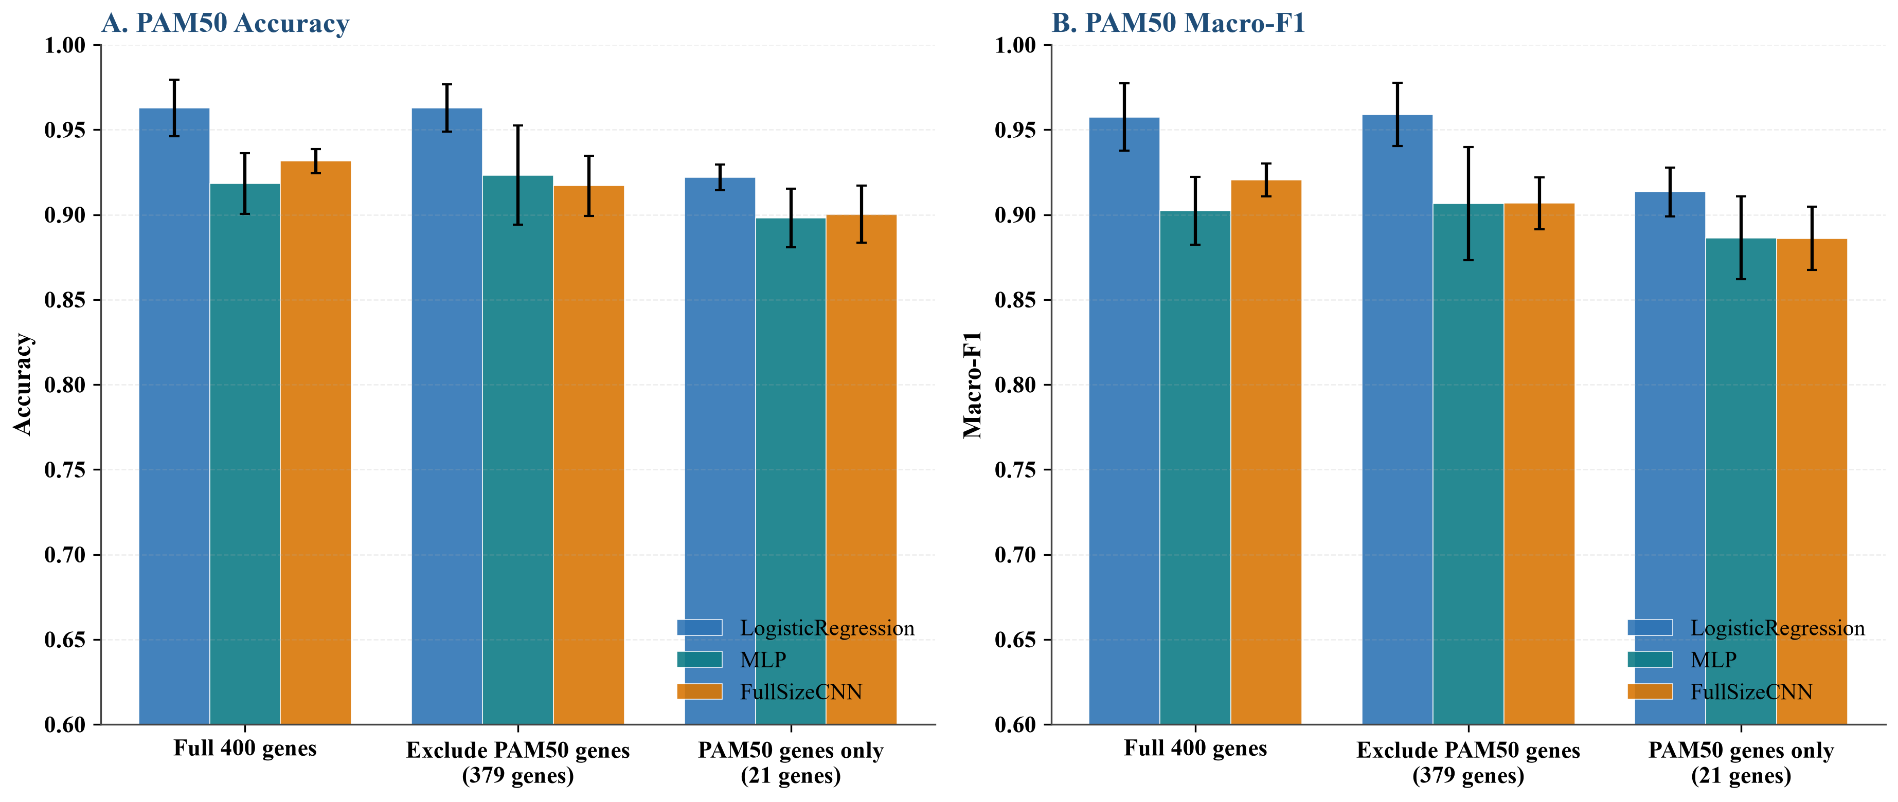
Figure S15. PAM50 50-gene exclusion sensitivity analysis. A: Accuracy; B: Macro-F1. Removing the 21 PAM50-overlapping genes barely changes performance, whereas the 21 PAM50 genes alone underperform the full 400-gene signature; error bars show 5-fold CV SD.

S18. Leak-free nested cross-validation and strict PAM50 exclusion
To test for selection bias from sharing the same five-fold cross-validation between feature-number selection and final evaluation, leak-free nested cross-validation was added for mRNA PAM50: outer 5-fold × 5 repeats, with an inner 3-fold used to select from candidate feature counts {200, 400}. Feature selection used VarianceThreshold + LinearSVC(L1) (V_L1), and JSD-ordered FullSizeCNN images were generated. LogisticRegression, FullSizeCNN, and the Dense-equivalent baseline were evaluated on the outer test folds. Results are in Table S24.
Table S24. Nested 5×5 cross-validation for mRNA PAM50 (inner 3-fold feature-number selection with V_L1; outer 5-fold × 5 repeats; mean±SD)
experiment | model | metric | mean | std
nested_cv_PAM50_mRNA | LogisticRegression | accuracy | 0.8392 | 0.0288
nested_cv_PAM50_mRNA | LogisticRegression | macro_f1 | 0.8196 | 0.0374
nested_cv_PAM50_mRNA | FullSizeCNN | accuracy | 0.8510 | 0.0282
nested_cv_PAM50_mRNA | FullSizeCNN | macro_f1 | 0.8310 | 0.0344
nested_cv_PAM50_mRNA | Dense | accuracy | 0.8449 | 0.0326
nested_cv_PAM50_mRNA | Dense | macro_f1 | 0.8204 | 0.0383

Table S25. Strict PAM50 exclusion from the full transcriptome followed by fold-level feature selection (ANOVA F, k=400) and LogisticRegression (5-fold CV, mean±SD)
experiment | config | metric | mean | std
strict_PAM50_exclusion | full_transcriptome | accuracy | 0.8246 | 0.0163
strict_PAM50_exclusion | full_transcriptome | macro_f1 | 0.8045 | 0.0181
strict_PAM50_exclusion | exclude_pam50_genes | accuracy | 0.8161 | 0.0226
strict_PAM50_exclusion | exclude_pam50_genes | macro_f1 | 0.7931 | 0.0249

S19. FullSizeCNN-Cox survival control
To provide a strictly time-to-event image-model control, the FullSizeCNN image backbone was retained on mRNA Survival images while the final output was replaced with the Cox negative partial log-likelihood, evaluated under 5-fold stratified cross-validation. Results are in Table S26.
Table S26. FullSizeCNN-Cox on mRNA Survival images (5-fold CV, mean±SD; exploratory, based on cohort-level pre-selected images; superseded by the leak-free censoring-aware results)
experiment | model | metric | mean | std
FullSizeCNN_Cox | FullSizeCNN_Cox | roc_auc | 0.6611 | 0.0541
FullSizeCNN_Cox | FullSizeCNN_Cox | c_index | 0.6818 | 0.0401

S20. Statistical robustness and comparison with existing methods
To help interpret the statistical evidence of the 5-fold paired tests, effect sizes (Cohen's d) and approximate 95% confidence intervals were computed for fold-level mean differences between the best fusion and the best single-omics model. Because these are based on only five fold-level scores, they should be regarded as descriptive comparisons rather than strict equivalence tests.
Table S27. Fold-level effect sizes and approximate 95% CIs for best-fusion vs best-single comparisons (n=5 folds; descriptive only; none is statistically significant).
task | metric | comparison | mean_difference | ci_lower | ci_upper | cohens_d | interpretation
PAM50 | accuracy | CNN_LateAvg vs mRNA_RF | -0.0104 | -0.0702 | 0.0493 | -0.2169 | non-significant; descriptive only
PAM50 | accuracy | Concat_MLP vs mRNA_RF | -0.0166 | -0.0857 | 0.0525 | -0.2983 | non-significant; descriptive only
Survival | roc_auc | CNN_LateAvg vs miRNA_RF | +0.0107 | -0.1387 | 0.1601 | 0.0890 | non-significant; descriptive only
Survival | roc_auc | Concat_MLP vs miRNA_RF | -0.0224 | -0.1432 | 0.0984 | -0.2306 | non-significant; descriptive only

Table S28. Comparison with representative omics-to-image and interpretable deep-learning methods. The current framework differs by supervised divergence-guided ordering, pixel-to-gene traceability, and systematic falsification controls. "Not reported" indicates that the original publication did not explicitly report that control; it does not imply that the control is absent or inapplicable.
Method | Supervision | Ordering | Traceable attribution | Dense control | Random-order control | Nested CV
DeepInsight | Unsupervised (t-SNE) | Data-driven 2-D projection | Indirect | Not reported | Not reported | Not reported
DeepInsight-3D | Unsupervised | 3-D projection | Indirect | Not reported | Not reported | Not reported
Yan et al. feature map | Task-related | Transcriptomic feature map | Partial | Not reported | Not reported | Not reported
SurvConvMixer | Pathway-level | Pathway image | Partial | Not reported | Not reported | Not reported
MoACNN-XGNet | Multi-omics | Interpretable multi-omics convolution | Partial | Not reported | Not reported | Not reported
This study (JSD-FullSizeCNN) | Supervised JSD | Deterministic center-out spiral | Pixel-to-gene mapping | Yes | Yes | Yes

S21. METABRIC external single-omics validation
To assess cross-cohort generalizability, and given that a complete mRNA+CNV+miRNA multi-omics external cohort was unavailable, the independent METABRIC cohort was used for mRNA and CNV single-omics external validation. The mRNA FullSizeCNN was additionally evaluated under the same preprocessing (342 shared genes, per-platform standardization): PAM50 accuracy 0.8203 and macro-F1 0.8099 on n=1608, versus 0.8165/0.8034 for the Dense control and 0.7917/0.7735 for LogisticRegression (data/metabric_fullsize_external_validation_results.tsv). The mRNA PAM50 model retained moderate discriminative ability but weaker survival-risk ranking; CNV single-omics external discrimination was likewise limited. Results are in Table S29.
Table S29. METABRIC external single-omics validation for PAM50 and survival tasks. Models were trained on the TCGA full cohort (cohort-level pre-selected features) and applied directly to the held-out METABRIC cohort (frozen-model validation; single external test-set estimates). PAM50 n=1608 (Luminal A 700, Luminal B 475, HER2-enriched 224, Basal-like 209); survival n=1980 with 1143 deaths (57.7% event rate, 837 censored). Bootstrap 95% CIs for the headline mRNA metrics: PAM50 MLP accuracy 0.7985 [0.7780, 0.8184]; survival MLP C-index 0.5370 [0.5175, 0.5563] and ROC AUC 0.5222 [0.4971, 0.5474]. The near-chance survival discrimination on METABRIC reflects the difficulty of predicting death status from bulk mRNA, so survival is treated as an auxiliary exploratory objective.
omics | task | model | metric | value
mRNA | PAM50 | LogisticRegression | accuracy | 0.7861
mRNA | PAM50 | LogisticRegression | macro_f1 | 0.7685
mRNA | PAM50 | LinearSVC | accuracy | 0.7786
mRNA | PAM50 | LinearSVC | macro_f1 | 0.7478
mRNA | PAM50 | RandomForest | accuracy | 0.7792
mRNA | PAM50 | RandomForest | macro_f1 | 0.7627
mRNA | PAM50 | MLP | accuracy | 0.7985
mRNA | PAM50 | MLP | macro_f1 | 0.7864
mRNA | Survival_death_status | LogisticRegression | accuracy | 0.4404
mRNA | Survival_death_status | LogisticRegression | balanced_accuracy | 0.4960
mRNA | Survival_death_status | LogisticRegression | roc_auc | 0.4726
mRNA | Survival_death_status | LogisticRegression | c_index | 0.5090
mRNA | Survival_death_status | MLP | accuracy | 0.4348
mRNA | Survival_death_status | MLP | balanced_accuracy | 0.5001
mRNA | Survival_death_status | MLP | roc_auc | 0.5222
mRNA | Survival_death_status | MLP | c_index | 0.5370
mRNA | Survival_risk_level | LogisticRegression | accuracy | 0.5303
mRNA | Survival_risk_level | LogisticRegression | balanced_accuracy | 0.5303
mRNA | Survival_risk_level | LogisticRegression | roc_auc | 0.5470
mRNA | Survival_risk_level | LogisticRegression | c_index | 0.5421
mRNA | Survival_risk_level | MLP | accuracy | 0.5197
mRNA | Survival_risk_level | MLP | balanced_accuracy | 0.5197
mRNA | Survival_risk_level | MLP | roc_auc | 0.5205
mRNA | Survival_risk_level | MLP | c_index | 0.5235
CNV | PAM50 | LogisticRegression | accuracy | 0.5914
CNV | PAM50 | LogisticRegression | macro_f1 | 0.5363
CNV | PAM50 | LinearSVC | accuracy | 0.5634
CNV | PAM50 | LinearSVC | macro_f1 | 0.4945
CNV | PAM50 | RandomForest | accuracy | 0.5802
CNV | PAM50 | RandomForest | macro_f1 | 0.5204
CNV | PAM50 | MLP | accuracy | 0.5871
CNV | PAM50 | MLP | macro_f1 | 0.5434
CNV | Survival_death_status | LogisticRegression | accuracy | 0.4518
CNV | Survival_death_status | LogisticRegression | balanced_accuracy | 0.5165
CNV | Survival_death_status | LogisticRegression | roc_auc | 0.5344
CNV | Survival_death_status | LogisticRegression | c_index | 0.5288
CNV | Survival_death_status | MLP | accuracy | 0.4604
CNV | Survival_death_status | MLP | balanced_accuracy | 0.5206
CNV | Survival_death_status | MLP | roc_auc | 0.4933
CNV | Survival_death_status | MLP | c_index | 0.4810
CNV | Survival_risk_level | LogisticRegression | accuracy | 0.4937
CNV | Survival_risk_level | LogisticRegression | balanced_accuracy | 0.4937
CNV | Survival_risk_level | LogisticRegression | roc_auc | 0.4994
CNV | Survival_risk_level | LogisticRegression | c_index | 0.4796
CNV | Survival_risk_level | MLP | accuracy | 0.5159
CNV | Survival_risk_level | MLP | balanced_accuracy | 0.5159
CNV | Survival_risk_level | MLP | roc_auc | 0.5152
CNV | Survival_risk_level | MLP | c_index | 0.5222

To further evaluate whether the prioritized candidate genes replicate in an independent cohort, we examined their subtype expression and overall-survival association in METABRIC. The four Luminal-associated candidates (ESR1, TFF1, AGR3, PGR) were strongly Luminal-enriched and the Basal-associated candidates (FOXC1, MIA, FABP7) were strongly Basal-enriched, recapitulating the TCGA subtype patterns. Univariable Cox identified CCL19 (HR 0.849, p=4.2e-6), PGR (HR 0.865, p=1.8e-6), BIRC5 (HR 1.133, p=3.4e-5), and E2F8 (HR 1.083, p=6.8e-3) as associated with overall survival, and all four survived BH-FDR correction (q<0.05). After adjustment for age, Nottingham Prognostic Index, and subtype, CCL19 (HR 0.889, p=1.0e-3) and PGR (HR 0.929, p=2.2e-2) remained significant, whereas BIRC5 and E2F8 did not. These are independent univariable (and partly multivariable) associations rather than proof of clinical independent prognostic value.

Table S32. Independent METABRIC replication of prioritized candidate genes. Subtypes are the PAM50-derived Claudin categories from the METABRIC clinical annotation [S20], restricted to the four main classes; claudin-low (n=218), Normal (n=148), and unannotated samples were excluded. Cox analyses used n=1608 samples with 965 deaths. Univ HR is univariable; Adj HR is adjusted for age, Nottingham Prognostic Index, and subtype. BH-q is the Benjamini-Hochberg false-discovery-rate q-value across the 12 genes. The four Luminal-enriched genes (ESR1, TFF1, AGR3, PGR) and Basal-enriched genes (FOXC1, MIA, FABP7) recapitulate the TCGA subtype patterns; CCL19 and PGR retained significant survival associations after adjustment.
Gene | Top subtype | Kruskal p | Univ HR (95% CI) | Univ p | BH-q | Adj HR (95% CI) | Adj p
ESR1 | Luminal B | 3.6e-166 | [0.919, 1.042] | 0.496 | 0.676 | 0.943 [0.870, 1.022] | 1.51e-01
TFF1 | Luminal A | 4.8e-108 | [0.891, 1.005] | 0.0698 | 0.168 | 0.982 [0.920, 1.048] | 5.90e-01
AGR3 | Luminal A | 9.9e-146 | [0.894, 1.010] | 0.101 | 0.201 | 0.977 [0.908, 1.052] | 5.38e-01
FOXC1 | Basal-like | 3.9e-124 | [0.958, 1.090] | 0.507 | 0.676 | 1.086 [1.008, 1.170] | 2.95e-02
MIA | Basal-like | 8.1e-66 | [0.921, 1.056] | 0.687 | 0.824 | 1.059 [0.984, 1.140] | 1.25e-01
FABP7 | Basal-like | 1.3e-59 | [0.945, 1.076] | 0.796 | 0.868 | 1.000 [0.935, 1.069] | 9.89e-01
CCL19 | Basal-like | 1.1e-19 | [0.792, 0.911] | 4.2e-06 | 2.5e-05 | 0.889 [0.828, 0.953] | 1.01e-03
MS4A1 | Basal-like | 3.6e-04 | [0.931, 1.066] | 0.909 | 0.909 | 0.948 [0.885, 1.015] | 1.24e-01
PGR | Luminal A | 1.8e-101 | [0.815, 0.918] | 1.8e-06 | 2.1e-05 | 0.929 [0.871, 0.990] | 2.24e-02
MYBL2 | Basal-like | 8.2e-04 | [0.963, 1.086] | 0.458 | 0.676 | 0.982 [0.925, 1.042] | 5.52e-01
BIRC5 | Basal-like | 5.5e-175 | [1.068, 1.202] | 3.4e-05 | 1.4e-04 | 1.043 [0.968, 1.124] | 2.69e-01
E2F8 | Basal-like | 2.5e-50 | [1.022, 1.148] | 0.0068 | 0.0204 | 1.042 [0.980, 1.107] | 1.90e-01

S22. Gene-interaction and network-reordering analysis
To examine whether gene-interaction structure can provide more biologically meaningful spatial adjacency for imaging, three network types were constructed on the PAM50 intersection samples: an mRNA co-expression network, a consensus-gene STRING PPI network, and cross-omics networks of miRNA–mRNA negative correlations and CNV–mRNA correlations. After reordering mRNA features by co-expression community and generating a 20×20 image, FullSizeCNN Accuracy was 0.8931, below the original JSD spiral ordering; the sparse community ordering therefore did not improve prediction but can still serve as a complementary, biologically adjacent representation. Complete network files are in data/gene_interaction/.
Table S30. Community-informed mRNA image ordering vs original JSD spiral ordering for FullSizeCNN PAM50 (5-fold CV, mean±SD; exploratory, compared against the cohort-level JSD spiral ordering)
variant | task | metric | mean | std
original_jsd_spiral | PAM50 | accuracy | 0.9316 | 0.0071
original_jsd_spiral | PAM50 | macro_f1 | 0.9205 | 0.0097
community_reorder | PAM50 | accuracy | 0.8931 | 0.0351
community_reorder | PAM50 | macro_f1 | 0.8758 | 0.0328

S23. Perturbation-fidelity evaluation of attribution rankings

To quantitatively compare the attribution quality of the proposed JSD ordering against model-native attributions, we performed a perturbation-fidelity analysis on the mRNA PAM50 task under leak-free five-fold cross-validation. On each training fold the 400 selected features were ranked by JSD, SHAP (LogisticRegression), FullSizeCNN input-gradient saliency, and random order (10 repeats); the top features were then progressively zeroed and the frozen models were re-evaluated. A better attribution produces a steeper accuracy drop (a lower deletion AUC).

Table S31. Deletion AUC for attribution rankings (lower is better; mean±SD over 5 folds; Random is the average of 10 permutations per fold). LogisticRegression: JSD 0.6514±0.0189, SHAP 0.6114±0.0259, Random 0.6660±0.0214. FullSizeCNN: JSD 0.7756±0.0251, Saliency 0.6740±0.0045, Random 0.7888±0.0293. Paired test (n=5 folds) JSD vs Random: LogisticRegression t-test p=0.107 (Wilcoxon p=0.063); FullSizeCNN t-test p=0.022 (Wilcoxon p=0.063); these are suggestive but limited by the small fold count. The FullSizeCNN 0%-removal accuracy (0.8416) is from this independent run and differs slightly from Table S5 (0.8478) because the two analyses were run separately, within run-to-run stochastic variation.
Model | Ranking | Deletion AUC
LogisticRegression | JSD | 0.6514
LogisticRegression | SHAP | 0.6114
LogisticRegression | Random | 0.6660
FullSizeCNN | JSD | 0.7756
FullSizeCNN | Saliency | 0.6740
FullSizeCNN | Random | 0.7888

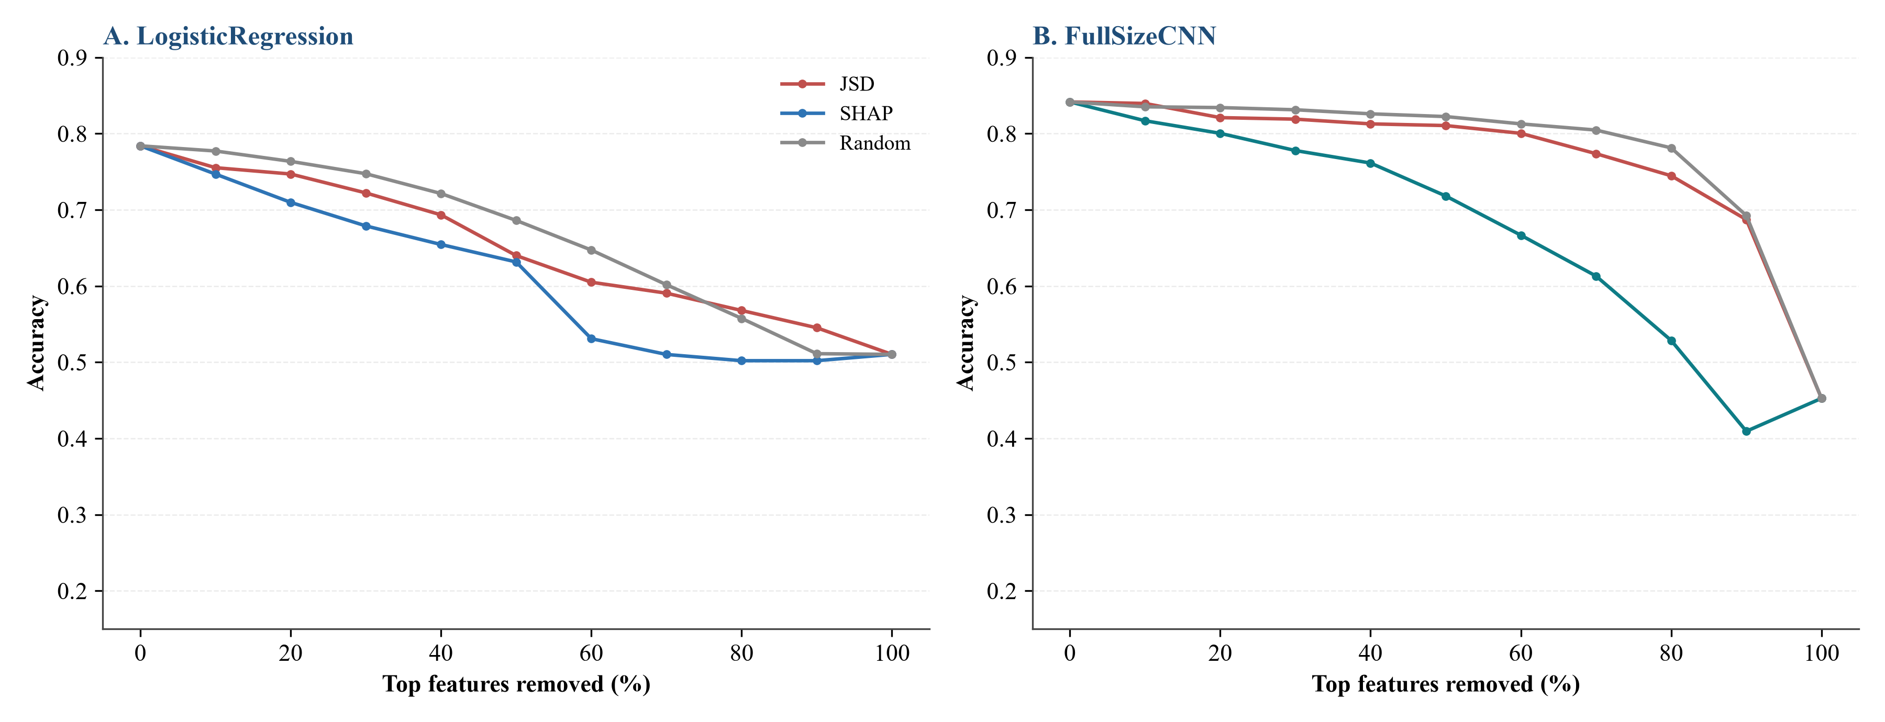

Figure S16. Perturbation-fidelity comparison of attribution rankings for mRNA PAM50. A: LogisticRegression; B: FullSizeCNN. Accuracy is shown as the top-k% ranked features are zeroed. Model-native attributions (SHAP, saliency) drop fastest, while JSD ordering falls between them and random ordering; the curves confirm that JSD provides a supervised, traceable prior rather than the most faithful attribution.

S24. Data and script files
- data/final_datasets/PAM50/{mRNA,CNV,miRNA}_PAM50_final.tsv
- data/final_datasets/Survival/{mRNA,CNV,miRNA}_Survival_final.tsv
- data/images/PAM50/{mRNA,CNV,miRNA}/images.npy and order.tsv
- data/images/Survival/{mRNA,CNV,miRNA}/images.npy and order.tsv
- data/pam50_gene_exclusion_results.tsv
- data/dense_equivalent_baseline_results.tsv
- data/random_permutation_control_results.tsv
- data/random_permutation_control_stats.tsv
- data/stress_pathway_gene_sets.tsv
- data/stress_pathway_analysis_results.tsv
- data/omics_functional_category_annotation.tsv
- data/sample_level_provenance.tsv
- scripts/run_comprehensive_batch1_single_omics.py
- scripts/run_comprehensive_triple_integration.py
- scripts/run_comprehensive_pairwise_integration.py
- scripts/run_final_9model_stacking.py
- scripts/run_advanced_method*.py
- scripts/run_interpretability_key_factors.py
- scripts/run_scheme2_category_masking.py
- scripts/run_other_omics_category_masking.py
- scripts/run_mrna_equal_mask_control.py
- scripts/supplement_masking_analyses.py
- scripts/generate_jsd_images.py
- scripts/adaptive_jsd.py
- scripts/pam50_gene_exclusion_sensitivity.py
- scripts/run_dense_baseline.py
- scripts/run_random_permutation_control.py
- scripts/run_stress_pathway_analysis.py
- scripts/generate_annotation_mapping.py
- scripts/generate_sample_provenance.py
- data/nested_cv_pam50_mrna_results.tsv
- data/fullsize_cnn_cox_survival_results.tsv
- data/strict_pam50_exclusion_results.tsv
- scripts/run_additional_validation_experiments.py
To avoid embedding all result tables in Word, this supplement keeps only key summary tables and figures; all data/**/*.tsv result tables have been converted to CSV and packaged as data/supplementary_data/supplementary_data_tables.zip. The archive contains manifest.tsv, which records for each source TSV its relative path, corresponding CSV filename, row count, column count, and conversion status as the authoritative machine-readable inventory. Readers can download the archive from the GitHub repository for item-by-item verification.
Software and library versions: Python 3.11, scikit-learn, PyTorch, lifelines, pandas, NumPy, and matplotlib. The main computational libraries are cited as scikit-learn [S16], PyTorch [S17], and lifelines [S18].
For reproducibility, fix random seed 42; scaling, data augmentation, and model fitting were performed within cross-validation training folds, and test folds were not used for any preprocessing or parameter selection. The primary leak-free analyses performed feature selection and JSD ordering inside each training fold (Tables S4–S8); a separate earlier cohort-level pipeline that selected features and ordered images on the full cohort before cross-validation is retained for historical comparison only and is superseded by the leak-free results (Table S24).

S25. Supplementary references
[S1] Grossman RL, Heath AP, Ferretti V, Varmus HE, Lowy DR, Kibbe WA, et al. Toward a Shared Vision for Cancer Genomic Data. N Engl J Med. 2016;375(12):1109-1112. doi:10.1056/NEJMp1607591. PMID:27653561.
[S2] Goldman MJ, Craft B, Hastie M, Repecka K, McDade F, Kamath A, et al. Visualizing and interpreting cancer genomics data via the Xena platform. Nat Biotechnol. 2020;38(6):675-678. doi:10.1038/s41587-020-0546-8. PMID:32444850.
[S3] Mermel CH, Schumacher SE, Hill B, Meyerson ML, Beroukhim R, Getz G. GISTIC2.0 facilitates sensitive and confident localization of the targets of focal somatic copy-number alteration in human cancers. Genome Biol. 2011;12(4):R41. doi:10.1186/gb-2011-12-4-r41. PMID:21527027.
[S4] Guyon I, Elisseeff A. An introduction to variable and feature selection. J Mach Learn Res. 2003;3:1157-1182.
[S5] Tibshirani R. Regression shrinkage and selection via the lasso. J R Stat Soc Series B Stat Methodol. 1996;58(1):267-288. doi:10.1111/j.2517-6161.1996.tb02080.x.
[S6] Goodfellow I, Pouget-Abadie J, Mirza M, Xu B, Warde-Farley D, Ozair S, et al. Generative adversarial nets. In: Advances in Neural Information Processing Systems. 2014;27:2672-2680. arXiv:1406.2661.
[S7] Arjovsky M, Chintala S, Bottou L. Wasserstein generative adversarial networks. In: Proceedings of the 34th International Conference on Machine Learning. PMLR. 2017;70:214-223.
[S8] Gulrajani I, Ahmed F, Arjovsky M, Dumoulin V, Courville A. Improved training of Wasserstein GANs. In: Advances in Neural Information Processing Systems. 2017:5767-5777. arXiv:1704.00028.
[S9] Simonyan K, Vedaldi A, Zisserman A. Deep inside convolutional networks: visualising image classification models and saliency maps. arXiv:1312.6034. 2014.
[S10] Selvaraju RR, Cogswell M, Das A, Vedantam R, Parikh D, Batra D. Grad-CAM: visual explanations from deep networks via gradient-based localization. In: Proceedings of the IEEE International Conference on Computer Vision. 2017:618-626. doi:10.1109/ICCV.2017.74.
[S11] Lundberg SM, Lee SI. A unified approach to interpreting model predictions. In: Advances in Neural Information Processing Systems. 2017;30:4765-4774. arXiv:1705.07874.
[S12] Kozomara A, Birgaoanu M, Griffiths-Jones S. miRBase: from microRNA sequences to function. Nucleic Acids Res. 2019;47(D1):D155-D162. doi:10.1093/nar/gky1141. PMID:30423142.
[S13] The Gene Ontology Consortium. The Gene Ontology knowledgebase in 2023. Genetics. 2023;224(1):iyad031. doi:10.1093/genetics/iyad031. PMID:36866529.
[S14] Kanehisa M, Furumichi M, Sato Y, Ishiguro-Watanabe M, Tanabe M. KEGG: integrating viruses and cellular organisms. Nucleic Acids Res. 2021;49(D1):D545-D551. doi:10.1093/nar/gkaa970. PMID:33125081.
[S15] Gillespie M, Jassal B, Stephan R, Milacic M, Rothfels K, Senff-Ribeiro A, et al. The reactome pathway knowledgebase 2022. Nucleic Acids Res. 2022;50(D1):D687-D692. doi:10.1093/nar/gkab1028. PMID:34788843.
[S16] Pedregosa F, Varoquaux G, Gramfort A, Michel V, Thirion B, Grisel O, et al. Scikit-learn: Machine Learning in Python. J Mach Learn Res. 2011;12:2825-2830.
[S17] Paszke A, Gross S, Massa F, Lerer A, Bradbury J, Chanan G, et al. PyTorch: an imperative style, high-performance deep learning library. In: Advances in Neural Information Processing Systems. 2019;32:8024-8035.
[S18] Davidson-Pilon C. lifelines: survival analysis in Python. J Open Source Softw. 2019;4(40):1317. doi:10.21105/joss.01317.
[S19] Zhu J, Rosset S, Tibshirani R, Hastie T. 1-norm support vector machines. In: Advances in Neural Information Processing Systems. 2003;16:49-56.
[S20] Curtis C, Shah SP, Chin SF, Turashvili G, Rueda OM, Dunning MJ, et al. The genomic and transcriptomic architecture of 2,000 breast tumours reveals novel subgroups. Nature. 2012;486(7403):346-352. doi:10.1038/nature10983. PMID:22522925.

