Supplementary Material: Data, Feature Selection, Single-Omics and Multi-Omics Modeling Results
补充材料：数据、特征筛选、单组学与多组学建模完整结果

S1. 数据来源与样本清单
数据来自 TCGA-BRCA 的公开平台 GDC 与 UCSC Xena[S1,S2]。mRNA 采用 HiSeqV2 基因表达矩阵；CNV 采用 GISTIC2 基因级阈值化拷贝数[S3]；miRNA 采用 miRNA 表达矩阵。样本优先选择原发肿瘤，按 TCGA barcode 对齐。
Table S1. Sample sizes by omics and intersections
Task | mRNA | CNV | miRNA | Triple intersection | mRNA∩CNV | mRNA∩miRNA | CNV∩miRNA
PAM50 | 833 | 818 | 497 | 493 | 818 | 497 | 493
Survival | 1073 | 1057 | 739 | 731 | 1055 | 737 | 733

表 S1 仅给出样本数量。完整的样本级 provenance（case ID、sample type、mRNA/CNV/miRNA sample ID、PAM50 亚型、vital status、OS time/event 及各组学可用性）见 data/sample_level_provenance.tsv（共 1,098 例）。

S2. 特征提取算法
本研究比较了 4 种基础特征筛选方法及其两两组合[S4]。低方差过滤（V）移除近常数特征；F 值（ANOVA F）衡量连续特征与分类标签的线性判别能力；L1/LASSO 通过线性 SVM 的稀疏系数进行嵌入式选择[S5]；JSD 基于类别间分箱直方图的 Jensen–Shannon divergence。
JSD 公式：D_JSD(P||Q)=0.5 Σ_x [P(x) log2(2P(x)/(P(x)+Q(x))) + Q(x) log2(2Q(x)/(P(x)+Q(x)))]。实际计算时 P、Q 为加 ε 后归一化的类别直方图；二分类直接计算两类间 JSD。PAM50 mRNA 和生存数据使用平均 pairwise JSD，PAM50 CNV 使用 one-vs-rest max JSD，PAM50 miRNA 先使用 pairwise JSD 粗筛、再以 L1 精筛。
组合方式包括 V、V_F、V_L1、V_JSD、V_F_L1、V_F_JSD、V_L1_F、V_L1_JSD、V_JSD_F、V_JSD_L1，其中 V 表示低方差预过滤，下划线后的顺序表示先粗筛后精筛或先粗筛后嵌入选择。
Table S2. Feature-selection algorithm combinations
Method | Description
V | Low-variance filter
V_F | Low-variance + ANOVA F
V_L1 | Low-variance + L1/LASSO
V_JSD | Low-variance + JSD
V_F_L1 | Low-variance + F coarse + L1 fine
V_F_JSD | Low-variance + F coarse + JSD fine
V_L1_F | Low-variance + L1 coarse + F fine
V_L1_JSD | Low-variance + L1 coarse + JSD fine
V_JSD_F | Low-variance + JSD coarse + F fine
V_JSD_L1 | Low-variance + JSD coarse + L1 fine

S3. 最终特征数量与数据集
PAM50 最终特征数：mRNA 400、CNV 50、miRNA 600。生存最终特征数：mRNA 200、CNV 150、miRNA 600。特征名全部保留，数据文件见 data/final_datasets/。
Table S3. Final feature counts and JSD image sizes
Task | Omics | Final features | Image size | Grid capacity | Zero-padded
PAM50 | mRNA | 400 | 20×20 | 400 | 0
PAM50 | CNV | 50 | 8×8 | 64 | 14
PAM50 | miRNA | 600 | 25×25 | 625 | 25
Survival | mRNA | 200 | 15×15 | 225 | 25
Survival | CNV | 150 | 13×13 | 169 | 19
Survival | miRNA | 600 | 25×25 | 625 | 25

S4. 单组学全部模型结果
Table S4 reports full-sample single-omics 5-fold CV results based on final features selected within each training fold.
Table S4. Single-omics full-sample 5-fold CV results (mean±SD; features selected within each training fold)
omics | task | model | metric | mean | std
mRNA | PAM50 | LogisticRegression | accuracy | 0.9628 | 0.0167
mRNA | PAM50 | LogisticRegression | macro_f1 | 0.9575 | 0.0199
mRNA | PAM50 | RandomForest | accuracy | 0.9207 | 0.0164
mRNA | PAM50 | RandomForest | macro_f1 | 0.9056 | 0.0341
mRNA | PAM50 | GradientBoosting | accuracy | 0.9219 | 0.0171
mRNA | PAM50 | GradientBoosting | macro_f1 | 0.9124 | 0.0264
mRNA | PAM50 | SVC | accuracy | 0.9580 | 0.0197
mRNA | PAM50 | SVC | macro_f1 | 0.9527 | 0.0226
mRNA | PAM50 | KNN | accuracy | 0.8763 | 0.0230
mRNA | PAM50 | KNN | macro_f1 | 0.8617 | 0.0352
mRNA | PAM50 | MLP | accuracy | 0.9183 | 0.0179
mRNA | PAM50 | MLP | macro_f1 | 0.9023 | 0.0199
mRNA | PAM50 | FullSizeCNN | accuracy | 0.9316 | 0.0071
mRNA | PAM50 | FullSizeCNN | macro_f1 | 0.9205 | 0.0097
CNV | PAM50 | LogisticRegression | accuracy | 0.7140 | 0.0320
CNV | PAM50 | LogisticRegression | macro_f1 | 0.6657 | 0.0482
CNV | PAM50 | RandomForest | accuracy | 0.6736 | 0.0312
CNV | PAM50 | RandomForest | macro_f1 | 0.6180 | 0.0467
CNV | PAM50 | GradientBoosting | accuracy | 0.7164 | 0.0429
CNV | PAM50 | GradientBoosting | macro_f1 | 0.6613 | 0.0604
CNV | PAM50 | SVC | accuracy | 0.6981 | 0.0277
CNV | PAM50 | SVC | macro_f1 | 0.6444 | 0.0424
CNV | PAM50 | KNN | accuracy | 0.6834 | 0.0253
CNV | PAM50 | KNN | macro_f1 | 0.5982 | 0.0298
CNV | PAM50 | MLP | accuracy | 0.7213 | 0.0156
CNV | PAM50 | MLP | macro_f1 | 0.6694 | 0.0264
CNV | PAM50 | FullSizeCNN | accuracy | 0.7164 | 0.0246
CNV | PAM50 | FullSizeCNN | macro_f1 | 0.6727 | 0.0352
miRNA | PAM50 | LogisticRegression | accuracy | 0.8410 | 0.0120
miRNA | PAM50 | LogisticRegression | macro_f1 | 0.8256 | 0.0069
miRNA | PAM50 | RandomForest | accuracy | 0.7786 | 0.0504
miRNA | PAM50 | RandomForest | macro_f1 | 0.6685 | 0.0645
miRNA | PAM50 | GradientBoosting | accuracy | 0.7927 | 0.0604
miRNA | PAM50 | GradientBoosting | macro_f1 | 0.7455 | 0.0693
miRNA | PAM50 | SVC | accuracy | 0.8330 | 0.0187
miRNA | PAM50 | SVC | macro_f1 | 0.8164 | 0.0278
miRNA | PAM50 | KNN | accuracy | 0.6922 | 0.0178
miRNA | PAM50 | KNN | macro_f1 | 0.5582 | 0.0549
miRNA | PAM50 | MLP | accuracy | 0.8350 | 0.0148
miRNA | PAM50 | MLP | macro_f1 | 0.8121 | 0.0166
miRNA | PAM50 | FullSizeCNN | accuracy | 0.8230 | 0.0227
miRNA | PAM50 | FullSizeCNN | macro_f1 | 0.7785 | 0.0338
mRNA | Survival | LogisticRegression | roc_auc | 0.6192 | 0.0270
mRNA | Survival | LogisticRegression | c_index | 0.6390 | 0.0681
mRNA | Survival | RandomForest | roc_auc | 0.5896 | 0.0295
mRNA | Survival | RandomForest | c_index | 0.6181 | 0.0399
mRNA | Survival | GradientBoosting | roc_auc | 0.6013 | 0.0225
mRNA | Survival | GradientBoosting | c_index | 0.6317 | 0.0417
mRNA | Survival | SVC | roc_auc | 0.6161 | 0.0227
mRNA | Survival | SVC | c_index | 0.6297 | 0.0696
mRNA | Survival | KNN | roc_auc | 0.5994 | 0.0385
mRNA | Survival | KNN | c_index | 0.6249 | 0.0525
mRNA | Survival | MLP | roc_auc | 0.6590 | 0.0519
mRNA | Survival | MLP | c_index | 0.6916 | 0.0467
mRNA | Survival | FullSizeCNN | roc_auc | 0.6768 | 0.0549
mRNA | Survival | FullSizeCNN | c_index | 0.7125 | 0.0303
mRNA | Survival | CoxPH | roc_auc | 0.6636 | 0.0604
mRNA | Survival | CoxPH | c_index | 0.6979 | 0.0318
CNV | Survival | LogisticRegression | roc_auc | 0.6977 | 0.0328
CNV | Survival | LogisticRegression | c_index | 0.7007 | 0.0261
CNV | Survival | RandomForest | roc_auc | 0.6127 | 0.0351
CNV | Survival | RandomForest | c_index | 0.6481 | 0.0468
CNV | Survival | GradientBoosting | roc_auc | 0.6118 | 0.0356
CNV | Survival | GradientBoosting | c_index | 0.6187 | 0.0450
CNV | Survival | SVC | roc_auc | 0.6529 | 0.0419
CNV | Survival | SVC | c_index | 0.6652 | 0.0358
CNV | Survival | KNN | roc_auc | 0.5346 | 0.0644
CNV | Survival | KNN | c_index | 0.5490 | 0.0714
CNV | Survival | MLP | roc_auc | 0.6217 | 0.0307
CNV | Survival | MLP | c_index | 0.6083 | 0.0467
CNV | Survival | FullSizeCNN | roc_auc | 0.6244 | 0.0428
CNV | Survival | FullSizeCNN | c_index | 0.6199 | 0.0591
CNV | Survival | CoxPH | roc_auc | 0.6949 | 0.0515
CNV | Survival | CoxPH | c_index | 0.7109 | 0.0339
miRNA | Survival | LogisticRegression | roc_auc | 0.6126 | 0.0508
miRNA | Survival | LogisticRegression | c_index | 0.5665 | 0.0521
miRNA | Survival | RandomForest | roc_auc | 0.6016 | 0.0215
miRNA | Survival | RandomForest | c_index | 0.5863 | 0.0318
miRNA | Survival | GradientBoosting | roc_auc | 0.5740 | 0.0625
miRNA | Survival | GradientBoosting | c_index | 0.5686 | 0.0671
miRNA | Survival | SVC | roc_auc | 0.5982 | 0.0491
miRNA | Survival | SVC | c_index | 0.5509 | 0.0517
miRNA | Survival | KNN | roc_auc | 0.5448 | 0.0270
miRNA | Survival | KNN | c_index | 0.5307 | 0.0267
miRNA | Survival | MLP | roc_auc | 0.6020 | 0.0532
miRNA | Survival | MLP | c_index | 0.5781 | 0.0773
miRNA | Survival | FullSizeCNN | roc_auc | 0.6301 | 0.0401
miRNA | Survival | FullSizeCNN | c_index | 0.6067 | 0.0703
miRNA | Survival | CoxPH | roc_auc | 0.5538 | 0.0735
miRNA | Survival | CoxPH | c_index | 0.5751 | 0.0573

S5. 交集单组学基线
为与多组学融合公平比较，在统一交集样本上重新计算单组学基线。
Table S5. Single-omics baselines on triple-omics intersection samples (mean±SD; features selected within each training fold)
omics | task | model | metric | mean | std
mRNA | PAM50 | LogisticRegression | accuracy | 0.9270 | 0.0217
mRNA | PAM50 | LogisticRegression | macro_f1 | 0.9184 | 0.0316
mRNA | PAM50 | RandomForest | accuracy | 0.9066 | 0.0441
mRNA | PAM50 | RandomForest | macro_f1 | 0.8817 | 0.0773
mRNA | PAM50 | GradientBoosting | accuracy | 0.8865 | 0.0359
mRNA | PAM50 | GradientBoosting | macro_f1 | 0.8629 | 0.0435
mRNA | PAM50 | SVC | accuracy | 0.9269 | 0.0255
mRNA | PAM50 | SVC | macro_f1 | 0.9136 | 0.0413
mRNA | PAM50 | KNN | accuracy | 0.8519 | 0.0305
mRNA | PAM50 | KNN | macro_f1 | 0.8277 | 0.0562
mRNA | PAM50 | MLP | accuracy | 0.9026 | 0.0220
mRNA | PAM50 | MLP | macro_f1 | 0.8801 | 0.0490
mRNA | PAM50 | FullSizeCNN | accuracy | 0.9047 | 0.0360
mRNA | PAM50 | FullSizeCNN | macro_f1 | 0.8854 | 0.0547
CNV | PAM50 | LogisticRegression | accuracy | 0.7202 | 0.0377
CNV | PAM50 | LogisticRegression | macro_f1 | 0.6538 | 0.0347
CNV | PAM50 | RandomForest | accuracy | 0.7059 | 0.0305
CNV | PAM50 | RandomForest | macro_f1 | 0.6397 | 0.0492
CNV | PAM50 | GradientBoosting | accuracy | 0.7040 | 0.0452
CNV | PAM50 | GradientBoosting | macro_f1 | 0.6236 | 0.0617
CNV | PAM50 | SVC | accuracy | 0.6998 | 0.0488
CNV | PAM50 | SVC | macro_f1 | 0.6359 | 0.0703
CNV | PAM50 | KNN | accuracy | 0.6715 | 0.0419
CNV | PAM50 | KNN | macro_f1 | 0.5557 | 0.0634
CNV | PAM50 | MLP | accuracy | 0.7324 | 0.0390
CNV | PAM50 | MLP | macro_f1 | 0.6685 | 0.0673
CNV | PAM50 | FullSizeCNN | accuracy | 0.7283 | 0.0307
CNV | PAM50 | FullSizeCNN | macro_f1 | 0.6726 | 0.0584
miRNA | PAM50 | LogisticRegression | accuracy | 0.8418 | 0.0139
miRNA | PAM50 | LogisticRegression | macro_f1 | 0.8223 | 0.0186
miRNA | PAM50 | RandomForest | accuracy | 0.7850 | 0.0351
miRNA | PAM50 | RandomForest | macro_f1 | 0.6349 | 0.0360
miRNA | PAM50 | GradientBoosting | accuracy | 0.8012 | 0.0535
miRNA | PAM50 | GradientBoosting | macro_f1 | 0.7525 | 0.0765
miRNA | PAM50 | SVC | accuracy | 0.8357 | 0.0038
miRNA | PAM50 | SVC | macro_f1 | 0.8141 | 0.0272
miRNA | PAM50 | KNN | accuracy | 0.6896 | 0.0192
miRNA | PAM50 | KNN | macro_f1 | 0.5444 | 0.0611
miRNA | PAM50 | MLP | accuracy | 0.8276 | 0.0146
miRNA | PAM50 | MLP | macro_f1 | 0.7797 | 0.0268
miRNA | PAM50 | FullSizeCNN | accuracy | 0.7972 | 0.0262
miRNA | PAM50 | FullSizeCNN | macro_f1 | 0.7652 | 0.0377
mRNA | Survival | LogisticRegression | roc_auc | 0.6535 | 0.0696
mRNA | Survival | LogisticRegression | c_index | 0.6201 | 0.0829
mRNA | Survival | RandomForest | roc_auc | 0.6136 | 0.0586
mRNA | Survival | RandomForest | c_index | 0.6626 | 0.0819
mRNA | Survival | GradientBoosting | roc_auc | 0.5999 | 0.0446
mRNA | Survival | GradientBoosting | c_index | 0.6091 | 0.0535
mRNA | Survival | SVC | roc_auc | 0.6314 | 0.0680
mRNA | Survival | SVC | c_index | 0.5891 | 0.0953
mRNA | Survival | KNN | roc_auc | 0.5943 | 0.0815
mRNA | Survival | KNN | c_index | 0.6352 | 0.0450
mRNA | Survival | MLP | roc_auc | 0.7258 | 0.0690
mRNA | Survival | MLP | c_index | 0.7362 | 0.0756
mRNA | Survival | FullSizeCNN | roc_auc | 0.7246 | 0.0656
mRNA | Survival | FullSizeCNN | c_index | 0.7448 | 0.0705
mRNA | Survival | CoxPH | roc_auc | 0.6649 | 0.0681
mRNA | Survival | CoxPH | c_index | 0.6954 | 0.0867
CNV | Survival | LogisticRegression | roc_auc | 0.6953 | 0.0305
CNV | Survival | LogisticRegression | c_index | 0.6907 | 0.0575
CNV | Survival | RandomForest | roc_auc | 0.6421 | 0.0568
CNV | Survival | RandomForest | c_index | 0.6278 | 0.0615
CNV | Survival | GradientBoosting | roc_auc | 0.6688 | 0.0526
CNV | Survival | GradientBoosting | c_index | 0.6402 | 0.0693
CNV | Survival | SVC | roc_auc | 0.6731 | 0.0458
CNV | Survival | SVC | c_index | 0.6643 | 0.0747
CNV | Survival | KNN | roc_auc | 0.5826 | 0.0212
CNV | Survival | KNN | c_index | 0.5708 | 0.0342
CNV | Survival | MLP | roc_auc | 0.6261 | 0.0116
CNV | Survival | MLP | c_index | 0.5999 | 0.0510
CNV | Survival | FullSizeCNN | roc_auc | 0.6337 | 0.0328
CNV | Survival | FullSizeCNN | c_index | 0.6074 | 0.0269
CNV | Survival | CoxPH | roc_auc | 0.6822 | 0.0480
CNV | Survival | CoxPH | c_index | 0.6933 | 0.0353
miRNA | Survival | LogisticRegression | roc_auc | 0.6110 | 0.0580
miRNA | Survival | LogisticRegression | c_index | 0.5871 | 0.0547
miRNA | Survival | RandomForest | roc_auc | 0.5960 | 0.0879
miRNA | Survival | RandomForest | c_index | 0.5915 | 0.0738
miRNA | Survival | GradientBoosting | roc_auc | 0.5779 | 0.0788
miRNA | Survival | GradientBoosting | c_index | 0.5740 | 0.0655
miRNA | Survival | SVC | roc_auc | 0.6072 | 0.0583
miRNA | Survival | SVC | c_index | 0.5771 | 0.0484
miRNA | Survival | KNN | roc_auc | 0.5374 | 0.0565
miRNA | Survival | KNN | c_index | 0.5452 | 0.0631
miRNA | Survival | MLP | roc_auc | 0.6338 | 0.0568
miRNA | Survival | MLP | c_index | 0.6174 | 0.0461
miRNA | Survival | FullSizeCNN | roc_auc | 0.6325 | 0.0532
miRNA | Survival | FullSizeCNN | c_index | 0.6162 | 0.0474
miRNA | Survival | CoxPH | roc_auc | 0.5818 | 0.0529
miRNA | Survival | CoxPH | c_index | 0.6279 | 0.0409

S6. 三组学融合结果
Table S6. Triple-omics fusion 5-fold CV results (mean±SD; features selected within each training fold)
scheme | task | metric | mean | std
Concat_LogisticRegression | PAM50 | accuracy | 0.9108 | 0.0162
Concat_LogisticRegression | PAM50 | macro_f1 | 0.9008 | 0.0274
Concat_RandomForest | PAM50 | accuracy | 0.8965 | 0.0219
Concat_RandomForest | PAM50 | macro_f1 | 0.8621 | 0.0584
Concat_GradientBoosting | PAM50 | accuracy | 0.8865 | 0.0249
Concat_GradientBoosting | PAM50 | macro_f1 | 0.8564 | 0.0222
Concat_SVC | PAM50 | accuracy | 0.9168 | 0.0120
Concat_SVC | PAM50 | macro_f1 | 0.9125 | 0.0162
Concat_KNN | PAM50 | accuracy | 0.7951 | 0.0221
Concat_KNN | PAM50 | macro_f1 | 0.7439 | 0.0513
Concat_MLP | PAM50 | accuracy | 0.8764 | 0.0446
Concat_MLP | PAM50 | macro_f1 | 0.8686 | 0.0327
CNN_TripleConcat | PAM50 | accuracy | 0.8945 | 0.0279
CNN_TripleConcat | PAM50 | macro_f1 | 0.8849 | 0.0599
CNN_TripleGated | PAM50 | accuracy | 0.9046 | 0.0154
CNN_TripleGated | PAM50 | macro_f1 | 0.8955 | 0.0338
CNN_LateAvg | PAM50 | accuracy | 0.8925 | 0.0292
CNN_LateAvg | PAM50 | macro_f1 | 0.8793 | 0.0470
Concat_LogisticRegression | Survival | roc_auc | 0.6765 | 0.0563
Concat_LogisticRegression | Survival | c_index | 0.6657 | 0.0411
Concat_RandomForest | Survival | roc_auc | 0.6144 | 0.0898
Concat_RandomForest | Survival | c_index | 0.6329 | 0.0860
Concat_GradientBoosting | Survival | roc_auc | 0.5801 | 0.0618
Concat_GradientBoosting | Survival | c_index | 0.5915 | 0.0493
Concat_SVC | Survival | roc_auc | 0.6439 | 0.0530
Concat_SVC | Survival | c_index | 0.6330 | 0.0372
Concat_KNN | Survival | roc_auc | 0.5453 | 0.0481
Concat_KNN | Survival | c_index | 0.5711 | 0.0643
Concat_MLP | Survival | roc_auc | 0.7528 | 0.0683
Concat_MLP | Survival | c_index | 0.7588 | 0.0492
CNN_TripleConcat | Survival | roc_auc | 0.7161 | 0.0566
CNN_TripleConcat | Survival | c_index | 0.6972 | 0.0464
CNN_TripleGated | Survival | roc_auc | 0.7096 | 0.0473
CNN_TripleGated | Survival | c_index | 0.7021 | 0.0712
CNN_LateAvg | Survival | roc_auc | 0.7591 | 0.0619
CNN_LateAvg | Survival | c_index | 0.7503 | 0.0525

S7. 两两组学融合结果
Table S7. Pairwise-omics fusion 5-fold CV results (mean±SD; features selected within each training fold)
pair | scheme | task | metric | mean | std
mRNA+CNV | Concat_LogisticRegression | PAM50 | accuracy | 0.9633 | 0.0039
mRNA+CNV | Concat_LogisticRegression | PAM50 | macro_f1 | 0.9610 | 0.0104
mRNA+CNV | Concat_RandomForest | PAM50 | accuracy | 0.9242 | 0.0207
mRNA+CNV | Concat_RandomForest | PAM50 | macro_f1 | 0.9170 | 0.0244
mRNA+CNV | Concat_GradientBoosting | PAM50 | accuracy | 0.9218 | 0.0070
mRNA+CNV | Concat_GradientBoosting | PAM50 | macro_f1 | 0.9110 | 0.0096
mRNA+CNV | Concat_SVC | PAM50 | accuracy | 0.9535 | 0.0132
mRNA+CNV | Concat_SVC | PAM50 | macro_f1 | 0.9458 | 0.0171
mRNA+CNV | Concat_KNN | PAM50 | accuracy | 0.8692 | 0.0123
mRNA+CNV | Concat_KNN | PAM50 | macro_f1 | 0.8597 | 0.0155
mRNA+CNV | Concat_MLP | PAM50 | accuracy | 0.9144 | 0.0239
mRNA+CNV | Concat_MLP | PAM50 | macro_f1 | 0.9061 | 0.0244
mRNA+CNV | CNN_TwoConcat | PAM50 | accuracy | 0.9181 | 0.0268
mRNA+CNV | CNN_TwoConcat | PAM50 | macro_f1 | 0.9133 | 0.0239
mRNA+CNV | CNN_TwoGated | PAM50 | accuracy | 0.9168 | 0.0211
mRNA+CNV | CNN_TwoGated | PAM50 | macro_f1 | 0.9075 | 0.0265
mRNA+CNV | CNN_LateAvg | PAM50 | accuracy | 0.8888 | 0.0517
mRNA+CNV | CNN_LateAvg | PAM50 | macro_f1 | 0.8706 | 0.0752
mRNA+miRNA | Concat_LogisticRegression | PAM50 | accuracy | 0.9095 | 0.0109
mRNA+miRNA | Concat_LogisticRegression | PAM50 | macro_f1 | 0.9020 | 0.0176
mRNA+miRNA | Concat_RandomForest | PAM50 | accuracy | 0.8954 | 0.0165
mRNA+miRNA | Concat_RandomForest | PAM50 | macro_f1 | 0.8754 | 0.0228
mRNA+miRNA | Concat_GradientBoosting | PAM50 | accuracy | 0.8774 | 0.0276
mRNA+miRNA | Concat_GradientBoosting | PAM50 | macro_f1 | 0.8525 | 0.0298
mRNA+miRNA | Concat_SVC | PAM50 | accuracy | 0.9034 | 0.0164
mRNA+miRNA | Concat_SVC | PAM50 | macro_f1 | 0.8908 | 0.0311
mRNA+miRNA | Concat_KNN | PAM50 | accuracy | 0.7968 | 0.0163
mRNA+miRNA | Concat_KNN | PAM50 | macro_f1 | 0.7449 | 0.0377
mRNA+miRNA | Concat_MLP | PAM50 | accuracy | 0.8933 | 0.0190
mRNA+miRNA | Concat_MLP | PAM50 | macro_f1 | 0.8778 | 0.0159
mRNA+miRNA | CNN_TwoConcat | PAM50 | accuracy | 0.8933 | 0.0153
mRNA+miRNA | CNN_TwoConcat | PAM50 | macro_f1 | 0.8730 | 0.0364
mRNA+miRNA | CNN_TwoGated | PAM50 | accuracy | 0.8733 | 0.0204
mRNA+miRNA | CNN_TwoGated | PAM50 | macro_f1 | 0.8532 | 0.0278
mRNA+miRNA | CNN_LateAvg | PAM50 | accuracy | 0.8893 | 0.0143
mRNA+miRNA | CNN_LateAvg | PAM50 | macro_f1 | 0.8642 | 0.0258
CNV+miRNA | Concat_LogisticRegression | PAM50 | accuracy | 0.8438 | 0.0443
CNV+miRNA | Concat_LogisticRegression | PAM50 | macro_f1 | 0.8379 | 0.0469
CNV+miRNA | Concat_RandomForest | PAM50 | accuracy | 0.7808 | 0.0443
CNV+miRNA | Concat_RandomForest | PAM50 | macro_f1 | 0.6348 | 0.0390
CNV+miRNA | Concat_GradientBoosting | PAM50 | accuracy | 0.8113 | 0.0542
CNV+miRNA | Concat_GradientBoosting | PAM50 | macro_f1 | 0.7619 | 0.0808
CNV+miRNA | Concat_SVC | PAM50 | accuracy | 0.8376 | 0.0300
CNV+miRNA | Concat_SVC | PAM50 | macro_f1 | 0.8290 | 0.0407
CNV+miRNA | Concat_KNN | PAM50 | accuracy | 0.7059 | 0.0145
CNV+miRNA | Concat_KNN | PAM50 | macro_f1 | 0.5941 | 0.0302
CNV+miRNA | Concat_MLP | PAM50 | accuracy | 0.8378 | 0.0374
CNV+miRNA | Concat_MLP | PAM50 | macro_f1 | 0.8116 | 0.0638
CNV+miRNA | CNN_TwoConcat | PAM50 | accuracy | 0.8337 | 0.0341
CNV+miRNA | CNN_TwoConcat | PAM50 | macro_f1 | 0.8056 | 0.0606
CNV+miRNA | CNN_TwoGated | PAM50 | accuracy | 0.8316 | 0.0308
CNV+miRNA | CNN_TwoGated | PAM50 | macro_f1 | 0.7875 | 0.0591
CNV+miRNA | CNN_LateAvg | PAM50 | accuracy | 0.8195 | 0.0242
CNV+miRNA | CNN_LateAvg | PAM50 | macro_f1 | 0.7850 | 0.0393
mRNA+CNV | Concat_LogisticRegression | Survival | roc_auc | 0.6721 | 0.0485
mRNA+CNV | Concat_LogisticRegression | Survival | c_index | 0.6916 | 0.0431
mRNA+CNV | Concat_RandomForest | Survival | roc_auc | 0.6210 | 0.0315
mRNA+CNV | Concat_RandomForest | Survival | c_index | 0.6720 | 0.0541
mRNA+CNV | Concat_GradientBoosting | Survival | roc_auc | 0.6142 | 0.0323
mRNA+CNV | Concat_GradientBoosting | Survival | c_index | 0.6401 | 0.0725
mRNA+CNV | Concat_SVC | Survival | roc_auc | 0.6511 | 0.0497
mRNA+CNV | Concat_SVC | Survival | c_index | 0.6673 | 0.0443
mRNA+CNV | Concat_KNN | Survival | roc_auc | 0.5467 | 0.0256
mRNA+CNV | Concat_KNN | Survival | c_index | 0.5916 | 0.0322
mRNA+CNV | Concat_MLP | Survival | roc_auc | 0.7155 | 0.0308
mRNA+CNV | Concat_MLP | Survival | c_index | 0.7451 | 0.0458
mRNA+CNV | CNN_TwoConcat | Survival | roc_auc | 0.6714 | 0.0311
mRNA+CNV | CNN_TwoConcat | Survival | c_index | 0.6857 | 0.0478
mRNA+CNV | CNN_TwoGated | Survival | roc_auc | 0.6575 | 0.0497
mRNA+CNV | CNN_TwoGated | Survival | c_index | 0.6572 | 0.0496
mRNA+CNV | CNN_LateAvg | Survival | roc_auc | 0.7269 | 0.0205
mRNA+CNV | CNN_LateAvg | Survival | c_index | 0.7353 | 0.0292
mRNA+miRNA | Concat_LogisticRegression | Survival | roc_auc | 0.6417 | 0.0564
mRNA+miRNA | Concat_LogisticRegression | Survival | c_index | 0.6232 | 0.0797
mRNA+miRNA | Concat_RandomForest | Survival | roc_auc | 0.5986 | 0.0491
mRNA+miRNA | Concat_RandomForest | Survival | c_index | 0.5980 | 0.0524
mRNA+miRNA | Concat_GradientBoosting | Survival | roc_auc | 0.5569 | 0.0320
mRNA+miRNA | Concat_GradientBoosting | Survival | c_index | 0.5701 | 0.0212
mRNA+miRNA | Concat_SVC | Survival | roc_auc | 0.6153 | 0.0507
mRNA+miRNA | Concat_SVC | Survival | c_index | 0.5976 | 0.0834
mRNA+miRNA | Concat_KNN | Survival | roc_auc | 0.5816 | 0.0409
mRNA+miRNA | Concat_KNN | Survival | c_index | 0.5529 | 0.0501
mRNA+miRNA | Concat_MLP | Survival | roc_auc | 0.7207 | 0.0657
mRNA+miRNA | Concat_MLP | Survival | c_index | 0.7337 | 0.0770
mRNA+miRNA | CNN_TwoConcat | Survival | roc_auc | 0.7001 | 0.0352
mRNA+miRNA | CNN_TwoConcat | Survival | c_index | 0.7070 | 0.0428
mRNA+miRNA | CNN_TwoGated | Survival | roc_auc | 0.6691 | 0.0404
mRNA+miRNA | CNN_TwoGated | Survival | c_index | 0.6734 | 0.0598
mRNA+miRNA | CNN_LateAvg | Survival | roc_auc | 0.6880 | 0.0534
mRNA+miRNA | CNN_LateAvg | Survival | c_index | 0.6712 | 0.0761
CNV+miRNA | Concat_LogisticRegression | Survival | roc_auc | 0.6673 | 0.0624
CNV+miRNA | Concat_LogisticRegression | Survival | c_index | 0.6402 | 0.0476
CNV+miRNA | Concat_RandomForest | Survival | roc_auc | 0.6223 | 0.0651
CNV+miRNA | Concat_RandomForest | Survival | c_index | 0.6226 | 0.0651
CNV+miRNA | Concat_GradientBoosting | Survival | roc_auc | 0.5823 | 0.0389
CNV+miRNA | Concat_GradientBoosting | Survival | c_index | 0.5684 | 0.0328
CNV+miRNA | Concat_SVC | Survival | roc_auc | 0.6360 | 0.0703
CNV+miRNA | Concat_SVC | Survival | c_index | 0.6141 | 0.0621
CNV+miRNA | Concat_KNN | Survival | roc_auc | 0.5477 | 0.0422
CNV+miRNA | Concat_KNN | Survival | c_index | 0.5530 | 0.0577
CNV+miRNA | Concat_MLP | Survival | roc_auc | 0.7226 | 0.0654
CNV+miRNA | Concat_MLP | Survival | c_index | 0.6922 | 0.0434
CNV+miRNA | CNN_TwoConcat | Survival | roc_auc | 0.6898 | 0.0471
CNV+miRNA | CNN_TwoConcat | Survival | c_index | 0.6538 | 0.0409
CNV+miRNA | CNN_TwoGated | Survival | roc_auc | 0.6484 | 0.0430
CNV+miRNA | CNN_TwoGated | Survival | c_index | 0.6171 | 0.0699
CNV+miRNA | CNN_LateAvg | Survival | roc_auc | 0.7464 | 0.0420
CNV+miRNA | CNN_LateAvg | Survival | c_index | 0.7216 | 0.0436

S8. 9 模型 Stacking 与复杂方法
Table S8. Nine-model Stacking and base-model results (mean±SD; features selected within each training fold)
model | task | metric | mean | std
mRNA_ML | PAM50 | accuracy | 0.9270 | 0.0217
mRNA_ML | PAM50 | macro_f1 | 0.9184 | 0.0316
mRNA_MLP | PAM50 | accuracy | 0.9026 | 0.0220
mRNA_MLP | PAM50 | macro_f1 | 0.8801 | 0.0490
mRNA_CNN | PAM50 | accuracy | 0.9128 | 0.0151
mRNA_CNN | PAM50 | macro_f1 | 0.8808 | 0.0521
CNV_ML | PAM50 | accuracy | 0.7202 | 0.0377
CNV_ML | PAM50 | macro_f1 | 0.6538 | 0.0347
CNV_MLP | PAM50 | accuracy | 0.7324 | 0.0390
CNV_MLP | PAM50 | macro_f1 | 0.6685 | 0.0673
CNV_CNN | PAM50 | accuracy | 0.7242 | 0.0398
CNV_CNN | PAM50 | macro_f1 | 0.6667 | 0.0614
miRNA_ML | PAM50 | accuracy | 0.8418 | 0.0139
miRNA_ML | PAM50 | macro_f1 | 0.8223 | 0.0186
miRNA_MLP | PAM50 | accuracy | 0.8276 | 0.0146
miRNA_MLP | PAM50 | macro_f1 | 0.7797 | 0.0268
miRNA_CNN | PAM50 | accuracy | 0.8094 | 0.0287
miRNA_CNN | PAM50 | macro_f1 | 0.7805 | 0.0432
Stacking_9 | PAM50 | accuracy | 0.9229 | 0.0378
Stacking_9 | PAM50 | macro_f1 | 0.9108 | 0.0548
mRNA_ML | Survival | roc_auc | 0.6535 | 0.0696
mRNA_ML | Survival | c_index | 0.6201 | 0.0829
mRNA_MLP | Survival | roc_auc | 0.7258 | 0.0690
mRNA_MLP | Survival | c_index | 0.7362 | 0.0756
mRNA_CNN | Survival | roc_auc | 0.7122 | 0.0674
mRNA_CNN | Survival | c_index | 0.7334 | 0.0645
CNV_ML | Survival | roc_auc | 0.6953 | 0.0305
CNV_ML | Survival | c_index | 0.6907 | 0.0575
CNV_MLP | Survival | roc_auc | 0.6261 | 0.0116
CNV_MLP | Survival | c_index | 0.5999 | 0.0510
CNV_CNN | Survival | roc_auc | 0.6840 | 0.0357
CNV_CNN | Survival | c_index | 0.6695 | 0.0569
miRNA_ML | Survival | roc_auc | 0.6110 | 0.0580
miRNA_ML | Survival | c_index | 0.5871 | 0.0547
miRNA_MLP | Survival | roc_auc | 0.6338 | 0.0568
miRNA_MLP | Survival | c_index | 0.6174 | 0.0461
miRNA_CNN | Survival | roc_auc | 0.6459 | 0.0258
miRNA_CNN | Survival | c_index | 0.6221 | 0.0631
Stacking_9 | Survival | roc_auc | 0.7469 | 0.0386
Stacking_9 | Survival | c_index | 0.7321 | 0.0548

Table S9. Complex integration-method results (mean±SD; features selected within each training fold)
method | task | metric | mean | std
Multi-task | PAM50 | accuracy | 0.8683 | 0.0322
Multi-task | PAM50 | macro_f1 | 0.8522 | 0.0461
Multi-task | Survival | roc_auc | 0.6992 | 0.0626
Multi-task | Survival | c_index | 0.6519 | 0.1053
DeepSurv | Survival | roc_auc | 0.7074 | 0.0535
DeepSurv | Survival | c_index | 0.6534 | 0.0460
Transformer | PAM50 | accuracy | 0.9270 | 0.0132
Transformer | PAM50 | macro_f1 | 0.9288 | 0.0128
Transformer | Survival | roc_auc | 0.6996 | 0.0611
Transformer | Survival | c_index | 0.6938 | 0.0521
Low-rank bilinear | PAM50 | accuracy | 0.7221 | 0.0248
Low-rank bilinear | PAM50 | macro_f1 | 0.6726 | 0.0173
Low-rank bilinear | Survival | roc_auc | 0.6150 | 0.0590
Low-rank bilinear | Survival | c_index | 0.6304 | 0.0269
GNN | PAM50 | accuracy | 0.8702 | 0.0245
GNN | PAM50 | macro_f1 | 0.8635 | 0.0177
GNN | Survival | roc_auc | 0.6771 | 0.0603
GNN | Survival | c_index | 0.6493 | 0.0360

S9. 配对检验
Table S10. Paired tests between best fusion and best single-omics (5-fold CV, mean±SD; features selected within each training fold)
Task | Metric | Best fusion | Fusion mean | Fusion std | Best single-omics | Single mean | Single std | Fusion−single difference | Paired t p | Wilcoxon p
PAM50 | accuracy | Transformer | 0.9270 | 0.0132 | mRNA LogisticRegression | 0.9270 | 0.0217 | 0.0000 | 0.9979 | 0.8750
PAM50 | macro_f1 | Transformer | 0.9288 | 0.0128 | mRNA LogisticRegression | 0.9184 | 0.0316 | 0.0104 | 0.6125 | 1.0000
Survival | roc_auc | CNN LateAvg | 0.7591 | 0.0619 | mRNA MLP | 0.7258 | 0.0690 | 0.0333 | 0.0930 | 0.1250
Survival | c_index | Concat MLP | 0.7588 | 0.0492 | mRNA FullSizeCNN | 0.7448 | 0.0705 | 0.0140 | 0.5480 | 0.4375

S10. 图像化消融与结构对比
不同排序方案的 FullSizeCNN 结果、经典全尺寸卷积结构和 WGAN-GP 数据增强结果如下。WGAN-GP 数据增强基于 GAN、Wasserstein GAN 和梯度惩罚训练策略实现[S6-S8]。
Table S11. JSD spiral ordering vs functional-reordering schemes (PAM50; mean±SD; features selected within each training fold)
variant | task | metric | mean | std
original_jsd_spiral | PAM50 | accuracy | 0.9316 | 0.0071
original_jsd_spiral | PAM50 | macro_f1 | 0.9205 | 0.0097
scheme1_function_block | PAM50 | accuracy | 0.9292 | 0.0206
scheme1_function_block | PAM50 | macro_f1 | 0.9210 | 0.0216
scheme2_function_center | PAM50 | accuracy | 0.9304 | 0.0188
scheme2_function_center | PAM50 | macro_f1 | 0.9243 | 0.0249
scheme3_expression_cluster | PAM50 | accuracy | 0.9196 | 0.0172
scheme3_expression_cluster | PAM50 | macro_f1 | 0.9062 | 0.0216

Table S12. Classical full-size convolutional structures (mean±SD; features selected within each training fold)
variant | task | metric | mean | std
FullSizeCNN | PAM50 | accuracy | 0.9316 | 0.0071
FullSizeCNN | PAM50 | macro_f1 | 0.9205 | 0.0097
GroupNorm_Mish_FullSizeCNN | PAM50 | accuracy | 0.9183 | 0.0274
GroupNorm_Mish_FullSizeCNN | PAM50 | macro_f1 | 0.9047 | 0.0301
FCN_FullSize | PAM50 | accuracy | 0.9100 | 0.0309
FCN_FullSize | PAM50 | macro_f1 | 0.9081 | 0.0254
ResNet_FullSize | PAM50 | accuracy | 0.9207 | 0.0345
ResNet_FullSize | PAM50 | macro_f1 | 0.9010 | 0.0484
MultiBranch_SE_FullSize | PAM50 | accuracy | 0.9064 | 0.0249
MultiBranch_SE_FullSize | PAM50 | macro_f1 | 0.8936 | 0.0260
FullSizeCNN | Survival | roc_auc | 0.6768 | 0.0549
FullSizeCNN | Survival | c_index | 0.7125 | 0.0303
GroupNorm_Mish_FullSizeCNN | Survival | roc_auc | 0.6424 | 0.0658
GroupNorm_Mish_FullSizeCNN | Survival | c_index | 0.6844 | 0.0397
FCN_FullSize | Survival | roc_auc | 0.6340 | 0.0399
FCN_FullSize | Survival | c_index | 0.6630 | 0.0529
ResNet_FullSize | Survival | roc_auc | 0.6897 | 0.0455
ResNet_FullSize | Survival | c_index | 0.7250 | 0.0259
MultiBranch_SE_FullSize | Survival | roc_auc | 0.6774 | 0.0616
MultiBranch_SE_FullSize | Survival | c_index | 0.6991 | 0.0666

Table S13. WGAN-GP augmentation (baseline vs 1x/5x/10x) with FullSizeCNN across mRNA, CNV, and miRNA (5-fold CV, mean±SD; features selected within each training fold)
omics | task | variant | metric | mean | std
mRNA | PAM50 | baseline | accuracy | 0.9316 | 0.0071
mRNA | PAM50 | baseline | macro_f1 | 0.9205 | 0.0097
mRNA | PAM50 | aug_1x | accuracy | 0.9195 | 0.0204
mRNA | PAM50 | aug_1x | macro_f1 | 0.9120 | 0.0248
mRNA | PAM50 | aug_5x | accuracy | 0.9352 | 0.0259
mRNA | PAM50 | aug_5x | macro_f1 | 0.9209 | 0.0355
mRNA | PAM50 | aug_10x | accuracy | 0.9208 | 0.0175
mRNA | PAM50 | aug_10x | macro_f1 | 0.8989 | 0.0174
CNV | PAM50 | baseline | accuracy | 0.7164 | 0.0246
CNV | PAM50 | baseline | macro_f1 | 0.6727 | 0.0352
CNV | PAM50 | aug_1x | accuracy | 0.7201 | 0.0210
CNV | PAM50 | aug_1x | macro_f1 | 0.6806 | 0.0317
CNV | PAM50 | aug_5x | accuracy | 0.7103 | 0.0330
CNV | PAM50 | aug_5x | macro_f1 | 0.6589 | 0.0385
CNV | PAM50 | aug_10x | accuracy | 0.7079 | 0.0209
CNV | PAM50 | aug_10x | macro_f1 | 0.6560 | 0.0250
miRNA | PAM50 | baseline | accuracy | 0.8230 | 0.0227
miRNA | PAM50 | baseline | macro_f1 | 0.7785 | 0.0338
miRNA | PAM50 | aug_1x | accuracy | 0.8451 | 0.0259
miRNA | PAM50 | aug_1x | macro_f1 | 0.8178 | 0.0475
miRNA | PAM50 | aug_5x | accuracy | 0.7987 | 0.0391
miRNA | PAM50 | aug_5x | macro_f1 | 0.7822 | 0.0259
miRNA | PAM50 | aug_10x | accuracy | 0.8129 | 0.0216
miRNA | PAM50 | aug_10x | macro_f1 | 0.7704 | 0.0343
mRNA | Survival | baseline | roc_auc | 0.6768 | 0.0549
mRNA | Survival | baseline | c_index | 0.7125 | 0.0303
mRNA | Survival | aug_1x | roc_auc | 0.6758 | 0.0510
mRNA | Survival | aug_1x | c_index | 0.7132 | 0.0288
mRNA | Survival | aug_5x | roc_auc | 0.6769 | 0.0529
mRNA | Survival | aug_5x | c_index | 0.7082 | 0.0438
mRNA | Survival | aug_10x | roc_auc | 0.6814 | 0.0553
mRNA | Survival | aug_10x | c_index | 0.7128 | 0.0521
CNV | Survival | baseline | roc_auc | 0.6244 | 0.0428
CNV | Survival | baseline | c_index | 0.6199 | 0.0591
CNV | Survival | aug_1x | roc_auc | 0.6111 | 0.0287
CNV | Survival | aug_1x | c_index | 0.6027 | 0.0671
CNV | Survival | aug_5x | roc_auc | 0.6026 | 0.0235
CNV | Survival | aug_5x | c_index | 0.6070 | 0.0519
CNV | Survival | aug_10x | roc_auc | 0.5754 | 0.0371
CNV | Survival | aug_10x | c_index | 0.5738 | 0.0650
miRNA | Survival | baseline | roc_auc | 0.6301 | 0.0401
miRNA | Survival | baseline | c_index | 0.6067 | 0.0703
miRNA | Survival | aug_1x | roc_auc | 0.6389 | 0.0576
miRNA | Survival | aug_1x | c_index | 0.6084 | 0.0726
miRNA | Survival | aug_5x | roc_auc | 0.6328 | 0.0436
miRNA | Survival | aug_5x | c_index | 0.6084 | 0.0704
miRNA | Survival | aug_10x | roc_auc | 0.6461 | 0.0482
miRNA | Survival | aug_10x | c_index | 0.6139 | 0.0718

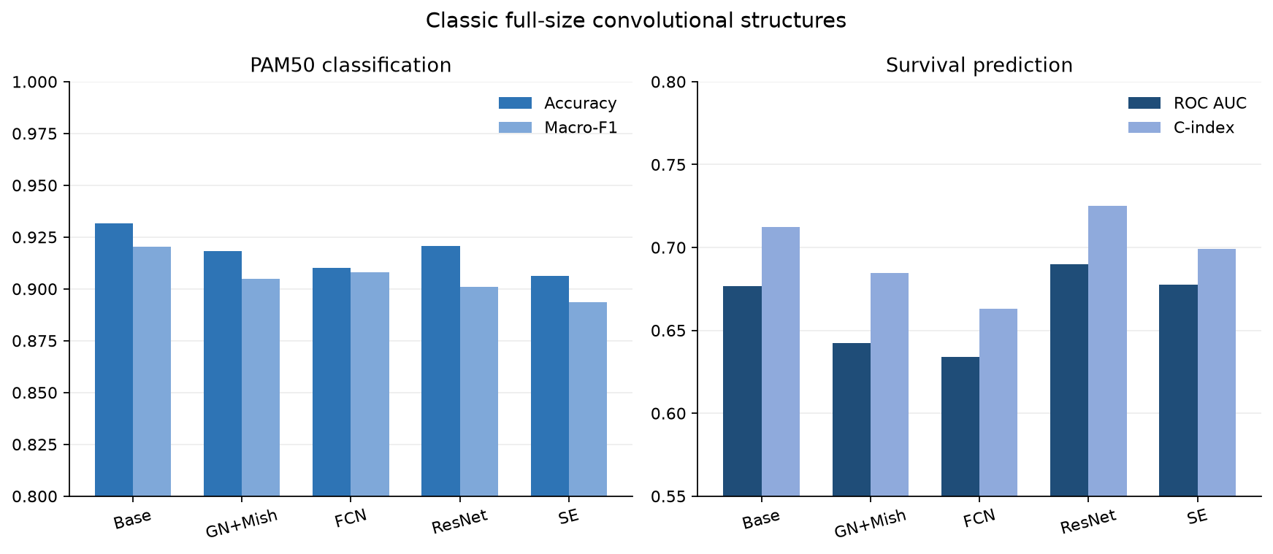
Figure S1. Classical full-size convolutional structures. Accuracy/Macro-F1 and ROC AUC/C-index are compared for FullSizeCNN, GroupNorm+Mish, FCN, ResNet, and multi-branch SE; error bars show 5-fold CV SD.
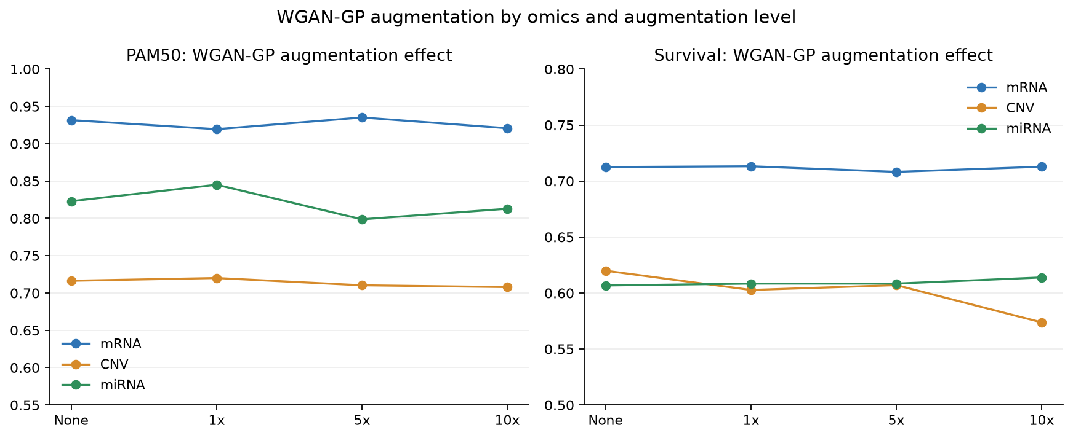
Figure S2. WGAN-GP augmentation for single-omics prediction. Comparisons include no augmentation, 1x, 5x, and 10x for mRNA, CNV, and miRNA; error bars show 5-fold CV SD.
为检验二维空间结构是否带来额外增益，训练了与 FullSizeCNN 首层参数量一致的 Dense 等价基线（Flatten→Dense(32)→Dense(64)→输出）。Dense 等价基线与 FullSizeCNN 的逐组学、逐任务、逐指标比较见 Table S14 与 Figure S3。
Table S14. Dense-equivalent baseline vs FullSizeCNN (5-fold CV, mean±SD; features selected within each training fold)
Omics | Task | Metric | Dense-equivalent mean±SD | FullSizeCNN mean±SD
mRNA | PAM50 | accuracy | 0.9568±0.0184 | 0.9316±0.0071
mRNA | PAM50 | macro_f1 | 0.9521±0.0211 | 0.9205±0.0097
mRNA | Survival | roc_auc | 0.6596±0.0555 | 0.6768±0.0549
mRNA | Survival | c_index | 0.6802±0.0739 | 0.7125±0.0303
CNV | PAM50 | accuracy | 0.7238±0.0270 | 0.7164±0.0246
CNV | PAM50 | macro_f1 | 0.6703±0.0329 | 0.6727±0.0352
CNV | Survival | roc_auc | 0.6434±0.0421 | 0.6244±0.0428
CNV | Survival | c_index | 0.6563±0.0631 | 0.6199±0.0591
miRNA | PAM50 | accuracy | 0.8370±0.0073 | 0.8230±0.0227
miRNA | PAM50 | macro_f1 | 0.8104±0.0148 | 0.7785±0.0338
miRNA | Survival | roc_auc | 0.6471±0.0481 | 0.6301±0.0401
miRNA | Survival | c_index | 0.5961±0.0486 | 0.6067±0.0703

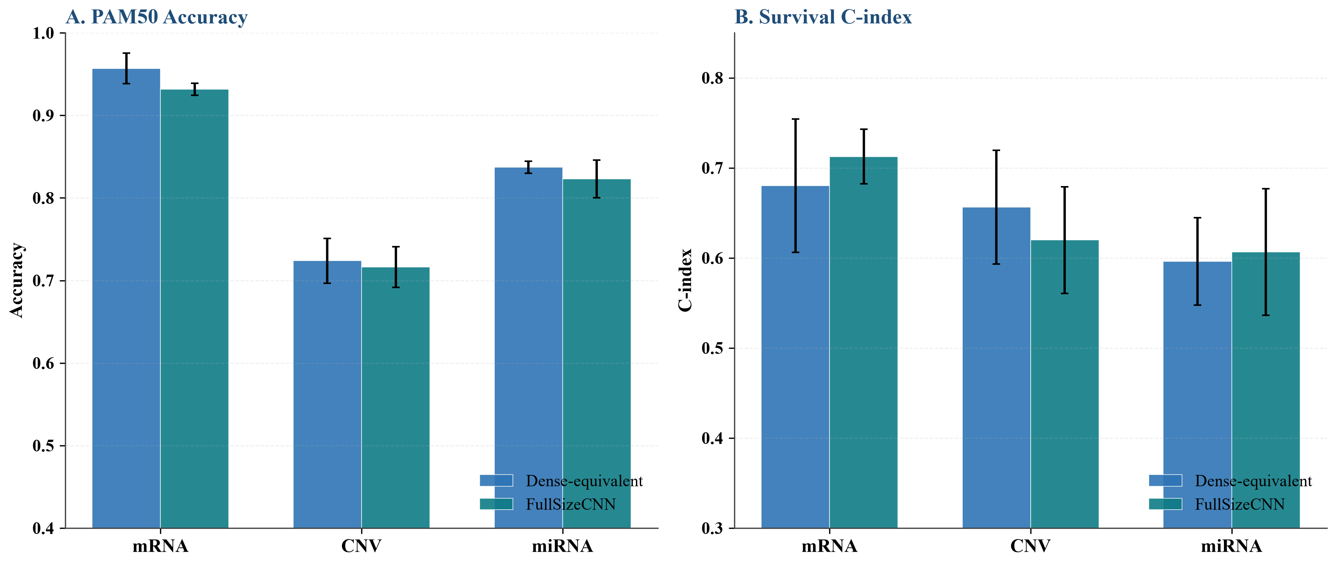
Figure S3. Dense-equivalent baseline vs FullSizeCNN. A: PAM50 Accuracy; B: Survival C-index. The dense network with an identical first-layer parameter count performs comparably to, or better than, FullSizeCNN, indicating that the 2-D spatial arrangement does not itself provide a consistent predictive gain; error bars show 5-fold CV SD.
为检验 JSD 螺旋排序是否优于随机排序，对 mRNA 生成 20 次随机基因排列，并加入均值表达排序作为确定性对照。随机排列的分布、均值表达排序与 JSD 螺旋排序的对比见 Table S15 与 Figure S4；经验 p 值为 20 次随机排列中不低于 JSD 结果的占比。
Table S15. Random-permutation ordering control for mRNA (5-fold CV; JSD spiral vs 20 random orders vs mean-expression ordering)
Task | Metric | JSD spiral | Mean expression | Random mean | Random std | Random min | Random max | p(random ≥ JSD)
PAM50 | accuracy | 0.9316 | 0.9316 | 0.9267 | 0.0075 | 0.9112 | 0.9400 | 0.2500
PAM50 | macro_f1 | 0.9205 | 0.9232 | 0.9168 | 0.0076 | 0.9004 | 0.9298 | 0.4000
Survival | roc_auc | 0.6768 | 0.6604 | 0.6698 | 0.0124 | 0.6393 | 0.6853 | 0.3500
Survival | c_index | 0.7125 | 0.6914 | 0.7055 | 0.0124 | 0.6796 | 0.7237 | 0.3500

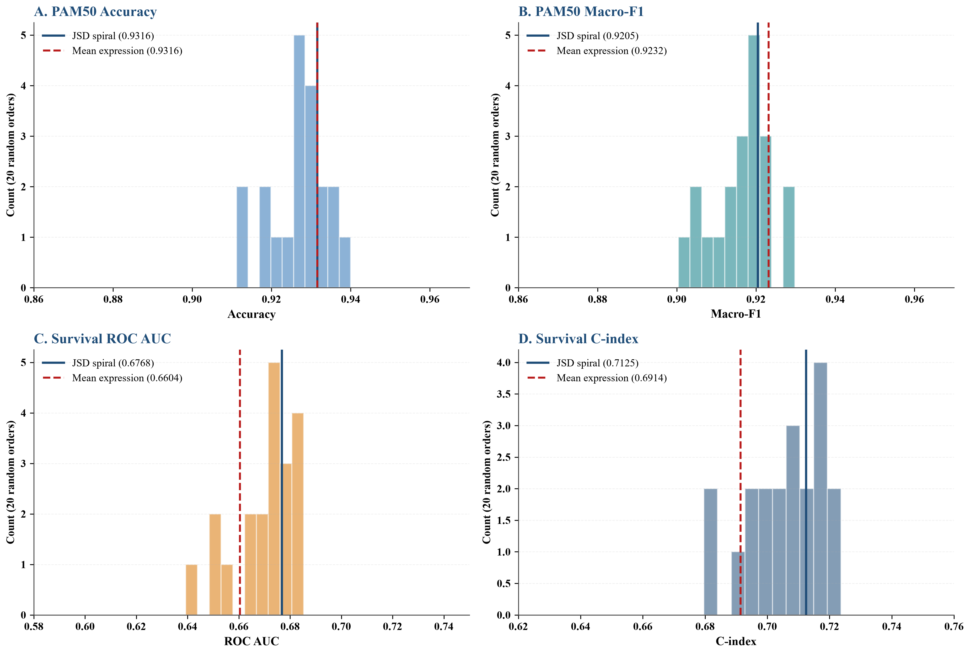
Figure S4. Random-permutation ordering control. A: PAM50 Accuracy; B: PAM50 Macro-F1; C: Survival ROC AUC; D: Survival C-index. Histograms show the distribution over 20 random gene orders; the JSD spiral and mean-expression orderings fall within the null, so the spatial ordering does not itself improve prediction.

S11. 可解释性补充图
SHAP、梯度 saliency 与 Grad-CAM 分别用于全局特征归因、单样本像素/基因重要性解释和卷积梯度定位[S9-S11]。
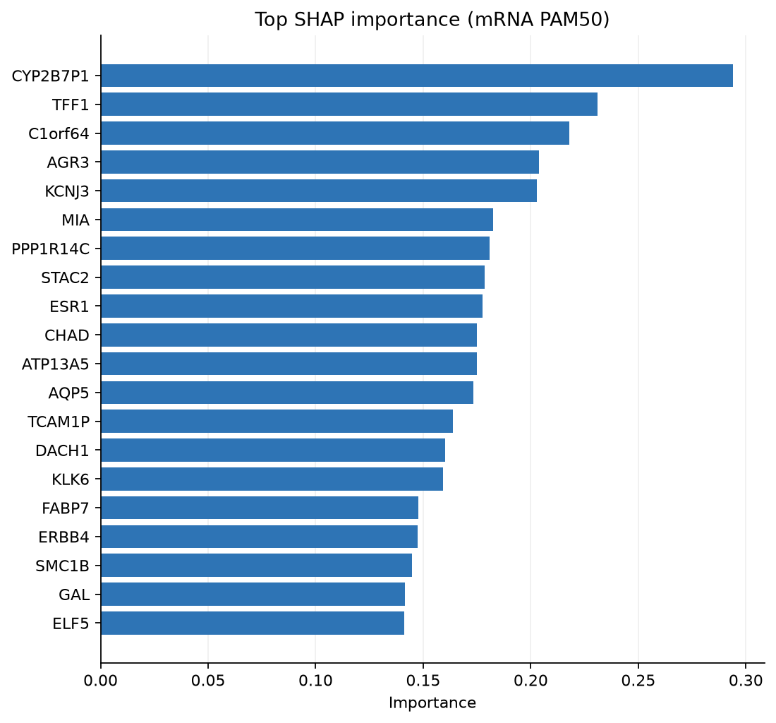
Figure S5. Top-20 SHAP genes for mRNA PAM50 LogisticRegression. The x-axis is mean absolute SHAP contribution; the y-axis is gene name.
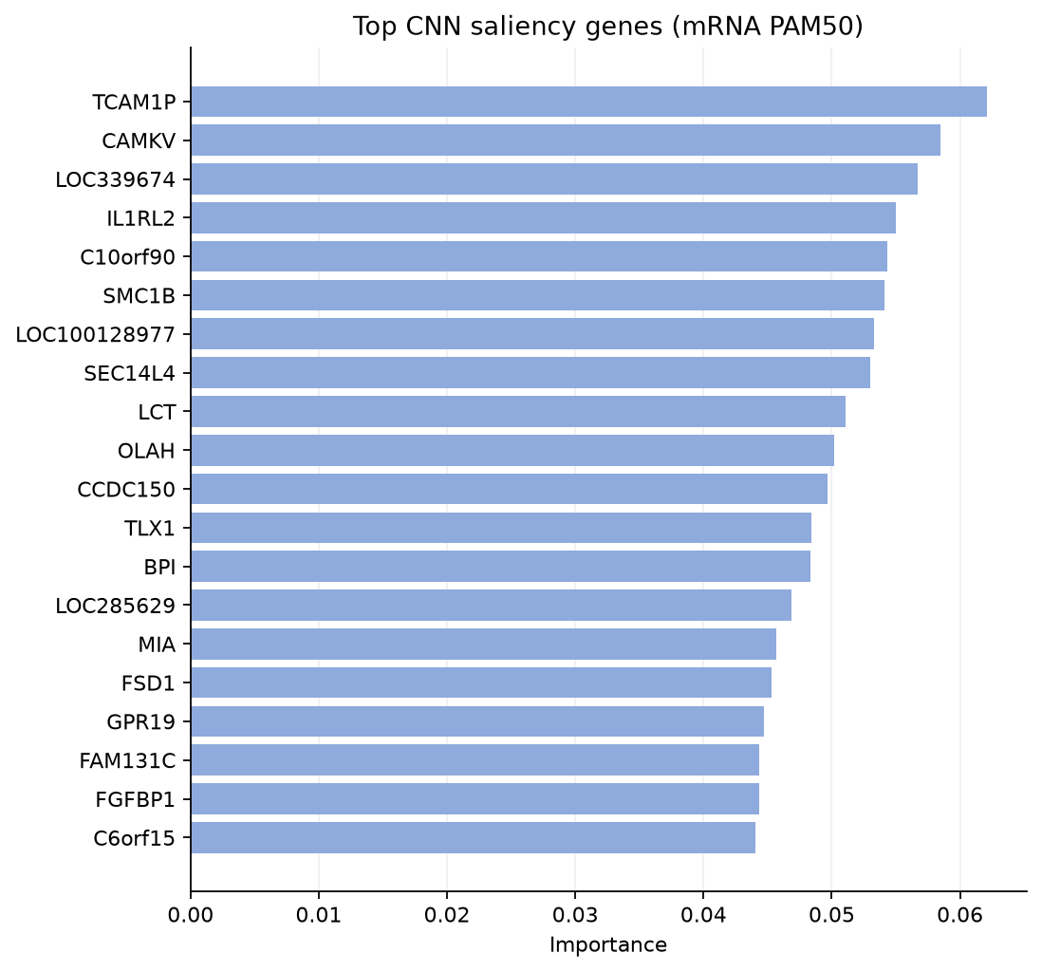
Figure S6. Top-20 CNN saliency genes for mRNA PAM50. Gradient-based saliency ranks input pixels/genes and highlights the most attended image regions.
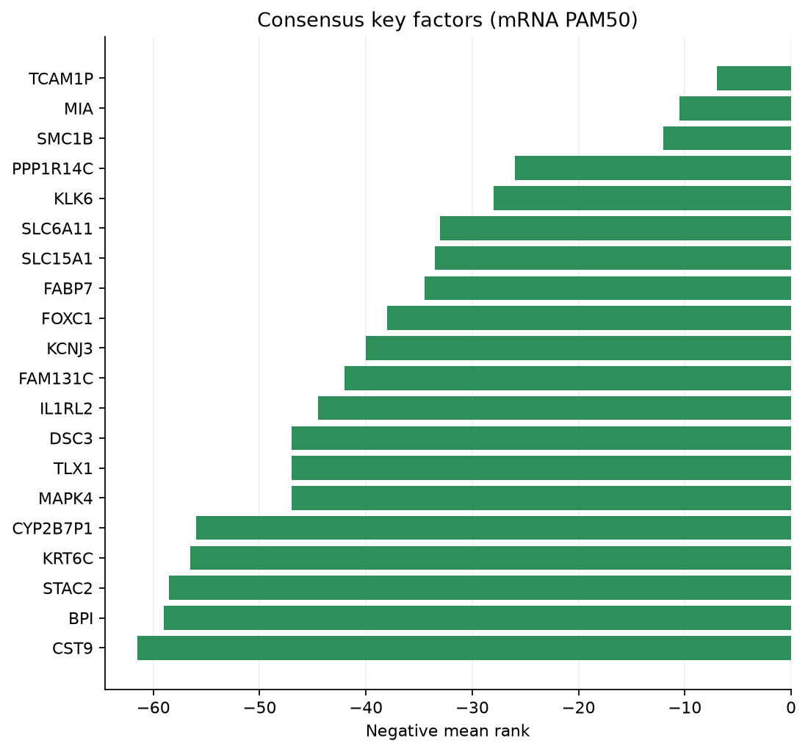
Figure S7. Top-20 consensus genes between SHAP and CNN saliency.
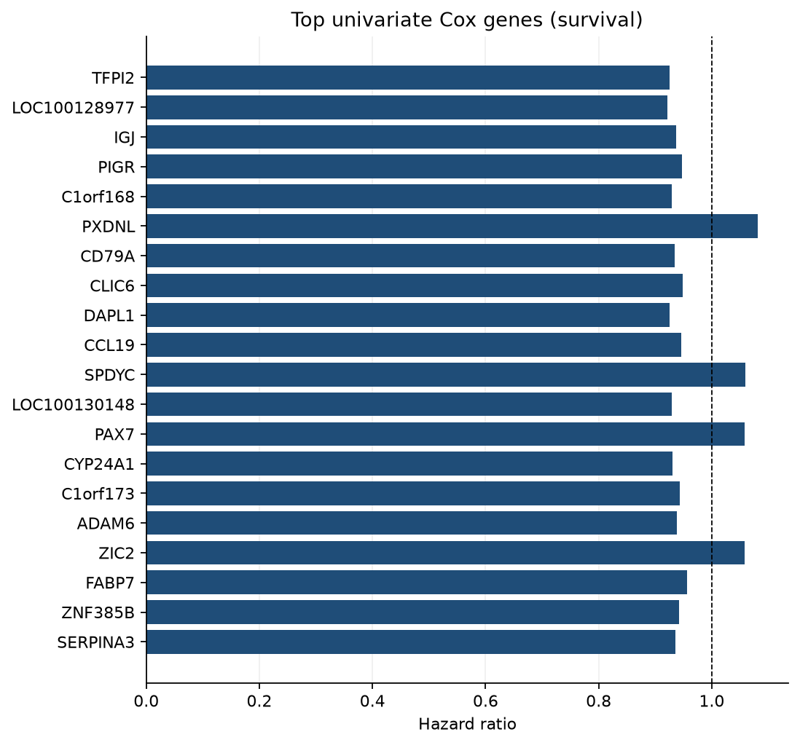
Figure S8. Top univariate Cox hazard ratios for survival genes. HR<1 indicates association with better survival; HR>1 indicates worse survival.
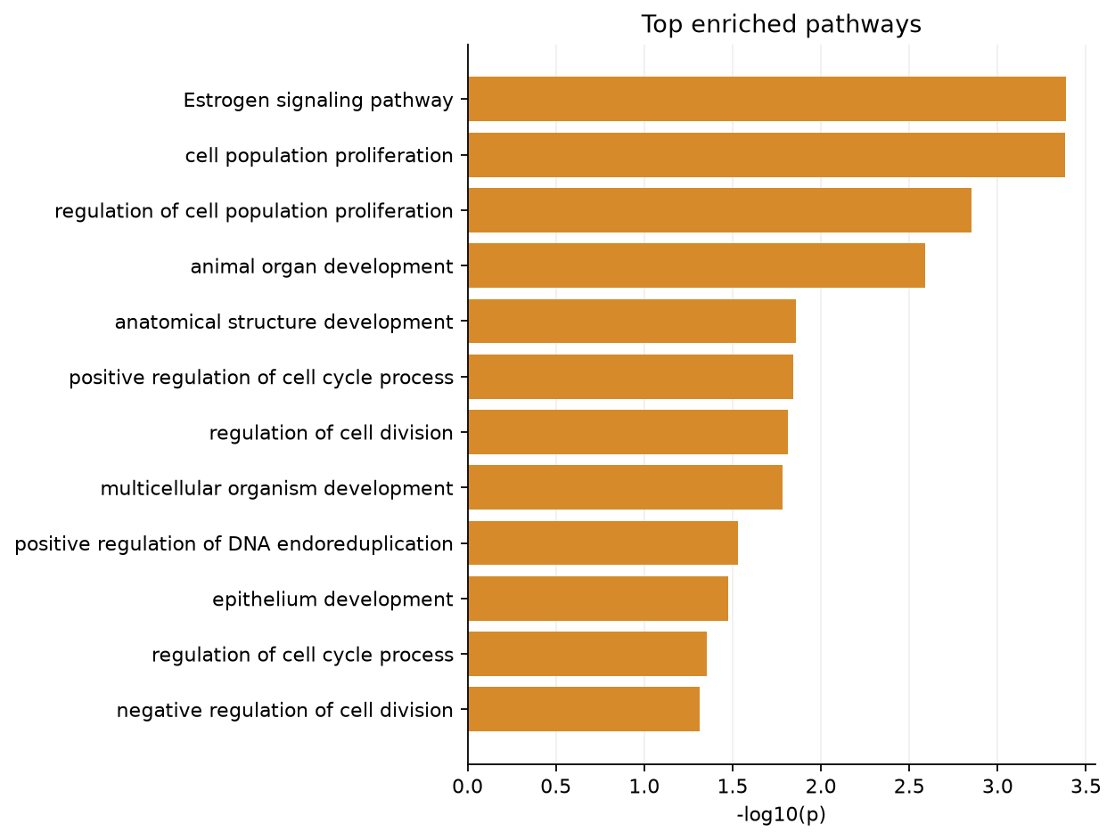
Figure S9. Pathway enrichment of consensus genes.

S12. 方案2功能类别遮盖实验
为解释功能模块对模型的贡献，在方案2图像上逐一遮盖各功能类别，比较 FullSizeCNN 的 PAM50 分类与生存风险建模性能。遮盖方式为将目标类别像素置零，其余类别保持不变。
Table S16. mRNA scheme-2 functional-category masking results (mean±SD; features selected within each training fold)
variant | category | task | metric | mean | std
baseline | Baseline | PAM50 | accuracy | 0.9244 | 0.0124
baseline | Baseline | PAM50 | macro_f1 | 0.9069 | 0.0133
mask_category_0 | Development / Epithelium | PAM50 | accuracy | 0.9112 | 0.0087
mask_category_0 | Development / Epithelium | PAM50 | macro_f1 | 0.9005 | 0.0097
mask_category_1 | Signaling / Transport | PAM50 | accuracy | 0.9268 | 0.0254
mask_category_1 | Signaling / Transport | PAM50 | macro_f1 | 0.9148 | 0.0334
mask_category_2 | Hormone / Metabolism | PAM50 | accuracy | 0.9112 | 0.0348
mask_category_2 | Hormone / Metabolism | PAM50 | macro_f1 | 0.8967 | 0.0412
mask_category_4 | Cell cycle / Proliferation | PAM50 | accuracy | 0.9160 | 0.0166
mask_category_4 | Cell cycle / Proliferation | PAM50 | macro_f1 | 0.8961 | 0.0130
mask_category_5 | Other | PAM50 | accuracy | 0.9100 | 0.0135
mask_category_5 | Other | PAM50 | macro_f1 | 0.8819 | 0.0210
baseline | Baseline | Survival | roc_auc | 0.6650 | 0.0784
baseline | Baseline | Survival | c_index | 0.6984 | 0.0756
mask_category_0 | Development / Epithelium | Survival | roc_auc | 0.6887 | 0.0421
mask_category_0 | Development / Epithelium | Survival | c_index | 0.7239 | 0.0349
mask_category_1 | Signaling / Transport | Survival | roc_auc | 0.6689 | 0.0666
mask_category_1 | Signaling / Transport | Survival | c_index | 0.7082 | 0.0433
mask_category_2 | Hormone / Metabolism | Survival | roc_auc | 0.6637 | 0.0706
mask_category_2 | Hormone / Metabolism | Survival | c_index | 0.6970 | 0.0509
mask_category_4 | Cell cycle / Proliferation | Survival | roc_auc | 0.6709 | 0.0537
mask_category_4 | Cell cycle / Proliferation | Survival | c_index | 0.7070 | 0.0543
mask_category_5 | Other | Survival | roc_auc | 0.6375 | 0.0764
mask_category_5 | Other | Survival | c_index | 0.6757 | 0.0715

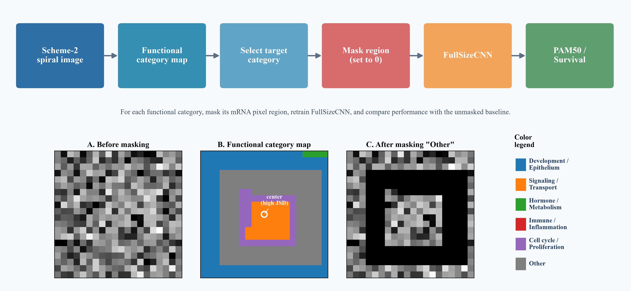
Figure S10. Scheme-2 functional-category masking workflow. A: before masking; B: functional category map; C: after masking Other.
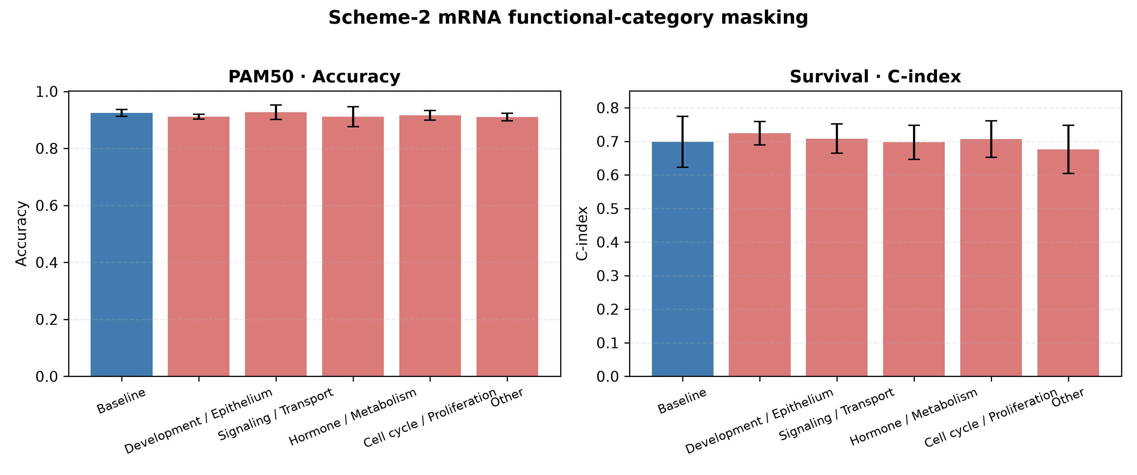
Figure S11. mRNA scheme-2 functional-category masking performance. A: PAM50 Accuracy; B: Survival C-index; error bars show 5-fold CV SD.

S13. CNV 与 miRNA 功能类别遮盖实验
需要说明，CNV 与 miRNA 的功能分类均为启发式注释（heuristic annotation），而非互斥的生物学本体。CNV 通过基因符号的关键词规则归入六大类别；miRNA 先由 MIMAT 映射至 hsa-miR 名称，再按其家族/已知功能归入同一六大类别[S12]。该规则仅覆盖部分基因，大量特征被归入 Other，因此相关遮盖结果应视为方向性证据而非确定的生物学结论。完整的特征→类别注释映射见 data/omics_functional_category_annotation.tsv。两种组学均采用与 mRNA 相同的遮盖-重训练-评估流程。
Table S17. CNV and miRNA functional-category masking results (mean±SD; features selected within each training fold)
omics | task | variant | category | metric | mean | std
CNV | PAM50 | baseline | Baseline | accuracy | 0.7176 | 0.0202
CNV | PAM50 | baseline | Baseline | macro_f1 | 0.6659 | 0.0319
CNV | PAM50 | mask_category_0 | Development/Epithelium | accuracy | 0.7091 | 0.0239
CNV | PAM50 | mask_category_0 | Development/Epithelium | macro_f1 | 0.6616 | 0.0328
CNV | PAM50 | mask_category_1 | Signaling/Transport | accuracy | 0.7128 | 0.0240
CNV | PAM50 | mask_category_1 | Signaling/Transport | macro_f1 | 0.6589 | 0.0391
CNV | PAM50 | mask_category_2 | Hormone/Metabolism | accuracy | 0.7164 | 0.0256
CNV | PAM50 | mask_category_2 | Hormone/Metabolism | macro_f1 | 0.6617 | 0.0332
CNV | PAM50 | mask_category_3 | Immune/Inflammation | accuracy | 0.7164 | 0.0193
CNV | PAM50 | mask_category_3 | Immune/Inflammation | macro_f1 | 0.6641 | 0.0225
CNV | PAM50 | mask_category_4 | Cell cycle/Proliferation | accuracy | 0.7152 | 0.0215
CNV | PAM50 | mask_category_4 | Cell cycle/Proliferation | macro_f1 | 0.6651 | 0.0309
CNV | PAM50 | mask_category_5 | Other | accuracy | 0.6737 | 0.0436
CNV | PAM50 | mask_category_5 | Other | macro_f1 | 0.5904 | 0.0645
CNV | Survival | baseline | Baseline | roc_auc | 0.6642 | 0.0248
CNV | Survival | baseline | Baseline | c_index | 0.6679 | 0.0471
CNV | Survival | mask_category_0 | Development/Epithelium | roc_auc | 0.6653 | 0.0247
CNV | Survival | mask_category_0 | Development/Epithelium | c_index | 0.6642 | 0.0479
CNV | Survival | mask_category_1 | Signaling/Transport | roc_auc | 0.6694 | 0.0343
CNV | Survival | mask_category_1 | Signaling/Transport | c_index | 0.6718 | 0.0601
CNV | Survival | mask_category_2 | Hormone/Metabolism | roc_auc | 0.6620 | 0.0213
CNV | Survival | mask_category_2 | Hormone/Metabolism | c_index | 0.6692 | 0.0508
CNV | Survival | mask_category_3 | Immune/Inflammation | roc_auc | 0.6604 | 0.0292
CNV | Survival | mask_category_3 | Immune/Inflammation | c_index | 0.6572 | 0.0520
CNV | Survival | mask_category_4 | Cell cycle/Proliferation | roc_auc | 0.6631 | 0.0226
CNV | Survival | mask_category_4 | Cell cycle/Proliferation | c_index | 0.6717 | 0.0488
CNV | Survival | mask_category_5 | Other | roc_auc | 0.5799 | 0.0814
CNV | Survival | mask_category_5 | Other | c_index | 0.5688 | 0.0633
miRNA | PAM50 | baseline | Baseline | accuracy | 0.8088 | 0.0230
miRNA | PAM50 | baseline | Baseline | macro_f1 | 0.7783 | 0.0441
miRNA | PAM50 | mask_category_0 | Development/Epithelium | accuracy | 0.8028 | 0.0328
miRNA | PAM50 | mask_category_0 | Development/Epithelium | macro_f1 | 0.7659 | 0.0570
miRNA | PAM50 | mask_category_1 | Signaling/Transport | accuracy | 0.8028 | 0.0138
miRNA | PAM50 | mask_category_1 | Signaling/Transport | macro_f1 | 0.7670 | 0.0251
miRNA | PAM50 | mask_category_2 | Hormone/Metabolism | accuracy | 0.8129 | 0.0267
miRNA | PAM50 | mask_category_2 | Hormone/Metabolism | macro_f1 | 0.7752 | 0.0315
miRNA | PAM50 | mask_category_3 | Immune/Inflammation | accuracy | 0.8048 | 0.0263
miRNA | PAM50 | mask_category_3 | Immune/Inflammation | macro_f1 | 0.7685 | 0.0384
miRNA | PAM50 | mask_category_4 | Cell cycle/Proliferation | accuracy | 0.8008 | 0.0228
miRNA | PAM50 | mask_category_4 | Cell cycle/Proliferation | macro_f1 | 0.7540 | 0.0328
miRNA | PAM50 | mask_category_5 | Other | accuracy | 0.7264 | 0.0194
miRNA | PAM50 | mask_category_5 | Other | macro_f1 | 0.5314 | 0.0365
miRNA | Survival | baseline | Baseline | roc_auc | 0.6056 | 0.0588
miRNA | Survival | baseline | Baseline | c_index | 0.5807 | 0.0768
miRNA | Survival | mask_category_0 | Development/Epithelium | roc_auc | 0.6051 | 0.0615
miRNA | Survival | mask_category_0 | Development/Epithelium | c_index | 0.5737 | 0.0825
miRNA | Survival | mask_category_1 | Signaling/Transport | roc_auc | 0.5994 | 0.0722
miRNA | Survival | mask_category_1 | Signaling/Transport | c_index | 0.5752 | 0.0848
miRNA | Survival | mask_category_2 | Hormone/Metabolism | roc_auc | 0.5985 | 0.0442
miRNA | Survival | mask_category_2 | Hormone/Metabolism | c_index | 0.5824 | 0.0633
miRNA | Survival | mask_category_3 | Immune/Inflammation | roc_auc | 0.6005 | 0.0518
miRNA | Survival | mask_category_3 | Immune/Inflammation | c_index | 0.5684 | 0.0811
miRNA | Survival | mask_category_4 | Cell cycle/Proliferation | roc_auc | 0.6041 | 0.0629
miRNA | Survival | mask_category_4 | Cell cycle/Proliferation | c_index | 0.5685 | 0.0795
miRNA | Survival | mask_category_5 | Other | roc_auc | 0.5218 | 0.0553
miRNA | Survival | mask_category_5 | Other | c_index | 0.5640 | 0.0649

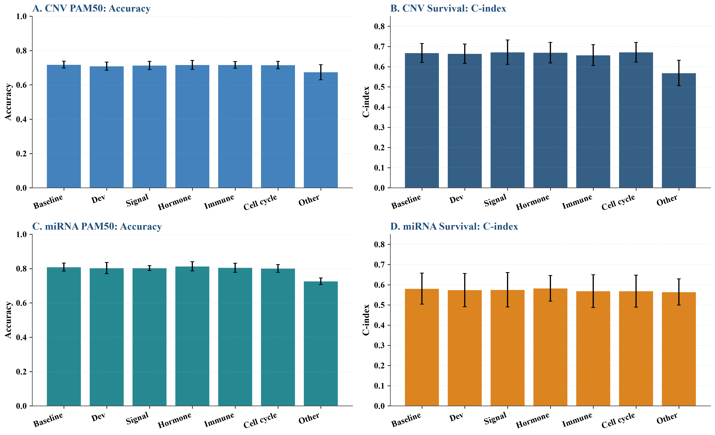
Figure S12. CNV and miRNA functional-category masking performance. A-D: CNV PAM50, CNV Survival, miRNA PAM50, and miRNA Survival.

S14. 等量随机遮盖对照与统计检验
为控制特征数量和区域大小效应，对 mRNA 每个功能类别生成同数量随机基因遮盖对照。折级指标见补充文件，配对 t 检验与 Wilcoxon 检验结果见下表。
Table S18. Fold-level metrics for mRNA equal-size random masking controls
task | fold | variant | metric | value
PAM50 | 0 | baseline | accuracy | 0.8982
PAM50 | 0 | baseline | macro_f1 | 0.8814
PAM50 | 0 | mask_category_0 | accuracy | 0.9341
PAM50 | 0 | mask_category_0 | macro_f1 | 0.9032
PAM50 | 0 | random_equal_0 | accuracy | 0.9162
PAM50 | 0 | random_equal_0 | macro_f1 | 0.8925
PAM50 | 0 | mask_category_1 | accuracy | 0.9162
PAM50 | 0 | mask_category_1 | macro_f1 | 0.8938
PAM50 | 0 | random_equal_1 | accuracy | 0.9102
PAM50 | 0 | random_equal_1 | macro_f1 | 0.8870
PAM50 | 0 | mask_category_2 | accuracy | 0.9162
PAM50 | 0 | mask_category_2 | macro_f1 | 0.8944
PAM50 | 0 | random_equal_2 | accuracy | 0.9162
PAM50 | 0 | random_equal_2 | macro_f1 | 0.8820
PAM50 | 0 | mask_category_4 | accuracy | 0.8982
PAM50 | 0 | mask_category_4 | macro_f1 | 0.8693
PAM50 | 0 | random_equal_4 | accuracy | 0.9102
PAM50 | 0 | random_equal_4 | macro_f1 | 0.8981
PAM50 | 0 | mask_category_5 | accuracy | 0.9042
PAM50 | 0 | mask_category_5 | macro_f1 | 0.8805
PAM50 | 0 | random_equal_5 | accuracy | 0.8982
PAM50 | 0 | random_equal_5 | macro_f1 | 0.8820
PAM50 | 1 | baseline | accuracy | 0.9521
PAM50 | 1 | baseline | macro_f1 | 0.9476
PAM50 | 1 | mask_category_0 | accuracy | 0.9521
PAM50 | 1 | mask_category_0 | macro_f1 | 0.9457
PAM50 | 1 | random_equal_0 | accuracy | 0.9401
PAM50 | 1 | random_equal_0 | macro_f1 | 0.9310
PAM50 | 1 | mask_category_1 | accuracy | 0.9701
PAM50 | 1 | mask_category_1 | macro_f1 | 0.9661
PAM50 | 1 | random_equal_1 | accuracy | 0.9401
PAM50 | 1 | random_equal_1 | macro_f1 | 0.9329
PAM50 | 1 | mask_category_2 | accuracy | 0.9521
PAM50 | 1 | mask_category_2 | macro_f1 | 0.9385
PAM50 | 1 | random_equal_2 | accuracy | 0.9341
PAM50 | 1 | random_equal_2 | macro_f1 | 0.9224
PAM50 | 1 | mask_category_4 | accuracy | 0.9401
PAM50 | 1 | mask_category_4 | macro_f1 | 0.9329
PAM50 | 1 | random_equal_4 | accuracy | 0.9581
PAM50 | 1 | random_equal_4 | macro_f1 | 0.9484
PAM50 | 1 | mask_category_5 | accuracy | 0.9281
PAM50 | 1 | mask_category_5 | macro_f1 | 0.9140
PAM50 | 1 | random_equal_5 | accuracy | 0.9581
PAM50 | 1 | random_equal_5 | macro_f1 | 0.9466
PAM50 | 2 | baseline | accuracy | 0.8443
PAM50 | 2 | baseline | macro_f1 | 0.8436
PAM50 | 2 | mask_category_0 | accuracy | 0.8982
PAM50 | 2 | mask_category_0 | macro_f1 | 0.8933
PAM50 | 2 | random_equal_0 | accuracy | 0.8683
PAM50 | 2 | random_equal_0 | macro_f1 | 0.8894
PAM50 | 2 | mask_category_1 | accuracy | 0.8802
PAM50 | 2 | mask_category_1 | macro_f1 | 0.8754
PAM50 | 2 | random_equal_1 | accuracy | 0.9102
PAM50 | 2 | random_equal_1 | macro_f1 | 0.8954
PAM50 | 2 | mask_category_2 | accuracy | 0.8563
PAM50 | 2 | mask_category_2 | macro_f1 | 0.8687
PAM50 | 2 | random_equal_2 | accuracy | 0.8563
PAM50 | 2 | random_equal_2 | macro_f1 | 0.8679
PAM50 | 2 | mask_category_4 | accuracy | 0.8563
PAM50 | 2 | mask_category_4 | macro_f1 | 0.8579
PAM50 | 2 | random_equal_4 | accuracy | 0.8743
PAM50 | 2 | random_equal_4 | macro_f1 | 0.8655
PAM50 | 2 | mask_category_5 | accuracy | 0.8503
PAM50 | 2 | mask_category_5 | macro_f1 | 0.8489
PAM50 | 2 | random_equal_5 | accuracy | 0.8743
PAM50 | 2 | random_equal_5 | macro_f1 | 0.8796
PAM50 | 3 | baseline | accuracy | 0.8795
PAM50 | 3 | baseline | macro_f1 | 0.8536
PAM50 | 3 | mask_category_0 | accuracy | 0.8795
PAM50 | 3 | mask_category_0 | macro_f1 | 0.8639
PAM50 | 3 | random_equal_0 | accuracy | 0.8614
PAM50 | 3 | random_equal_0 | macro_f1 | 0.8344
PAM50 | 3 | mask_category_1 | accuracy | 0.8735
PAM50 | 3 | mask_category_1 | macro_f1 | 0.8379
PAM50 | 3 | random_equal_1 | accuracy | 0.8795
PAM50 | 3 | random_equal_1 | macro_f1 | 0.8674
PAM50 | 3 | mask_category_2 | accuracy | 0.8795
PAM50 | 3 | mask_category_2 | macro_f1 | 0.8536
PAM50 | 3 | random_equal_2 | accuracy | 0.8976
PAM50 | 3 | random_equal_2 | macro_f1 | 0.8780
PAM50 | 3 | mask_category_4 | accuracy | 0.9096
PAM50 | 3 | mask_category_4 | macro_f1 | 0.9053
PAM50 | 3 | random_equal_4 | accuracy | 0.8795
PAM50 | 3 | random_equal_4 | macro_f1 | 0.8784
PAM50 | 3 | mask_category_5 | accuracy | 0.9096
PAM50 | 3 | mask_category_5 | macro_f1 | 0.9102
PAM50 | 3 | random_equal_5 | accuracy | 0.8976
PAM50 | 3 | random_equal_5 | macro_f1 | 0.8891
PAM50 | 4 | baseline | accuracy | 0.9157
PAM50 | 4 | baseline | macro_f1 | 0.8957
PAM50 | 4 | mask_category_0 | accuracy | 0.9036
PAM50 | 4 | mask_category_0 | macro_f1 | 0.8818
PAM50 | 4 | random_equal_0 | accuracy | 0.8916
PAM50 | 4 | random_equal_0 | macro_f1 | 0.8514
PAM50 | 4 | mask_category_1 | accuracy | 0.9157
PAM50 | 4 | mask_category_1 | macro_f1 | 0.8872
PAM50 | 4 | random_equal_1 | accuracy | 0.9337
PAM50 | 4 | random_equal_1 | macro_f1 | 0.9175
PAM50 | 4 | mask_category_2 | accuracy | 0.9096
PAM50 | 4 | mask_category_2 | macro_f1 | 0.8899
PAM50 | 4 | random_equal_2 | accuracy | 0.8916
PAM50 | 4 | random_equal_2 | macro_f1 | 0.8769
PAM50 | 4 | mask_category_4 | accuracy | 0.9157
PAM50 | 4 | mask_category_4 | macro_f1 | 0.8872
PAM50 | 4 | random_equal_4 | accuracy | 0.9217
PAM50 | 4 | random_equal_4 | macro_f1 | 0.9019
PAM50 | 4 | mask_category_5 | accuracy | 0.9217
PAM50 | 4 | mask_category_5 | macro_f1 | 0.8884
PAM50 | 4 | random_equal_5 | accuracy | 0.9217
PAM50 | 4 | random_equal_5 | macro_f1 | 0.9177
Survival | 0 | baseline | roc_auc | 0.6856
Survival | 0 | baseline | c_index | 0.7502
Survival | 0 | mask_category_0 | roc_auc | 0.6816
Survival | 0 | mask_category_0 | c_index | 0.7077
Survival | 0 | random_equal_0 | roc_auc | 0.6930
Survival | 0 | random_equal_0 | c_index | 0.7522
Survival | 0 | mask_category_1 | roc_auc | 0.6649
Survival | 0 | mask_category_1 | c_index | 0.7366
Survival | 0 | random_equal_1 | roc_auc | 0.6996
Survival | 0 | random_equal_1 | c_index | 0.7375
Survival | 0 | mask_category_2 | roc_auc | 0.6802
Survival | 0 | mask_category_2 | c_index | 0.7346
Survival | 0 | random_equal_2 | roc_auc | 0.6825
Survival | 0 | random_equal_2 | c_index | 0.7581
Survival | 0 | mask_category_4 | roc_auc | 0.6800
Survival | 0 | mask_category_4 | c_index | 0.7498
Survival | 0 | random_equal_4 | roc_auc | 0.6705
Survival | 0 | random_equal_4 | c_index | 0.7248
Survival | 0 | mask_category_5 | roc_auc | 0.6751
Survival | 0 | mask_category_5 | c_index | 0.7033
Survival | 0 | random_equal_5 | roc_auc | 0.7029
Survival | 0 | random_equal_5 | c_index | 0.7463
Survival | 1 | baseline | roc_auc | 0.5858
Survival | 1 | baseline | c_index | 0.6177
Survival | 1 | mask_category_0 | roc_auc | 0.6546
Survival | 1 | mask_category_0 | c_index | 0.6855
Survival | 1 | random_equal_0 | roc_auc | 0.6247
Survival | 1 | random_equal_0 | c_index | 0.6865
Survival | 1 | mask_category_1 | roc_auc | 0.6040
Survival | 1 | mask_category_1 | c_index | 0.6532
Survival | 1 | random_equal_1 | roc_auc | 0.6625
Survival | 1 | random_equal_1 | c_index | 0.6758
Survival | 1 | mask_category_2 | roc_auc | 0.6115
Survival | 1 | mask_category_2 | c_index | 0.6655
Survival | 1 | random_equal_2 | roc_auc | 0.5955
Survival | 1 | random_equal_2 | c_index | 0.6310
Survival | 1 | mask_category_4 | roc_auc | 0.6092
Survival | 1 | mask_category_4 | c_index | 0.6358
Survival | 1 | random_equal_4 | roc_auc | 0.6011
Survival | 1 | random_equal_4 | c_index | 0.6268
Survival | 1 | mask_category_5 | roc_auc | 0.5613
Survival | 1 | mask_category_5 | c_index | 0.6003
Survival | 1 | random_equal_5 | roc_auc | 0.6332
Survival | 1 | random_equal_5 | c_index | 0.6574
Survival | 2 | baseline | roc_auc | 0.6885
Survival | 2 | baseline | c_index | 0.7147
Survival | 2 | mask_category_0 | roc_auc | 0.7458
Survival | 2 | mask_category_0 | c_index | 0.7726
Survival | 2 | random_equal_0 | roc_auc | 0.6557
Survival | 2 | random_equal_0 | c_index | 0.6866
Survival | 2 | mask_category_1 | roc_auc | 0.6769
Survival | 2 | mask_category_1 | c_index | 0.6996
Survival | 2 | random_equal_1 | roc_auc | 0.6607
Survival | 2 | random_equal_1 | c_index | 0.6944
Survival | 2 | mask_category_2 | roc_auc | 0.6951
Survival | 2 | mask_category_2 | c_index | 0.7270
Survival | 2 | random_equal_2 | roc_auc | 0.6926
Survival | 2 | random_equal_2 | c_index | 0.7311
Survival | 2 | mask_category_4 | roc_auc | 0.6973
Survival | 2 | mask_category_4 | c_index | 0.7335
Survival | 2 | random_equal_4 | roc_auc | 0.6775
Survival | 2 | random_equal_4 | c_index | 0.7112
Survival | 2 | mask_category_5 | roc_auc | 0.6485
Survival | 2 | mask_category_5 | c_index | 0.6979
Survival | 2 | random_equal_5 | roc_auc | 0.7124
Survival | 2 | random_equal_5 | c_index | 0.7675
Survival | 3 | baseline | roc_auc | 0.6397
Survival | 3 | baseline | c_index | 0.7521
Survival | 3 | mask_category_0 | roc_auc | 0.6757
Survival | 3 | mask_category_0 | c_index | 0.7541
Survival | 3 | random_equal_0 | roc_auc | 0.6414
Survival | 3 | random_equal_0 | c_index | 0.7541
Survival | 3 | mask_category_1 | roc_auc | 0.6308
Survival | 3 | mask_category_1 | c_index | 0.7441
Survival | 3 | random_equal_1 | roc_auc | 0.6181
Survival | 3 | random_equal_1 | c_index | 0.7231
Survival | 3 | mask_category_2 | roc_auc | 0.6248
Survival | 3 | mask_category_2 | c_index | 0.7341
Survival | 3 | random_equal_2 | roc_auc | 0.6384
Survival | 3 | random_equal_2 | c_index | 0.7451
Survival | 3 | mask_category_4 | roc_auc | 0.6382
Survival | 3 | mask_category_4 | c_index | 0.7566
Survival | 3 | random_equal_4 | roc_auc | 0.6431
Survival | 3 | random_equal_4 | c_index | 0.7501
Survival | 3 | mask_category_5 | roc_auc | 0.6211
Survival | 3 | mask_category_5 | c_index | 0.7336
Survival | 3 | random_equal_5 | roc_auc | 0.6565
Survival | 3 | random_equal_5 | c_index | 0.7426
Survival | 4 | baseline | roc_auc | 0.7768
Survival | 4 | baseline | c_index | 0.7343
Survival | 4 | mask_category_0 | roc_auc | 0.7446
Survival | 4 | mask_category_0 | c_index | 0.7488
Survival | 4 | random_equal_0 | roc_auc | 0.8156
Survival | 4 | random_equal_0 | c_index | 0.7616
Survival | 4 | mask_category_1 | roc_auc | 0.7848
Survival | 4 | mask_category_1 | c_index | 0.7308
Survival | 4 | random_equal_1 | roc_auc | 0.7413
Survival | 4 | random_equal_1 | c_index | 0.6873
Survival | 4 | mask_category_2 | roc_auc | 0.7779
Survival | 4 | mask_category_2 | c_index | 0.7153
Survival | 4 | random_equal_2 | roc_auc | 0.7904
Survival | 4 | random_equal_2 | c_index | 0.7388
Survival | 4 | mask_category_4 | roc_auc | 0.7601
Survival | 4 | mask_category_4 | c_index | 0.6980
Survival | 4 | random_equal_4 | roc_auc | 0.7701
Survival | 4 | random_equal_4 | c_index | 0.7267
Survival | 4 | mask_category_5 | roc_auc | 0.7832
Survival | 4 | mask_category_5 | c_index | 0.7602
Survival | 4 | random_equal_5 | roc_auc | 0.7516
Survival | 4 | random_equal_5 | c_index | 0.7028

Table S19. Paired tests between mRNA functional-category masks and baseline. P values are unadjusted and should be interpreted descriptively because of the small number of folds and multiple comparisons.
task | variant | metric | ttest_stat | ttest_p | wilcoxon_stat | wilcoxon_p
PAM50 | mask_category_0 | accuracy | -1.2432 | 0.2817 | 1.0000 | 0.5000
PAM50 | mask_category_0 | macro_f1 | -1.2120 | 0.2922 | 4.0000 | 0.4375
PAM50 | random_equal_0 | accuracy | 0.2498 | 0.8150 | 6.0000 | 0.8125
PAM50 | random_equal_0 | macro_f1 | 0.3035 | 0.7766 | 6.0000 | 0.8125
PAM50 | mask_category_1 | accuracy | -1.7707 | 0.1513 | 1.0000 | 0.2500
PAM50 | mask_category_1 | macro_f1 | -0.8798 | 0.4287 | 4.0000 | 0.4375
PAM50 | random_equal_1 | accuracy | -1.2614 | 0.2757 | 1.5000 | 0.3750
PAM50 | random_equal_1 | macro_f1 | -1.4369 | 0.2241 | 3.0000 | 0.3125
PAM50 | mask_category_2 | accuracy | -1.0859 | 0.3386 | 1.0000 | 0.5000
PAM50 | mask_category_2 | macro_f1 | -0.7308 | 0.5054 | 3.0000 | 0.6250
PAM50 | random_equal_2 | accuracy | -0.1295 | 0.9032 | 7.0000 | 1.0000
PAM50 | random_equal_2 | macro_f1 | -0.1022 | 0.9235 | 7.0000 | 1.0000
PAM50 | mask_category_4 | accuracy | -0.8466 | 0.4449 | 1.5000 | 0.7500
PAM50 | mask_category_4 | macro_f1 | -0.4913 | 0.6490 | 7.0000 | 1.0000
PAM50 | random_equal_4 | accuracy | -2.0945 | 0.1043 | 0.0000 | 0.1250
PAM50 | random_equal_4 | macro_f1 | -3.0661 | 0.0374 | 0.0000 | 0.0625
PAM50 | mask_category_5 | accuracy | -0.5634 | 0.6032 | 4.0000 | 0.3750
PAM50 | mask_category_5 | macro_f1 | -0.2724 | 0.7988 | 7.0000 | 1.0000
PAM50 | random_equal_5 | accuracy | -2.2398 | 0.0886 | 0.0000 | 0.1250
PAM50 | random_equal_5 | macro_f1 | -2.3043 | 0.0826 | 2.0000 | 0.1875
Survival | mask_category_0 | roc_auc | -1.3270 | 0.2552 | 3.0000 | 0.3125
Survival | mask_category_0 | c_index | -0.9980 | 0.3748 | 3.0000 | 0.3125
Survival | random_equal_0 | roc_auc | -0.8080 | 0.4644 | 3.0000 | 0.3125
Survival | random_equal_0 | c_index | -0.8884 | 0.4245 | 4.0000 | 0.4375
Survival | mask_category_1 | roc_auc | 0.4268 | 0.6915 | 5.0000 | 0.6250
Survival | mask_category_1 | c_index | 0.1019 | 0.9238 | 5.0000 | 0.6250
Survival | random_equal_1 | roc_auc | -0.0573 | 0.9571 | 6.0000 | 0.8125
Survival | random_equal_1 | c_index | 0.5659 | 0.6017 | 5.0000 | 0.6250
Survival | mask_category_2 | roc_auc | -0.3880 | 0.7178 | 6.0000 | 0.8125
Survival | mask_category_2 | c_index | -0.1146 | 0.9143 | 6.0000 | 0.8125
Survival | random_equal_2 | roc_auc | -1.4573 | 0.2188 | 3.0000 | 0.3125
Survival | random_equal_2 | c_index | -1.7187 | 0.1608 | 2.0000 | 0.1875
Survival | mask_category_4 | roc_auc | -0.2505 | 0.8146 | 7.0000 | 1.0000
Survival | mask_category_4 | c_index | -0.0929 | 0.9304 | 6.0000 | 0.8125
Survival | random_equal_4 | roc_auc | 0.5168 | 0.6326 | 6.0000 | 0.8125
Survival | random_equal_4 | c_index | 1.0499 | 0.3530 | 4.0000 | 0.4375
Survival | mask_category_5 | roc_auc | 2.2770 | 0.0851 | 1.0000 | 0.1250
Survival | mask_category_5 | c_index | 1.2662 | 0.2741 | 4.0000 | 0.4375
Survival | random_equal_5 | roc_auc | -1.3694 | 0.2427 | 4.0000 | 0.4375
Survival | random_equal_5 | c_index | -0.6021 | 0.5796 | 6.0000 | 0.8125

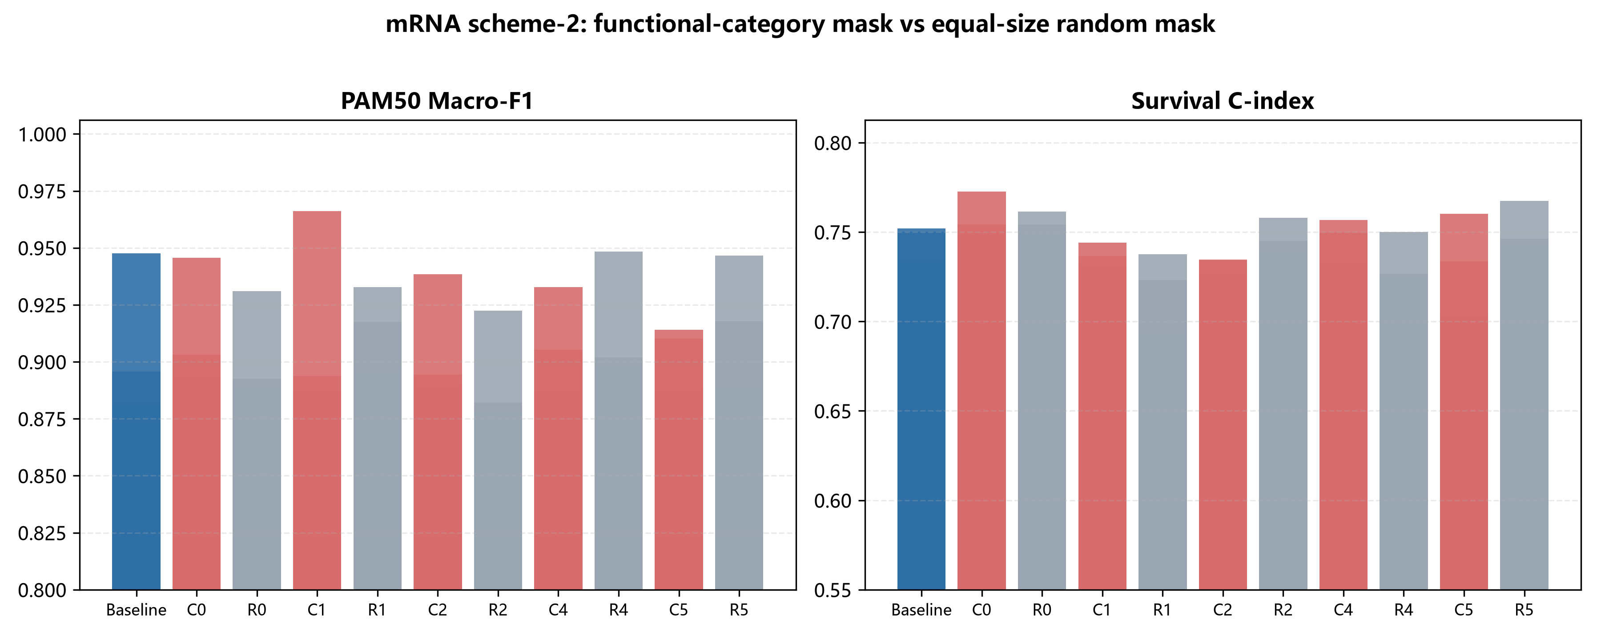
Figure S13. mRNA functional-category masks vs equal-size random masks.

S15. Other 类二次富集与共识基因交叉验证
对 mRNA PAM50 的 Other 类基因重新进行 GO/KEGG/Reactome 富集，并与 SHAP/CNN saliency Top50 共识基因进行功能类别交叉验证[S13-S15]。
Table S20. Secondary functional enrichment of mRNA PAM50 Other genes (top 12)
source | term_id | term_name | p_value | intersection_size
GO:BP | GO:0030855 | epithelial cell differentiation | 0.0000 | 22
GO:BP | GO:0060429 | epithelium development | 0.0000 | 28
GO:BP | GO:0009888 | tissue development | 0.0000 | 36
KEGG | KEGG:04915 | Estrogen signaling pathway | 0.0002 | 9
GO:BP | GO:0009653 | anatomical structure morphogenesis | 0.0092 | 37
GO:BP | GO:0009913 | epidermal cell differentiation | 0.0103 | 10
GO:BP | GO:0032501 | multicellular organismal process | 0.0206 | 72
GO:BP | GO:0048856 | anatomical structure development | 0.0218 | 62
GO:BP | GO:0032502 | developmental process | 0.0266 | 66
GO:BP | GO:0008283 | cell population proliferation | 0.0309 | 29
GO:BP | GO:0030216 | keratinocyte differentiation | 0.0333 | 8
GO:BP | GO:0030154 | cell differentiation | 0.0346 | 50

Table S21. Overlap between SHAP/CNN saliency Top50 consensus genes and mRNA functional categories
category | category_size | consensus_overlap | overlap_genes
Development/Epithelium | 156 | 22 | MYBL2;TLX1;IL1RL2;SLC6A11;DSC3;KLK6;OGN;SLC15A1;GPR19;C10orf90;NAV3;PPP1R14C;MAPK4;SYT8;KCNH1;FSD1;FLJ45983;MIA;C1orf173;CCDC150;PTX3;FGFBP1
Signaling/Transport | 38 | 4 | KCNJ3;FABP7;FAM131C;AQP5
Hormone/Metabolism | 4 | 1 | OSR1
Cell cycle/Proliferation | 36 | 6 | STAC2;MAG;ZBTB16;MAPT;TPSG1;BIRC5
Other | 166 | 17 | ANKRD30A;CST9;TCAM1P;PLA2G10;KRT17;PGR;E2F8;ESR1;HSD17B2;CYP2B7P1;KRT6C;SMC1B;BPI;ATP10B;LCT;FOXC1;AMY1A

S16. 应激与适应性重编程通路分析
面向 Molecular Stress Responses and Adaptive Reprogramming 主题，在全转录组（TCGA-BRCA HiSeqV2，20,530 基因）上对 Hypoxia、ROS、OXPHOS、UPR、mTORC1、Glycolysis、EMT、DNA repair 八条通路进行了探索性分析。这些通路采用人工整理的紧凑型标志基因签名，用于代表经典应激/适应性重编程程序，而非完整的 MSigDB Hallmark 或 Reactome 基因集；基因依据文献中经典 marker 先验选择，未根据本研究 TCGA 结果进行事后筛选。完整 pathway–gene 清单见 `data/stress_pathway_gene_sets.tsv`，其中包含 evidence_source、database_ID 和 selection_rule 字段。以标志基因签名计算每样本通路评分，并用 Fisher 精确检验考察其在前 500 个 JSD 高重要性基因中的富集，用 Kruskal-Wallis 检验考察其与 PAM50 亚型的关联，用单变量 Cox 回归考察其与总生存的关联。所有 p 值均为原始未校正 p，同时报告 Benjamini–Hochberg FDR q-value。
Table S22. Stress / adaptive-reprogramming pathway analysis over the full mRNA transcriptome (Fisher enrichment in top-500 JSD genes; Kruskal-Wallis for PAM50; univariate Cox for overall survival). P values are raw and BH-FDR q-values are also shown.
Pathway | Genes in transcriptome | Genes in top-500 | Enrichment OR | Fisher p | Fisher BH-q | PAM50 Kruskal-Wallis p | PAM50 BH-q | Survival HR | HR 95% lower | HR 95% upper | Cox p | Cox BH-q
Hypoxia | 21 | 1 | 2.0050 | 0.4043 | 0.5391 | 0.0000 | 0.0000 | 1.0630 | 0.8350 | 1.3520 | 0.6201 | 0.9427
ROS | 18 | 1 | 2.3590 | 0.3585 | 0.5391 | 0.0000 | 0.0000 | 0.9700 | 0.6670 | 1.4130 | 0.8751 | 0.9427
OXPHOS | 18 | 0 | 0.0000 | 1.0000 | 1.0000 | 0.0000 | 0.0000 | 0.9760 | 0.7780 | 1.2260 | 0.8373 | 0.9427
UPR | 17 | 1 | 2.5070 | 0.3425 | 0.5391 | 0.0000 | 0.0000 | 0.9160 | 0.6830 | 1.2270 | 0.5547 | 0.9427
mTORC1 | 17 | 2 | 5.3590 | 0.0633 | 0.5061 | 0.0000 | 0.0000 | 0.9600 | 0.7140 | 1.2910 | 0.7862 | 0.9427
Glycolysis | 16 | 1 | 2.6740 | 0.3261 | 0.5391 | 0.0000 | 0.0000 | 0.9910 | 0.7850 | 1.2520 | 0.9427 | 0.9427
EMT | 18 | 0 | 0.0000 | 1.0000 | 1.0000 | 0.0000 | 0.0000 | 1.0230 | 0.8130 | 1.2870 | 0.8467 | 0.9427
DNA repair | 21 | 1 | 2.0050 | 0.4043 | 0.5391 | 0.0000 | 0.0000 | 0.7890 | 0.5920 | 1.0500 | 0.1043 | 0.8344

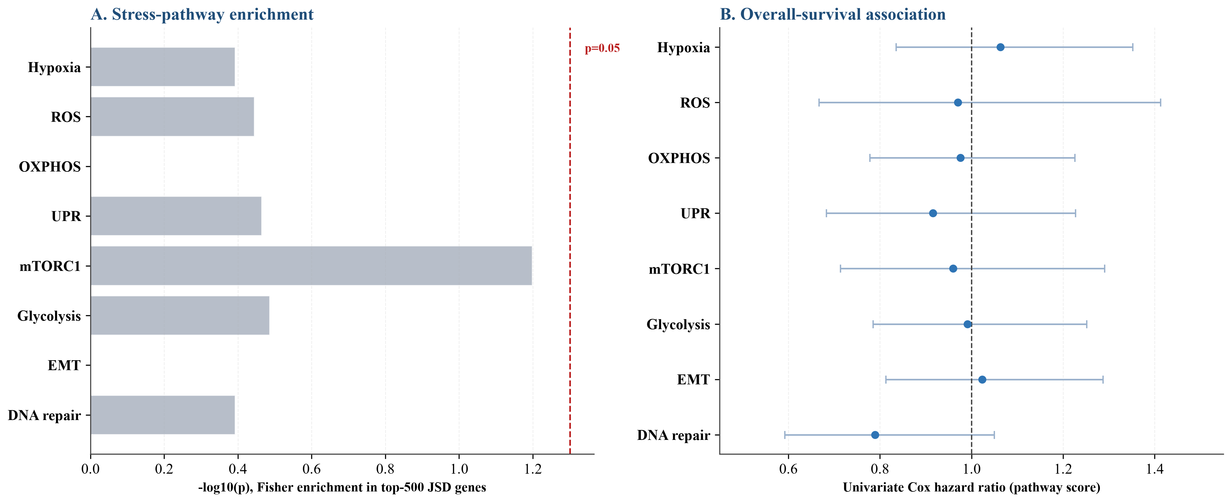
Figure S14. Stress / adaptive-reprogramming pathway analysis. A: Fisher enrichment (-log10 p) of eight pathways among the top-500 JSD genes; B: univariate Cox hazard ratios for overall survival. No pathway is significantly enriched or prognostic; error bars show 95% confidence intervals.

S17. PAM50 50 基因剔除敏感性分析
为验证 mRNA PAM50 任务的判别信号是否主要来自经典 PAM50 50 基因面板，本研究在 mRNA PAM50 的最终 400 个 JSD 排序特征上进行了剔除敏感性分析。三种配置分别为：Full 400 genes（完整 400 特征）、Exclude PAM50 genes（从 400 特征中删除与 PAM50 50 基因重叠的 21 个基因，剩 379 特征）和 PAM50 genes only（仅保留重叠的 21 个基因）。对每种配置重新计算 JSD 排序并生成对应尺寸的灰度图，采用 LogisticRegression、MLP 和 FullSizeCNN 在统一 5 折分层交叉验证下评估 Accuracy 与 Macro-F1。
Table S23. PAM50 50-gene exclusion sensitivity analysis for mRNA PAM50 (5-fold CV, mean±SD; features selected within each training fold)
Configuration | Model | Accuracy | Macro-F1
Full 400 genes | LogisticRegression | 0.9628±0.0167 | 0.9575±0.0199
Full 400 genes | MLP | 0.9183±0.0179 | 0.9023±0.0199
Full 400 genes | FullSizeCNN | 0.9316±0.0071 | 0.9205±0.0097
Exclude PAM50 genes (379 genes) | LogisticRegression | 0.9628±0.0138 | 0.9590±0.0185
Exclude PAM50 genes (379 genes) | MLP | 0.9232±0.0292 | 0.9065±0.0332
Exclude PAM50 genes (379 genes) | FullSizeCNN | 0.9171±0.0177 | 0.9068±0.0153
PAM50 genes only (21 genes) | LogisticRegression | 0.9220±0.0076 | 0.9134±0.0144
PAM50 genes only (21 genes) | MLP | 0.8980±0.0173 | 0.8864±0.0243
PAM50 genes only (21 genes) | FullSizeCNN | 0.9003±0.0169 | 0.8861±0.0186

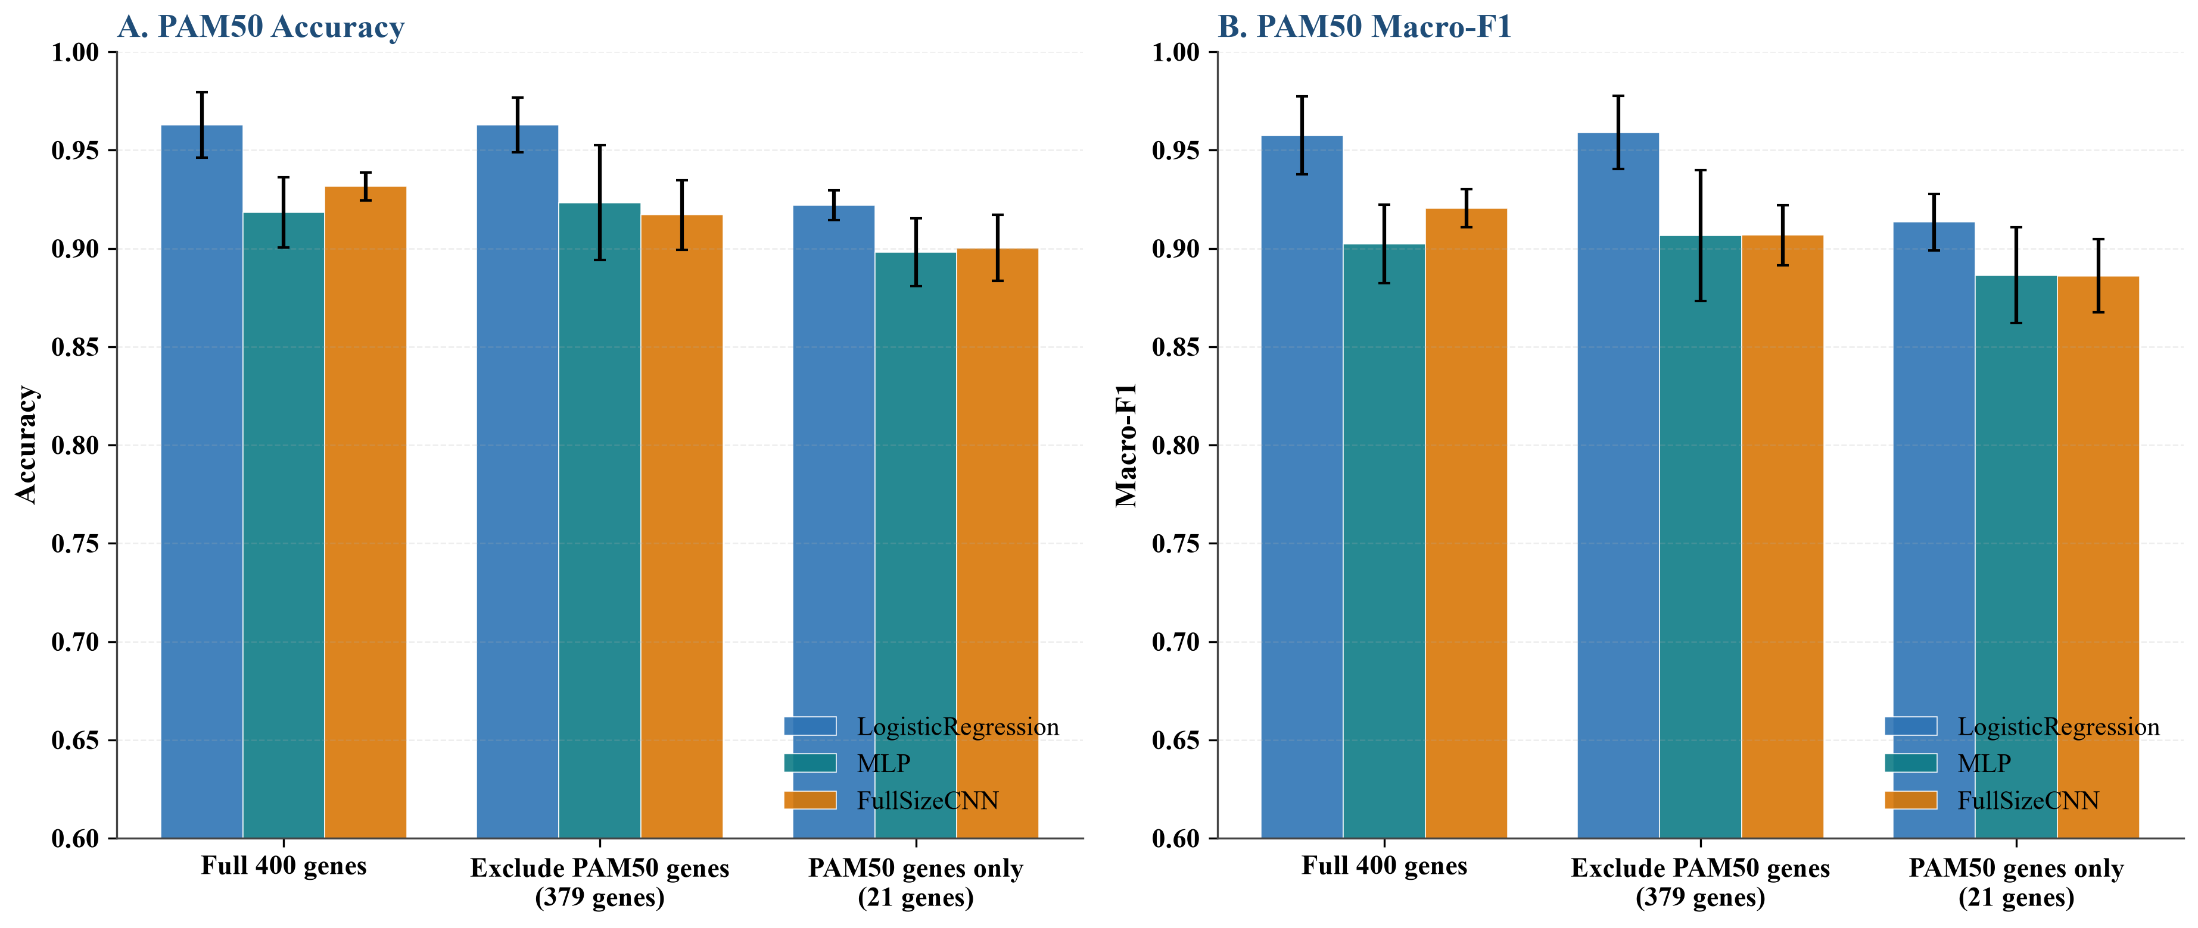
Figure S15. PAM50 50-gene exclusion sensitivity analysis. A: Accuracy; B: Macro-F1. Removing the 21 PAM50-overlapping genes barely changes performance, whereas the 21 PAM50 genes alone underperform the full 400-gene signature; error bars show 5-fold CV SD.

S18. 无泄漏嵌套交叉验证与严格 PAM50 排除
为检验特征数量选择与最终评估共用同一 5 折交叉验证可能带来的选择偏倚，本研究对 mRNA PAM50 增加了无泄漏嵌套交叉验证：外层 5-fold × 5 repeats，内层 3-fold 用于从候选特征数 {200, 400} 中选择，特征选择采用 VarianceThreshold + LinearSVC(L1)（V_L1），并按 JSD 排序生成 FullSizeCNN 图像。LogisticRegression、FullSizeCNN 和 Dense 等价基线均在外层测试折上评估。结果见 Table S24。
Table S24. Nested 5×5 cross-validation for mRNA PAM50 (inner 3-fold feature-number selection with V_L1; outer 5-fold × 5 repeats; mean±SD)
experiment | model | metric | mean | std
nested_cv_PAM50_mRNA | LogisticRegression | accuracy | 0.8392 | 0.0288
nested_cv_PAM50_mRNA | LogisticRegression | macro_f1 | 0.8196 | 0.0374
nested_cv_PAM50_mRNA | FullSizeCNN | accuracy | 0.8510 | 0.0282
nested_cv_PAM50_mRNA | FullSizeCNN | macro_f1 | 0.8310 | 0.0344
nested_cv_PAM50_mRNA | Dense | accuracy | 0.8449 | 0.0326
nested_cv_PAM50_mRNA | Dense | macro_f1 | 0.8204 | 0.0383

Table S25. Strict PAM50 exclusion from the full transcriptome followed by fold-level feature selection (ANOVA F, k=400) and LogisticRegression (5-fold CV, mean±SD)
experiment | config | metric | mean | std
strict_PAM50_exclusion | full_transcriptome | accuracy | 0.8246 | 0.0163
strict_PAM50_exclusion | full_transcriptome | macro_f1 | 0.8045 | 0.0181
strict_PAM50_exclusion | exclude_pam50_genes | accuracy | 0.8161 | 0.0226
strict_PAM50_exclusion | exclude_pam50_genes | macro_f1 | 0.7931 | 0.0249

S19. FullSizeCNN-Cox 生存对照
为提供严格时间到事件版本的图像模型对照，在 mRNA Survival 图像上保持 FullSizeCNN 图像 backbone，将最后输出替换为 Cox negative partial log-likelihood，并在 5 折分层交叉验证下评估。结果见 Table S26。
Table S26. FullSizeCNN-Cox on mRNA Survival images (5-fold CV, mean±SD)
experiment | model | metric | mean | std
FullSizeCNN_Cox | FullSizeCNN_Cox | roc_auc | 0.6611 | 0.0541
FullSizeCNN_Cox | FullSizeCNN_Cox | c_index | 0.6818 | 0.0401

S20. 统计稳健性与已有方法比较
为帮助解释 5 折配对检验的统计证据强度，对最优融合与最优单组学之间的折级均值差计算了效应量（Cohen's d）与近似 95% 置信区间。由于仅基于 5 个折级分数，这些值应视为描述性比较而非严格的等价性检验。
Table S27. Fold-level effect sizes and approximate 95% CIs for best-fusion vs best-single comparisons (n=5 folds; descriptive only)
task | metric | comparison | mean_difference | ci_lower | ci_upper | cohens_d | interpretation
PAM50 | accuracy | transformer vs mRNA_LR | 0.0000 | -0.0223 | 0.0223 | 0.0000 | non-significant; descriptive comparison only
PAM50 | macro_f1 | transformer vs mRNA_LR | 0.0104 | -0.0195 | 0.0403 | 0.4310 | non-significant; descriptive comparison only
Survival | roc_auc | late_fusion_avg vs mRNA_MLP | 0.0333 | -0.0480 | 0.1146 | 0.5080 | non-significant; descriptive comparison only
Survival | c_index | concat_mlp vs mRNA_FullSizeCNN | 0.0140 | -0.0614 | 0.0894 | 0.2300 | non-significant; descriptive comparison only

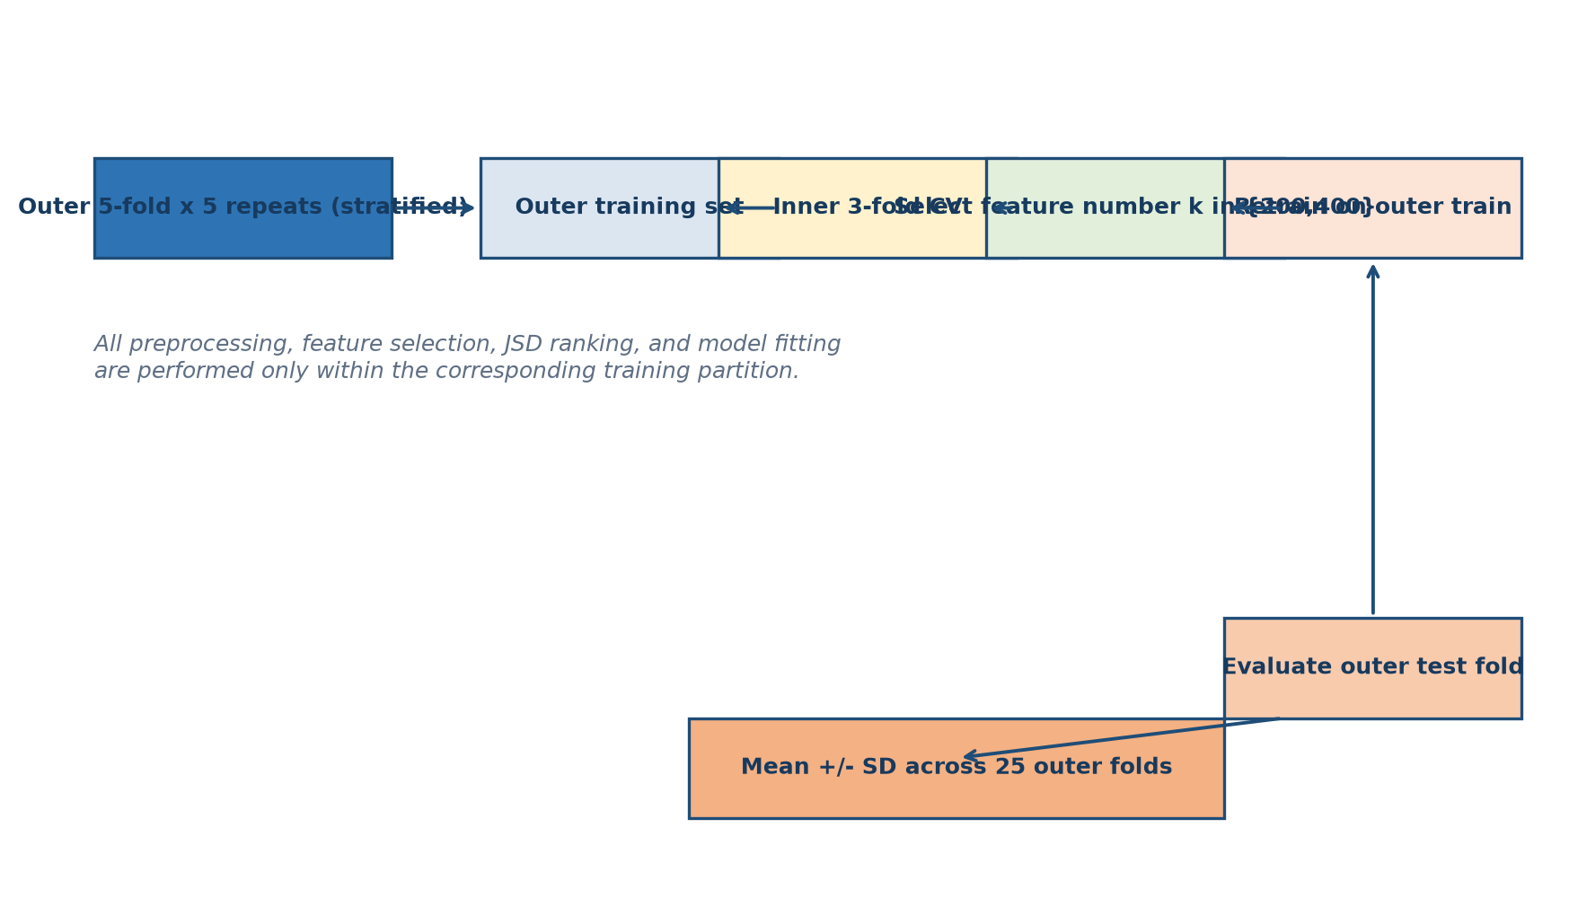
Figure S16. Nested repeated CV design. Outer 5-fold × 5 repeats are used for evaluation; inner 3-fold CV selects the feature number from {200, 400}. All preprocessing, feature selection, JSD ranking, and model fitting are performed only within the corresponding training partition.
Table S28. Comparison with representative omics-to-image and interpretable deep-learning methods. The current framework differs by supervised divergence-guided ordering, pixel-to-gene traceability, and systematic falsification controls.
Method | Supervision | Ordering | Traceable attribution | Dense control | Random-order control | Nested CV
DeepInsight | Unsupervised (t-SNE) | Data-driven 2-D projection | Indirect | No | No | No
DeepInsight-3D | Unsupervised | 3-D projection | Indirect | No | No | No
Yan et al. feature map | Task-related | Transcriptomic feature map | Partial | No | No | No
SurvConvMixer | Pathway-level | Pathway image | Partial | No | No | No
MoACNN-XGNet | Multi-omics | Interpretable multi-omics convolution | Partial | No | No | No
This study (JSD-FullSizeCNN) | Supervised JSD | Deterministic center-out spiral | Pixel-to-gene mapping | Yes | Yes | Yes

S21. METABRIC 外部单组学验证
为评估跨队列泛化能力，在无法获得完整 mRNA+CNV+miRNA 多组学外部队列的情况下，本研究使用 METABRIC 独立队列对 mRNA 和 CNV 单组学进行了外部验证。mRNA PAM50 模型保留中等判别能力，但生存风险排序能力较弱；CNV 单组学外部判别能力同样有限。结果见表 S29。
Table S29. METABRIC external single-omics validation for PAM50 and survival tasks (values are single external test-set estimates)
omics | task | model | metric | value
mRNA | PAM50 | LogisticRegression | accuracy | 0.7861
mRNA | PAM50 | LogisticRegression | macro_f1 | 0.7685
mRNA | PAM50 | LinearSVC | accuracy | 0.7786
mRNA | PAM50 | LinearSVC | macro_f1 | 0.7478
mRNA | PAM50 | RandomForest | accuracy | 0.7792
mRNA | PAM50 | RandomForest | macro_f1 | 0.7627
mRNA | PAM50 | MLP | accuracy | 0.7985
mRNA | PAM50 | MLP | macro_f1 | 0.7864
mRNA | Survival_death_status | LogisticRegression | accuracy | 0.4404
mRNA | Survival_death_status | LogisticRegression | balanced_accuracy | 0.4960
mRNA | Survival_death_status | LogisticRegression | roc_auc | 0.4726
mRNA | Survival_death_status | LogisticRegression | c_index | 0.5090
mRNA | Survival_death_status | MLP | accuracy | 0.4348
mRNA | Survival_death_status | MLP | balanced_accuracy | 0.5001
mRNA | Survival_death_status | MLP | roc_auc | 0.5222
mRNA | Survival_death_status | MLP | c_index | 0.5370
mRNA | Survival_risk_level | LogisticRegression | accuracy | 0.5303
mRNA | Survival_risk_level | LogisticRegression | balanced_accuracy | 0.5303
mRNA | Survival_risk_level | LogisticRegression | roc_auc | 0.5470
mRNA | Survival_risk_level | LogisticRegression | c_index | 0.5421
mRNA | Survival_risk_level | MLP | accuracy | 0.5197
mRNA | Survival_risk_level | MLP | balanced_accuracy | 0.5197
mRNA | Survival_risk_level | MLP | roc_auc | 0.5205
mRNA | Survival_risk_level | MLP | c_index | 0.5235
CNV | PAM50 | LogisticRegression | accuracy | 0.5914
CNV | PAM50 | LogisticRegression | macro_f1 | 0.5363
CNV | PAM50 | LinearSVC | accuracy | 0.5634
CNV | PAM50 | LinearSVC | macro_f1 | 0.4945
CNV | PAM50 | RandomForest | accuracy | 0.5802
CNV | PAM50 | RandomForest | macro_f1 | 0.5204
CNV | PAM50 | MLP | accuracy | 0.5871
CNV | PAM50 | MLP | macro_f1 | 0.5434
CNV | Survival_death_status | LogisticRegression | accuracy | 0.4518
CNV | Survival_death_status | LogisticRegression | balanced_accuracy | 0.5165
CNV | Survival_death_status | LogisticRegression | roc_auc | 0.5344
CNV | Survival_death_status | LogisticRegression | c_index | 0.5288
CNV | Survival_death_status | MLP | accuracy | 0.4604
CNV | Survival_death_status | MLP | balanced_accuracy | 0.5206
CNV | Survival_death_status | MLP | roc_auc | 0.4933
CNV | Survival_death_status | MLP | c_index | 0.4810
CNV | Survival_risk_level | LogisticRegression | accuracy | 0.4937
CNV | Survival_risk_level | LogisticRegression | balanced_accuracy | 0.4937
CNV | Survival_risk_level | LogisticRegression | roc_auc | 0.4994
CNV | Survival_risk_level | LogisticRegression | c_index | 0.4796
CNV | Survival_risk_level | MLP | accuracy | 0.5159
CNV | Survival_risk_level | MLP | balanced_accuracy | 0.5159
CNV | Survival_risk_level | MLP | roc_auc | 0.5152
CNV | Survival_risk_level | MLP | c_index | 0.5222

S22. 基因互作与网络重排分析
为考察基因互作关系是否能为图像化提供更贴近生物学的空间邻接，本研究在 PAM50 交集样本上构建了三类网络：mRNA 共表达网络、consensus-gene STRING PPI 网络，以及 miRNA–mRNA 负相关和 CNV–mRNA 相关的跨组学网络。根据共表达社区重新排列 mRNA 特征并生成 20×20 图像后，FullSizeCNN 的 Accuracy 为 0.8931，低于原始 JSD 螺旋排序，说明当前稀疏社区排序未带来预测增益，但可作为生物学邻接的补充表示。完整网络文件见 `data/gene_interaction/`。
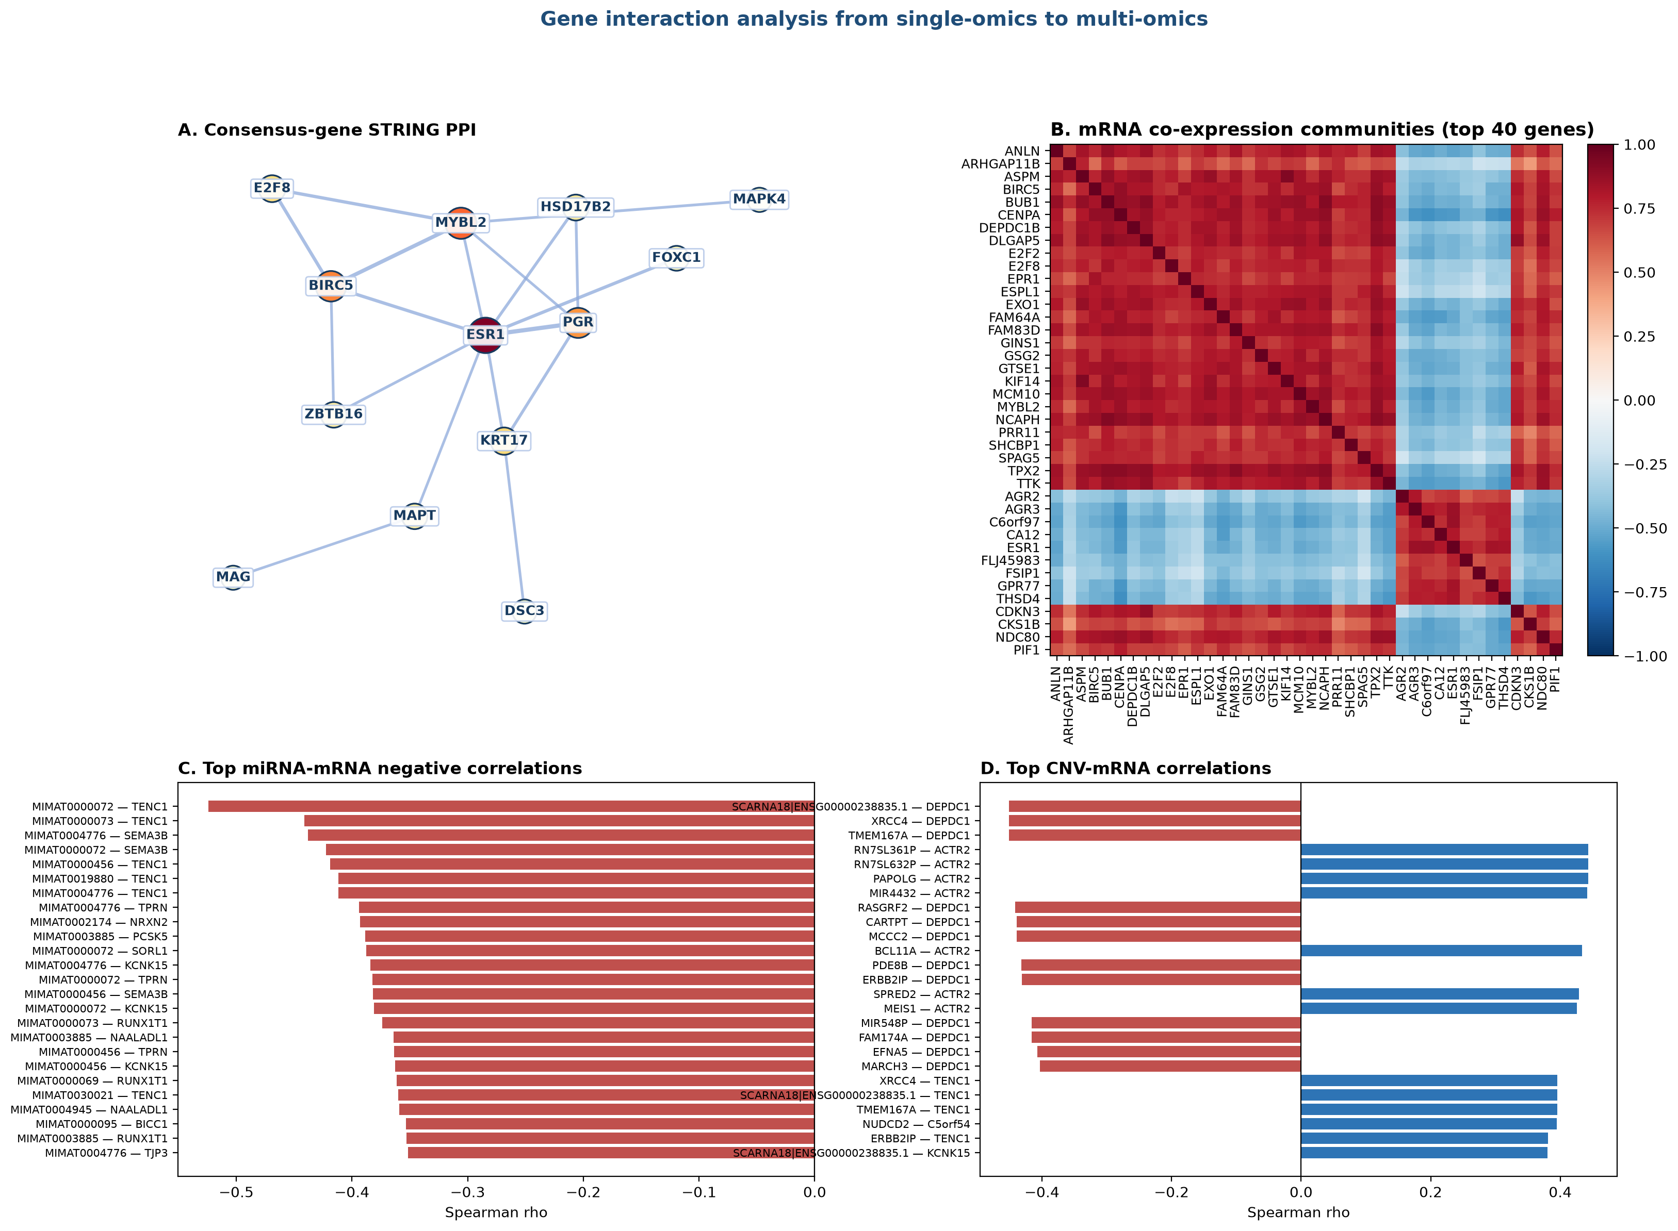
Figure S17. Gene interaction analysis overview. A: consensus-gene STRING PPI; B: mRNA co-expression communities; C: top miRNA-mRNA negative correlations; D: top CNV-mRNA correlations. A larger version is shown as Figure 10 in the main text.
Table S30. Community-informed mRNA image ordering vs original JSD spiral ordering for FullSizeCNN PAM50 (5-fold CV, mean±SD)
variant | task | metric | mean | std
original_jsd_spiral | PAM50 | accuracy | 0.9316 | 0.0071
original_jsd_spiral | PAM50 | macro_f1 | 0.9205 | 0.0097
community_reorder | PAM50 | accuracy | 0.8931 | 0.0351
community_reorder | PAM50 | macro_f1 | 0.8758 | 0.0328

S23. 数据与脚本文件
- data/final_datasets/PAM50/{mRNA,CNV,miRNA}_PAM50_final.tsv
- data/final_datasets/Survival/{mRNA,CNV,miRNA}_Survival_final.tsv
- data/images/PAM50/{mRNA,CNV,miRNA}/images.npy 及 order.tsv
- data/images/Survival/{mRNA,CNV,miRNA}/images.npy 及 order.tsv
- data/pam50_gene_exclusion_results.tsv
- data/dense_equivalent_baseline_results.tsv
- data/random_permutation_control_results.tsv
- data/random_permutation_control_stats.tsv
- data/stress_pathway_gene_sets.tsv
- data/stress_pathway_analysis_results.tsv
- data/omics_functional_category_annotation.tsv
- data/sample_level_provenance.tsv
- scripts/run_comprehensive_batch1_single_omics.py
- scripts/run_comprehensive_triple_integration.py
- scripts/run_comprehensive_pairwise_integration.py
- scripts/run_final_9model_stacking.py
- scripts/run_advanced_method*.py
- scripts/run_interpretability_key_factors.py
- scripts/run_scheme2_category_masking.py
- scripts/run_other_omics_category_masking.py
- scripts/run_mrna_equal_mask_control.py
- scripts/supplement_masking_analyses.py
- scripts/generate_jsd_images.py
- scripts/adaptive_jsd.py
- scripts/pam50_gene_exclusion_sensitivity.py
- scripts/run_dense_baseline.py
- scripts/run_random_permutation_control.py
- scripts/run_stress_pathway_analysis.py
- scripts/generate_annotation_mapping.py
- scripts/generate_sample_provenance.py
- data/nested_cv_pam50_mrna_results.tsv
- data/fullsize_cnn_cox_survival_results.tsv
- data/strict_pam50_exclusion_results.tsv
- scripts/run_additional_validation_experiments.py
为避免把大量结果表全部嵌入 Word，本补充材料仅保留关键汇总表与图示；全部 `data/**/*.tsv` 结果表已转换为 CSV 并打包为 `data/supplementary_data/supplementary_data_tables.zip`。压缩包内含 `manifest.tsv`，逐行记录源 TSV 的相对路径、对应 CSV 文件名、行数、列数与转换状态，作为机器可读结果的权威清单。读者可从 GitHub 仓库下载该压缩包逐项复核。
软件与库版本：Python 3.11、scikit-learn、PyTorch、lifelines、pandas、NumPy 和 matplotlib。主要计算库引用为 scikit-learn[S16]、PyTorch[S17] 与 lifelines[S18]。
复现时建议固定随机种子 42；所有特征筛选、标准化、数据增强和模型拟合均在交叉验证训练折内完成，测试折不参与任何预处理与参数选择。

S24. 补充材料参考文献
[S1] Grossman RL, Heath AP, Ferretti V, Varmus HE, Lowy DR, Kibbe WA, et al. Toward a Shared Vision for Cancer Genomic Data. N Engl J Med. 2016;375(12):1109-1112. doi:10.1056/NEJMp1607591. PMID:27653561.
[S2] Goldman MJ, Craft B, Hastie M, Repecka K, McDade F, Kamath A, et al. Visualizing and interpreting cancer genomics data via the Xena platform. Nat Biotechnol. 2020;38(6):675-678. doi:10.1038/s41587-020-0546-8. PMID:32444850.
[S3] Mermel CH, Schumacher SE, Hill B, Meyerson ML, Beroukhim R, Getz G. GISTIC2.0 facilitates sensitive and confident localization of the targets of focal somatic copy-number alteration in human cancers. Genome Biol. 2011;12(4):R41. doi:10.1186/gb-2011-12-4-r41. PMID:21527027.
[S4] Guyon I, Elisseeff A. An introduction to variable and feature selection. J Mach Learn Res. 2003;3:1157-1182.
[S5] Tibshirani R. Regression shrinkage and selection via the lasso. J R Stat Soc Series B Stat Methodol. 1996;58(1):267-288. doi:10.1111/j.2517-6161.1996.tb02080.x.
[S6] Goodfellow I, Pouget-Abadie J, Mirza M, Xu B, Warde-Farley D, Ozair S, et al. Generative adversarial nets. In: Advances in Neural Information Processing Systems. 2014;27:2672-2680. arXiv:1406.2661.
[S7] Arjovsky M, Chintala S, Bottou L. Wasserstein generative adversarial networks. In: Proceedings of the 34th International Conference on Machine Learning. PMLR. 2017;70:214-223.
[S8] Gulrajani I, Ahmed F, Arjovsky M, Dumoulin V, Courville A. Improved training of Wasserstein GANs. In: Advances in Neural Information Processing Systems. 2017:5767-5777. arXiv:1704.00028.
[S9] Simonyan K, Vedaldi A, Zisserman A. Deep inside convolutional networks: visualising image classification models and saliency maps. arXiv:1312.6034. 2014.
[S10] Selvaraju RR, Cogswell M, Das A, Vedantam R, Parikh D, Batra D. Grad-CAM: visual explanations from deep networks via gradient-based localization. In: Proceedings of the IEEE International Conference on Computer Vision. 2017:618-626. doi:10.1109/ICCV.2017.74.
[S11] Lundberg SM, Lee SI. A unified approach to interpreting model predictions. In: Advances in Neural Information Processing Systems. 2017;30:4765-4774. arXiv:1705.07874.
[S12] Kozomara A, Birgaoanu M, Griffiths-Jones S. miRBase: from microRNA sequences to function. Nucleic Acids Res. 2019;47(D1):D155-D162. doi:10.1093/nar/gky1141. PMID:30423142.
[S13] The Gene Ontology Consortium. The Gene Ontology knowledgebase in 2023. Genetics. 2023;224(1):iyad031. doi:10.1093/genetics/iyad031. PMID:36866529.
[S14] Kanehisa M, Furumichi M, Sato Y, Ishiguro-Watanabe M, Tanabe M. KEGG: integrating viruses and cellular organisms. Nucleic Acids Res. 2021;49(D1):D545-D551. doi:10.1093/nar/gkaa970. PMID:33125081.
[S15] Gillespie M, Jassal B, Stephan R, Milacic M, Rothfels K, Senff-Ribeiro A, et al. The reactome pathway knowledgebase 2022. Nucleic Acids Res. 2022;50(D1):D687-D692. doi:10.1093/nar/gkab1028. PMID:34788843.
[S16] Pedregosa F, Varoquaux G, Gramfort A, Michel V, Thirion B, Grisel O, et al. Scikit-learn: Machine Learning in Python. J Mach Learn Res. 2011;12:2825-2830.
[S17] Paszke A, Gross S, Massa F, Lerer A, Bradbury J, Chanan G, et al. PyTorch: an imperative style, high-performance deep learning library. In: Advances in Neural Information Processing Systems. 2019;32:8024-8035.
[S18] Davidson-Pilon C. lifelines: survival analysis in Python. J Open Source Softw. 2019;4(40):1317. doi:10.21105/joss.01317.

