Jensen–Shannon Divergence-Guided Omics Imaging for Interpretable Breast Cancer Subtype Reconstruction and Candidate Gene Prioritization
Hu Meng¹, Bingye Li¹, Zhihao Du¹, Zhixia Teng², Yongqiang Xing¹, Qing Yang¹, Guoqing Liu¹, Lu Cai^{1,*}
¹ Inner Mongolia Key Laboratory of Life Health and Bioinformatics, College of Life Science and Technology, Inner Mongolia University of Science and Technology, Baotou 014010, China
² College of Information and Computer Engineering, Northeast Forestry University, Harbin, China
* Correspondence:
Lu Cai
nmcailu@163.com

Simple Summary
Breast cancer varies a great deal from one patient to the next, so subtype and survival are hard to call from any single type of molecular data. We turned three types of data, messenger RNA, copy-number variation, and microRNA, into gray-scale pictures. Each gene is first scored by how well it separates the main breast-cancer subtypes, and the most informative genes are placed in the middle of the picture along a spiral; a convolutional neural network then reads the pictures. We compared the image-based approach with standard machine-learning methods on data from The Cancer Genome Atlas, and we checked the key findings in a separate cohort (METABRIC). Messenger RNA turned out to be the strongest signal for telling the four major subtypes apart. The pictures did not improve accuracy over plain tables of numbers; their real value is that they make it possible to trace which genes drive each prediction. That tracing surfaced candidate biomarkers such as ESR1 and CCL19, which are linked to hormone signaling, cell growth, and survival. In short, the method is a transparent way to prioritize candidate genes and biomarkers for follow-up work, not a shortcut to higher accuracy.

Abstract
Breast cancer is highly heterogeneous, and single-omics models cannot robustly capture PAM50 subtypes. We propose a supervised, Jensen–Shannon divergence (JSD)-guided omics imaging framework in which each feature is scored for discriminative importance, arranged by center-outward spiral filling into a single-channel grayscale image, and processed by a full-size convolutional network (FullSizeCNN). Using TCGA-BRCA mRNA, CNV, and miRNA under leak-free five-fold cross-validation, we benchmarked the representation against classical machine-learning and MLP models. mRNA dominated PAM50 subtype reconstruction (FullSizeCNN accuracy 0.869), whereas multi-omics fusion did not significantly exceed the best single omics, and survival prediction remained weak-to-moderate and is treated as an exploratory objective. Dense-equivalent and random-permutation controls showed that the two-dimensional layout adds no predictive gain, so the representation's value lies in interpretability rather than accuracy. The pixel-to-gene coordinate system recovered ESR1, TFF1, AGR3, FOXC1, MIA, FABP7, CCL19, and MS4A1 with stable cross-fold attribution, and enriched estrogen-signaling, proliferation, and epithelial-development programs; CCL19 and PGR retained significant survival associations after adjustment in METABRIC. The framework therefore provides a traceable, interpretable interface for candidate gene prioritization and follow-up validation.
Keywords: breast cancer; multi-omics; omics imaging; Jensen-Shannon divergence; PAM50; subtype reconstruction; biomarker discovery; candidate gene prioritization

Introduction
Breast cancer is among the most common malignancies in women. Its initiation, progression, and therapeutic response are governed by genetic, transcriptional, epigenetic, and microenvironmental layers, giving rise to marked molecular and clinical heterogeneity [1,2,3]. Intrinsic molecular subtyping based on gene expression classifies breast cancer into Luminal A, Luminal B, Basal-like, HER2-enriched, and Normal-like subtypes, and the PAM50 gene set has become a standard tool for molecular subtyping and recurrence-risk estimation [1]. Large-scale genomic studies have shown that the breast-cancer molecular landscape is shaped jointly by somatic mutations, copy-number variation (CNV), the transcriptome, and miRNAs [4,5], and reproducible molecular subgroups exist even within triple-negative and invasive lobular carcinomas [6,7]. Tumor progression and treatment failure are also shaped by stress responses and adaptive reprogramming: cancer cells co-opt oxidative, metabolic, proteotoxic, and replication-stress programs to survive treatment, and these programs can become candidate vulnerabilities [8,9]. Because overall survival (OS) directly reflects long-term outcome, simultaneously characterizing PAM50 subtypes and survival risk from multi-omics data has clear translational value.
The Cancer Genome Atlas (TCGA) and its Pan-Cancer Analysis Project provide large-scale, multi-platform, publicly available tumor molecular data, enabling systematic comparison of cross-omics patterns in breast and other cancers [4,10]. Multi-platform analyses have shown that tissue of origin and molecular subtype jointly determine global molecular features, whereas a single omics often captures only part of the signal [11]. Multi-omics integration is widely expected to fuse complementary information and has advanced cancer classification, prognostic modeling, and drug-response prediction [12,13]. Nevertheless, integration still faces high dimensionality, limited effective sample size, heterogeneous scales, missingness, and batch effects, which make interpretable and reproducible modeling difficult.
Feature selection helps control overfitting, lower computational cost, and make high-dimensional omics models easier to interpret [14]. Common approaches include variance- or univariate-statistic-based filters, LASSO/elastic-net embedded sparsity, mutual-information-based minimal-redundancy maximal-relevance (mRMR), and Boruta-style random-forest importance wrappers [15,16,17,18,19]. These methods screen features from the perspectives of stability, linear discrimination, information redundancy, and perturbation importance, but their applicability and the retained feature sets are not identical.
At the classical machine-learning level, logistic regression, support vector machines, random forests, gradient boosting, and k-nearest neighbors have been widely applied to genomic and clinical prediction [20,21,22], and remain baselines because of their interpretability, computational efficiency, and robustness on tabular data [23,24,25]. These methods usually take gene-expression or copy-number vectors directly as input and therefore cannot exploit spatial or network adjacency among features.
Deep learning has brought new representation-learning tools to biomedical data analysis [23,24,25]. Convolutional neural networks (CNNs) extract local features effectively, and architectures from LeNet and AlexNet to ResNet and Squeeze-and-Excitation Networks have successively improved capacity and generalization [26,27,28,29]; U-Net-style encoder-decoders are widely used in biomedical imaging [30]. Transformer and attention mechanisms further extend sequence and set modeling to multimodal scenarios [31]. Hybrid dilated, gated, and depthwise-separable convolutions have also been applied to single-base-resolution nucleosome-occupancy prediction, where convolution modules matched to the data scale and receptive field improve sequence modeling [32]. However, deep models are parameter-rich and data-hungry, and without a suitable input representation and strict leakage control they overfit on small-sample omics tasks.
Turning tabular omics data into images is one practical way to make convolutional networks usable on high-dimensional molecular features. DeepInsight maps non-image data onto a two-dimensional canvas so that a CNN can process gene-expression tables [33]; DeepInsight-3D extends this idea to multi-omics drug-response prediction [34]. Recent work also uses transcriptomic feature maps for cancer-type and survival prediction [35]. These studies show that, with a reasonable feature-mapping scheme, imaging can preserve raw values while introducing a spatial inductive bias; however, molecular features usually lack a pixel-like natural adjacency, so the ordering and filling scheme directly determine the biological meaning of each two-dimensional position.
Survival analysis underpins clinical prognostic modeling. The Cox proportional-hazards model provides a semiparametric risk framework [36], the C-index is a common measure of risk-ranking concordance [37], and the Uno C-statistic further accounts for censoring and overall risk-prediction adequacy [38]. Random survival forests and DeepSurv extend ensemble learning and deep networks to survival data [39,40], and decision-level multi-omics fusion has been used for breast-cancer overall-survival prediction [41].
Multi-omics fusion strategies have progressed from early feature concatenation, decision-level fusion, and stacking toward attention-based, low-rank bilinear, and graph-neural-network deep integration [12,13,41]. Generative adversarial networks (GANs) and their Wasserstein variants offer conditional augmentation for small-sample omics data, but test-set information leakage must be strictly controlled [42,43,44]. Few studies, however, have systematically compared how these fusion and augmentation strategies preserve sample alignment, feature-scale consistency, and model interpretability.
Interpretability is a prerequisite for translating omics predictors into clinical practice. Saliency maps, Grad-CAM, LIME, and SHAP explain model outputs from gradient, local-perturbation, or game-theoretic perspectives [45,46,47,48]. For image-based omics models, interpretability requires not only listing important genes but also mapping attended pixels back to the corresponding biological features, which further highlights the importance of the imaging ordering scheme.
To address these issues, we propose a Jensen-Shannon-divergence (JSD)-guided omics imaging framework. We first score the discriminative importance of each gene or probe with respect to the outcome classes, then fill the image by center-outward spiral ordering in descending JSD so that high-importance features are placed centrally. A full-size convolutional network (FullSizeCNN) serves as the imaging baseline and is compared with classical machine-learning models, an MLP, and classical CNN structures. The scheme retains the raw expression values while explicitly encoding discriminative importance in two dimensions, facilitating downstream key-factor localization.
We pose three research questions: (1) does JSD-guided spatial ordering produce a detectable predictive gain over random or expression-based ordering, and is its main value interpretability rather than performance; (2) can FullSizeCNN reach competitive performance against classical machine learning on small-sample omics tasks, with a dense-equivalent baseline separating the contribution of image structure from the raw feature values; and (3) does multi-omics fusion on a unified sample set provide a reproducible gain over the best single omics?
Our contributions are a JSD-guided center-spiral omics imaging framework; a systematic comparison of classical machine learning, MLP, FullSizeCNN, and several multi-omics fusion strategies, reported as mean and standard deviation under strict five-fold cross-validation; and key-factor visualization with SHAP, CNN saliency, and gene functional-category maps. The traceable gene-to-pixel interface supports candidate biomarker prioritization and candidate target nomination, and a Scheme 2 functional-category masking experiment with equal-size random-masking controls quantifies how much each functional module contributes to PAM50 classification and survival-risk modeling. Finally, we include an exploratory pathway-level analysis of representative stress-adaptive marker-gene signatures (Hypoxia, ROS, OXPHOS, UPR, mTORC1, Glycolysis, EMT, and DNA repair) to examine whether image-based key factors map onto known cancer biological programs.

Materials and Methods
This section describes only the core methods and parameters. Figure 1 shows the overall technical route and Table 1 summarizes sample sizes; the sample-level manifest is in Supplementary Table S1, feature-selection combinations in Table S2, and final feature counts in Table S3. Full single-omics results are in Table S4, intersection single-omics baselines in Table S5, triple-omics fusion in Table S6, pairwise fusion in Table S7, and stacking/complex methods in Tables S8-S9. Fusion statistical tests are in Table S10, imaging-structure comparisons in Tables S11-S13, the dense-equivalent baseline in Table S14 and Figure S3, and the random-permutation control in Table S15 and Figure S4. Interpretability figures are in Figures S5-S13, masking analyses in Tables S16-S21, the pathway-enrichment analysis in Table S22 and Figure S14, PAM50 50-gene exclusion in Table S23 and Figure S15, leak-free nested cross-validation in Table S24, strict PAM50 exclusion in Table S25, FullSizeCNN-Cox in Table S26, effect sizes in Table S27, method comparison in Table S28, METABRIC external validation in Table S29, gene-interaction analysis in S22, community reordering in Table S30, perturbation-fidelity evaluation in Table S31 and Figure S16, and METABRIC candidate-gene replication in Table S32.
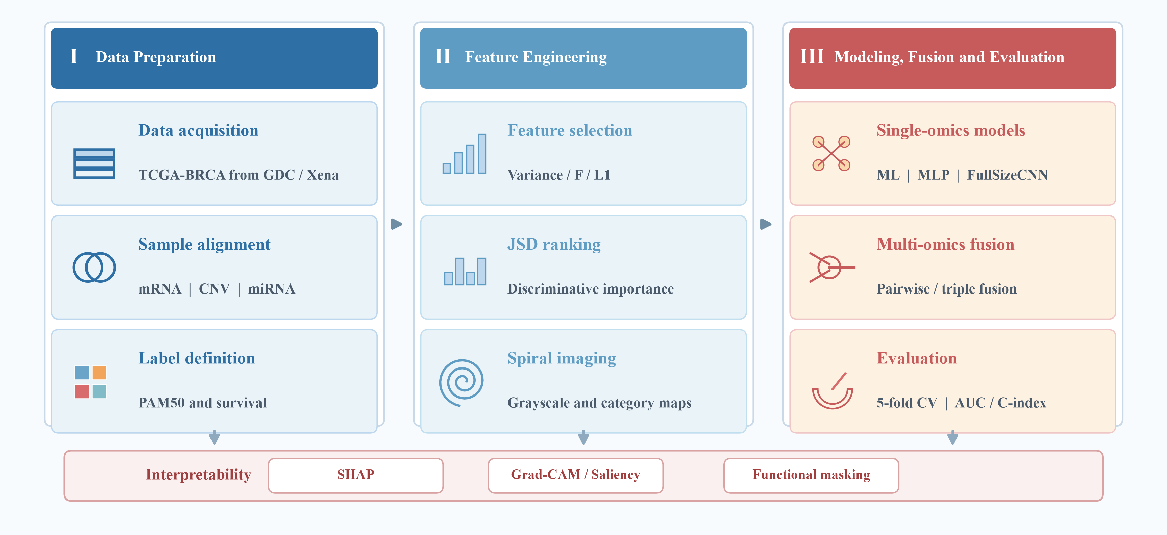
Figure 1. Overall technical route. The three phases are data preparation, feature engineering, and modeling/fusion/evaluation; SHAP, Grad-CAM/saliency, and functional masking are used as downstream interpretability modules.

Data sources and sample alignment
We used public TCGA-BRCA data from the Genomic Data Commons (GDC) and UCSC Xena. mRNA was the TCGA BRCA HiSeqV2 log2(RSEM+1) gene-expression matrix, CNV was analyzed under two encodings. The primary leak-free analyses used the Xena GISTIC2 thresholded gene-level calls (-2, -1, 0, +1, +2). As a sensitivity check, we also rebuilt gene-level copy-number states from GDC Gene Level Copy Number files (ASCAT2, ASCAT3, and ABSOLUTE LiftOver) with integer discretization (0→-2, 1→-1, 2→0, 3→+1, ≥4→+2; missing→0), which conflates unmeasured with normal copy number. The rebuilt integer matrix agreed with the GISTIC2 calls on 50.6% of overlapping entries (κ=0.257, Pearson r=0.565), and the two encodings gave consistent downstream results (see Results), and miRNA was the miRNA expression matrix. Clinical labels included PAM50 subtype, vital status, and survival time. Primary tumor samples were selected by TCGA patient barcode, the three omics were intersected, and the -01 primary tumor sample was preferred per case. All data are public and de-identified, so no new patient sampling was involved; per-omics and intersection sample sizes are in Supplementary Table S1.
After excluding Normal-like, the PAM50 task retained four main subtypes with 832 mRNA, 826 CNV, and 492 miRNA samples, and a 486-sample triple-omics intersection. The survival task had 1072 mRNA, 1067 CNV, and 734 miRNA samples, with a 725-sample triple-omics intersection. Pairwise intersections were: PAM50 mRNA∩CNV 825, mRNA∩miRNA 492, CNV∩miRNA 486; survival mRNA∩CNV 1064, mRNA∩miRNA 732, CNV∩miRNA 727.
Table 1. Sample sizes by omics and triple-omics intersection
Task | mRNA | CNV | miRNA | Triple-omics intersection
PAM50 | 832 | 826 | 492 | 486
Survival | 1072 | 1067 | 734 | 725

Label definition
PAM50 molecular subtype is a four-class label (Luminal A, Luminal B, Basal-like, HER2-enriched). For survival, the OS event is a binary label (1 = death, 0 = censored) and the time from diagnosis to death or last follow-up is used as the survival time. Because death events are a minority, the survival task is class-imbalanced. Across the 1,075-patient survival cohort, 149 deaths were observed (13.9% event rate) with a median follow-up of 860 days (2.35 years); median follow-up was 1,174 days for events and 773 days for censored patients.
Except for CoxPH, CoxNet, random survival forest, and DeepSurv, which are time-to-event models, all other models (LogisticRegression, SVC, RandomForest, MLP, FullSizeCNN, etc.) fit the OS event with binary cross-entropy and are therefore mortality-status classifiers; their output is used as a continuous risk score and combined with survival time to compute the C-index for survival-ranking evaluation. Hence, our 'survival-risk modeling' is not equivalent to strict hazard-rate modeling.

Feature selection and JSD
The primary analyses used leak-free five-fold cross-validation, with feature selection, scaling, JSD ordering, and image generation performed inside each training fold. An earlier cohort-level exploratory pipeline that pre-selected features and ordered images on the full cohort is retained for historical comparison only and is not used for the primary performance claims. Base feature-selection methods were low-variance filtering, ANOVA F, L1-regularized linear SVM, and Jensen-Shannon divergence (JSD) [49]. JSD compares binned histograms of a feature across classes and computes the symmetric information divergence between two discrete distributions. Leak-free nested repeated cross-validation (Supplementary Table S24) and strict PAM50-exclusion analyses (Supplementary Table S25) provide additional unbiased estimates.
Low-variance filtering first removes near-constant features; ANOVA F compares class means for continuous features; L1-regularized linear SVM feature selection uses the sparse coefficients of LinearSVC(penalty='l1', dual=False, C=0.1, max_iter=5000). Feature-selection combinations are listed in Supplementary Table S2.
Var(x_j) = (1/N) ∑_i (x_ij - x̄_j)²; F_j = MS_between / MS_within (1)
JSD is defined for the class histograms P and Q as D_JSD(P||Q) = 0.5 ∑_x [ P(x) log_2( 2P(x) / (P(x)+Q(x)) ) + Q(x) log_2( 2Q(x) / (P(x)+Q(x)) ) ]. Binary tasks compute the two-class JSD directly. For multi-class tasks the strategy is omics-specific: PAM50 mRNA and survival use average pairwise JSD, PAM50 CNV uses one-vs-rest max JSD, and PAM50 miRNA uses pairwise JSD coarse screening followed by L1 refinement. A small constant ε is added to histograms before probability normalization for numerical stability.
D_JSD(P||Q) = 0.5 ∑_x [ P(x) log_2( 2P(x) / (P(x)+Q(x)) ) + Q(x) log_2( 2Q(x) / (P(x)+Q(x)) ) ] (2)
Feature counts were compared at base values 200/50/200 and 2x, 3x, 4x, and 5x expansion. The final PAM50 feature counts were mRNA 400, CNV 50, and miRNA 600; the survival counts were mRNA 200, CNV 150, and miRNA 600. When Accuracy/Macro-F1 or ROC AUC/C-index was near-optimal, we preferred the more efficient and stable feature count; final counts and image sizes are in Table 2, with detail in Supplementary Table S3.
Because the main analysis selected feature numbers and evaluated final performance using the same five-fold cross-validation, the reported Accuracy, Macro-F1, ROC AUC, and C-index are exploratory cross-validation estimates and may carry feature-number selection bias. To quantify this, we ran leak-free nested repeated CV for the key mRNA PAM50 models: outer 5-fold x 5 repeats, inner 3-fold feature-number selection from {200, 400} with V_L1, and JSD ordering only within the training fold; see Supplementary Table S24.

Omics imaging
For each task and omics, we computed per-feature JSD scores and sorted them in descending order, then filled a square grid by center-outward spiral ordering so that the highest-importance features occupy the center and the next-highest follow the spiral outward. Positions beyond the feature count were zero-padded. The image is a single-channel grayscale map whose pixel values are the corresponding omics feature values; standardization parameters were estimated only on the training fold and applied to both training and test folds. Final image sizes were PAM50 mRNA 20x20, CNV 8x8, miRNA 25x25, and survival mRNA 15x15, CNV 13x13, miRNA 25x25.
To improve the biological meaning of pixel adjacency, Scheme 2 first groups features by functional category, sorts within each block by descending JSD, and fills blocks by their mean JSD from the center outward. mRNA and CNV categories came from gene functional annotations; miRNA was mapped by MIMAT to hsa-miR names and then assigned by family or known function. This yields a functional-category map aligned pixel-wise with the expression and JSD maps. The complete feature-to-category mapping, including source database identifiers (gene symbol, MIMAT, and category rules), is provided in the machine-readable file omics_functional_category_annotation.tsv, and CNV/miRNA categories are treated as heuristic annotations rather than mutually exclusive biological ontologies. Key hormone and proliferation genes are now assigned to their functional groups (e.g., ESR1/PGR to Hormone/Metabolism, E2F8/BIRC5 to Cell cycle/Proliferation, FOXC1/KRT to Development/Epithelium), and the annotation is provided as a multi-label GO:BP/Reactome table (mRNA_functional_category_annotation.tsv). The categories are intended as visualization-aided grouping rather than a strict biological module definition. In masking experiments, the target category pixels were set to zero, FullSizeCNN was retrained, and performance was compared with the unmasked baseline and equal-size random-gene masks.
Table 2. Final feature counts and JSD image sizes
Task | Omics | Final features | Image size | Zero-padded positions
PAM50 | mRNA | 400 | 20×20 | 0
PAM50 | CNV | 50 | 8×8 | 14
PAM50 | miRNA | 600 | 25×25 | 25
Survival | mRNA | 200 | 15×15 | 25
Survival | CNV | 150 | 13×13 | 19
Survival | miRNA | 600 | 25×25 | 25

Models
Classical baselines were LogisticRegression, RandomForest, GradientBoosting, linear SVC, KNN, and MLP, with CoxPH added for survival-risk modeling. LogisticRegression used L2 regularization with increased iterations; RandomForest used 200 trees; GradientBoosting used 100 rounds; SVC used a linear kernel; KNN used k=5; and MLP used 128-64 hidden units with dropout. CoxPH served as the conventional time-to-event comparator using a separately defined top-100 variance feature subset and a 0.1 penalty. For censoring-aware survival baselines, we additionally evaluated CoxNet (elastic-net-penalized Cox, l1_ratio=0.5) and random survival forest (200 trees) with the scikit-survival package [50], and computed cumulative/dynamic time-dependent AUC.
MLP and FullSizeCNN used the Adam optimizer (lr=1e-3, weight_decay=1e-4), 30 epochs, and batch size 64. PAM50 used cross-entropy with four-class output; survival-risk modeling used binary cross-entropy with a death-risk output. StandardScaler parameters were estimated only on the training fold and reused for the test fold.
FullSizeCNN takes an HxWx1 image and uses a full-size HxW kernel with 32 filters to produce 32 1x1 feature maps, which are flattened to a 32-dimensional vector. Single-omics tasks feed this vector through a 64-unit fully connected layer with ReLU and dropout to the classification logits or survival risk. For multi-omics integration, the three 32-dimensional descriptors are concatenated to 96 dimensions, reweighted by a softmax gated attention to 32 dimensions, and passed through a 32-to-64 fully connected head; probability late-averaging is an alternative. Figure 2 shows the FullSizeCNN structure (A) and representative omics image examples (B). The full-size kernel is mathematically equivalent to a flattened linear projection, so we regard FullSizeCNN as a full-field convolutional network that retains an image-coordinate interface for attribution rather than a sliding local-feature extractor. As architecture and ordering ablations, alternative functional-reordering schemes, classical full-size convolutional structures, and WGAN-GP-based training-set augmentation were also evaluated (Supplementary Tables S11–S13 and Figures S1–S2).
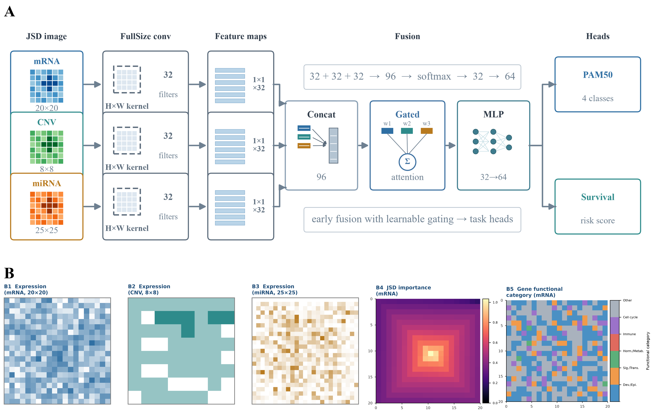
Figure 2. Omics image representation and the multi-omics FullSizeCNN. A: three JSD-ordered grayscale maps (mRNA 20×20, CNV 8×8, miRNA 25×25) are processed by full-size H×W convolutions with 32 filters into 32 global descriptors, concatenated (96), reweighted by a gated attention (32), and passed through a 32→64 MLP head feeding PAM50 and survival outputs. B: representative omics images (B1–B3 grayscale expression maps for mRNA, CNV, and miRNA; B4 JSD importance map; B5 gene functional category map). High-JSD features are placed centrally; survival image sizes are 15×15 / 13×13 / 25×25.
Multi-omics integration used three strategy families: (1) feature-level concatenation followed by classical ML/MLP; (2) independent FullSizeCNN branches followed by concatenation, gated-attention fusion, or probability late-averaging; and (3) complex strategies including nine-model stacking, Transformer cross-omics attention, DeepSurv, low-rank bilinear fusion, graph neural networks, and multi-task learning.
Key complex-method hyperparameters were: Transformer d_model=32, nhead=4, layers=2, dim_feedforward=64, dropout=0.1, with each omics projected to a 32-dimensional token and mean-pooled; low-rank bilinear rank r=8 with projection dimension d=32; GNN built on absolute Pearson correlation, top-k=40 neighbors per node with self-loops and symmetric normalization, and a two-layer GCN (1→32→32); nine-model stacking generated out-of-fold base-model predictions by inner five-fold stratified CV with LogisticRegression (max_iter=3000) as the meta-learner; WGAN-GP used 64-dimensional noise and 16-dimensional class embeddings, three discriminator updates per iteration, and gradient-penalty λ_GP=10; DeepSurv used negative log partial likelihood. All deep models used Adam (lr=1e-3, weight_decay=1e-4), no early stopping, and 30 epochs.

Evaluation and statistical tests
All models used five-fold cross-validation. Classification reported Accuracy and Macro-F1; survival reported ROC AUC and C-index. For LogisticRegression/RandomForest/SVC/KNN/MLP, predicted probability or decision function was used as the risk score; for CoxPH, the partial hazard was used. Paired t-tests and Wilcoxon signed-rank tests compared models on the same folds. All preprocessing, scaling, feature selection, and training were performed inside the training fold, and the test fold was used only for evaluation.
Accuracy is the proportion of correctly predicted samples; Macro-F1 averages per-class F1 arithmetically to reduce class-imbalance effects. ROC AUC uses the death-risk score as a continuous prediction against the binary event label. A larger risk score indicates higher death risk, and the C-index uses the negated risk score so that it measures the concordance between predicted risk ranking and true survival order.
C-index = P( R(x_i) > R(x_j) | T_i < T_j, δ_i = 1 ) (3)
Statistical tests compare paired per-fold scores to reduce between-fold variation; paired t-test and Wilcoxon p-values are reported with a significance threshold of 0.05.
Analyses used Python 3.11: scikit-learn for classical machine learning and cross-validation, PyTorch for MLP/FullSizeCNN/deep fusion, lifelines for CoxPH and C-index, and SHAP plus gradient saliency for interpretability. The random seed was fixed to 42.
Note: unless stated otherwise, all tables and figures report 5-fold cross-validation mean ± SD based on features selected within each training fold (leak-free) before cross-validation; the leak-free nested repeated CV (Supplementary Table S24) and strict PAM50-exclusion analysis (Supplementary Table S25) provide the unbiased estimates. PAM50 four-class classification reports Accuracy and Macro-F1; survival-risk modeling reports ROC AUC and Cox C-index. ROC AUC is computed from the predicted death-risk probability or risk score; C-index is computed with lifelines.utils.concordance_index from the same risk score, survival time, and event indicator.

Gene interactions and network reordering
To examine whether gene-interaction structure can provide a more biologically meaningful spatial adjacency, we built three networks on the PAM50 intersection samples: an mRNA co-expression network, a consensus-gene STRING PPI network, and miRNA-mRNA negative and CNV-mRNA correlation networks. The mRNA co-expression network used Pearson correlation with an edge threshold |r|>=0.75; this conservative threshold yields sparse communities, so the network should be read as high-confidence edges rather than a final biological module definition. PPI used STRING high-confidence edges [51], and cross-omics correlations used Spearman correlation keeping the strongest candidate edges. We then reordered mRNA features by co-expression communities into the same 20x20 image and compared FullSizeCNN under five-fold cross-validation.

Results
The main text shows representative results; complete per-model, per-fold means and standard deviations are in Supplementary Tables S4-S30. Results are reported in three tiers: (i) primary leak-free estimates, in which feature selection, scaling, and JSD ordering are performed inside each training fold; (ii) nested cross-validation estimates, which additionally guard against feature-number selection bias; and (iii) exploratory cohort-level analyses, which pre-select features on the full cohort and are used only for interpretability, masking, and sensitivity checks. Primary conclusions rely on the first two tiers.

Omics image examples
Figure 2B shows representative omics image examples. The grayscale expression maps (B1–B3) show the mRNA, CNV, and miRNA images at their respective sizes, the JSD importance map (B4) encodes discriminative importance derived from class-distribution differences in the training data, and the gene functional category map (B5) aligns pixel-wise with the expression and JSD maps so that attended regions can be translated into biological interpretation.

Single-omics prediction
Table 3 summarizes the best model per task and Figure 3A shows all compared models as mean ± SD under leak-free five-fold cross-validation (feature selection, scaling, and JSD ordering inside each fold). mRNA was the strongest signal for PAM50 subtype reconstruction, followed by miRNA and then CNV. For mRNA PAM50, FullSizeCNN reached per-class F1 of 0.926 (Basal-like), 0.791 (HER2-enriched), 0.900 (Luminal A), and 0.787 (Luminal B), and LogisticRegression reached 0.925, 0.744, 0.862, and 0.689 for the same classes; Luminal A and Luminal B were the most frequently confused classes, followed by Basal-like and HER2-enriched (Supplementary Table S4b). Single-omics survival models showed weak-to-moderate discrimination, ranging from near-chance for CNV (C-index down to ~0.50) to 0.656 for miRNA random survival forest.
Table 3. Overall best single-omics models on full samples (5-fold CV, mean±SD; features selected within each training fold (leak-free)). The survival C-index shown is from the main single-omics baselines (CoxPH); censoring-aware survival models (CoxNet, random survival forest) are reported separately, with miRNA random survival forest reaching C-index 0.6563. Per-omics and per-model detail is in Supplementary Table S4.
Task | Metric | Best model | Mean | Std
PAM50 | accuracy | mRNA FullSizeCNN | 0.8690 | 0.0169
PAM50 | macro_f1 | mRNA FullSizeCNN | 0.8508 | 0.0170
Survival | roc_auc | miRNA Dense | 0.6452 | 0.0251
Survival | c_index | miRNA CoxPH | 0.6236 | 0.0469

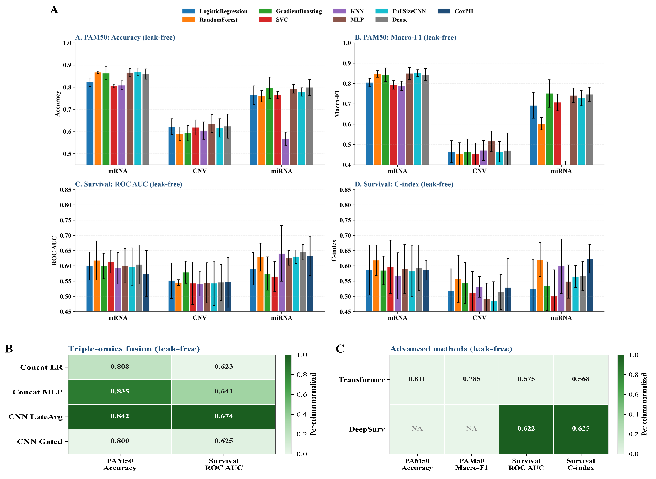
Figure 3. Prediction performance under leak-free five-fold cross-validation (feature selection and JSD ordering inside each training fold). A: single-omics prediction on full samples (PAM50 Accuracy and Macro-F1; survival ROC AUC and C-index; PAM50 sample sizes mRNA 832, CNV 826, miRNA 492; survival mRNA 1072, CNV 1067, miRNA 734). B: triple-omics fusion performance as a heatmap (fusion schemes × PAM50 Accuracy and Survival ROC AUC; PAM50 n=486, survival n=725). C: advanced integration methods as a heatmap (Transformer and DeepSurv × PAM50 Accuracy/Macro-F1 and Survival ROC AUC/C-index; DeepSurv has no PAM50 output). Heatmap colors are normalized per column, and cells show the 5-fold CV mean; SD is reported in Supplementary Tables S6 and S9.

Multi-omics integration
On the 486-sample triple-omics intersection, the best leak-free PAM50 fusion was CNN late-average (Accuracy 0.8415±0.0327), followed by Concat MLP (0.8353±0.0316) and Concat LogisticRegression (0.8085±0.0653); gated attention was lower (0.8003±0.0539). These did not exceed the best intersection single-omics mRNA RandomForest (0.8519±0.0285).
For survival-risk modeling, CNN late-average fusion reached ROC AUC 0.6742±0.0385, numerically above the best single-omics model on the same intersection (miRNA RandomForest, 0.6634±0.0909); Concat MLP reached 0.6410±0.0504, while gated attention (0.6255±0.0399) and Concat LogisticRegression (0.6234±0.0382) were lower. The survival gain over the best single omics was small and not statistically significant (see the paired tests below).
Figure 3B summarizes the triple-omics fusion performance across all schemes and metrics.

Pairwise, stacking, and complex methods
Pairwise fusion and nine-model stacking were recomputed under the same leak-free five-fold cross-validation (feature selection, scaling, and JSD ordering inside each training fold), each on its own sample intersection. For PAM50, pairwise fusion was comparable to the best single omics: mRNA+CNV CNN late-average reached Accuracy 0.8667±0.0184 (n=825), mRNA+miRNA CNN late-average 0.8414±0.0537 (n=492), and CNV+miRNA Concat LogisticRegression 0.7879±0.0464 (n=486). For survival-risk modeling, pairwise CNN late-average reached ROC AUC 0.6608±0.0497 (CNV+miRNA, n=727) and 0.6342±0.0704 (mRNA+miRNA, n=732). Nine-model stacking reached PAM50 Accuracy 0.8518±0.0339 (Macro-F1 0.8218±0.0270) and survival ROC AUC 0.6683±0.0435 (C-index 0.6100±0.0561) on the triple-omics intersection. Paired tests on the same folds found no significant advantage of stacking over the best single omics or the simple triple-omics fusion (PAM50 stacking versus mRNA RandomForest p=0.995, versus CNN late-average p=0.090; survival stacking versus CNN late-average p=0.507, versus miRNA RandomForest p=0.931). Pairwise and nine-model stacking results are detailed in Supplementary Tables S7 and S8.
Under leak-free evaluation, Transformer reached PAM50 Accuracy 0.8106±0.0476 (Macro-F1 0.7854±0.0440) and survival C-index 0.5677±0.0649, below the simple CNN late-average fusion; DeepSurv reached survival ROC AUC 0.6222±0.0625 (C-index 0.6252±0.0569). Multi-task, low-rank bilinear, and GNN were evaluated in the exploratory setting only and are reported in Supplementary Table S9. Figure 3C summarizes the leak-free advanced-method results.

Statistical tests
Paired tests between the best fusion and the best intersection single-omics on the same folds and the same 486/725 patients are in Supplementary Table S10. The best single-omics model was selected as the highest mean metric among single-omics models on the same intersection (mRNA RandomForest for PAM50 Accuracy; miRNA RandomForest for Survival ROC AUC). For PAM50, CNN late-average fusion versus mRNA RandomForest had an Accuracy difference of -0.0104 (paired t p=0.6531, Wilcoxon p=0.6250), and Concat MLP versus mRNA RandomForest had a difference of -0.0166 (p=0.5412, Wilcoxon p=0.6250). For survival, CNN late-average fusion versus miRNA RandomForest had a ROC AUC difference of +0.0107 (paired t p=0.8519, Wilcoxon p=1.0000), and Concat MLP versus miRNA RandomForest had a difference of -0.0224 (p=0.6333, Wilcoxon p=0.8125). Thus no fusion strategy reached a statistically significant advantage over the best single-omics counterpart at the 0.05 threshold.

Interpretability and key factors
SHAP used the LinearExplainer of the scikit-learn LogisticRegression with all training-fold samples as background; CNN saliency aggregated input gradients across the five folds; and functional enrichment used the full mRNA transcriptome as the background universe through g:Profiler GO/KEGG/Reactome [52] with its default multiple-testing correction. For the imaging pipeline, each pixel was first mapped back to its gene through the image order file, and attribution was then aggregated at the gene level, so fold-level attributions were never averaged across pixels encoding different genes. The interpretability analyses used a single cohort-level JSD ordering and are therefore exploratory.
SHAP for mRNA PAM50 LogisticRegression highlighted CYP2B7P1, TFF1, C1orf64, AGR3, KCNJ3, MIA, PPP1R14C, ESR1, and STAC2. Consensus genes between CNN saliency and SHAP included TCAM1P, MIA, SMC1B, PPP1R14C, KLK6, SLC6A11, FABP7, and FOXC1. Univariate survival Cox identified MS4A1, COL17A1, C2orf40, PLA2G2D, FABP7, CCL19, and GZMB. The top-20 SHAP genes appeared in the top-100 importance ranking in all five folds (fold frequency 5/5), indicating stable cross-fold attribution; pathway enrichment indicated targetable estrogen signaling, proliferation, cell division, and epithelial development. These stable, traceable factors constitute candidate biomarkers and candidate targets to be validated. The SHAP, saliency, consensus, survival-Cox, and enrichment figures are Supplementary Figures S5-S9.
Figure 4A shows how the JSD imaging scheme aligns model attribution (SHAP importance, CNN saliency, and the expression–saliency overlay) in one coordinate system, so that attributions can be localized to gene pixels rather than emitted only as a table. Detailed SHAP, saliency, consensus-gene, hazard-ratio, and enrichment rankings are in Supplementary Figures S5–S9.

Functional-category masking
To assess how different functional regions contribute, we masked functional categories on the Scheme 2 images. Unlike the original global JSD ordering, Scheme 2 groups features by category, sorts within blocks by JSD, and fills blocks by mean importance from the center outward, so each color region corresponds to one functional module and the center holds high-JSD modules. Figure 4B shows the masking workflow; the complete workflow and per-omics masking performance are in Supplementary Figures S10–S13.
These masking analyses use cohort-level pre-selected features and JSD ordering and are therefore exploratory; accordingly, the mRNA PAM50 baseline Accuracy reported here (0.9244) is higher than the leak-free full-sample estimate (0.8690). For mRNA, PAM50 baseline Accuracy was 0.9244±0.0124 and Macro-F1 0.9069±0.0133; masking Other reduced Macro-F1 to 0.8819±0.0210. mRNA survival baseline C-index was 0.6984±0.0756 and fell to 0.6757±0.0715 after masking Other. CNV and miRNA likewise showed the largest drop after masking Other, but because Other has the most features, the drop also reflects module size. Figure 4C shows the masking delta heatmap for mRNA, CNV, and miRNA; mRNA results are in Supplementary Table S16 and CNV/miRNA in Table S17.
To separate functional-module specificity from feature-set size, we added equal-size random-gene masks for each mRNA category. The functional-category mask did not consistently outperform the equal-size random mask in most comparisons. Re-enrichment of mRNA PAM50 Other genes still showed epithelial-cell differentiation, epithelial and tissue development, estrogen signaling, and cell-population proliferation. The Top50 consensus genes between SHAP and saliency fell mainly into Development/Epithelium and Other, followed by Cell cycle/Proliferation, Signaling/Transport, and Hormone/Metabolism. Fold-level metrics are in Supplementary Table S18, paired tests in Table S19, Other re-enrichment in Table S20, and consensus overlap in Table S21.
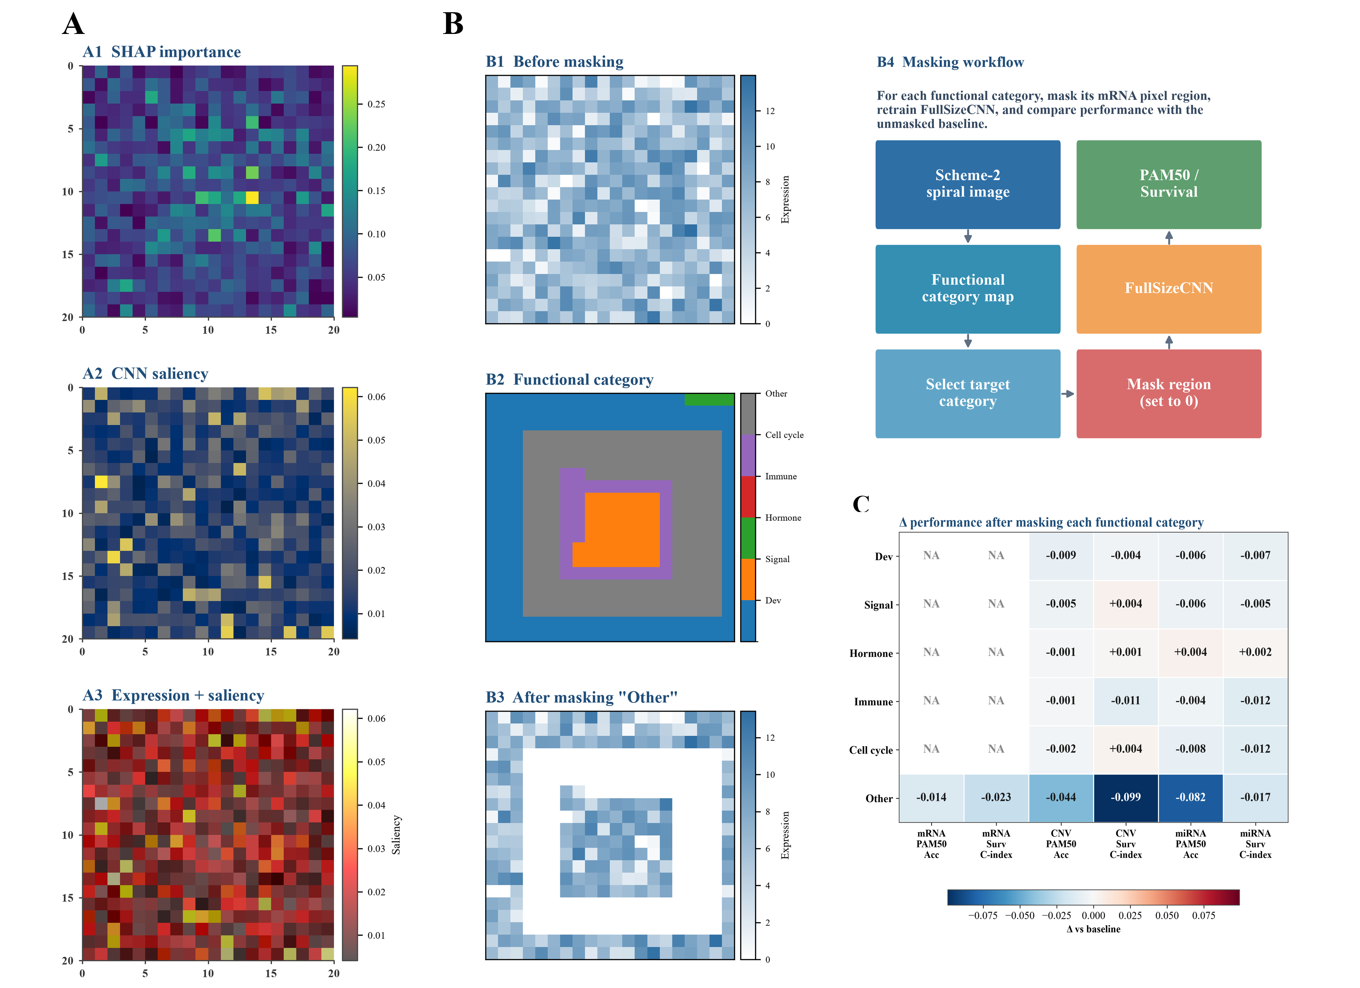
Figure 4. Interpretability and functional-category masking. A: mRNA PAM50 attribution maps (A1 SHAP importance, A2 CNN saliency, A3 expression–saliency overlay). B: Scheme 2 masking workflow (B1 before masking, B2 functional category map, B3 after masking; B4 flow diagram). C: functional-category masking delta heatmap for mRNA, CNV, and miRNA (red, decrease; blue, increase). Masking analyses use cohort-level pre-selected features (exploratory); 5-fold cross-validation SD is reported in Supplementary Tables S16–S17.

Gene interactions and network reordering
The consensus-gene STRING PPI mainly involved ESR1, PGR, MYBL2, BIRC5, and E2F8, coupling hormonal signaling to proliferation and mitosis; because only high-confidence edges were kept, these PPI results should be treated as exploratory. The mRNA co-expression network formed sparse communities at the conservative threshold, and cross-omics analyses identified candidate miRNA-mRNA negative and CNV-mRNA correlations. Reordering the mRNA image by co-expression communities gave FullSizeCNN Accuracy 0.8931, below the original JSD spiral ordering, indicating that biological adjacency adds interpretability context but not predictive gain here. Figure 5 summarizes the gene-interaction analyses; full network files are in Supplementary S22, with the community comparison in Table S30.
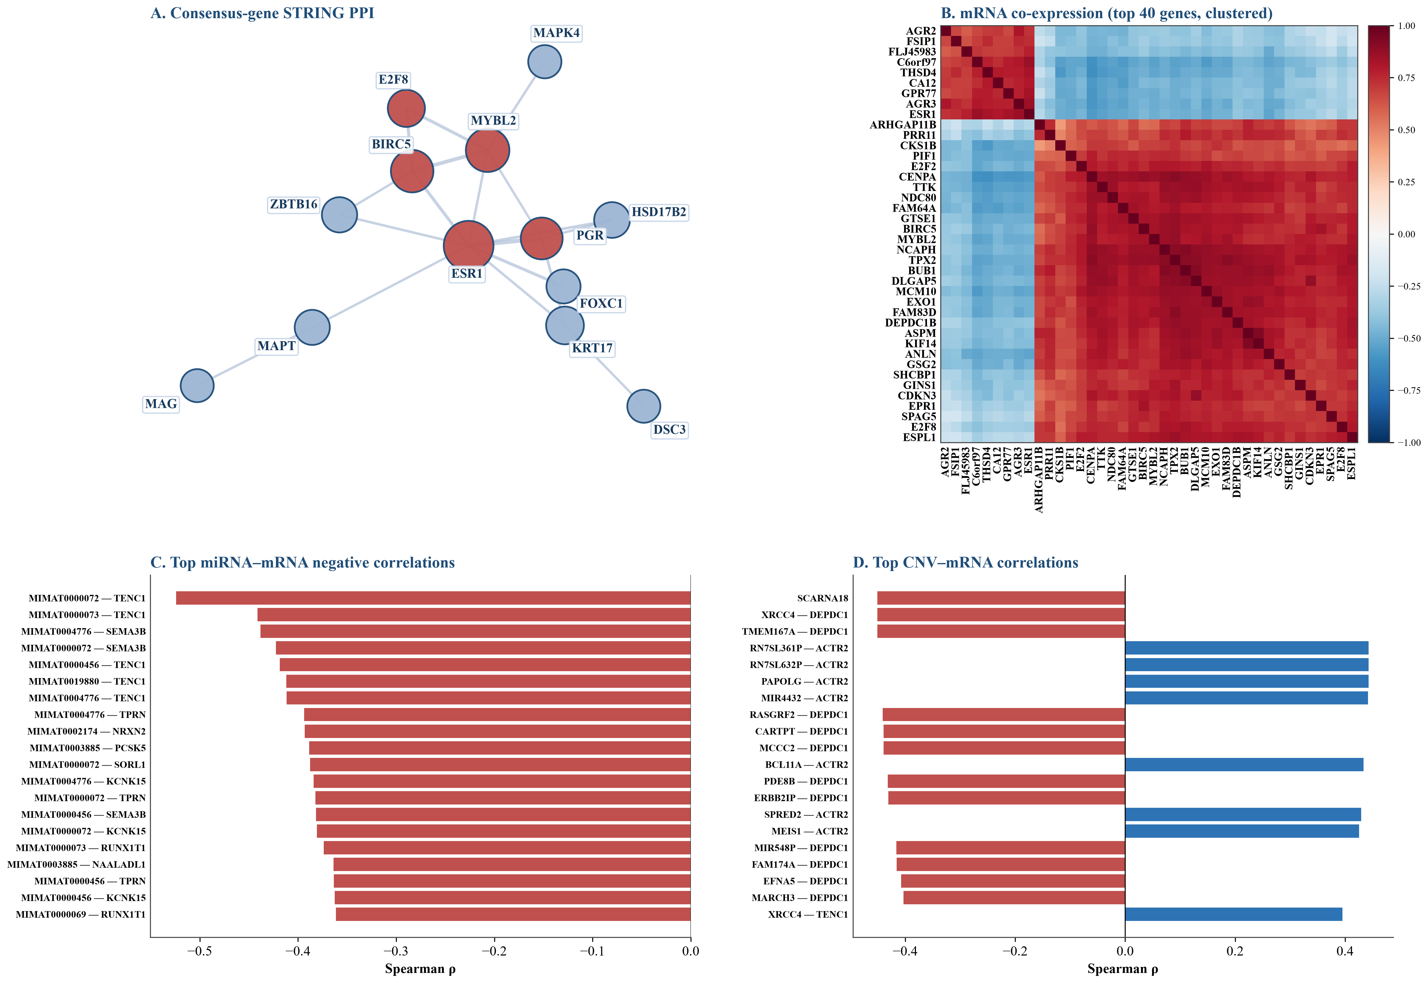
Figure 5. Gene interaction analysis. A: consensus-gene STRING PPI (hub genes ESR1, PGR, MYBL2, BIRC5, E2F8 in red); B: mRNA co-expression of the top 40 genes, hierarchically clustered; C: top 20 miRNA-mRNA negative correlations; D: top 20 CNV-mRNA correlations. The community-informed ordering is compared with the JSD spiral ordering in Supplementary Table S30.

Discussion
mRNA was the dominant signal source for PAM50 subtype reconstruction: its leak-free FullSizeCNN reached 0.8690±0.0169 Accuracy, with LogisticRegression lower (0.8221±0.0186). CNV alone had limited discriminative power (MLP 0.6354±0.0410), and its survival discrimination was near chance. Re-running the CNV analyses with the rebuilt integer-discretized matrix gave results consistent with the GISTIC2-based primary analysis (PAM50 accuracy 0.58-0.64 and survival C-index near 0.5 under both encodings), indicating that the weak CNV signal reflects biology rather than a preprocessing artifact. miRNA had the smallest sample size and intermediate single-omics performance.
To separate PAM50 subtype prediction from PAM50-gene-panel reconstruction, we removed the 21 genes overlapping the canonical PAM50 50-gene set from the final 400 JSD-ranked mRNA features (exploratory estimate on the cohort-level feature set): LogisticRegression five-fold Accuracy was largely unchanged, and using only those 21 genes markedly reduced performance. The strict version from the full transcriptome with fold-internal selection is in Supplementary Table S25. The discriminative information in the JSD-selected mRNA set therefore comes from a broader transcriptomic signal rather than the 50-gene panel, so the mRNA PAM50 task should be read as subtype reconstruction.
Multi-omics fusion added little for PAM50 because mRNA is already highly discriminative and other omics tend to inject noise under high dimensionality and small samples. For survival-risk modeling, CNN late-average fusion modestly exceeded the best single omics (ROC AUC 0.6742 versus 0.6634), indicating some complementarity, but the gain was small relative to the cross-validation standard deviation and was not formally significant.
JSD imaging offers interpretability rather than the highest accuracy. By placing high-JSD genes centrally and drawing functional-category and saliency maps together, the attended convolutional regions map intuitively to key genes and pathways. This traceable, pixel-to-gene coordinate system is the core contribution, because it lets a reader move from a model-attended region directly to a biological entity. For candidate biomarker prioritization and target nomination, the stable, traceable factors (ESR1, PGR, FOXC1, MYBL2, BIRC5, TFF1, AGR3, and others) point to estrogen signaling, proliferation, and epithelial differentiation as candidate actionable modules. This matches the goal of integrative multi-omics computation: to nominate biomarkers and targets for further experimental validation. A perturbation-fidelity control quantified this: for mRNA PAM50, JSD ordering gave a lower deletion AUC than random ordering (LogisticRegression 0.651 vs 0.666, paired t p=0.107; FullSizeCNN 0.776 vs 0.789, paired t p=0.022), whereas model-native attributions were the most faithful (SHAP 0.611; saliency 0.674). With only five fold-level observations this evidence is suggestive rather than definitive, and it confirms that imaging's value is the traceable coordinate system rather than superior attribution accuracy (Figure S16, Table S31). Independent METABRIC replication further supported these candidates: ESR1, TFF1, AGR3, and PGR remained strongly Luminal-enriched and FOXC1, MIA, and FABP7 remained Basal-enriched, while CCL19 (HR 0.85, p=4.2e-6), PGR (HR 0.87, p=1.8e-6), BIRC5 (HR 1.13, p=3.4e-5), and E2F8 (HR 1.08, p=6.8e-3) showed univariable survival associations that survived BH-FDR correction; after adjustment for age, Nottingham Prognostic Index, and subtype, CCL19 (HR 0.89, p=1.0e-3) and PGR (HR 0.93, p=2.2e-2) remained significant, whereas BIRC5 and E2F8 did not. These are independent univariable (and partly multivariable) associations rather than proof of clinical independent prognostic value, supporting candidate biomarker prioritization rather than novel target discovery (Table S32). We therefore distinguish four concepts: feature ranking (JSD ordering), attribution fidelity (SHAP and saliency deletion tests), biomarker association (univariable and multivariable Cox models), and therapeutic target validation (functional experiments); the present evidence supports the first three, whereas target validation is not claimed.
To test whether the two-dimensional structure itself adds anything, we trained a dense-equivalent baseline (Flatten→Dense(32)→Dense(64)→output) with the same first-layer parameter count as the full-size kernel. The dense baseline was comparable to FullSizeCNN under leak-free evaluation (PAM50 mRNA 0.8593 versus 0.8690; CNV 0.6238 versus 0.6162; miRNA 0.7989 versus 0.7785) and was similar on survival C-index. The discriminative information therefore comes mainly from the raw feature values, not from the imposed two-dimensional adjacency; the imaging interface mainly supports attribution. This parity also held externally: on METABRIC (n=1608, 342 genes shared with the TCGA feature set), the mRNA FullSizeCNN reached PAM50 accuracy 0.8203 and macro-F1 0.8099, comparable to the Dense control (0.8165 / 0.8034) and above LogisticRegression (0.7917 / 0.7735), showing that the image-based model generalizes to an independent cohort without the 2-D layout being responsible for the accuracy.
(This random-permutation control was run on the cohort-level 400-feature set and is therefore exploratory.) As a direct test of the ordering hypothesis, we compared JSD spiral ordering with 20 random gene orders on mRNA. JSD did not outperform random ordering: PAM50 Accuracy was 0.9316 for JSD versus a random mean of 0.9267 (range 0.9112-0.9400, empirical p=0.25), and survival C-index was 0.7125 versus 0.7055 (empirical p=0.35). Mean-expression ordering matched JSD on PAM50 Accuracy (0.9316). Pixel position therefore carries almost no predictive information, and we position imaging as an interpretable spatial representation rather than an accuracy-boosting ordering method.
To control the selection bias from sharing the same cross-validation between feature-number selection and final evaluation, we ran leak-free nested repeated CV for mRNA PAM50: outer 5-fold x 5 repeats, inner 3-fold feature-number selection from {200, 400} with V_L1, and JSD ordering only inside the training fold. LogisticRegression reached 0.8392±0.0288, FullSizeCNN 0.8510±0.0282, and the dense baseline 0.8449±0.0326, all below the main-text 400-feature estimates; FullSizeCNN and dense did not differ beyond the CV standard deviation. The gap may reflect both feature-number and pipeline changes, not a single optimistic-bias mechanism, so these leak-free estimates and the fold-internal single-omics rerun both fall below the earlier cohort-level estimates, confirming that the original exploratory results were optimistic (Supplementary Tables S24 and S4).
Under leak-free evaluation, censoring-aware survival models confirmed a weak-to-moderate omics survival signal: CoxNet and random survival forest reached C-index 0.6321±0.0519 and 0.6235±0.0607 for mRNA, 0.5554±0.0388 and 0.5581±0.0434 for CNV, and 0.5730±0.0543 and 0.6563±0.0440 for miRNA; the mRNA CoxNet time-dependent AUC was 0.6128. The earlier FullSizeCNN-Cox estimate (C-index 0.6818±0.0401) was based on cohort-level pre-selected images and is superseded by these leak-free results.
The consensus genes were also enriched in a STRING network coupling hormonal signaling with proliferation and mitosis, and cross-omics analyses identified candidate miRNA-mRNA and CNV-mRNA edges. Reordering the mRNA image by co-expression communities did not exceed the original JSD spiral ordering (Accuracy 0.8931), so biological adjacency enriches interpretability without yet improving the full-size convolutional predictor.
As a further biological annotation, we compared Hypoxia, ROS, OXPHOS, UPR, mTORC1, Glycolysis, EMT, and DNA-repair marker-gene signatures against the JSD high-importance genes, PAM50 subtypes, and survival. None of these pathways was nominally enriched among the top-500 JSD genes (Fisher p after BH-FDR correction was not significant), and univariate Cox found no pathway score associated with overall survival. Pathway scores differed strongly across PAM50 subtypes (Kruskal-Wallis p<0.001), which is not surprising given that the subtypes are themselves defined by expression. We therefore treat these as exploratory negative findings under bulk expression and compact signatures, and suggest validation in single-cell, spatial transcriptomic, or perturbation settings. From a stress-adaptation perspective, these negative results do not exclude a role for stress responses in breast-cancer biology; they indicate that compact marker-gene signatures do not resolve such programs at bulk-transcriptome resolution in this cohort, and they motivate single-cell, spatial, or perturbation-based follow-up.
Compared with existing table-to-image representations, DeepInsight lays out features with unsupervised t-SNE, DeepInsight-3D extends this to multi-omics, and Yan et al. use transcriptomic feature maps for cancer-type and survival prediction [33,34,35]; SurvConvMixer uses pathway-level expression images [53], and MoACNN-XGNet builds an interpretable multi-omics CNN for breast-cancer subtyping [54]. Our framework differs in two ways: it uses supervised JSD rather than unsupervised dimensionality reduction to guide the layout and binds expression, importance, function, and attention into one traceable coordinate system; and its dense-equivalent and random-permutation controls show that the 2-D layout itself does not add predictive gain at this data scale. This complements rather than contradicts the DeepInsight motivation: spatial structure is more likely to help when larger samples or a genuine spatial prior (such as a pathway network) are available.
Functional-category masking showed the largest drop for Other across mRNA, CNV, and miRNA, but Other also has the most features; equal-size random-mask controls did not show that functional-module masking consistently beat random masking. The larger Other drop more likely reflects a high-dimensional unannotated feature set carrying discriminative signal plus a module-size effect, rather than a single known category. CNV and miRNA categories are rule-based, so those results should be read as directional.
Limitations include a single retrospective TCGA-BRCA cohort; although METABRIC provides mRNA/CNV single-omics external validation, a complete external cohort with mRNA, CNV, and miRNA is still missing. Survival events are few and class-imbalanced; the spiral position is not a true biological space; and complex models may overfit. Statistically, the paired tests use only five fold-level scores, so power is limited and no multiple-comparison correction was applied; non-significant numerical differences (e.g., survival ROC AUC paired t p=0.852) should not be interpreted as evidence of no difference, and repeated CV, bootstrap confidence intervals, or fold-level effect sizes should be used to strengthen inference. Finally, the main analysis shares the same CV for feature-number selection and evaluation, so selection bias remains; the multi-omics fusion results are leak-free 5-fold estimates but have not been re-evaluated under fully nested CV, and independent external validation is still necessary. Survival modeling should be regarded as an auxiliary exploratory objective rather than a clinical prognostic tool, given the few death events and near-chance external discrimination. The rebuilt GDC gene-level CNV matrix and the miRNA matrix have slightly smaller sample coverage than the original cohort manifest, so the triple-omics intersections (486 PAM50, 725 survival) differ from the earlier 493/731 counts.
Rather than maximizing classification accuracy, this work offers a traceable, gene-mappable omics imaging representation that keeps the raw feature values while encoding discriminative importance into image space, giving downstream key-factor mining and clinical translation a unified interface.

Conclusions
JSD-guided omics imaging provides a traceable, interpretable interface for breast-cancer PAM50 subtype reconstruction and candidate gene prioritization. mRNA carried the strongest signal for subtype reconstruction, and its discriminative information was not driven mainly by the canonical PAM50 panel. Multi-omics fusion gave numerical but not statistically significant gains, and survival prediction remained weak-to-moderate, so both are treated as complementary and exploratory rather than as a clinical tool. FullSizeCNN serves as a lightweight, interpretable baseline for omics imaging. Future work should add direct external validation of the image-based models, resolve stress-adaptive programs at single-cell or spatial resolution, and functionally validate the prioritized candidate genes.

References
1. Parker, J.S.; Mullins, M.; Cheang, M.C.U.; Leung, S.; Voduc, D.; Vickery, T.; et al. Supervised Risk Predictor of Breast Cancer Based on Intrinsic Subtypes. J. Clin. Oncol. 2009, 27, 1160-1167. https://doi.org/10.1200/JCO.2008.18.1370
2. Perou, C.M.; Sørlie, T.; Eisen, M.B.; van de Rijn, M.; Jeffrey, S.S.; Rees, C.A.; et al. Molecular Portraits of Human Breast Tumours. Nature 2000, 406, 747-752. https://doi.org/10.1038/35021093
3. Sørlie, T.; Perou, C.M.; Tibshirani, R.; Aas, T.; Geisler, S.; Johnsen, H.; et al. Gene Expression Patterns of Breast Carcinomas Distinguish Tumor Subclasses with Clinical Implications. Proc. Natl. Acad. Sci. USA 2001, 98, 10869-10874. https://doi.org/10.1073/pnas.191367098
4. Cancer Genome Atlas Network. Comprehensive Molecular Portraits of Human Breast Tumours. Nature 2012, 490, 61-70. https://doi.org/10.1038/nature11412
5. Curtis, C.; Shah, S.P.; Chin, S.F.; Turashvili, G.; Rueda, O.M.; Dunning, M.J.; et al. The Genomic and Transcriptomic Architecture of 2,000 Breast Tumours Reveals Novel Subgroups. Nature 2012, 486, 346-352. https://doi.org/10.1038/nature10983
6. Ciriello, G.; Gatza, M.L.; Beck, A.H.; Wilkerson, M.D.; Rhie, S.K.; Pastore, A.; et al. Comprehensive Molecular Portraits of Invasive Lobular Breast Cancer. Cell 2015, 163, 506-519. https://doi.org/10.1016/j.cell.2015.09.033
7. Lehmann, B.D.; Bauer, J.A.; Chen, X.; Sanders, M.E.; Chakravarthy, A.B.; Shyr, Y.; et al. Identification of Human Triple-Negative Breast Cancer Subtypes and Preclinical Models for Selection of Targeted Therapies. J. Clin. Investig. 2011, 121, 2750-2767. https://doi.org/10.1172/JCI45014
8. Hanahan, D.; Weinberg, R.A. Hallmarks of Cancer: The Next Generation. Cell 2011, 144, 646-674. https://doi.org/10.1016/j.cell.2011.02.013
9. Luo, J.; Solimini, N.L.; Elledge, S.J. Principles of Cancer Therapy: Oncogene and Non-Oncogene Addiction. Cell 2009, 136, 823-837. https://doi.org/10.1016/j.cell.2009.02.024
10. Cancer Genome Atlas Research Network; Weinstein, J.N.; Collisson, E.A.; Mills, G.B.; Shaw, K.R.M.; Ozenberger, B.A.; et al. The Cancer Genome Atlas Pan-Cancer Analysis Project. Nat. Genet. 2013, 45, 1113-1120. https://doi.org/10.1038/ng.2764
11. Hoadley, K.A.; Yau, C.; Wolf, D.M.; Cherniack, A.D.; Tamborero, D.; Ng, S.; et al. Multiplatform Analysis of 12 Cancer Types Reveals Molecular Classification within and across Tissues of Origin. Cell 2014, 158, 929-944. https://doi.org/10.1016/j.cell.2014.06.049
12. Cantini, L.; Zakeri, P.; Hernandez, C.; Naldi, A.; Thieffry, D.; Remy, E.; et al. Benchmarking Joint Multi-Omics Dimensionality Reduction Approaches for the Study of Cancer. Nat. Commun. 2021, 12, 124. https://doi.org/10.1038/s41467-020-20430-7
13. Subramanian, I.; Verma, S.; Kumar, S.; Jere, A.; Anamika, K. Multi-Omics Data Integration, Interpretation, and Its Application. Bioinform. Biol. Insights 2020, 14, 1177932219899051. https://doi.org/10.1177/1177932219899051
14. Guyon, I.; Elisseeff, A. An Introduction to Variable and Feature Selection. J. Mach. Learn. Res. 2003, 3, 1157-1182.
15. Battiti, R. Using Mutual Information for Selecting Features in Supervised Neural Net Learning. IEEE Trans. Neural Netw. 1994, 5, 537-550. https://doi.org/10.1109/72.298224
16. Kursa, M.B.; Rudnicki, W.R. Feature Selection with the Boruta Package. J. Stat. Softw. 2010, 36, 1-13. https://doi.org/10.18637/jss.v036.i11
17. Peng, H.; Long, F.; Ding, C. Feature Selection Based on Mutual Information: Criteria of Max-Dependency, Max-Relevance, and Min-Redundancy. IEEE Trans. Pattern Anal. Mach. Intell. 2005, 27, 1226-1238. https://doi.org/10.1109/TPAMI.2005.159
18. Tibshirani, R. Regression Shrinkage and Selection via the Lasso. J. R. Stat. Soc. Ser. B 1996, 58, 267-288. https://doi.org/10.1111/j.2517-6161.1996.tb02080.x
19. Zou, H.; Hastie, T. Regularization and Variable Selection via the Elastic Net. J. R. Stat. Soc. Ser. B 2005, 67, 301-320. https://doi.org/10.1111/j.1467-9868.2005.00503.x
20. Breiman, L. Random Forests. Mach. Learn. 2001, 45, 5-32. https://doi.org/10.1023/A:1010933404324
21. Cortes, C.; Vapnik, V. Support-Vector Networks. Mach. Learn. 1995, 20, 273-297. https://doi.org/10.1007/BF00994018
22. Friedman, J.H. Greedy Function Approximation: A Gradient Boosting Machine. Ann. Stat. 2001, 29, 1189-1232. https://doi.org/10.1214/aos/1013203451
23. Ching, T.; Himmelstein, D.S.; Beaulieu-Jones, B.K.; Kalinin, A.A.; Do, B.T.; Way, G.P.; et al. Opportunities and Obstacles for Deep Learning in Biology and Medicine. J. R. Soc. Interface 2018, 15, 20170387. https://doi.org/10.1098/rsif.2017.0387
24. Libbrecht, M.W.; Noble, W.S. Machine Learning Applications in Genetics and Genomics. Nat. Rev. Genet. 2015, 16, 321-332. https://doi.org/10.1038/nrg3920
25. Zou, J.; Huss, M.; Abid, A.; Mohammadi, P.; Torkamani, A.; Telenti, A. A Primer on Deep Learning in Genomics. Nat. Genet. 2019, 51, 12-18. https://doi.org/10.1038/s41588-018-0295-5
26. He, K.; Zhang, X.; Ren, S.; Sun, J. Deep Residual Learning for Image Recognition. In Proceedings of the IEEE Conference on Computer Vision and Pattern Recognition (CVPR), Las Vegas, NV, USA, 27-30 June 2016; pp. 770-778. https://doi.org/10.1109/CVPR.2016.90
27. Hu, J.; Shen, L.; Sun, G. Squeeze-and-Excitation Networks. In Proceedings of the IEEE Conference on Computer Vision and Pattern Recognition (CVPR), Salt Lake City, UT, USA, 18-23 June 2018; pp. 7132-7141. https://doi.org/10.1109/CVPR.2018.00745
28. Krizhevsky, A.; Sutskever, I.; Hinton, G.E. ImageNet Classification with Deep Convolutional Neural Networks. In Advances in Neural Information Processing Systems 25 (NIPS 2012); 2012; pp. 1097-1105.
29. LeCun, Y.; Bottou, L.; Bengio, Y.; Haffner, P. Gradient-Based Learning Applied to Document Recognition. Proc. IEEE 1998, 86, 2278-2324. https://doi.org/10.1109/5.726791
30. Ronneberger, O.; Fischer, P.; Brox, T. U-Net: Convolutional Networks for Biomedical Image Segmentation. In Proceedings of the Medical Image Computing and Computer-Assisted Intervention (MICCAI 2015), Munich, Germany, 5-9 October 2015; pp. 234-241. https://doi.org/10.1007/978-3-319-24574-4_28
31. Vaswani, A.; Shazeer, N.; Parmar, N.; Uszkoreit, J.; Jones, L.; Gomez, A.N.; et al. Attention Is All You Need. In Advances in Neural Information Processing Systems 30 (NIPS 2017); 2017; pp. 5998-6008.
32. Shi, F.; Wang, M.; Teng, Z.; Cai, L.; Liu, G.; Xing, Y.; et al. HDGS-Net: Nucleosome Occupancy Prediction Based on a Hybrid Dilated Gated Separable Convolutional Neural Network. BMC Genom. 2026, 27, 209. https://doi.org/10.1186/s12864-026-12523-2
33. Sharma, A.; Vans, E.; Shigemizu, D.; Boroevich, K.A.; Tsunoda, T. DeepInsight: A Methodology to Transform a Non-Image Data to an Image for Convolution Neural Network Architecture. Sci. Rep. 2019, 9, 11399. https://doi.org/10.1038/s41598-019-47765-6
34. Sharma, A.; Lysenko, A.; Boroevich, K.A.; Tsunoda, T. DeepInsight-3D Architecture for Anti-Cancer Drug Response Prediction with Deep-Learning on Multi-Omics. Sci. Rep. 2023, 13, 2483. https://doi.org/10.1038/s41598-023-29644-3
35. Yan, M.; Dong, Z.; Zhu, Z.; Qiao, C.; Wang, M.; Teng, Z.; et al. Cancer Type and Survival Prediction Based on Transcriptomic Feature Map. Comput. Biol. Med. 2025, 192, 110267. https://doi.org/10.1016/j.compbiomed.2025.110267
36. Cox, D.R. Regression Models and Life-Tables. J. R. Stat. Soc. Ser. B 1972, 34, 187-202. https://doi.org/10.1111/j.2517-6161.1972.tb00899.x
37. Harrell, F.E., Jr.; Califf, R.M.; Pryor, D.B.; Lee, K.L.; Rosati, R.A. Evaluating the Yield of Medical Tests. JAMA 1982, 247, 2543-2546. https://doi.org/10.1001/jama.1982.03320430047030
38. Uno, H.; Cai, T.; Pencina, M.J.; D'Agostino, R.B.; Wei, L.J. On the C-Statistics for Evaluating Overall Adequacy of Risk Prediction Procedures with Censored Survival Data. Stat. Med. 2011, 30, 1105-1117. https://doi.org/10.1002/sim.4154
39. Ishwaran, H.; Kogalur, U.B.; Blackstone, E.H.; Lauer, M.S. Random Survival Forests. Ann. Appl. Stat. 2008, 2, 841-860. https://doi.org/10.1214/08-AOAS169
40. Katzman, J.L.; Shaham, U.; Cloninger, A.; Bates, J.; Jiang, T.; Kluger, Y. DeepSurv: Personalized Treatment Recommender System Using a Cox Proportional Hazards Deep Neural Network. BMC Med. Res. Methodol. 2018, 18, 24. https://doi.org/10.1186/s12874-018-0482-1
41. Mitchel, J.; Chatlin, K.; Tong, L.; Wang, M.D. A Translational Pipeline for Overall Survival Prediction of Breast Cancer Patients by Decision-Level Integration of Multi-Omics Data. In Proceedings of the IEEE International Conference on Bioinformatics and Biomedicine (BIBM), San Diego, CA, USA, 18-21 November 2019; pp. 1573-1580. https://doi.org/10.1109/BIBM47256.2019.8983243
42. Arjovsky, M.; Chintala, S.; Bottou, L. Wasserstein Generative Adversarial Networks. In Proceedings of the 34th International Conference on Machine Learning (ICML), Sydney, Australia, 6-11 August 2017; pp. 214-223.
43. Goodfellow, I.; Pouget-Abadie, J.; Mirza, M.; Xu, B.; Warde-Farley, D.; Ozair, S.; et al. Generative Adversarial Nets. In Advances in Neural Information Processing Systems 27 (NIPS 2014); 2014; pp. 2672-2680.
44. Gulrajani, I.; Ahmed, F.; Arjovsky, M.; Dumoulin, V.; Courville, A. Improved Training of Wasserstein GANs. In Advances in Neural Information Processing Systems 30 (NIPS 2017); 2017; pp. 5767-5777.
45. Lundberg, S.M.; Lee, S.-I. A Unified Approach to Interpreting Model Predictions. In Advances in Neural Information Processing Systems 30 (NIPS 2017); 2017; pp. 4765-4774.
46. Ribeiro, M.T.; Singh, S.; Guestrin, C. Why Should I Trust You?: Explaining the Predictions of Any Classifier. In Proceedings of the 22nd ACM SIGKDD International Conference on Knowledge Discovery and Data Mining (KDD), San Francisco, CA, USA, 13-17 August 2016; pp. 1135-1144. https://doi.org/10.1145/2939672.2939778
47. Selvaraju, R.R.; Cogswell, M.; Das, A.; Vedantam, R.; Parikh, D.; Batra, D. Grad-CAM: Visual Explanations from Deep Networks via Gradient-Based Localization. In Proceedings of the IEEE International Conference on Computer Vision (ICCV), Venice, Italy, 22-29 October 2017; pp. 618-626. https://doi.org/10.1109/ICCV.2017.74
48. Simonyan, K.; Vedaldi, A.; Zisserman, A. Deep Inside Convolutional Networks: Visualising Image Classification Models and Saliency Maps. arXiv 2014, arXiv:1312.6034.
49. Lin, J. Divergence Measures Based on the Shannon Entropy. IEEE Trans. Inf. Theory 1991, 37, 145-151. https://doi.org/10.1109/18.61115
50. Pölsterl, S. scikit-survival: A Library for Time-to-Event Analysis Built on Top of scikit-learn. J. Mach. Learn. Res. 2020, 21, 1-6.
51. Szklarczyk, D.; Kirsch, R.; Koutrouli, M.; Nastou, K.; Mehryary, F.; Hachilif, R.; et al. The STRING Database in 2023: Protein-Protein Association Networks and Functional Enrichment Analyses for Any Sequenced Genome of Interest. Nucleic Acids Res. 2023, 51, D638-D646. https://doi.org/10.1093/nar/gkac1000
52. Raudvere, U.; Kolberg, L.; Kuzmin, I.; Arak, T.; Adler, P.; Peterson, H.; et al. g:Profiler: A Web Server for Functional Enrichment Analysis and Conversions of Gene Lists (2019 Update). Nucleic Acids Res. 2019, 47, W191-W198. https://doi.org/10.1093/nar/gkz369
53. Wang, S.; Liu, Y.; Zhang, H.; Liu, Z. SurvConvMixer: Robust and Interpretable Cancer Survival Prediction Based on ConvMixer Using Pathway-Level Gene Expression Images. BMC Bioinform. 2024, 25, 133. https://doi.org/10.1186/s12859-024-05745-2
54. Li, Q.; Liu, L.; Zhang, Q.; Zhang, X.; Li, N.; Zhao, Y.; et al. MoACNN-XGNet: Interpretable Multi-Omics Convolutional Network for Breast Cancer Subtyping and Prognostic Genes Identification. IEEE J. Biomed. Health Inform. 2026, 30, 3267-3280. https://doi.org/10.1109/JBHI.2025.3595381

Author Contributions
Hu Meng: Conceptualization, Methodology, Software, Formal analysis, Investigation, Visualization, Writing – original draft. Bingye Li: Data curation, Software, Validation, Writing – review & editing. Zhihao Du: Formal analysis, Validation, Writing – review & editing. Zhixia Teng: Methodology, Software, Writing – review & editing. Yongqiang Xing: Resources, Validation, Writing – review & editing. Qing Yang: Data curation, Investigation, Writing – review & editing. Guoqing Liu: Supervision, Funding acquisition, Writing – review & editing. Lu Cai: Conceptualization, Supervision, Project administration, Funding acquisition, Writing – review & editing.

Conflicts of Interest
The authors declare that they have no known competing financial interests or personal relationships that could have appeared to influence the work reported in this paper.

Funding
This work was supported by the National Natural Science Foundation of China (No. 62271132); the National Natural Science Foundation of China Key Program (No. 62231013); the Natural Science Foundation of Inner Mongolia (No. 2025MS03116); and the 2025/2026 Inner Mongolia Key Laboratory of Life Health and Bioinformatics Project (2025KYPT0135/2026KYPT0062).

Institutional Review Board Statement
Not applicable. This study used only publicly available, de-identified data from The Cancer Genome Atlas (TCGA-BRCA); no human participants or animal subjects were involved.

Informed Consent Statement
Not applicable.

Data Availability Statement
The raw public data are available from the NCI Genomic Data Commons (project TCGA-BRCA) and UCSC Xena. Processed data, feature-selection and modeling code, JSD images, result tables, supplementary material, and reproducibility notes are available in the GitHub repository Supervised_distribution_divergence_omics_imaging_breast_cancer (https://github.com/381521602/Supervised_distribution_divergence_omics_imaging_breast_cancer), archived at commit 4bfe45f.

Acknowledgments
None.

