Educational Project

gmailDaniela Florencia Gutiérrez

gmail_image<https://www.linkedin.com/in/daniela-gutierrez-107820237/>

flor.dani.gutierrez.006@gmail.com



**Data Analysis - Naruto Shippuden**

DATASET

Data extraction from the webpage to perform a descriptive and exploratory analysis of:

<https://www.kaggle.com/code/mariaglezhfhfhhf/naruto-shippuden-dataset>

The dataset provides the following information, explored at a glance using the notepad tool:

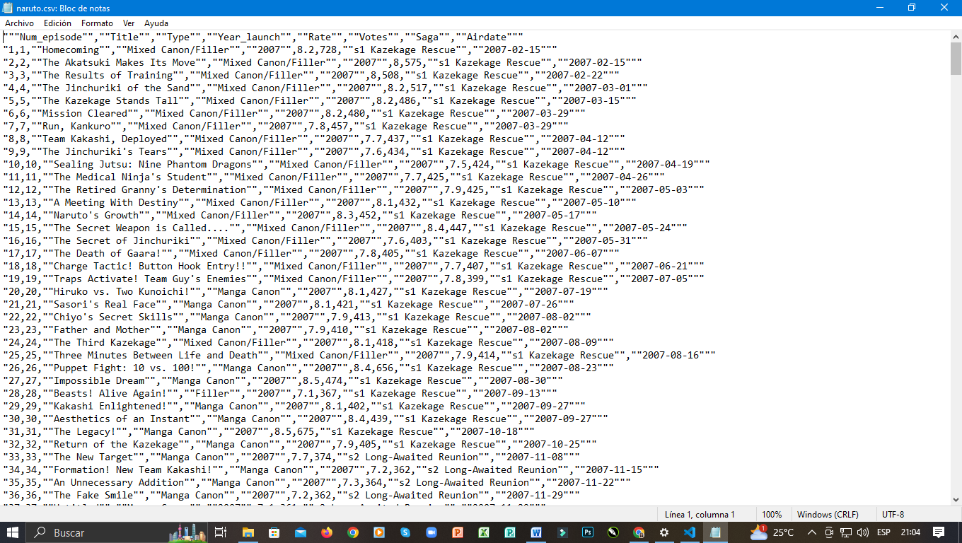

MYSQL

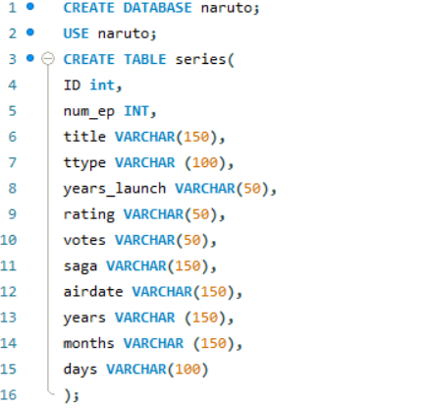Proceeding to create a table in MySQL as we will use it to clean the data and perform transformations. If we load it directly into Power BI, it is because one of the objectives is to demonstrate the advantages of the MYSQL tool. We create a database named "naruto" to load the dataset. We will use a table called "series" with variables declared with the titles noted in the notepad:

The type of variable we all use is VARCHAR or INT (integer). Then we load the data, in this step, an error may occur depending on the security measures of the user's MySQL version, so it will be up to the reader to resolve. The following page can be helpful, and caution should be taken when using "/" or "" or trying the following scripts.

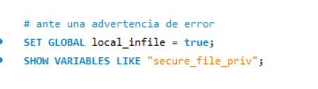



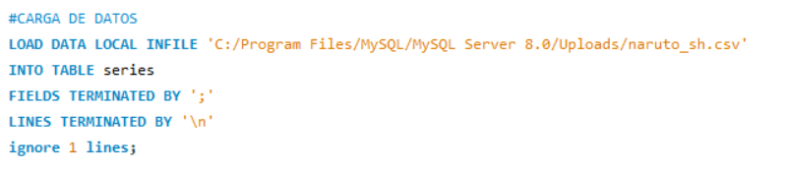

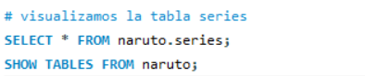

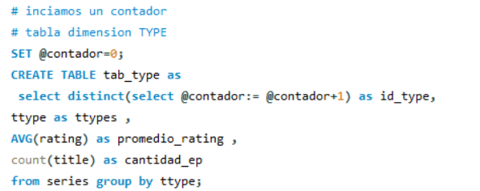

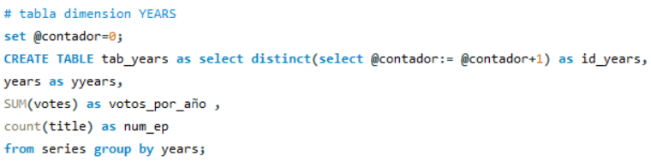

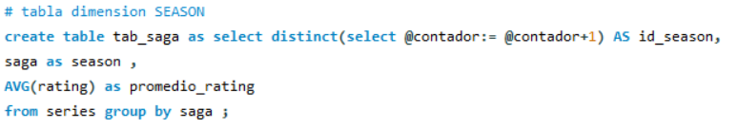

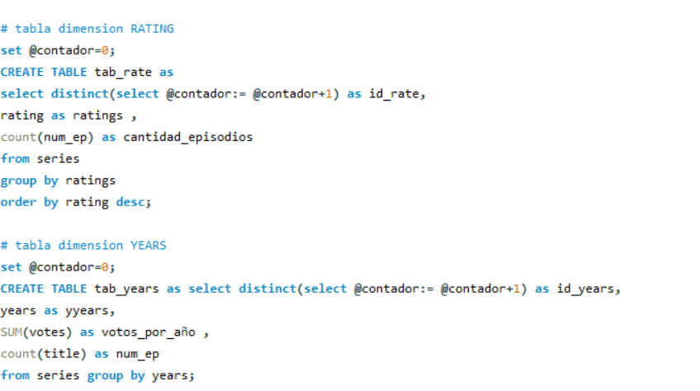

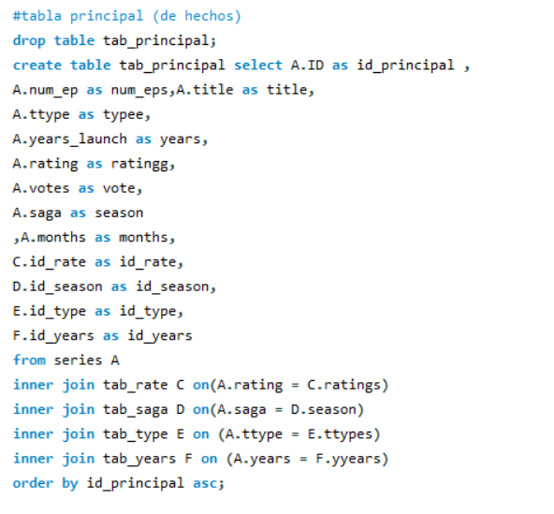

Power BI

To connect the database to MYSQL, we install connectors so that updating the scripts reflects in Power BI. Upon entering to obtain data, we will have the following window where we will select the MYSQL database option:

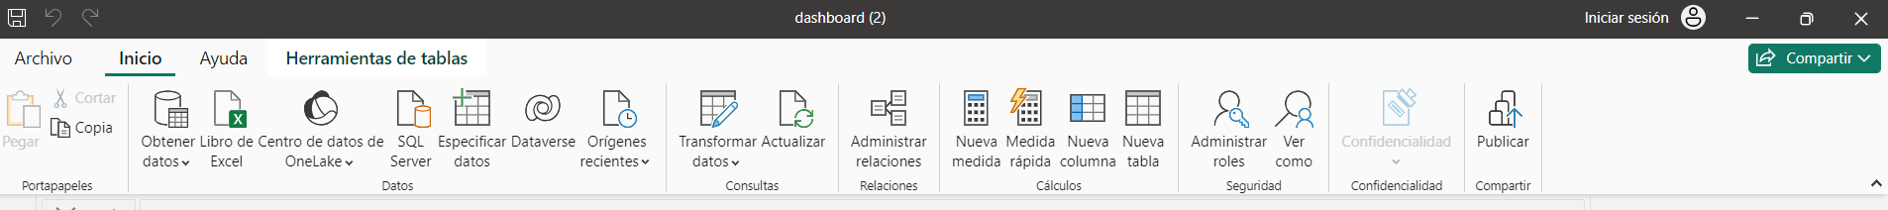

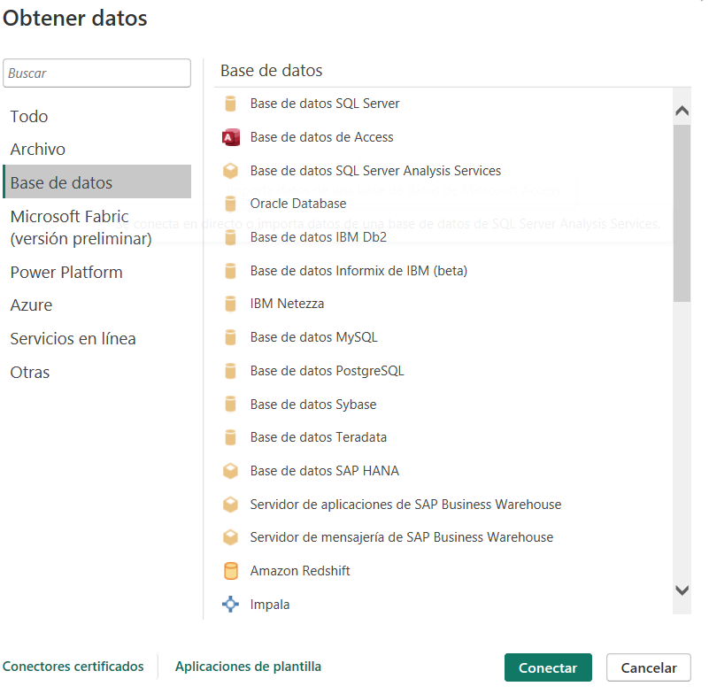

Next, to visualize the entity-relationship diagram that was correctly loaded in the model view option, we can obtain the relationships as follows:

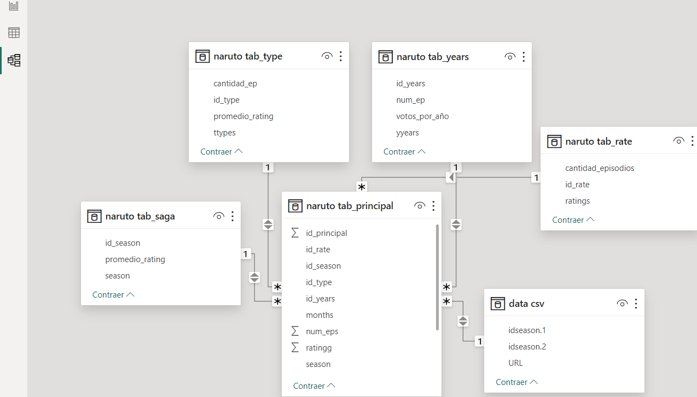

We can also view the loaded tables in the table view section:

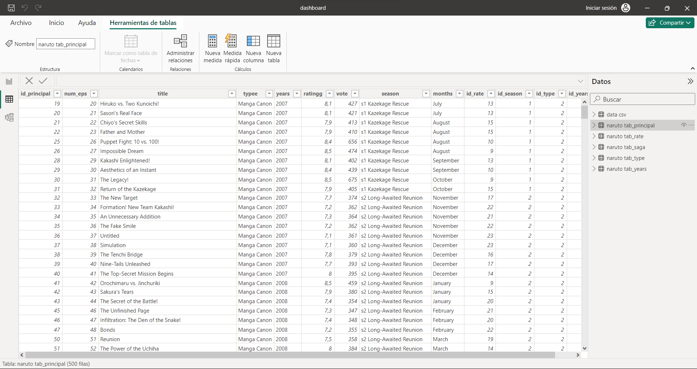

Later, you can visualize charts and images in the report view section:

