Openapi消息通知编码：100100

1把openapi自身作为app注册

2把openapi自身提供的接口注册

3 申请openapi自身的token（后台调用的token）

以上三步也可以直接导入原始sql解决

其他服务调用发送通知接口时，申请2调用的权限调用即可。

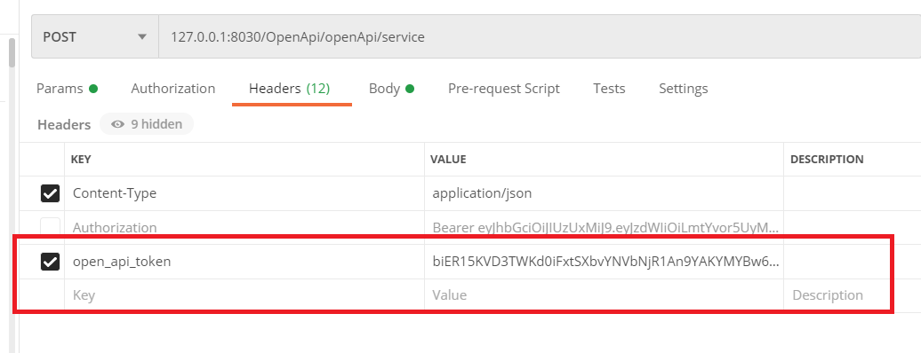

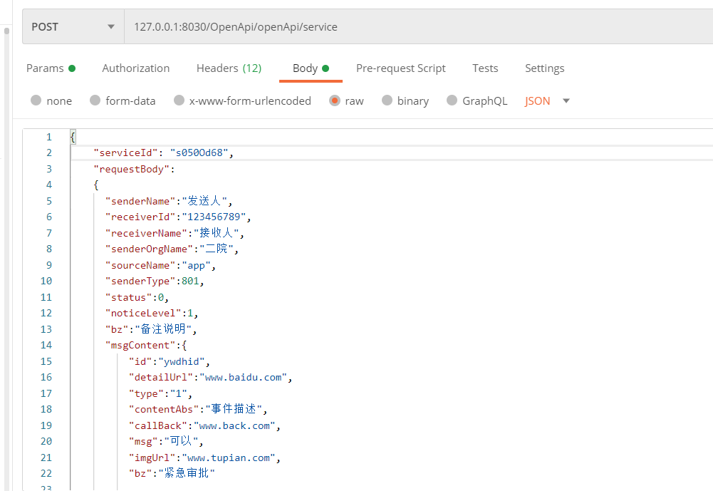

审批例子：

{

"senderName":"发送人",

"receiverId":"123456789", --接收人id

"receiverName":"接收人",

"senderOrgName":"二院",

"sourceName":"app",

"senderType":801,

"status":0,

"noticeLevel":1,

"bz":"备注说明",

"msgContent":{

"id":"ywdhid",

"detailUrl":"www.baidu.com",

"type":"1",

"contentAbs":"事件描述",

"callBack":"www.back.com",

"msg":"可以",

"imgUrl":"www.tupian.com",

"bz":"紧急审批"

}

}

云雀前端收到：

no handler

1. *{code: 100100, data: {…}}*
   1. code: 100100
   2. data:
      1. bz: "备注说明"
      2. msgContent:
         1. bz: "紧急审批"
         2. callBack: "www.back.com"
         3. contentAbs: "事件描述"
         4. detailUrl: "www.baidu.com"
         5. id: "ywdhid"
         6. imgUrl: "www.tupian.com"
         7. msg: "可以"
         8. type: "1"
         9. __proto__: Object
      3. noticeId: "raq8JhaS"
      4. noticeLevel: 1
      5. noticeRead: 0
      6. receiverId: "yanzhenqing"
      7. receiverName: "接收人"
      8. senderName: "发送人"
      9. senderOrgName: "二院"
      10. senderType: 801
      11. sourceName: "app"
      12. status: 0
      13. time: "2021-03-23 15:09:25"
      14. __proto__: Object
   3. __proto__: Object

系统通知例子：

{

    "serviceId": "s050Od68",

    "requestBody":

    {

      "senderName":"发送人",

      "receiverId":"123456789",

      "receiverName":"接收人",

      "senderOrgName":"二院",

      "sourceName":"app",

      "senderType":802,

      "status":0,

      "noticeLevel":1,

      "bz":"备注说明",

      "msgContent":{

          "id":"ywdhid",

          "detailUrl":"www.baidu.com",

          "type":"1",

          "contentAbs":"事件描述",

          "contentDetail":"商店大促销",

          "imgUrl":"www.tupian.com",

          "bz":"紧急审批"

        }

    }

}

数据更新例子:

{

    "serviceId": "s050Od68",

    "requestBody":

    {

      "senderName":"发送人",

      "receiverId":"123456789",

      "receiverName":"接收人",

      "senderOrgName":"二院",

      "sourceName":"app",

      "senderType":803,

      "status":0,

      "noticeLevel":1,

      "bz":"备注说明",

      "msgContent":{

          "projectName":"飞行项目",

          "projectId":"proId",

          "postData":{

              "id":"id1",

              "name":"test"

          },

          "changeData": {

              "id":"id1",

              "name":"test2"

          },

          "version":"v1.1",

          "correlation":"1",

          "bz":"最新数据"

        }

    }

}

推荐例子：

{

    "serviceId": "s050Od68",

    "requestBody":

    {

      "senderName":"发送人",

      "receiverId":"123456789",

      "receiverName":"接收人",

      "senderOrgName":"二院",

      "sourceName":"app",

      "senderType":804,

      "status":0,

      "noticeLevel":1,

      "bz":"备注说明",

      "msgContent":{

          "url":"wwww.baidu.com",

          "titile":"大促销",

          "time":"2021-01-03 15:59:03",

          "source":"www.source.com",

          "author":"王六六",

          "domain":"baidu.com",

          "rsource":"resource.com",

          "relevancy":0.9,

          "bz":"最新数据"

        }

    }

}