Student FP5. Performance Evaluation 1.
The following images show the examples of the Lidar TTC with inaccurate estimates:

The first image shows that the lidar TTC calcualted is around 7 seconds,
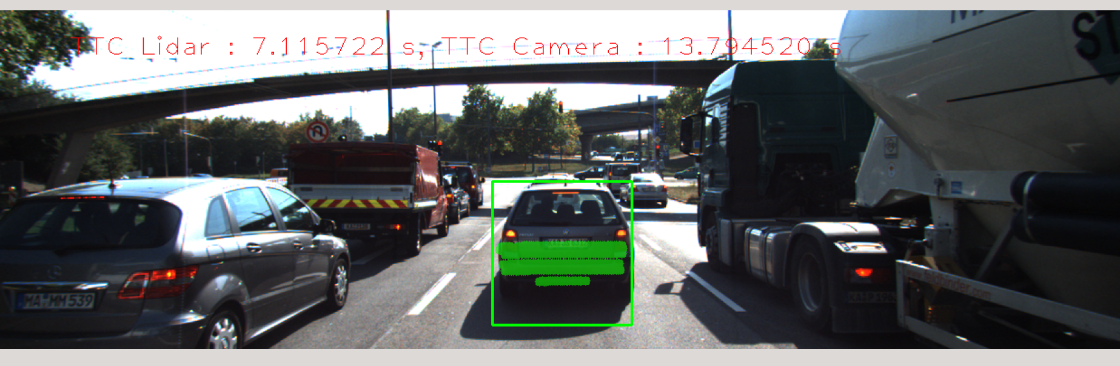
while the second one shows that it increased to 34.34 seconds

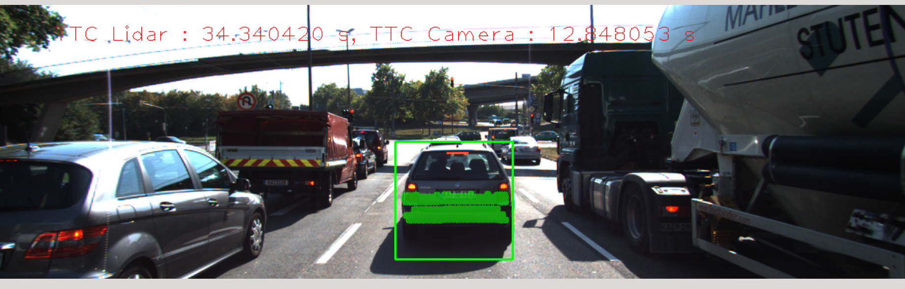
the third image showed that there is a drop of the TTC to just 9 seconds.

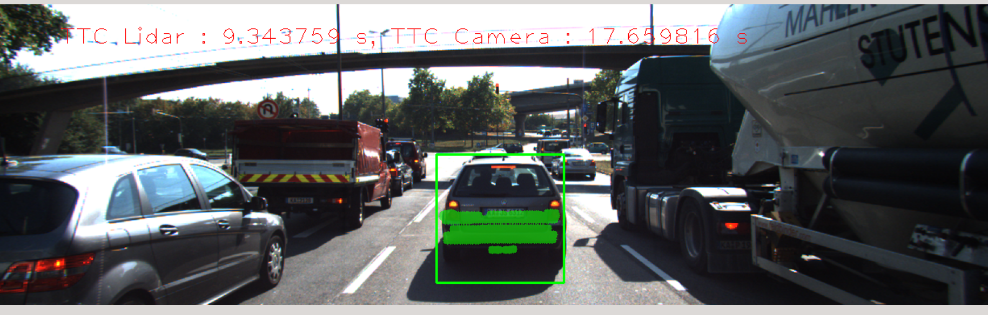
One observation is that for each of these images, the image based or camera based measurments are consistantly dropping with a steady pace as the camera approaches the car in the front slowly.
To explaine why this situation happened, as we observe the equation of the lidar TTC: d1 * Δt / (d1 – d0). This small increment of distance between two frames might cause a problem making the denominator too large and thus TTC has a huge change.

