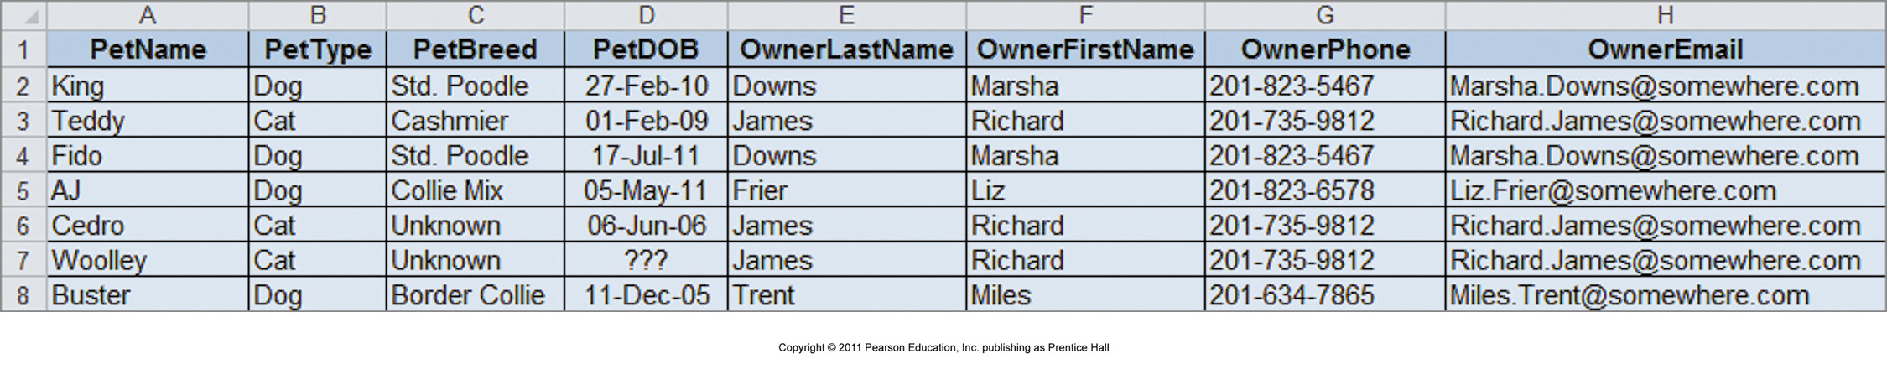
Additional Info:
No two pets share the same PetName, and no two owners share the same OwnerPhone and/or OwnerEmail. (Columns may be used as Primary Keys; surrogate key unnecessary.)

Identify Candidate Keys:
- PetName

Identify Functional Dependencies:
- PetName determines PetType, PetBreed, PetDOB, OwnerEmail, OwnerPhone, OwnerLastName, and OwnerFirstName.
- OwnerEmail determines OwnerPhone and vice versa. Turn into composite key: OwnerEmail+OwnerPhone.
- OwnerEmail + OwnerPhone determines OwnerLastName, and OwnerFirstName.

Examine Determinants of Functional Dependencies:
- OwnerEmail + OwnerPhone is not a candidate key; not well-formed.
- New relation: OWNER(OwnerEmail+OwnerPhone), OwnerLastName, OwnerFirstName)
- Revised original relation: PET(PetName, PetType, PetBreed, PetDOB, OwnerEmail+OwnerPhone)

Referential integrity constraint:
- OwnerEmail+OwnerPhone in PETS must exist within OwnerEmail+OwnerPhone in OWNER.

Repeat:
PET(PetName, PetType, PetBreed, PetDOB, OwnerEmail+OwnerPhone)
- Candidate Key: PetName.
- No other functional dependencies.
- Relation well-formed.
OWNER(OwnerEmail+OwnerPhone), OwnerLastName, OwnerFirstName)
- Candidate Key: OwnerEmail+OwnerPhone.
- No other functional dependencies.
- Relation well-formed.

No further repeats, list has been normalized.

