- Draw an E-R Crow's Foot relational database diagram for the following.
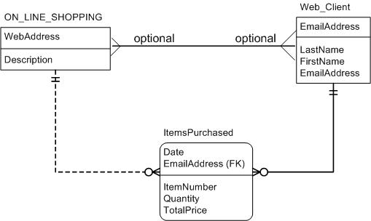
ON_LINE_SHOPPING
(K) WebAddress
-----------------------------
Description

WEB_CLIENT
(K) EmailAddress
---------------------
LastName
FirstName
CLIENT_LIST
(K) WebAddress (FK)
(K) EmailAddress(FK)
-------------------------------
ITEMSPURCHASED
(K) Date
(K) EmailAddress (FK)
-------------------
ItemNumber
Quantity
TotalPrice
WebAddress (FK)

