**CNET 327 SEC 005**

Technologist Project – Final Report

Nihal Ghuman 301092332

Farah Naz 301123217

Submitted To Prof. Abid Bashir

Table of Contents:

Declaration of Authorship 21

Abstract: 22

Introduction: 23

About Us: 24

Team Member Bios 25

VP of Operations - Pranav Vij 25

Project management Lead - Vanshika Kaushal 25

Technology Consultant Lead - Yusuf Salad 25

Services 26

About the Customer 27

Business: 27

Challenges, shortfalls, and issues 27

1. Budgetary Constraints *-* 27

2. Security Concerns - 28

3. Complex Solutions *-* 28

4. Lack of Modern IT Faculties 28

Hogwarts Current Network: 29

Proposal: 30

**Current Network Topology** 32

Proposed Future Network Topology 35

Design Phase and Stages: 39

Detail Budget 45

Hardware 45

Software 46

Services 46

Risk Analysis and Limitations: 47

Risk Management Procedure 47

Risk Register 49

Deliverables 51

Procedures and Implementation Plan 52

Naming Conventions 53

IP Addressing 56

Simplified View of IP subnets 56

Toronto VLANS 57

Montreal VLANS 57

Ottawa VLANS 58

Vancouver VLANS 58

Calgary VLANS 59

Services and Application Addressing 59

OSPF 60

Toronto OSPF 61

Montreal OSPF 65

Ottawa OSPF 69

Vancouver OSPF 72

SFTP 76

Setting-up the Ubuntu Server 76

Installing GUI on the server 91

Configure SSH Daemon 93

Create SFTP user account 94

L**ogin to SFTP using GUI** 95

MariaDB 97

Configuring MariaDB on an ubuntu server 98

Cacti Network Management System 109

DHCP 124

Adding a DHCP Scope 139

DHCP Pools 152

Toronto DHCP Pools 152

Montreal DHCP Pools 153

Ottawa DHCP Pools 153

Vancouver DHCP Pools 154

Calgary DHCP Pools 154

DHCP Relay Agents 155

TO-RT-1-1 156

TO-RT-2-2 157

MO-RT-1-1 158

MO-RT-2-2 159

OT-RT-1-1 160

VC-RT-1-1 161

Redundancy 162

Redundant Devices and Links 162

HSRP 163

Toronto HSRP Configuration 165

Toronto HSRP Validation 167

Montreal HSRP 168

Montreal HSRP Validation 171

Failover Server Farms 171

Data Backups 172

VOIP 173

VoIP Dial Plan 174

Ottawa VOIP Configs 175

Vancouver VoIP Config 178

VoIP Validation 181

Wireless Networking 182

Site Inspection for Wireless Networks 183

Wireless Network Design Concepts 183

Wireless Network Security 185

Wireless Network Management 185

Simulation of Wireless Network 186

AD/DS 192

Installing Active Directory Domain Services 192

Active Directory Users and Computers 211

Creating New Organizational Units (OUs) 211

Creating New Users 215

Creating New Groups 222

DNS 225

Configuring a DNS Server 225

IIS 238

Installing IIS 238

New Web Site 249

VPN 255

VPN Configurations 256

Summary 266

Recommendations 267

References 268

Figure - Network topology of the structure of the current Toronto HQ site 31

Figure - Network topology of the structure of the current Montreal site 32

Figure - Network topology of the structure of the current Ottawa site 32

Figure - Network topology of the structure of the current Vancouver site 33

Figure - Proposed topology of the future Toronto HQ site 34

Figure - Proposed topology of the future Montreal site 35

Figure - Proposed topology of the future Ottawa site 36

Figure - Proposed topology of the future Vancouver site 37

Figure - Proposed topology of the future new Calgary remote site 38

Figure - Design phase and stages: Gantt Chart 42

Figure - Design Phase and Stages Timeline 43

Figure - A diagram of the proposed OSPF areas 59

Figure - Results of the 'sh ip ospf' command on the TO-RT-1-1 router 61

Figure - IP routes learned through OSPF on the TO-RT-1-1 router 62

Figure - Results of the 'sh ip ospf neighbor' command on the TO-RT-1-1 router 63

Figure - The OSPF configurations for the Toronto HQ site on the TO-RT-1-1 router 64

Figure - Results of the 'sh ip ospf' command on the MO-RT-1-1 router 65

Figure - IP routes learned through OSPF on the MO-RT-1-1 router 66

Figure - Results of the 'sh ip ospf neighbor' command on the MO-RT-1-1 router 67

Figure - The OSPF configurations for the Montreal site on the MO-RT-1-1 router 67

Figure - Results of the 'sh ip ospf' command on the OT-RT-1-1 router 69

Figure - IP routes learned through OSPF on the OT-RT-1-1 router 70

Figure - Results of the 'sh ip ospf neighbor' command on the OT-RT-1-1 router 71

Figure - The OSPF configurations for the Ottawa site on the OT-RT-1-1 router 71

Figure - Results of the 'sh ip ospf' command on the VC-RT-1-1 router 72

Figure - IP routes learned through OSPF on the VC-RT-1-1 router 73

Figure - Results of the 'sh ip ospf neighbor' command on the VC-RT-1-1 router 74

Figure - The OSPF configurations for the Vancouver site on the VC-RT-1-1 router 74

Figure - Create a new Ubuntu Server VM 76

Figure - Choose option to install Guest Operating System 77

Figure - Choose the OS and Version 78

[Figure - Choose the VM Name and Location 79](https://centennialcollegeedu.sharepoint.com/sites/TechnologistProject435/Shared%20Documents/General/CNET327%20Final%20Report%20(Work%20in%20Progress).docx#_Toc120222780)

[Figure - Select the Network Type 80](https://centennialcollegeedu.sharepoint.com/sites/TechnologistProject435/Shared%20Documents/General/CNET327%20Final%20Report%20(Work%20in%20Progress).docx#_Toc120222781)

[Figure - Choose the memory 80](https://centennialcollegeedu.sharepoint.com/sites/TechnologistProject435/Shared%20Documents/General/CNET327%20Final%20Report%20(Work%20in%20Progress).docx#_Toc120222782)

[Figure - Select the disk size and choose how to store the disk 81](https://centennialcollegeedu.sharepoint.com/sites/TechnologistProject435/Shared%20Documents/General/CNET327%20Final%20Report%20(Work%20in%20Progress).docx#_Toc120222783)

[Figure - Installer update 82](https://centennialcollegeedu.sharepoint.com/sites/TechnologistProject435/Shared%20Documents/General/CNET327%20Final%20Report%20(Work%20in%20Progress).docx#_Toc120222784)

[Figure - Select the desired language 82](https://centennialcollegeedu.sharepoint.com/sites/TechnologistProject435/Shared%20Documents/General/CNET327%20Final%20Report%20(Work%20in%20Progress).docx#_Toc120222785)

[Figure - Keyboard Configuration 83](https://centennialcollegeedu.sharepoint.com/sites/TechnologistProject435/Shared%20Documents/General/CNET327%20Final%20Report%20(Work%20in%20Progress).docx#_Toc120222786)

[Figure - Configure Network Connection 83](https://centennialcollegeedu.sharepoint.com/sites/TechnologistProject435/Shared%20Documents/General/CNET327%20Final%20Report%20(Work%20in%20Progress).docx#_Toc120222787)

[Figure - Configure Proxy 84](https://centennialcollegeedu.sharepoint.com/sites/TechnologistProject435/Shared%20Documents/General/CNET327%20Final%20Report%20(Work%20in%20Progress).docx#_Toc120222788)

[Figure - Choose type of Installation 84](https://centennialcollegeedu.sharepoint.com/sites/TechnologistProject435/Shared%20Documents/General/CNET327%20Final%20Report%20(Work%20in%20Progress).docx#_Toc120222789)

[Figure - Configure Ubuntu Mirror 85](https://centennialcollegeedu.sharepoint.com/sites/TechnologistProject435/Shared%20Documents/General/CNET327%20Final%20Report%20(Work%20in%20Progress).docx#_Toc120222790)

[Figure - Guided storage Configuration 85](https://centennialcollegeedu.sharepoint.com/sites/TechnologistProject435/Shared%20Documents/General/CNET327%20Final%20Report%20(Work%20in%20Progress).docx#_Toc120222791)

[Figure - Confirm the Storage Configuration 86](https://centennialcollegeedu.sharepoint.com/sites/TechnologistProject435/Shared%20Documents/General/CNET327%20Final%20Report%20(Work%20in%20Progress).docx#_Toc120222792)

[Figure - File System Summary 86](https://centennialcollegeedu.sharepoint.com/sites/TechnologistProject435/Shared%20Documents/General/CNET327%20Final%20Report%20(Work%20in%20Progress).docx#_Toc120222793)

[Figure - Profile Setup 87](https://centennialcollegeedu.sharepoint.com/sites/TechnologistProject435/Shared%20Documents/General/CNET327%20Final%20Report%20(Work%20in%20Progress).docx#_Toc120222794)

[Figure - SSH Setup 87](https://centennialcollegeedu.sharepoint.com/sites/TechnologistProject435/Shared%20Documents/General/CNET327%20Final%20Report%20(Work%20in%20Progress).docx#_Toc120222795)

[Figure - Installation Complete 88](https://centennialcollegeedu.sharepoint.com/sites/TechnologistProject435/Shared%20Documents/General/CNET327%20Final%20Report%20(Work%20in%20Progress).docx#_Toc120222796)

[Figure - Select Featured Server Snaps 88](https://centennialcollegeedu.sharepoint.com/sites/TechnologistProject435/Shared%20Documents/General/CNET327%20Final%20Report%20(Work%20in%20Progress).docx#_Toc120222797)

Figure - Welcome Screen 89

Figure - Package Configuration Screen 90

[Figure - Log-in Screen 91](https://centennialcollegeedu.sharepoint.com/sites/TechnologistProject435/Shared%20Documents/General/CNET327%20Final%20Report%20(Work%20in%20Progress).docx#_Toc120222800)

Figure - Desktop Welcome Screen 91

Figure - Applications Screen 92

[Figure - Configuring SSH 93](https://centennialcollegeedu.sharepoint.com/sites/TechnologistProject435/Shared%20Documents/General/CNET327%20Final%20Report%20(Work%20in%20Progress).docx#_Toc120222803)

Figure - Creating a New SFTP user account and logging-in via command line. 94

Figure - Connect to SFTP sever using GUI 95

Figure - To connect enter SFTP account credentials 95

Figure - Successful connection to SFTP server 96

Figure - Installation of MariaDB 97

Figure - MariaDB Installation Status 98

[Figure - Configure MariaDB Security 98](https://centennialcollegeedu.sharepoint.com/sites/TechnologistProject435/Shared%20Documents/General/CNET327%20Final%20Report%20(Work%20in%20Progress).docx#_Toc120222810)

[Figure - Connecting to MariaDB Server 99](https://centennialcollegeedu.sharepoint.com/sites/TechnologistProject435/Shared%20Documents/General/CNET327%20Final%20Report%20(Work%20in%20Progress).docx#_Toc120222811)

[Figure - Create a hogwarts database 99](https://centennialcollegeedu.sharepoint.com/sites/TechnologistProject435/Shared%20Documents/General/CNET327%20Final%20Report%20(Work%20in%20Progress).docx#_Toc120222812)

[Figure - Creating a table 100](https://centennialcollegeedu.sharepoint.com/sites/TechnologistProject435/Shared%20Documents/General/CNET327%20Final%20Report%20(Work%20in%20Progress).docx#_Toc120222813)

[Figure - Active Status of MariaDB 100](https://centennialcollegeedu.sharepoint.com/sites/TechnologistProject435/Shared%20Documents/General/CNET327%20Final%20Report%20(Work%20in%20Progress).docx#_Toc120222814)

Figure - MariaDB Working 101

Figure - Edit the file /etc/apt/sources.list 102

Figure - Install Webmin 103

Figure - Downloading the Webmin File 104

Figure - Resolving the error out 104

Figure - Troubleshooting any errors 105

[Figure - Webmin Login Page 105](https://centennialcollegeedu.sharepoint.com/sites/TechnologistProject435/Shared%20Documents/General/CNET327%20Final%20Report%20(Work%20in%20Progress).docx#_Toc120222821)

Figure - Webmin Dashboard 106

Figure - MariaDB Server on Webmin 107

[Figure - User Permissions 107](https://centennialcollegeedu.sharepoint.com/sites/TechnologistProject435/Shared%20Documents/General/CNET327%20Final%20Report%20(Work%20in%20Progress).docx#_Toc120222824)

Figure - MariaDB Settings 108

Figure - Cacti Package Downloaded 109

Figure - Extracting and moving the database 109

Figure - Active status of Apache Service 110

Figure - Cacti Login Window 111

Figure - Change Username's Password 111

[Figure - Accept the Cacti License Agreement 112](https://centennialcollegeedu.sharepoint.com/sites/TechnologistProject435/Shared%20Documents/General/CNET327%20Final%20Report%20(Work%20in%20Progress).docx#_Toc120222831)

[Figure - Cacti Installation Type 112](https://centennialcollegeedu.sharepoint.com/sites/TechnologistProject435/Shared%20Documents/General/CNET327%20Final%20Report%20(Work%20in%20Progress).docx#_Toc120222832)

Figure - Cacti Directory Permission Checks 113

Figure - Check Critical Binary Locations and Versions 113

Figure - Input Validation Whitelist Protection Page 114

Figure - Update the Network Range and Cron Interval Setting 114

Figure - Template Setup 115

Figure - Confirm Installation 115

Figure - Cacti Installation Complete 116

[Figure - Powered Off Base Server Instance is Used for Cloning 117](https://centennialcollegeedu.sharepoint.com/sites/TechnologistProject435/Shared%20Documents/General/CNET327%20Final%20Report%20(Work%20in%20Progress).docx#_Toc120222840)

Figure - Clone VM Wizard 118

Figure - Clone Source 118

Figure - Clone Type 119

Figure - Select VM Name and Location 120

Figure - Cloning the VM 121

Figure - VM Cloning Completed 122

Figure - Add roles and features 124

Figure - Before you begin page 125

Figure - Select installation type 126

Figure - Select Destination Server 127

Figure - Select Server Roles 128

Figure - Add Features pop-up 129

Figure - DHCP server role added 130

Figure - DHCP Server 131

Figure - Confirm installation selections 132

Figure - Installation Progress 133

Figure - Installation Complete 134

Figure - DHCP Post–Install configuration wizard 135

Figure - DHCP Post–Install configuration wizard Authorization 136

Figure - Summary 137

Figure - Server Manager: Tools 138

Figure - DHCP Manager 139

Figure - DHCP Manager: New Scope... 140

Figure - New Scope Wizard 141

Figure - Scope Name popup 142

Figure - IP Address Range 143

Figure - Exclusions and Delay 144

Figure - Lease Duration 145

Figure - Configure DHCP Options 146

Figure - Domain Name and DNS Server 147

Figure - WINS Server 148

Figure - Activate Scope 149

Figure - Completing the New Scope Wizard 150

Figure - TO-RT-1-1 set up as a DHCP relay agent 155

Figure - TO-RT-2-2 set up as a DHCP relay agent 156

Figure - MO-RT-1-1 set up as a DHCP relay agent 157

Figure - MO-RT-2-2 set up as a DHCP relay agent 158

Figure - OT-RT-1-1 set up as a DHCP relay agent 159

Figure - VC-RT-1-1 set up as a DHCP relay agent 160

Figure - An example of how packets will be routed using HSRP with the configuration for one of the VLANs (VLAN 100) at the Toronto HQ site 163

Figure - Results of the 'sh standby brief' command showing that the TO-RT-1-1 is the active router in this HSRP configuration 164

Figure - Results of the 'sh standby brief' command showing that TO-RT-2-2 is the standby router in this HSRP configuration 164

Figure - TO-RT-1-1 HSRP configurations 165

Figure - TO-RT-1-1 HSRP configurations continued 166

Figure - Validation that HSRP is functioning correctly as TO-RT-2-2 becomes the active router when the previously active router TO-RT-1-1 goes down 166

Figure - Results of the 'sh standby brief' command showing that MO-RT-1-1 is the active router in this HSRP configuration 167

Figure - Results of the 'sh standby brief' command showing that MO-RT-2-2 is the standby router in this HSRP configuration 167

Figure - MO-RT-1-1 HSRP configurations 168

Figure - MO-RT-2-2 HSRP configurations 169

Figure - Validation that HSRP is functioning correctly as MO-RT-2-2 becomes the active router when the previously active router MO-RT-1-1 goes down 170

Figure - Simulated VoIP topology at the Ottawa Site 174

Figure - Test DHCP pools at the Ottawa site to simulate a VoIP environment 174

Figure - VoIP configurations at the OT-RT-1-1 router at the Ottawa site 175

Figure - OT-SW-1-1 VLAN settings to support VoIP at the Ottawa site 176

Figure - Simulated VoIP topology at the Vancouver Site 177

Figure - Test DHCP pools at the Vancouver site to simulate a VoIP environment 177

Figure - VoIP configurations at the VC-RT-1-1 router at the Vancouver site 178

Figure - VC-SW-1-1 VLAN settings to support VoIP at the Vancouver site 179

Figure - Calling of VoIP phones at the Ottawa site using extensions 3100 and 3101 180

Figure - Calling of VoIP phones at the Vancouver site using extensions 4100 and 4101 180

Figure - Vancouver phone extension 4100 successfully calling Ottawa phone extension 3100 181

Figure - Example of the channel reuse principle from Datacom Network.(n.d.). Turbotenna RF Planning. Datacom Network. Retrieved November 24, 2022, from http://www.danets.com/turbotenna/RFplanning.php 183

Figure - Simulated Hogwarts WLAN including a RADIUS server connected to the core routers, with a WLC and AP in the access layer 185

Figure - RADIUS server simulated configuration showing shared secret with WLC and user for authentication 186

Figure - TO-Staff WLAN configuration at the WLC 187

Figure - TO-Guest WLAN configuration at the WLC 188

Figure - Laptop at Toronto site connecting to the WLAN using WPA2-Enterprise authentication using user credentials stored on the RADIUS server 189

Figure - Smartphone connecting to the TO-Guest WLAN at the Toronto site using WPA2-PSK authentication 190

Figure - Server Manager console 191

Figure - Add Roles and Features Wizard page 192

Figure - Select installation type page 193

Figure - Select destination server page 194

Figure - Select server roles page 195

Figure - Add Roles and Features Wizard dialog box 196

Figure - Back at the Select server roles page 197

Figure - Select features page 198

Figure - Active Directory Domain Services page 199

Figure - Confirm installation selections page 200

Figure - Installation Progres 201

Figure - Yellow exclamation symbol in server manager console 202

Figure - Active Directory Domain Services Configuration Wizard page 203

Figure - Active Directory Domain Services Configuration Wizard page: Root domain name 203

Figure - Domain Controllers Options page 204

Figure - DNS Options page 205

Figure - Additional Options page 206

Figure - Paths page 206

Figure - Review Options page 207

Figure - Prerequisite Check page 208

Figure - Installation Progress 208

Figure - Computer restart pop up 209

Figure - Windows server now on Domain 209

Figure - Active Directory Users and Computers 210

Figure - Active Directory Users and Computers: New→Organizational Unit 211

Figure - New Object - Organizational Unit 212

Figure - Computers OU in HorizonUniversity.com/STAFF 213

Figure - Users OU in HorizonUniversity.com/STAFF 213

Figure - Security Groups OU in HorizonUniversity.com/STAFF 214

Figure - Users OU: New→User 215

Figure - New Object: User 216

Figure - Password settings 217

Figure - Verify the information for the new user 218

Figure - Another user added to Users OU 219

Figure - Properties for multiple users 220

Figure - Office and Description information 221

Figure - Security Groups OU: New→Group 222

Figure - Management Group 223

Figure - Management group in Console 224

Figure - Server Console: Tools→DNS 225

Figure - Forward Lookup Zones: New Zone 226

Figure - New Zone Wizard 227

Figure - Zone Type 228

Figure - Active Directory Zone Replication Scope 229

Figure - Zone Name 230

Figure - Dynamic Update 231

Figure - Completing the New Zone Wizard 232

Figure - HorizonUniversity.com Zone: New Host (A or AAAA). 233

Figure - IP address for the new host 234

Figure - HorizonUniversity.com Zone: New Alias (CNAME) 235

Figure - New Resource Record pop up 235

Figure - Configured DNS Manager 236

Figure - Before you begin 237

Figure - Select installation type 238

Figure - Select Destination Server 238

Figure - Select Server Roles: Web Server (IIS) 239

Figure - Working Web Server 240

Figure - www.HorizonUniversity.com working 241

Figure - Server Console: Internet Information Services (IIS) Manager 242

Figure - IIS Manager: Local Server Start Page 243

Figure - Default Web Site: View Virtual Directories 244

Figure - Virtual Directories: Add Virtual Directory 245

Figure - Add Virtual Directory dialog box 246

Figure - The Virtual directory now appearing in list of directories 247

Figure - Example of local website 248

Figure - IIS Manager: Add Website 249

Figure - Add Website dialog box 250

Figure - Horizon University website added 251

Figure - www.Horizon University.com picture 1 252

Figure - www.Horizon University.com picture 2 252

Figure - www.Horizon University.com picture 3 252

Figure - www.Horizon University.com picture 4 253

Figure - www.Horizon University.com picture 5 253

Figure - www.Horizon University.com picture 6 253

Figure - www.Horizon University.com picture 7 254

Figure - www.Horizon University.com picture 8 254

Figure - VPN configurations on the TO-RT-1-3 router 256

Figure - Mapping VPN configurations on the TO-RT-1-3 interface which leads to the internet 257

Figure - VPN configurations on the CA-RT-1-1 router 258

Figure – Mapping VPN configurations on the CA-RT-1-1 interface which leads to the internet 259

Figure - Access control lists which are meant to filter out traffic that will be sent over the VPN 260

Figure - Access control lists which are meant to filter out traffic that will be sent over the VPN 261

Figure - Verifying that the packets traveling over the internet are being encrypted and encapsulated so that they can safely reach their destination over the internet 262

Figure - ISAKMP and IPSEC security associations at the Toronto site 263

Figure - - ISAKMP and IPSEC security associations at the Calgary site 264

**List of Tables:**

Table 1: Team Member BIOS

Table 2: Components of the Proposed Network

Table 3: Deliverables of the Project

Table 4: Detailed Gantt Chart Report

Table 5: Detailed Cost Analysis

Table 6: Risk Register

Table 7: Overall Project Deliverable

Table 8: IP Addressing Scheme

Declaration of Authorship

We, Nihal Ghuman, Farah Naz, and the team at EduTech Solutions, hereby confirm that the breakdown of authorship presented in this document accurately represents our individual contributions to the work submitted for assessment. We attest that our contributions are our own original work and are expressed in our own words. Any use made within this Technology Report of the works of any other author, separate from our team, in any form (ideas, equations, figures, texts, tables, programs), has been properly acknowledged at the point of use. We have included a list of all references used at the end of this document in accordance with academic standards.

Signed,

Nihal Ghuman

Farah Naz

EduTech Solutions

Dated - April 1, 2023

Abstract:

The capstone project for the computer systems technology networking program aims to apply theoretical and technical knowledge to a real-world scenario. Students will utilize skills from different networking fields, such as routing, switching, telephony, VOIP, WAN, datacenter, wireless, network design, and project management. The mixed environment for the server infrastructure includes Windows and Linux servers.

In the project, students will act as networking consultants, responsible for upgrading existing infrastructure and building the networking infrastructure for a client's expansion into a new province. Services such as DNS, DHCP, AD, Domain, and IIS webserver will be provided through Windows 2016 Servers VMs, while Linux servers will provide services such as MariaDB and sftp. The client's simulated environment includes OSPF, Remote site VPN, VoIP, ACLs, DHCP, wireless networks, and RADIUS servers.

By using packet tracer and virtual machines, students will simulate and emulate an upgraded version of the client's network, showcasing their technical knowledge and skill. Additionally, recommendations for further upgrades for Horizon University will be provided.

Introduction:

Horizon University is a privately-owned educational institution that was founded in 2015 and is situated in Toronto, Canada. The institution offers various academic curricula and comprises four buildings located at a single campus, with each building housing programs in Business, Science, Law, and Project Management. The user base of the institute includes around 2200 individuals, encompassing both students and operations personnel.

EduTech Solutions, an established IT consulting firm, has been contacted to provide network consulting services to Horizon University. The privately-owned educational institution, located in Toronto, Canada, is expanding its user base and opening five additional locations across the Greater Toronto Area. With a growing student population and the need for modern network infrastructure, Horizon University requires a reputable IT company to upgrade its existing infrastructure and develop network security requirements. EduTech Solutions will create a proposal for the expansion, including a detailed design for the new office space, upgrading of existing infrastructure, and implementation plan.

About Us:

**EduTech Solutions** is an IT consultant firm that specializes in providing technology solutions to educational institutions. Their primary focus is on assisting educational institutions in leveraging technology to improve student outcomes, streamline operations, and achieve strategic objectives. EduTech Solutions offers a range of services, including the assessment of an organization's existing IT infrastructure, the development of customized IT strategies, and the implementation of software and hardware solutions. The company's goal is to provide educational institutions with reliable, cost-effective, and scalable technology solutions that meet their unique needs and requirements. By doing so, EduTech Solutions helps to empower educators, administrators, and students to achieve their goals and realize their full potential.

Team Member Bios:

**Note: Since we have only two members in our group, we have assigned random names to some of the essential roles in our report.**

| **Name** | **Role** | **Responsibilities** |
| --- | --- | --- |
| Farah Naz | VP of Operations | Responsible for overseeing the firm's operations, including project management and technology |
| Nihal Ghuman | Project Management Lead | Responsible for managing various projects undertaken by the firm with the help of other project managers |
| Alex Johnson | Technology Consultant Lead | Responsible for the technological side of client contracts, overseeing network design and building |
| Emily Brown | Project Manager | Assists the project management lead in managing the various projects undertaken by the firm |
| Samantha Davis | Technology Consultant | Assists the technology consultant lead in overseeing network design and building for clients |
| Rachel Garcia | Operations Coordinator | Supports the VP of Operations in the day-to-day operations of the firm |

*Table1: Team Member Bios*

Services:

1. **Cybersecurity Consulting:** This service will assist educational institutions to protect their computer systems and networks from various cyber threats such as ransomware, DDoS attacks, recovery, and remediation. EduTech Solutions can help design a security framework that meets the specific needs of Horizon University.
2. **Infrastructure Upgrade Consulting**: EduTech Solutions can help Horizon University and other educational institutions upgrade their IT infrastructure to ensure smooth and efficient operations. This may include upgrading hardware, software, and networks.
3. **Wireless Technology Consulting:** EduTech Solutions can provide advice and recommendations to educational institutions on implementing a wireless network infrastructure that supports the growing demand for connectivity in learning environments.
4. **VPN Solutions:** EduTech Solutions can provide Virtual Private Network (VPN) solutions to enable secure and remote access to the university's network for students, faculty, and staff.
5. **Cloud Migration Solutions**: EduTech Solutions can help educational institutions migrate their IT systems and applications to the cloud, allowing them to save on hardware costs, improve scalability, and enhance accessibility.
6. **Procurement and Deployment of IT solutions:** EduTech Solutions can help educational institutions purchase and deploy various IT solutions, including hardware, software, and cabling.
7. **24/7 on-site support:** EduTech Solutions can provide on-site support 24 hours a day, seven days a week to ensure that the university's IT systems are always functioning optimally.
8. **Remote support:** EduTech Solutions can also provide remote support to educational institutions, enabling them to quickly resolve IT issues without the need for on-site visits.
9. **Backup and Disaster Management (DRaaS)**: EduTech Solutions can provide backup and disaster management services, including Disaster Recovery as a Service (DRaaS), to ensure that Horizon University's critical data is secure and can be restored in case of a disaster.
10. **Software Deployment:** EduTech Solutions can assist in deploying various software solutions to improve the university's IT systems' functionality.
11. **Hardware Deployment:** EduTech Solutions can assist in deploying various hardware solutions to improve the university's IT systems' functionality.
12. **Management, Monitoring, and Reporting:** EduTech Solutions can provide management, monitoring, and reporting services to educational institutions, enabling them to monitor their IT systems' performance and identify areas for improvement.

About the Customer

Business:

Horizon University is committed to providing quality education to students in various fields, including business, project management, law, and science. After successfully running the main branch in Toronto at four different locations, the university has decided to expand its reach by opening dedicated branches for these fields. This decision was made in response to the growing demand for specialized education in these areas and to better serve the needs of students who are interested in pursuing careers in these fields. The university believes that by opening these dedicated branches, it will be able to provide students with the resources and expertise they need to succeed in their chosen fields.

Challenges, Shortfalls, and Issues:

1. **Visual branding and marketing:** Like any new business or institution, Horizon University will need to establish a strong and consistent visual identity in order to build brand recognition and attract potential students and faculty. This will require significant investment in design, marketing materials, and website development.
2. **Coordinating across multiple branches:** As Horizon University opens new branches for different programs, it will need to effectively coordinate across departments and ensure that resources are being allocated efficiently. This may require significant planning and coordination to avoid duplicating efforts and wasting resources.
3. **Technical challenges:** Interconnecting multiple branches of the university will require a robust network infrastructure, effective security protocols, and careful management of data and sensitive information. Horizon University will need to invest in technical resources and expertise to ensure that its network is always secure and operational.
4. **Faculty and staff recruitment:** As a new institution, Horizon University may face challenges in recruiting top-tier faculty and staff who are willing to take a chance on a new and unproven institution. This will require significant investment in recruitment efforts, competitive compensation packages, and an appealing workplace culture.
5. **Financial constraints:** Like any business, Horizon University will need to manage its finances carefully and make strategic investments in order to remain competitive. This may require making tough decisions about resource allocation and prioritizing certain programs or initiatives over others.
6. **Adapting to new technologies:** As technology continues to evolve at a rapid pace, Horizon University will need to stay up to date with the latest trends and tools in order to remain competitive. This may require ongoing investment in IT resources and expertise, as well as a willingness to experiment with new tools and approaches.

Horizon’s Current Network:

Proposal:

| **Component** | **Description** |
| --- | --- |
| Exchange Server | A mail server to handle email communication between students, staff, and faculty |
| Network Services | Various network services such as DHCP, DNS, and NTP to ensure efficient network operation |
| Database Server | A database server to store and manage student and faculty information, grades, and other data |
| WampServer for hosting websites | A web server to host the university's website and other web-based applications |
| Security Service | A robust firewall with Intrusion Detection/Prevention System (IDS/IPS) to ensure network security |
| VOIP | Voice Over Internet Protocol (VOIP) for efficient and cost-effective communication among staff/faculty |
| Wireless Service | A robust wireless infrastructure to provide seamless and reliable wireless connectivity |
| Routing and Switching | Appropriate routing and switching infrastructure to ensure efficient and reliable data transfer |
| Computer Hardware/Software | Reliable computer hardware and software to support daily operations at the university |
| Linux Server | A Linux server to provide additional services and support for the university's operations |

***Table 2: Components of the Proposed Network***

**Proposed network design for Horizon University recommendations:**

* Deploying primary server infrastructure in Toronto for centralized management and maintenance.
* Deploying regional servers in Downtown Mississauga, Scarborough, Vaughan, and Brampton to support different campus locations.
* Configuring regional servers to replicate data with the primary server for efficient and reliable access to critical data.
* Including appropriate routing and switching infrastructure for efficient data transfer.
* Designing wireless infrastructure for seamless connectivity and secure wireless access.
* Including appropriate segmentation and VLAN configurations to ensure efficient and secure data transfer between departments and programs.
* Including robust security measures such as firewalls, IDS/IPS, and other security measures to ensure data integrity and confidentiality.

This network design aims to support the different courses and programs offered at each campus location of Horizon University while ensuring efficient data transfer, secure wireless access, and data integrity across all campus locations.

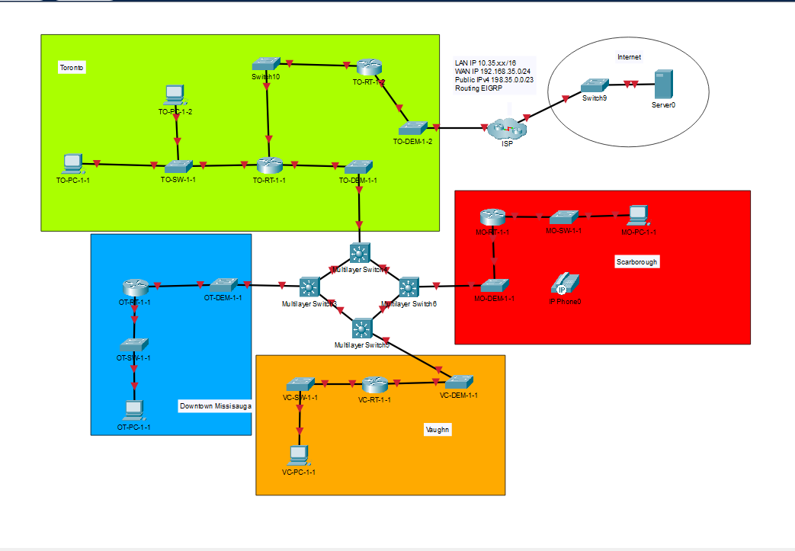Current/Proposed Network Topology:

Fig: Current network of Horizon University showing the Toronto headquarters and three other campus locations.

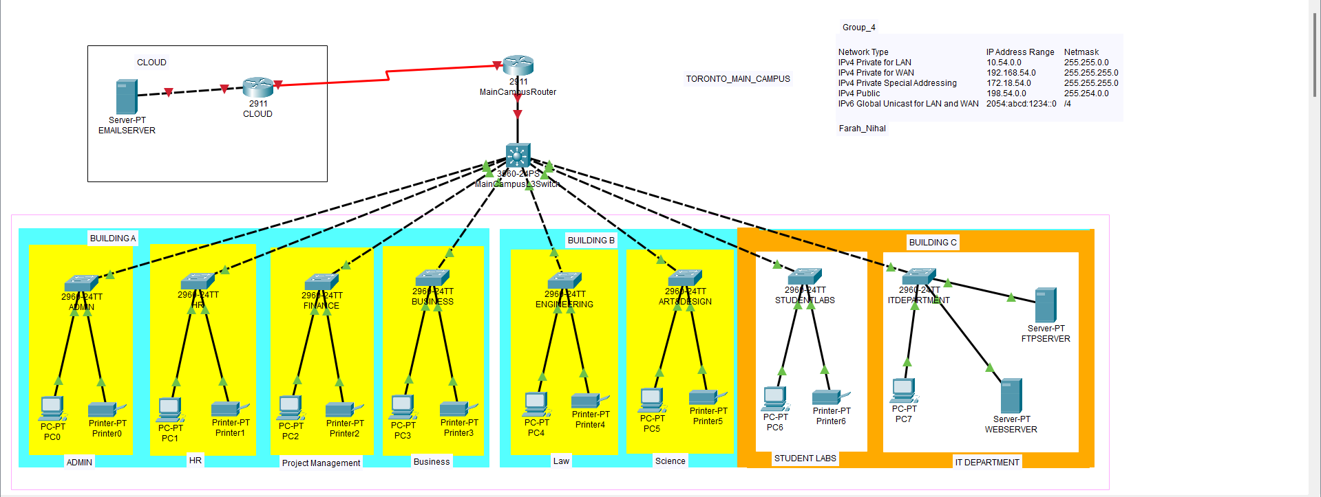Fig: Fully Functional Toronto campus

Procedure:

**The table outlines the procedures and deliverables** for the project at Horizon University, starting with necessary analysis and documentation, followed by planning and development of LAN and WLAN framework, and the provision of an authenticated plan with appropriate security measures. In the execution stage, all adaptations and services will be implemented, including a fully designed LAN and cloud. The final stage involves the evaluation and troubleshooting of any errors, with the delivery of a troubleshooting guide for Horizon University's use.

|  |
| --- |
|  |
| **Number** | **Name** | **Start Date** | **End Date** | **Duration** |
| 1 | Analysis of Current Network | 01-01-2023 | 06-01-2023 | 5 days |
| 2 | Identification of Network Requirements | 07-01-2023 | 10-01-2023 | 4 days |
| 3 | Assessment of Budget | 11-01-2023 | 13-01-2023 | 3 days |
| 4 | Development of Project Proposal | 14-01-2023 | 18-01-2023 | 5 days |
|  | **Deliverable:** Finalized Project Proposal |  |  |  |
| 5 | Planning of Network Architecture Topology | 19-01-2023 | 23-01-2023 | 5 days |
| 6 | Procurement of Network Equipment | 24-01-2023 | 27-01-2023 | 4 days |
| 7 | Drafting of Security Policies | 28-01-2023 | 30-01-2023 | 3 days |
| 8 | Initial Design of University Website | 31-01-2023 | 04-02-2023 | 5 days |
|  | **Deliverable:** Approved Network Design |  |  |  |
| 9 | Installation of Network Equipment | 05-02-2023 | 10-02-2023 | 6 days |
| 10 | Configuration of Network Scripts | 11-02-2023 | 14-02-2023 | 4 days |
| 11 | Testing of Network | 15-02-2023 | 17-02-2023 | 3 days |
|  | **Deliverable:** Tested Network |  |  |  |
| 12 | Migration to Upgraded Network | 18-02-2023 | 21-02-2023 | 4 days |
| 13 | Training and Documentation | 22-02-2023 | 25-02-2023 | 4 days |
|  | **Deliverable:** Training and Documentation |  |  |  |
| 14 | Evaluation of Project | 26-02-2023 | 28-02-2023 | 3 days |
|  | **Deliverable:** Project Evaluation Report |  |  |  |

*Table 3: Deliverables of the Project*

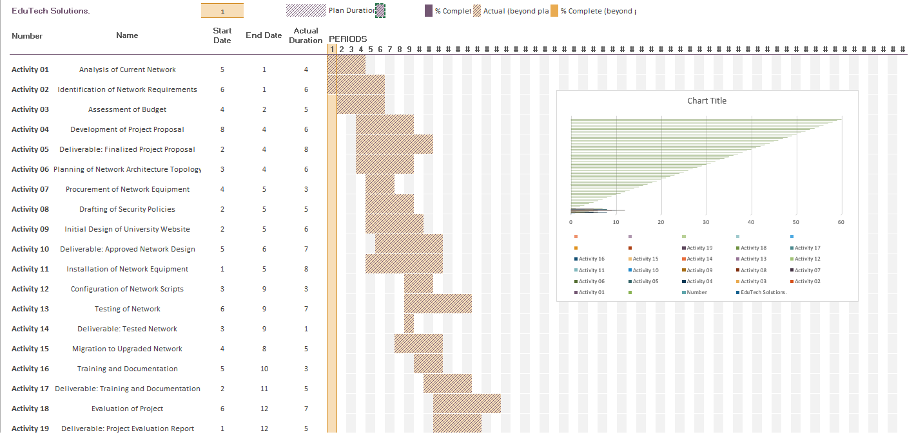Gantt Chart:

***Table 4: Detailed Gantt Chart Report***

Estimated Cost:

| **Hardware** | **Device Model** | **Quantity** | **Price/Device** | **Total** |
| --- | --- | --- | --- | --- |
| Network Devices | Multilayer Switch | 5 | $3,458.65 | $17,293.25 |
|  | Cisco Catalyst WS-C3650-48PS-S | 5 | $3,458.65 | $17,293.25 |
|  | Switch (48-P) CISCO SG350X-48P | 13 | $1,725.38 | $22,429.94 |
| Firewalls | Firewall ASA 5516-X Cisco ASA 5500 | 2 | $2,039.75 | $4,079.50 |
|  |  |  |  |  |
|  | Cisco IP Phone CP-7821-K9 | 75 | $110.00 | $8,250.00 |
|  |  |  |  |  |
| Routers | Cisco 1941 | 7 | $1,125.79 | $7,880.53 |
|  |  |  |  |  |
| Ethernet Cables | 5ft Cat6a SSTP 26AWG 10GB | 100 | $4.29 | $429.00 |
|  | Ethernet Cables 100ft Cat6a SSTP 26AWG 10GB | 10 | $37.62 | $376.20 |
|  |  |  |  |  |
| Serial Cable | DCE/DTE Db60 Crossover Cable 3Ft - Monoprice | 3 | $15.00 | $45.00 |
|  | For Cisco Serial |  |  |  |
|  |  |  |  |  |
| Total Hardware |  |  |  | $214,571.56 |
| End-User Devices | Desktop Think Station P340 Tiny | 25 | $1,749.00 | $43,725.00 |
|  | Laptops ThinkPad L13 | 75 | $1,219.99 | $91,499.25 |
|  | Printers RICOH IM550F | 5 | $2,719.00 | $13,595.00 |
|  | Servers PowerEdge R740xD Rack Server | 1 | $4,968.89 | $4,968.89 |
|  |  |  |  |  |
| Total Hardware |  |  |  | $153,788.14 |
|  |  |  |  |  |
| Software | Windows server 2016 Standard | 6 | $1,053.68 | $6,322.08 |
|  | Microsoft Office 365 | 75 | $16.00 | $14,400.00 |
|  |  |  |  |  |
| Total Software |  |  |  | $20,722.08 |
|  |  |  |  |  |
| Labor | Installation and setup |  |  | $170,000.00 |
|  | Staff Training and Hand over to Local |  |  | $30,000.00 |
|  | IT Staff |  |  |  |
|  |  |  |  |  |
| Total Labor Cost |  |  |  | $200,000.00 |
|  |  |  |  |  |
| Grand Total Cost |  |  |  | $435,293.56 |

***Table 5: Detailed Cost Analysis***

Budget:

Horizon University has allocated a budget of approximately $500,000 to upgrade their existing network infrastructure. Our company, EduTech Solutions, has agreed to work within this budget and provide a detailed breakdown of the hardware, software, and services required to implement the network upgrade. We will ensure that the necessary resources are acquired and utilized efficiently to maximize the value of the investment.

Risk Analysis, Scope, and Limitations:

**Risk Management Procedure for Horizon University Network Upgrade:** The Technology Consultant Lead for the Horizon University Network Upgrade project will ensure that risks are actively recognized, examined, and managed throughout the course of the project in collaboration with the project team. Responding to project risks comprises the following steps:

**Identify the Risks and Contributing Variables:** The development team will examine the project's objectives, financial forecasts, timeline, obstacles, stakeholder expectations, external and internal dependencies, and other factors to identify potential risks. Historical information from previous projects, key informant interviews, and threat inventories can also provide valuable information for risk evaluation. The risk identification process is ongoing and will be updated as new information becomes available.

**Categorize and Prioritize Risks:** Each identified risk will be categorized and given a priority based on its potential impact and probability.

**Create a Plan for Risk Mitigation:** A plan will be developed that links every identified risk to a plan for mitigating it.

**Monitor Risk Triggers:** The project team will watch out for risk triggers throughout the project.

**Reduce Risks as Necessary:** If a risk materializes, the necessary steps will be taken to reduce it.

**Share Risk Status:** The risk status will be shared at every stage of the project.

**Continuous Risk Assessment:** Identifying every potential hazard to the project is the first step, which should be done at the beginning of the project, regularly, and following the achievement of a significant milestone. The risks will be evaluated and assessed based on their consequences, impacts, and probabilities. The qualitative and quantitative effects of each risk will be evaluated. Each risk will be given its own set of responsibilities and tasks.

**Risk Monitoring, Controlling, and Reporting:** The amount of risk will be recorded, controlled, and reported throughout the project. The project team will keep track of a "Top

10 Risk List" and submit it as part of the procedure for reporting project status for the Horizon University Network Upgrade project. All requests for project changes will be examined for any potential effects on the project risks. Important changes to the risk status will be reported to management as part of the Executive Project Status Report.

**Risk Assessment Meeting:** A risk assessment meeting will be held during the planning phase of the Horizon University Network Upgrade project. The project manager will invite all participants and provide them with an agenda so they can identify and review any risks they may have in advance.

Risk Register:

The primary objective of a risk register is to identify, monitor, and document potential project hazards. Whenever a risk is identified by the project team, it is assessed and recorded in the risk register. Risk registers are valuable tools for managing projects, particularly as the scope of work expands. The responsibility for maintaining the risk register typically falls to the project manager unless there is a designated risk manager or coordinator on the team.

|  |
| --- |
|  |
| **Risk Factor** | **Threat** | **Risk Level** | **Mitigation** |
| Financial | * There is no financial risk associated with this project because the projected budget is enough. | 0 | * NONE |
| Labor | * Inadequate setup and support personnel because of other projects website resources | 2 | * Provide more overtime to stay on top of the project timeline. |
| Equipment | * Hardware has a lifespan of 7-10 years, with concerns around availability, price, failover, and downtime | 2 | * Replace servers 2 years before the end of service, adhere to warranty contracts, explore alternative vendors, and set up backup UPS and redundancy systems |
| Environmental | * Tree blocking the installation of the leased line cabling | 2 | * Obtain a municipal permit and an environmental permit before moving the tree. |
| Computer Viruses | * Viruses can damage your files and remove important data, which will have a detrimental effect on your everyday operations. * To prevent this, it's crucial to instruct team members to never open unfamiliar emails or click on unknown links. | 3 | * Install firewalls and VPN services, update hardware and software, use non-administrator accounts, be cautious when downloading or clicking on links, avoid pop-up windows requesting software downloads, limit file-sharing, and implement antivirus software |

*Table 6: Risk Register*

Deliverables:

| **Deliverable** | **Description** |
| --- | --- |
| Plan of execution and network design | This deliverable includes a pre-configuration and security setup for the new infrastructure, and it will be developed by EduTech Solutions. |
| LAN network deployment | This deliverable takes place after the execution phase when network scripts are completed, and equipment is installed and configured, and it involves making the LAN network ready for deployment. |
| Enterprise network configuration | This deliverable involves implementing all necessary services and networks into the working infrastructure of the Horizon University. |
| Troubleshooting documentation | This deliverable is an ongoing process of documenting bug reports and troubleshooting steps for every issue encountered. |

*Table 7: Overall Project Deliverable*

IP Addressing Scheme:

The following IP Addressing schema will be used for the successful expansion of Horizon University’s network:

Summary:

Horizon University has identified an outdated network infrastructure and recognizes the need for an upgrade to support its expansion plans. To achieve this, they have enlisted the expertise of EduTech Solutions to perform a network assessment and propose specific requirements for the network upgrade. Based on the identified requirements, EduTech Solutions has introduced redundancy measures such as redundant links, standby devices, HSRP, and failover server farms. Additionally, scalability has been achieved by updating IP addressing, and organization through VLANs. To further enhance the network infrastructure, EduTech Solutions has upgraded the network devices, implemented a new server farm with upgraded SFTP, OSPF routing, and VoIP capabilities. However, there may be additional opportunities to take Horizon University's network to the next level, which can be explored in the future.

Recommendations:

1. Consideration of migrating the web server from the DMZ to a cloud infrastructure provider, such as AWS or Microsoft Azure, utilizing their Infrastructure as a Service (IaaS) model.
2. Exploration of summarizing OSPF routes to enhance OSPF efficiency by decreasing the size of routing tables and required bandwidth for advertising a large quantity of routes.
3. Integration of IoT devices onto the designated IoT subnet for potential convenience benefits, such as security cameras and thermostats.
4. Implementation of IPv6 routing to aid in handling the growing demand for IPv6 routing in contemporary network infrastructure.

References:

Red Hat Ansible Automation. (2018, October 18). Ansible for Network Automation (Arista Networks) - Part 1 [Video file]. Retrieved from <https://www.youtube.com/watch?v=e1cD2KIme-E&t=680s>

Calculator.net. (n.d.). IP Subnet Calculator. Retrieved from <https://www.calculator.net/ip-subnet-calculator.html>