Lab #1

**Student name: Aya Khaled Abu-Elhija.**

**Student ID: 11718412**

**Collage : IT**

In this homework I have made a RESTful API by microservices, then I had make many REST Get and DELETE Requests through 2 different tools which are : browser & postman .

I recorded the responses I got in the attached images with explanations.

I used **python** language by micro web framework **Flask**

1. **Catalog server :**

**For the DataBase I have used MySql and I installed flask-mysqldb in the flask project file also to use it in host catalog server ,It have the id of each book, the name of the book and cont of the book.** 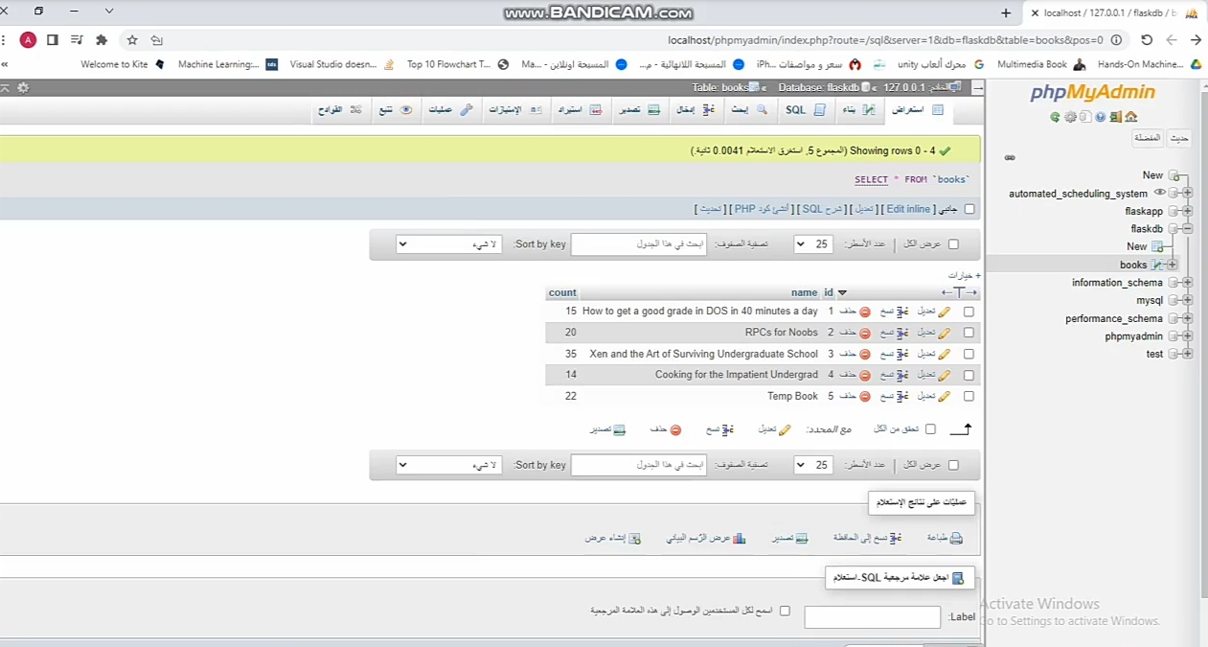

And I have installed pymysql in client side server..

in Catalog server I wrote two operations:

* **Search** by (fetchall())
* **Info** (fetchone())

That can be request from the browser as shown in the next images:

127.0.0.1:5000/search

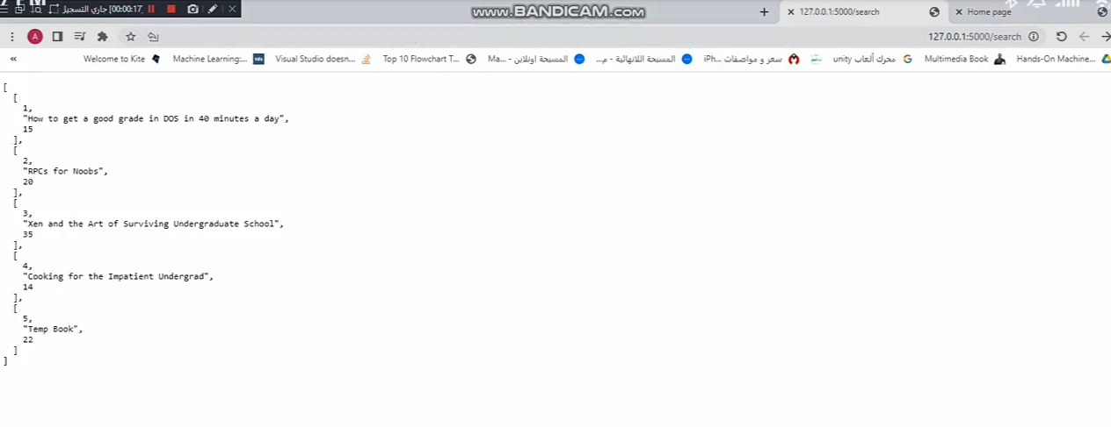

_____________________________________________________________________  
  
127.0.0.1:5000/info/(id)

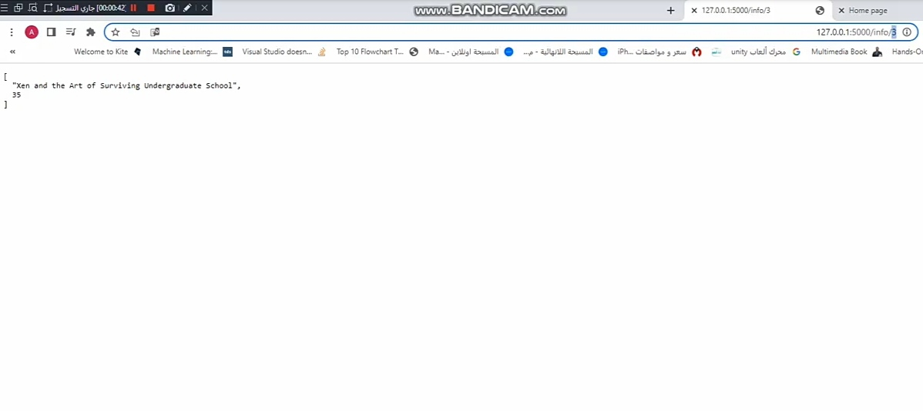

1. **Front end server** : supports three operations , my front end server accepting the requests and perform initial processing:

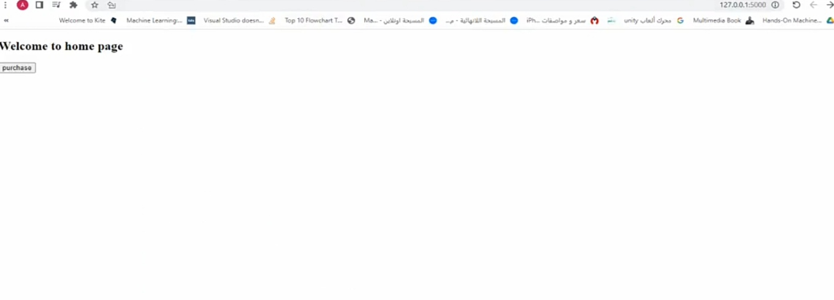

**3. Order server** : Here I have wrote the purchase operation.

On VirtualBox Ubuntu system.

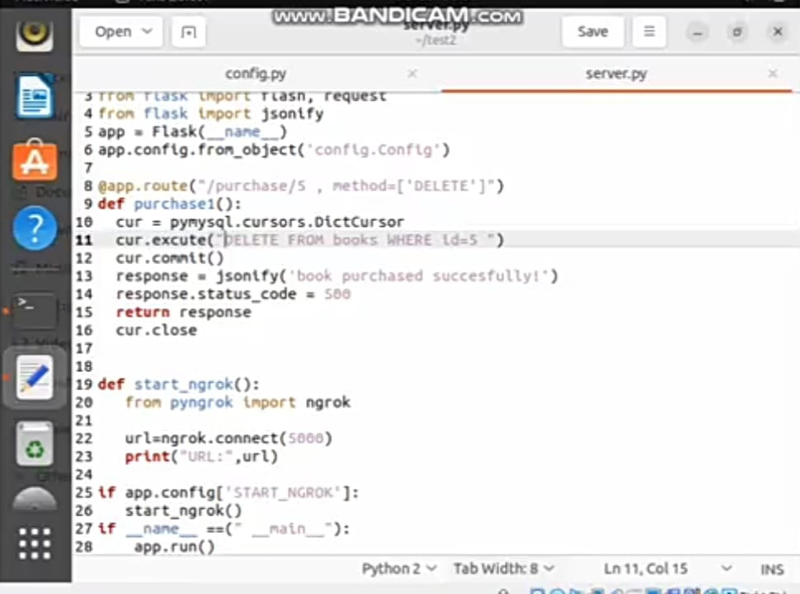

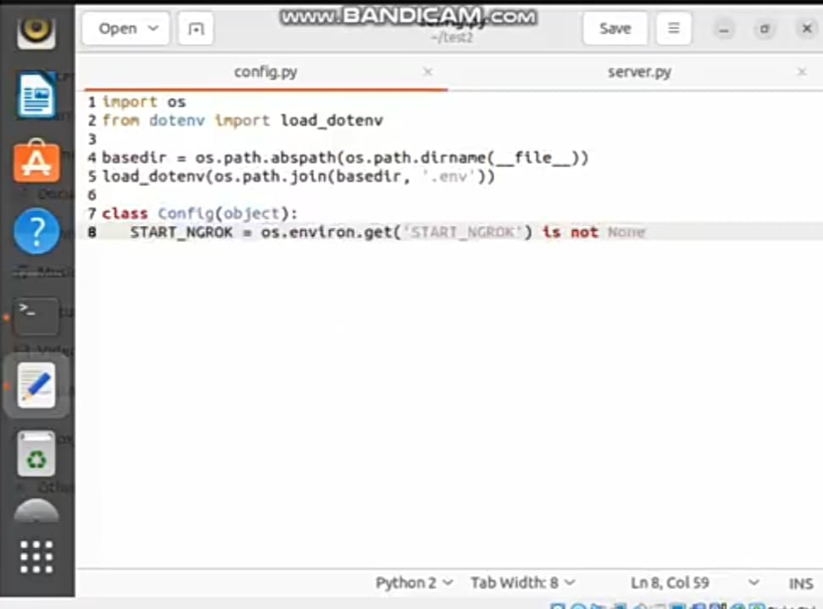

**Then I got the link from the terminal cmd in ubuntu that I used to make a connection between this server named server.py and the other servers.**

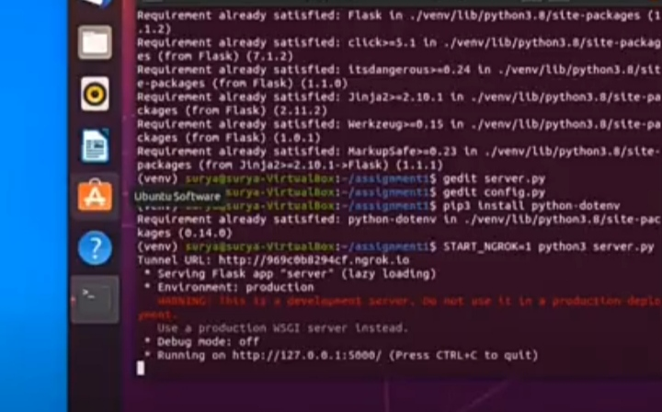

And here is the connection in the front end host side after taking the link from the other server http://adc9-82-102-244-175.ngrok.io

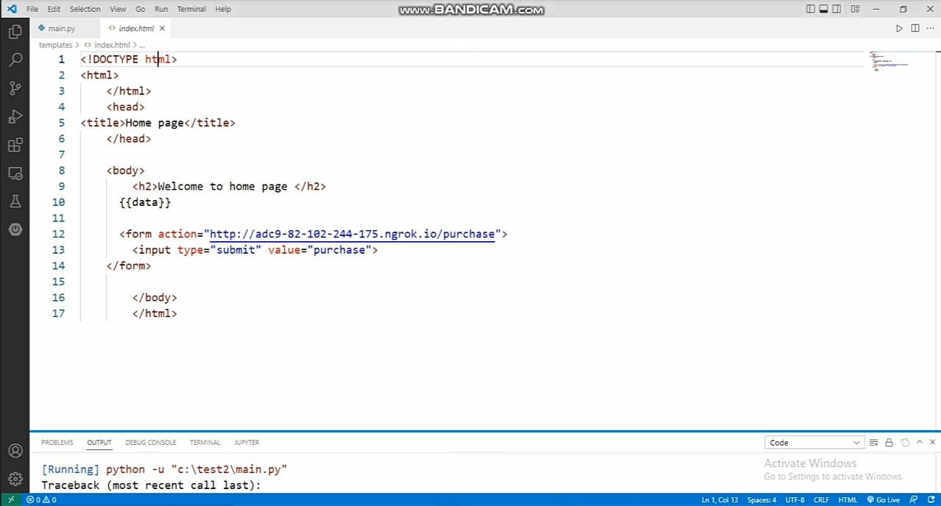

I implemented the interfaces for each component as a HTTP REST interface as I mentioned before with the previous attached images .

**Browser test:**

The information of the request and response as shown below in the image:

1. Request URL: <http://localhost:5000/search> (port 5000)
2. Request Method: GET
3. Status Code: 500
4. Response in json

I run my project by write in cmd : **python main.py**

Then it will give me the localhost link with port 5000 as shown below :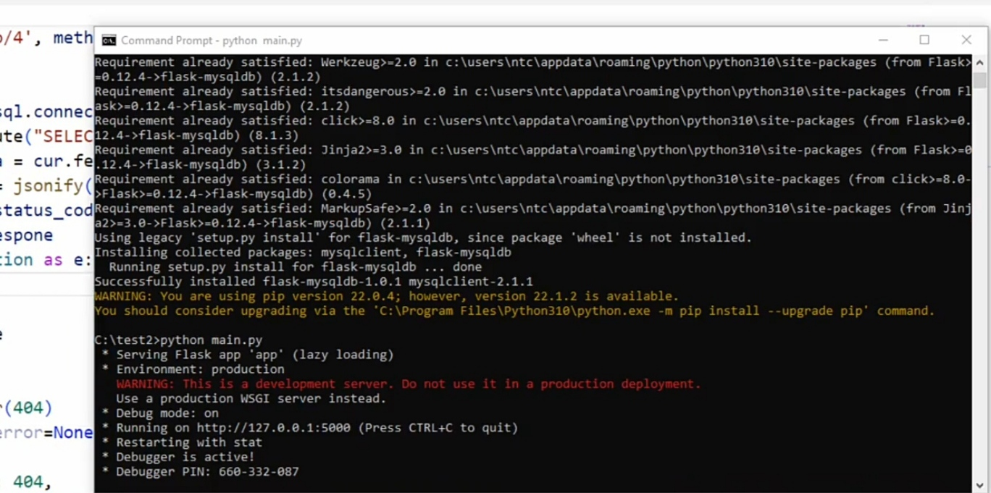

After I test **search** and **info** requests that’s what return in command:

