Socket IO

- Socket.IO is used for real time web applications. It is a JavaScript library that enables real time communication between web clients and servers.
- In general, two-way communication demonstration is seen via Socket.IO through the image below. With sockets, when the server receives a new message it will send it to the client and notify them, bypassing the need to send requests between client and server.

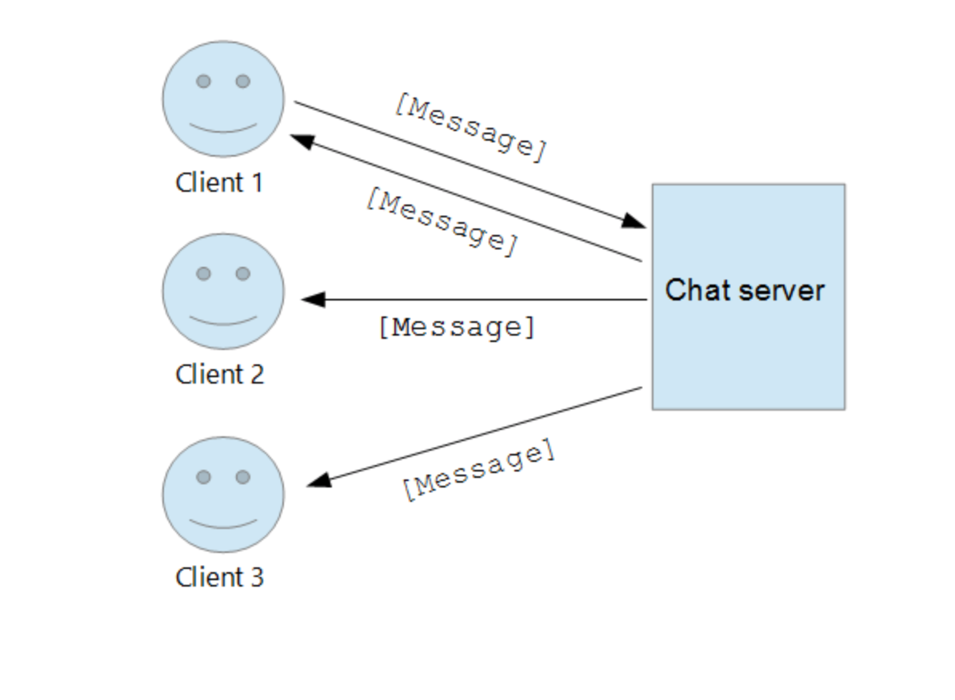
https://ably.com/topic/socketio
https://socket.io/docs/v4/index.html

Integrating Real-Time Chat App with React and Firebase

- Firebase is a backend service that can be used to store real-time database.
- https://www.youtube.com/watch?v=zQyrwxMPm88&ab_channel=Fireship

