# 版本1enhanced

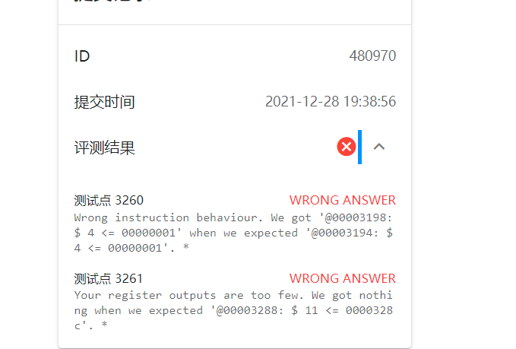

Strong

ID

480354

提交时间

2021-12-28 08:31:35

评测结果

测试点 2801WRONG ANSWER

Wrong instruction behaviour. We got '@0000300c: $ 1 <= 0000ffff' when we expected '@0000300c: $ 1 <= 7fffffff'. *

测试点 2804WRONG ANSWER

Wrong instruction behaviour. We got '@0000300c: $ 2 <= 0000884c' when we expected '@0000300c: $ 2 <= 5b0a884c'. *

测试点 2792WRONG ANSWER

Wrong instruction behaviour. We got '@00003004: $ 1 <= 0000abfc' when we expected '@00003004: $ 1 <= ffffabfc'. *

测试点 2793WRONG ANSWER

Wrong instruction behaviour. We got '@00003004: $ 1 <= 000089ac' when we expected '@00003004: $ 1 <= ffff89ac'. *

测试点 2794WRONG ANSWER

Wrong instruction behaviour. We got '@00003004: * 00000000 <= 00000000' when we expected '@00003004: * 00000000 <= 00007668'. *

测试点 2795WRONG ANSWER

Wrong instruction behaviour. We got '@00003004: $ 1 <= 0000a24c' when we expected '@00003004: $ 1 <= ffffa24c'. *

测试点 2796WRONG ANSWER

Wrong instruction behaviour. We got '@00003004: * 00000000 <= 00000000' when we expected '@00003004: * 00000000 <= 00000617'. *

测试点 2797WRONG ANSWER

Wrong instruction behaviour. We got '@00003004: * 00000000 <= 00000000' when we expected '@00003004: * 00000000 <= 00002ef6'. *

测试点 2798WRONG ANSWER

Wrong instruction behaviour. We got '@00003004: $ 1 <= 00008bd8' when we expected '@00003004: $ 1 <= ffff8bd8'. *

测试点 2799WRONG ANSWER

Wrong instruction behaviour. We got '@00003104: $ 1 <= 0000f8ac' when we expected '@00003104: $ 1 <= fffff8ac'. *

测试点 2800WRONG ANSWER

Wrong instruction behaviour. We got '@00003104: * 00000000 <= 00000000' when we expected '@00003104: * 00000000 <= 00001757'. *

测试点 2803WRONG ANSWER

Wrong instruction behaviour. We got '@00003004: $ 8 <= 00000000' when we expected '@00003000: $ 31 <= 00003008'. *

测试点 2802WRONG ANSWER

Wrong instruction behaviour. We got '@00003010: $ 2 <= 000045c5' when we expected '@00003010: $ 2 <= 886f45c5'. *

# 版本二

测试点 2801WRONG ANSWER

Wrong instruction behaviour. We got '@000032e8: $ 12 <= fffffffe' when we expected '@000032e4: $ 12 <= fffffffe'. *

测试点 2804ACCEPTED

Accepted.

测试点 2792WRONG ANSWER

Wrong instruction behaviour. We got '@000032b0: $ 9 <= ffff0000' when we expected '@000032ac: $ 4 <= 0000726f'. *

测试点 2793WRONG ANSWER

Wrong instruction behaviour. We got '@000034ac: $ 9 <= 00005d68' when we expected '@000034a8: $ 6 <= 00004cca'. *

测试点 2794WRONG ANSWER

Wrong instruction behaviour. We got '@00003190: $ 6 <= ffffbeff' when we expected '@0000318c: $ 6 <= ffffbeff'. *

测试点 2795WRONG ANSWER

Wrong instruction behaviour. We got '@00003188: $ 31 <= 00002de8' when we expected '@00003184: $ 6 <= 00003ff2'. *

测试点 2796WRONG ANSWER

Wrong instruction behaviour. We got '@000031ac: $ 31 <= 00005e49' when we expected '@000031a8: $ 21 <= 00002bbd'. *

测试点 2797WRONG ANSWER

Wrong instruction behaviour. We got '@000035b0: * ffffcab8 <= 0a0b0000' when we expected '@000035b0: * 0000006c <= 0a0b0000'. *

测试点 2798WRONG ANSWER

Wrong instruction behaviour. We got '@00003508: * ffffcb70 <= 00005272' when we expected '@00003508: * 0000007c <= 00005272'. *

测试点 2799WRONG ANSWER

Wrong instruction behaviour. We got '@000039ce: $ 8 <= 00000001' when we expected '@000032a0: $ 20 <= 00000001'. *

测试点 2800WRONG ANSWER

Wrong instruction behaviour. We got '@00003278: $ 31 <= fffffdc4' when we expected '@00003278: $ 31 <= 00003040'. *

测试点 2803WRONG ANSWER

Wrong instruction behaviour. We got '@000031d0: $ 12 <= 00000000' when we expected '@000031d4: $ 10 <= 7fffffff'. *

测试点 2802WRONG ANSWER

Wrong instruction behaviour. We got '@000035f4: $ 2 <= f2629f51' when we expected '@000035f4: $ 2 <= 74aeb991'. *

# 版本3