WaveDrom with MS Word

# Here are the steps:

1. Edit timing diagram using WaveDrom Editor: <http://wavedrom.googlecode.com/svn/trunk/editor.html>

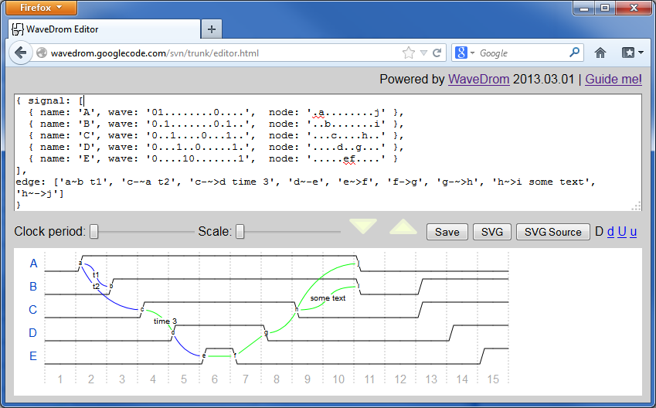

1. Press SVG button:  (new Tab will open with SVG picture)

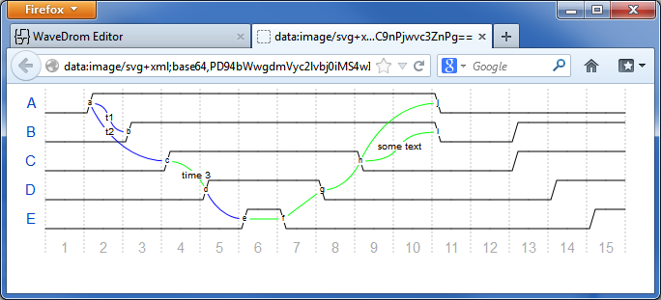

1. Ctrl+S to save the SVG with the name and in the folder of your choice:

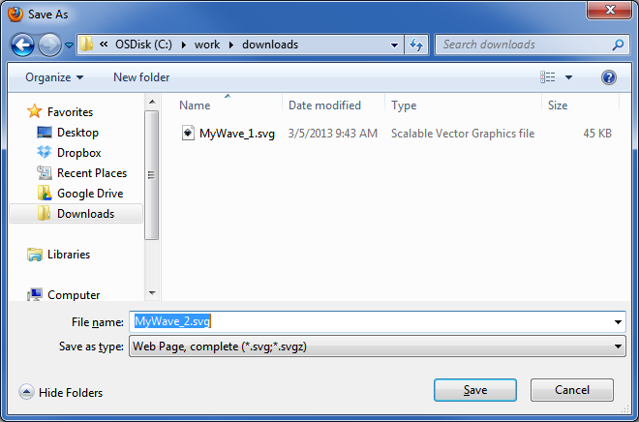

1. You can convert SVG 🡪 PNG using Inkscape vis GUI or from command line:

"c:/Program Files (x86)/Inkscape/inkscape.exe" MyWave_2.svg **--export-png**= MyWave_2.png

And Then insert as picture below:

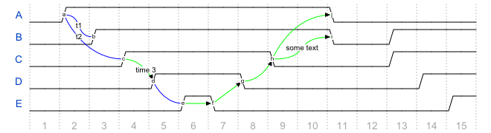

1. Or similar story for SVG 🡪 EPS (but now the vector format is preserved!)

"c:/Program Files (x86)/Inkscape/inkscape.exe" MyWave_2.svg **--export-eps**= MyWave_2.eps



# Simplified flow

You can use Windows Snipping Tool to get quick raster picture into your MS Word document.