3D report

ITPM5.240 Agile Projects |  | Halley Gerrard  2005007101



iteration 1
1 Weekly Report
2 Stakeholder Register.
3 Three personas.
4 Review personas.
5 Reference information: read me doc. Git hub.
6 Improvements for Iteration 2

01

Halley gerrard

Software developer
Progress Report.

I have contributed to the task by developing three detailed persona that represent different types of users who interact with our system. Each persona includes demographic details, goals, motivations, challenges, and expected use cases. This contribution strengthened the technical workflow, improved collaboration efficiency and ensured code consistency. I also provided a review of all three personas accurately representing their background information, ensuring consistency in formatting, tone and level of detail. this review strengthened the quality of the personas and ensured they would be practical tools for informing design decision. Overall, everything went well for this part of the project, the positives are everything was completed within the allocated time frame. The negatives, nothing to report.

Second contribution is the Git hub constraints and local repository setup. I downloaded Git to one laptop PL107B04 and was completely on schedule. Unfortunately, that device doesn’t save downloaded software, and I lost my lead. I then downloaded Git to a PC in room LAB and followed the instructions to the assignment, which was a complete success 😊. I was happy with how the program ran and applied itself to the files. .vs appeared; I knew it was going to be easier from here. A team member advised me to delete.vs. As I tried to negotiate with this team member, we did not agree, and .vs was deleted as the resolution. I knew the next process was going to be even longer, which is a huge negative from the software developer.

https://github.com/3D-byt/Progress-report.git

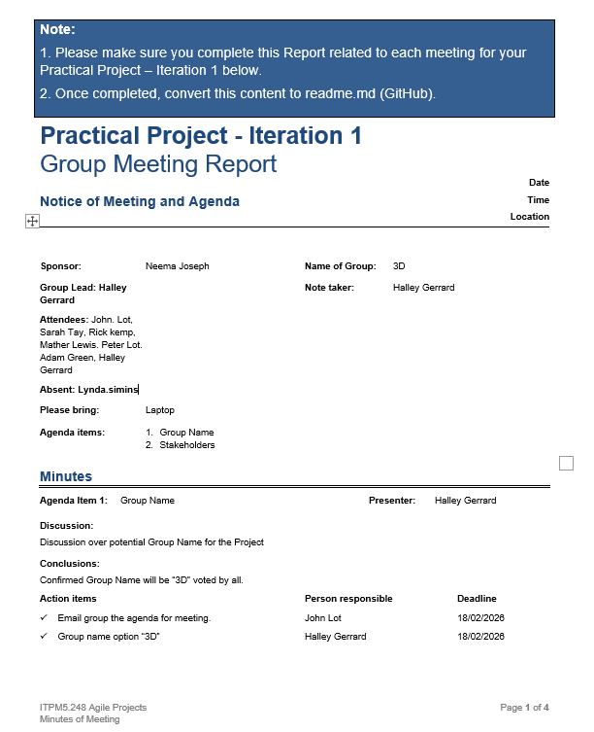
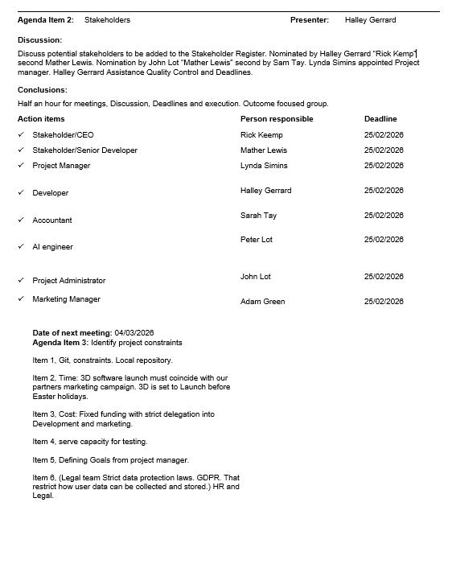
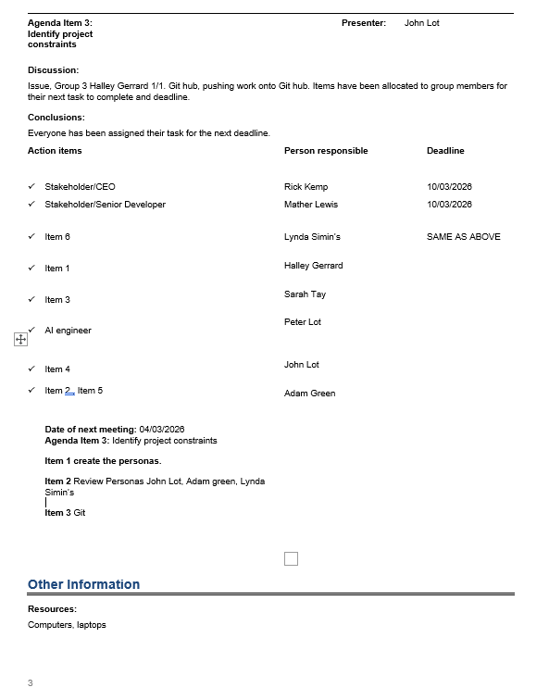
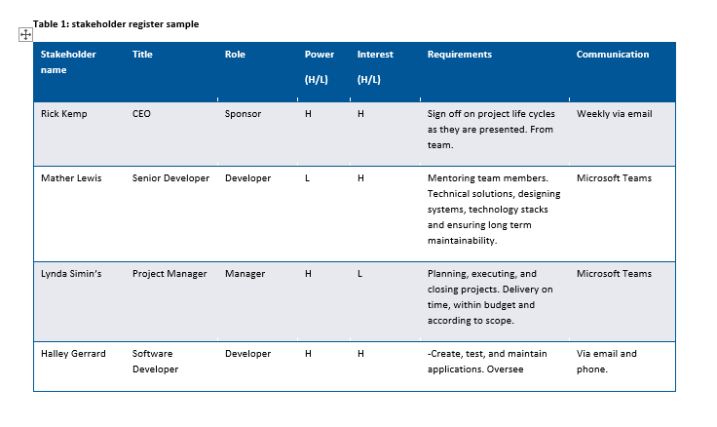
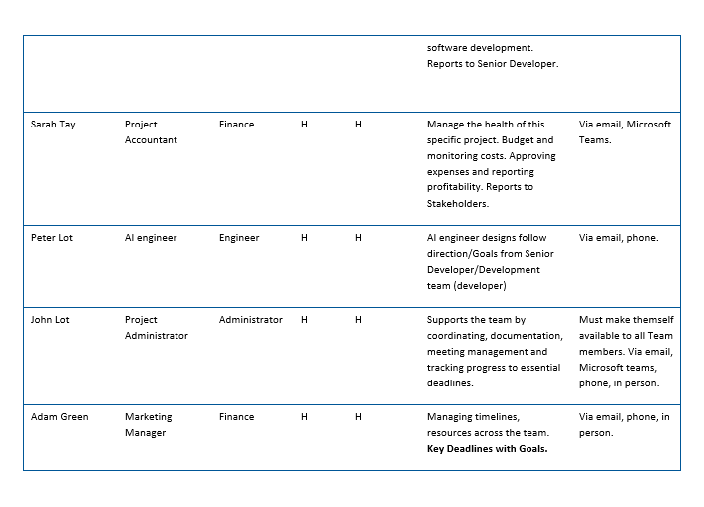

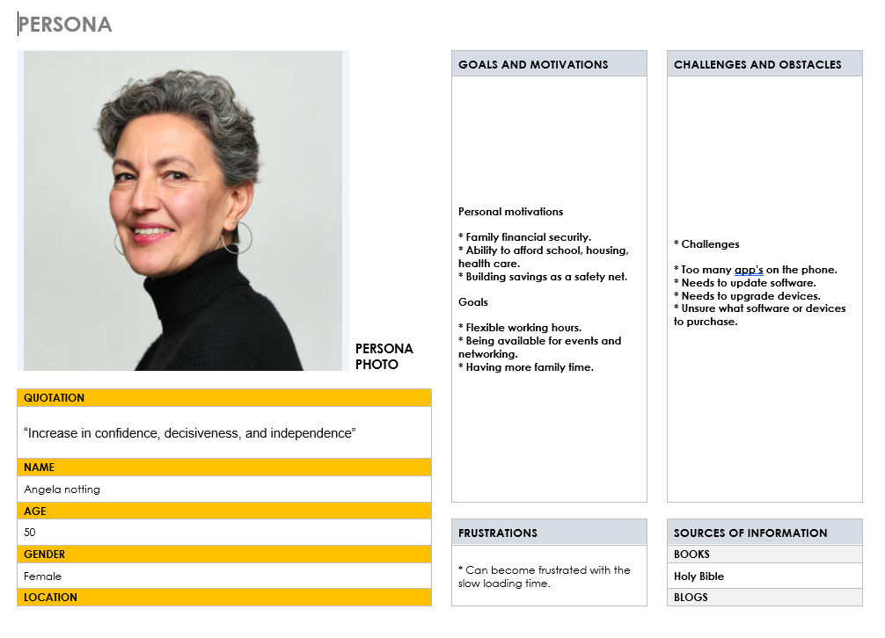

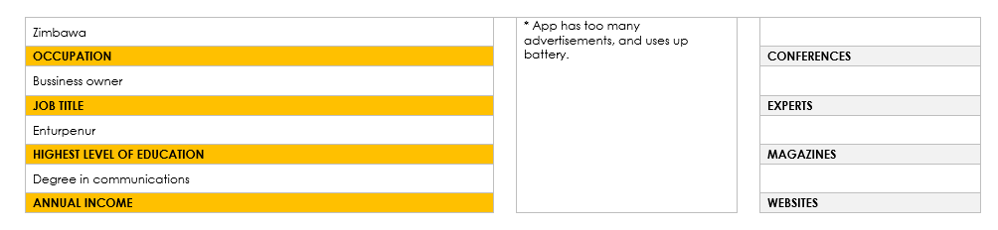

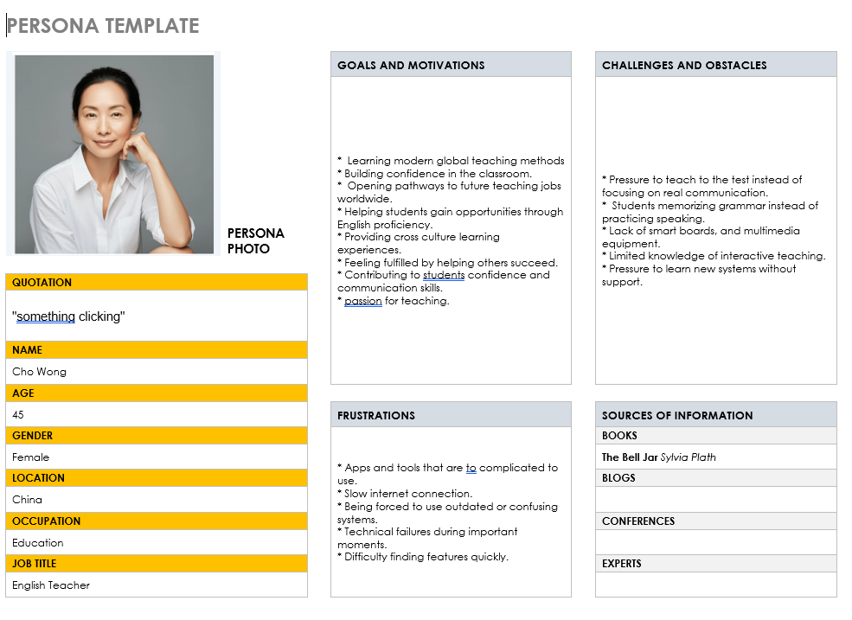
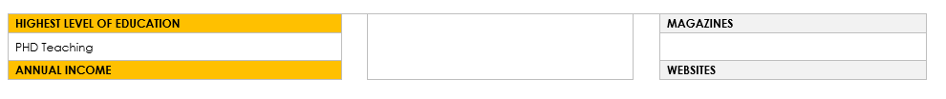
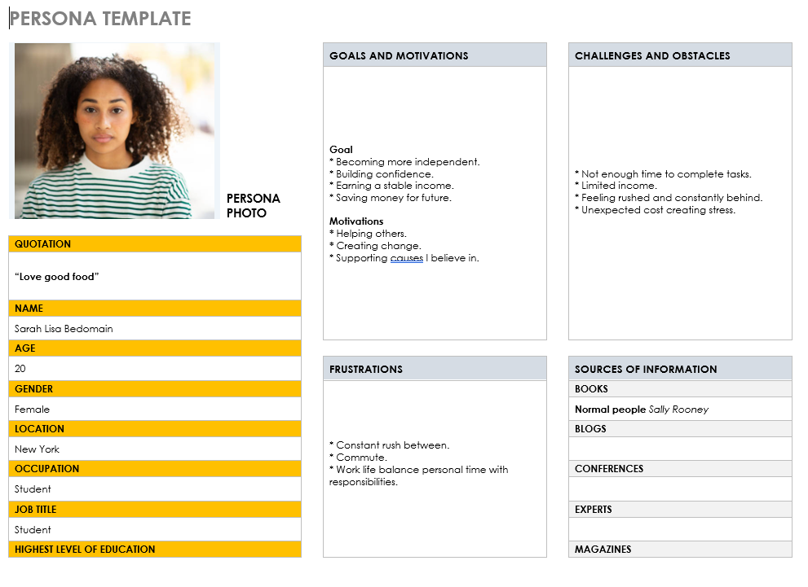
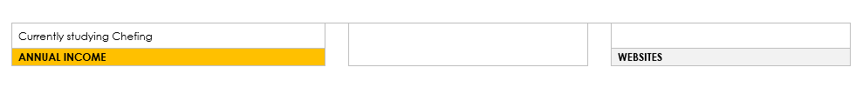

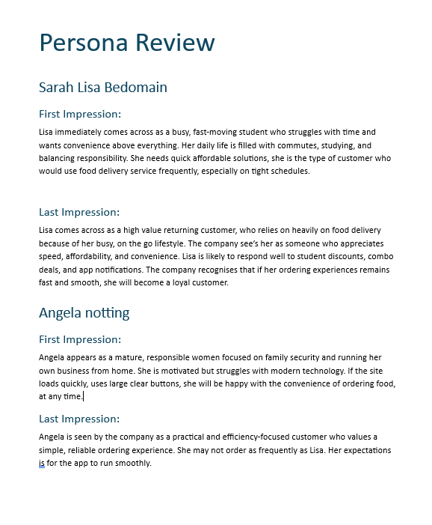


Improvements for Iteration 2
- Eliminate waste.
- Build quality.
- Defer commitment.
- Create simple solutions.

