# 1 – Installation

1. To install the plugin (packaged as a *.unitypackage)   
   in your Unity window select: “Assets > Import Package > Custom Package”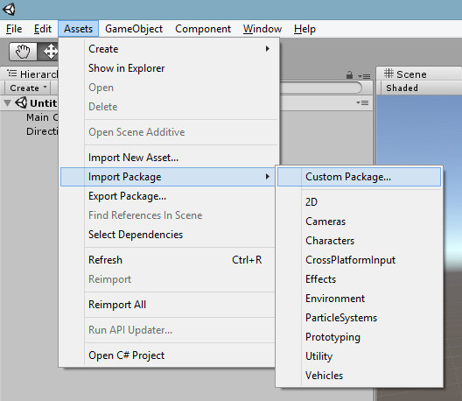
2. Find the package in your filesystem and click “Open”.
3. If the package imported correctly open the plugin UI by selecting “Window > 3D Scanner” 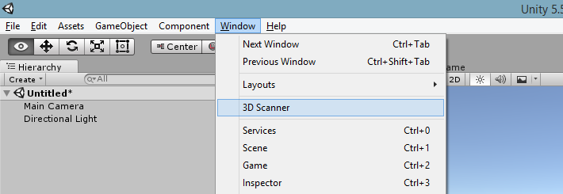

The 3D Unity Scanner is successfully installed!  
  
NOTE: You can snap the window anywhere you like, but it was built with a column-layout in mind. It is recommended to snap to the right or left side of the scene window

# 2 – Interface

The following is an overview of the plugin interface from top to bottom. 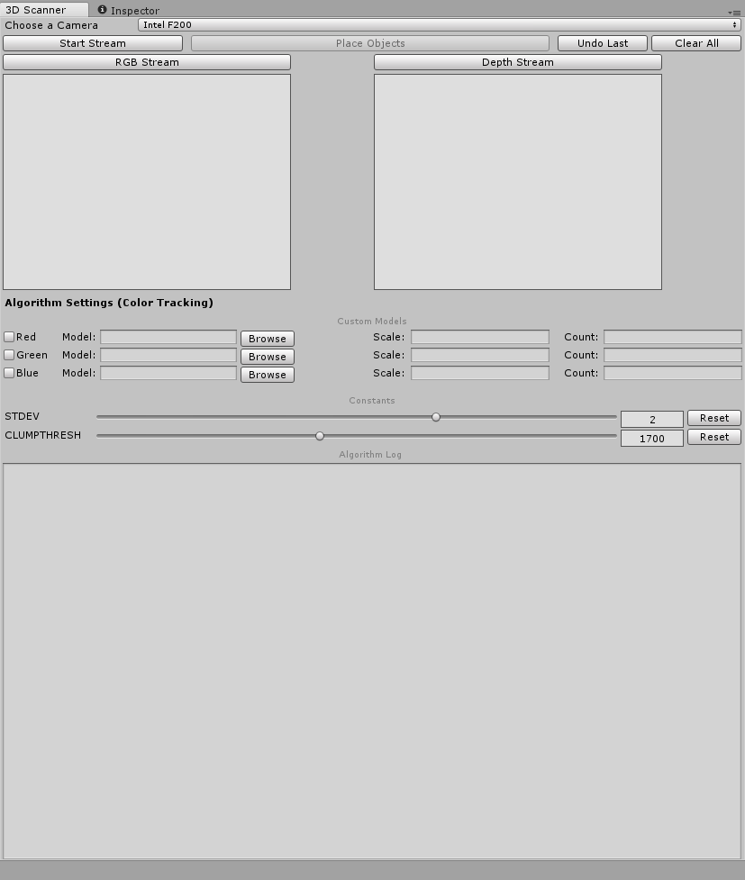

1. **Choose a Camera –** The top of the interface is a drop-down menu to select different camera devices (Default: Intel F200).
2. **Start Stream –** This button begins the video stream from the selected camera and displays the output in the “RGB Stream” and “Depth Stream” boxes.
3. **Place Objects –** When the stream is running you can press this button to perform detection and place the corresponding models in the Unity Scene.
4. **Undo Last –** This button will clear the previous scanned objects from the Unity Scene and restore a previous scan if available.
5. **Clear All –** This button will clear the current scene and previous scans.
6. **Red/Green/Blue –** If any of these options are checked the algorithm will associate the user selected model at the specified scale for the corresponding detected color. For further explanation of this feature see Section 3 - Use Cases.
7. **STDEV –** Allows the user to change the tolerance of the background pixels in the algorithm. A higher value corresponds with a higher likelihood of a pixel being recognized as a background pixel.

# 3 – Use Cases

# 4 – Troubleshooting