TITLE: CityGML 3.0 Development Process

Author Name (s): Steve Smyth, Carsten Rönsdorf, Claus Nagel, Thomas Kolbe

Email:[steve@opensiteplan.org](mailto:steve@opensiteplan.org), [Carsten.Roensdorf@ordnancesurvey.co.uk](mailto:Carsten.Roensdorf@ordnancesurvey.co.uk), [cnagel@virtualcitysystems.de](mailto:cnagel@virtualcitysystems.de), [thomas.kolbe@tum.de](mailto:thomas.kolbe@tum.de)

DATE: 11 March 2014

CATEGORY: SWG Process

# Overview

The Open Geospatial Consortium (OGC) CityGML Standards Working Group (SWG) is large and has many members with an interest in specific topics. The SWG’s CityGML 3.0 development process recognizes the diversity of member interests and the value of specialization with a specialized process. This document defines that process and its relationship to the OGC policies and procedures, as well as the memorandum of understanding between SIG 3D and OGC.

The SWG has structured twenty-one issues derived from the existing change requests, results of the past four SWG meetings, and a workshop hosted by the Technische Universität München in June, 2013 into fourteen “work packages” (WPs). Each WP has a simple theme, identified participants, and in most cases a designated leader. The SWG formally adopted these WPs as the global scope of development for CityGML 3.0.

The development work will be accomplished as much as possible in an open manner, while following the OGC and SWG procedures. In a high-level view, teams will work in parallel; to develop technical solutions or answers to the existing change requests (CRs), plus new change requests submitted to address work packages themes.

Some existing CRs may be out of scope and will not be addressed by CityGML 3.0. Conversely, some areas within the scope of the work packages may not be the subject of any existing CR. To standardize the process, new CRs will be solicited via OGC-linked marketing and communications channels including public announcements, postings to various LinkedIn groups, and other social media. Each of these new CRs will correspond to one specific work package. Only those work packages where a new work package CR (WP-CR) is submitted and for which there are participants willing to lead and carry out the work will be developed for CityGML 3.0. Authors of all existing CRs will be notified as to their disposition.

This document defines the rules and procedures for the CityGML 3.0 development process.

# CityGML 3.0 Work Packages

There are fourteen work packages. The titles have been edited and the numbering changed from that found in previous documents. The numbering scheme used in the GitHub wiki and the scheme used in the merge of related work packages are listed in brackets as **[***number(s) used in GitHub* ***/*** *number used in merge***]**

1. Revise and maintain the UML representations of the conceptual model(s) [3.01 / 1]
2. Design and implement the standards document(s). [3.02 / 2]
3. Revise the level-of-detail (LoD) concept. [3.12 / 11]
4. Remove root-level inheritance from GML and separation of conceptual model and encodings. [3.13, 3.21 / 12]
5. Develop a method to keep CityGML synchronized with changing GML versions. [3.17 / 14]
6. Develop a representation for changing content of entire models or parts of a model: [3.06, 3.20 / 6]
   1. Time-sequences of successive representations,
   2. Simultaneously existing alternate versions,
   3. Mobile objects.
7. Develop a materials module and/or revise the textured surfaces module. [3.03, 3.19 / 3]
8. Develop a representation for land administration. [3.04 / 4]
9. Develop a representation for non-building building-like structures. [3.05 / 5]
10. Develop a representation for utility networks. [3.07 / 7]
11. Develop a representation for volumetric construction and work toward harmonization with the Industry Foundation Classes (IFC). [3.08 / 8]
12. Develop representation for metadata, complex attributes, and harmonize with INSPIRE. [3.09, 3.16 / 9]
13. Develop a representation for storeys (*Am.* “stories”) and other new semantic constructs. [3.10 / 10]
14. Develop or a mechanism for parameterized implicit geometries. [3.17 / 14]

WP teams will work as much as possible in parallel between now and March 2015. During this time, the WPs will periodically report back to the whole SWG on issues and progress. In March 2015 the WPs will begin to work together to discover and resolve conflicts. When that negotiation phase is complete, the WP teams will formally submit their proposed solutions to the SWG.

Two WPs (UML Editor and Standard Editor) have an ongoing editing and integration role.

# Details of the Development Process

The following diagram summarizes the CityGML 3.0 development process. Work proceeds from submission of change requests corresponding to work package topics, disposition of existing change requests, development of proposals for meeting the goals of the individual work packages, discovery and negotiation of conflicts, to final acceptance by the SWG as a proposed standard:

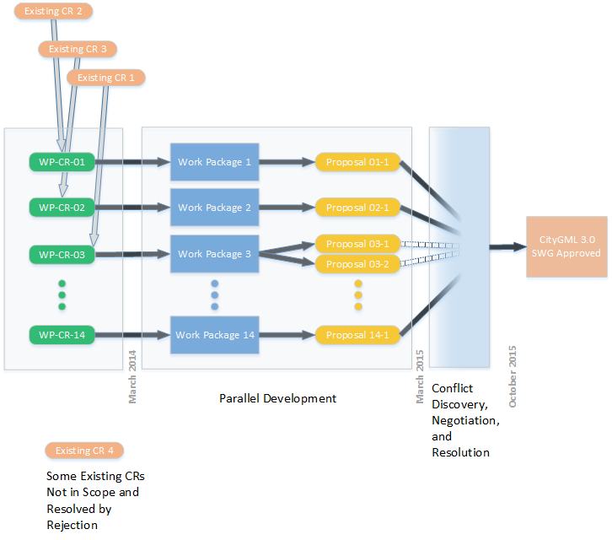

The following sections detail the process.

## Scope and Participation:

The SWG has adopted a set of work packages (WPs), which define the scope of development for CityGML 3.0. Development of the theme of a work package is governed as follows:

1. Development of a work package depends on the existence of participants willing to do the work.
2. A WP will not be developed unless someone submits an OGC change request (CR) asking for the topic of a specific WP to be developed. Such WPs (designated as WP-CRs) are the mechanism for placing a topic within the scope of CityGML 3.0.
3. Anyone may participate in the development of any WP and the ultimate presentation of proposals for resolution of WP-CRs to the CityGML SWG.

## Adoption of Change Requests Corresponding to Work Packages:

The following rules apply to WP-CRs:

1. A WP-CR corresponds to an existing work package.
2. There can be at most one WP-CR per work package.
3. A WP-CR must be accompanied by a document specifying exactly what issues are addressed and the general approach(es) to resolving them. There may be more than one expected path to a resolution and more than one proposed resolution may be expect as the work product of the WP team.
4. Those later working on the work package will provide a point of contact with the SWG. The method of organization of the WP team is up to the individual WP teams except in those areas governed by OGC policies and procedures, SWG decisions, or the Memorandum of Agreement between SIG 3D and OGC.
5. Expectation: most WP-CRs will be submitted before the Washington meeting OGC TC meeting and all before the Geneva TC meeting.
6. The SWG will hold e-votes on proposed WP-CRs and their assignment to a corresponding work package as soon as possible after receipt of a WP-CR.
7. E-vote on any WP-CRs that arrive after Washington meeting
8. We expect some WP-CRs by the time of the Washington meeting.
9. We plan a Geneva OGC TC meeting deadline for WP-CRs
10. We encourage different people working on WP-CRs corresponding to the same WP to work together.

## Resolution of Existing CRs:

As each WP-CR is accepted by the SWG

1. SWG members may propose resolution of some existing CRs by combining them with a WP-CR. This should be done by a separate vote to discharge the existing CR.
2. Some existing CRs may not be addressed by any WP-CR and should be resolved by “will not be in 3.0” due to lack of willing participants at the time of the Geneva meeting.
3. The author(s) of all existing CRs will be notified as to the resolution of their submitted CR, whether the request is assigned to a CityGML 3.0 work package or declared out of scope.

## Work Package Team Open Development Procedures:

Development of the work packages is intended to be as open as possible within the OGC policies and procedures, the Memoranda of Understanding between OGC and SIG 3D, OGC and bSI and the procedures adopted by the SWG itself. The following are the work package team procedures:

1. Management of the work and the disclosure and IP rules are governed by the WPT Open Development Procedures. The goal is to be as open as possible to ideas and expertise from many sources while still following the OGC policies and procedures.
2. Work may start on a WP as soon as the corresponding WP-CR has been accepted by the SWG.
3. A work package team (WPT) is responsible for carrying out the development of changes appropriate to the work package topic(s) as expressed in the corresponding WP-CR after acceptance by a vote of the SWG. The planned end of WPT work is the March 2015 OGC TC meeting.
4. Meetings for the purpose of discovery of conflicts and dependencies between work packages will be held as part of or in conjunction with CityGML SWG meetings. WP teams should focus on the work package topic rather than attempting to find and resolve inter-WP issues.
5. The individual WPTs may complete their work and submit zero or more proposals for resolving the original WP-CR to the SWG. This can be done any time up to the end of the WPT work period planned for the March 2015 OGC TC meeting.
6. Before consideration of the individual proposed resolutions by the SWG, there will be a six month period of negotiation between WPT’s in order to identify and resolve conflicts. The Editors will guide this process. The planned beginning of the period is the March 2015 OGC TC meeting end of the period is the September 2015 OGC TC meeting.
7. Participation by SIG 3D and CityGML SWG members is covered by the OGC rules and the Memorandum of Understanding between SIG 3D and OGC.
8. Participation by external experts requires execution of the OGC Observer Agreement for the CityGML SWG and approval by a vote of the SWG.
9. Publication of any joint work products (intermediate results or final proposals) of a WPT must be in conformance with OGC policies and procedures, including the IPR restrictions of the CityGML SWG. Details of such publication should be negotiated among the members of the WPT. Proper credit must be given to the OGC CityGML SWG and the names of the individual WPT members involved in the development shall be stated, unless they do not want to be named. Such publications should be coordinated with the CityGML SWG and announced via OGC marketing and communications channels, where feasible. The publication of original suggestions and contributions to the WP development by individual WPT members is not subject to this rule.
10. Each formal participant in a WPT must agree that all contributions made to the work within the WPT and all joint work products will be subject to the OGC policies, procedures, and intellectual property right restrictions. If a participant decides to leave a WPT his/her contributions remain within the WPT under these IPR rules.

# Planned Timeline

The following is the planned timeline:

1. SWG selects WPs – January 2014 [completed]
2. CityGML 3.0 process is accepted by the SWG. – March [2014]
3. SWG accepts WP-CRs submitted by participants – March (-June) 2014 [Vote 1: Washington, Geneva]
4. Call for public participation. March 2014
5. SWG resolves existing CRs – June 2014 [Vote 2: prior and up to Geneva]
6. WPT develop proposals for resolving WP-CRs – March 2014 – March 2015 [Vote 3 or process determined by WPTs]
7. All participants work together to discover conflicts between WPT proposals and negotiate resolutions for SWG approval – March 2015 – September 2015
8. SWG votes on proposed resolutions of WP-CRs – December 2015 [Vote 4]
9. Editors (and other interested members) prepare the CityGML final draft model and encoding standard(s) – December 2015 – June 2016
10. SWG approves draft standard(s) to be submitted to final OGC process – June 2016 [Vote]
11. OGC TC votes to accept [Vote 5]

# WP-CR Template

A change request must be submitted as a WP-CR via the OGC change request application at <http://portal.opengeospatial.org/public_ogc/change_request.php> should reference the corresponding WP by using the WP title in the CR title. The correspondence to the WP should be established in more detail via the “Reason for Change”, “Summary of Change”, and (optionally) with a longer associated uploaded document as “Supporting Documentation.” The key fields in the CR submission application are as follows:

**Name/Version:**\* City Geography Markup Language (CityGML) Encoding Standard / 2.0

**Title:** \**<Title of corresponding work package addressed>*

**Category:** * C (Functional modification of feature)

**Reason for change:**\* *<Short statement of purpose>*

**Summary of change:**\* *<Outline of methodology and plan for achieving the desired change>*

**Supporting Documentation:** *<May include a document with a more detailed plan or reference documents>*

If multiple WP-CRs are submitted for the same WP, the SWG will act to combine them.

# GitHub Procedures

The development process will use GitHub repositories to organize work products of the WP teams. From time to time, a WP team may request that the SWG approve publication of intermediate products for public review. These activities will involve both a private and a public repository as follows:

## Private GitHub Repository

GitHub enables parallel work by allowing the WPs to fork their own branch of the UML model and standard document, record their work as change sets, and ultimately submit the changes back to the Editors for merge. Starting in March 2015, we are planning six months of full SWG work for the final merge, though we hope that the work is actually done incrementally during the year and one-half 3.0 development cycle to avoid a “big bang” effect at the end. This use of GitHub is in a private repository, accessible to the SWG, SIG 3D, and possible external experts identified, requiring a vote by the SWG, and admitted with an executed observer agreement as you describe.

## Outreach via Public GitHub Repository

Independently, the SWG intends to expose some results via GitHub during the course of the development cycle to get external review, much as we did during GeoPackage 1.0. For this purpose there will be a second public repository with a slightly different URL such as  <http://www.github.com/opengeospatial/CityGML-Public> (and then the private one could be as  <http://www.github.com/opengeospatial/CityGML-SWG> . This is a technical issue to be determined jointly with OGC staff.