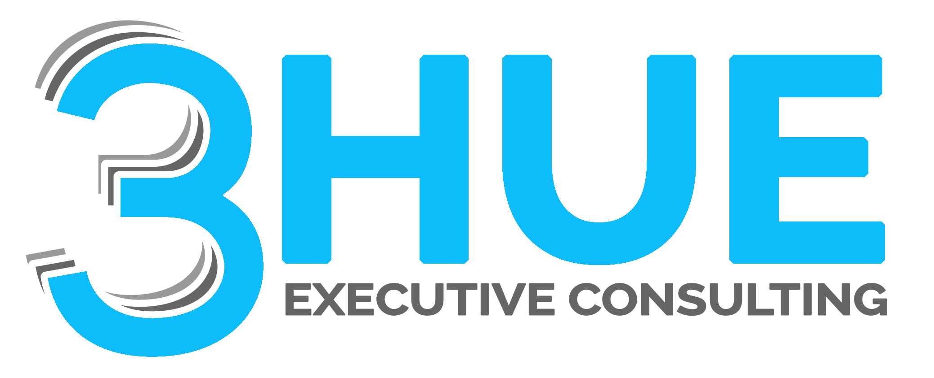
SOC 2 Multi-Framework Meta-Audit Overview
How 3HUE's USR Framework Maps One Program to Many Audits, Simultaneously

What is a meta-audit?
3HUE’s USR (Unified Security & Risk Framework) maps every control your organization is responsible for once, to a single governed baseline: UCB (Unified Control Baseline), the platform methodology 3HUE architected as AiVRIC’s GRC Build partner. Because every obligation is mapped to that one baseline, a single program of continuous evidence collection and control testing produces audit-ready evidence that satisfies many frameworks at the same time — instead of running a separate, siloed audit program for each certification, mandate, or regulation your organization carries.
We call this a meta-audit: any combination of Trust Services Criteria, and any combination of frameworks mapped into USR/UCB, evaluated together, continuously, from one evidence set.

Flagship example: SOC 2 + HITRUST as a combined audit
Many organizations — particularly in healthcare, health tech, and their vendor ecosystems — need both a SOC 2 report and a HITRUST assessment to satisfy customers, partners, and regulators. Run separately, these are two audit programs, two evidence requests, and two audit windows.
Because SOC 2’s Trust Services Criteria and HITRUST’s control requirements both map into the same USR/UCB baseline, 3HUE runs them as a combined audit: one control testing cycle, one evidence set, produced once and mapped to both reports. This is the model example for how USR/UCB extends to any other combination of frameworks your organization carries.

Popular certifications, mandates, and frameworks covered
A representative view of the frameworks 3HUE’s USR/UCB control mapping supports today, grouped by category.
Category | Frameworks
Security & Risk | ISO/IEC 27001 • NIST Cybersecurity Framework (CSF) 2.0 • CIS Critical Security Controls v8.1 • COBIT 2019
Compliance & Assurance | SOC 2 (Trust Services Criteria) • HITRUST • PCI DSS v4.0.1 • CMMC 2.0 • FedRAMP
Privacy & Data Protection | HIPAA Security Rule • ISO/IEC 27701 • GDPR • CCPA / CPRA
Sector & Regional | GLBA • FFIEC guidance • NY DFS 23 NYCRR 500
Represents a subset of the frameworks 3HUE’s USR/UCB control mapping supports — ask your account team about additional frameworks relevant to your industry and region.

How the meta-audit engagement works
01 Map once to USR
Every obligation across your target frameworks is mapped a single time to the USR/UCB control baseline.
02 Collect evidence continuously
Evidence is gathered on an ongoing basis instead of scrambled together per audit cycle.
03 Validate every framework in parallel
Each control is tested once and checked against every mapped framework at the same time.
04 Deliver one audit-ready evidence set
A single evidence trail supports SOC 2, HITRUST, and every other framework in scope — reviewed once, not once per certification.
Ready to consolidate your audits?
Request a consult with 3HUE to scope a meta-audit program across your frameworks.
3hue.net/contact.html

AiVRIC CloudSignals+ RiskOps and the AIRE Agentic Mesh are AiVRIC Technologies platforms; 3HUE architected UCB as AiVRIC’s GRC Build partner. USR is 3HUE’s own framework used to deliver ISG Managed Programs. Framework names are the property of their respective standards bodies. Service scope and terms confirmed in an executed Statement of Work.

