## TUT – Pervasive Computing – TIE-21106 Software Engineering Methodology

Teachers: Farshad Ahmadi, Tero Ahtee, Kari Systä

## Authors:

* Milla Mäkinen <milla.makinen@student.tut.fi>
* Mengyang Chen <mengyang.chen@student.tut.fi>
* Daniel Berezvai <daniel.berezvai@student.tut.fi>
* Alexandre Kirszenberg <alexandre.kirszenberg@student.tut.fi>

# Manual

## Installation

This game is distributed as source code. To compile, you need [Processing](https://processing.org/) version 3.3 or similar. (Also required to run the game.)

Java runtime environment: You need the latest JRE (should be installed with Processing)

Compatibility with other processing versions is not guaranteed!

## Synopsis

In a small town next to a big river, lived, <personalized Story Name>.

Fighter jets had for years been peacefully coexisting with the surrounding nature.

They had adapted to the life of fisher-jets: they survived by fishing stray fuel barrels from the river.

However, recently, the fuel supply was not what it had been before.

It seemed to have diminished greatly. This was naturally a cause of concern, the jets did not really have any other sources of fuel.

They suspected it may be the evil organization of Environmentalists behind this all, trying to make the poor jets die of starvation!

It was clear this could not continue like this.

Someone had to go and revive the ever flowing stream of barrels before it was too late.

The nearby airport, long deserted, had to be opened again.

And thus, it began: many young and brave jets set on their quest to replenish the source of life.

If only they could get far enough upstream, the answers would be found, and their families saved...

## How to play

The game's goal is to get as far as possible following the river. This means that the player has to both collect fuel and destroy the enemies they face. Either by shooting them, or by ramming into them. Though the latter can only be done so many times before you yourself explode!

## Controls

At the beginning of the game, the game prompts the user for the name. Type the name and press **enter**. The jet is controlled by **arrow keys**, and shooting can be done with **spacebar**. For those looking for score attack, **Q** shows the in-game score board. Finally, debug mode is toggled by pressing the **D** key.

## UI

In the game UI, the main focus is the playing area which shows the river and the riverbed, as well as the jet and the enemies. On the top of the screen, you can see the fuel and the lives of the player as well as the current score. If debug mode is on, the screen also shows the hitboxes of the objects.

## Enemies

The enemies in this game are tankers, helicopters, fuel depots, jets and bridges. Of course, fuel depots are not very malicious, instead, you can collect fuel by flying near them. (Slow down as you are right on top of them to collect more fuel.) Bridges are non-moving, passive objects. However, they — just like the rest of the enemies — will shoot at you. Quite rapidly in fact!

Pictures and score values follow on the next page. The two pictures side by side are (one) original art and (two) downscaled version as they appear in game. Drawn by the talented Milla ☺

### Fuel

Worth no points, but refills your gas. Keep above it as long as you can.

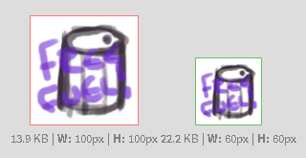

### Helicopter

Worth 60 points. Placeholder art made into feature.

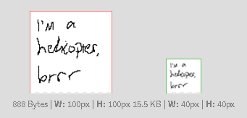

### Jet

Worth 100 points. Flies and shoots quickly.

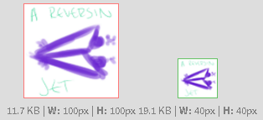

### Tank(er)

Worth 30 points. Not a threat.

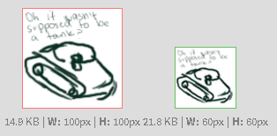

### Bridge

Worth a whopping 500 points! Destroy to get to the next level (seamless, no loading screen)



The end. Good luck in game!